24 Hours in Florence, Italy
In between Salzburg and London, we squeezed in a quick trip down to Florence, Italy. Even though it made the week a bit more packed, I knew that we needed to squeeze it in somehow for Amber's sake. There is so much art to experience in Florence, and so, at my urging, we carved out 24 hours to see all that we could reasonably see during that short amount of time.
We took the train from Vicenza down to Florence, which took about 3.5 hours, changing trains once in the middle. It was actually quite enjoyable to just relax and either read, or look out the window, and appreciate the restful time that we had.
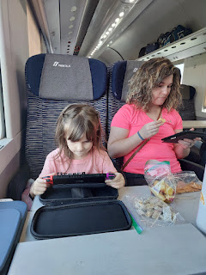

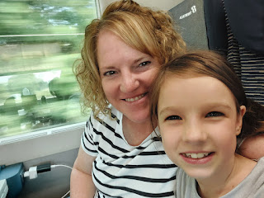

After we got settled in at our AirBnB, we went on a little explore. We ended up having several disappointments in a row, which caused quite a bit of frustration for the girls (and us) as we walked from place to place and their feet were growing tired.

Darn-it #1: Amber found a darling park nearby, devoted to Leonardo da Vinci and some of his clever inventions. We walked about 10 minutes to get there, only to discover that the park was closed. The gate was locked and we could see through the iron fence that some major renovations were underway. The sign on the locked gate was all in Italian, but we could see the dates listed on it, indicating that the project was a lengthy one (from late August until the end of October). Google did not have this information on the internet . . .

Darn-it #2: Amber had selected a cute pizza restaurant near to the park, so we walked over there next. It was also closed. Google showed that it was open . . .

Darn-it #3: We found a different park to walk to. This one did not have playground equipment, but it mentioned a river and walking trails adjacent to it and sounded promising. We walked a few more minutes to get there, only to find that the "river" was just a dried up canal that was completely overgrown and full of weeds and bushes.

We did, however, find these cool murals on the other side of the "river".

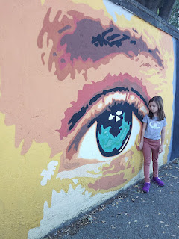

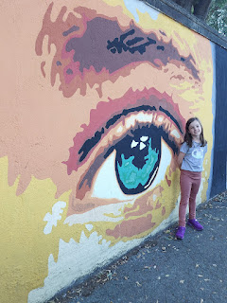

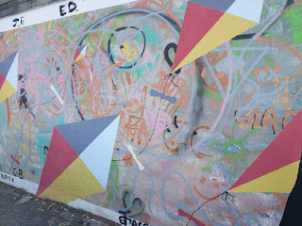

As the girls were growing very tired of endless walking and endless disappointments, we decided to make food our primary focus and then to head back to the AirBnB to relax. We found a cute cafe and grabbed a little of this and a little of that to haul home.

One of the items I purchased was this little baby-sized baguette with bologna, cream, and chopped pistachios on top. It was interesting and delicious at the same time.

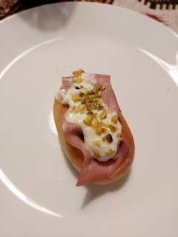

We prepared for bed a little earlier than usual and got a fairly good night of sleep. Originally, we had planned to have the girls sleep in the second bedroom together, since there were two twin beds in there. But Gwen and Abby had been having trouble settling down lately back at our house in Vicenza, staying up waaayyyy past their bedtime and getting into mischief together, ha ha. So Amber made the executive decision to split them up so that we could all get some sleep. She slept in the extra twin bed in Abby's room, while Gwen shared the queen bed next door with me.

Gwen was unable to get comfy for quite a while, tossing and turning, etc. She moved over to snuggle me as I read my scriptures, even taking turns reading some verses with me. She ended up falling asleep as she laid her head on my leg, perpendicular to the bed, ha ha. I let her sleep like that for a while, as I played on my phone until I got sleepy. Then I moved her over to the other side of the bed and tucked her in for the night.

We woke up happy and ate a minimalistic breakfast with the few items I had picked up the night before at a little neighborhood grocery store. We had also asked our host in advance if we could store some of our luggage at the AirBnB for part of the day until we were ready to leave town, but he told us there was no place to put it and that another family was due to arrive soon after we checked out. We did a little research before arriving in Florence, and found what looked to be a good alternative solution.

There is an app called "Radical Storage" and it basically works like this:
Within the app, you can search for a place nearby (or near to where you
will
be) that can store your luggage.
You pay 5 euros per bag per day. Pay first in the app, then go to to the luggage dropoff place that you selected.
The storage facilities may range from a cafe, or a store, or a hotel. Ours happened to be a trophy shop down the street from the train station. They have all been vetted to make sure they are a respectable business that can be trusted with people's personal belongings.
When you arrive at the selected location, you show them the QR code in the app, or in the email confirmation that you received.
They scan the QR code, take a photo of the items you will be leaving in their care, and then off you go.
When you return, they scan the QR code again to "check out", and voila - you are all set. They bring your bags out and then you are free to go.
They are in several cities across Europe, which is a great option for future reference.
The interesting part of our experience, is that we were the FIRST customers to use this little trophy shop, so they were a little unsure of how to do it. They made a phone call and then once they understood what to do, we were all very pleased with how easy the whole process was. We left two of our backpacks with them for the day, since all we had brought with us was a total of 3 backpacks and my purse for the 24 hours. It was SO NICE to not be so loaded down with gear as we toured around the city. I also gave them 5 stars in my review.

We boarded a train from the Florence Rifredi Station to go about 20 minutes south to the Florence Santa Maria Novella Station, which is closest to all the historic and touristy sites.

We found a cute cafe once we got off the train where the girls could get some yummy bread and Amber got a handsome looking sandwich.

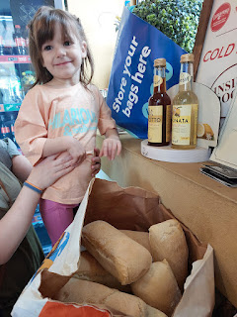

Video of the guy slicing up some meat for Amber's sandwich: (6 seconds)
https://photos.app.goo.gl/6LyZrHvGDN2tKpRb8

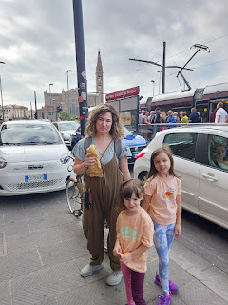

Video of Gwen happily munching on her plain baguette bread: (5 seconds)
https://photos.app.goo.gl/GbaacwYcXpXF8BZa6

One of the public water stations in Florence . . . (I refilled my water bottle here and it was delicious)

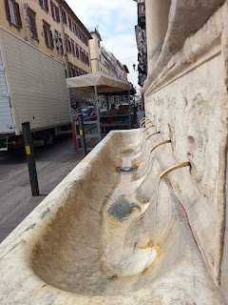

The streets were very narrow, with hardly any room for pedestrians going the opposite way. At times, cars or buses would zoom by just inches from your swinging arm that was closest to the street . . . so we had to keep a tight watch on the girls. Sometimes we could walk 2x2 (one grownup + one girl), but other times we had to walk single file.

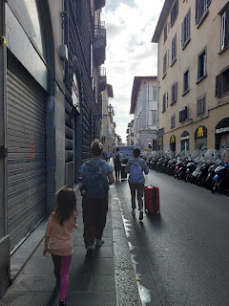

Our first stop was the San Marco Church, completed in the year 1443.

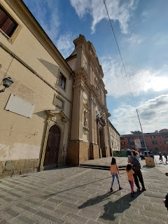

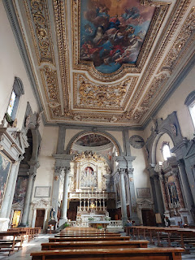

There were some centuries-old frescoes to reverently appreciate within the old church.

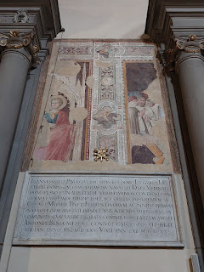

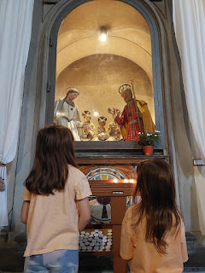

Video of the interior of the church: (11 seconds)
https://photos.app.goo.gl/aN2VLbamNGcW8ik27

Video of some of the "behind-the-scenes" work that takes place in these beautiful edifices: (7 seconds)
https://photos.app.goo.gl/arjcU4jZ1J9xNVdM6

It was around this time that Darn-it #4 happened: Abby realized that she accidentally left her new purse back at the AirBnB. She was in tears as we reached out to the host to see if we could meet up with him at some point in the day. He was very gracious in arranging a time for us to meet later in the afternoon.

Darn-it #5: Gwen was tired. She didn't know what was in it for her, as we walked all over Florence. She either wanted something that was "out of reach" (unattainable) or that was intended for later, which she struggled having enough patience for. She wanted to buy everything she saw, and when she was told no, she would melt into tears. Poor thing. She needed a little break to sit down and rest for a bit.

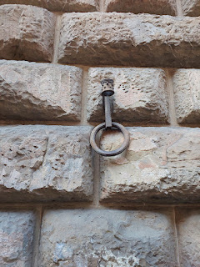

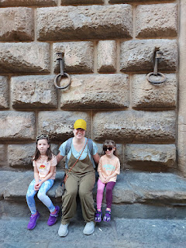

Video taken through the gates of the Palazzo Medici Riccardi Museum: (7 seconds)
https://photos.app.goo.gl/rqD5WczM6MQU2xFM6

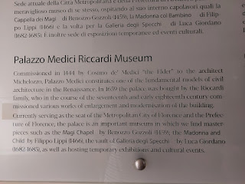

We were beginning to realize that Florence is made more for adults than it is for young children. How sad. Some big cities in the world have a lot to offer for children, but not so much here. We had to downsize our wish list and just pick one or two more things to see that day, in order to keep the peace.

So what do you do when the meltdowns are happening left and right? You find some food. That always makes things better.

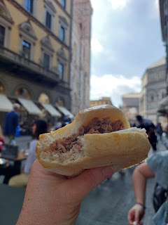

And hallelujah for this guy, who set up his very capable speaker near to where we sat outside the cafe, and began singing BEAUTIFUL OPERA songs for all the passersby. It was just lovely to listen to him for a while.

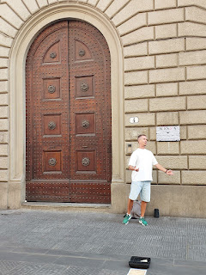

Video # 1 of him singing: (50 seconds)
https://photos.app.goo.gl/Z1XzmGeLvKrxa6RP6

Video #2 of him singing: (36 seconds)
https://photos.app.goo.gl/5DEHW9s3FnoA7h3E8

Video #3 of him singing: (8 seconds) *Bonus - Gwen danced as he sang.
https://photos.app.goo.gl/FTFUS6s917D8bmiX9

We would have loved to see inside the Florence Cathedral and climbed the 463 steps to get up inside the dome at the top, but we decided to skip it on behalf of the children. It took about 200 years to build the Cathedral, beginning in 1296, with the finishing touches being completed in 1436.

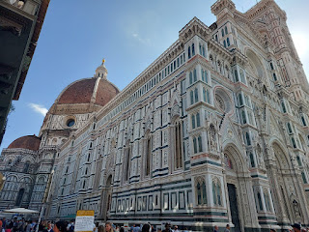

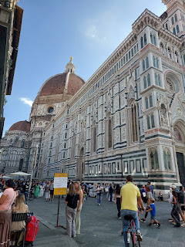

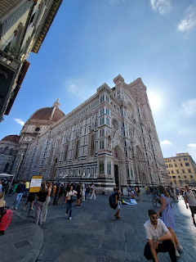

Instead, we made our way over to the Accademia Gallery for a scheduled tour that we paid for through the Viator app (also on Viator.com).

We passed this darling man playing his accordion in the street on our way to the Accademia Gallery . . .

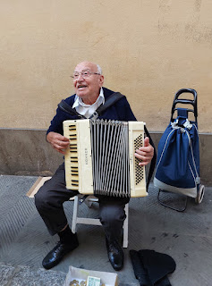

We met up with the group outside and listened to the guide explain a little background about Michelangelo and his life before we entered the museum. This was one of the most important reasons I wanted to bring Amber to Florence, was to see Michelangelo's David, considered to be one of his greatest works.

We each had an audio guide to hang around our neck, which allowed us to hear the guide better once we were inside the Gallery. It didn't take long, though, before the girls were tired of listening. It was hard to concentrate on the guide's explanations as we maneuvered through the very crowded rooms. I wanted Amber to be the one to really absorb everything, so I opted to exit the tour with the girls. We found a bench to sit down on and just relax as the swarms of people pressed forward past us.

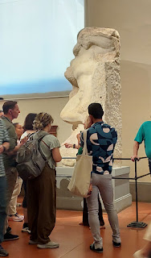

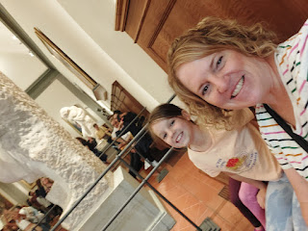

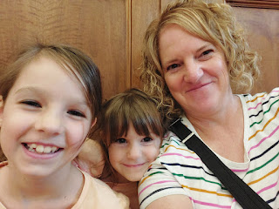

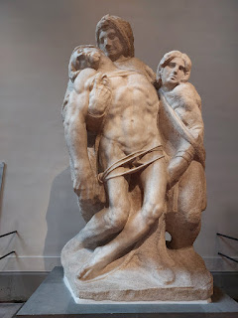

The sculpture above is especially beautiful (and famous). It is called The Pieta' (pee-eh-TAW), originally created by Michelangelo for the Vatican. This particular version is contested as to who actually created it, as seen in the explanation below. (click photo to enlarge)

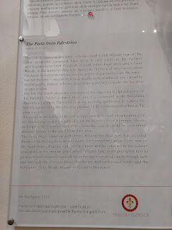

When the tour was done, Amber came back to find us. She was full of joy and knowledge, which made me very happy. She scooped the girls up to take them over to see David with her.

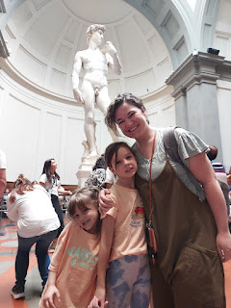

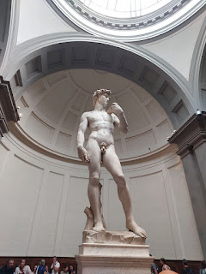

There is a long hallway nearby, with several busts and statues. As we slowly walked around the room, taking everything in, I noticed that Amber had tears in her eyes. When I asked if she was okay, she replied, "I love all of this. I'm seeing all of these beautiful creations and I'm realizing that this is in me. It's always been in me." How precious is that. I gave her a squeeze and then we continued on.

I loved seeing someone with "space buns" (or piggy buns") from centuries ago . . .

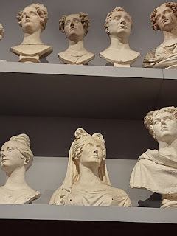

The girls loved seeing all the beautiful statues as well . . .

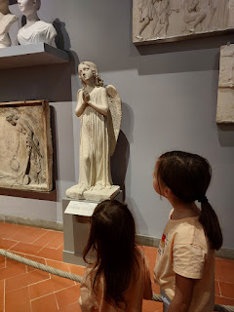

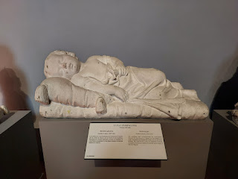

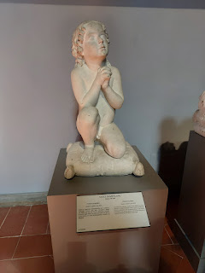

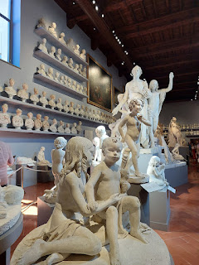

As we walked through other parts of the Accademia Gallery, we saw this large painting on the wall and it took our breath away!! It's called "Tree of Life", created in roughly 1310 AD. To understand the context, it's important to read the explanation in the photo below. (click photo to enlarge)

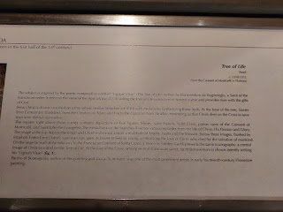

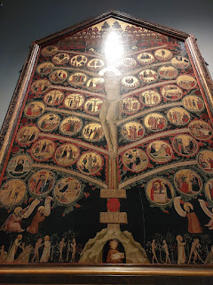

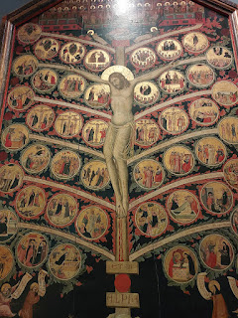

So, in summary, the Accademia Gallery was pretty special. Even though the girls were having a hard time at the beginning, it helped tremendously to take a big break away from the tour. Chewing a piece of spearmint gum and finding ways to be happy while resting on a bench did a lot to increase their morale before we continued onward. And Amber connected with the art on a very deep level, which is the whole reason I brought her to Florence in the first place. So . . . mission accomplished. :)

Amber really wanted to get Weston something special at a nearby music shop, one of the largest in Florence. While we waited for them to open up after the afternoon riposo (like a Mexican siesta), we treated ourselves to some gelato and sat on the steps of the music shop to eat it.

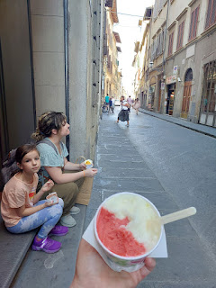

Around this time we received a text from our AirBnB host, asking if we could meet him in a different spot. The new spot was so much more convenient, because it was only a 5 minute walk from where we were sitting and eating our gelato. I took Abby with me to go retrieve her purse, while Amber took Gwen into the music store with her.

We retrieved the purse, much to Abby's delight, and as we backtracked to the music store, we saw the cutest restaurant!

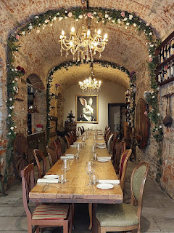

We also saw what appeared to be a tiny toy store, and I suggested we go inside to find a little gift for Gwen's birthday coming up. As we made our way through the front portion of the store, it opened up and then it just kept on going! The store was HUGE and went all the way through the large building to the street on the opposite side!

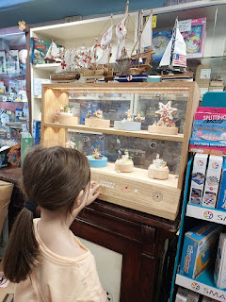

We found the perfect gift for Gwen - a collectible tin with 2 packs of Pokemon cards inside. Gwen is obsessed with Pokemon and she even wanted a Pokemon birthday cake, too, ha ha. They wrapped it up for us in the store and we skipped off to meet Amber and Gwen again.
We made our way north again, arriving at the Florence Rifredi Train Station with plenty of time to spare, so we had a leisurely dinner across the street and hung out there for a while before our train was due to take us back to Vicenza.

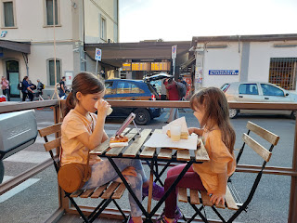

Buon appetito!!

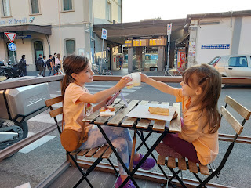

The girls took turns playing on the new recorder that Amber found at the music store. We bought it so we could bring it to London in a couple days, as a tribute to our musical Bassano ancestors who lived there and sold recorders back in the 1600's.

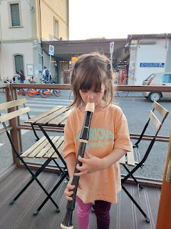

Our train was delayed, so while we waited at the platform, we found ways to entertain ourselves.

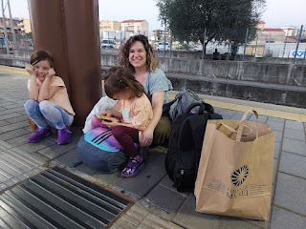

Abby read on her kindle, while Gwen practiced some Italian on DuoLingo . . .

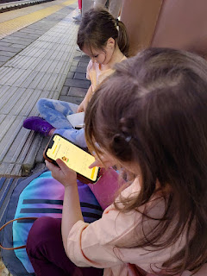

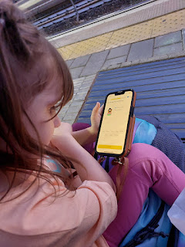

We played Uno Flip on the train ride back to Vicenza. It's a new version of the game and it is super fun! We read and ate snacks and passed the time very well. As we switched trains from Padova to Vicenza, we got a little silly . . .

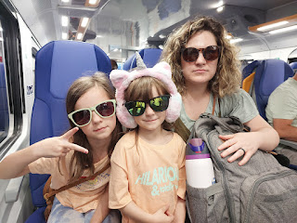

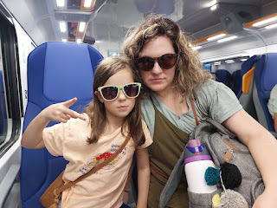

Florence is more for adults than it is for children, but we survived. We overcame several obstacles and "dead ends" and we made our own adjusted agenda. We took breaks when we needed them, and we helped the girls work through their tears. One thing that I said to try and motivate them was, "This is our warm-up for London, girls. Think about how strong our legs are getting! We will be so strong for when we go see all the Harry Potter stuff . . ."

That seemed to help . . .

