32nd Anniversary in Paris
We just returned from an epic weekend in France, mostly in the Normandy province on the western coastline. We had the BEST TIME!! This was my third visit to France, and the longest stay so far. I went to Rouen, France for about 48 hours with my sister, Charmaine back in 2018. We were following in the footsteps of our 13th great grandfather, Nicholas Lanier, who was born in Rouen. I visited France again briefly on my second trip in 2021, where I rented a car in Strasbourg, France so I could get around to a few of the tiny surrounding towns where our ancestors came from (i.e. Duntzenheim). Strasbourg is on the eastern edge of France, bordering Germany, and is part of the Alsace region.
This time
, however, our focus was on the Eiffel Tower in Paris and then over to the beaches of Normandy, where D-Day and Operation Overlord took place 80 years ago this month.

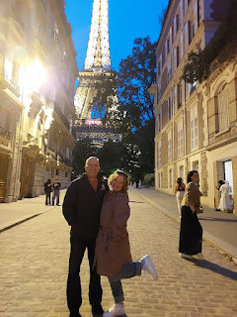

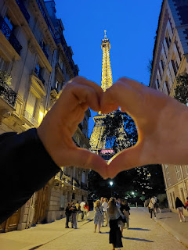

32 YEARS
- the absolute best years of my life. I can't believe we've been married this long, because we still feel so young, ha ha. I definitely appreciate the fact that we had our children right away, so that we are somewhat young as empty nesters now, and that we have the energy to see the world together and to have all of these adventures.

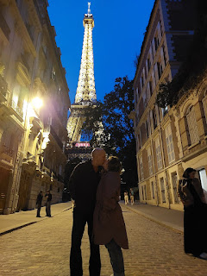

I had been a little under the weather for a few days leading up to this trip, but I woke up feeling better on Thursday, June 13th. I was surprised when later in the day, as we prepared to board our plane in Venice, I began feeling feverish. On the flight, I closed my eyes and rested for the almost 2 hours and that felt really nice. Ibuprofen helped to diminish my symptoms so that by the time we landed and got our rental car, I was ready to play.

We really liked our rental car - a forest green European model SUV (Dacia). It was comfortable and roomy. The Alamo rental car attendants were impressed that we were comfortable with driving a stick-shift, since most Americans prefer (and can only drive) an automatic. This car had SIX gears. Wowzers.

On our way to the Eiffel Tower, we drove past the Arc de Triomphe - an impressive arch with a long, tree-lined avenue. Construction began in 1806, and it was finally completed in 1836. The Arc honors those who fought and died for France during the French Revolutionary and Napoleonic Wars, with a vault underneath for the Tomb of the Unknown Soldier during World War I.

To read more about the Arc de Triomphe, click here:
https://www.paris-arc-de-triomphe.fr/en/discover/history-of-the-arc-de-triomphe

Video as we drove toward the Arc on our way to the Eiffel Tower: (14 seconds)
https://photos.app.goo.gl/Mg5wprXoCkgUXuhX6

Everything went picture-perfect on our way to the Eiffel Tower. It was almost shocking, ha ha. We had done our research, though, and it was paying off, but luck was also on our side as far as traffic patterns and using Google Maps. We parked in an underground parking garage a short distance away from the Tower, with maybe a 7-8 minute walk to get there.

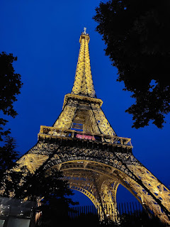

Research on various travel blogs helped us to identify a few key pieces of information for our experience:
For many, purchasing a ticket online in advance is key. But because we had too many moving parts that evening (airport arrival, luggage retrieval, getting the rental car, driving 50 minutes to get there, etc.) and we couldn't designate a specific time that we could ACTUALLY be there, we opted to just buy a ticket once we arrived. If you buy a ticket on-site, there may be a long line and a waiting period to enter the Tower. But late at night, this was not going to be much of an issue for us (thank goodness!).
We learned that entry through the south entrance is typically less congested than the east entrance, so that is exactly where we headed! True to form, it was a piece of cake to get in. You go through security first, then you can get your tickets and go up. While Scott did a little "recon" to find the ticket booth, I stood underneath the Eiffel Tower and, almost hypnotized by the sheer magnitude, took some pictures and videos.
Tickets to use the stairs are roughly 11 euros each. Tickets to use the elevator are roughly 18 euros each.
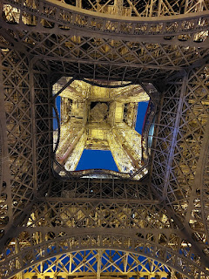

Video while standing underneath: (12 seconds)
https://photos.app.goo.gl/zL9NTRVPx56DUZUZ6

Continuing with the helpful hints through the travel blogs we studied ahead of time:
There are steps to climb, if you so choose. But I knew we'd be tired after a long day, so I suggested we just take the elevator up. We had read that the entire experience could take 2-3 hours if you go all the way to the very top (including the use of the elevator), so we also had to consider the lateness of the hour for our ETA. When you take the elevator, it automatically takes you up to the SECOND floor, with a great viewing platform. If you want to see the first floor, you will need to take the stairs back down because there is no elevator stop for that floor.
There is usually a long wait to get into the elevator for the tippy top of the Eiffel Tower. The elevator can only hold so many people, so be prepared for a long wait. We opted to skip this step altogether, because of the lateness of the hour. We had a wonderful viewing experience on the 2nd floor and did not feel like we missed out on anything by not going up.

It was almost midnight by this point, so the stairs going down to the first floor were now closed. So basically we just took the elevator up to the second floor, spent quite a while up there, and then we took the elevator down.

Here is a helpful "map" of the Eiffel Tower and each of the levels. (click to enlarge photo)

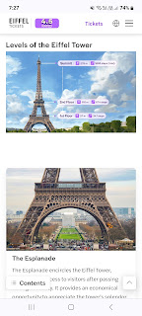

Incidentally, as we crammed into the elevator to go up, we heard some Americans talking next to us. As we struck up a conversation with them, we learned that they were also celebrating their wedding anniversary. We told them it was our 32nd anniversary, and shut-the-front-door they were ALSO celebrating their 32nd anniversary!! We were married on the same exact day: 13 June 1992. What a small world!!

As you may have guessed, the elevator does not go straight up vertically. In fact, it goes up at an angle, using one of the "legs" of the tower as its bracing.

Watch here to feel like you're going up with us: (12 seconds)
https://photos.app.goo.gl/4vmxzJH1Y6bxkknMA

Video showing a portion of the engineering for the elevator: (3 seconds)
https://photos.app.goo.gl/752fGaYo7GLeq8Ko7

Our first view over the city of Paris . . .

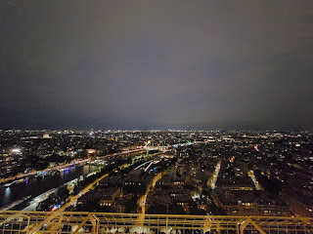

Every evening, at the top of each hour, there is a sparkling light show on the Eiffel Tower from dusk until midnight. The sparklies only last for 5 minutes, but they are oh-so-magical.

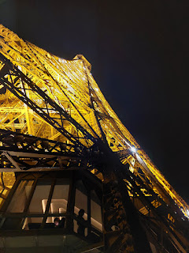

Video as I caught the beginning of the 5-minute masterpiece light show: (22 seconds)
https://photos.app.goo.gl/Lqj1GzmCsofGwzoT6

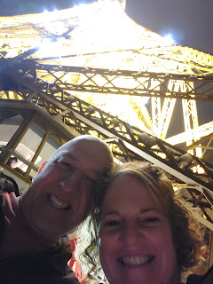

We wandered around to all four sides of the viewing platform, catching different landscapes and historical monuments that were lit up in the huuuuuuge city of Paris.

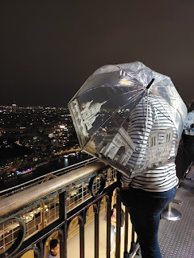

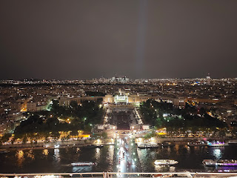

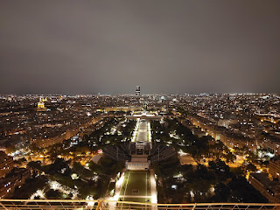

Video of whatever direction it was (??) heading toward the Seine River: (8 seconds)
https://photos.app.goo.gl/qKFvc9txsfw6qEh96

Video from the Seine River and continuing on in whatever direction (ha ha): (9 seconds)
https://photos.app.goo.gl/5v4XFTuBRpqdqEuq9

Being so close to midnight, things were starting to shut down. We could not access the first floor via the stairs because the stairs were closed. Everyone was being shepherded over to the main elevator, and then they crammed in as many of us as possible - worse than sardines - and somehow the who-knows-how-old-elevator got us all down safely.

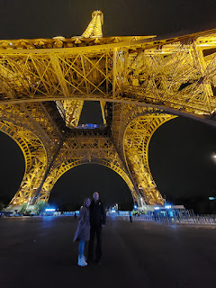

The exit from the elevator ended up being at the opposite end from where we had entered earlier, so we had to walk around to the other side. This allowed us to see the "front", which proudly displays the Olympic rings, since Paris will be hosting the Summer Olympics in just a couple of weeks.

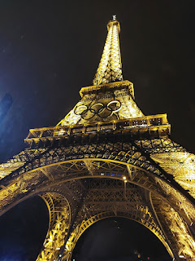

Once we got back to our car, we were relieved to see that our hotel was just about 30 minutes away. But, the congestion of Paris had a whole different plan in mind for us. Approximately 2 blocks from the parking garage was the gnarliest and worst intersection either of us has ever been stuck in.

Imagine a large roundabout . . . with 4 stoplights to help facilitate getting around it. Now add in maybe 4 lanes in each direction. Next, add in every single car from Paris and they're all trying to get through that ONE intersection - all at the same time. And you know the rule in America that says "don't block the intersection", especially if your light is about to turn red? Well, forget all of that in Paris. It's every man (or woman) for himself. Complete and utter gridlock. Cars all honking in frustration. Nobody is able to move. The lights turn green, but nobody can go anywhere. What a nightmare!! It took us about 40 minutes or more just to get through that ONE spot. So the 30 minutes to our hotel turned into over an hour.

When we arrived at the hotel, I went inside to check in while Scott stayed in the car, since we had parked in a temporary spot. The concierge instructed us drive to a parking garage about 5 minutes away, and he wrote down the name on a piece of paper for me. The only issue was that the name of the place was also the name for a bus stop, a neighborhood, and another 3 bus stops. We got lost, and then lost again.

We thought at one point, "Maybe it's this entrance..." - a narrow and steeply inclined driveway that went underground to what we thought was the public parking garage. But no . . . not our luck, LOL. As we carefully squeezed our SUV down the curved driveway, at the bottom there was only a gate blocking our entrance. So then we had to BACK UP the steep and curved driveway to get out. I got out of the car and tried to help Scott navigate a little. The 2023 SUV model was beeping and bleeping all kinds of frantic warnings at us with every inch that he crept up the slope. Beeep - watch out on the right! Beeep - watch out on the left! Beeep - watch out behind you! Finally, we made it back up to civilization and found a place to pull over and reassess our situation.

What actually worked was to put in the name that the concierge had given us -
PLUS
the words "parking garage" after it. That's when we finally had success. We parked, got our luggage, and walked about 4 minutes back to the hotel where we could settle in for the night. No big deal . . . we went to sleep around 2:00 a.m.

Thankfully, we were in no particular hurry the next day. I got about 6 hours of pretty decent sleep. Scott did a little better than I did. Check-out wasn't until noon, so that was nice. We found a restaurant option that we could just WALK to, ha ha, and it wasn't too far away. Maybe a 10 minute walk.

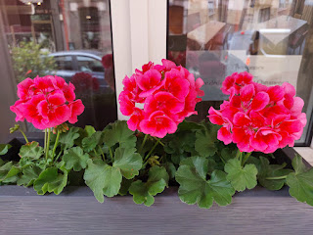

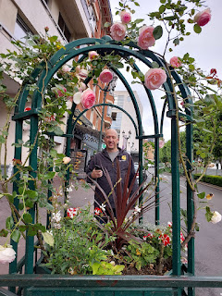

A beautiful old French church on our way to brunch . . . and by the way, we stayed at the Hotel Vivaldi in Puteaux, which is located on the western outskirts of Paris. The area was very clean and quiet.

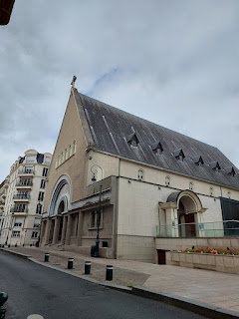

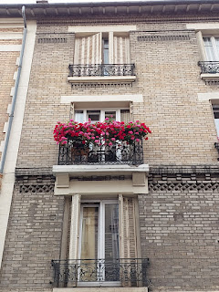

I thought the menu might have some breakfast or brunch-y items, but we ended up just eating an early lunch.

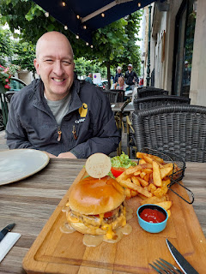

With real FRENCH fries . . .

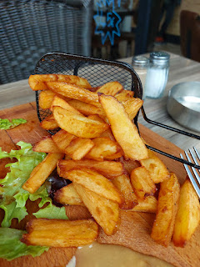

Someone's cute mail slot as we walked back to the hotel . . .

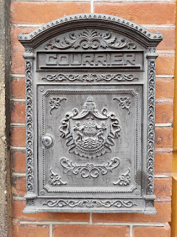

And we saw a postman riding on a bicycle, loaded with saddle bags full of mail to deliver . . .

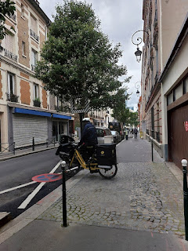

Not terribly exciting, but when you see rotisserie chickens in FRANCE, the word "rotisserie" takes on a whole new meaning.

Video here: (4 seconds)
https://photos.app.goo.gl/YmhF7Utow3jSTefCA

I also learned that a boulangerie is a French bakery (think breads & croissants), whereas a patisserie is a French pastry shop.

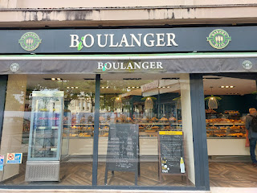

The street where Hotel Vivaldi is located a little ways down on the left . . .

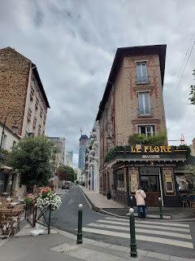

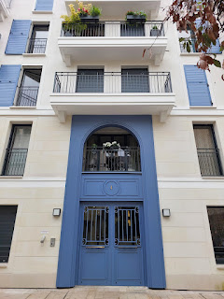

After we checked out of the hotel, we began making our way down to the Normandy coastline, southwest of Paris, and along the way we stopped to see the Paris Temple, located in Versailles.

Side note: when we were chatting with some other hotel guests the following morning, they were like, "You were in Versailles? Did you visit the Palace? It is so stunning and gorgeous . . ." Um, no, but we visited the temple and it was also stunning and gorgeous . . . just in a different category.

The Paris, France LDS Temple . . .

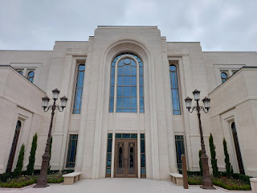

Note that the temple doesn't have a steeple or a golden prophet named Moroni on top. The sister missionaries told us that when the temple was being built a few years ago, city officials told the church architects that there are regulations against building anything taller than or more beautiful than the Palace of Versailles. And nothing gold was allowed on the exterior, either. The temple was dedicated and opened for patrons in 2017.

The flowers were the first thing to catch my eye . . . besides the temple of course!

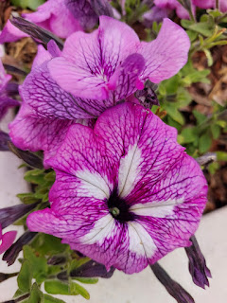

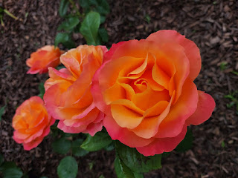

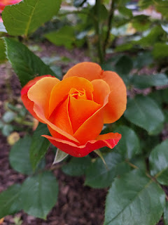

From the backside of the visitor center, looking all the way back through the gardens. The temple is out of view on the left.

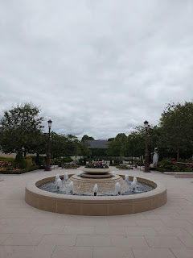

A 360-degree view from behind the Visitor Center of the Temple: (23 seconds)
https://photos.app.goo.gl/iiw8KBbmitwjbPvd6

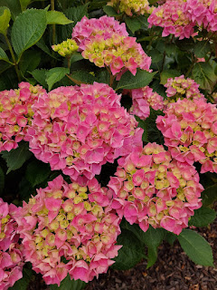

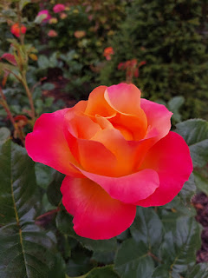

I think most (or all) of the temples across the globe have a beautiful Christus - either inside or outside. He is always very tall, maybe 12 feet?

Video walking towards Christ: (8 seconds)
https://photos.app.goo.gl/bsSNwTCnFpHWYco96

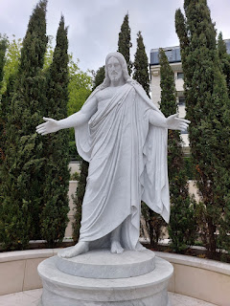

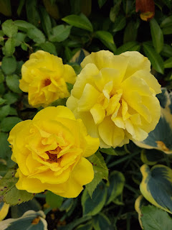

Video from the fountain at the back of the gardens, looking toward the Visitor Center and the Temple (on the right): (13 seconds)
https://photos.app.goo.gl/i2UEz7nLDqetY5kAA

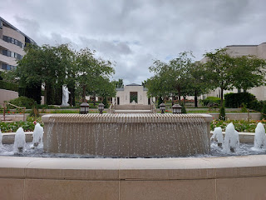

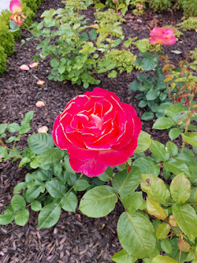

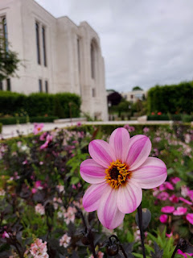

My sweet husband of 32 years . . .

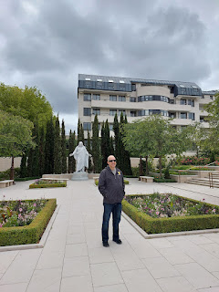

Me, touching Jesus' foot . . .

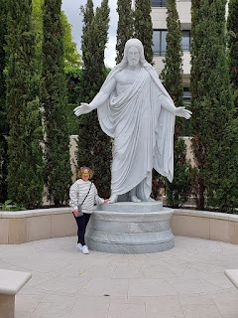

Inside the Visitor Center, the sister missionaries shared a lot of great information with me about the design theme inside the temple, which was based on the traditional flowers of France. I hope you will find these next few photos as fascinating as I did. (click each one to enlarge)

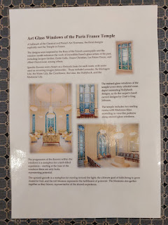

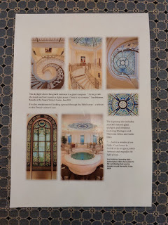

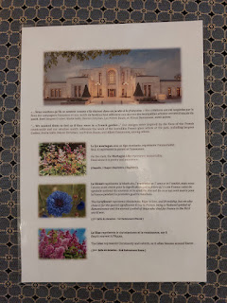

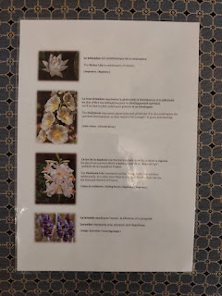

You can see the Madonna Lilies etched into the windows of the Visitor Center here. They were so beautiful!

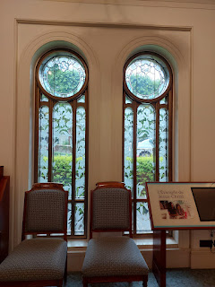

An old copy of the Book of Mormon in French . . . the Book of Mormon is another book of scripture that testifies of Jesus Christ and His visit to the Americas after His resurrection.

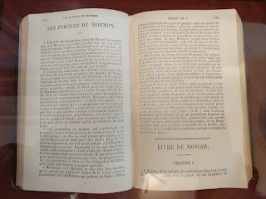

I couldn't speak when the missionaries told me that in the Celestial Room of the temple, the room that represents us stepping into God's presence, there are hollyhocks all throughout the space. It's because they represent "welcoming" and that everyone is welcome and wanted and invited to come to Him. My eyes filled up with tears. What a beautiful concept . . .

A sample of the hollyhocks that have been incorporated into the Celestial Room . . .

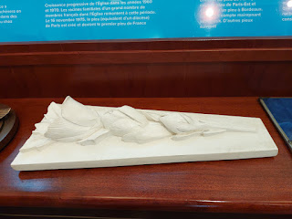

John 14:6 (in French): "I am the way, the truth, and the life; no man cometh unto the Father, but by me." (displayed in the Visitor Center)

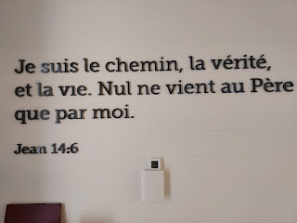

The same artist that created a similar stained glass of Jesus Christ for the Rome, Italy Temple also made this one. It has an olive tree as well as several Madonna Lilies. The missionaries pointed out that the artist intended for the lilies to represent each one of us, and if you look closely, each hue in every single flower is also included on Christ's robes. This is symbolic of how He took upon Himself all of our sins, our pains, and our struggles. We are part of Him and He is part of us.

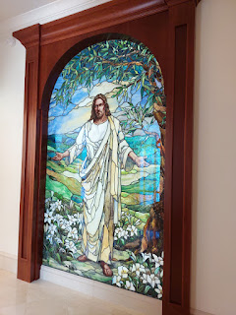

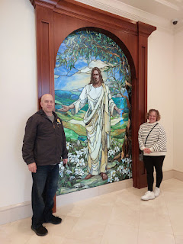

Another window with beautiful floral etchings . . .

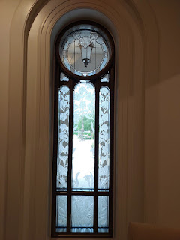

I've never seen packaged crepes for sale in a roadside rest stop and gas station before, but then this was France, ha ha . . . These particular ones had an apple and caramel filling inside. They were pretty good. Not super fresh as far as the quality of the crepes, but overall they weren't bad.

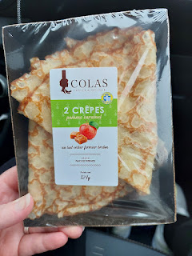

France has a surprising portion of farm land and colorful crops growing everywhere. They have a good climate for it, though. For the most part, the temperatures in France were around 10-15 degrees cooler than what we've been seeing in Italy. The whole time we were there, it hovered between 55-65 degrees, which was fantastic!

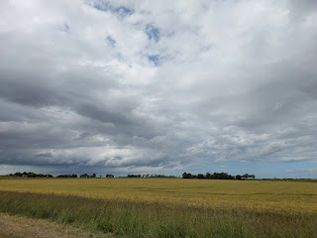

We stayed at a place called The Cat Farm. I didn't know this when I booked our stay, but thankfully it was the best place we've ever stayed - AND the (8) cats all live outside.

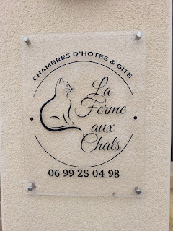

The farm is only 10 minutes south of Omaha Beach. It's within walking distance of a little grocery market, and a charming and very old church is directly across the street. They have chickens, ducks, cats, dogs, gardens, patios, and guest cottages. We stayed in the main house in a room upstairs.

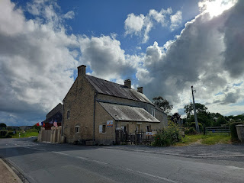

We had a very cute bathroom all to ourselves . . .

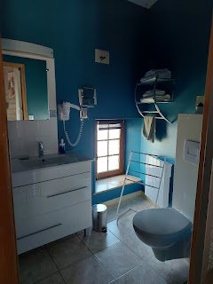

And our bedroom was very spacious, with plenty of storage in the wardrobes. We were quite smitten with the WWII print above the bed . . .

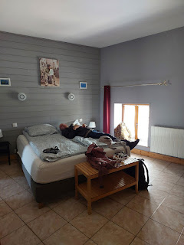

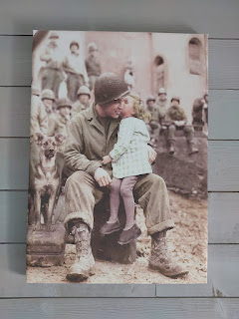

Scott has been diligently hunting on the internet for a print that he can purchase. He found the image, but we just need to find a way to buy it so we can put it in a frame.

Everywhere we went in the Normandy region, there were French flags and American flags flying proudly together. Occasionally, we'd see Canadian flags or British flags, but not so much in the Omaha Beach area. The Canadians and Brits landed on the 3 beaches further east, named Gold, Juno, and Sword - so I'm sure there would be more flags over there. There were also several flags with "80th Anniversary Omaha Beach D-Day" on them.

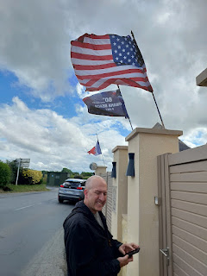

We were so bushed from our late night in Paris and the long drive to Normandy (about 3.5 hours). Neither of us wanted to go out to eat in a restaurant that evening, so we decided to just walk to the market and find something that we could bring home and eat in our room.

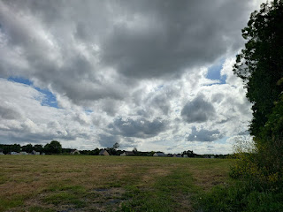

At the roundabout near the market, there was an important looking monument, so we went over to investigate. Created by the artist Arthur Le Duc, it was dedicated to the decisive French victory in this tiny little town during the Hundred Years War (in 1450) against the English. This town where we stayed is called Formigny - pronounced kind of like "fore-mee-nee".

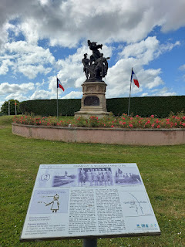

At the market, Scott chose a sandwich/wrap, while I chose some mushroom soup, bananas, and yogurt. I also found a few nice postcards and a couple of D-Day books (in English).

This sign, near the church on our way back, mentions how this region has had a rich history with horses throughout many centuries. William the Conqueror rode through Normandy on a horse in 1047 at the age of 19 years, receiving clothing and other assistance as he traveled through.

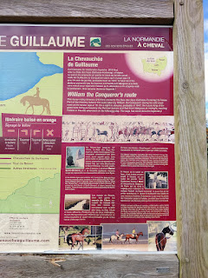

This is the church across from our cute Cat Farm lodging, called St. Martin's Church. (In French: L'eglise Saint-Martin) It was built during the 13th century and has seen a lot or war in its lifetime, with the most recent of course being WWII. The church served as a mini-hospital as it was one of the first towns to be liberated after D-Day.

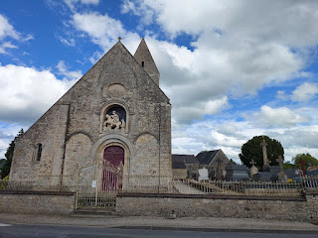

This marker explains a little more of the history of the church. (click photo to enlarge)

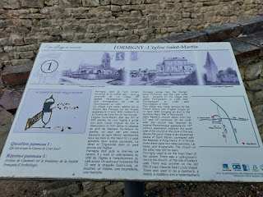

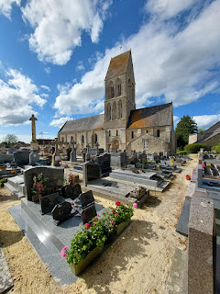

One of the most decorated graves in the church cemetery . . .

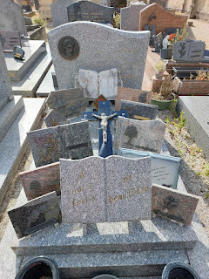

And these memorials caught my eye because of how old they were, but also because someone must be coming regularly to groom the sandy mounds. The two on the left died in 1900 and 1899, while the person on the right was a young boy named Edmund who died at just 8 years old in 1864.

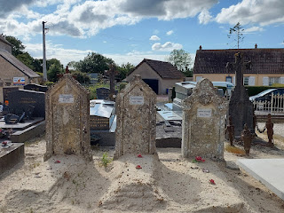

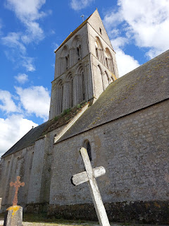

With happy tummies and exhausted brains, we tucked ourselves into bed while it was still light outside. We had a big day ahead and we needed a good night of sleep . . .

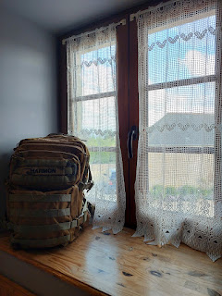

Stay tuned for the next blog post: D-Day sites on the Beaches of Normandy.

