A Cooking Class, A Cello Concert, and Christmas Errands
It's been busy around here lately! I keep telling myself that there will be quieter moments just around the corner, but that doesn't ever seem to be the case. I realize that this is usually how I set things up for myself - because I LOVE LIFE - so I am trying to just smile and keep up with everything right now . . .

First, I want to share about my recent visit with Avery and how absolutely delightful that was. After several mismatched scheduling issues between Kylie and me, we finally had a day that actually worked out for both of us. I drove up to Aviano to pick up Kylie and Avery so we could go out to dinner. I parked close to their driveway and started walking over when I saw Avery around the corner. The most magical thing happened when she saw me: Her face lit up in shock, her jaw hit the ground, she did a sharp intake of breath in surprise, and then she started RUNNING to me!!! Her mouth stayed in that oval shaped, open mouth of surprise the whole time that she ran over to my open arms. I scooped her up and she immediately just wrapped her little arms around my neck and pressed her whole body into me. It was the best feeling in the whole world!!

I had been worrying all these months that she might forget about me at her young age, because I haven't seen her since late July (and that was back in Idaho). But all those fears were quickly put to rest when I got such a warm welcome from her. She could not stop smiling, ha ha. Every few seconds she would just look at me and then melt into my shoulder again for another hug.

We also got the BEST selfie on the FIRST TRY!!

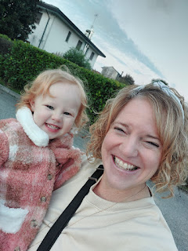

We drove into town to go to dinner at one of Kylie's favorite places, San Giorgio's. They have pasta, meats, and seafoods, all at fantastic prices, too. Avery went right to the waitress and was just fine with being picked up. The waitress took her around the corner and then brought her back with a lollipop in her hand. Avery is surprisingly friendly for her age, but what a great thing to see.

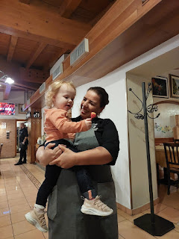

Avery is also quite impressive about eating very long noodles. She is definitely skilled! Kylie would twist her fork a few times, gathering up the pasta, and then Avery would open wide, like a little baby bird in the nest, ha ha.

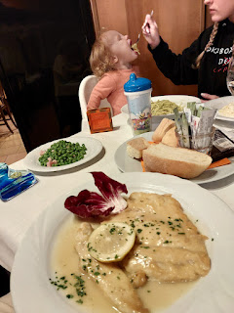

I thought it was so cute that I took a video: (11 seconds)
https://photos.app.goo.gl/YewjBWZs3scV1fLe6

I also got a cute video of Avery's giggles with her momma: (6 seconds)
https://photos.app.goo.gl/3nC1CDUhza7SbsC29

After dinner, we hung out in front of the restaurant for a little bit. I gave Kylie a bag with some warm clothes for Avery, since she is growing and the season is starting to turn cold. Plus, it was an early birthday gift to Avery from me and from Great Grandma Linda. One of the items included a cute little stuffed pig.

Kylie captured a darling moment of Avery and me on video: (14 seconds)
https://photos.app.goo.gl/qmmiVgyrpJnysSLv6

When it came time to say goodbye, Avery wasn't having any of that. She clung to me and didn't want me to leave. I started tearing up at one point, but I didn't want to fully cry in front of her, so I pulled myself together as best as I could. We just stood on the front porch for about 20 extra minutes, chatting and laughing, and occasionally trying to convince her to go to Kylie. Nope, ha ha. What got me through that long goodbye was the knowledge that I would see her again soon. Kylie eventually had to PEEL Avery from me and then whisk her inside to get ready for bed (in her new pajamas). Thankfully, Avery didn't cry because that would have sent me over the edge.

I reveled in the memories of that special visit for the whole drive home, about 90 minutes. I was supposed to see her a couple of days ago, but then I got sick and I didn't feel up to going anywhere. Instead, I arranged a video call so I could sing Happy Birthday to Avery on her actual birthday (Nov. 19). It ended up being a group call, since I was already on a video call with Scott. We sang to her from different countries, and it didn't matter that there was a timing difference, ha ha. She enjoyed it anyway!



I was recently asked to help babysit my friend Marnie's two teenage daughters for a weekend, so she and her husband, Kevin, could slip away together. They haven't gone anywhere (just the two of them) for over 2 years, she said. She offered to pay me, but I told her no way and that it was my turn to "pay her back" for all the help and assistance she's given me in the past year or so. She found a workaround to paying me, though . . . a ticket to go to a cello concert here in Vicenza!!

Marnie's husband, Kevin, and their middle daughter, Ava, both take cello lessons. When they heard about this cello concert through their instructor, they got enough tickets for their family, but then only some of them could go. I ended up going to the concert with Kevin, Ava, and their cello instructor, Guido. It was so amazing!!

First of all, it was in one of the halls inside the Olympic Theater (Teatro Olimpico), which was built by Andrea Palladio in 1585. We got there early enough to secure seats in the second row. Kevin wanted the first row, but those seats were reserved.

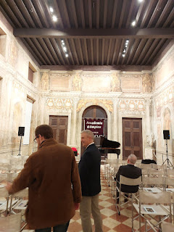

L to R: Guido, Kevin, Ava, and me.

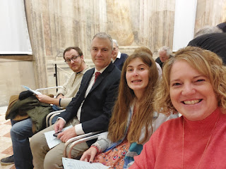

The program was in Italian, but here is some interesting background about the cellist and the pianist. The cellist, Ettore Pagano, is only 20 years old!! The pianist was amazing, too. Her name was Monica Cattarossi. (click photo below to read their background and where they studied, awards they've won, etc.)



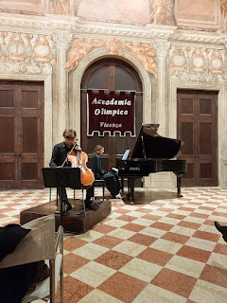

The first half consisted of songs by Sergej Rachmaninov.
Sonata in sol minore op. 19
Lento
Allegro moderato
Allegro scherzando
Andante
Allegro mosso
The second half of the concert was divided - with one song by the composer Ferruccio Busoni, called Kultaselle - Variazioni su un tema finlandese, and then we heard several songs by Igor Stravinsky.
Suite Italiane
Introduzione
Serenata
Aria
Tarantella
Minuetto e Finale
They also played a couple of encore numbers at the end, including a version of the Flight of the Bumblebee. Everything they did was incredible. I captured several videos (you're welcome), so if you like cello music (I sure do), then sit back and enjoy these videos from the second row in a 438 year old theater.

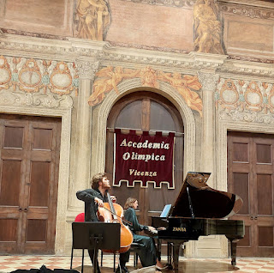

Video #1: (2 min, 32 seconds)
https://photos.app.goo.gl/cnoEm9sxFE46PCRm7

Video #2: (2 min, 34 seconds)
https://photos.app.goo.gl/gdDAHsS7pApnPaXy5

Video #3: (55 seconds)
https://photos.app.goo.gl/XVq8naNGvdLdA7TXA

*Remember: he is only 20 years old!! Simply incredible.

Video #4: (39 seconds)
https://photos.app.goo.gl/Cnjt2ah4C1wLhN5z5

Video #5: (58 seconds)
https://photos.app.goo.gl/aKrxFPz4X7vhF6A2A

Video #6: (3 min, 6 seconds)
https://photos.app.goo.gl/7Q4GcsZUqQGU8Jqv7

Video #7: (43 seconds)
https://photos.app.goo.gl/s52Kr6mg86E3nifz6

Video #8: (1 min, 48 seconds)
https://photos.app.goo.gl/MZwiJWwW9orcgrz17

Video #9: (1 min, 44 seconds) (Flight of the Bumblebee, I believe)
https://photos.app.goo.gl/31JCNyEoSgXwtPxAA

Video #10 (As they took one of dozens of bows) (6 seconds)
https://photos.app.goo.gl/rzwJPBipi46XLVtv9

I don't know if this is just an Italian custom or not, but they would bow a few times, then walk off and into the hallway for a moment. As the clapping continued, they would come back out and bow a few more times, then exit again. As the clapping still continued, they would come out maybe 3-4 times or so, repeating this process. At this point, they would end up playing an encore number and then repeat the bows and exits and returns once again. Eventually, however, the concert did finally end and we could go home, ha ha. It was after 10:00 p.m. when we got home . . .

Did I mention that this concert was FREE?? It was first come first serve to grab the tickets, though, so good job Parkers for scoring tickets for the 4 of us to enjoy this experience together. And I should also add that technology has come a long way in the music sense. The pianist had an i-Pad mounted in front of her, where she just tapped in the corner of her screen to begin. I think she already knew her own speed and had set it up in advance, because I didn't see her touch the screen anymore during each song. It would automatically advance for her! As for the cellist, he had a little thing on the floor next to his feet that he could tap to advance the music on his i-Pad. Wow.

Each week during November, I have been teaching family history lessons to small groups on the base. There is a free dinner on Wednesdays at the Spiritual Life Center with several different denominations that participate. The dinner portion goes quickly, only lasting about 30 minutes. Then the head Chaplain offers a spiritual thought and a prayer before we dismiss to our respective classrooms within the building. My class is in Classroom #7. Different individuals and families have been attending each week, but we also have a couple of people who have consistently come each Wednesday to learn something new. This means that I have to be prepared to deliver something new, but also backtrack a little to get the newcomers all caught up.

In between these lessons on Wednesdays, I have been squeezing in some research of my own so that I can find an interesting situation to show everyone. I like to walk them through how I made the discovery and then how do I work through the whole process to save the record source or fix the issue. I try to keep it short and sweet so that I can spend the rest of the time helping each person with something they need before our time is up. It has been a huge blessing to me, because it requires me to spend some time in my family tree, which I always love, but sometimes I don't make enough time for it. When I dig into my family tree and make new discoveries, I come away feeling empowered, strengthened, and rejuvenated. I feel like whatever problems come my way, they don't feel as big as they might otherwise. I am deeply aware that I have a huge support network on the "other side", and I can feel of their energy, their love, their strength, and their peace as I go about my day.

Here is a recent photo of a group of attendees in my family history class: (L to R) Elder Jeff Haines, Loren Bickley, the young elder missionaries, Lochlaen Galli (with the hat) - a newly baptized member of the Church of Jesus Christ of Latter-day Saints, Sister Sherry Haines next to him, the Lloyds, and the Halls. Not shown, but who has consistently been my tech support while Scott is gone, is Cameron Preece.

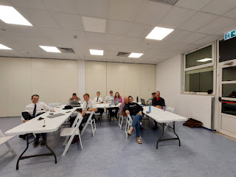

Sometimes there are a handful of people who work at the USO on base who attend the class. It doesn't matter if you're a member of our church or not, family history is for everyone! They have been learning a lot, too, and I have really enjoyed making some new friends. Sometimes I go hang out at the USO and help someone with their family history research there. It's a great place to relax because there are free snacks, lots of tables and desk space, good wi-fi, and something entertaining is always on the big screen TV, too.

I've been so grateful for the opportunity to help teach new people how to find their family and fill in the branches of their trees. It's always time well spent. Always.

On another one of our beautiful sunny days this autumn, I went for an explore up near Monte Berico. A friend had told me about a trail up there, but it looked too muddy after the recent rains. So I started up the hill on the sidewalk instead. I started at the Basilica of Monte Berico and headed south from there.

I saw a sweet elderly nun across the street, walking home from the Basilica, I assumed.

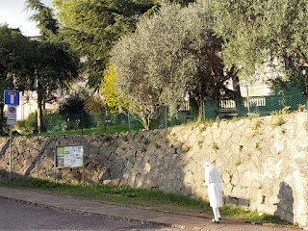

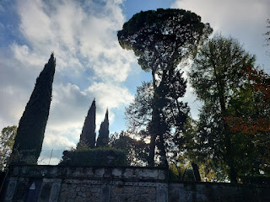

I passed some interesting trees as I walked up the hill. The weather was so pleasant after several days of rain. Eventually, I made it to something that looked important. It is called Il Parco Storico Di Villa Guiccioli. (Historic Park - and Museum - of the Villa Guiccioli) Essentially, the museum documents the historical period between Napoleon's campaign in Italy in 1796, through to WWII and the fight for liberation. The museum is free, but I didn't know that at the time and I didn't bring any money with me on my walk. I will go up there again soon, though, because it was so peaceful and beautiful.

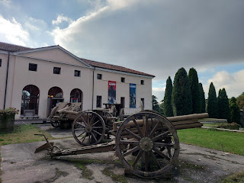

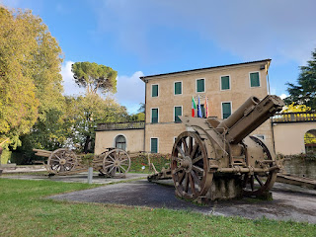

Behind the museum is a very large park, with over 536 trees and shrubs, spacious walking trails, and lots of peace and quiet.

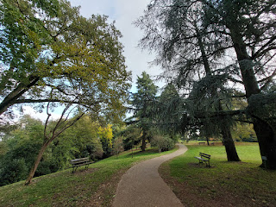

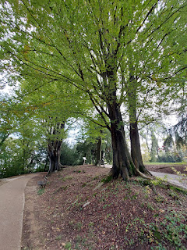

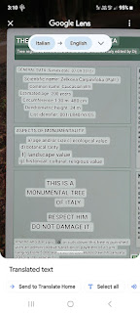

The tree below, as described in the translated sign above, is a very rare and special tree: known as a Caucasian Elm. It is over 200 years old!

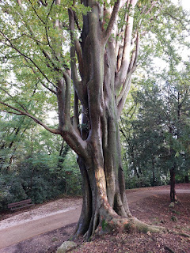

Video of the majestic tree: (13 seconds)
https://photos.app.goo.gl/qGkp2AHATtnDCRcG8

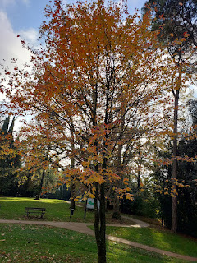

Video of some of the breadth and depth of the park - so beautiful: (19 seconds)
https://photos.app.goo.gl/NzHd1uJwz2yVMnuA6

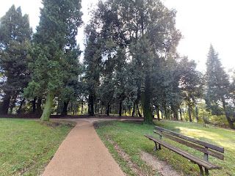

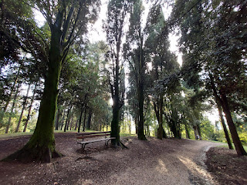

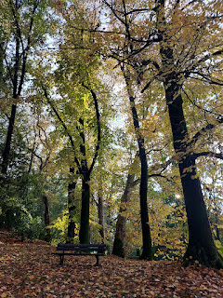

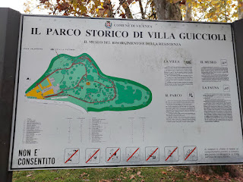

I even came across someone sitting in a meditation pose off in the trees . . .

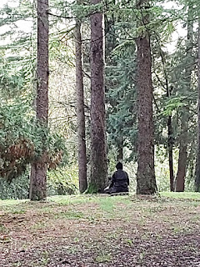

This is a historical marker, dedicated to the fallen comrades who contributed during WWII from 1940-1945. (More in the translated description below)

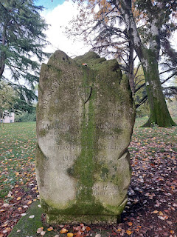

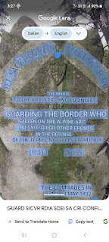

The views from up there were just out of this world. I wish I could just walk and walk and explore for the rest of my life. And occasionally stop to eat some yummy food. That would make me so happy.

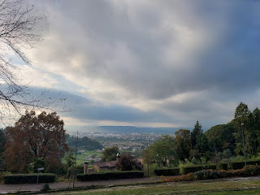

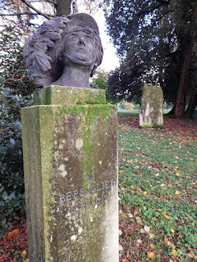

As I walked back out to the front, I did a quick Google translate to see what this sign meant.
"Brothers in Supreme Sacrifice."

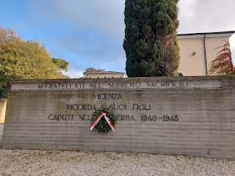

On their giant wall of names of fallen comrades, I saw someone with *almost* the same last name as Bassano . . . Bassano del Grappa is only about 30 minutes drive from here, so it's not too far fetched to think that we might be related . . .

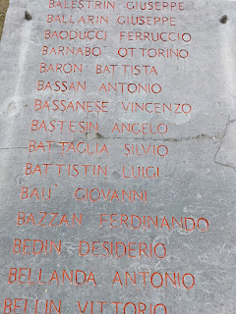

Outside the museum and garden trails is a beautiful wall enclosure. I loved the stars on the outside of the wall. It got me thinking about how I could maybe frame this photo and display it somewhere in my Idaho home.

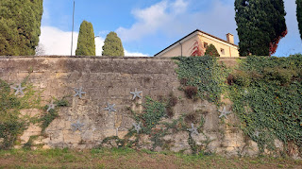

The view across the street from the wall . . .

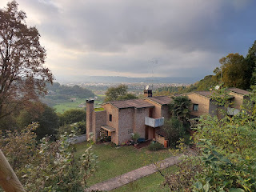

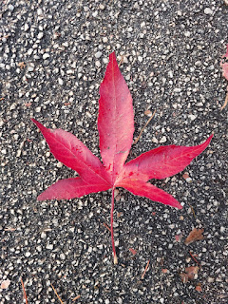

As the clouds rolled in once again, suggesting a possible rain shower later that evening, the sun still found a nice spot to shine: the bell tower of Monte Berico.

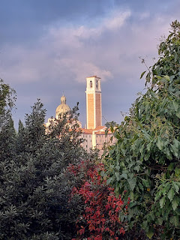

Monte Berico, coming from the south and looking north . . .

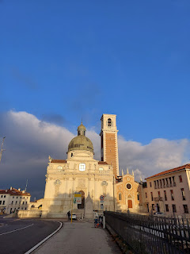

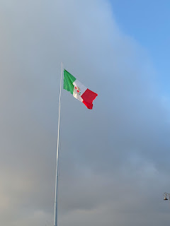

A panoramic view overlooking Vicenza from the parking lot . . . what a beautiful place.

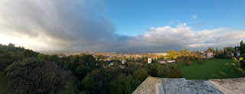

During Veteran's Day weekend, I had the privilege of babysitting Ava and Olivia Parker, Marnie's daughters. They were a delight and we had a great time chatting, cooking, doing homework, and going on walks.

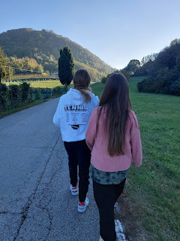

On a longer than anticipated walk, we passed by a lazy cat on top of a hay bale in a barn. Living the good life.

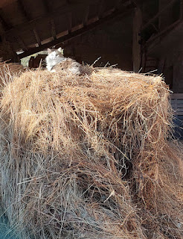

Originally, we planned to just walk down the road a bit and then come back.

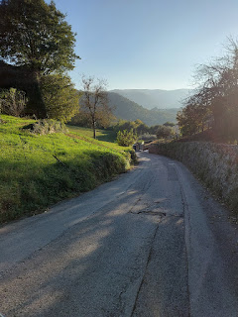

But our adventurous side came out and we ended up on a trail through the forest to get down to Lago di Fimon. The girls had been there before, but it had been a while. We made it to the water's edge after about 40 minutes of walking.

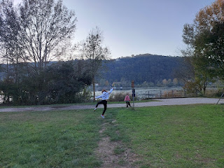

Video of Ava and Olivia doing a heel-click in the air: (2 seconds) ha ha
https://photos.app.goo.gl/6RZ8Hf6rW8EDUjGQ9

Lago di Fimon is the oldest lake in Northern Italy, dating back about 35,000 years!! It even pre-dates Lake Garda, which is the largest lake in all of Italy. We got there shortly before sunset, so we didn't stay very long, knowing that we had a 40 minute walk back through the forest to get home. We didn't want to be hiking in the dark . . . But it was very pretty and I would like to bring Scott back here someday. The lake is covered with lily pads and there are several swans-a-swimming, too. I read online that in the spring, there are dozens of species of birds and flowers to enjoy, so that sounds like a good time to return with my sweetheart. There is a nice trail that goes all the way around the lake for walkers and bikers alike.

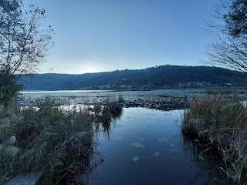

We made it back up the hill to their house before dark. Whew!

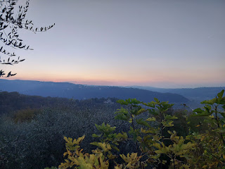

The next day, after church (and after a lovely nap), we went on another walk, this time a shorter one. We walked up the road a little bit to visit the nearby Italian cemetery.

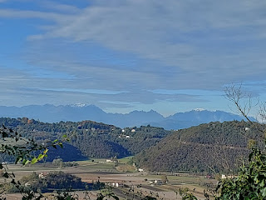

We made a game of trying to find the "oldest" person in the cemetery. This lady was the winner. Her name was Petronilla Bedin and she was born in 1870. I guess I should clarify, we were looking for who was born the
earliest
out of everyone. Not necessarily who lived the longest . . . although that would have been fun, too.

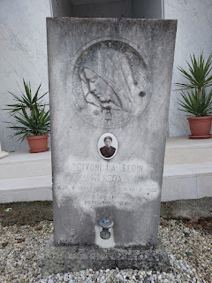

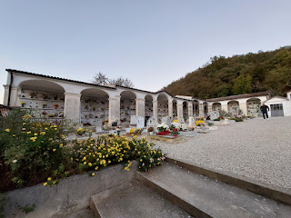

The girls enjoyed the experience and it was nice to be out in the fresh air for a bit before we went back to doing our respective homework assignments (my homework was last week's blog post). Ava delighted us for a time as she practiced her cello, and Olivia became very animated as she shared some of her entreprenurial creations with crocheting. She has made a variety of toys out of yarn, from a squid to a spud, and she likes to make clothes and outfits for them to wear. I told her she could make a lot of money if she made enough items to sell at a craft booth. Right now, though, she is just enjoying the journey of discovering what she can make, and that's okay, too. After all, she is only 11 years old.

This ancient olive tree sits at the base of the long driveway up to their house. There is a little sign at the base, along with a few spotlights that come on at dusk. This stalwart tree is approximately 2,000 years old!! Omigosh.

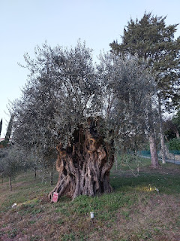

Sunset from the Parker Villa . . .

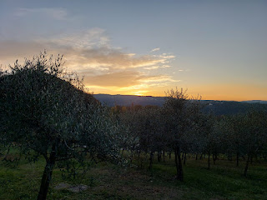

Before I left the following morning, I took a picture of this wise admonition in the upstairs room where I slept. It is sitting on the desk in Lauren's room (Marnie's older daughter) . . . She is off to college in Rexburg, Idaho right now, but she was the student body president of the Vicenza High School during her senior year (last year). Lauren is an amazing person: dynamic, bubbly, inclusive, a friend to all, and a talented singer/songwriter. She recently released her own album in June - it's on Spotify. (Look up Lauren Parker - Apollo)



Marnie has one of those homes that looks like it's out of a stylish magazine . . . she has elegant taste and loves to travel, but she is also very down to earth and easy to talk to. I cherish my friendship with her.

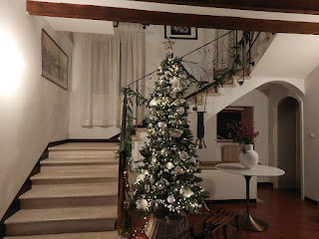

I participated in a very fun cooking class this past week as part of our Wednesdays in Italy Group. Rachel McGovern is friends with one of the two chefs, so she got us all signed up to come and learn together. The cost was $50/person for about 3.5-4 hours of instruction and plenty of eating at the end.

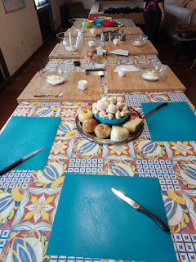

Silvia and Alessandra do this full time, hosting several classes each week with varying menu items.

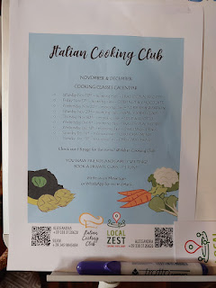

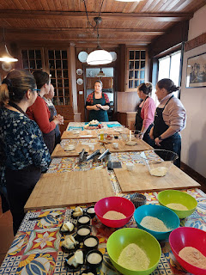

We made 3 dishes total. The first course was Savory Strudel.

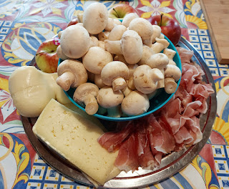

You roll out the dough very, very thin. Chop up the apples and cheeses, sautee the mushrooms, and prepare the smoked speck by laying it out so it's ready to place on the dough.

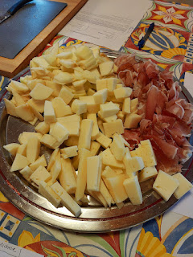

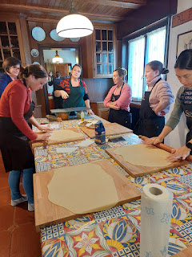

Layer everything onto the dough, roll it up, brush with butter, sprinkle with poppy seeds, and bake.

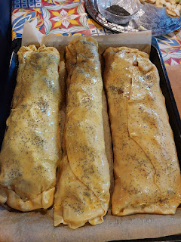

The head chef, Silvia, experimented with some leftover apples to make a sort of applesauce on the side.
I liked the filling, but I didn't enjoy the pastry very much. I thought it could have used a little more zing in the form of spices, too. I gave it 8/10 in my mind.

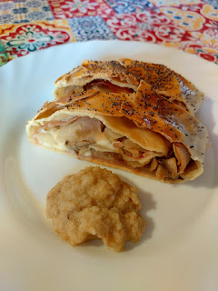

Dish #2 was Pumpkin Gnocchi. This was my favorite item on the menu. It had a mixture of cooked and riced potatoes and squash (all squash seems to be called pumpkin in Italy). The acorn squash had been roasted in advance, although we had to peel it and rice it during the class. To rice it, there is a special tool that is used. Here is a link to one on Amazon so you can see what it looks like:

https://www.amazon.com/Priority-Chef-Potato-Perfection-Stainless/dp/B00MUEHPGQ/ref=sr_1_5?crid=34SWVTBWL2IH1&keywords=potato+ricer&qid=1700417543&sprefix=potato+ricer%2Caps%2C2769&sr=8-5

And this is probably the world's fastest explanation on how to make gnocchi, ha ha: (48 seconds)
https://www.youtube.com/shorts/SxEYj4AcdLM

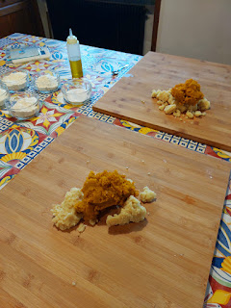

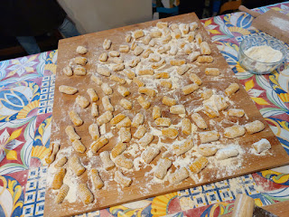

Silvia added FRESHLY GRATED NUTMEG to the squash and potatoes, too. It smelled HEAVENLY!!

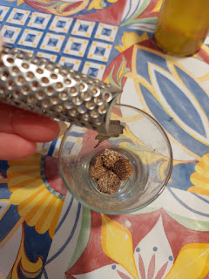

Once the gnocchi are cooked in boiling salted water (they rise to the top when done), you strain them out and place them into some delicious melted butter and fresh sage.

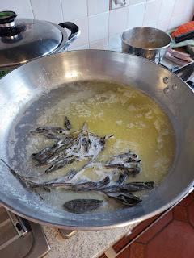

Add some freshly grated cheese on top and you have yourself a winner. I gave this dish 11/10.

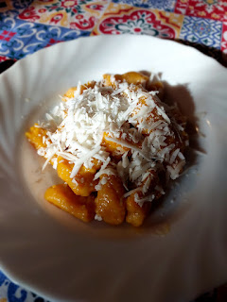

For dessert, we made Sbriciolata Di Ricotta e Amaretti. Translation: A tart with fresh ricotta and crushed amaretto cookies. After preparing the dough, we covered them and let them sit for a while.

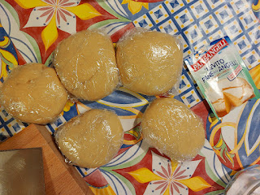

I learned that this brand is also available in the U.S. Who knew?!?

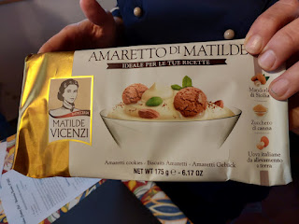

We made individual tarts, but you can make a family sized tart instead, if you wish.

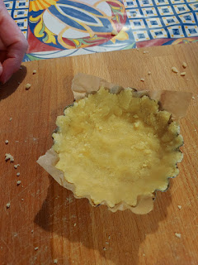

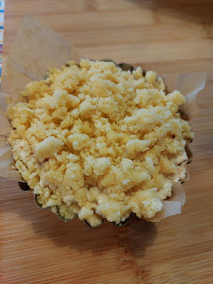

I enjoyed it very much. It was light and delicate, and I enjoyed the almond extract that came through from the amaretto cookies. I gave it a 9/10 in my mind.

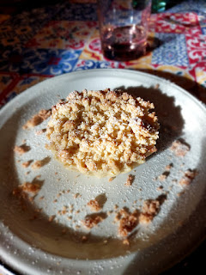

Here are the recipes, although I took copious amounts of notes throughout the class and my papers look much different now.

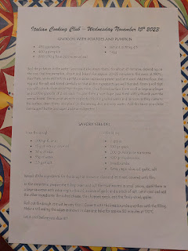

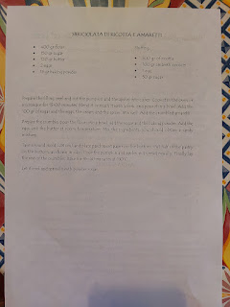

I made a reel (a little video) about our cooking class and posted it on both Instagram and Facebook. A reel uses a combination of selected photos and short video clips set to music, which makes the whole thing quite fun! If you want to watch the reels, you can find me here:

On Instagram my username is: @mamaharmon13
On Facebook my username is: Michele Snider Harmon

The last thing I wanted to share was the day I took another trip to Bassano del Grappa this past week. My purpose was to do a little Christmas shopping and it ended up being such a special day! This was the first time I drove there by car, and only the second time I've gone there by myself. My first visit to Bassano was in 2018 when I arrived by train from Innsbruck, Austria.

I had no set agenda this time, other than doing some Christmas errands. (Keep in mind that over here we have to send packages BEFORE Thanksgiving if we want them to make it in time to the U.S.)

To my surprise and delight, it was Farmers Market Day in Bassano, with booths lining several streets.

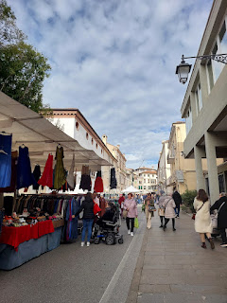

Vendors were selling everything from purses and belts, to clothing for the whole family, to meats and cheeses, and yes, even farm fresh produce.

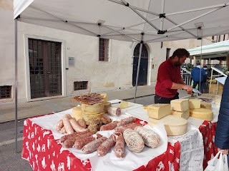

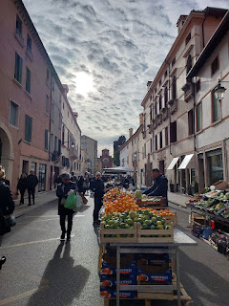

I didn't buy anything from them, but I enjoyed looking as I walked down toward the river. This time, the King Kong Rhino exhibit was open. Hooray!

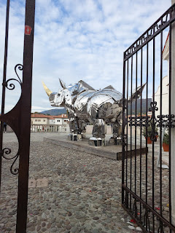

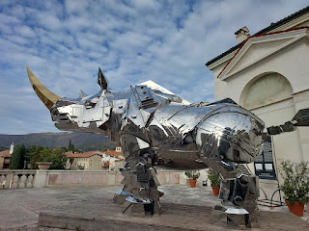

The River Brenta seemed especially gorgeous.

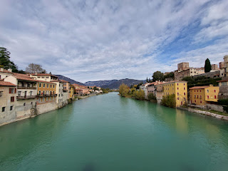

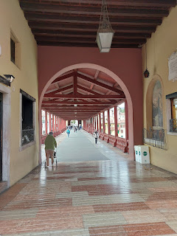

I walked all over and it felt amazing to be in the same place as my ancestors. I know I've said that before, but there was something EXTRA special about going there again by myself.

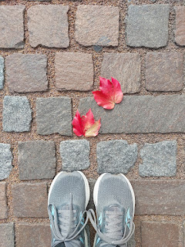

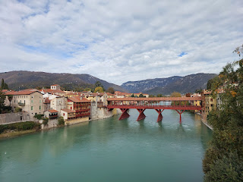

My errands were successful, my time was well spent, my heart was full to the brim, and I left feeling uplifted and strengthened.

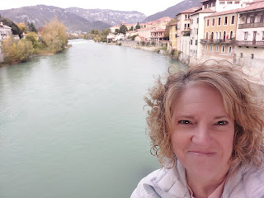

The weather was definitely crisp in Bassano, ha ha. I wished that I had one more layer on, plus some gloves and some warmer socks . . . the wind was definitely colder here than in Vicenza for sure!

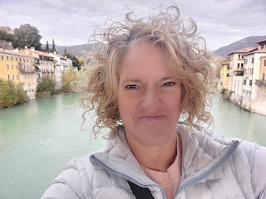

By the end of the week, I have now shipped a total of 14 packages to family and friends in the U.S. and that's pretty much a wrap.

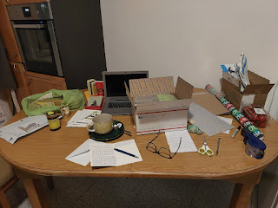

Now I can settle into a relaxing week ahead where I can really enjoy the Thanksgiving holiday. I can be grateful for my blessings and ponder on each of those. I will also be slipping away to visit Scott for a WHOLE WEEK in an undisclosed location. My mother knows where I'll be, and a few of my friends here know where I'll be. I will be safe, because if it weren't safe, I wouldn't even be getting on a plane to go see him.

Happy Thanksgiving everyone. Eat all the turkeys. Gobble Gobble.

