A Deep Freeze That Killed My Car
While the past week has been relatively quiet, I've enjoyed having numerous visits with family members in the area, which has helped me to pass the time. It still feels like I'm "in between" a busy period of life and another busy period coming up. Some days I am tackling several things from morning until evening, and other days I am just plain tired, so I don't do a whole lot on those days. I suppose it could also be the January Blahs that have kicked in. I am forcing myself to crank out this post right now, even though I am not very motivated to do so . . . ha ha.

It is currently 13 degrees outside, with the bright blue sky beginning to fade to a light blue about an hour before sunset. As I went to bed last night, I was excited at the opportunity to "make a day of it" today while I'm stuck at home with no car to speak of. But as the day has slowly progressed, my motivation has slowly waned as well . . .

More on that in a minute . . .

I want to give credit to my wonderfully talented daughter, Amber, who enthusiastically created a new illustration last week for the header on my blog. I am 5 years in now with typing up a weekly accounting of my life with all of its ups and downs (mostly ups), and I figured that it was time for a new header at the top. She cranked something out in less than 24 hours, bless her heart. 2025 is the year to advance her illustration skills, she has said, and so she jumped at the chance to make something for her dear momma. :) I am eternally grateful. XOXO

This may be one of the shortest posts I've ever written, and for some of you this may bring a smile to your face.

Last week, I had a 3 hour appointment with my hairdresser, Tessa, to add some color and highlights to the drab state my hair was in. She always does a great job. We always talk and talk the entire time and it's always a lot of fun.

Yes, I know I look a bit scary . . . it was my intent to send a hilarious goodnight message to Scott, who was 8 hours ahead, and to make him laugh. His only response was "Eek." Ha ha
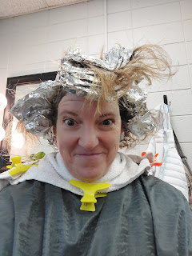

With a crisp blue sky and plenty of frozen snow surrounding the Idaho Falls Temple, I had a heartwarming session on the inside last Thursday. Consistent attendance in the House of the Lord has helped me to keep my head on straight, and to remember my divine worth as a daughter of God. I am so grateful to have a temple just 10 minutes across town, instead of 5 hours away in Italy.



I sent off some very special "DNA" last week, in the form of a stool sample. It's called a Gut Microbiome Kit, and it's not cheap. Well, there are some kits in the just-under-$200 range, but they don't have the quality of customer service and information and reports and coordination with your doctor as some of the more expensive ones provide. My doctor did some research of her own and narrowed it down to four options that she felt confident in recommending to me. I chose Genova Diagnostics, mainly because I was smitten with the reports that they offer, ones that are chock-full of beautiful graphs and colorful pie charts and a wealth of information. The cost was (cough cough) $489.

Yes, I know that's a big chunk of change. But my health is important too, and the answers hiding behind some consistent issues are critical to not only my present quality of life, but my future health and quality of life as well.

I had to go off my probiotics for 2 weeks leading up to the "special" day. (not my favorite thing to do, but I had no choice) Luckily, all the stars aligned and I was able to produce something to work with. I played the part of a temporary scientist as I prepared all the vials and tubes for shipment. Everything went into a biohazard bag, which was placed into another biohazard bag, which was placed inside a sturdy box, which was placed into a final (and quality) shipping bag. FedEx took it from there, and within a little over 48 hours, I received notice that my "specimen" had been received in North Carolina. Now the lab work begins . . .

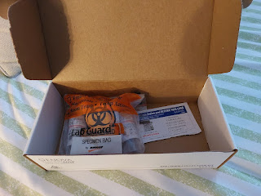

A documentary on Netflix was recommended to me recently, and I gotta say, it was fascinating and well put together. It's called, "Hack Your Health: Secrets To Your Gut." It's a little over one hour and very informative. Essentially, your gut is every bit as important as your brain. It's even being referred to as your body's second brain. Lately, more and more research is being conducted on the digestive system, and for that I am grateful.

The issues I am currently dealign with are: (in no particular order)
Bloating with almost every single thing I eat
Terrible cramps after eating some things, even with something as simple as an apple
Chronic constipation
Severe iron deficiency (even while taking doctor-recommended and pricy supplements)
Recent weight gain that is unexplained (about 5 lbs that I can't shake - or exercise - off)
An almost constant feeling of being tired
Intolerance to wheat and wheat-related foods
When it's not fun to eat anymore, then maybe it's time to take a closer look at what's happening deep inside your body. And that is precisely where I'm at.

I was happy that I could check this little procedure off my to-do list, so that I could enjoy going out to dinner with my niece, Mari, that evening. We tried a new restaurant called Himalayan Flavor in downtown Idaho Falls. It was SO GOOD. I ordered the Coconut Curry Shrimp with some garlic naan bread on the side. Wow. And the vegetable samosas were amazing, too, especially when dipped into the tamarind sauce on the side. I was especially grateful that I was able to take my enzyme capsules prior to eating, so that I could digest the foods better, and with less side effects. While leading up to my "science experiment", I couldn't take any enzymes or probiotics.



A few days ago, I made an executive decision to pay a lot more than I anticipated, in order to preserve a family heirloom that is precious to me. My grandparents, Linton and Lillian Norman, used to have a ranch in Ukiah, CA for several years. I was spent a great deal of my childhood on their handsome ranch, while my parents both worked full-time. After school, my sister (Charmaine) and I would walk from Nokomis Elementary to the end of Helen Avenue and up the long driveway to hang out with Grandma and Grandpa until our parents got home.

And during the summer months, we would walk over to the ranch from our house at 300 Tedford Avenue to spend the whole day there. We'd cut through the Seventh Day Adventist Church parking lot - kiddy korner to our back yard, and just behind the church was a gated entrance to the ranch. The days we spent with Grandma and Grandpa were some of the happiest memories from my entire childhood.

A couple years ago, Grandma Lillian gave me this wooden sign that used to hang at the ranch. I believe that her son, Tim Moore, painted it. I can just barely make out what looks like his signature below the blue winking owl. He used to sign his artwork with "TimMor", if I'm not mistaken. Sadly, he passed away in 2021. But his art and the nostalgia of the ranch will live on, once the framing process is completed in a few weeks.

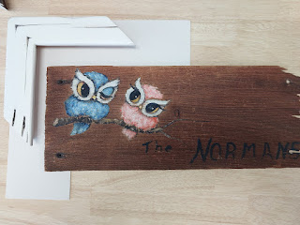

Even though it's been crazy cold for several days, surprisingly we got about 2-3 inches of new snow! It just kept coming and coming one afternoon. My neighbor, Kim, came over to see me and just like a great neighbor does, she brought her own shovel in order to shovel a path up to my front door. Nobody enjoys having to shovel snow that's been packed down by footprints or the tread of a car on the driveway. If you've lived long enough in Eastern Idaho, you come to know this unspoken creed, ha ha.

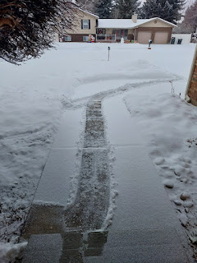

After she left a little while later, I went outside to shovel the rest of the snow. Kim's husband, Ben, came across to help me finish things up. They are the BEST.

This was a GENEROUS forecast for the current week. It ended up being much colder, in fact. Today (Tuesday), I think we saw a high of 9 degrees, and last night we had a warning that with the wind chill it would get down as low as -25 . . . yikes.

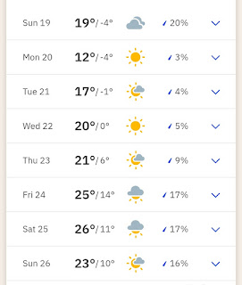

One of Scott's cute and hilarious facial expressions during one of our video chats . . .

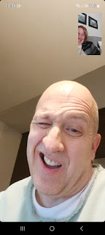

I drove up to Rigby on Sunday afternoon to have a meal with all the family up there. Scott's sister, Bev lives there with her husband, Ken. Their daughter, Vanessa also lives in Rigby, with two of her kids: her son Caleb, his wife Bethanne, along with their two little boys Harrison and Everett; and her youngest daughter, Taylor, who is finishing up high school while simultaneously attending BYU-Idaho. Bethanne's parents were up visiting from Utah too, so we had a houseful!

Thankfully, Bev attended culinary school many years ago, and knows how to put an amazing meal together. This time, she made the largest chicken pot pie that I've ever seen . . . and it was delicious. She also made corn on the cob, mashed potatoes, and a fancy green salad with dried cranberries and feta cheese.

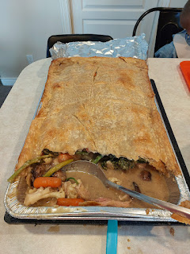

My job was simple: bring something for dessert. I made the always-popular layered sugar-free pudding dessert with a buttery, flaky crust on the bottom. It has a layer of cool whip to cover up the butterscotch & vanilla pudding layer, underscored by a cream cheese layer underneath. It is SO GOOD.

Here's a link to the recipe that I always use:
https://photos.app.goo.gl/DtPQ97XqrEytHzHJA

Caleb and Bethanne's son, Harrison, is one of the most delightful 4.5 year olds in the whole world. He is exceptionally bright and is very chipper and fun, too. His Gran Vanessa and I played a few rounds of "Keepy Uppy" downstairs with him, which essentially involves keeping a balloon up in the air as we volley it back and forth.

Vanessa, in her usual charming fashion, would call him out if he started inaccurately taking credit for winning the round. He'd spike the balloon down in his excitement from time to time, and then because it touched the floor before we could hit it, he would exclaim, "I won! I won!"

Vanessa, with her quick wit, would respond with, "Hey, I forgot...what is this game called again?"
Harrison would respond with, "It's called Keepy Uppy!"
Vanessa: That's what I thought . . . so how about we try to keep it UPPY instead of spiking it DOWNY.
Harrison: Oh yeah . . . you're right. :)

Harrison is also extremely fond of me. I had no idea to the extent that this is true, until Vanessa mentioned it to me. She said he loves all of his aunts and uncles and other family members, but something changes whenever Aunt Micheley's name comes up. She was adamant that I am his clear favorite. I'm not sure what I did to deserve this, but he sure is a cutie.

When I mentioned that I needed to head home soon before it got dark, Harrison became very sad. While he didn't shed any tears, he still had a very sad countenance and would not be consoled by the fact that we would be getting together again in just THREE DAYS. He agreed to draw me a picture before I left, though.

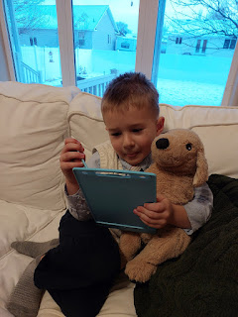

"Aunt Micheley, I drew both of us holding hands . . ." XOXO

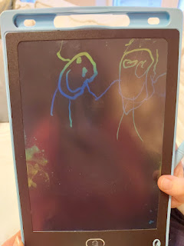

You see what I mean? He is so precious.

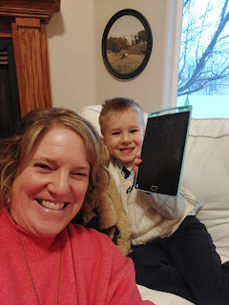

The topic of my front entry came up during the dinner conversation in Rigby. Bev's husband, Ken, who is a retired contractor, wants to help me replace my front doors this spring. They are not very weather-proof, but that's not the biggest concern. The double doors are not as secure as they need to be, and that worries me. Quite often, in fact.

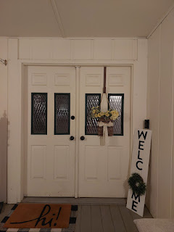

One of the locking mechanisms on the stationary door somehow died many years ago. If someone wanted to kick my front doors in, they probably could. And that's a scary thought. Ken is planning to come over in a few days and do some measuring. I need to shop for a new set of doors, and then he and Scott can potentially install them while Scott is here in April.

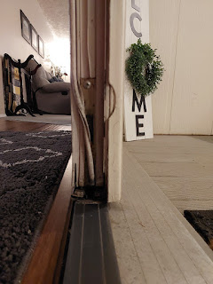

I had a lot of fun making a birthday cake for a different nephew of mine named Caleb. My sister Melanie's son just turned 22 this week (today in fact), and since he is attending BYU-Idaho just a few miles up the road, I hosted a smallish birthday party for him at my house on Monday.

I asked him what kind of cake he wanted and what kind of frosting. Chocolate, on both counts was the response. And he wanted chocolate chips in the cake, too. Alrighty! I do love a good chocolate cake . . .

I found a highly rated online recipe to use: (her chocolate buttercream frosting recipe is included too)
https://addapinch.com/the-best-chocolate-cake-recipe-ever/comment-page-915/#comments

*Note: I did not use the espresso powder in either the cake or the frosting. It tasted just fine without.

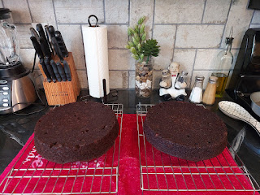

Caleb arrived in time to watch me frost the cake. He marveled at how I placed pieces of wax paper underneath the bottom layer before I began frosting it. He commented, "Wow, you take this very seriously!"

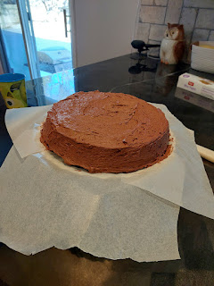

As the second layer was gently added on and the frosting was slathered on sufficiently and generously, the last step was to carefully pull the pieces of wax paper out from underneath. Voila! No mess on the pedestal cake stand. I don't recall who may have taught me that technique many years ago . . . maybe my mom? Or my Aunt Carol? Mom . . . Dad . . . if you have some ideas, please let me know.

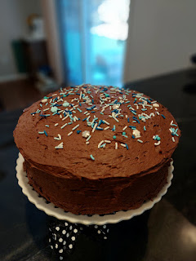

Part of the reason why Caleb had come down to Idaho Falls so early in the day was so we could try to figure out why he wasn't able to get any windshield washer fluid to squirt onto his windshield.

Attempt #1: He had filled the reservoir with washer fluid down in Arizona before driving up to college, but it wasn't intended for such cold temperatures. We needed to get the potentially frozen fluid out, and then put the cold-temperature rated fluid in afterwards.

Result: After pouring in as much of the new washer fluid as the reservoir could hold, and after using my hair dryer to heat up the lines, he still couldn't get anything to squirt out onto the windshield. So we decided to wait a little longer and let it sit in my garage for a bit.

Attempt #2: After letting the new fluid mix with the old, we figured it was time to run an errand and see if we could get it to squirt out as the car warmed up, too.

Result: Nothing happened. And when we got home and checked the fluid level, it was down several inches. He began to wonder if there was a leak, but we didn't see any puddles anywhere.

Attempt #3: Call Grandpa John. He had the brilliant idea that maybe there's something wrong with the pump that sends the fluid up through the tubes and onto the windshield. He asked if we could hear any sort of sound like the hum of a motor when we tried to make it squirt.

Result: Nope. No sound.

So that's where we left off in the matter of the non-squirting washer fluid. No satisfying end yet.

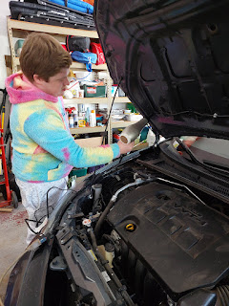

At this point, Caleb was ready to drive back up to Rexburg to pick up his cousin and a couple of friends for the birthday bash. We discussed some options for dinner, and settled on just picking up some supplies from Costco that he really likes. But when I tried to start my car in the driveway, it wouldn't start.

I figured it was because it was so cold outside, and I had backed it out from the garage several hours earlier so that Caleb's car could be in the garage. It had only pitifully started up that first time, and again, I just attributed it to the cold weather. But even after Caleb and I got the jumper cables out and tried to jump start it, it was deader than dead.

Caleb ended up driving me to Costco where we got the needed supplies, and then he drove me back home before heading north to Rexburg a little later than planned. Meanwhile, I called my neighbor, Kim, to see if she had any ideas. As a matter of fact, she did. Her mom's car had the same exact situation recently, too, as it had been sitting on the side of their house for a few months and hadn't been driven much. It wouldn't respond to jumper cables either, and they had ended up buying a whole new battery.

And that's exactly what we ended up doing for my car, too. Kim's son, Jackson, came over in frigid single-digit temperatures to pull the old battery out last night. He took it in today to have the auto parts store test it. Yep, it was deader than dead. So we bought a new battery and he hooked it all up for me. The car started right away and I was able to pull it into the garage and out of the cold once again. It was a balmy 7 degrees with a wind chill factor of -1 degrees as this 17 year old kid was out there touching metal stuff with his bare hands . . . What a hero.

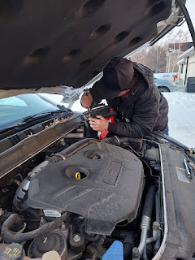

Back to the birthday party last night . . . Caleb's cousin Rachel wasn't feeling well, so she and her boyfriend didn't end up coming. But Rachel's roommate, Kate, joined us. She was a real cutie. She was friendly and chatty, cheerful, kind, wise, and seems to be a very confident young lady. She added a really fun dynamic to the evening. We had a nice dinner together, we played some games, and then we sang happy birthday to Caleb, with his family joining us on FaceTime back in Arizona. He blew out all 22 candles with hardly any effort at all. What a guy. :)

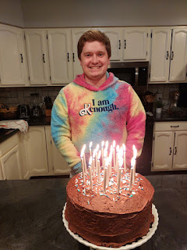

And since we're on the subject of cars . . . This is what Benson's car looks like as of Sunday night. They finally got another cherry picker to lift the old engine out of his Audi, so it's officially out now . . . after a very lengthy wait. Next weekend, they (Benson and his buddies) will carefully place the new engine in. We're all holding our breath that it will start up and function as it should. Benson told us, "If this car even looks at me the wrong way after this, I'm selling her!"

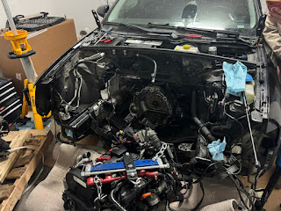

I'll end on the best possible note, with a cuter-than-cute video of Maisie: (17 seconds)
https://photos.app.goo.gl/yzT2NgWMFkDhUWKj8

She's 4.5 months old now and she sure is growing up fast! I love her personality so much. She's so content and happy and observant. It's clear that she loves her family a lot. XOXO

I'll be traveling to Italy next week to help us move into the new house. I might be a little late with the next blog post, but I'll have some great photos and videos to share!!

