A Little Red Headed Girl
The highlight of my entire week was spending an afternoon with my little granddaughter, Avery. She is almost 7 months old now and has the cutest blue eyes and strawberry-blonde hair! I was able to hang out with her while her parents had an important appointment and we had the best time while they were gone.


I may have gone a little overboard with her parent's humble request for a couple of baby toys that would be a little more challenging to Avery than her assortment of rattles and simple toys. (I had told them about the Bimbo Toy Store here in Vicenza) But what good is it being a grandparent IN ITALY if you don't get a bunch of fun things to bring on your next visit?!!
(*I did NOT buy everything that you see in the photos below)
The many cute faces of Avery:
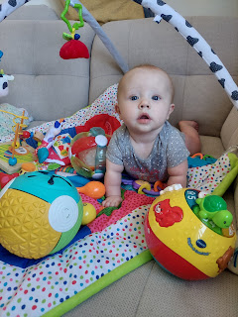

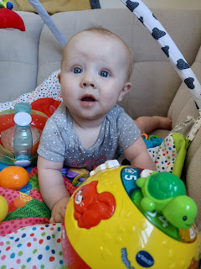

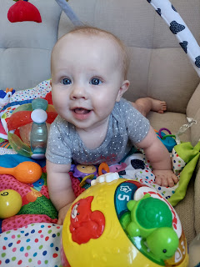

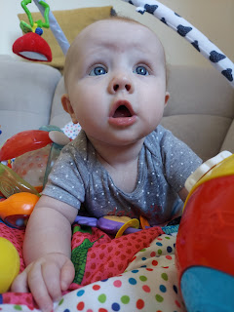

As I drove up to Aviano, I was enjoying the CRISP blue skies that were everywhere. We've had several days recently that were more of a light blue with some haze over the mountains, but I think the rain had cleared out all of the lingering haze overnight. (Thank you rain!)

I took ONE photo while driving. It was AFTER I got off the freeway, and after I exited a round-about, so I was going pretty slow. I was on a straight-away and nobody was anywhere close to me. There, those are my excuses. Also - I just held up my phone and said in a commanding voice, "Capture!" and then the camera app took the photo for me. I can keep my eyes on the road the entire time . . . (pay no mind to the bug on the windshield in the photo below)

The Dolomites on a brilliant blue-sky day . . .

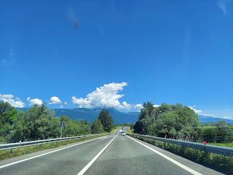

After Avery and I played with her new toys for a while, I decided to take her out on the front porch so we could enjoy the beautiful view. Plus we kept hearing a few Air Force jets practicing their maneuvers in the sky and I wanted to see some of what they were doing.

As we stood on the porch, looking out at this view (below), it just felt so peaceful. I held her facing out, but she was nestled into me and we just slowly swayed back and forth, cheek to cheek. I quietly chatted with her and the whole experience was so serene and peaceful. It was seriously the best thing I've done the whole time that I've been here in Italy. :)

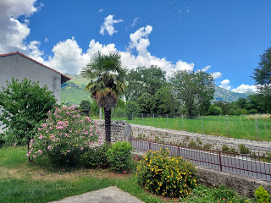

We walked slowly around to the back yard, admiring the blueness of the sky and the billowy white clouds over the mountains.

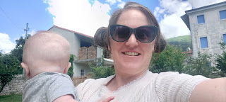

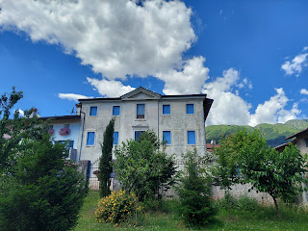

Soon, however, she was ready for a bottle and a nap. I sang several songs to her as she drank some of her bottle, and when I laid her down in her crib, she was asleep in about 5 minutes. What a perfect little angel.

I love this expression as she's concentrating on one of the toys I was holding for her. Such focus!

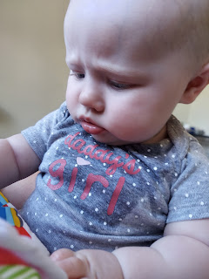

She was still sound asleep more than 2 hours after I laid her down, by which time Kylie had returned. We had to wake her up in order to not mess up the schedule for the rest of the day. But she woke up wide-eyed and bushy-tailed, ha ha.

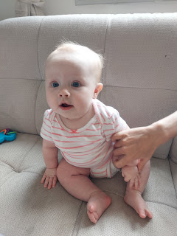





Benson had already gone back to work, but I stayed to visit with Kylie for another hour or so, before heading back to Vicenza. Everything was fine on the drive home, until I got a few km away from my final exit. I had seen several digital billboard signs on the freeway saying that there was a MANDATORY exit at "Vicenza Est", which was also MY exit. I wasn't too worried until I got a little closer.

That's where the traffic was at a complete stop for several minutes, and then it was mostly "stop" with only an occasional "go". It took FOREVER to get to where I could even see the exit sign that I needed.

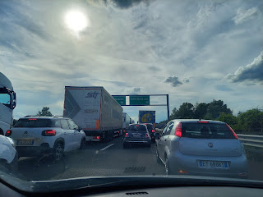

Originally, I was due home by 5:45. I got home closer to 6:45 p.m. With that mandatory exit, we went from 4 westbound lanes down to one - the lane that was forced to exit.

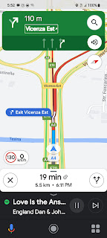

And then, the kicker, is that at that particular exit, that's where you also have to pay the tolls for traveling on the Autostrada (freeway). So all those cars that were squeezed off the road were now in ANOTHER bumper-to-bumper jam to have to pay our individual toll fees.

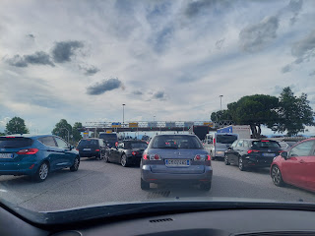

It was right about here (above) that my car started acting up. We think that it was getting overheated or something, with all of the endless idling in that big mess, but it started revving constantly while in the idle mode with my foot on the brake. A couple of times while trying to crawl forward to pay my toll, it even died!! To prevent it from shutting off, I would put it in neutral, where it still continued to rev-rev-rev the entire time. (It's an automatic transmission, Dad)

ANYway, I finally made it to the toll booth, paid my ticket fee, and even though the car died a third time, I was able to start it up and pull forward . . . into the next gnarly mess of bumper-to-bumper cars.

It took another 10 minutes to get out of that mess and onto another side road. There was still a steady stream of cars, but this time at least we crawled along more than we were stopped. FINALLY, I got onto a road that allowed me the freedom to actually DRIVE. This was reassuring because I did not want to stop or slow down ONE more time. The car had sputtered to a stop 5x by this point and I just wanted to get home to where I knew Scott was waiting for me down at the courtyard gate.

The reason we think it just got overheated from almost an hour of idling and crawling along, is because Scott drove it to work and back the next day (Thursday) to see if there were any residual issues, but it was just fine. This was a huge relief, since he would be leaving a few hours later for Morocco and I would be at home by myself.

Just to be safe, I asked him if I could try out his stick-shift Suzuki car in case the Peugot gave me any more problems in his absence. He got home early from work on Thursday and took me to a quiet area behind the Ederle Inn on base where I got behind the wheel to see if I still had the skills. It has been YEARS since I've driven a stick-shift car, but it all came back to me as soon as I inched forward in first gear and I did great! I drove us around on two additional errands before heading home and parking it in the courtyard. It felt awesome to know that I had another car if I needed it. :)

I looked on the news to see what had caused that mess on the freeway. The only thing I could find was that early Wednesday morning a Serbian man had shot and killed his ex-girlfriend in Vicenza after she dropped off her kids at school and then he fled the scene. They had shut down a portion of the freeway during the massive manhunt. I haven't checked back to see if they ever caught him. Maybe I should do that . . . What a massive undertaking though, to shut down an entire section of the freeway, knowing the mess that it would cause . . .

Thursday was my last night with Scott in this house for the next several months. By the time he gets back from Morocco, I will already be in the United States until the end of September.

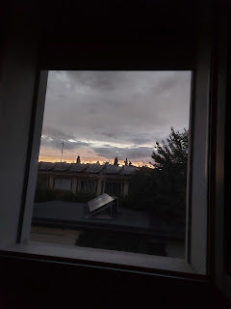

More Grandbabies . . .

I just love seeing each one of my grandchildren grow and learn how to do new things. I especially love cheering them on and giving them all the love in my heart without having any parental responsibilities!! :)

Jack is getting SO FAST with walking now. If he falls down, he gets right back up and just keeps on trucking.

Video #1: (45 seconds) Walking down a long hallway like a PRO
https://photos.app.goo.gl/XNhipZxfYGDdM9yY9

Video #2: (27 seconds) Hauling pickleball equipment for his parents' date night
https://photos.app.goo.gl/dknv4jzNrgdE6nWPA

We had a group video chat over the weekend between Scott, Jacob, and me. Jacob graciously kept the camera pointed at Jack while we visited about this or that. Sometimes Jack would come over and smile at us. My favorite thing was if we tipped our heads to the side, he would do the same!







He also went back to the Washington DC Temple open house a second time (*that grin of his*).

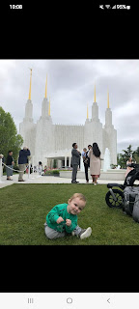

Abby is cruising comfortably on her roller skates - doing laps around their living room for practice. I can't wait to go skating with her again!

Video of Abby wheeling around: (22 seconds)
https://photos.app.goo.gl/vqpgZMy51FLydkbcA

And Gwennie has the cutest bangs with her latest trim from Mom . . .

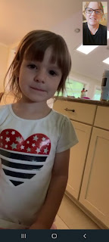

Amber has been working HARD on this family history book project. I am but her humble servant in helping her dream to come true. I've been finding old photos to add to the stories that I've been sharing with her for the book. What an honor it is to collaborate with your own child!! I am really excited for this idea to take hold and eventually go to print!

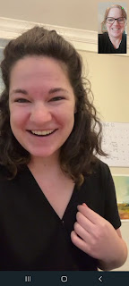

I tried a new recipe this week and I think it's my favorite recipe now. We made Tuscan Butter Salmon together at the beginning of the week and man oh man. It was SO GOOD!!

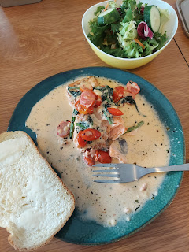

Here is the recipe:

https://www.delish.com/cooking/recipe-ideas/recipes/a58412/tuscan-butter-salmon-recipe/

I'm still in awe of the fresh seafoods and meats in the different grocery stores. Emisfero (like a Super Walmart but 1,000 times better) has a BEAUTIFUL meat section of the store.

I keep seeing these colorful skewers in almost every grocery store. Someday we need to try them out.

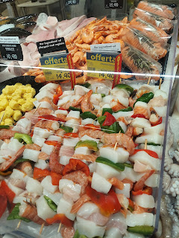

Even though I'm a seafood lover, I'm not exactly sure what I would do with these . . .

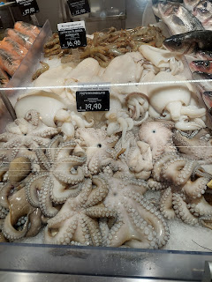

In the middle of the night (Thursday), Scott left for some training in Morocco. He had driven his little red car over to the base and parked it behind the Ederle Inn before boarding a bus for the airport. The following morning, I walked over to retrieve it and got some exercise at the same time!

I'm seeing several different colors of hydrangeas blooming right now. So far I've just seen the French Hydrangea (bright pink with lime green), but now I'm seeing light pinks and whites, along with the typical lavender/blue blooms.

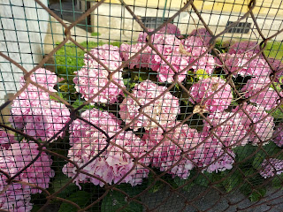

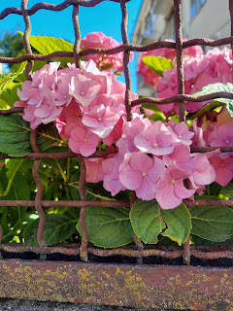

"Flowers of Italy" photo album link:
https://photos.app.goo.gl/i4RGiVYYiVicd4Ln6

I FINALLY got into the salon on Friday after weeks of waiting and was able to get a much-needed haircut. Usually I get my hair cut every 5 weeks. Well . . . it's been about 10 weeks and I just now got it cut.

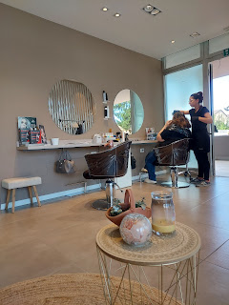

After a fancy scalp massage and collagen treatment - while laying back in a recliner chair with lumbar massage - the assistant pulled my hair up while I waited a few more minutes for Antoinella to begin the cut. She is the owner of the salon and thankfully knows a fair amount of English.

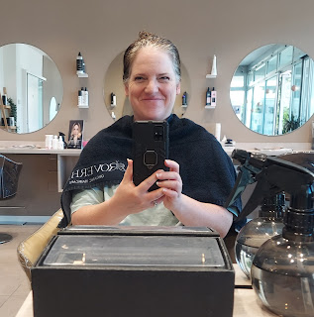

We discussed how much to take off the length, and she even showed me with her fingers - indicating about a 1/2 inch. I told her that would be great. She wanted to color my hair when I arrived for my appointment, but I told her that my friend is already planning to do that in a few weeks when I get back to the U.S. Antoinella had some good ideas for how to work with my gray hair when it comes to coloring. Typically, I like a medium brown color - since it's closest to my own natural hair. But the gray hair usually starts coming back around 6 weeks after I get it colored, leaving me to wait the agonizing rest of the 3 months until I can get it colored again. And the contrast is quite stark between the medium brown and the light gray.

She suggested that I get some blonde and golden highlights that will hide the gray much better and therefore I won't have to get it colored as often. Sounds good to me!

By the time she was done cutting my hair, I noticed that it was MUCH shorter than I had anticipated. I think she ended up taking about 2 inches off!! Add in the fact that my curls spring up when they dry, and my hair doesn't even touch my shoulders now . . .

I always have to laugh inside when hairdressers want to "style" my hair. What that really means is they want to make it as big and fluffy as possible and then ooh and aah over how beautiful it is. Proof below.



Scott had a REALLY long day in getting to his hotel in Morocco on Friday. He left at 2:30 a.m. from our house (Thursday), to catch a bus to Venice. He flew from Venice to Madrid where he sat for 4 hours in the airport. Then he flew to Casablanca and sat another 2 hours before arriving at his final destination. Even after he landed, there were several soldiers to round up and gather everyone's luggage. Then they left on shuttles that took them out to where they'll be conducting their business for the next few weeks so they could see where they will be working, and then they finally arrived at their hotel late in the evening.

His hotel is right on the beach, but also has its own pool and water slides to beat the heat (although he said it was almost chilly on Saturday).

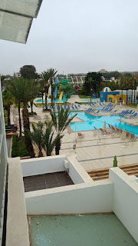

He took me out back behind the hotel to show me the Atlantic Ocean while we were on a video call.

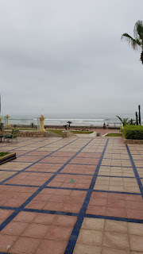

There is a promenade that goes on for miles along the beachfront. Sadly, it is overloaded with panhandlers, Scott said. They are all trying to get you to buy a pair of sunglasses, a hat, a scarf, etc. and they can be pushy and overly assertive. The hotel has a guard where the promenade meets up with the path to the hotel so that none of the panhandlers can come into the hotel property to push their wares on the hotel guests. That's a nice amenity to have on hand.

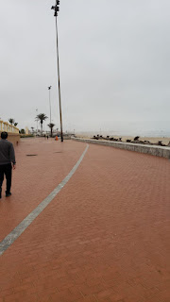

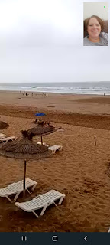

He likes to take his breakfast outside to eat and listen to the ocean waves lapping onto the shore.

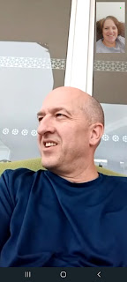

Inside the hotel, it's pretty fancy. Not only do they have a ginormous fountain that cascades down to the inner court below, but they have several restaurants and souvenir shops inside as well.

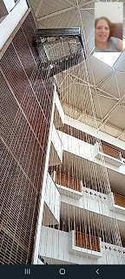

He told me last night that when he had dinner in one of the restaurants, the waiter was so kind and attentive and wouldn't even let him pour his own water to refill his glass. He's gonna be so spoiled! :)

TOMORROW IS OUR 30TH WEDDING ANNIVERSARY!! Wow, I can't believe it's been so long! It feels like yesterday that we were newlyweds . . . oh yeah, that's because we still act like newlyweds, ha ha ha. But seriously, I am the luckiest lady in the world to have someone so kind and loving, patient and funny, sweet and studious, smart and handy, and a spiritual rock in my life. He has been THE biggest blessing in my entire life and I am forever grateful that we found each other 31 years ago as friends in college.

I am so excited to meet up with him in Morocco this week for an anniversary rendezvous, some culture shock, some sunshine, and plenty of new adventures to share!!

