A Little Trip to the ER . . .
In the middle of the week, in the middle of the afternoon, I got a worrisome call from my mother-in-law, Coy. Her voice was shaky as she told me that she thought she was having a heart attack. She was at the Community Care in Rigby, waiting for transport by ambulance to the Regional Hospital just around the corner from my house. I was surprised that she felt well enough to call, but I was grateful that she did. At that point, we didn't know if my father-in-law, Phil, would be able to catch a ride in the ambulance or if he would need separate transportation. I told her I was available to help in any way that was needed, and then we hung up.

I jumped into action, first sending a text to all of Scott's siblings so they would know what was going on. Then I called my friend, ReNae Cunningham, to let her know I would not be able to join them at the temple that evening, but that I would hurry and print out the family names so that they could still perform the proxy baptisms in my absence.

(*To understand what proxy baptisms are and why they are performed, please click on the following link to learn more:
https://www.churchofjesuschrist.org/temples/what-is-proxy-baptism?lang=eng
)

I dropped off the family name cards to ReNae and then I hurried over to the hospital ER, just around the corner from my house, to wait. After some time, with me trying to be patient, I saw an ambulance pull in through the waiting room window. I could see my father-in-law in the front seat, which was a relief to know that he had made it there as well.

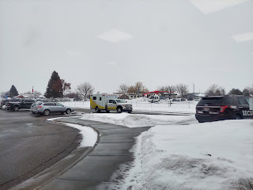

Mom was pale and in quite a bit of discomfort. It was no wonder, when her heart rate was up around 152 consistently . . . The staff were very efficient and calm, caring and helpful. We were told that they had given her some medication through an IV to bring her heart rate down (they called it "converting" - meaning bringing it back to a normal rhythm). It would take about 30 minutes to see if the medicine had done its job properly or not. If it didn't work, then they would have to shock her heart to "force" it to convert. And if that didn't work, then they would keep her overnight to continue to work on the problem.

Staff members flowed in and out, conducting their business quietly and efficiently. At one point, a couple of ladies came in with a giant x-ray machine. One of the ladies was someone I knew! She is Kylie's MOM!! Her name is Tamra and you can see her in the photo below, wearing green, and talking with Coy on the left side of the bed. We had a little laugh over seeing each other in the ER - of all places! I think the last time I saw her in person was when Benson and Kylie got married.

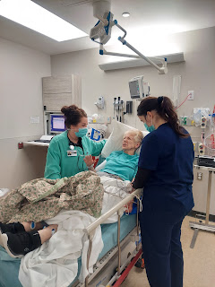

It didn't take long before I noticed that Coy's heart rate had come down significantly. On the monitor below, you can see the green number on the top right (64). Much better than 152!

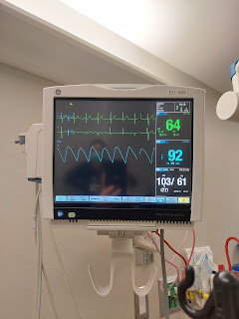

She seemed to perk up a little more, too. She became more conversational, asking questions about my latest family history projects, among other things. It was good to see her feeling better. After the x-ray, and an EKG, and a doctor's approval, she was told she could be discharged. Hallelujah! And Happy Day!

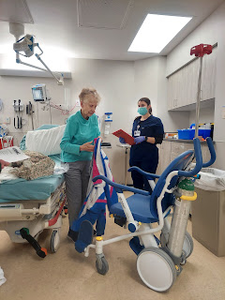

I drove the two of them back to Rigby, where we picked up Dad's car from the Community Care and then caravanned back to their house. I insisted on staying to make them something to eat before I left, even though Mom had a hard time sitting down and letting me have free rein in her kitchen. They had a simple appetite and were both very tired, so I ended up just heating up some tomato soup from a can, along with some canned pears and cottage cheese on the side for Dad.

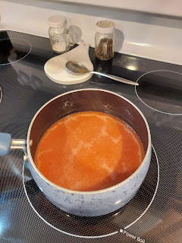

The reason why I have so many photos of the anxiety-producing adventure, is because I was sending regular photos and texts to all the siblings so they could know everything that was going on. I thought it was also important for them to see their mother feeling better and eating her bowl of soup at home by the end of the evening. :)

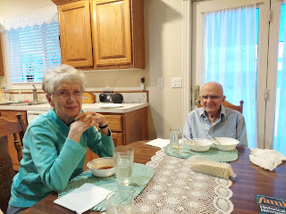

It turned out that it wasn't a heart attack, even though it must have felt like one with all of the squeezing and pressure in her chest, along with a racing heart for hours and hours. She has gone into A-fib many times, unfortunately, even with a pacemaker that she's had for years now. Her heart eventually "converts", but sometimes it takes a long time and it is very draining physically on her poor body. I'm so glad that she's feeling better now, even though I'm so sorry that she has to go through this from time to time.

As I was driving home that evening, the temperature outside was EIGHT degrees. Gross.

When I had originally asked the Cunninghams if they could help me with the family baptisms at the temple, I had no idea that it would turn out to be such a special occasion for their family. ReNae's niece had never been to the temple before, even though she was married and had a family of her own. They arranged for her to come with them and it was a really special experience.

The niece is on the left, ReNae is in the middle, and ReNae's daughter, Brielle is on the right.

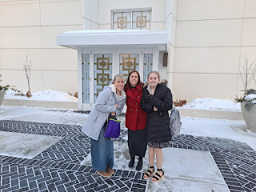

Brielle (left) and her cousin - so joyful after their temple service (even though it was 8 degrees outside)

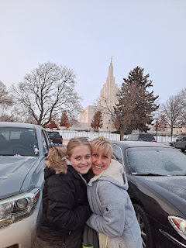

Other items from the week . . .

I began work on Abby's special embroidery project for her upcoming baptism in April. I'll be finishing it up this week and it will be oh so wonderful.

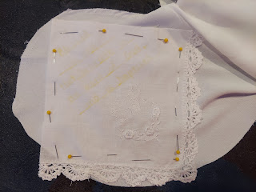

I also did another couple of scanning projects at the FamilySearch Center across town. One of the projects involved scanning 357 pages of letters and postcards that my parents wrote home to Grandma Zoe and Grandpa John Snider while we lived in Adak, Alaska. My dad was stationed there with the Navy (1971), and it was an interesting time for us. I was just a small baby when we moved up there, and Charmaine was one year old. I learned to sit, crawl, and walk in Adak. I don't remember any of it, of course, which is why these letters are so priceless. There are several references to items being ordered out of catalogs by my grandparents and then mailed up to my parents in Alaska because they simply weren't available up there. Things like barrettes for our hair, for example.

This was my work station at the FamilySearch Center.

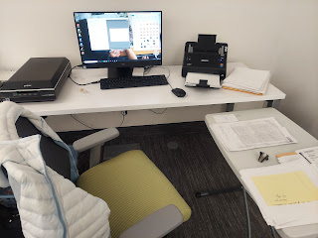

Scanning the documents went much faster than the little stacks of photos (i.e. my project for Grandma Lillian), since I could put a larger stack in all at once.

Video of the incredible scanning speed: (10 seconds)
https://photos.app.goo.gl/HKGWa9eeLL5s2QhX6

My good friend, Steve Meyers, works at the Center on Fridays, and he was able to help me put all 357 pages into one PDF document by the time I was done. It took some fenagling, but he eventually got it all worked out.

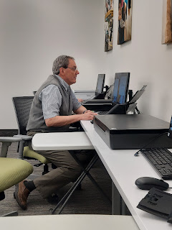

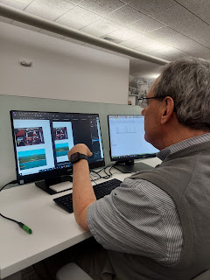

The other project that I did surprised me at how long it took. I anticipated that it would take me several days to get all of my Snider family history scanned, especially if I used our dinosaur scanner here at home. But, to my joyous surprise, I got everything scanned onto a thumb drive in just 3 hours!! WOW!! What a time saver - - and a life saver. It was such a relief because when I was sick for an entire WEEK, I knew I was significantly behind in the things I needed to squeeze in before I leave the country again. This was a huge boost to my mood and improved my outlook on the dwindling number of days ahead.

Now, I have photos and documents all scanned and ready to work with from wherever I happen to be. Thanks, Google. You're awesome!!

I've also been working extensively on another Rawles Family Blog this week. I spent several hours on Saturday, typing up the last big section regarding my 2nd great grandfather, Thomas Edward Rawles. I'll include a link next week, since I want to be certain first that it's truly ready for sharing.

I went to the temple again, too. In the days that follow any time that I spend in the temple, I feel such a sense of inner strength and a feeling of "I can do whatever is set before me". It has been such a blessing to be so close to the temple for the past couple of months. I will miss my weekly attendance when I go back to Italy . . .

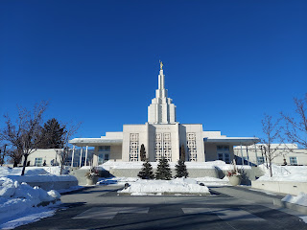

Unfortunately, my dryer died this weekend . . .

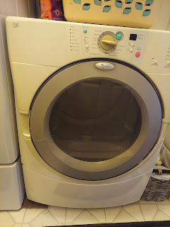

The heating element stopped working, so all it does is just toss the clothes around with cold air and the clothes never get dry. I hauled everything to the nearest laundromat and now I'm in good shape to start the week. I brought a bunch quarters with me, but it turned out that I could use my credit card to pay for the dryer instead! How fancy.

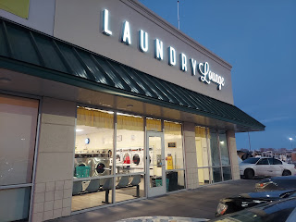

Also, this insightful and thought-provoking quote on my daughter's Instagram account, really made an impact on me. Sometimes we are so quick to judge others based on a strict sense of what is right or wrong. We forget about loving the person caught in the middle. Love is the most important thing of all. Love God. Love our neighbors. Love ourselves. Love looks like many things: being inclusive, being merciful, being compassionate, being kind. Tip for the week: Let's all try to take notice of someone who could use a little more of these attributes. :)

Spoken by Charlie Bird, former mascot at BYU - -



I don't often share things going on with my siblings and their families, and perhaps I should more often, but this story was worth including in today's post. My brother, Ryan, is a police sergeant in Rohnert Park, CA. He went out on a call at 1:00 a.m. this week . . . to rescue a HORSE!!

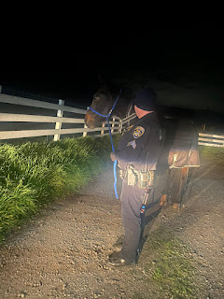

In his words: "I got to help rescue a horse last night. Responded to a call of a black horse running on the road around 1 a.m. As I responded, I was updated that the horse had been hit. I used the patrol vehicle to corral it up a driveway and out of the road, then called animal control and an emergency vet. Surprisingly, the horse was okay and no broken bones. Helped comfort the horse, put the halter on, steadied the horse while the vet examined it, and then I led it to a nearby pasture while they tried to find the owner."

Good work, Ryan! That's so cool.

My favorite part each week is to share photos of my grandchildren. Here we go!!!

Little Miss Avery
- getting long hair now and still that spunky & silly little girl that I miss so much.

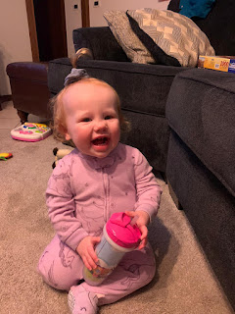

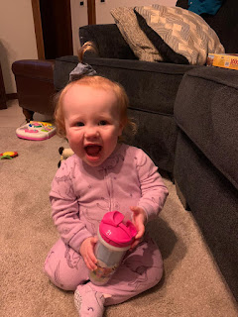

Jack
had a lot of fun with "Chip" the cat at his cousin's house in Michigan.

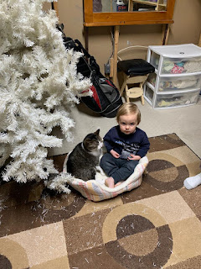

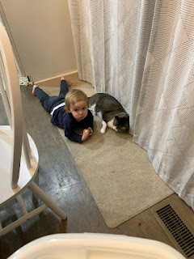

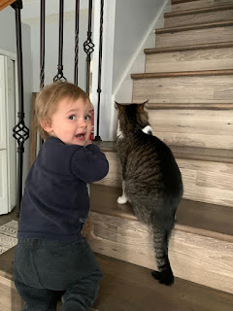

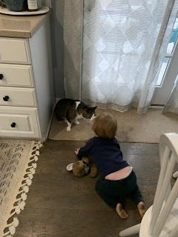

(This next photo is now the screensaver on my phone . . .) XOXO

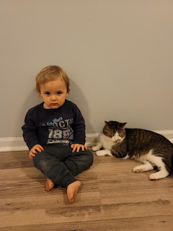

Abby and Gwen, along with their parents, flew up to spend a few days with Jacob & Co. in Arlington, VA. They've been so busy sightseeing and having ALL the adventures, that I'm still patiently waiting for more photos to be shared. Here are a few that she posted online.

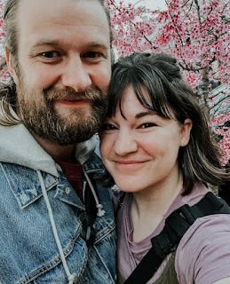

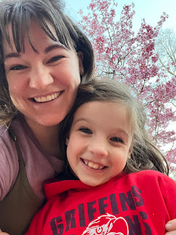

Abby is big enough to pick Jack up, LOL

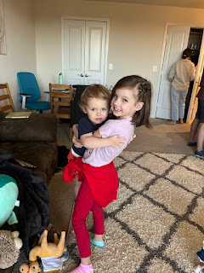

Gwen, spreading her butterfly wings . . .

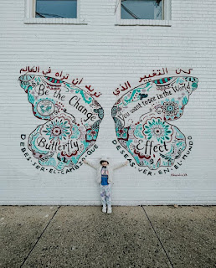

Mt. Vernon: Weston, Amber, Gwen and Abby XOXO

