A New Baby is Born!!
Welcome to the family, Miss Avery Mae!! She is a real cutie. She was born a few days early, on Friday, Nov. 19th and was 7 lbs and 4 oz. She is eating well and thriving, as far as we know.
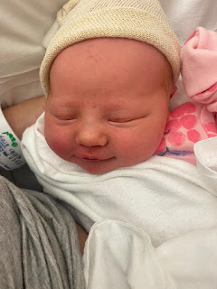



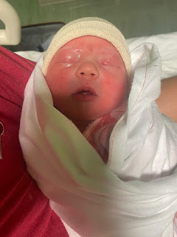

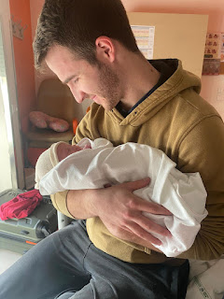

Kylie barely made it to the hospital in Italy, when she went from 6 cm to 9 cm quite fast! She was able to get an epidural at 9 cm, but they reported that it only half worked. She quipped that "it was better to be half numb than no numb"! How true that is! Apparently it only worked to numb her left side, but didn't numb the right side. She pushed for about an hour and then voila! Avery made her debut into the world.

In the aftermath, some differences between an Italian hospital and an American hospital became very apparent. First, Kylie was in a shared room with another mother and her baby. While Avery was calm and quiet, sleeping reasonably well and eating well, the other baby would cry often. It made it difficult for Kylie to get any rest for the almost 3 days they kept her there. There was also the issue with her not getting any pain medication. And she wasn't getting any food either. Benson was having to bring her meals so that she didn't pass out from being so hungry and malnourished! That's disappointing that in this day and age there isn't better treatment for the patients over there. I hope that now she is home, Kylie can get much better treatment and care.

We are very happy for Benson and Kylie, as first time parents. We also look forward to the day when we can meet Avery and hold her for the first time.

As for the rest of the week . . .

Last Sunday:
The primary children at church performed their annual program, with speaking parts and several songs. They did a great job! Scott's class, with all the children that are 6 years old, were the first to share their messages. They each shared how they know Heavenly Father loves them, whether it is through praying or reading scriptures or being part of a loving family on earth.

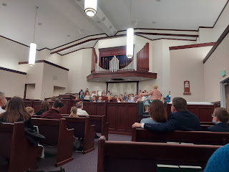

I made artisan bread for the first time in ages. I like to make a double batch because I have two stoneware baking pans (from Pampered Chef). We always keep a loaf for ourselves, and then we give the other loaf to someone else.

While it takes several hours (about 6 total) before it's ready to go in the oven, it literally - and I mean literally - only takes about 5 minutes of your time and effort. The rest of the time it's just sitting on the counter, doing it's own thing.

First, I mix the handful of ingredients: flour, water, salt, and yeast. (Times 2)

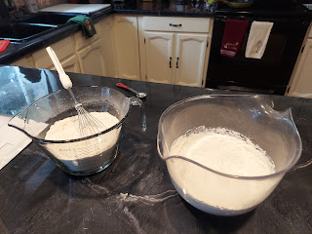

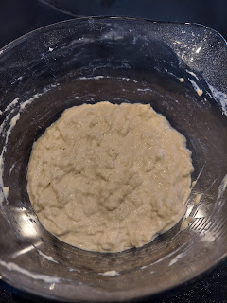

Then I let it sit for several hours, covered, on the counter. At long last, it's ready to be dumped out onto a floured surface.

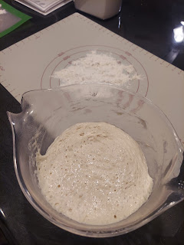

I fold it over onto itself about 4-5 times, and that's it.

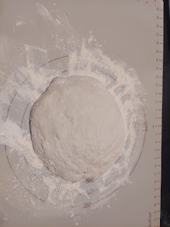

I use my pastry mat to work with one of the dough mixtures, and then I use a flexible cutting mat for the other. I fold each mat over and then cover them with a dish towel to rest for another hour or so.

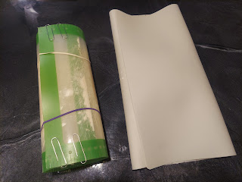

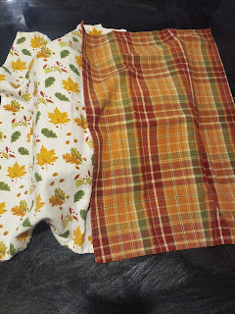

In the last 30 minutes of the resting time, I put the stoneware crocks into the oven and let them heat up with the oven until they reach 450 degrees. When I plop the dough into the super hot pan, it gives a tiny little sizzle. It's a very satisfying sound. Trust me.

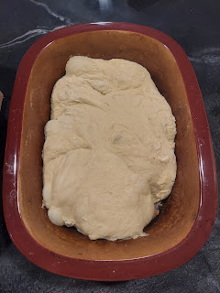

They bake covered for about 25 minutes, then another 8 minutes, uncovered. The crust turns out crunchy on the outside, but the inside is so soft and chewy and light and fluffy. It's quite amazing! Next time, I think I would like to add some freshly grated parmesan and maybe some herbs on the top before I bake them.

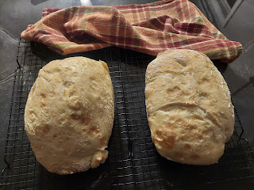

Monday:
Gwen got some help from her mother to have her hair braided for the first time. It has taken a long time for her hair to grow long enough for braids, but she was very happy about it!

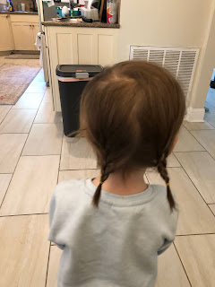

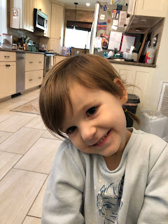

I also got this darling video of Gwen at the store, admiring all the Nutcrackers on display. Amber said that Gwen is obsessed with all of the varieties of Nutcrackers every time they go to the store.

Here's the cute video:
https://photos.app.goo.gl/4rrgMc9QL1sMyhXS6

As we prepare for the Christmas season, we have to take advantage of "good" weather opportunities up here in Idaho. You can't just wait until after Thanksgiving, or sometime in December, to put up your Christmas lights. If you do, you will be sorrier than sorry! And you will probably lose some of your fingers to frostbite as well. So instead, we usually hang up the lights a little early while the weather isn't too brutal yet. Monday ended up being a pretty good day to hang the lights. :)

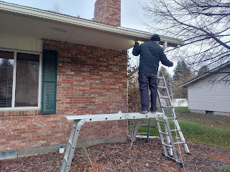

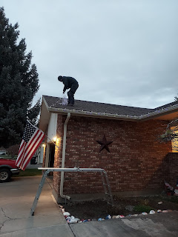

Scott did all the work, while my job was to steady the ladder and the makeshift "scaffolding" so he didn't die. :)

Tuesday:
I worked on Avery's baby quilt in the morning, and then did quite a bit of baking in the afternoon. For our young women's activity that evening, we had a huge planning meeting with all the girls. But first we had to get them excited enough to come! Cue the homemade crescent rolls . . .

This is a recipe that our friends, Rich & Andrea Garner, shared with us about 20+ years ago. We have been making these repeatedly ever since, and every single time they turn out amazing!

Once the dough has had an hour or so to rise, I just plop it directly onto the counter that I spray with nonstick cooking spray. (I spray the rolling pin too)

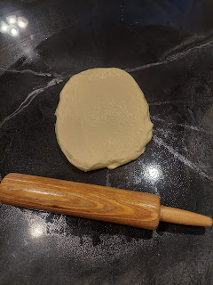

Roll it out until it's nice and round like a giant pizza. You don't want it too thick though. Thinner is better.

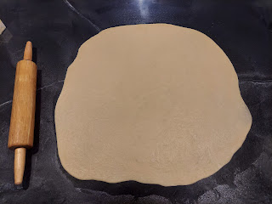

Then, I had to be creative as to how to cut the dough into triangles this time because I didn't want to scratch up our new countertops. In the past, I have used a metal pizza cutter, but I was worried it would do some damage to the new epoxy surface. I hunted through my drawers and found this plastic pastry cutter instead. It has 2 additional attachments, for making designer lattice strips on a pie with artsy edging. But for the crescent rolls, I just chose the simple straight edge wheel.

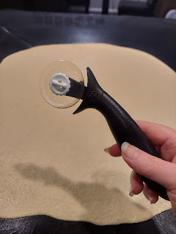

Video of me cutting the dough into triangles: (39 seconds)
https://photos.app.goo.gl/NZGUxDWLGUUyKP2g6

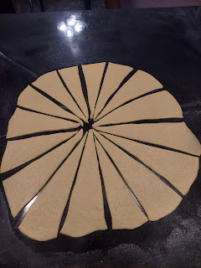

Next: lightly butter each triangle.

Video: (57 seconds)
https://photos.app.goo.gl/QBAmxniFRswfJfV28

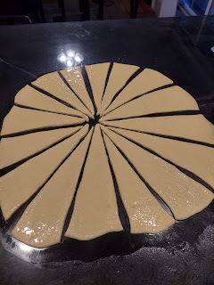

Then, roll them all up and place them on the cookie sheet.

Video: (43 seconds)
https://photos.app.goo.gl/m2NgEnVE4K7919a66

Cover them with saran wrap and let them rise for about 15-20 minutes in a warm place. They need to go from this . . .

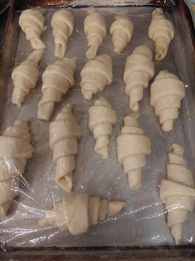

To this.

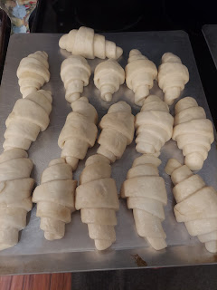

Once they come out of the oven, I lightly brush them with melted butter again.

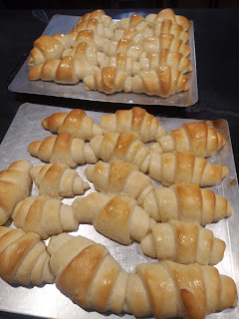

I made a double batch this time, since we would be having a pretty good size crowd that evening. Each batch makes 2 1/2 dozen. My kitchen smelled amazing. Well, actually, the whole house smelled like heaven. :)

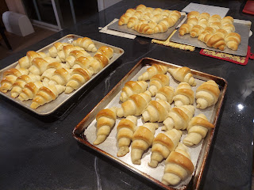

Here is the recipe that I've had for years. It's starting to fade a little . . .

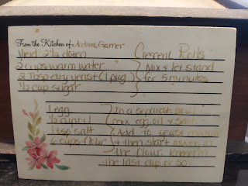

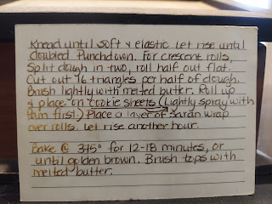

At the activity, the girls wrote down ideas for future activities on sticky notes that coordinated with the 4 categories of the Children & Youth Program. (Spiritual, Intellectual, Social, and Physical) They had some fun ideas that they came up with!

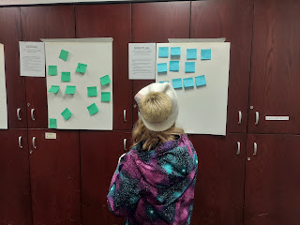

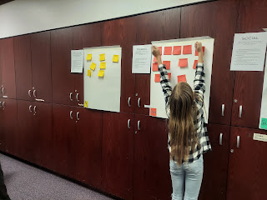

Some of the ideas included: Stump the Bishop (by asking gospel questions), do some humanitarian work locally, do an Ancestor Meal Night, play Minute to Win It Games, have an Etiquette Dinner, have a Modest Fashion Show with dresses, learn self defense, go ice skating/roller skating, sledding or XC skiing, learn how to change a tire, learn how to use a sewing machine, and a variety of fun activities to do with the young men (nerf gun war, basketball, yoga, Just Dance, and glow in the dark dodgeball). I look forward to the next several months of activities with these girls! It should be a lot of fun.

Wednesday:
Abby had a fun field trip day with her school, and she didn't have to wear her usual uniform. :)



I finished Avery's baby quilt. With Scott's help the night before, and with several more hours Wednesday morning, we got all the edges clipped.

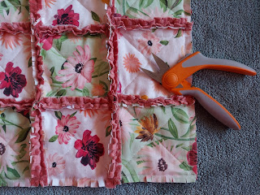

I enjoyed watching a few episodes of the Great British Baking Show while I clipped the quilt on the couch downstairs. I chose the leather couch down there because I knew it would make a big mess and I didn't want the minky and flannel fibers to stick to the fabric couch upstairs. I also wore an apron, ha ha.

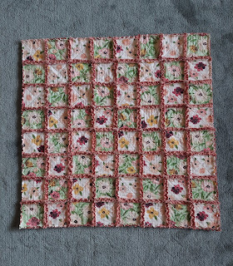

After all the clipping was finished, I put it into the washer and dryer. That's when the darling little curling effects took place from all the snipping.

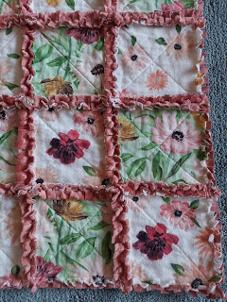

All done!

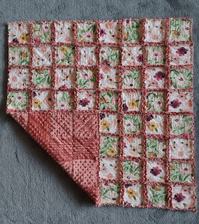

Meanwhile, Jack is learning how to roll around and scoot to get to what he wants.

Click to watch: (1 minute)
https://photos.app.goo.gl/s34RuHUeLWx3qcNA7

Thursday:
I woke up to the most beautiful and vibrant sunrise! I wish that my camera could have captured just how bright the red was, but this is the best I could do.



Abby's gratitude project from school. I love that she is thankful for math! :)

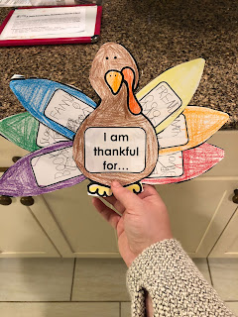

Another day of baking!! Today was cupcake day for my young women. I baked pumpkin cupcakes from scratch, whipped topping from scratch, and cute little pumpkins from pie dough that I made as well.

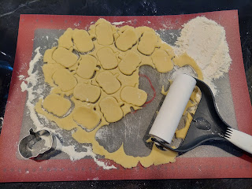

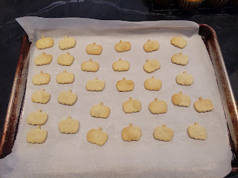

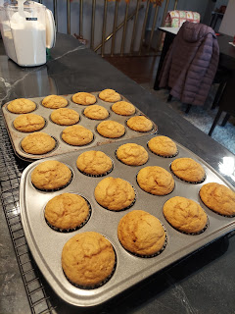

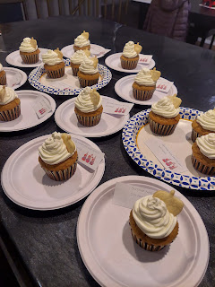

The note says: "Gratitude turns what we have - - into enough".

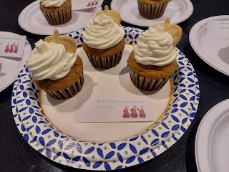

Gwen and Amber went to a local Children's Museum together and they shared some photos and videos with us. This place reminds me of the DoSeum in San Antonio. So much fun for the little ones!!

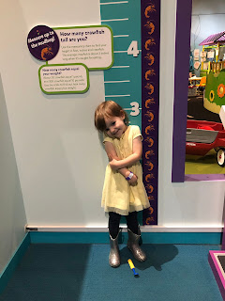

Video #1: Gwen playing with a fantastic water table that rivals every other water table you've ever seen! (26 seconds)
https://photos.app.goo.gl/f2NyuMXzNzLGoHQv5

Video #2: Gwen and Amber putting out a dangerous fire together! (18 seconds)
https://photos.app.goo.gl/6u185mndK4t5bANy6

And later, after they got home, Amber shared this hilarious invention of Gwen's. :)

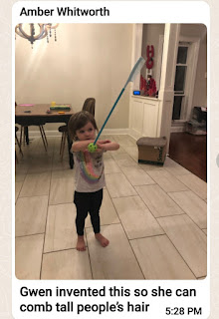

Friday:
The day was busy enough once we knew that Avery had been born while we slept soundly and dreamt of hot cocoa weather and cozy pajamas. Kylie did some amazing work though. We had a lot of chatter in the family group text for most of the morning, and it was so nice to have some jovial and lighthearted banter as a family.

I had a scheduled massage that morning as well. It's still the best gift to myself each month and I'm grateful that Marie is so skilled in her profession. I don't even want to think about the day when she retires from her practice . . .

I mailed Avery's baby quilt off to Italy, and then I came home to work on cleaning the house a bit. My youngest brother Michael and his wife Stephanie, were also keeping us posted on their son's surgery that same day too. Logan (who is 3 years old), has been suffering from a seizure syndrome for almost 2 years now, coupled with multiple other health issues. He hasn't been able to swallow food very well for a long time, and was starting to show signs of malnourishment. The doctors advised, and Mike and Steph reluctantly agreed to allow a surgery to place a feeding tube so that Logan could have a brighter future. It was not an easy decision, but we hope it will bring some much needed results.

After Scott got home from school, we went to a wedding reception for our friends, Melissa Hafen Anderson and her husband, Nolan Anderson. They were married over a year ago, but had recently made plans to be sealed in the Idaho Falls Temple this weekend. They have a 3 month old baby together, as well as a blended family from each of their previous marriages. They are such wonderful parents to their (now) 6 children. It was fun to see all of the Hafens at the reception. Scott taught all of the Hafen kids at some point or another, whether it was when he taught at Bonneville High School early on in his career, or later at Idaho Falls High School when we all moved into town. Melissa used to babysit OUR kids when they were young! Now she's married and is a mom of 6 kids! Wow.

After the reception and a trip to the grocery store, we also had the joy of receiving Sophie, our favorite neighborhood dog, for the entire Thanksgiving week while her owners travel to the Oregon Coast with their extended family.

Saturday:
While Scott began setting things up to start on our kitchen backsplash, I got ready to help the Hafen-Anderson family in the temple. Along with another lady from our ward, Danielle Jensen, we were in charge of tending the 6 children, including the 3 month old baby, while Melissa and Nolan were sealed to each other first. While we waited in the youth waiting room together, the children were all so well behaved. Melissa had packed puzzles for them to play with quietly, and the baby slept the whole time. We had to wake him up eventually so that we could get him dressed in white clothing for his turn to be sealed to his parents at one of the altars in the temple.

At one point, I asked the female temple worker if it would be okay to take a couple of pictures of the children. She simply answered: "You didn't even ask. Just go ahead." LOL

So I did! And the Andersons were so grateful!! Here are a few of the special moments we had in the waiting room, and as the older children helped to dress their baby brother.

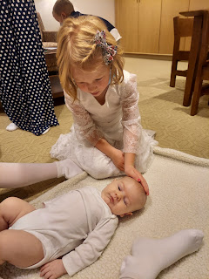

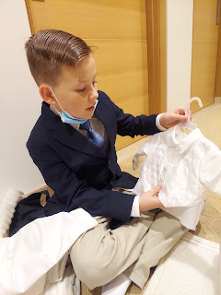

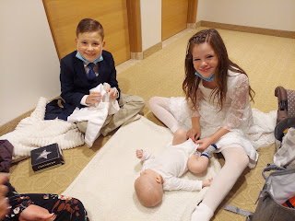

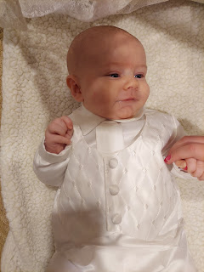

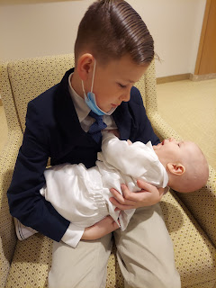

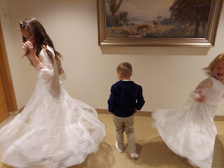

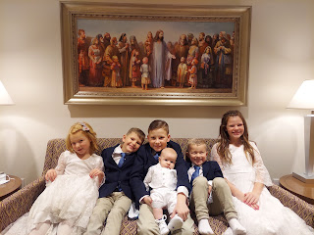

At the designated time, we all quietly followed the temple workers upstairs to the sealing room. The room was full of their family from both sides. As soon as we entered the room, lots of fresh tears were seen rolling down everyone's faces. You could just feel how important this occasion was, and the sweet spirit in the room was almost tangible. To be sealed as a family means that your family ties will exist after death. What is recorded on earth will also be recorded in heaven. Family is central to God's plan for all of His children, and He wants each one of us to return to live with Him someday.

I vaguely remember the details of the day I was sealed to my parents and my sister, Charmaine, in the Oakland CA Temple. I was only 7 years old at the time. I remember the toys and the wooden slide in the children's playroom inside the temple. I remember the sweet older ladies, who were temple workers at the time, and who were so kind and loving. They were a big part of the impression that was left upon me that day. I vaguely remember them leading Charmaine and me through the temple to the sealing room, where our parents and a few other friends were waiting for us. Mostly I just remember the feelings of that special day. I've carried them with me all these years. I don't even remember my baptism a few months later, because the feelings of being in the temple completely overshadow any memories of my baptism.

I love the temple so much! The peace and the love and joy that I feel when I'm in the temple help to keep my life in better balance. I'm able to deal with adversity better, I feel more calm and assured, I feel armed with the angels of heaven to go out and face another day - or another week - with all its ups and downs. Overall, I just feel more connected to heaven.

Here are a couple final photos of the whole family yesterday, after everything was done and we went outside. What a beautiful day for them. :)

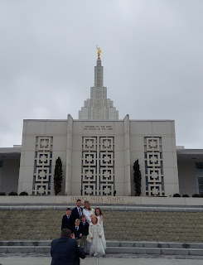

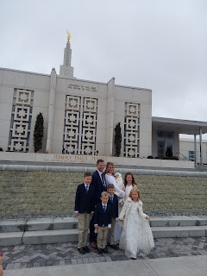

When I got home, Scott had accomplished quite a bit while I was gone.

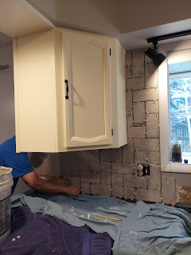

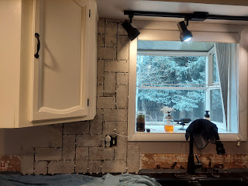

And by dinner time, this was where we left off. The tiles have been cut and mortared to the wall. Spacers are in between each tile so they don't do any creeping while our backs are turned.

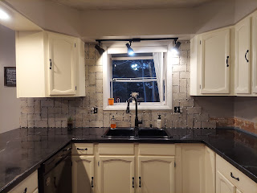

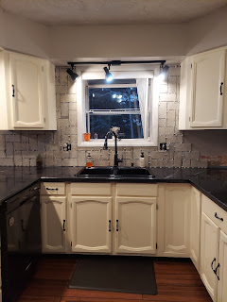

I love it so much!! I love the tile design - how it's so rustic and farmy. I love the colors and how the tiles make the whole kitchen seem taller and more open. Most of all, I love having a husband who is so capable and makes all of my dreams come true! :)

This week, we will get the rest of the kitchen done. We will aim to have all the mess cleaned up in time to host Thanksgiving dinner here at our house. Wish us luck!

I have 2 final photos to share.

Here are Abby and Gwen, showcasing the guest suite that their parents have been working on tirelessly out in Louisiana. Weston's cousins are coming this week for Thanksgiving, and in a few weeks, Scott and I will be heading down there for Christmas. Looks like a great place to lay our sleepy heads on Christmas Eve!!

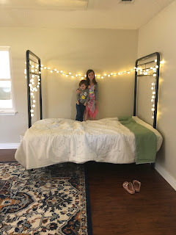

And my blog would not be complete without another picture of Jack. When Jacob shared this photo in our family group chat today, Abby said, "I thought he wasn't gonna get any cuter. But then he did."

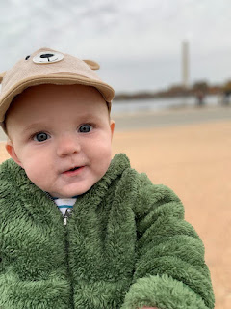

So true.

