A Russian Mid-Air Crisis + Welcome Home, Sicko
Sunday, December 17th:
I'm pretty sure I have Covid right now and I've been feeling like garbage for about 3-4 days. I tried to take an at-home test this morning, but unfortunately, I botched it. I accidentally put the 3 drops into the results area instead of the correct area. Whoops. And that was the only test I had at home, too. The reason why I think it might be Covid is because the only other times in recent history that I have had to use my inhaler every 2 hours is when I have also tested positive for Covid. While I don't have a positive result right now (because I ruined it), I'm having similar symptoms to my past run-ins with Covid, and I'm also having to use my inhaler every couple of hours so that I don't cough to the point of throwing up.

Well, 'tis the season of nasty respiratory sicknesses that are spreading faster than any of us would like them to. Scott was sick for about 5 days leading up to when I left Italy. I started getting a sore throat the afternoon before I flew out early the next morning. I had loaded up my backpack with a variety of supplies, just in case: several kleenexes, several cough drops, etc. I didn't know at the time that it might be Covid - I just thought it was going to be a bad cold. I didn't wear a mask on my flight because I was blowing my nose so darn often that it would have just been a nuisance. I am so sorry to those who may now be getting sick over the holidays because of me. I am so incredibly sorry.

BUT - I have a story to share. A story of profound anger, extreme language barriers, buttery kindness, friendship, and miracles along the way.

The story begins in Frankfurt, Germany and ends in Denver, Colorado.

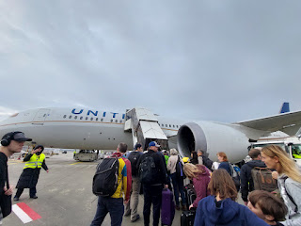

After I boarded the plane last Friday (Dec. 15th) and got settled into my seat, I said hello to the lady seated 2 seats over on my left. We nervously acknowledged to each other several minutes later, when it appeared that the boarding process was all but over, that maybe we would get lucky and have an empty seat in between us (giving us more room to sprawl). A few more minutes went by, and we started placing a few of our extra items underneath the empty seat in between us (where people would normally store their purse or backpack).

And then we heard some very angry words in a foreign language at a very high volume, coming down the aisle towards us. Everyone stopped what they were doing and we were all just watching this crazy scene unfold. An older lady, tall, blonde, and wearing a bright red sweater, was angrily shouting foreign words at the airline assistant who was clearly trying to help her. (Later I figured out that the girl had been assigned to help the lady by pushing her wheelchair to get to the gate and onto the plane.) The girl was trying to find some overhead bin space to place a few personal items for the lady, but was struggling to find anywhere at all. Most of the bins were full and closed up by now. But it also seemed like this wasn't the only issue causing the lady distress. We had no idea what she was saying, though, because none of it made any sense, which just made her even more frustrated.

It was also around this same time that we realized that her assigned seat was in our row . . .

I offered to place her long woolen coat and her scarf in the overhead bin on my side of the aisle - and I did this through gestures and minimal words in English. She accepted my offer and allowed me to help her. But she was still irate and rattled about who knows what. I had to climb up and stand on my seat to reach the overhead bin, ha ha, but I managed to tuck her things up there successfully.

She disappeared for a little while, having walked toward the back of the plane, but we could all still hear her from where we were. (Later I learned that her small suitcase was tucked up into the overhead bin about 20 rows back, because that's where there was finally some open space to do so.)

Finally, she made her way back up to our row, still very fired up and angry and yelling and gesticulating. Everyone was very uncomfortable at this point, because we had a 10.5 hour flight coming up and this would make the long flight feel like a much longer one.

Kathleen, on her left, and I introduced ourselves to the lady and tried to help her get comfortable in her seat. She didn't know how to buckle her seatbelt, she didn't know how to communicate effectively, and we had to figure something out FAST in order to salvage the whole back half of the plane's sanity for the rest of the day. We learned that her name was Tatiana Vinogradova and she is from RUSSIA. She only speaks Russian, which explained the language barrier. We were in Germany, but clearly we were up a creek since nobody around us spoke Russian. Kathleen and I pulled out our phones to use the Good Ol' Google Translate app.

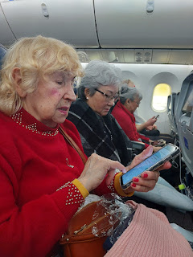

Tatiana tried to use an app that she had on her phone, but it couldn't hold a candle to Google Translate, so she let me take over and facilitate our communication from that point on. The fastest way to pass info back and forth was through the microphone feature. She would hold my phone and talk and talk and talk in Russian, while the app tried to keep up. Sometimes it would just stop recording and I would lose some of the conversation . . . But here is a sampling of one of the early pieces where you can see what she said in Russian, plus the pronunciation below it, and then the English translation at the bottom.

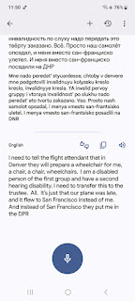

As the plane started to take off, she was chomping at the bit to get up and walk around to see if anyone spoke Russian. We had to explain (through Google Translate) that she can't just get up whenever she wants to, but she would have to wait until the seatbelt sign goes off. She was frustrated about that, too, but Kathleen and I worked hard to help her feel more comfortable and she began to relax a little bit. We used the app to get more information about her situation and this is what we learned.
She was traveling alone.
She is hard of hearing.
She travels alone a lot, all over the world, even to the U.S. a few times.
She was on her way to Honolulu, Hawaii of all places, to meet up with her daughter and a friend named Robert.
She began her day from Moscow, Russia and arrived late into Frankfurt. This caused her to miss her flight from Frankfurt to San Francisco, which would have taken her on to Honolulu.
She was reassigned to our flight from Frankfurt to Denver, and then she'd be flying from Denver to Honolulu.
She was very anxious about the details and the changes and did not get a chance to relay the new info to her daughter and to Robert.
She wanted to make sure she would have a wheelchair when we arrived in Denver.
She wanted to find someone who could speak Russian on our flight.
And she needed to figure out the timeline of when we were supposed to land in Denver and how much time she would have to make it to her next flight to Honolulu. We had to explain this to her several times. She did not understand that it was noonish in Frankfurt, and that we would be traveling for 10.5 hours, but that we would also be going back in time (arriving at 1:35 p.m. Denver local time later that same day).
Because of a late departure from Frankfurt, however, we ended up arriving 45 minutes late into Denver, which significantly shortened her connection time (and mine). This caused a whole new round of worry and concerns about how it would all work out.
But, eventually, she settled down, ate her in-flight meal, and took a nice long nap.

At one point, I got up to use the bathroom, and while I stood with a couple other passengers as we waited for a bathroom to open up, one of them said to me, "You guys deserve a medal." I was surprised and asked why. He said, "Well, the way you got that lady to calm down. That was amazing." I told him, "Well, it is Christmas time and a little kindness goes a long way." He liked that answer.

Now, keep in mind, I was sick. My nose was running, my ears were hurting on occasion, and all I wanted to do was just close my eyes and sleep. I tried to watch a movie, but had to pause it numerous times because Tatiana had more to say or more to ask in Russian. Eventually, though, I was able to rest for quite a while. I felt bad that she was handling my germ-laden phone, but it couldn't be helped. I felt bad that I couldn't put the 6 feet of distance between us to keep her safe. I had a mask, but it wouldn't have mattered since she was using my phone to speak Russian into the microphone (very loudly).

The miracle that took place was when Tatiana began her quest to find someone who spoke Russian, she hit the jackpot at the very back of the plane. When the seatbelt sign went off early into the flight, she practically bolted over Kathleen to get into the aisle. She began asking loudly and repeatedly: (in a very SLOW and overly-enunciated way) "Do - you - speak - Russian? Do - you - speak - Russian?" To every row of passengers, while methodically working her way back.

Eventually, she came back about 30 minutes later with a young man named John who spoke Russian. The ONE guy on the whole plane who did!! I had seen him earlier as we formed into lines to scan our boarding passes at the gate. He was a young father of two boys, maybe ages 7 and 5, and he was so kind and patient with them. It was really sweet to see how he interacted with them. They had been running through the airport to get to the gate on time, and they were all sweaty and tired, but in good spirits. John even said to his boys, "Now remember, our seats aren't going to be right next to each other, but at least we'll be in the same row. It's up to you boys to put on your best charming faces so that maybe someone will be willing to swap seats with us so we can all sit together."

I asked John how in the world he knew how to speak Russian. He just so happens to be a math teacher, currently living in Kazakhstan, where Russian is one of the languages there. Incredible. Amazing. Wow.

Between John being able to translate, and me knowing what the upcoming plans were, I was able to help facilitate the things that Tatiana needed. For example, I borrowed her notebook and wrote a detailed note to the person who would be assisting her once we landed in Denver. The note explained how she is hard of hearing and she only speaks Russian. She has a very tight connection and they will need to hustle through customs and over to her next gate very quickly. She would also need help contacting her daughter and Robert to let them know about her flight changes, and I included their numbers. And then I let Tatiana know (through Google Translate) exactly what I had written in her behalf.

She hugged me and even planted a bright red lipstick mark on my cheek as she exclaimed in broken English: "You. My. Very. Dear. Friend. Thank. You. Very. Much."

And from then on, anything I did to help her, she would repeat that same phrase, sometimes adding on, "I. Love. You."

Even though I was so tired, I knew that I was doing a great work by helping Tatiana. Even though she should NOT be traveling alone anymore (she didn't know how to buckle or unbuckle her seatbelt!), it clearly gave someone like me an opportunity to serve, to diffuse, to be a peacemaker, and to show Christ's love during this celebratory season of His birth. And even though I have probably passed on my germs to her, I don't see how I could have helped her any other way. I just hope she has a strong respiratory system and a good immune system.

We took photos of the three of us before we landed so that we could all have this memory forever. :)

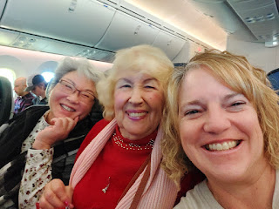

Also . . . maybe it's a Russian custom, but she began singing the Russian National Anthem as we were landing. It reminded me of the movie, "Hunt for Red October" with Sean Connery, ha ha. I managed to grab my phone near the end of her song to record the last couple of lines as she sang. (9 seconds)
https://photos.app.goo.gl/GqFUFfBUYaxuGbpQA

Side note: chewing gum really does help with the ear pressure as you descend.

Backing up to the beginning of last week . . .

Monday, December 11th:
When Scott got home from work (by sneaking out early - shhhhh), we drove 30 minutes north to Cittadella. (CHEE-tah-DELL-lah) He brought his drone with us and we had a lovely late afternoon stroll around the medieval wall that surrounds the town.

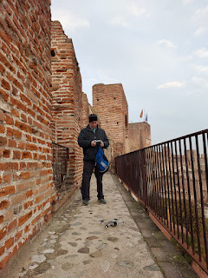

Video as the drone launches up: (20 seconds)
https://photos.app.goo.gl/e8FNd63ij2Lc27fV9

Video from the drone footage: (4 min, 40 seconds) *It takes about 13 seconds before it "lifts off".
https://photos.app.goo.gl/fGyXmTnrPoDYHuXD9

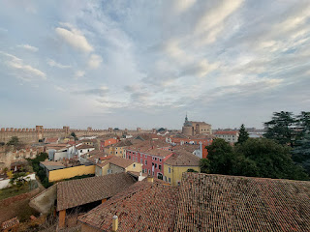

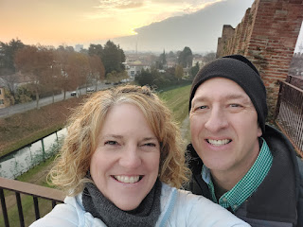

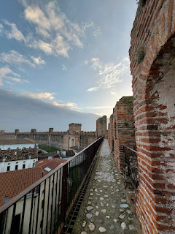

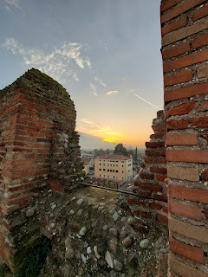

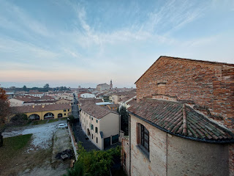

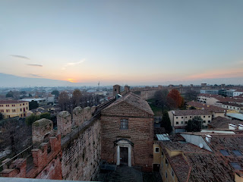

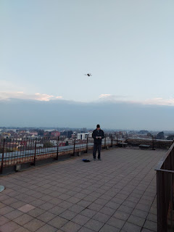

Video of me trying to imitate when Gwen was doing her silly exaggerated hips walk in this same spot back in October: (7 seconds)
https://photos.app.goo.gl/WPseykbcNjHUA6oG9

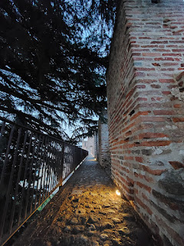

It takes about one hour to walk around the entire circumference. We enjoyed seeing the waning sunset and then, soon after, the festive Christmas lights began to light up the town below.

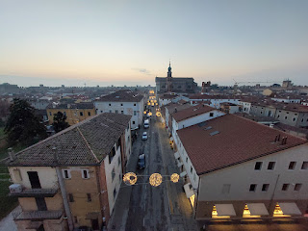

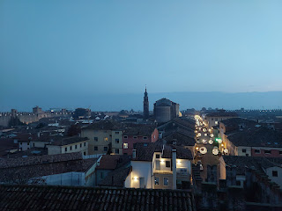

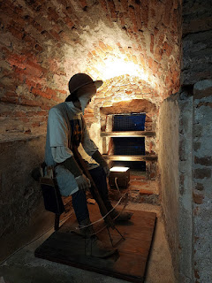

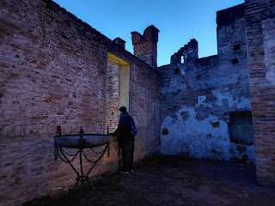

Cittadella really is a charming little town. It was interesting to note during this visit how the town expands outside of the medieval wall and is actually much larger than I thought. I just love to walk through the arched walkways and soak in the feelings of so much history that has taken place through the centuries.

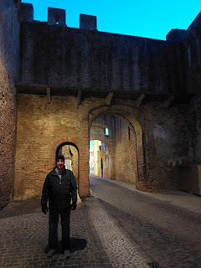

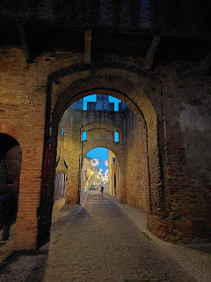

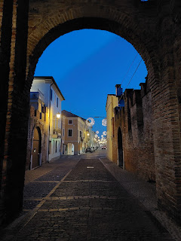

The downtown area had several offerings for families during the holiday season: a train ride, an ice rink, and other inviting activities.

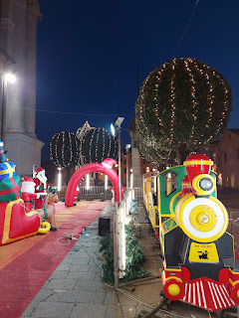

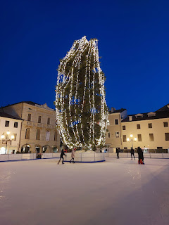

Video of the ice skaters: (11 seconds)
https://photos.app.goo.gl/kBS2rpLCHDjXTL916

Even the entrance to the Polizia and City Hall was welcoming.

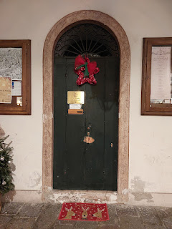

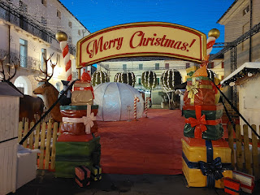

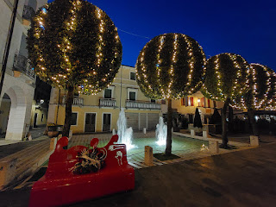

I was suprised to see this in a storefront window: Roy Rogers - it's an actual clothing line!!

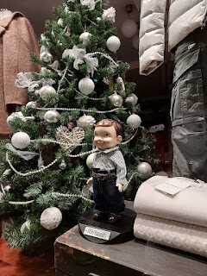

Balconies were adorned with beautiful greenery and ornaments . . .

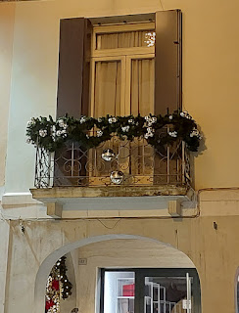

A very fun photo op . . .

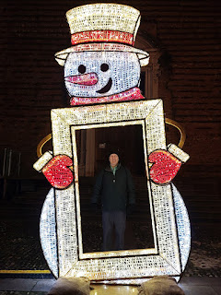

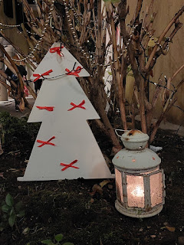

One of my favorite things to do, and apparently it's an Italian thing too, is to look in the storefront windows and just take a minute to appreciate the effort that went into each one. I like to see what they have, but I also just like to enjoy the cheerful arrangements.

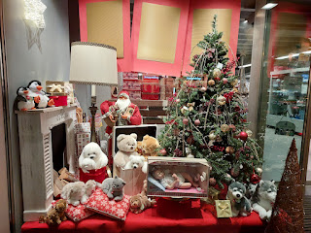

Based on what we saw in another storefront window, we made a couple of purchases for some last minute Christmas gifts to finish off our list. We bought some locally made Christmas ornaments and they are so beautiful!



I bought this bell set for myself - it's a set of two bells and they are both on my tree back home now.

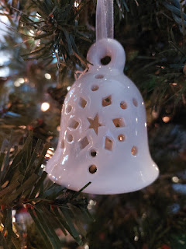

Tuesday, December 12th:
I walked over to the base to see my friend, Christine Swanson, one more time before I left town for a while. We had a really nice visit, a much longer one this time. She works at the USO and man, they ALWAYS have something going on. It is a happening place all year long, but especially around the holidays at the end of the year. She was really busy, but was able to step away to chat for close to an hour with me! Wow.

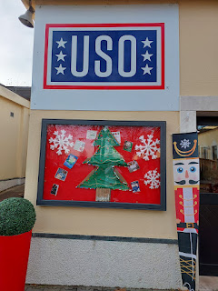

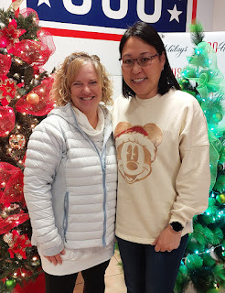

Wednesday, December 13th:
I cooked up a storm in the kitchen! First, I tried making a packet of Italian hot chocolate to test it out before bringing several boxes' worth home in my suitcase to share with friends and neighbors. It was delicious! I'm not sure what's in the packet exactly, but there must be a thickening agent in there. You pour the packet of cocoa into a small pot, add 1 cup of milk, then stir and heat until you reach the desired thickness. I also added a heaping portion of spray can whipped cream on top of the hot chocolate, but forgot to take a photo. It was quite enjoyable and I found a new (and inexpensive) way to share a piece of Italy with loved ones back home.

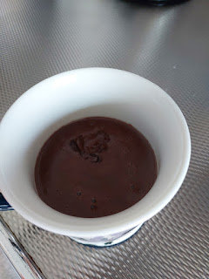

I made a big batch of chocolate chip cookies for Scott, so he could have something sweet to nibble on after I left. I put some portions into freezer bags to freeze for later, kept plenty out for him, shared a plate with Zhanna, our next door neighbor, and gave a big plate to the missionaries after I taught my last family history class that evening.

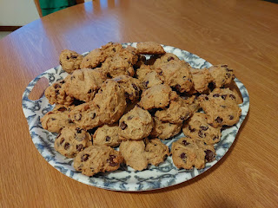

And I made a second round of applesauce to fill up the last 3 jars that I had ordered. This was my one Christmas gift for Scott.

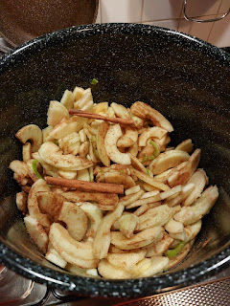

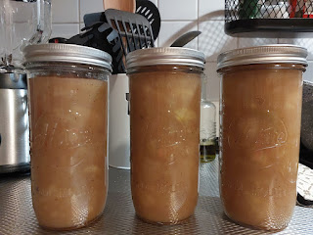

Thursday, December 14th:
I only had one goal: Finish Packing. Everything else was secondary to that. I did all the laundry so I could have clean clothes to come home with, and I made Scott a casserole so he would have a few meals that he didn't have to cook. I started having a scratchy throat on this day, and I was tired, so I made sure to go to bed extra early.

Friday, December 15th:
We got up at 3:15 a.m. to be out the door by 4:00 for our drive to the Venice Airport. Scott came inside with me while I got my luggage checked in. One last hug . . . and then I went through security and he drove home.

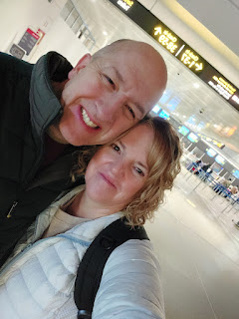

After that whole flight to Denver, my last flight into Idaho Falls was quiet and uneventful. There was an interesting pink hue that hung over Eastern Idaho as the sun was setting.

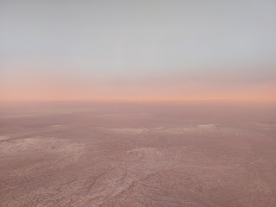

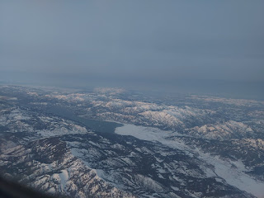

My neighbor, Kim, came to pick me up at the local airport and bring me home. I could not wait to eat a little soup and just climb into bed. She had been diligently bringing in all the mail and packages for the past few weeks, so there was a huge pile on my kitchen counter . . .

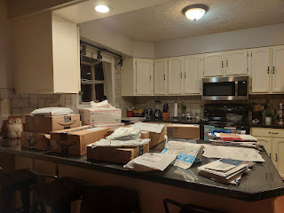

I didn't touch any of it until the next day, and even then, I only opened a few things. Mostly I just stayed in bed all day feeling lousy.

Saturday, December 16th:
Benson arrived late in the afternoon to bring my car home for me, and to take a look once again under the hood of his Audi that has been sitting in the garage for four months. After some assessing and tinkering, but with limited time, he made some plans for this next weekend when he will return again. He ended up taking my car back to Mountain Home for a few more days, which was fine with me because I have plenty to do around the house. Besides, Jacob will be arriving late tonight (Tuesday, Dec. 19th) with a rental car that we can share for the next few days.

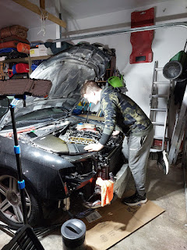

He needs to get this entire component out of the car AGAIN, so he can fix the timing of the pistons. He has a good plan on how to accomplish this over Christmas weekend. Crossing fingers . . .

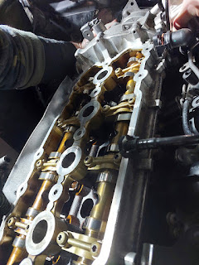

It was so nice to see Benson again. I had missed him after we spent so much time together during the summer. I wasn't the best company this time since I was so sick, but we managed to squeeze in some good conversation. I used Clorox wipes everywhere regularly and tried to not touch too many things. He just kept reminding me, "Mom, I'm immune."

Sunday, December 17th:
After coughing the entire day, almost throwing up multiple times, and giving myself a whopper headache, miraculously I was able to sleep soundly through the night. I attribute it to two things:

1) Using some strategic essential oils to calm my bronchial passageways (Frankincense and a mix called R.C. - meant for respiratory issues). I diffused several oils mixed together next to my bed, swallowed some of the Frankincense after researching how to use it for asthma related issues, and held the bottle of R.C. next to my face and inhaled slowly for several minutes. It helped a lot, surprisingly.

2) The power of prayer. I did not have Scott here to ask him for a priesthood blessing. I did not want to ask a friend or neighbor to come give me a blessing either, because I didn't want to share my germs. So I prayed that Heavenly Father, if He saw fit to do so, would bless me as if I had been able to receive a blessing. I prayed for the ability to make it through the night, and that if I still felt lousy in the morning, I would go to the doctor.

Monday, December 18th:
In the morning, when I woke up, I could tell that my energy had increased for the first time in a few days. Other than my heavy and tight chest, I felt that I had somehow made it over the hump. When I started coughing again, though, I knew I needed to see a doctor so I could get a steroid to help where my inhaler couldn't keep up.

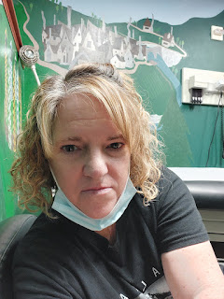

At the urgent care, they did a nasal swab to see if I had any of the usual culprits this time of the year. Negative on Covid, and negative for the Flu. That was great news! He didn't have an answer, though, as to what ailed me. Just some upper respiratory something-or-other. He recommended that I get a steroid shot (in the hip) and to also do a breathing treatment. That was my first time doing a breathing treatment. My kids have had them several times when they were young, but not me. You just breathe normally through the "peace pipe" for 10 minutes. It has a slightly bitter taste, but it wasn't too bad.

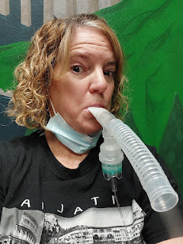

I picked up a couple of prescriptions as well - a new inhaler (the one I got in Italy is a year old now) and additional steroid pills in case I needed them going forward. My coughing was finally under control and I could now start to unpack my suitcases and get my house in order. Benson left around 11:30 a.m. to drive back to Mountain Home after I picked up a few groceries first.

I had the brilliant idea to decorated for Christmas back in August, and I'm SO GLAD I DID!!! To come home and see everything so festive and ready for family celebrations was such a huge relief, especially with being sick and not having a whole lot of energy. Now I am just focusing on cleaning bathrooms, tidying, dusting, and wrapping some gifts while I wait for all of my kids to trickle in over the next few days. I even felt well enough to go to my hair appointment today! It always feels better when you can get your hair taken care of.

Merry Christmas in advance!! I'll probably be a little late with my next blog post . . . but that's okay. I'm really looking forward to playing lots of games with my kids, cooking lots of good food, and hopefully watching my favorite Christmas movie, Elf.

