A Week Full of "Firsts"!!
Even though I'm 51 years old, I experienced several "firsts" this week while visiting my Grandma Lillian in Salem, Oregon. Some people might be quite shocked when they see what some of those "firsts" are . . .

I'll start at the beginning . . .

Monday:
It was SO COLD!! (And Tuesday was no warmer) I ran a few errands and packed and got ready for my trip.



I dropped my car off at the Ford Dealership in Idaho Falls so they could fix a bushing while I'm gone. It needed fixing because of a recall notice. Then I settled in for the night.

Tuesday:
I got up at 5:30 a.m. to get ready to leave. My friend picked me up at 6:15 with a comfortably heated car, and took me to the Idaho Falls Airport.

While on the plane, the pilot let us know that even though the plane had been plugged in with heat all night, the water pipes were still frozen. They had to haul over some giant heating tubes to blow heat on wherever it could help the pipes to thaw.

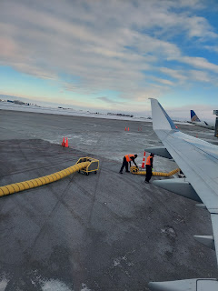

Eventually, the water was working on board and we could move over to the de-icing area. They spray the wings with something so they will continue to function in spite of the cold. Very reassuring . . .

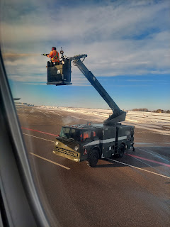

Video of the de-icing process: (47 seconds) It only took about 6-7 minutes to get it all done.
https://photos.app.goo.gl/KdfnwGPK2s3BL9oD8

By the time the pipes were unfrozen and the de-icing was finished, we were up in the air almost an hour behind schedule. My layover in Seattle was only one hour, so this was not good.

View of the arctic landscape of Idaho Falls below us during take-off.

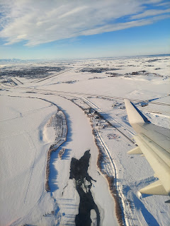

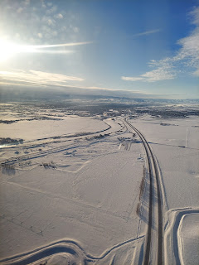

Coming into Seattle, the landscape of the forested peninsulas and abundant waterways were so beautiful.

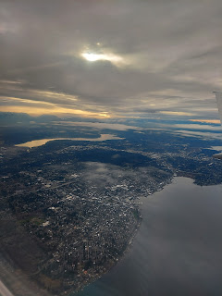

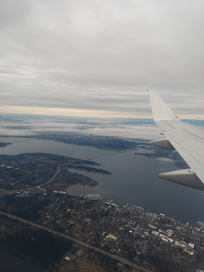

Alaska Airlines is a fantastic airline, by the way. Before we even landed in Seattle, they had announced all 12 seats (of passengers) who had a TIGHT connection, so that those seated next to them could clear a path once we arrived at the gate. When they announced my seat number, everyone nearby turned to look to see who was in 14A.

Once the seatbelt sign was off (usually everyone stands up), the flight attendants made one more announcement. "We should only be seeing the 12 people who have that tight connection making their way forward. Everyone else please stay seated." It was the most orderly and polite disembarking I've ever been a part of! And as I stood with the other 11 people waiting for the airplane door to open so we could frantically dash off to our next gate, people around us were wishing us well. "Hope you make it!" "Good luck!" "Run like the wind!" ha ha

I did run . . . HARD. When I arrived at my next gate, I discovered that the next flight was about 25 minutes LATE and they hadn't even started boarding yet. Ha ha, wheez, wheez, cough, cough, cough . . . umm, okay. Well, at least I didn't miss my flight! :)

View over the vast Columbia River coming into Portland.

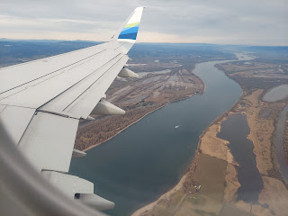

When I picked up my rental car in Portland, they gave me a free upgrade to a BMW X3. I had paid for a mid-size car, but maybe they ran out?? So they upgraded me. I have never driven any type of BMW before, so the young man showed me a few important features and then I was on my way south down to Salem. (only an hour's drive) Definitely a sweet ride in that fancy SUV.

Here's my car, even though it looks weird because it's covered in frost in front of Mike & Suzy's house.

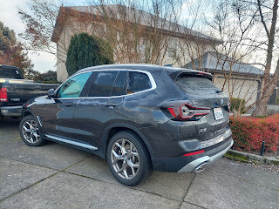

Hooray!! I made it to Grandma Lillian!! XOXO

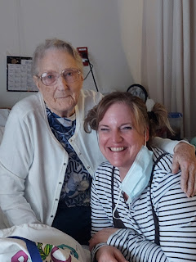

Uncle Mike Moore took me across town to see her where she lives now. She is in a care home and they take very good care of her there. She was in an apartment for the last several years, but wasn't getting her medication monitored very well and it was taking a toll on her health. The daytime caregivers came Monday - Friday, but nobody was there to help her on the weekends. She has a lot of allergies to medications, including ibuprofen, and if she didn't take her pills on time, or if she forgot when the last time was that she DID take them, that could be very dangerous. She was starting to swell with water weight and it was affecting her ability to walk. It was a treacherous domino trail of side effects that eventually landed her in the hospital. Family members made the executive decision to get her situated in this new care home and she is receiving round-the-clock care. She is much more healthy now, thankfully. What a blessing!

I didn't stay too long Tuesday afternoon. It had been a long day of traveling for me, so I was ready for dinner and my pajamas.

Wednesday:
I got up early to go on a lovely walk in the neighborhood near Mike and Suzy's house. I walked and walked and walked for a full hour and it felt awesome! It was especially nice to see so much green instead of white everywhere . . .

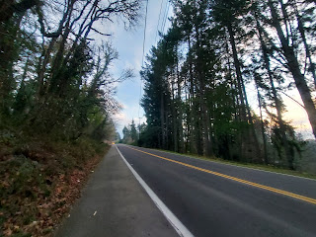

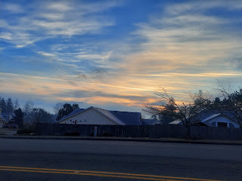

This was a cute fairy garden that I saw, arranged in a wheelbarrow just a couple streets over from Mike & Suzy's house.

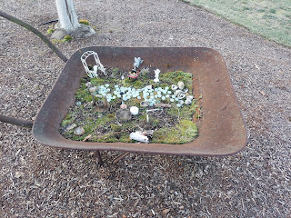

This is Mike & Suzy's house in a well-kept culdesac. They all know each other and are all friends there, taking care of each other's homes/pets/etc. if anyone goes on vacation.

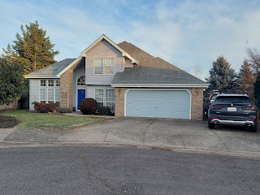

*Clarification: Grandma Lillian is not my DNA Grandma, but she is still my very special Grandma. She married my Grandpa Linton (my mom's father) and literally helped to raise my older sister and me. Both our parents worked full-time when we were growing up, so after school we'd walk across the playground (of Nokomis Elementary) and up the street to the Norman Ranch in Ukiah, CA. In the summer months, we'd walk behind our house and diagonally across the street through the Seventh-Day Adventist Church parking lot to the ranch. They lived super close and it was perfect.

Grandma Lillian ran a daycare, while Grandpa Linton was a real estate agent and also served as President of the Mendocino County Board of Realtors.

Grandma Lillian was married first to Dean Moore and they had 5 boys: Mike, Dave, Gary, Tim, and Mark. My mom had 2 older full brothers and 5 younger step-brothers!! She was the only girl.

So when I say that I stayed with Uncle Mike and his wife, Suzy, he is Grandma Lillian's oldest son from her first marriage.

I had a little video chat with Kylie and Avery in Italy on Wednesday morning. Avery was close to bedtime so she was a bundle of energy again, ha ha.





She has molars now (finally) and was very interested in what's going on in her mom's mouth . . . LOL

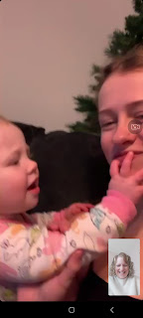

She also knows how to climb down from the couch now. That's a good skill to have!

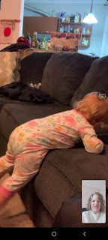

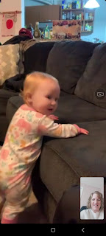

Kylie had the cutest little braids that day! She said that she often puts her hair into braids when she goes to the gym. She takes Avery and drops her off in the children's play area while she goes to work out. Some days, Avery does great and Kylie can get in a nice workout. Other days, the workout doesn't really work out. (you see what I did there?)

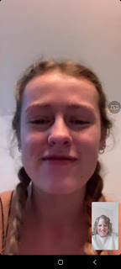

It was nice to visit and make sure everyone was doing okay. And they are. :)

I drove over to Grandma's around 10:30 a.m. and we spent 5 hours sorting through boxes, envelopes, and stacks of old photos. She would specify what "pile" the photo needed to go into, and I would place it accordingly. We had ziploc bags and a permanent marker (thanks to Suzy) and I began labeling each bag for who the photos would be allocated to. (i.e. Mike, Dave, Gary, her brother Mitchell in Texas, some of her grandchildren, etc.) I also had a large stash of photos for myself that need to be scanned so that more people can have access to them eventually.

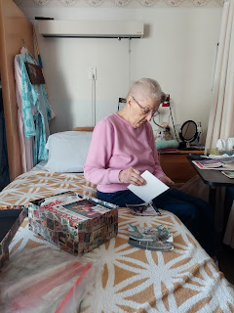

When the nurses brought lunch around, Grandma asked them for an extra tray for me as well. We had a little piece of ham, some sweet potatoes, spinach, green salad, and a slice of carrot cake.

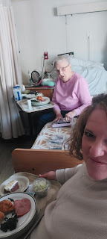

Something I didn't realize until having lunch with Grandma, is that the residents of a care home generally don't like the meals that are prepared 3x/day. To supplement the flavor issues, they have their own stash of condiments and other flavor enhancers. I saw Grandma immediately reach into her drawer next to the bed for her supply of salt, pepper, soy sauce, vinegar, etc. She offered me some of her pantry items to improve upon my somewhat bland lunch, which I gratefully accepted. Her roommate, Alice, did the same thing and reached over for her stash of "flavor enhancers". Also, when Mike drove me over on Tuesday, he brought his mom some packets of mayo/mustard/ranch, etc. to add to her dwindling supply.

One of the beautiful things we came across as we sorted through boxes of old photos, was this sweet song lyric that her youngest son, Mark, wrote several years ago. He wrote it with his step-dad, Linton (my grandpa), in mind. It was typed up on some of Grandpa Linton's real estate stationery, with a few edits and scribbles on the page. Truly a beautiful message and I enjoyed the discovery.

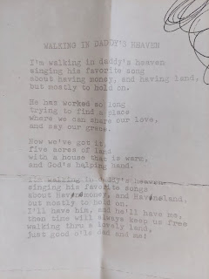

Grandma was a trooper, plowing through stack after stack after stack of photos for hours on end.

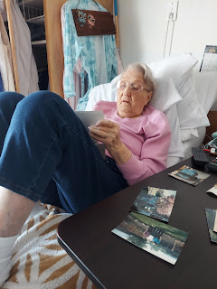

I loved seeing this one! I have so many fond memories of swinging on this bench swing at their ranch while growing up.

L to R: Me (holding my cousin Justin), my sister Melanie, my sister Charmaine (holding our brother Ryan), Christy Moore, Terri Moore (holding little Erin Moore). The three Moore girls all belong to my Uncle Gary, Grandma Lillian's third son.

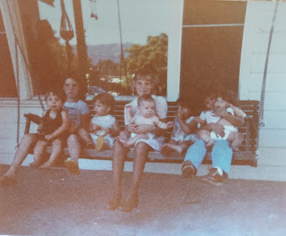

This is a photo of Grandma Lillian with her first husband, Dean Moore. Aren't they a beautiful couple?

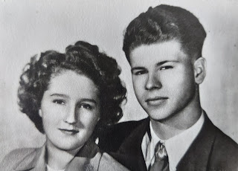

By the end of the afternoon, this is what the foot of Grandma's bed looked like . . .

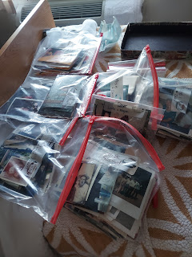

Wednesday was the warmest and sunniest day of the week in Salem. As I left around 4:00, I went across the parking lot to see all the duckies hanging out in the pond. There is a supply of duck feed available inside at the front desk, but I just wanted to say hello and get a picture. :)

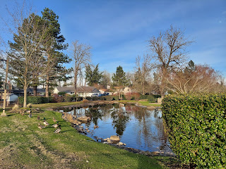

This is the care home where Grandma lives. It's called Tierra Rose and they do a really nice job there. I felt like the staff were very caring and kind.

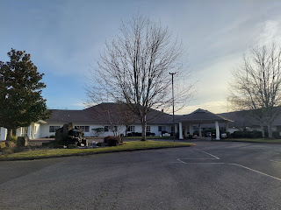

Next, I headed south to Albany, Oregon, where my COUSIN Suzi lives. I haven't seen Suzi in years . . . I can't even remember the last time that we got together. It was most likely back in 2010 when the kids and I spent the night there, but it's possible that I saw her one other time since then - during one of my annual trips to Oregon to visit Grandma.

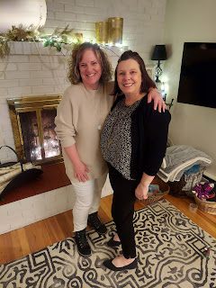

Suzi Slay Smith is the daughter of Juanita Brown Slay, my dad's older sister. My Grandma Zoe was first married to Wallace Brown, and together they had 4 children: Carol, Donna, Juanita, and Jim. Wallace may have been a good husband at some point, but they ended up getting a divorce later on. I heard that he would leave Grandma Zoe for long periods of time without any financial assistance. Aunt Juanita told me once that they used to have to forage in the forest for things to eat because they had nothing.

Aunt Juanita was probably my favorite aunt. She was matter of fact, fun, and quick-witted. She was spunky and always loved a juicy story. Whenever I called her, or she called me, we would always jump immediately into the "good stuff". She was a deep thinker and we had many conversations about spiritual matters, especially in the few years before she died. She was suffering from so many health issues, including congestive heart failure. She really wanted to have a good understanding of where she was going and what would be happening once she got there.

Suzi, her daughter, has always been just as down to earth and fun and a good conversationalist as her mother was. My sister, Charmaine, and I were the candlelighters at Suzi and Mitch's wedding. I was a sophomore in high school at the time, and Charmaine would have been a junior.

When I arrived at Suzi's house, I didn't even have to knock on the door because she was already outside hurrying over to hug me and greet me. We visited for a long time about everything under the sun and then she gave me a tour of their house. They used to live a few houses up the street, but when this one became available about 6 years ago, they bought it because it was almost double the size of their previous house. They have done some beautiful renovations so far. Mitch, her husband, is about as handy as my husband is.

This is their very cute kitchen. During the covid year of 2020, they worked hard to fix up this space. They bought a paint sprayer and painted all the upper cabinets white and the lower ones a light grey. They replaced the counter tops and added a decorative backsplash.

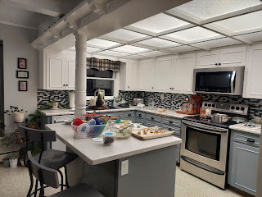

I loved the inviting decor on the table in the dining room. Suzi has a fondness for bottle brush trees, something I am familiar with because my daughter, Amber, loves them every bit as much.

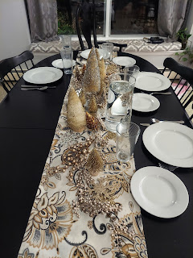

I asked her if she made some of the trees herself, but she said no. She just always keeps an eye out for them when she goes into any store, adding one or two at a time to her growing collection. She has different colored trees for each room of the house, including the bathrooms.

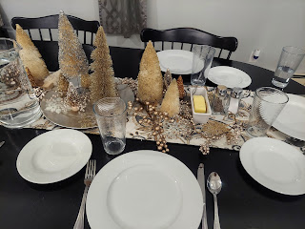

Suzi's father, Arlen Slay, joined us for dinner. He is just the cutest man. He is 85 years old now, but you would never know it. He looks young, he sounds young, and he still works on projects like he's young. At one point he told us about how he was working hard in the neighbor's yard, cleaning things up for them - - even though the neighbors are in their mid-60's and he's 85!! He always has a twinkle in his eyes, but you can also just feel the genuine love he has to offer when he hugs you. He is so sweet and it was so wonderful to see him again!

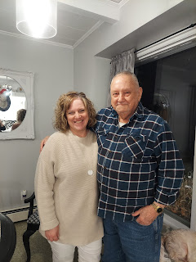

For dinner, we had baked chicken, cooked carrots, asparagus, salad, rolls, roasted potatoes, and chocolate cake for dessert! I could only eat a couple bites of the cake because I was already so full . . . but it was delicious!

After dinner, we visited for a while and took some pictures in the living room before I needed to leave because it was getting late. It was about a 40 minute drive back to Mike and Suzy's up in Salem. I got in around 10:00 p.m. What a day! I spent 5 hours with Grandma, and then 5 hours with Suzy down in Albany.

Thursday:
I had a harder time getting out of bed in the morning, ha ha. I went to sleep around midnight the night before (it always takes me a while to settle down after so much visiting) and then it was just so comfy in my bed the next morning. If I didn't need to go anywhere, I would have just had a lazy morning in bed, ha ha. But I had to get up and get ready to go back over to Grandma's again.

We picked up where we had left off the day before, sorting through the rest of the photos throughout the day.

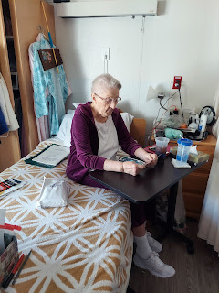

I was glad to learn that Grandma Lillian is who made the large black baby doll that I have downstairs in my "grandchildren guest room." I thought that my Grandma Zoe had made it, but it wasn't in the same style of her other dolls.

This photo is what sparked that whole conversation. I had only remembered Grandma Lillian making us a lot of doll clothes and outfits, but she also let me know that she made several dolls as well. The three children that I recognize in this photo are Terri Moore (back right), Jennifer Moore (in front of Terri) and Justin Moore (front left). The other two girls are likely from Grandma's daycare.

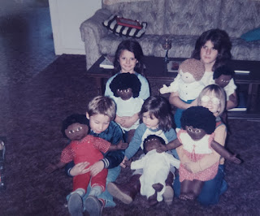

Here is the doll that I have downstairs.

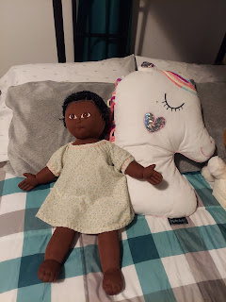

When lunch came around again, this is what was served. Grandma just doesn't like most of what they serve at the care home . . . it makes me sad that food is not something enjoyable to her on a regular basis. All she ate was the roll and a little bit of the potatoes. She couldn't eat the chicken because she didn't have all of her teeth (yet) and she didn't like the peas or the canned pears. Again, she reached for her stash of salt & pepper to add a little flavor to the food.

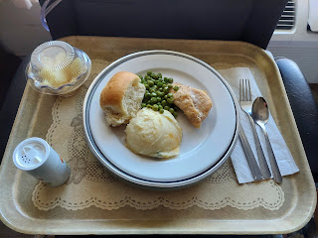

Later in the afternoon, I was able to take her to an appointment with her denturist down in Stayton, about 15 minutes south. I wheeled Grandma outside in her wheelchair, helped her get into the car, then loaded the chair and the heavy oxygen tank into the trunk. Off we went on our first adventure away from the care home!

In the waiting room, she wanted me to park her close to the fireplace so she could relax and warm up there.

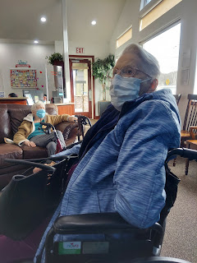

Her bottom teeth didn't fit right when they made them a year ago, and it has been a long process to get everything fixed. When it was time to try on her teeth and see how they felt, she noticed a small scratchy area that concerned her.

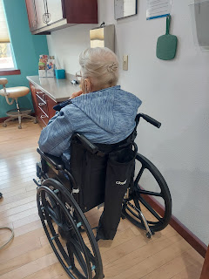

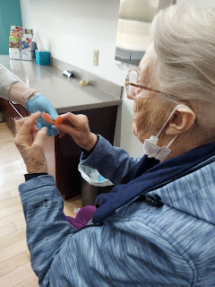

So the assistant gave them a good polishing and had her try them back on. Another round of polishing was needed, and then we had success. Hooray, Grandma has all of her teeth to eat more foods again!

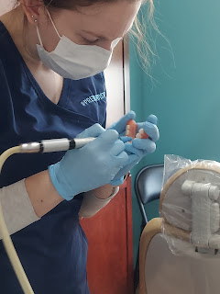

Before we went back to the care home, Grandma wanted to stop at FredMeyer to get a few groceries. I was under strict instructions from her daughter-in-law Marion to insist that she ride in the wheelchair, but Grandma was feeling adventurous and wanted to walk. She implored me to let her walk holding onto the grocery cart, and I relented. I caved. But I intended to stay close and make sure nothing bad happened.

Almost as soon as we got into the store, Jack called.

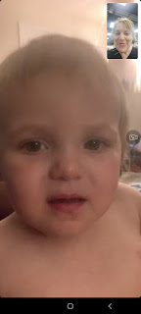

Among other things, he wanted to show me how he can make "fish lips", ha ha. I got a big kick out of that!



Jacob also wanted to share with me about his online interview with Notre Dame that same day, the school he is most interested in going to for his Ph.D program that will start in the fall. He said the interview went well, and only lasted about 15 minutes. Apparently there are 300 applicants, and only about 9 or 10 will be accepted into the program . . . He's not holding his breath, but he has hope nonetheless.

I was frantically trying to keep an eye on Grandma and still have a meaningful conversation with Jack and Jake, which I somehow did for several minutes. But eventually I whispered to Jacob that I should probably go because I wanted to pay better attention to Grandma. So we said goodbye - and we even got Jack to wave bye-bye to Grandma. Such a sweetie. :)

Grandma really enjoyed doing some shopping for herself, probably a first in a long while . . . We slowly meandered down oh-so-many aisles, while I just let her browse and add a few extra things to the cart that weren't on her list to begin with. Bread, lunchmeat, deli cheese, small single-serving peanut butters, cereal, buttermilk (she likes to drink it with pepper!!), some packing tape and permanent marker pens (she likes to label every article of clothing at the care home because sometimes things get stolen).

She also chose one single apple, ha ha. And before she added this giant orange into the cart, she explained to me how Grandpa Linton taught her to choose a good orange. You don't want the kind with a lumpy bumpy peel on the outside. Look for one with a smooth outer peel. Grandpa Linton would have known which oranges were best, because he grew up in Florida and his family had citrus trees.

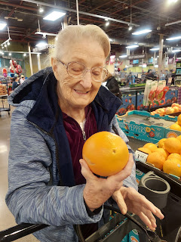

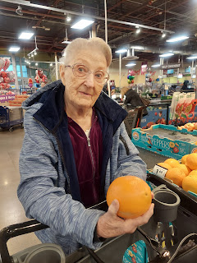

We cruised all over the store and Grandma did great. Near the end I could tell she was starting to hurt a little, but she did an impressive hike around that massive store. I bet she walked well over a mile by the time we were done!

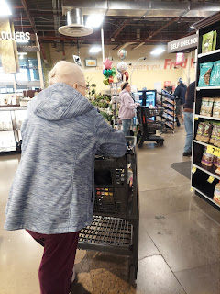

I brought her back to the care home and helped her put the groceries away. She has a tiny little fridge in her room - about the size of a TOASTER. I had to finesse the items a little to get everything to fit and still get the tiny little door to shut all the way.

Once I returned to Mike and Suzy's house, they were preparing baked chicken, baked potatoes, and broccoli for dinner. I shared with them all that we had done that day, and they were duly impressed with Grandma's grit and endurance.

As dinner was almost ready,
the first FIRST happened
: Mike offered to make me a virgin bloody Mary, which at first I declined. But then after some description about what was in it, I said, Why Not? YOLO. You only live once!

It was actually pretty good. I drank about half of it. It had tomato juice, olives, Worcestershire sauce, soy sauce, a pepperoncini, some celery sticks, and lots of chopped ice. Pretty healthy, actually.



I went to bed earlier than the previous night, and it felt amazing.

Friday:
I woke up early to go on a nice long walk again. This time, I reversed my route so that I had more uphills instead of downhills. The downhills gave me a little bit of shin splints on Wednesday morning, so any downhills on Friday I took much more carefully with my steps. I also chatted with Scott for almost the entire hour!!

We talked a lot about the cars that he's been looking at (for me) over in Italy, trying to find a few options for him to go test drive. He has some appointments set up for this coming week, so hopefully there will be one that makes his heart swoon.

On my way to Grandma's later in the morning, I made a quick stop to take a few photos of something that had caught my eye the day before. On one of my routes back to Mike & Suzy's house, I passed by this Afghanistan-Iraqi Veteran's Memorial. I wanted to come back and enjoy it when I wasn't in a hurry.

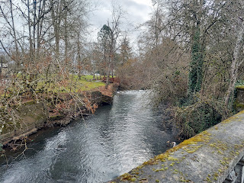

There is a beautiful little creek that runs along next to some of the State Buildings and leads to the Memorial.

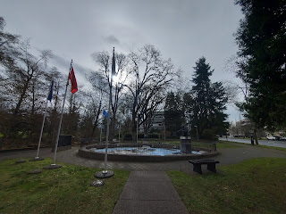

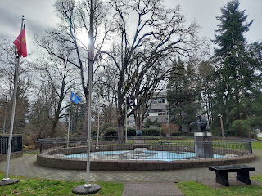

In the photo above you can see how the soldier is reaching out with his hand. Below you can see what he is reaching toward: the countries of Afghanistan and Iraq. Perhaps he is wistfully trying to extend a hand of friendship, even though some blood had been shed unnecessarily. None of us really enjoys war. Sometimes it is necessary, though, to maintain peace.

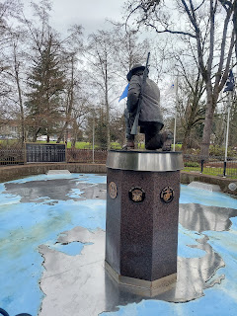

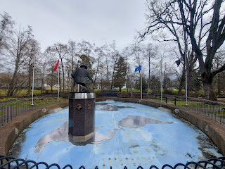

They have a list of names of soldiers who served in Afghanistan or Iraq, and who didn't make it out.

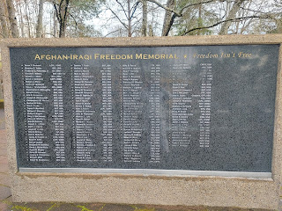

Another Memorial nearby stands as a tribute to all those who serve our country, both past and present.

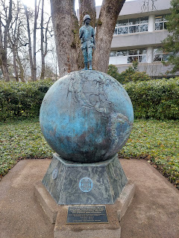

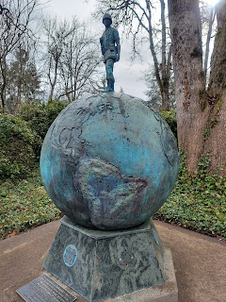

Gosh, that creek was so beautiful, with several little cascades as I made my way back to the car.

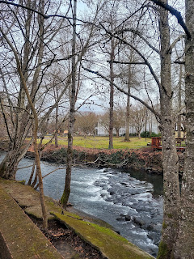

I took Grandma out to lunch first thing this time, because she had TEETH to enjoy a meal!! She chose sushi, which didn't surprise me. I bet she would eat sushi every day of the week if she could, ha ha.

We went to Sushi Kyo (on Rickey Street) in Salem, where she had been before. They have a sushi track where little plates of food travel slowly around the restaurant. You choose what you want to eat (each plate is covered for health safety), and the plates are all different colors. When you're done eating, the waitress adds up how many red plates you have at your table, how many blue, green, etc. Then the bill is calculated and you pay for your meal.

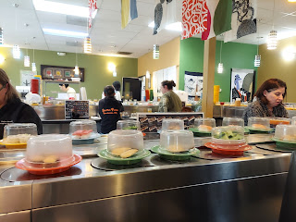

Video of the sushi track and one of my selections: (seaweed salad) (8 seconds)
https://photos.app.goo.gl/dSCXeW8noLVTcVF38

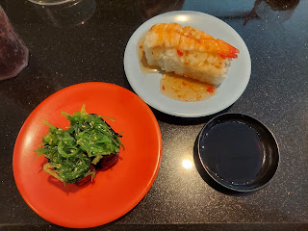

It was all SO GOOD. It's been a while since I've had sushi. I used to eat it more often, thinking that it was much less carbs than it actually is. But when I found out how many carbs there are in that small amount of rice, I was shocked! So now I usually try to steer away from it. Except for those times when you go out to lunch with Grandma. Then you eat it. :)

After we sufficiently stuffed ourselves, I took Grandma back to rest for a little bit while I ran a couple of errands for her. She was hurting a little after her hike through FredMeyer the day before.

Here's where some additional FIRSTS took place . . .

Grandma really wanted some wine, and so did her roommate, Alice, when Grandma brought up the subject. They were tired of the food in the care home, they were tired of a lot of things, and they were just tired in general. They both wanted something familiar and comforting. So Grandma asked if I would be willing to get them a bottle of White Zinfandel. At first I was concerned with both me getting in trouble for smuggling some alcohol in, and also with the possibility of them getting in trouble for drinking on the premises. Later, I found out that it was, in fact, okay, but initially I felt like I was taking a huge risk by saying yes. And ultimately, I did say yes.

I said yes because I wanted to make my Grandma happy. It wasn't about me and my preferences or my beliefs. I was doing something for someone I love, who couldn't do it for themselves. For me, it was just that simple.

Off I went to the FredMeyer plaza again. First, I mailed back some wigs that she didn't like, ha ha. The UPS Store was next door to FredMeyer. I also mailed a special package home to myself with a Norman family heirloom inside that is now 55 years old!! (Don't worry - the UPS workers were going to package it up really well before mailing it out. I just took a quick photo before I left the store.)

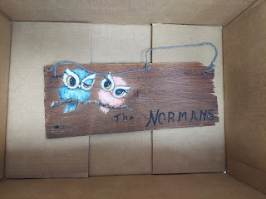

This sign used to hang at the ranch in Ukiah for many years, but it also hung in a few other houses prior to the ranch. When Grandma visited her sister, Ada Fay, in Boise back in 1968, one of Ada Fay's neighbors offered to paint the sign as a gift for Linton and Lillian's 4th wedding anniversary. (They got married in 1964) The neighbor happened to be a local painter named Charlene Burke. She painted the Norman sign on a wooden roof shingle and it was first hung on Linton and Lillian's home in Ukiah when they lived on Oak Manor Drive. After that, the sign hung by the front door on Mendocino Drive, then on Eastlick Avenue, and finally Helen Avenue, all in Ukiah. Later it hung in Newburg, Oregon, and then in all the other places Grandma has lived in Oregon since Grandpa's passing in 1997.

I feel so honored that the sign is now being passed down to me! I'm not 100% sure what I'll do with it yet, but Grandma suggested that I get it framed. I think that's a wonderful idea!!

Alright, next up was my first-ever alcohol run. I've never bought a bottle of alcohol in my entire life, and to find a specific type of wine was a little daunting, ha ha. The wine section of just about any store these days is so overwhelmingly huge . . .

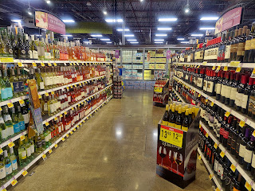

After hunting high and low, and not finding the White Zinfandel, I asked a young lady for help. She was shopping in the wine section as well, and she was very patient, kind, and helpful. It took a few minutes, but she finally found what I needed!!

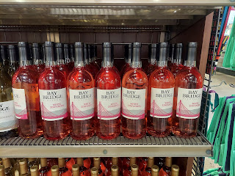

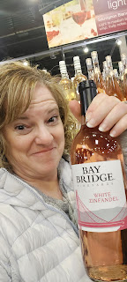

White Zinfandel. Check!

Next stop: PowerBall . . . another FIRST

Grandma was really craving a PowerBall ticket and some scratch-offs. She wrote down the numbers that she wanted and gave me $25 for the errand. The instructions were to buy the PowerBall and then use the remaining money to get as many scratch-offs as I could.

I drove around for a few minutes, looking for a convenience store. I was seeing several gas stations, but no convenience stores. Finally I found a 7-11 store and went inside. I told the clerk up front that I needed to do a PowerBall ticket but had no idea how to do it. She motioned for me to go to the kiosk at the back, and that the instructions should be back there. (She didn't know how to do it herself...)

At the kiosk, I didn't find any instructions whatsoever, so I must have looked a little lost. That's when I met Alan. Alan is a homeless man with no teeth, but he was the only person in the entire store who knew how to fill out a PowerBall ticket!!

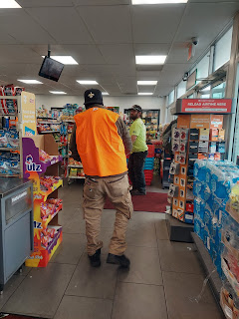

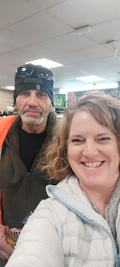

He instructed me on how to put 5 numbers in the first section, with one Quick Pick number underneath. The only problem was that Grandma had given me 9 numbers total . . . And nobody else knew how to fill out a PowerBall ticket! As each new person walked into the 7-11, I would ask them if they knew how to do it. The answers were all similar: I've never done a PowerBall, I only do Keno (or quick picks, or scratch-offs, etc).

The clerk at the register finally told me that Sam was coming on shift in a few minutes and that he definitely knew how to fill one out. So I told them I would come back.

Below: Having done my best to fill it out with the numbers I was given . . . I had to admit defeat.

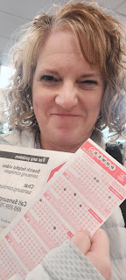

During all of the stress, trying to fill out the ticket correctly, Alan stayed with me the entire time. At one point, he asked if I was married. I showed him my ring and said, Yep! He smiled and didn't say anything. A little later he asked me if I believed in love at first sight. I replied, "Sometimes." He chuckled and humbly said, "Okay."

As I was leaving the store, I gave him $5 and thanked him for all of his generous help. I even gave him a hug. As I hugged him, he murmured (almost purring), "Mmmmm." I tried not to laugh, but I figured that he didn't get very many hugs from a lady. When I told Scott all the details, he laughed, but also added, "You're a good person." My Aunt Suzy told me, "You helped him feel like he was SEEN and that he mattered." Mike and Suzy worked with the homeless in Salem for over 15 years, so they know a lot about the behind-the-scenes . . .

I drove back to pick Grandma up, since we were going to dinner over at Mike & Suzy's house. We stopped at the 7-11 first, so we could get it all sorted out. Turns out that Alan was right all along. We needed to put 5 numbers in the main section, with a Quick Pick number underneath that. It was only $2.00, so Grandma bought a whole slew of scratch-offs to round out her $25 allotment.

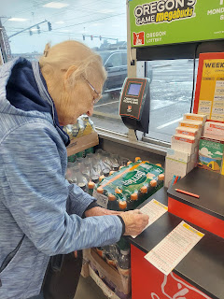

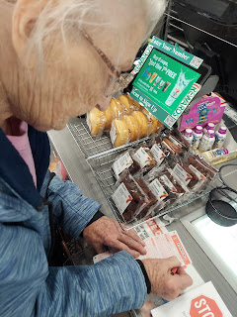

Finally it was off to dinner. And not just ANY dinner.

Another FIRST
: Fried Oysters.

Suzy gave me step-by-step instructions on how they do theirs.

First, you take a few jars of bottled oysters and dump them into a strainer in the sink. You can plan on roughly about 8-10 oysters per person.

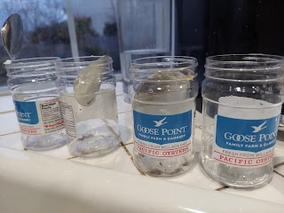

Next, place the oysters on some paper towels to drain. You'll need to pat them on top, too, to get them as dry as possible.

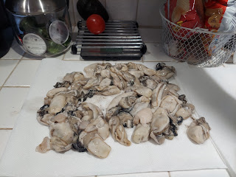

Video #1: Suzy patting everything nice and dry. (47 seconds)
https://photos.app.goo.gl/6b8c3H6QG15i7w1C7

Video #2: Suzy demonstrating dipping the oysters in egg and a flour/cornmeal mixture. (1 min, 18 sec)
https://photos.app.goo.gl/4FjKxYVjCHnq6Zir8

Video #3: Suzy doing another round of dipping and battering. (53 seconds)
https://photos.app.goo.gl/er2GQR1inynJ5jHr9

Video #4: Suzy placing the oysters in the oil. (1 min, 9 sec)
https://photos.app.goo.gl/AncR946n7cA7iAjn6

Video #5: Suzy checking for doneness after about 4 minutes. (30 seconds)
https://photos.app.goo.gl/yfeT1E8aYSBTSbgb6

Video #6: Suzy scooping them out of the pan after both sides are golden brown. (37 seconds)
https://photos.app.goo.gl/HT9ah1k3baV8nFWu5

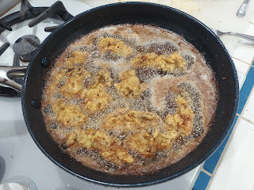

I battered the next 3 batches by myself and tended them at the stove while Suzy took care of some other dinner details.

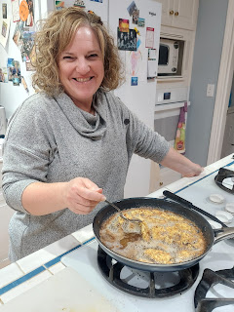

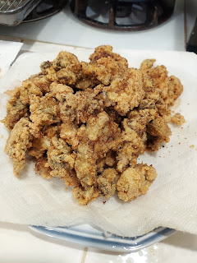

It all turned out MAH-velous!! Mike made a homemade tartar sauce that I thought was great! Turned out I was the only one who liked it. Everyone else dipped their oysters in cocktail sauce. That was nice, too. We had garlic toast and coleslaw salad on the side.

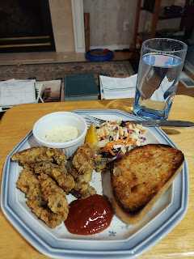

While dinner was being prepared, Mike and Grandma visited and looked at a bunch of the photos together (that we had so diligently sorted for 3 days).

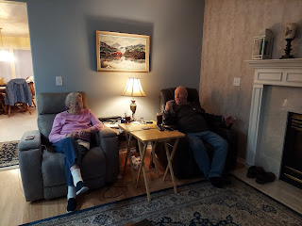

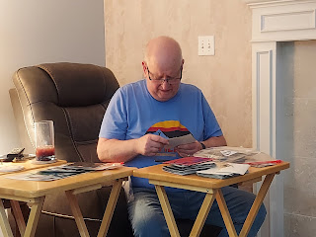

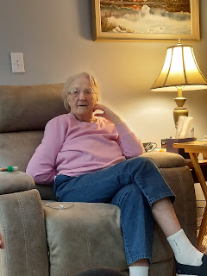

Grandma really enjoyed the evening out, along with the fried oysters (which she LOVES), and being with family. I'm so glad I could be a part of everything this past week. What an adventure!! As always, I packed a lot into a few days, but it was all good stuff. I have zero regrets.

This week, I helped my Grandma with a project that was important to her, but that was also stressful to her. I sorted and labeled photos for future generations. I took her to get her bottom teeth. We went to lunch. She tried doing some walking in the store and she did great! I helped her to get some wine and some lottery tickets that she really wanted. I drove her around and got her out of her room several times. We ate fried oysters together and laughed and talked. I feel like I honored her this week with all that I did. And that feels wonderful.

I also brought home 3 suitcases instead of just the one that I flew out there with. The extra 2 suitcases are full of Grandma's photo albums that we didn't get to. My plan is to get everything scanned and then at some point get everything back to her. With my military ID card, I was able to transport up to 5 pieces of luggage on Alaska Airlines for FREE, so that was extremely helpful. And in Idaho Falls, our FamilySearch Library has a high-speed scanner that I've used before with great success. A few years ago, I was able to scan roughly 500 photos in about an hour!! They were all saved to a thumb drive and I didn't have to do any cropping, because they are automatically saved as individual files. (j-pegs) ALL FOR FREE. The only cost is my time. And then getting everything back to Grandma eventually.

After several hugs, we parted ways once I got her situated back at the care home. My final words to Grandma and her roommate Alice were: "Try not to get too crazy with that bottle of wine . . . don't get too drunk and don't get too loud!" They giggled and laughed like they were two schoolgirls about to have a sleepover. LOL

Saturday:
I left Mike & Suzy's house around 9:30 and drove north to the Portland Airport. It was a short drive again, which was nice. Mike had suggested that I try curbside check-in with all the suitcases I was hauling, but it didn't work, unfortunately. Because I have a military ID and military orders, and because that entitles me to free luggage, I would have to go inside to the Alaska Airlines counter and take care of checking my bags there. The curbside service was just a basic service. Nothing fancy is allowed, ha ha.

So, I had to circle back around and drop off the rental car with all the suitcases in back. (Goodbye beautiful BMW . . .) I found a luggage cart ($6.00) and loaded everything up for a smallish hike back to the terminal and the Alaska Airlines counter. From there, everything went splendidly. Free luggage, got through security just fine, and all was well for the rest of the day.

At both the Portland Airport and the Seattle Airport, I worked hard on my blog and made a couple of phone calls. There was even a live musician next to our gate in Portland. He was really good!!

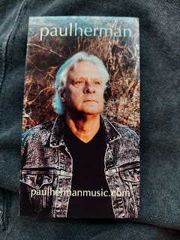

This song even brought a tear to my eye . . . it was so heartfelt! (1 min, 11 sec)

https://photos.app.goo.gl/rb6FD32iRjKvdWeF8

Goodbye Portland. You've been fun!

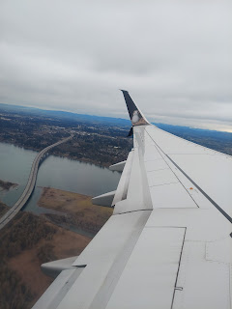

And Goodbye Seattle. I hope to explore there someday soon because it looks so beautiful!!

Up ahead:
Get the garage door fixed
Get my front door fixed
Work on scanning photos - both Grandma's and my own
Massage
Temple
More roller skating LOL

