Agadir, Morocco: Even Better Than The First Time
What a treat to be able to come back to Agadir a SECOND TIME!! This is probably my last time, unfortunately . . . mainly because it will be Scott's last assignment here, as well.

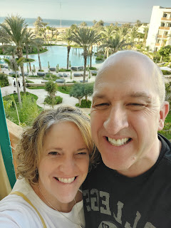

On Saturday, May 18th, I drove myself from Vicenza down to the Bologna International Airport (about 90 minutes south) and parked at a nearby long-term carpark. It was a bit of a hike to get from the car to where the shuttle bus was, but I made it in plenty of time before the bus arrived. A short drive to the airport later, I got into a long line to check in and drop off my suitcase.

As I stood in line, I turned around at one point, when - to my surprise - I saw Scott's commanding officer, Major "O"!! He was right behind me!! What a relief to have someone else to travel with. We stuck together for the most part, all the way down to Agadir. He had me refer to him by his first name, Jude, in public.

On the flight, Royal Air Maroc served us a meal, which surprised me. In the U.S., you don't get a meal served even when it's a 4-hour flight. But this was a 3 1/4 hour flight - WITH a meal. Interesting.

I chose the beef option over the other choice, which was fish. It came with beef, potatoes, a roll with cream cheese, and a yogurt. I only ate a little of the beef, and also the yogurt.

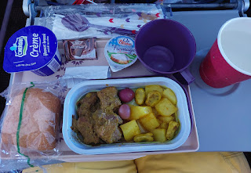

On the seat in front of me . . . English + Arabic

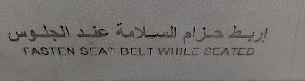

It was an extremely tight connection in Casablanca - firstly because the airline had already changed the time of my second flight, cutting my layover time in half, and secondly because the first flight (from Bologna) left about 30 minutes late. When we arrived in Casablanca, those of us who needed to hustle to the next flight RAN LIKE THE WIND through Terminal 2 all the way to Terminal 1. I was so winded by the time we got to the next gate, my asthma kicked in pretty hard and I wished I had an inhaler with me. I haven't needed one in a situation like this before, but because of too many times with stinking Covid, I'll probably need to carry one with me more often. I was coughing and coughing and coughing while I waited for the shuttle bus to take us out to the plane on the tarmac. Water didn't help, and neither did a piece of gum. It took several minutes to calm everything down in my throat and my upper chest. The last thing I wanted to happen was to climb aboard the plane coughing all over everyone . . .

This is what our second plane looked like in Casablanca . . . more like a regional jet. The propeller was directly outside my window.

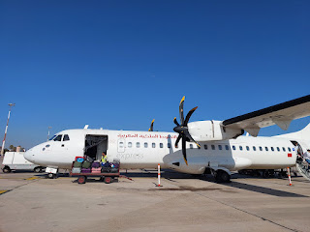

North Africa, somewhere between Casablanca and Agadir . . .

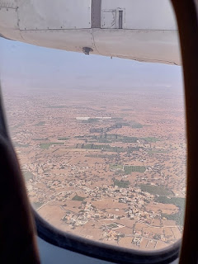

Video as we got close to Agadir: (13 seconds)
https://photos.app.goo.gl/923CLJqM6yCgQeyC8

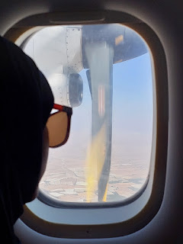

This time it felt like it took much longer to get OUT of the Agadir Airport. Far too many checkpoints and bottlenecked lines for no good reason. Why do they need to screen our carry-on bags on the way out? Maybe they were worried about so many military servicemembers coming in from so many countries and they just wanted to make sure we weren't bringing something crazy in? I dunno. Either way, it was tedious and a little annoying. But I finally made it outside where I could secure a taxi to the hotel.

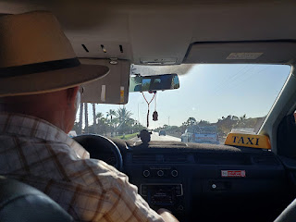

It takes about 30 minutes to get from the airport to the hotels along the beach. It was a comfortable ride and I enjoyed seeing the familiar trees, crazy roundabout intersections, horses pulling carts of produce on the busy roads, and all the people of Morocco.

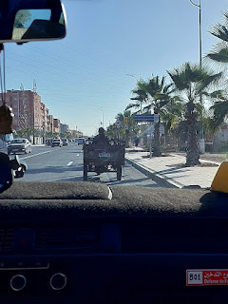

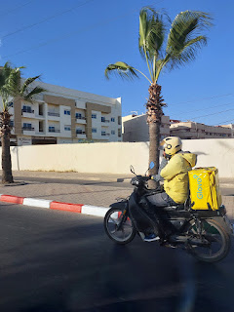

Oopsies . . . too many oranges on this old truck . . . some of them had spilled out onto the road and were getting smushed as the other cars drove over them . . .

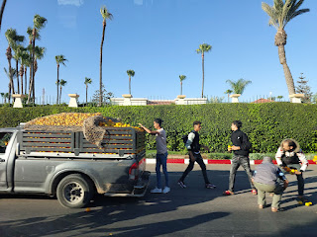

Scott was outside waiting for me when we pulled up at the hotel. This was our FIRST hotel, I should add. I stayed 2 nights at The View before we had to change to another hotel. More on that in a minute. The View was absolutely beautiful!! It is a 5-star hotel with someone to help you with every single thing that you might need, including pulling your
one
suitcase up to your room for you. :)

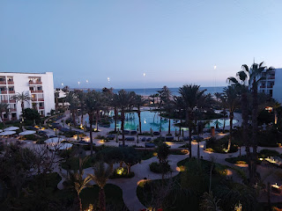

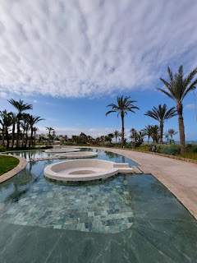

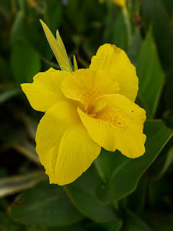

The following morning, Sunday (May 19th), I took a nice long walk along the promenade next to the beach. The air was fresh with a light breeze and just the sounds of the ocean were enough to make my heart sing with joy.

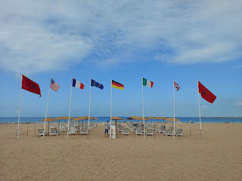

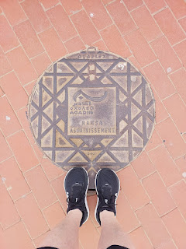

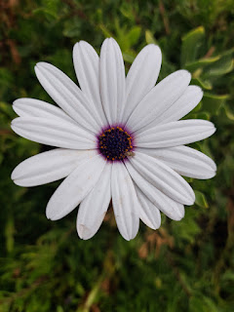

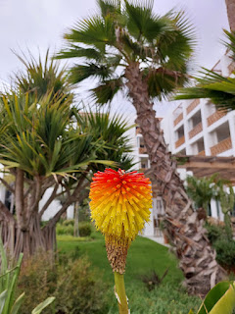

Later that afternoon, I met up with Abdo (technically I should start calling him Abdul, short for Abdullah, but it's hard to change after 2 years . . .). He is my adopted Moroccan son and is the same age as Amber. We sat under the shade of a tree next to the promenade and chatted for about 2 hours, catching up and also mapping out our plans for the following day. We would be going on a faraway adventure to Marrakech . . . and the details for that are in a separate blog post.

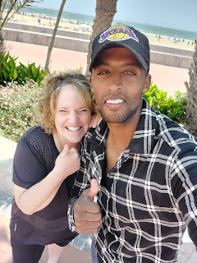

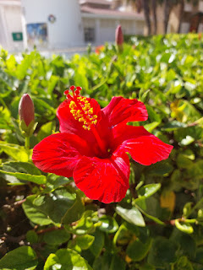

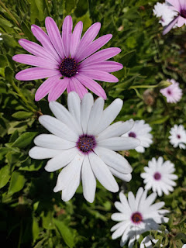

Monday, May 20th, was a long day to Marrakech and back. We were both exhausted, ha ha. So the following day, I just took it easy by enjoying a walk down the sandy beach, mingled with a LOT of resting.

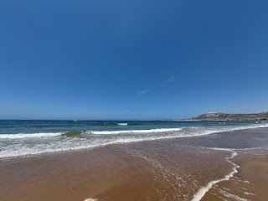

Video of the span of the beach: (9 seconds) **Note the white walls on top of the mountain to the right. That's where the very old Kasbah ruins of Agadir sit. I'll share more about them in another blog post.
https://photos.app.goo.gl/zdqmzme3z4izLcX6A

Video of the crashing waves: (23 seconds)
https://photos.app.goo.gl/rJFTThhW1EUWMdEm8

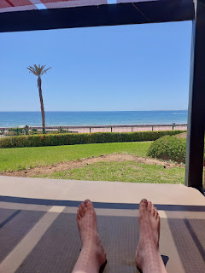

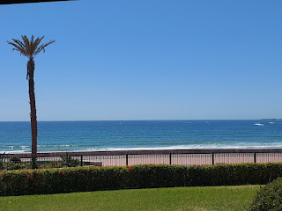

I asked Scott about the backwards flag on his uniform when he came back to the hotel that evening. He gave me a simple answer, but I wanted more information. So I turned to the internet for answers.

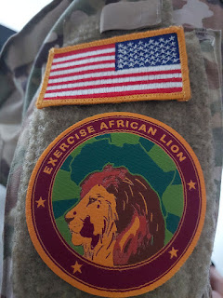

On the website:
medalsofamerica.com
they had a detailed answer that made good sense to me.

"The reason U.S. military members wear a reverse side flag on their uniforms is symbolic. It has to do with the placement of the flag's canton, which is the blue field that contains the 50 stars representing the 50 states. Customs dictate that the canton must be placed at the front to show respect to and honor those 50 states."

They continued: "There's another aspect to the backwards flag meaning, too. When the flag is not reversed, and the canton is on the left side, a military member will appear as if they are retreating when moving forward, as an actual flag would be trailing behind them in this situation. Imagine carrying a flag on a pole as you move forward at a good pace. The flag will be facing the opposite direction from the one you're moving in as the wind catches it, making it into a reverse flag. That's what the reversed military flag patch is intended to represent. In fact, a flag decorating any moving object is supposed to be reversed for this reason."

Breakfast at the hotel was a
whole experience
. I wish I had taken a video to show you, but I didn't know we would be moving to another hotel a day later. There was a young lady who greeted me as I walked in, and who offered to give me a TOUR. They had everything you could possibly imagine: breads, pastries, crepes, rolls, fruits of all kinds, yogurts with a million different toppings, grains and cereals, meats and cheeses, tomatoes/olives/etc that are so customary in this part of the world, and the list goes on and on. They even had an omelette station where you could tell the chef what you would like in it and he'll cook it up right in front of you.

They also had an area with different kinds of honey, and even some fresh honeycomb to break off and eat. I've never seen anything like that before! She also taught me that there is an argon oil that you can eat - to drizzle over your food - and it's different than the argon oil you would put on your skin. I chose an omelette, a traditional Moroccan circular bread with a drizzle of argon oil on it, and some fresh fruit.

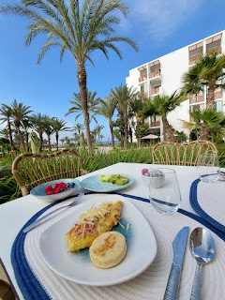

Midway through our long day in Marrakech, Scott texted me that we would be changing hotels later that evening. When I asked why, he didn't know why exactly, but his understanding was that someone more important needed our room. There was also a huge police and security convention going on, to celebrate their National Security Day. Abdo hears things through his friends who work at various hotels, and they told him that there were some VIP's coming to Agadir for the convention. One friend of his, named Mustafah, who works in the kitchen at The View had been instructed to get everything PERFECT and organized and prepped for these VIP's. But then the incoming group ended up staying at a totally different hotel! So maybe we didn't need to move after all . . . how sad.

We moved further down the promenade to a hotel called The Dunes. It is one of the oldest hotels along the beach, and therefore the rooms are reflective of that. It was a big step down as far as room quality, but the pool and the grounds are
very nice
and I have enjoyed them very much.

Breakfast at The Dunes is less fancy, but still a plentiful buffet of colors, textures, etc. And they also make omelettes here! Hooray! I'm trying to eat a hearty breakfast every morning, and then maybe just a piece of fruit for lunch.

This corner display looked pretty enough for a picture . . . but I'm not sure how you would eat any of these items for breakfast. They look like dried beans and grains, mostly. Maybe you could ask them to cook one of them for you?

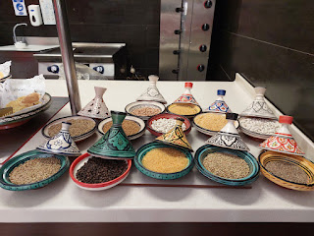

Crepes of various colors . . .

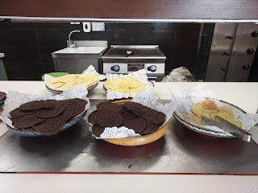

On my first morning at The Dunes, I went a little crazy and ate a fresh donut drizled with chocolate, in addition to my usual fruit and omelette. It wasn't quite the same as an American donut, but it was okay.

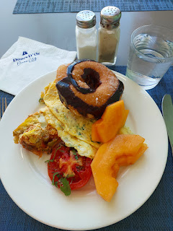

Every day, I absolutely love to see all the blooming flowers all over the hotel property. They make me so happy.

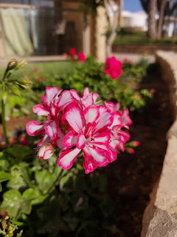

My stomach started feeling bimpy after breakfast . . . and I ended up going to the bathroom about 6 times. I was worried that the dreaded Moroccan Bobos had arrived (traveler's diarrhea), so I took some of Scott's prescription medicine to reverse the curse. I stayed in bed most of the day and just rested.

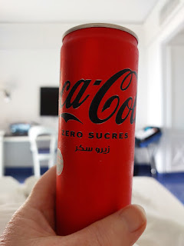

I don't think it actually was the Bobos, thank goodness . . . instead, I think I just cleaned out my colon after what I had eaten the night before, ha ha. I had the most delicious plate of grilled vegetables, abundantly drizzled with olive oil. It sure helped things move along! By the time Scott got home from work, I was ready to go for a short walk and eat a very "careful" dinner.

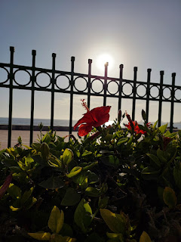

I chose some brothy soup and some simple sushi through the Glovo App, a delivery service similar to Door Dash. It really hit the spot.

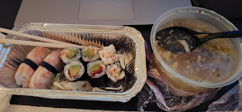

We watched the beautiful sunset from a lounge chair outside our room. A nice way to end the day.

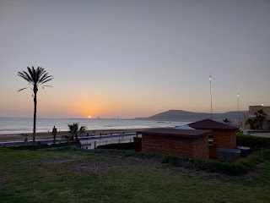

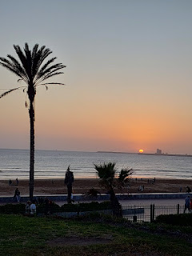

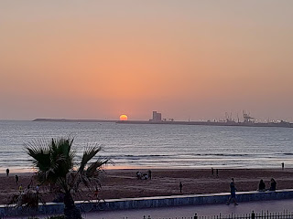

As I ate breakfast the next morning, I noticed a sign down below . . . Everything is in three languages here, sometimes four: German, French, English, and sometimes Arabic. Look at the French version of "Fitness Room" . . . Room (Salle) of Musculation . . . LOL

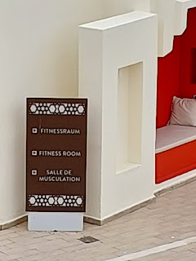

Looking down from the breakfast balcony where I sat . . .

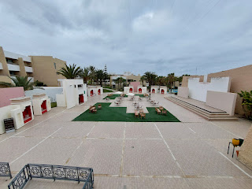

Just a pretty display of vases on the way up to breakfast every morning . . .

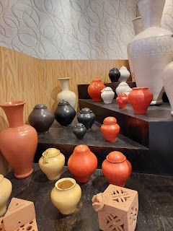

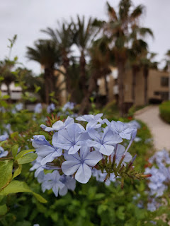

It has been a relaxing and invigorating 9 days in Morocco. I'll be sharing it in stages, since there is so much to share with you. This post is meant to be an introduction, and therefore it is short and sweet.

The Marrakech post is ready to share, but I'll wait a day or so to launch it.

Also: I fly back up to Italy tomorrow. (Memorial Day)

