Ah, the Simple Things in Life
It feels like forever just happened in between last Sunday and today. Time passed rather slowly, especially when we were recovering from Covid-19 and stuck at home in an obedient quarantine. Life felt different through the lens of being a recovered and triumphant new creature. Emerging from my isolated shell after so many days felt odd to me. I felt like I was on the outside looking in, gazing awkwardly on the never-ending pulse of society that was going on with or without me. And through it all, I have found myself with a deeper sense of gratitude for the simple things in life, the quieter side of things that typically go unnoticed in the busyness of life.


Take this sunrise on Thursday morning, for example. I noticed the deep and passionate colors in the eastern sky around 7:45 a.m. and they immediately took my breath away. Knowing that the horizon would change and fade quickly, I grabbed my phone to take a picture so I could share it with my family sprinkled all over the globe. Immediately, I noticed that even though I have a wonderful camera on my cellphone, it did not even begin to capture the deep dark red that I saw with my human eyes. I tried again and again to capture the rich colors that I saw out the window, but could not and did not. I had to just stop and enjoy the moment with my own eyes, and hope that I would never forget the beauty that I witnessed that morning. Sometimes we just need to be IN the moment. Nothing more, and nothing less. A lesson I am constantly being reminded of.

Last Sunday:
As I prepared for bed, I started coughing more and more. I tried several things to calm it down so I could go to sleep, but none of them worked. I tried drinking herbal tea with honey, cough drops, propping up my head with pillows in bed, putting Vicks rub on my throat, diffusing essential oils, even moving myself out to the living room couch where I could sit more upright. Nothing worked. I was coughing so hard I thought I was going to throw up or break a rib or two. Scott was trying to go to sleep in the guest room, but I'm sure it was quite futile with all my coughing just around the corner.

I finally went in to where he was and asked him if he could give me a priesthood blessing. I was so exhausted and felt so pathetic that it brought tears to my eyes. He lovingly leapt out of bed to try to help me, and we chose the living room couch for the location. Usually, as soon as he gently places his hands on my head on other occasions, I would instantly feel the love of my Heavenly Father flow through me. But I was so pitiful and sickly this time, that I felt nothing. I tried to listen to the words of the blessing and focus as best as I could. I remember hearing Scott bless me to be able to get some much needed rest and that my body would do what it needed to do to heal itself. I was amazed that I didn't cough once during the prayer.

Once he finished, I remember having one more cough, and then that was it. I didn't cough anymore until several hours later when I got up to go to the bathroom. Exertion will do that to you, ha ha. But I did get some decent sleep throughout the night, even though it wasn't the greatest sleep ever. I don't sleep as well when I'm partially upright, but at least I got some sleep.

Monday was definitely a turning point for my sickness and all of its exhausting symptoms.

Monday:
I woke up to this cheery little darling face. Miss Avery Mae, who was several hours ahead of me in Italy.





My cough had changed somewhat overnight, from the powerful and violent coughing the night before, to more of a productive one. It was less frequent, thank goodness, but when I did cough I noticed how much it hurt deep down in my chest. When I described it to Amber, she discussed it with Weston, who seemed to think that my forceful coughing from the night before probably aggravated my diaphragm and the surrounding muscles.

I took it easy throughout the day, and even took a shower! Wow!

In the afternoon, my appetite had increased to wanting and needing more than just applesauce, soups, or canned peaches. So I threw together a simple bowl of nachos. I called it: Corona Crunch. It was delicious.



For dinner later, I cooked up some chicken thighs with a spicy peanut sauce. It was very tasty, but for some reason it sent Scott into a big coughing fit.



He goes into a coughing fit after pretty much every meal he eats, but this one was quite epic. We think that when he eats, it causes a reaction in his sinuses for some reason, and his nose starts running, which makes him cough and cough. Sometimes he coughs so hard that I worry he's about to choke or barf! He always keeps a few peppermint drops handy, and some cough drops too. I just wish it wasn't so profound. Whenever we're at a restaurant, right about the time that he's paying the bill is when I'm getting anxious. We try to exit as quickly as possible and hope that people don't notice my husband hacking up a lung on our way out . . .

This was the recipe that I used. He does not have a peanut allergy. He eats PB&J sandwiches all the time! So I don't know what caused such a reaction in his throat that night. He didn't even finish eating his meal, poor guy.



It was still delicious though . . . (I served the chicken and sauce over some chopped red cabbage, with green beans on the side)



Tuesday:
(Day 6) I had more energy and mental clarity than I'd had in several days. I tackled a few chores around the house, trying to make sure that I didn't work TOO hard . . . I did some loads of laundry, washed our bedding, dusted a few areas, washed the dishes, and even vacuumed the stairs! It felt really good.

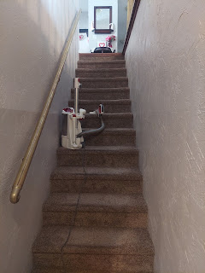

Scott fared much better than I did through our coronavirus adventure. He worked through his "version" at a much faster pace. Sunday and Monday he spent several hours making tutorial videos for his math students at school, who would be in the hands of an inexperienced substitute teacher for a couple of days. His students always appreciate when he makes explanatory videos for them and they tell him so.

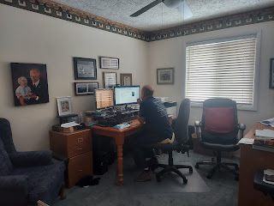

We set up a Walmart grocery order the night before, and patiently waited for our assigned pick-up time at 5:00 p.m. It's too bad that it takes almost 24 hours before you can get your order. I wish you could order it and have it ready in just a few hours.

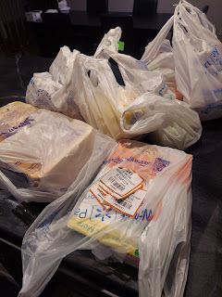

I thought this little cauliflower was quite comical, due to its tiny size! On the left is a pear and on the right is a ginormous spaghetti squash.

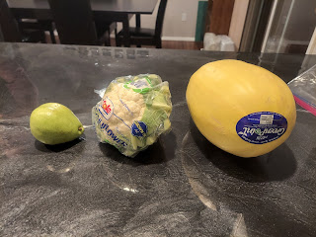

I have never in my life seen a cauliflower so small! We were happy to have some fresh fruits and vegetables once again, no matter if the cauliflower was miniscule.

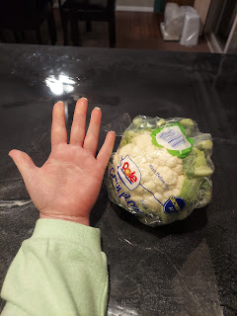

Our go-to for entertainment during our quarantine was to watch Mission Impossible movies. I bookmarked them all on Amazon Prime and so far we have watched 3 out of the 6 movies this past week. Super entertaining and always a good time.

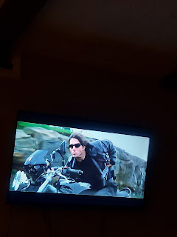

Wednesday:
Scott decided to go back to school (against my wishes). He had a variety of reasons, which I tried to shoot down (but couldn't). His reasons were: he felt really good, technically he had completed 5 days of isolation, he couldn't take another day of getting behind with his students, and the most compelling reason of all - there were no substitute teachers to be found! Even though it felt way too soon to me, I lost the battle.

He went to school and did just fine. When I worried about him being in close proximity to the students, especially if they had a question or needed help, he explained that he doesn't go over to their desk (nor do they come up to his desk). Instead, he asks them what problem number they are struggling with and then he writes it down at his desk and projects it onto the big screen and they work on it "together" from there. Very smart.

While he was at school solving all the world's problems, I decided to bake an apple pie and use up some apples that had been in the fridge for a while. It turned out fabulous and we enjoyed some warm apple pie at the end of the day together.

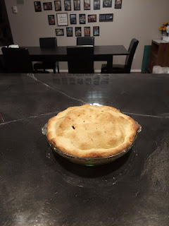

I also felt well enough that I wanted to get a little bit of exercise. I didn't want to go outside in the cold, so I put on my roller skates, moved some rugs out of the way, and skated around my house with the music cranked up. :)

Click here to watch: (39 seconds)
https://photos.app.goo.gl/zhi9PUjXZaBqpRqR6

It felt really good to move around and enjoy some fun music. I posted this to my Instagram account, stating, "This is what getting finished with Covid looks like". I ended up getting some very positive comments, ha ha.

Thursday:
I got another sweet photo of Avery.

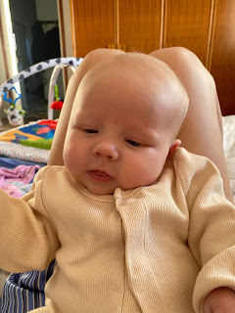

And I got caught up with Amber, who was finally feeling better in her recovery from Covid as well. Gwen asked me, yet again, "Mimi? Can you come here tomorrow??" Probably not tomorrow, Gwennie . . . but a little later on. XOXO



Amber had a really rough time with Covid. Weston is doing much better though, and was able to get out of bed and help with the girls and around the house while Amber slept for a few days straight. She is just coughing all the gunk up now, and is gaining her energy back. Gwen tested positive, even though she only had a low fever and a runny nose for maybe one day. Abby tested negative and didn't really seem to have any symptoms. She may have already had it before and was just asymptomatic (no symptoms). Either way, Abby is ready to go back to school this coming week!

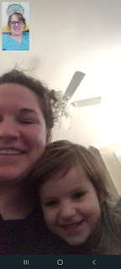

Abby borrowed her mom's phone and took me in her room to show me a few things.



This is a planet mobile that she made from a Kiwi Co. monthly box that arrived recently. The big yellow one is the sun, she informed me. It's hanging from her ceiling fan.



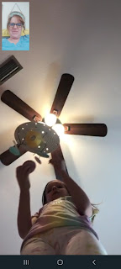

After showing me all her stuffed animals, we wrapped up the conversation so I could go get something to eat for lunch. It was very entertaining to chat with all three girls for a while. I'm so glad they are feeling well and that all is well finally.



Friday:
Something Amber and I enjoyed doing from our sick beds was to send funny Tik Tok videos back and forth every day. Here are some of my favorites from the week.

#1: For those of you who either have ADD or know someone who has it (I think we all have it in our family, except for maybe Jacob) LOL
(9 seconds)
https://photos.app.goo.gl/nP5fFw5jCXhajpSr6

#2: If you're ever feeling sad, just go for a bike ride . . . (14 seconds)
https://photos.app.goo.gl/SHKGesJbD2caqeZs7

#3: When you lie on a resume to get your dream job LOL (36 seconds)
https://photos.app.goo.gl/sbMCezLCC8w5U26Q9

#4: A VERY cool idea to teach your kids/grandkids for their own personal safety (55 seconds)
https://photos.app.goo.gl/RvbU5jurY81wGVAd7

#5: For those of us with BIG HAIR (18 seconds) - shown on a dual screen with Will Smith watching it for the first time too.
https://photos.app.goo.gl/aJaYUqdNPwHsWpeZA

#6: (27 seconds) This is why I love Switzerland so much!!
https://photos.app.goo.gl/Fhvbw8DSNcyBRwjQ9

Friday was my first big day out of the house in a whole week! (Besides going to the Dr last Saturday and doing a pickup order at Walmart) It felt weird going INSIDE Walmart and being with the main flow of the public again. It felt like I was on the outside looking in, and that I wasn't really there in person . . . it was all just a slow-mo hazy dream. I found all the things on my list and then drove home.



Avery is getting so big!!! She's learning to roll over and even sit up for brief periods of time (staged of course). But still!! :) What a precious!!



I worked on some YW binders for our new class presidency, printing the pages and organizing everything for them. This was in preparation for a training meeting which would be the following morning.

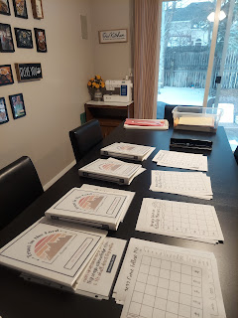

Friday night we took 6 of the young women in my class to the temple for the first time! It was really special to be there with them and to be a part of it all. We had several adults come along, too, all of them being parents of the girls, except for Scott and me. I wore a mask the entire time, even in the car, just as a precaution. Scott came as well, and we were all able to perform vicarious baptisms for several family members who have passed away and cannot take part in that ordinance for themselves. (They can, however, choose to accept the ordinance or not) It felt so wonderful to be in the temple again.

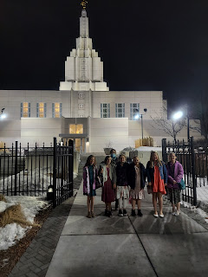

I was even able to get in the baptismal font and do the temple work for someone that I thoroughly enjoyed doing research on last year. My cousin, Valorie Sappingfield, had mentioned to me that our other cousin, Loreena Hester, had found some curious information in her mother's papers after she passed away. It implied that our relative, Jessie Loreena Orr, had somehow had two young children when she died at 18 years old, with no apparent husband to speak of. This was back in 1914 (when Jessie passed away).

My cousins were concerned that there might have been some improprieties as well as some previously unknown posterity, and they wanted to set the record straight. They asked if I could do a little digging to find some answers, which I was more than happy to start on right away!

As I began my search, I turned to Newspapers.com to see if there was any mention of Jessie. Turns out there were several! As I found more and more articles that mentioned Jessie Orr, I began to see a pattern emerge. There were TWO Jessie Orrs!!

One of them was Jessie Loreena Orr, the little sister of my great grandmother, Kate Lee Orr. And the other Jessie was someone different entirely! How did I come to know this? Because Jessie Loreena Orr showed up in all the newspaper articles as someone who played the piano, both solo and duet performances, at local events and charities. She was also mentioned as having earned the "Best Yell" award for Ukiah High School, being an enthusiastic cheerleader from up in the crowd. She was well loved and very respected. Upon her death just after graduation, the friends who sang and participated in the funeral program were the same names that had performed with her at those local concerts and recitals for years. There was no mention of any marriage, and certainly no mention of any children in her obituary. The cause of death was listed as typhoid fever. But my cousin Loreena Hester said that the story that was passed down to her was that Jessie had eaten some water cress leaves that she had picked on their property and shortly thereafter became very sick. They think maybe the plants had some bacteria on them that might have caused E-coli or something similar. Poor Jessie never recovered, and died so young at just 18 years old. Here is a photo of her. She was really quite something.

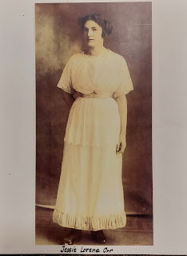

The OTHER Jessie Orr was an actress. She performed in local theaters, both in Ukiah and Willits, CA. She was always listed as Mrs. Jessie V. Orr. I didn't know what the "V." stood for at first, but I soon found a wedding announcement that gave more information. She was born Jessie Valida Perry and later married Francis Marion Orr, also known as "Frank". Thus she became Jessie V. Orr. Here's a fun fact: Francis Marion Orr was Jessie Loreena Orr's older brother!!!

So "Frank" Orr had a little sister named Jessie, and then he also married a young lady named Jessie. Are you thoroughly confused at this point? Well hang in there . . .

In November of 1906, Frank and Jessie V. Orr gave birth to a little boy. They named him Delbert J. Orr. In October of 1907, Frank was at work and had a terrible accident. He was operating a pile driver (used to drive steel, concrete or wood into the earth to provide a crucial foundation for large structures) when it began to topple a little. Worrying that it was going to tip over, he jumped off. But unfortunately he landed belly first on a huge 10x12 timber. He broke a rib, but everyone thought he was okay. He must have had some internal injuries, though, because he began to feel worse overnight, and passed away by the next day, October 10, 1907.

Well, his poor widow, Jessie V. Orr, not only had a small toddler to care for, but she was also pregnant with baby #2. She gave birth to a little girl a few months later on March 4, 1908. It was really very touching to learn that the daughter was named Frances Marian Orr. It was the female version of her father's exact same name! Wow. That tells me a lot about the love Jessie had for her husband, and that she also had the desire to pass on his legacy to their daughter through his name.

As I was piecing this whole story together through all the juicy tidbits on Newspapers.com, I didn't know at first that Frank Orr was a good man. I didn't even know that he was deceased at first either! I had seen a couple different articles that showed a Mrs. Jessie V. Orr appearing before the judge, pleading for financial assistance for her two small children, indicating that they were "orphaned" and "abandoned". I thought to myself, "Who is this jerk that left her so destitute??!!" She eventually qualified for financial assistance, thankfully, but even more importantly, I learned the whole story. Technically the children weren't orphaned or abandoned, but she sure felt that way with the passing of her dear husband.

Eventually, Jessie V. Orr remarried in 1910 to a Randall Robert Ross. They had a little boy together, whom they named Robert Randall Ross. (Try saying that a few times fast!) He was born in August of 1917, so they obviously waited a few years. Sadly, a short time later, Jessie died in October 1918. (Not sure what the cause of death was) All three children (Delbert, Frances, and little Robert) bounced around a bit after their mother died, sometimes staying with their grandparents and showing up on a US Census record. Randall Robert Ross, Jessie's second husband, died at a relatively young age as well. He passed away in 1933 at the age of 49. His young son, Robert, was listed as living with him in the 1930 Census (age 13). Robert truly was an orphan by the age of 16.

While this lengthy story might seem to have a plethora of sadness and death, there is a shining beacon that stood out to me by the time I had uncovered all the details. Jessie Loreena Orr left this world with a stellar reputation and no blemishes to be found. I found myself very connected to her throughout all the research. I felt like she was immensely grateful that I had proved her reputation to be intact.

And in the temple Friday night, I was able to do the temple work for Frances Marian Orr, the little girl who was named for her father. I felt really close to her there and I know she was happy that I had "found" her. Heavenly Father wants all of His children to be found because He loves each and every one of us. I love that family history helps us to find and connect our family members and that we can perform vicarious ordinances for them if they weren't able to have those things done while they were still on the earth.

Once we got home, I started working on a homemade strawberry syrup for the training breakfast the following morning. My assignment was to bring some syrups, so I decided to make two different kinds.

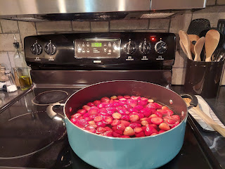

I found that the fastest way to follow this recipe was to use frozen strawberries that I didn't have to cut up at all. Here is the recipe that I used:

https://toriavey.com/toris-kitchen/strawberry-simple-syrup/

I ended up with 2 quart mason jars filled with strawberry syrup. Yummm!!

Saturday:
I got up and showered and hustled into the kitchen. I got to work making the second homemade syrup. This is the recipe that I used. (below) It is so tasty I could literally eat it by the spoonsful! I especially love that it has a little bit of cinnamon in the recipe.

https://tastesbetterfromscratch.com/homemade-pancake-syrup/

We had our YW Leadership Training Breakfast at 9:00 a.m. in the home of our YW President, Amanda Whipple. We had waffles, buttermilk pancakes, scrambled eggs, bacon, sausage, fruit on kebabs, homemade syrups, and a variety of juices and milk. Our tummies were extremely happy! (The bottle of Aunt Jemima syrup that you see in the photo below was for Amanda's son who made a new year's resolution to not eat sugar this year. *good luck* They bought a bottle of sugar free syrup just for him, ha ha.)

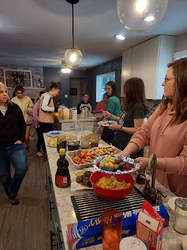

After we stuffed ourselves, we moved into the living room for some instruction and discussion. These girls were all recently called to serve in a class presidency, so we provided some training for them to better understand what to do and how to do their very best.

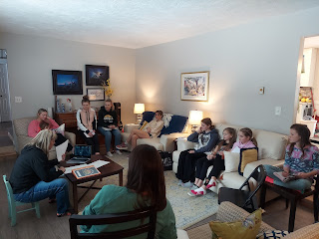

Later in the afternoon, Scott and I drove up to Rigby to check on his parents. Gordon is still staying there, alternating between working remotely for the government, entertaining/caring for his granddaughters, and keeping his parents company. Dad hasn't been feeling well for a few days, and he was feeling both low in spirit and low in his physical health. Gordon and Scott helped give their father a priesthood blessing, and oh it was so beautiful. Gordon blessed his father to be happy until the time comes that he will be called Home. He blessed Dad to continue to be a light to his family and to find ways to serve others until that day comes. We certainly hope he will be around for a while, but we also recognize that he is 90 years old and that it's not exactly up to us . . . But we could see how much that beautiful blessing meant to Dad. His demeanor improved, his mood was lifted, and you could tell he was comforted. We hope he is feeling better this week, too.

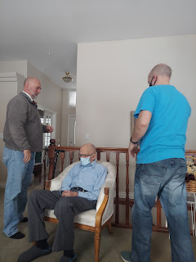

Jacob and Hannah shared this darling photo of Jack with me . . . this is the outfit I bought for him when I was in Germany but I hadn't seen it on him yet. What a handsome little guy he is!! (*those suspenders*) :)

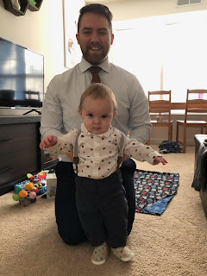

I also baked another round of cupcakes for all the girls in my class. Gordon came down to Idaho Falls to watch football with his brother while I baked chocolate cupcakes upstairs. It's fun when brothers can get together!!

Sunday:
We had church via Zoom this morning because so many people are sick in our area of Eastern Idaho. Other activities have been canceled for the week as well, so no mutual with the girls this Tuesday night . . .

It's okay I guess. I'm just so grateful that we made it through coronavirus and that we survived. Everything should be good from here on out. :) We'll be praying for everyone else that might be still struggling. XOXO

