All Moved In (well, mostly)
The flowers are just so beautiful right now and everywhere I go, I find more and more blooms to photograph. I decided to start sending a daily text to people that I care about, where I send a photo of an Italian flower to someone on my mind, or someone that could use a little lift. So far, it's had some wonderful results.


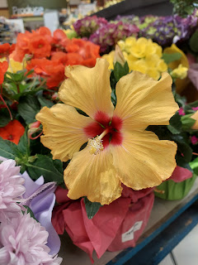

Click here if you'd like to see the entire album of blooms that I've collected so far. Keep in mind that it will just get bigger and bigger over time, so feel free to check back on the same link.

https://photos.app.goo.gl/i4RGiVYYiVicd4Ln6

Monday:
Kylie sent me a photo from their fun date the day before. She had bought tickets for herself and Benson to go watch a Formula 1 Race a couple hours away from where they live. It was her birthday gift to him. How thoughtful!

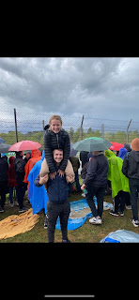

They had a great time, even though it rained a lot during the day. I bet they enjoyed having an adult date for a FULL DAY!! I remember when our kids were young and how important those regular dates were for our marriage. This was the longest she has been away from Avery, but Avery did fine in the care of their neighbor and friend, Mariah.

I walked over to the Tax Relief Office and learned a little bit more about how VAT works. (VAT = Value Added Tax) Here's how it works.

Step 1: Ask the store for a "Preventivo" (estimate) of your item(s) with and without the 22% tax. Your purchase needs to be at least 150 euros to qualify.
Step 2: Go to the bank and purchase a cashier's check for the total without the added tax.
Step 3: Bring the cashier's check to the Tax Relief Office, along with $10 for processing.
Step 4: Tax Relief will give you a sealed envelope with the cashier's check + documents to take back to the store.
Step 5: Return to the store and give them the sealed envelope and pick up your purchased items.

It sounds simple, but we are encountering a few extra steps along the way that make it even more tedious. We are thinking that for smaller items, we'll just pay for it all the first time while still in the store, rather than doing all the extra steps to save a little money.

In front of the Tax Relief Office there is a beautiful garden bed with lots of flowers in bloom.

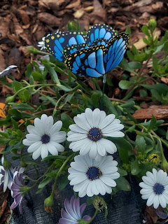

Whenever I get close to take a picture, there is always at least one lizard scurrying to get away from me, ha ha.

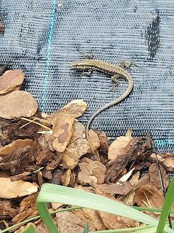

I called Kylie later in the afternoon to see how they are doing up north. Kylie was pretty tired because Avery is teething lately and isn't sleeping as well. Plus it sounded like Avery might be getting her first cold. She was a little congested and raspy sounding. It always seems like sickness comes right at the same time that those little teethies pop through.

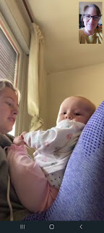

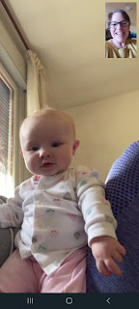

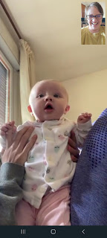

Nom nom nom. Chewing on mom's fingers helps . . .

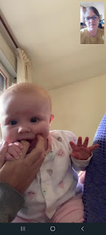

Kylie says that since Avery joined their family, Mocha is very protective of their household.

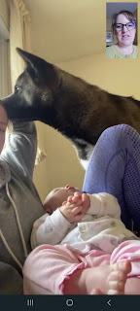

Mocha came over to look in on the baby. Avery looks like she's pushing Mocha away, but she was actually just gently touching Mocha's nose and face. It was really quite precious.

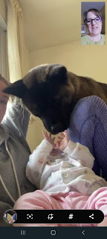

What a sweetie. :)



Late in the afternoon, I walked over to the Commissary to get some things for our dinner. Sadly, I forgot that the Commissary is closed on Mondays, so I walked home empty-handed. I couldn't go to an Italian grocery store either because it was Liberation Day for them (April 25) and ALL the stores were closed. According to the internet, Liberation Day is a day that marks Italy's liberation from Germany (their occupation and fascist rule) at the end of WWII.

So what were our dinner options? We could either make a PBJ sandwich with stale bread (by the time bread from the US makes it here to the PX, it's at its expiration date and we've already had it for several days) or go eat at the Chow Hall. Ultimately, we decided to eat at the Chow Hall, even though Scott got sick of it really fast beause he ate here every day when he first got to Vicenza. We walked across the base together and got there just before it closed. There weren't a lot of options left, but at least we left with full tummies.

Chow Hall on the right - -

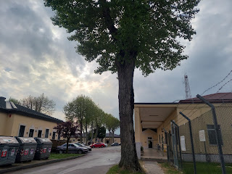

Scott had some grilled chicken bites, stuffing and peas & carrots. Bread on the side, with some ham. LOL

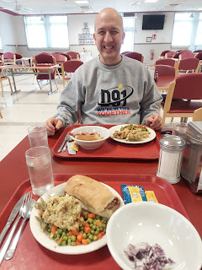

I had the server grill me up some thin steak and then she put it into a toasted bun. It was actually really good! Especially when I added some chopped red onions to it. I also had some stuffing, which was delicious, and peas & carrots, which wasn't so great.

On our walk back to the hotel, we found the most beautiful succulents in a planter box. I believe these are called Hens & Chicks, and my Grandma Zoe always seemed to have some of these in a variety of containers, including an old boot filled with dirt!

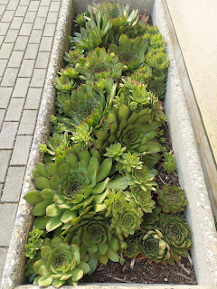

The lavender blossoms on the trees are starting to fall off . . .

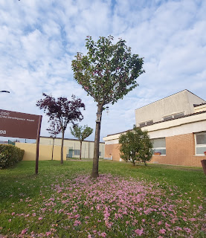

Tuesday:
My job was to walk over to the nearest Italian Post Office to mail an important form for Scott. If you don't want to pay 100 euros per year for Italian TV, then you have to send off this form via certified mail. I couldn't mail it from the English-speaking base this time. After consulting with Google Maps to find the closest post office, I saw that it was about 35 minutes on foot from our hotel. So off I went.

It was a little hard to find the entrance because the whole building's exterior was being renovated.

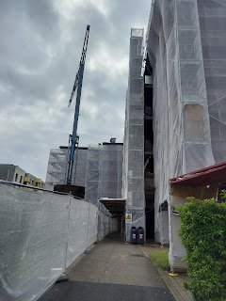

Ah - here we go. Clearly marked . . .

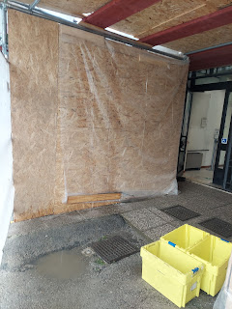

I had to put on my mask upon entering, which, when you're sweaty from a lengthy and brisk walk, is not ideal. As I got up to the counter and showed the lady what I was trying to do (the Army gave us a paper with explanations on how to send something by certified mail, including some key phrases in Italian), she starts speaking a million miles a minute in Italian, indicating that I need to get a form to fill out across the room. There are several stacks of forms, all in Italian . . . but she didn't budge from her native language and couldn't come out from behind the window either to show me which one. So I went over and started carefully scrutinizing each stack of forms at a time, hunting for one that had the word "Raccomandata" somewhere on it.

Meanwhile, a line started forming in this tiny little post office and everyone is just waiting for me . . . Finally I find the correct form and she tells me (with gesturing that makes more sense than her words) to fill it out right there at her window. In other words, it's my turn, and I am entitled to take as long as I need to finish my business. No pressure . . .

As soon as I put on my glasses so I could see what I'm doing, they instantly fogged up because I was so sweaty. The whole situation was a bit stressful, but I did it! I got that form filled out and when she told me how much it was, I just handed her a 20 euro bill because I had no idea what she just said, ha ha. It ended up being 6.95 euros and I fulfilled my mission successfully. Hallelujah!

On my 35 minute walk back to the hotel . . .

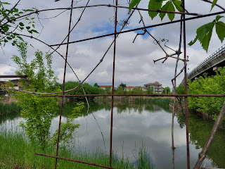

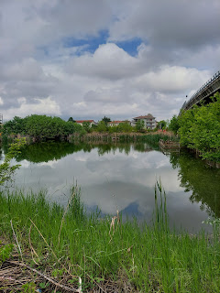

As I'm still struggling with the language barrier, I recognized that I need to go back and review some Italian numbers (and several other things). I am trying to squeeze in some practice time here and there, even if it's just for a couple of minutes.

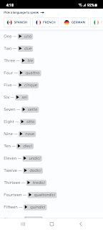

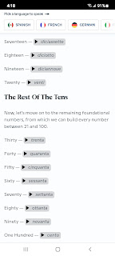

There's a lady here in our ward named Linzi and she is actively helping Ukrainian refugees along with her family. Her husband speaks Russian, which is extremely helpful - perhaps he served a mission in that area? From time to time she will post on the Relief Society Facebook page what the current needs are, since they might have multiple families coming and going within one week's time. The families will typically stay 1-2 nights with Linzi on their way to somewhere else. One of the things she has found to be most helpful is when the ladies in our ward bring her some dinners that she can keep on hand for those busy evenings. She is basically running a B&B out of her own home, changing the bedding every day, washing everything, etc. She has young children and other responsibilities, so when it gets close to dinner time - just knowing that she doesn't have to cook for everyone is a huge relief!

I'm not in an optimal position to help much (YET), given that I don't have a full kitchen setup or a car of my own to get around. But while talking to her and gently prying a little more into what some of the needs are, I discovered a very simple thing that I COULD do!! She only had minimal supplies of twin bedding sets and was having to strip the beds, wash everything, and then remake the beds all in the same day, which can be exhausting day after day. She said she could use more twin bedding sets. Bingo! We had Scott's set of twin sheets leftover from when he went to Texas for processing before he came to Italy. We didn't need it anymore so we offered to wash it and get it to her in the next day or so, which we did. That felt amazing. Small and simple things can bring great things to pass. I couldn't move a mountain, but I could provide a set of twin sheets for a refugee in need of some shelter and a comfortable place to lay their head.

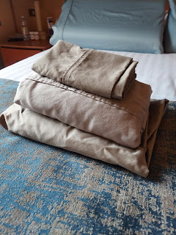

After all the stores were closed for Liberation Day, we were finally able to get some important supplies for the house on Tuesday after Scott got home from work. We split up for maximum efficiency - Scott had his short list for Leroy Merlin (like a Home Depot) and I had a very long list for Happy Casa. I put in one euro so I could have a shopping cart this time, which I got back at the end when I parked it. As I pushed the locking key back into place from the back, it pushed the coin out of the slot in the front. Perfetto!

Some of the items on my list were: bath towels and washcloths, soaps, hair dryer (Italian - with the correct plug for the wall), mattress protector, clothes hangers, dishes, pots & pans, mixing bowls, etc. My cart was heaping by the time I got up to the front, ha ha. Thankfully Scott had finished up at the other store and could help me up at the register. They don't provide you with bags, so our plan was to empty out the cart onto the conveyor belt and then use the cart to load everything up on the other end. Then we could just take everything out to the car and empty it into the trunk. We spent roughly 340 euros (about $365 USD) to get outfitted. There are a few more miscellaneous things that we still need, but there's no rush on any of them.

We've been learning what Amazon Italy has to offer and how it all works. It's pretty sweet actually. We order similarly to how we would order in the U.S. (but letting Google Chrome translate each page for us). It only took 2 days for our first item to arrive, and then we got a barcode in an email to scan at the "locker" facility. There are multiple lockers all over Vicenza, so that's really handy. We chose one close to the base and to our house. Once you scan the barcode at the lockers, a door pops open and you just reach into that slot and grab your package. We will be using that more often for sure!

Once we got back to the hotel and started making dinner, I had some enjoyable conversations with both Mari (my niece) and Amber. Mari was bored and wanted some lively conversation, ha ha. One of the things we discussed was what she could make for her dinner that day without any money and very minimal ingredients. She decided on eggs and chorizo. :)

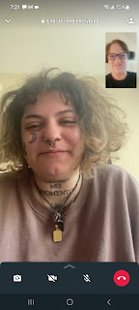

Next up was chatting with Amber and Gwennie. Preschool had just gotten out and the two of them were on their way home together.



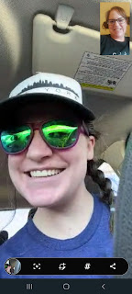

Both of them had pigtails for the day. Super cute!

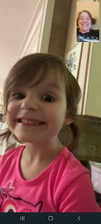

Amber gave me a tutorial on how to use micellar water to help fix my skin issues as of late. The water is super hard in Italy, and it's been wreaking havoc on my face. What I've learned is that hard water leaves mineral residue on your skin which then clogs your pores, leading to pimples and frustration. Micellar water, when gently patted onto your face, helps to break that residue up and open the pores, and it makes your face feel really soft. Thankfully I was able to find some micellar water in the Commissary and just in the 2 days since I started using it - no more breakouts! Amazing!

Scott will be ordering a water softener "filter" of sorts for our bathroom shower at the house. He was reading the reviews and saw that, depending on where you live and how hard the water is, this will determine how long the filter will last before needing to be replaced. It could last a month or two, or perhaps up to 5-6 months. We'll see how it goes.

I'm just grateful for products that work nicely to fix my skin sensitivity issues.

Wednesday:
Sometime during the day, Benson left Italy for a deployment with the Air Force. I can't say where he is, but I can say that he is somewhere safe. He will be gone for 2-3 months in support of Ukraine. Just remember that he is a jet engine mechanic, not a member of the infantry. His job will be to make sure that the pilots can get to wherever they need to go each day. That being said, prayers would always be appreciated in his behalf and on behalf of his wife and baby, too. :)

Scott and I got up early to meet with Silvia, the realtor, over at the new house by 8:30 and to get the house keys!! I had my alarm set for 6:30, but of course my brain woke up at 4:30 and I couldn't go back to sleep . . .

The utilities guy was there, too, making sure that everything worked properly. He spoke very good English and could supplement with whatever Silvia wasn't able to communicate to us. There was a question on if the water heater was working, but Silvia was on top of it and very assertive, calling the appropriate office immediately to get someone to look at it. It's a very small water heater, and it just now hit me that it might be what heats all the water in the entire house . . . maybe it's one of those kinds that heats on demand? I guess we'll find out soon enough! (nervous laugh) *Update: YES, it is a water heater that heats on demand. It's very energy efficient, so that's cool.

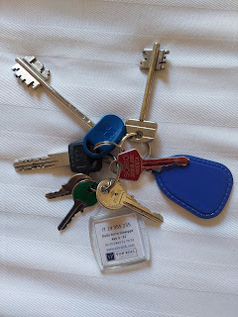

The keys we received are
many
, and the whole bundle is quite large and in charge. We plan to separate out the keys somehow so we don't have to haul such a big bundle in our pocket or purse. Scott had to get to work for the day, so he drove me back to the hotel and dropped me off.

A short while later, Silvia needed me to meet her at the house so we could meet with the electrician about the water heater again. I told her I would leave immediately to walk over and that it would take me about 15 minutes. It ended up taking me 20, but I was hustling the entire way.

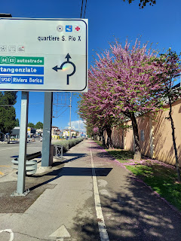

I was only needed over there for a few minutes, and there was no rush on the way back, so I decided to check out one of the several grocery stores next to our new house. I chose to go inside Conad City, an orange and white store on the outside, and recommended by other military families. It was bright, clean, and beautiful as soon as I stepped inside.

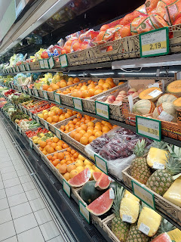

Romanesco - it's so beautiful to look at and also SO very tasty. Grandma Lillian and I figured out how to cook it a few years ago up in Salem, Oregon. It's related to broccoli and cauliflower, a cousin if you will, and can easily be cut up into smaller pieces for roasting. A light basting of olive oil with salt and pepper will suffice, and then a sprinkling of Parmesan cheese on top adds some delight. (at least to me) I'm excited to cook some Romanesco in our new house soon. :)

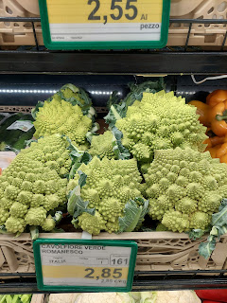

Lots of frozen pasta options . . .

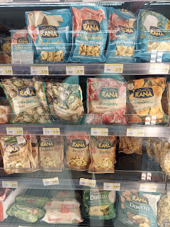

Chocolate salami . . . umm . . . I don't quite know what to say. Maybe gross?

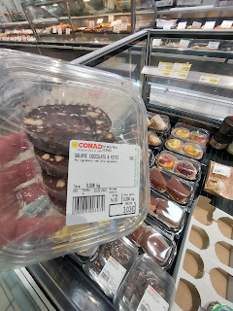

I looked it up to see what it's all about and apparently it's a dessert! According to Wikipedia:

Chocolate salami
is an
Italian
and
Portuguese
dessert made from
cocoa
, broken
biscuits
,
butter
,
eggs
and sometimes alcohol such as
port wine
or
rum
. The dessert became popular across Europe and elsewhere, often losing alcohol as an ingredient along the way.
[1]

Packaged chocolate salami at a supermarket in
Évora
,
Portugal
Chocolate salami is not a
meat
product. The appellation "
salami
" stems from physical resemblance. Like salami, chocolate salami is formed as a long cylinder and is sliced across into discs for serving. These discs are a brown, chocolaty matrix (like the red meat of salami) peppered with bright bits of cookie (like the white flecks of fat in salami). Some varieties also contain chopped nuts, such as
almonds
or
hazelnuts
and may be shaped like
truffles
.

Okay, so maybe it's not going to be so gross.

At the back of the store was a lengthy deli area with all sorts of interesting things to choose from. I chose a Frittelle di Zucchine, not knowing what it was, but it looked good and sounded kinda good. (It's a fried zucchini fritter)

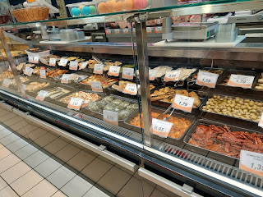

I asked the deli girl in very simple English if it needed a sauce. Nope. Next I asked if I should eat it hot or cold. After several attempts to get her to understand hot or cold, she finally understood and said, "Caldo?" I recognized that word from all my years of learning Spanish and knew that it meant hot. "Si, Si", I said. She emphatically let me know that NO, this was not meant to be eaten hot. "Okay, okay, grazie, grazie". Good to know!

By the way, it really was delicious. It was very soft and tasted a bit like Thanksgiving stuffing, but with little bits of things unrecognizable in it. Maybe some pine nuts? I would give it 5 out of 5 stars and I look forward to my next one. Also on this plate you will see my other two "adventures": thicker than thick cottage cheese with way too much protein (26g) and some tasty chocolate. I just got excited that I found cottage cheese at all and didn't pay much attention to the label. Next time I'll be more careful. I choked about half of it down before I couldn't eat any more.

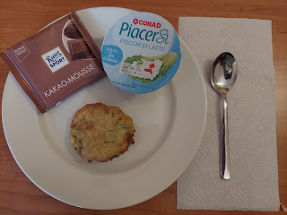

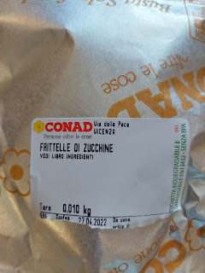

Other beautiful and interesting things in the grocery store: definitely these gorgeous bottles of olive oil.

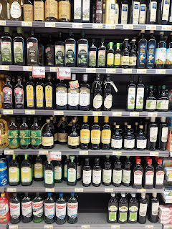

Several types of flour, many of which I had never heard of before.

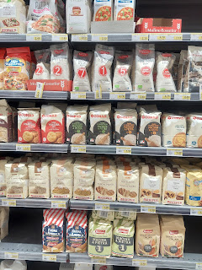

Now this I could recognize: chocolates. :)

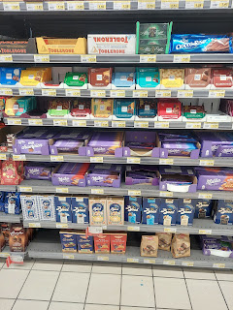

The sky was SO BLUE for the first time since I arrived in Italy. It was very warm and even though it was only in the mid-60's, the sun was very intense beating down on me as I walked the rest of the way back to the hotel. I was glad I wore a hat to protect my noggin.

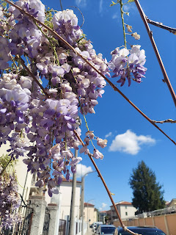

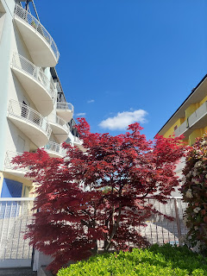

For the afternoon, I laid low at the hotel. I washed all the new towels and watched some TV and rested. It was wonderful.

After Scott got home and we ate a simple dinner in our room (frozen burger patties with shredded cheese on top and a dollop of pesto, served with some riced cauliflower and mixed veggies, and half of an apple on the side), we drove over to the new house again to drop off a few more things. It was a lovely evening to go up on the roof terrace and have a look around.

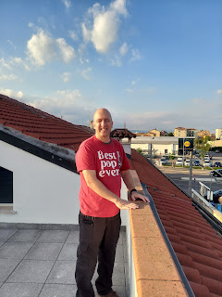

Something we had never noticed before was a small and secluded park just one block over. Because it was evening time, we could see and hear the children playing at yonder park and it drew our attention. We decided to walk over and check it out.

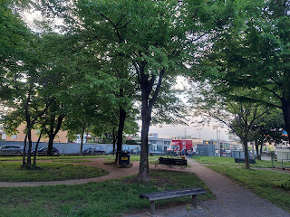

Some boys playing soccer . . .

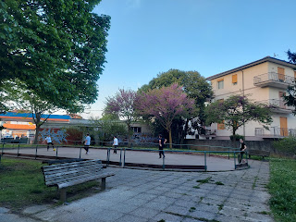

"Poppa" just needs some grandchildren to come and play with him. :)

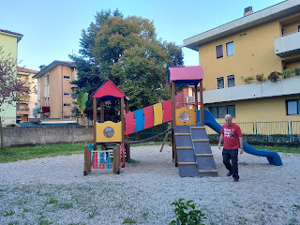

We thought it would be nice to continue our walk past the house in a direction we had not explored yet, so we went back out to the main street and walked to the west. Here are some of the things we found on the way.

Another park nearby.

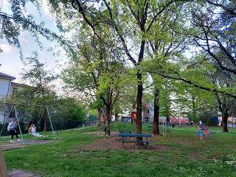

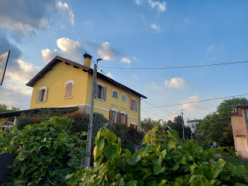

A one-way tunnel for cars, adjacent to an enclosed walking path for pedestrians and bicycles. On the other side it heads into the heart of Vicenza.

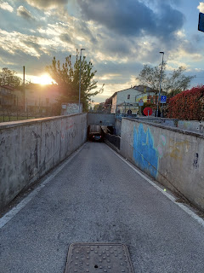

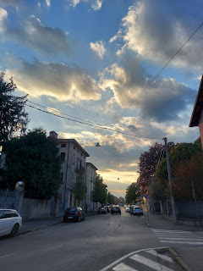

Wow was the sky sure pretty!!

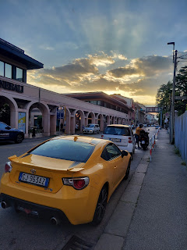

American fast food is alive and well in Europe, people. Domino's was the latest to surprise me. So far I've seen Burger King, McDonald's and now Domino's in the towns of Italy. On base, within the PX food court, they have Taco Bell, Subway, Popeye's, and a Philly Steak place.

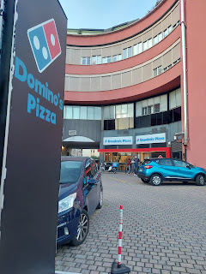

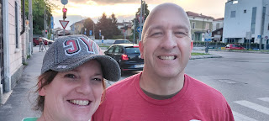

Back up the pedestrian walkway heading to the east and back to the house.

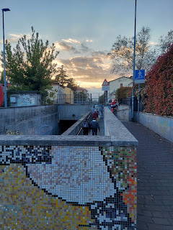

Up on the roof for one last breath in of this magnificent sunset.

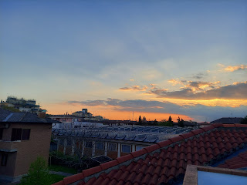

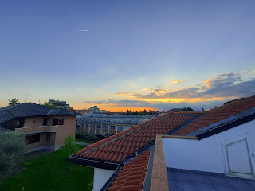

And then back to the hotel to get ready for bed. That was a really good day.

Thursday:
Up early again. This time it was so we could take the new 2nd car over to the mechanic for a workover. (The Peugot) When Scott tried to start it up, however, it wouldn't start . . . the battery was dead. He had to go out and find a set of jumper cables and chose to go to an Italian store nearby. He told me later that the man in the store, once he saw what Scott was after, said, "Jussa minuta. I goa finda you-a better one-a. Thisa one-a ees too esspensiva." He went into the back and came out with one that was identical but much cheaper. Scott was in awe of how nice people are here, and how much they really do want to help you.

After successfully jumping the battery and getting the motor running, I got buckled and behind the wheel to drive in Italy for the first time.

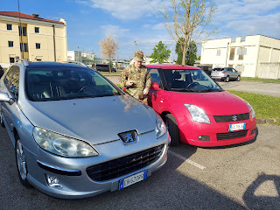

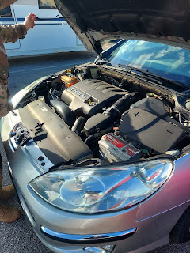

I followed Scott across town to the mechanic shop, one that caters to the military servicemembers here and speaks English. It was pretty hairy - the drive - but not because of the drive itself. I did fine. But the car - not so much . . . The first time I came to a roundabout and had to pause, the motor acted like it wanted to die. It kept revving and then sputtering, etc. I had to put it into neutral and rev it with one foot at each stop along the way. Very nervewracking. Sometimes we got separated from each other due to traffic, and each time Scott would find a place to pull over and wait for me. He would put his left hand out the window and give a thumbs up to ask me if things were okay. I would give him a "more or less" hand signal in return and then off we'd go again.

I was VERY grateful that we made it to the shop and that the car didn't die on the way, ha ha.



We'll keep it in the shop for as long as it takes to get things running properly and then once it's good to go, then I'll have a car for myself, which will be quite handy at times.

He dropped me off back at the hotel and then he went to work. I did some errands on foot multiple times throughout the day, all on the base. When I went to the PX for a few things, I saw this tent off to the side of the parking lot. This cheery Italian couple were selling several beautiful items that he made out of olive wood. This was the same guy that was selling some gorgeous Easter pieces that I wanted last week but he was already packing up for the day. I was happy to find him again.

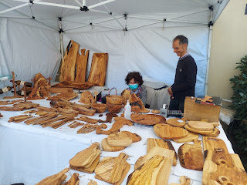

I decided to buy Scott a late birthday gift - as well as a "thank you" for all his many years of service in the military. The man told me that this piece is meant to hold all of Scott's serviceman's coins, which really grabbed my attention. He has several coins from 35+ years of service and they are all just sitting in a few military memorabilia boxes downstairs at home . . . not on display or anything special. I decided to splurge for something like this. I spent $60 total and they even engraved it (wood burned) with his name and a US flag. The lady had to look up the image of our US flag on her phone because she wanted to get it just right. How thoughtful!

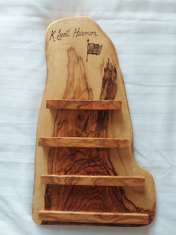

It sure turned out beautiful!! I can't wait to bring it home in my suitcase and find a place to hang it proudly in our home with all of his coins.

I found an image online of what something like this could look like:

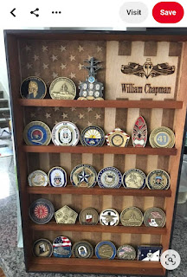

In the Commissary, I found another unique item that I would never find in the States. Kinda pricy if you're feeling like making guacamole and want this little "kit" from the Netherlands. Cute, but pricy.

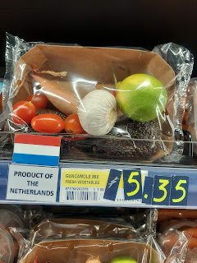

Once Scott got home, we headed over to the house and started tinkering around. I worked on getting the new dishes clean so I could use them to make our very first real dinner. Scott tried to figure out why the water heater wasn't producing any hot water . . .

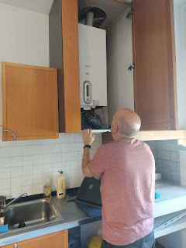

It's in a cupboard in the kitchen, and it's pretty small, but it's a "heat on demand" water heater and produces all the hot water for the entire house. Just not yet . . .

After some effort to get organized, finally I was ready to assemble the enchiladas.

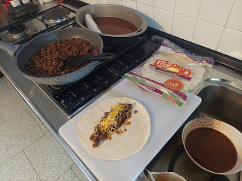

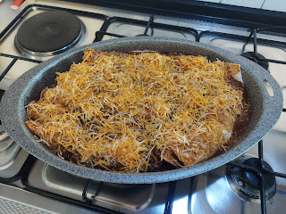

While the enchilada casserole baked in the oven, I washed all the dishes and got the kitchen a little bit cleaner. Scott helped out by drying everything and stacking them all at the far end of the counter. We couldn't put anything away in the drawers or cupboards yet because they weren't clean enough to do so. (That would come the following day)

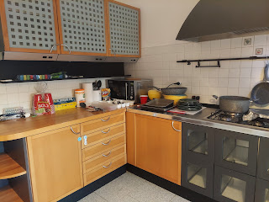

Once things were cleaned up and the casserole was done, we brought it back to the hotel so we could eat dinner and relax in front of a show to watch. It was very filling and felt wonderful to eat an actual home cooked meal that I made from scratch. :)

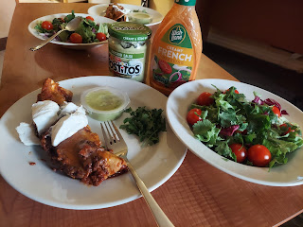

Friday:
We got up early again because a LOT would be happening all day long. Scott dropped me off at the new house and then went to work. My job was to be available for all the deliveries that were due to take place.

While I waited, I started attacking the kitchen, using Clorox wipes to get all the drawers, cupboards, and surfaces clean. Once everything was sparkly, I put all the dishes away that I washed the night before and moved on to clean two of the bathrooms with the wipes. Unfortunately, I had very limited cleaning supplies, which did not include a broom or a mop to work on the floors. That's okay, I had plenty of other things to keep me busy.

Eventually, the CFMO (not sure what it stands for, but basically it's the military furniture guys) arrived with the list of furniture that we had requested. They hire out to get the deliveries done, so the two men that brought our stuff were Italians. One of them spoke pretty good English, which was nice.

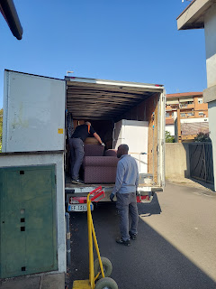

They were very strong as well as jovial, even though they had a TON of things to haul up a lot of stairs.
Couches, tables, dressers, chairs, even a bed.

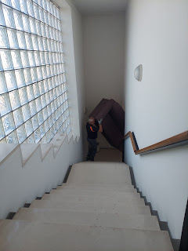

I felt bad telling them that the bed needed to go up another whole flight of stairs . . . but this would be for a guest bed, so up to the guest room it must go.

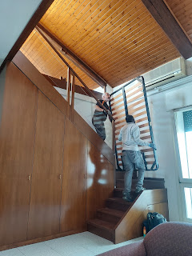

They also delivered a fridge that works! The fridge that came with the house doesn't work and nobody is sure why. But now we have one that works. Hooray! And we have a dining table and chairs, too.

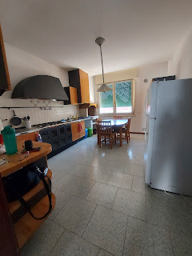

The couch set looks like what I had in my college dorm room 30 years ago, but that's okay. It's something to sit on and we are very grateful. Maybe I can find some covers for the couch and chairs to spruce them up a little bit.

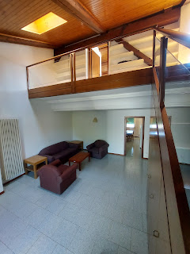

The undressed bed upstairs.

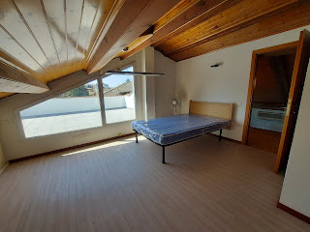

We even got a washer and dryer delivered too! They can't stack on top of each other so the dryer is in the office next door.

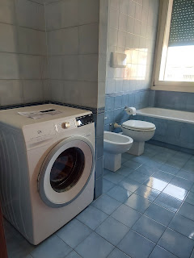

In addition to all the furniture coming in, our realtor Silvia's husband, Luciano, stopped by to take a look at the water heater situation, since the plumber was very busy. He noted that the heater was empty, which was kind of a big deal, ha ha. He didn't have the right tools to open the valve to fill it back up, so he had his wife, Silvia, call the
actual
plumber.

At the SAME time, the mattress guys called to say they were on their way. And then Amber called to chat as well! :) She was just waking Gwen up back in Louisiana.



And then Scott called on his way home from work. I answered with, "Ciao. This is the Harmon household switchboard. How may I direct your call?" ha ha

Soon, the plumber was on the scene with Luciano again, and then Scott got home, too. The plumber got everything fixed and all was well.

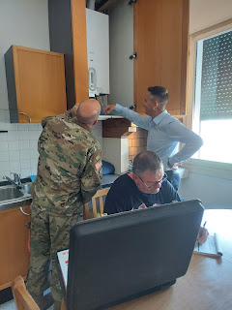

In the end, we got all the furniture we needed, the water heater got fixed, and our new bed was successfully delivered. A busy day, but a very successful day.

We needed a few more things at the store, so Scott dropped me off at Happy Casa again, while he went and got a new Italian cellphone - one with a nice data package and the ability to talk to the locals for both business and for work. Near the end of loading up my cart, I got a one-second video call from Jacob and then it hung up. I called him back but it was rejected. He messaged me saying that somehow Jack had managed to video call me on Whatsapp while the phone was locked!!

I responded with "It was meant to be." Jack must have been missing me, ha ha. Jacob said he had a break soon from work and would call me in a minute. When my phone rang and I answered it, there was sweet little Jack staring at me. Once he registered that it was me smiling at him, this is the gift that he gave me. (below)



My heart . . . he is the sweetest little guy and I love him so much! That was a wonderful gift at the end of a very busy day - just to see his cute little face smiling back at me.

We finished up our shopping, dropped it all off at the house, and then headed back to the hotel to eat leftover enchilada casserole, do some laundry, and watch a movie. :)

Saturday:
Pack up and move day! What an exhausting day that turned out to be, even though we don't really have very much stuff. Scott started the day with some allergic reaction to something in the air and was a combination of sneezing and runny nose for most of the morning. There are many things in bloom right now, so it was hard to know what was causing him such distress, but I did see some tiny little bits of cotton floating in the air so that could have been the culprit. He was pretty miserable and we couldn't find any non-drowsy Benadryl in any of the stores either. Eventually, once we knew we were done driving around for a while, he just took some regular Benadryl and powered through getting us moved in.

Saturday consisted of taking carloads of our belongings over from the hotel to the house, getting everything situated during the middle part of the day, and then running errands for several hours in the late afternoon/early evening until we were exhausted. He tackled things such as finding places for our new Italian surge protectors and getting us outfitted in the electronics category around the house, setting up the washer and dryer, putting together the frame for our bed, and getting his office set up and arranged. I worked on sweeping the entire downstairs, more cleaning, arranging everything that I hauled from the U.S. in my suitcases, organizing the 2 bathrooms downstairs, putting the bedding on our bed, and planning out a menu for the next few days and making a grocery list.

I'll include more photos from the weekend in next week's blog post because we are currently without any internet (except for using a mobile hotspot to finish this up). I had the wisdom and foresight to work on my blog each day throughout the week which made finishing it up today (Sunday) much simpler and faster. It's just taking forever to upload one photo at a time . . . (from Saturday and Sunday).

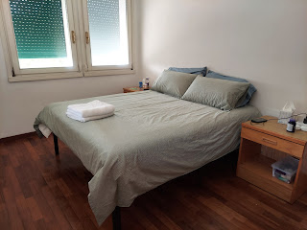

We do have a comfortable bed (hooray!), we have a working fridge and FOOD, and we have hot water. Everything else is secondary to those basic human needs.

Here's a photo of Scott installing a screen inside our bedroom window to keep the mosquitoes out. There are little kits at the Leroy Merlin that have some skinny velcro strips to attach just outside the window frame and then you can cut the screen material to fit and attach to the velcro. It was really nice to have the window open wide on my side of the bed all night and not worry about getting eaten alive. We intend to do more windows as time allows in the coming days.

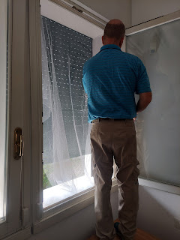

Today (Sunday) is much better in the sense that we don't have to run around to any stores, we don't have a long list of tasks to complete, Scott is feeling great today, and a family in the ward has invited us to dinner. What a lovely way to end a very busy week. :)

A few last photos of the Grandbabies
(ones that already landed in my Google photos before we went internet-dark).

Jack and Jake out to dinner

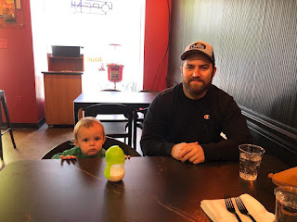

Getting warm?

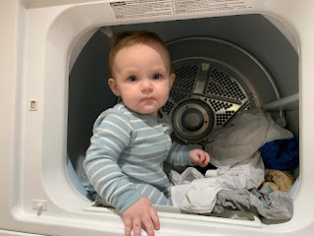

And Mr. One Sock On & One Sock Off is learning how to WALK!! How fun!!!
Video: (9 seconds)
https://photos.app.goo.gl/86U9c4AYCyLKVV5B6

Amber posted on the internet about their craft day at home recently. She wrote: "It's been a creative day today. I'm mapping out a garden for our yard, Gwen is learning to glue Gypsum bricks together to make a mill wheel, and we discovered the Sketchbook series on Disney+ where they tell the stories of animators and teach you to draw Disney characters. Not every day is this creative, but today feels good."

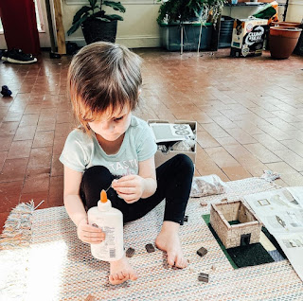

Their artistic and talented renditions of the snarky llama "Cusco" on The Emperor's New Groove.

