An Unplanned Failure, Spelunking, and a Beach Day
As disappointing as it was that we didn't get to go hiking in the Dolomites, we did our best to make the most of the day anyway. Traveling up to Cortina d'Ampezzo with my sister, Charmaine and her husband, Scott, along with my own husband named Scott, was going to be an amazing weekend for all of us. We had a hotel booked well in advance, and we were all excited to experience something new together.

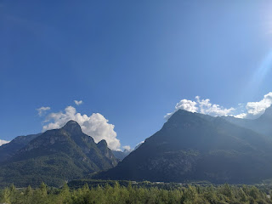

However, during our 2.5 hour drive north on
Saturday, September 7th
, we saw a warning light pop up on the dash. While Scott pulled over to investigate, I quickly researched on the internet what the warning light symbol meant. The light was indicating a problem with the glow plugs, so we studied up on that but it didn't make a whole lot of sense with our current situation. We later learned that the glow plug warning light can actually refer to a multitude of issues, not just the glow plugs.

We let the car rest for a few minutes . . . we said a prayer . . . and we felt good about getting back on the road again, so we did.

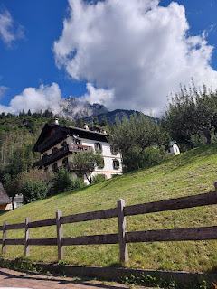

The drive was gorgeous, with spectacular heights on the Dolomites that we gawked at through our windows . . .

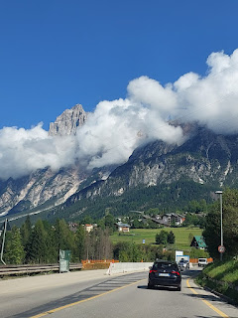

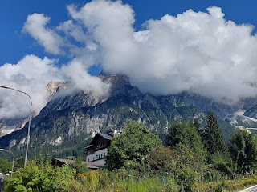

Video of the magnificent alps as we drove by: (4 seconds)
https://photos.app.goo.gl/77nUNrM7XAL6wnCx8

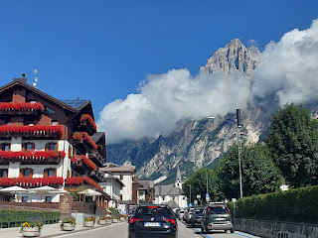

The tippy tops of the mountains seemed to compete with the church steeple in one of the towns we passed through . . .

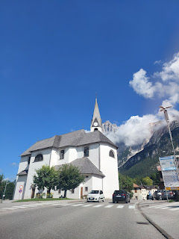

In Cortina d'Ampezzo, we turned off of the main road to begin a steep ascent up the mountain in order to get to the chairlift for our hike. But the car had other plans . . .

It was as if the car went into "limp mode", not wanting to go. Scott said the car was struggling in third gear, so he shifted down to second, but the car kept slowing down. After only going roughly one kilometer up the curvy mountain road, the car slowed down even more, not wanting to increase its speed even in first gear. Scott decided to pull over and shut the engine off. We sat there, perplexed, not daring to speak for a minute, or to admit defeat . . .

We were just 8 km from the chairlift that would take us up to the Cinque Torri hike. We had come so far . . . and it was looking pretty bleak. We said another prayer, asking for guidance on what to do. Scott felt in his heart that we needed to turn around and drive home, but I questioned the car's ability to drive all the way home with the issues it was currently having. He said he felt that the problem was more pronounced when we needed to go UPHILL, where the RPM's were higher. If we went back down the hill, and then just stuck to the mostly-level freeway, he reasoned, then we should get home alright.

I convinced him to at least stop somewhere back in Cortina so we could see if a mechanic was available to take a look. We found a hotel at the bottom of the hill (and in Cortina) with a very helpful and kind receptionist. She made several calls to try to track down a mechanic for us, but alas, mechanics don't typically work on Saturdays in Italy she regretfully told me.

We discussed other options, such as catching the bus up the mountain from where we were, but we would need to go back up that steep mountain road a couple of kilometers just to get to the bus stop, and we knew that wouldn't work. It seemed that home was indeed the intended target for the day after all.

I called our hotel to cancel the reservation for that night, which meant we were out roughly $250 because of the lateness of the cancellation. And then we began the long 2.5 hour drive home.

As we passed back through the large city of Cortina d'Ampezzo, I kept my eyes peeled for somewhere that we could get out and enjoy something. Anything! It didn't take long before we found a place to park and go for our own little explore. It was in a little town slightly south of Cortina, called San Vito di Cadore.

While this photo doesn't really show the beauty of this man-made river, the water was crystal clear and cascaded down the slope in splendid fashion, with the mountains as a lovely backdrop.

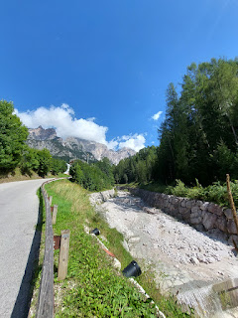

We walked up a fairly steep hill, in between several homes and old buildings, with a better view of the mountains as our goal.

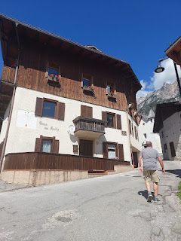

There was an unexpected teeny tiny, but tall and slender church . . .

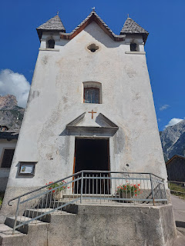

I took a quick peek inside . . .

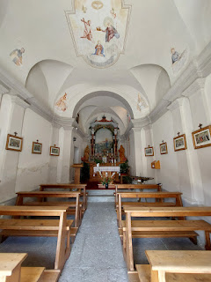

On the door of the church, it says, "Ave o Maria, Piena di Grazia." The English translations means: Hail Mary, Full of Grace.

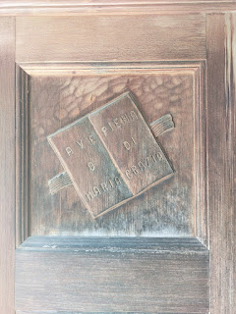

We found our view of the mountains alright . . .

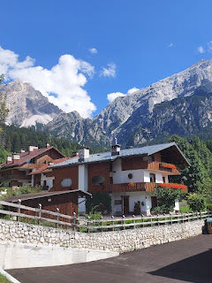

The air was crisp, and Charmaine found a few wildflowers still hanging on for the season . . .

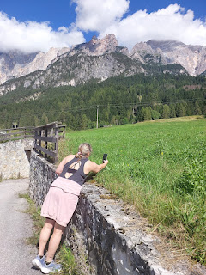

Charmaine and Scott . . .

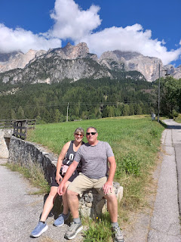

Scott sent up the drone for a couple minutes, too.

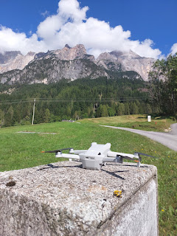

Here's the link to the footage that he took: (7 minutes, 11 seconds)
https://www.youtube.com/watch?v=I4MoolnGH2o

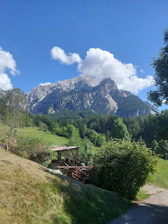

After we got our fill, we hiked back down to the main road that runs through town . . .

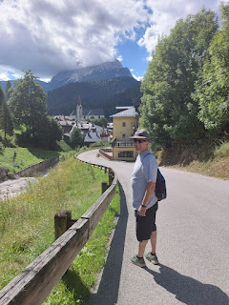

When life gives you lemons, you gotta at least try to make some lemonade. Or in this case, when the car says you can't make it up the mountain, you just carve your own path on foot.

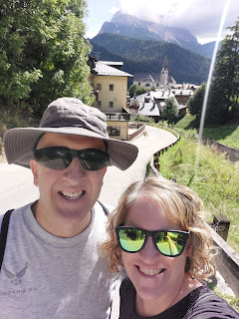

San Vito di Cadore is a really cute town. In our brief interaction, I was charmed and captivated.

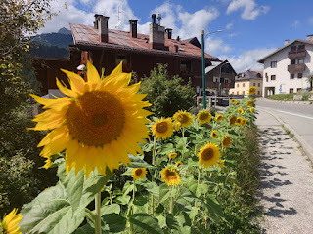

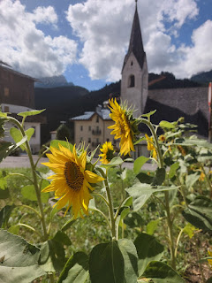

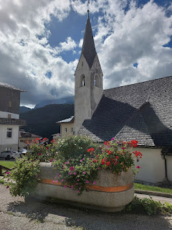

The church on the main street, across from where we parked is named, "Chiesa dei Santi Vito, Modesto e Crescenzia". I went inside for just a minute or two, but I didn't stay long because there were a handful of old Italian ladies cleaning the inside of the church and I didn't want to get in their way.

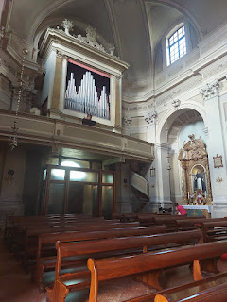

Video of those sweet ladies working hard to get everything ready for Sunday: (10 seconds)
https://photos.app.goo.gl/1z6TfdciDxcW6dmz5

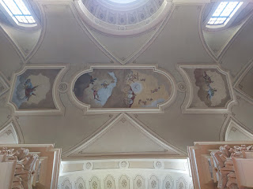

I thought that it would be a good idea to stop one more time on our way home, to give the car a rest, just in case it needed it. I did some detective work on my phone to find a place that was right next to the freeway and also had a scenic little walking trail next to a lake. It sounded so perfect . . .

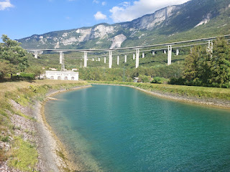

What the map didn't show is that the lake was considerably down
below
the highway, and while it was fine driving down a little at a time, we all started getting anxious as we navigated the last kilometer or so because that's when it got a little steep. It turned out that this was not a good idea . . . and nobody wanted to get out of the car to see the lake, because the fear of what might happen as we tried to drive back UP to get the freeway again kind of spoiled the mood . . . (You can see the freeway in the photo above - those very tall pillars and road above the lake.)

The lake WAS beautiful, so Scott and I got out to see it for a minute or two, and then we got back in the car and somehow we miraculously made it back up and onto the freeway.

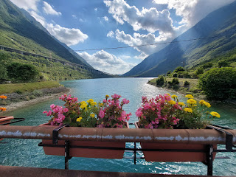

We made it the rest of the way home without further incident, thank goodness. The warning lights (we had another one come on during the last hour or so) ended up being linked to a problem with a hose that connects to the turbo. It had disconnected from the engine and needed to be replaced altogether. We paid our trusty mechanic, Vittorio, about $500 and he got everything fixed in less than 2 days. This included replacing the hose, replacing all the filters, changing the oil, along with all of the labor - plus parts. So now, we are all set to go up into the mountains a second time with our friends (the Garners), who are coming to see us next weekend. We are planning to go to the same place (Cinque Torri), so hopefully it all goes fabulously!

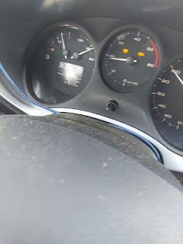

Charmaine and Scott went on a date that evening after we got home. They walked into downtown Vicenza to go on an explore and to find a nice restaurant for dinner. They walked home later when they were done, and reported that they had a wonderful time! Meanwhile, Scott and I enjoyed a nice, quiet night "in" for our date night.

The following day,
Sunday, September 8th
, even though the weather was looking a little "iffy", we decided that we needed to get out and see something. We drove our other car (the red "zippy" one) over to the Bassano del Grappa area to visit the Grotte di Oliero. This was on Charmaine's list for an earlier date, but the weather had been too poor so we had skipped it.

It's a cave system connected to some ancient springs, north of Bassano along the Brenta River.

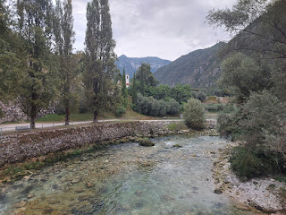

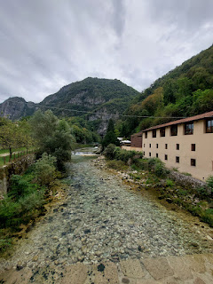

You can click on the photo below to see a detailed description of the Oliero Cave System.

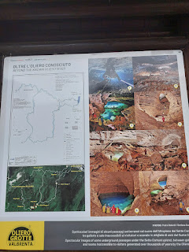

For more information, you can also visit this website: (it's in English!)
https://www.grottedioliero.com/complex/

We all really enjoyed the nature trails that led to and alongside the caves and the river.

Below: Scott and Charmaine, before our tour into the cave . . .

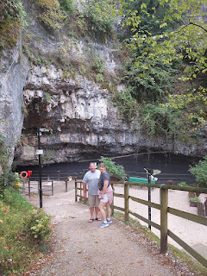

Note how clear the water is . . . this little rowboat looks like it's sitting on top of some sand and rocks, when in fact it's floating in the crystal clear water. This is the boat that took us into the cave a few minutes later . . .

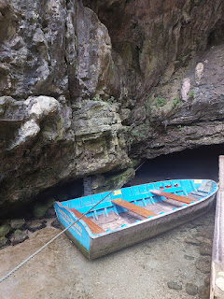

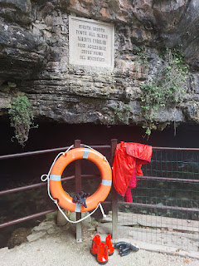

We were instructed to duck down for the first few meters, ha ha. This is also the place where we entered, believe it or not. There were approximately 10 of us seated in the boat, and we all had to bend forward to squeeze in between the water and the rocks just a few inches above our heads . . .

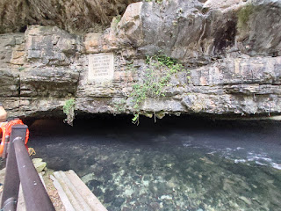

Video of the space before we boarded the little row boat: (21 seconds)
https://photos.app.goo.gl/sVgC1ps6Zo5xkwFd8

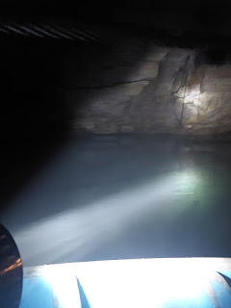

Video of our guide giving an explanation in Italian, before he switched to English for the four of us:
(16 seconds)
https://photos.app.goo.gl/ej2kWB9bS1ZJiY8P7

Our guide pointed out a huge stalactite with his flashlight as we entered the cave . . .

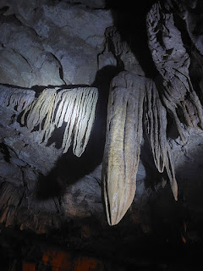

We were ferried by a rope system to the interior dock, with our young guide propelling our boat along as he pulled on the rope that connects to the dock. The pathway into the cave was well lit and we had plenty of room to walk around.

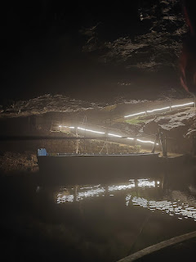

Video of our young tour guide docking our little boat: (9 seconds)
https://photos.app.goo.gl/SV85g2BaLspRb4gt9

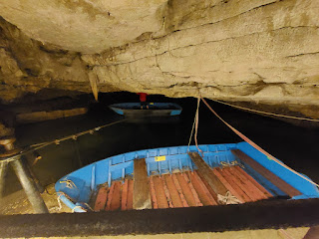

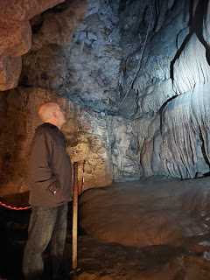

Our guide did a great job of making sure we had a complete explanation in English in each area of the cave, inviting us to speak up if we had any questions at all. We didn't go very far into the cave, though, because it would have been a very tight squeeze and would have required some higher levels of expertise and status to even be allowed any further back.

Here is a little bit of him explaining about the biggest and oldest formation: (32 seconds)
https://photos.app.goo.gl/pVTU4M5QUKRd9EHW9

The entire tour lasted about 30-40 minutes and then we began our rowboat ride back out to the entrance of the cave . . .

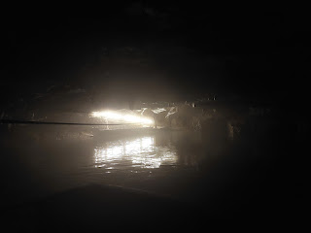

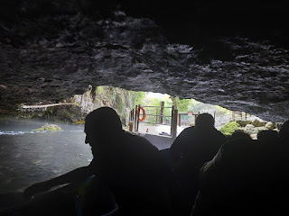

It was a little drizzly by the time we exited the cave. Scott and I posed for a couple of pictures . . .

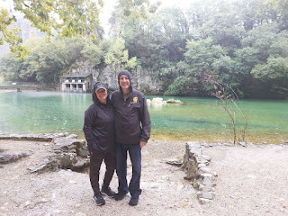

Hoods up first . . . and then we tried again with our hoods down . . . (much better!)

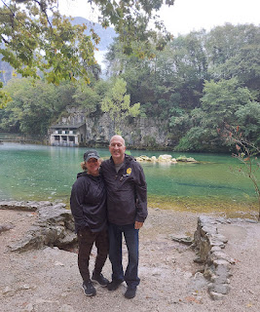

The water was SO BEAUTIFUL . . .

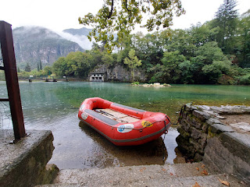

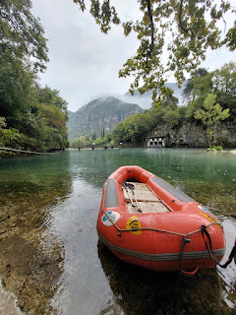

A beautiful sister next to a beautiful river . . .

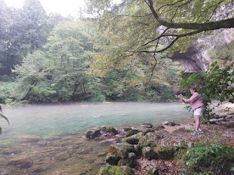

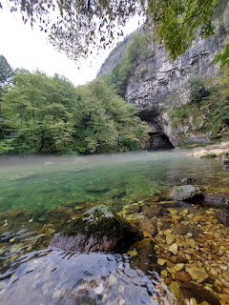

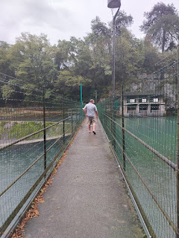

We followed the nature trail up above the caves for a while, eventually circling back to this point where we crossed the man-made dam . . .

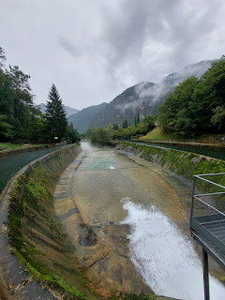

Video of the river, the dam, and into the beyond: (11 seconds)
https://photos.app.goo.gl/7h2gmgq9VBnv6Eiz9

Here are a handful of flowers from the Grotte di Oliero that we came across . . .

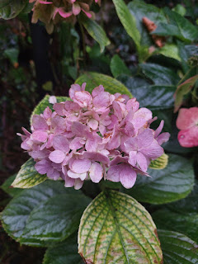

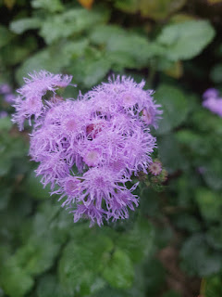

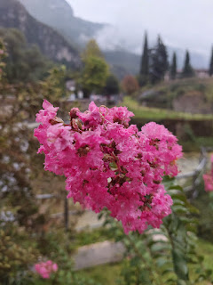

It was a cool experience, and we all enjoyed being out in nature, hearing the water, smelling the fresh air, relishing in the crispness of the temperatures that afternoon, etc. I would recommend it to other people because it was short, sweet, and inexpensive.

The following day,
Monday, September 9th
, we drove one hour ESE to visit Chioggia, one of my favorite places in Northern Italy. I love the smallness of the town, the authentic nature of the town with its fishing industry, the limited number of tourists, being on and around the water, eating a big bowl of mussels for 10 euros, and then hitting the beach at Sottomarina.

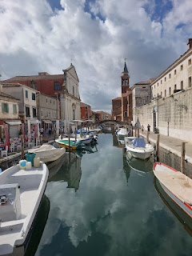

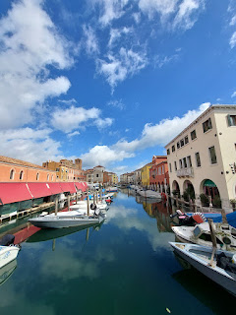

This was a new and very fun discovery! I've been to Chioggia many times, but I've never seen anything this cute there before . . .

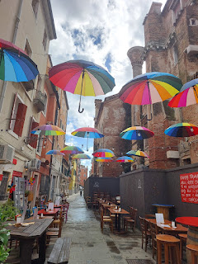

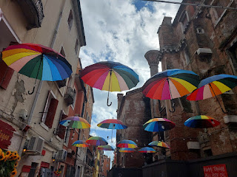

We took a one-hour boat tour around the canals, the harbor, and the open sea of the Adriatic, while sitting back and enjoying the breeze, the scenes, and the beautiful day.

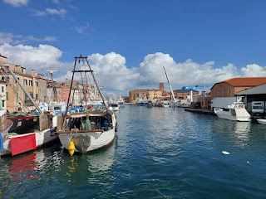

Sottomarina connects to Chioggia with ONE little bridge. While Chioggia is more of a working town, Sottomarina is its playful younger sibling, full of several beaches that line the narrow 12 km island. The "back side" of Sottomarina is where their boats (and pricy yachts) are parked, and you can also see their colorful apartment buildings where the locals live in their own little paradise.

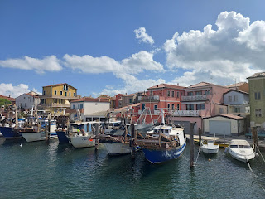

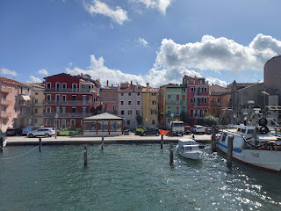

My super tasty lunch of mussles + tempura fried vegetables. XOXO

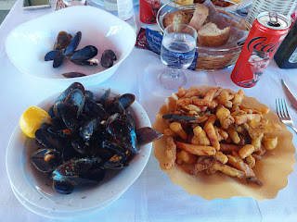

The day was plenty warm at the beach after lunch . . . and the skies were bright blue and gorgeous.

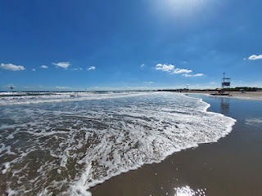

Charmaine enjoyed looking for a variety of seashells to bring home . . .

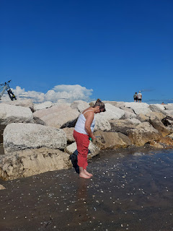

Huge ships sailed past us on the other side of the dike . . .

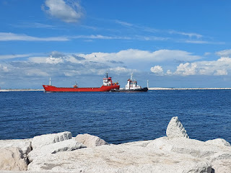

(Charmaine's) Scott contentedly stood in the water and watched the waves for a long time . . .

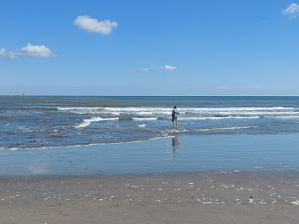

I got a kick out of watching a kite surfer zip back and forth across the waves.
You can watch him here: (29 seconds)
https://photos.app.goo.gl/Sm5wc9hL1K7bvqhz9

And this short clip shows how much "air" he got at one point: (5 seconds)
https://photos.app.goo.gl/eL4Q6NykYUpHqe2y7

More shell-sleuthing . . .

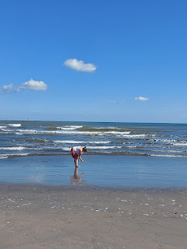

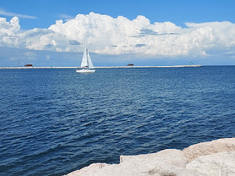

Charmaine and Scott on the northernmost dike of Sottomarina . . .

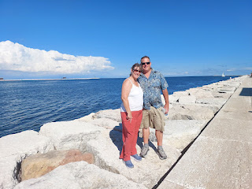

In order to use the nice bathrooms at the Il Diga Beach and parking area, you have to make a purchase at the restaurant/bar first. They print out a ticket as part of your receipt. You use the barcode on the receipt to scan in order to go through the turnstile and into the very nice bathrooms.

I made this delightful little purchase in order to access the bathrooms before we drove back to Vicenza.

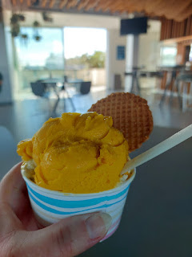

Next week
: Hopefully I can crank out another blog post before our next round of company arrives on Friday evening. I'll be sharing details from our recent overnight adventure to Croatia and Slovenia, along with a special discovery and full day in Venice before Charmaine and Scott traveled back to the U.S.

