Asian Week + Moving In
Besides all of the packing of boxes and hauling them down and up several flights of stairs, thus burning plenty of calories and upgrading our steel buns to the next level, I was craving some Asian food at the same time. I would plan out a menu, get the groceries, and every couple of days I'd make us a tasty meal that would last for an extra "freebie" night. It was a great way to get through the busy week that we've had . . .

We officially moved in yesterday (Saturday) and slept in the new house last night. It is very comfortable here, and very peaceful. It was helpful that the first house was so close to amenities for the past 3 years, like the Lidl grocery store (which was right across the street), and the main base was a 15 minute walk away or a 3 minute drive. But it was also noisy and crowded with several tall apartment buildings all crammed into the same neighborhood. We lived next door to a gas station and car wash, which also added some "ambient noise", ha ha.

The new house is very quiet and relaxing and it feels more like country living. It feels very safe here, too. We have a gated entrance off the main road and then a loooong driveway leading up to the house. There are several huge grocery stores nearby, and I hardly know where to begin. Even though there's not a store right across the street, there are plenty of options within close range, and I think we'll be okay if we accidentally forget one ingredient for dinner . . .

There are two "flats" in our building: Bruno lives in the lower level, which is technically the middle level since the garages are on the first level. His garage is in the front (see photo below) and ours is around on the back of the house. The garages are HUGE, with enough length for both of our cars to fit inside - plus room for lots of other things, too. We live on the upper level, or the third level.

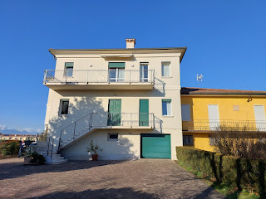

The balcony goes from the master bedroom (at the top, on the far right) past the dining area (the large double doors) and over to the kitchen at the end.

Here is another view of the house, with the upstairs windows of our living room that overlook the driveway and main entrance into the building. We have our own private entrance.

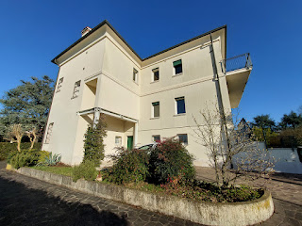

I've never been in Italy during January and February before, but it's been lovely! The weather has mostly been in the low 50's during the daytime, and the low 30's at night. Some mornings, I've woken up to a layer of ice on the windshield of my car. We don't have an ice scraper in Italy, so we used a not-so-important plastic card from Scott's wallet to clear the windshield one morning when I needed to drive him to work. (The white car was back in the shop for 2 days to get the "phlegm" from the diesel exhaust cleaned out.)

While the weather has been a mixture of overcast days and sunny days, it's been fun to capture some moody photos here and there. This is the view looking south from our balcony on one of those occasions.

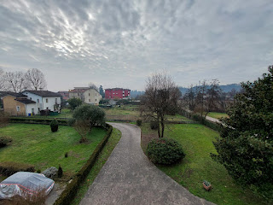

Off to the west, there is a field where the Three Wise Men stood valiantly during the Christmas season (and a little into the new year). They have since been cleared out and put to bed somewhere until next November.

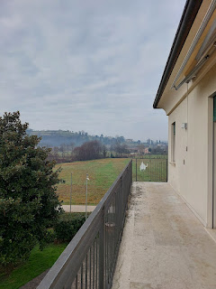

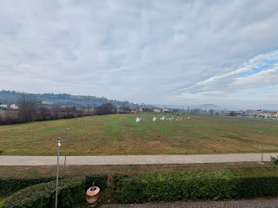

This is what I see when I'm standing at my kitchen sink . . .

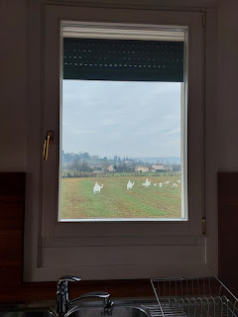

For one of our Asian dinner meals, I made Wonton Soup. If I were in the U.S., I could have made the easier version by utilitizing frozen wontons that were already put together. But . . . over here, it's harder to find such things, even in the Commissary, so I had to make them from scratch. I followed the recipe to assemble the wontons, by chopping up some green onions and garlic, shredding some ginger, and lazily chopping up some shrimp. I added some spices and sauces (sesame oil, soy sauce), stirred it all up, and then we added a teensy weensy bit to each wonton before folding them up.

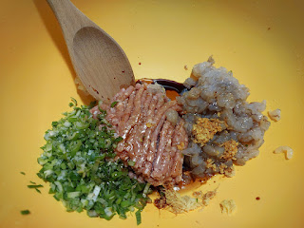

Scott was part of my assembly team . . .

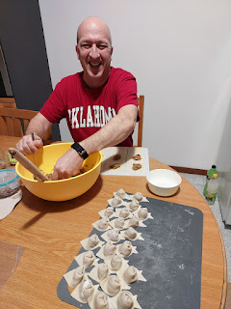

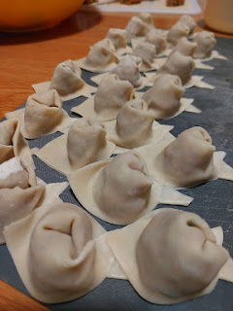

I sauteed the extra shrimp and the leftover ground pork, surplus from the wontons. Then I boiled the wontons until they floated up to the surface. I ladled a heaping portion of the shrimp, pork, and wontons into bowls and then moved on to sauteeing all the veggies.

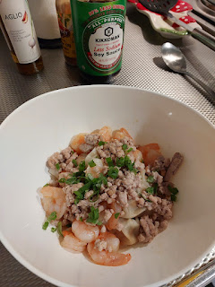

Pretty soon, I had a very thick soupy mixture filled with vegetables and broth. I added some bok choy, carrots, cabbage, and mushrooms.

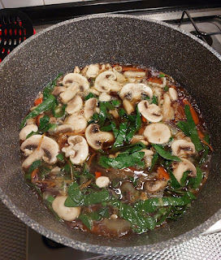

This is the recipe that I loosely followed: (I added way more vegetables)
https://www.recipetineats.com/wonton-soup/

It was super yummy.

We made another visit to the new house to meet up with Daniele, our landlord. He wanted to show us a few things, like how to get the heat going. There is a magnolia bush just outside our entry door that has several thick and fuzzy buds, itching to burst out someday very soon . . .

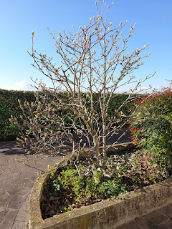

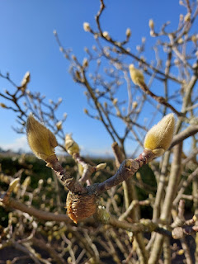

There is a fountain next to our driveway, too, with constantly running water. I'm hoping that this won't be a breeding location for mosquitoes when the warmer weather arrives. Daniele did indicate that they have "some" mosquitoes around the property . . . "oh boy". I recently found a Citronella essential oil that I will be applying DAILY, in the not too distant future. I'm SO GLAD we moved during the dormant season for those aggressive little Italian skeeters. I can't imagine how bad it would have been, with our car doors open while we unloaded carload after carload of stuff, plus the entry door was open as we hauled everything up the 4 flights of stairs. Yeah. I am
infinitely
grateful that we moved in February, as opposed to May or August or October (or
any
month from April to November).

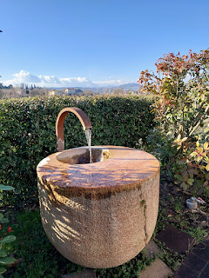

Daniele also gave me permission to do some gardening on the property. YAY!! There is a long flowerbed on the side of the house, and he said this would be a good place to plant some flowers.

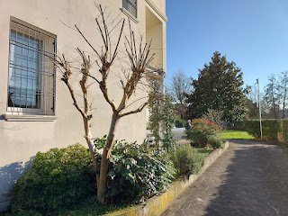

On the back side of the house is where our garage door opens up. There is a shady area off to the left, with potential for adding a few colorful blooms here as well . . .

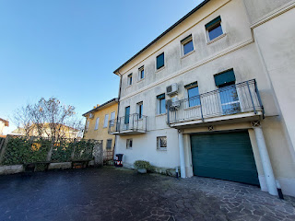

In that shaded area, there is some wooden seating, with wooden flower beds in between . . .

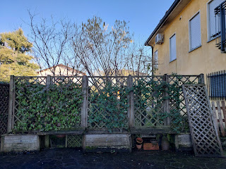

Around in front, there is a grassy patch with a hedge that surrounds it. Daniele said I could dig up a little section for a vegetable garden if I wanted to.

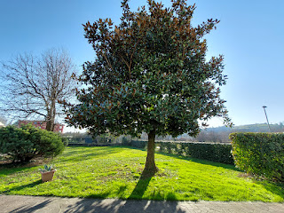

In the far right corner is where he suggested I work. It would get full sun all day long because the sun would be shining on it from the south, which is off to the left in this photo.

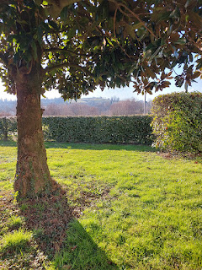

Last Sunday, Scott and I came back over to the new house so we could go on an explore. This is the view looking toward our gated entrance, with the main road on the opposite side.

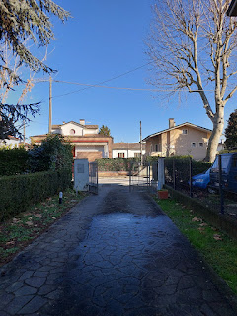

This is the view looking from the gated entrance towards the lane that leads to the house.

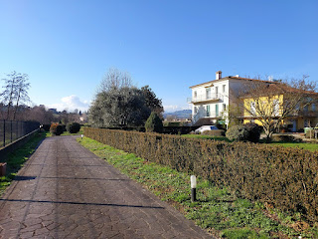

There is a gas station a short distance away, sort of diagonally across the street from our gated entrance.
If you look closely, you can see Del Din across the field behind the gas station. This is how close we are to the base where Scott works . . .

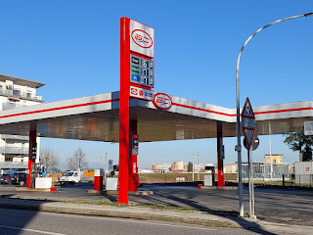

We found one of the entrances to the Romea Strata walking trail that goes behind our house. The trail is part of an extensive pilgrimage route to Rome (where Peter and Paul are buried), and one that Copernicas and Galileo Galilei have also traveled on anciently. Maybe they didn't walk on this specific section per se, because this little offshoot that we found doesn't connect directly into the other larger trail that continues across several countries in Eastern Europe before eventually heading south to Rome. But it was still fascinating to research what it all means.

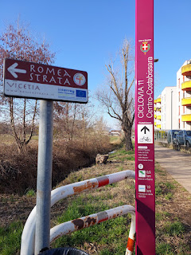

For a map of this section of the trail, that leads from Rovareto down to Badia Polesine (just west of Rovigo), you can click here:
https://www.romeastrata.org/en/via/the-via-romea-vicetia/

We followed the trail for a little ways, enjoying a scenic afternoon of discovery together. We passed by the Santa Maddalene Church, with a history going all the way back to 1437 AD. It also had some WWI souvenirs in front, as I'm sure most churches were inevitably in high demand during war time (either as a headquarters or perhaps as a makeshift hospital).

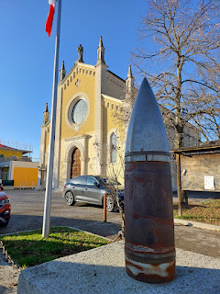

We don't live very far away from the church, and have already heard its bells ringing a few times. Such a beautiful and comforting peal, in my opinion.

As I mentioned earlier, the path continues along behind our house, as seen in the photo below. There is a small ditch filled with water between the path and the fenced hedge on the edge of the property. The ditch is like a creek, but the water doesn't move much, thus causing some pea-green algae to grow on the surface. Further on, the water moves a bit more as it connects into larger irrigation ditches for the area farmers.

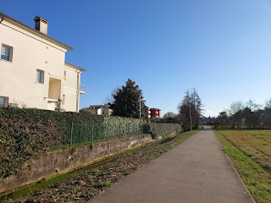

A map on the trail that shows how it passes through Vicenza . . .

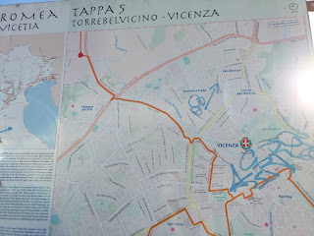

Scott is pointing to where Del Din would be, if the map extended just a little bit more to the north. The red dot shows where we were standing.

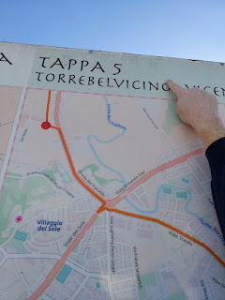

Even though someone got a little trigger happy with some sloppy blue paint, the bottom portion of the sign gives a historic description of the area in Italian, German, and English. I liked the quote from Psalm 119:59 that says, "I gave thought to my steps, and my feet were turned into the way of your unchanging word."

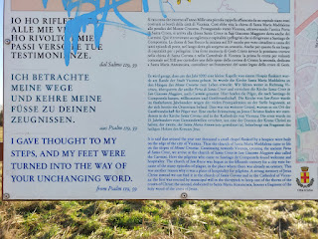

Here is a closeup of the description . . . (some words don't translate perfectly, ha ha)

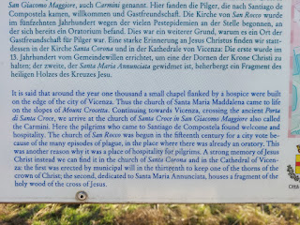

We found a way to walk up to the top of Mount Crocetta, the closest hill that we can see out our windows, the one that has terraced vineyards and farmland criss-crossing the length of it. Just before we began our slow ascent up the switch-backed road, we did a little research on our phones to learn why the Italian farmers always plow the fields up into huge chunks of dirt every season. (as seen below)

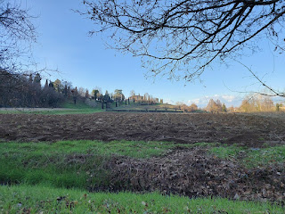

Apparently, there are a lot of benefits to doing this:
It breaks up compacted soil. Turning the dirt over in large chunks help loosen it, improving root penetration and drainage.
Increases aeration. The large chunks create air pockets, allowing oxygen to reach plant roots and beneficial microbes, which help to break down organic matter.
Weed and pest control. By burying weeds and insect eggs deep underground, this helps reduce competition for crops and minimizes pests.
Preserves moisture. Large clumps reduce surface evaporation by slowing down water loss, which is especially useful in hot, Mediterranean climates.
Prevents erosion. The rough texture of the soil slows down water runoff, helping to prevent soil erosion from heavy rains.
Improves soil fertility. When organic matter or fertilizers are mixed into the soil, large chunks help incorporate them more evenly over time.
"Deep plowing", as it is called, is still very common in Italy, expecially in areas with heavy or clay-rich soils. It's true, we have seen this method all over Northern Italy. Fascinating to understand WHY they use this method, though.

A selfie on our walk up the hill . . .

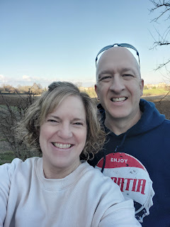

Up near the top, we found a little memorial to some local martyrs, who lost their lives at the very end of WWII. On 28 April 1945, the city of Vicenza was liberated from Nazi German occupation by the Allied Forces and some Italian Partisans who were part of the resistance.

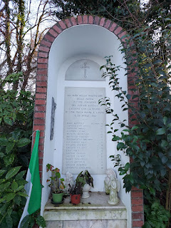

With Google Translate, the memorial reads: "At the dawn of the redemption of the Fatherland, the innocent victims of German fury fell with the vision of a New and Free Italy on 28 April 1945". And then there is a list of the names of the victims from this area.

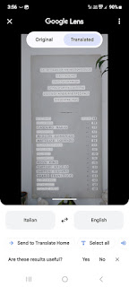

It may be a little hard to see, but as we descended down the hill, we could see a portion of Vicenza off in the distance . . .

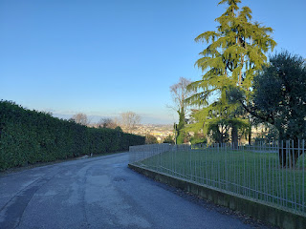

As the driveway curves around to the garage in back of our house, there is a large brick oven grill that we can use. Wood is already available, chopped up and ready. We just need to give it a whirl one of these days.

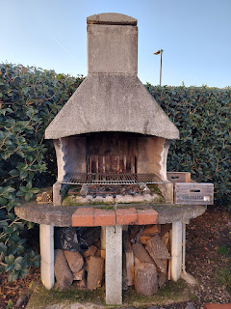

Here is a view at the bottom of the stairs that go up to our flat . . . we intend to make this a "mud room" where you can clean off a bit before trudging up the white marble steps.

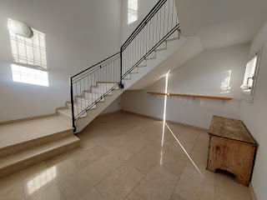

Back at the old house, I kept busy each day by emptying out as much of a room as I dared in advance, and then hauling the stuff over in my car to the new house. Sometimes, we'd load up both cars and then transport double the amount of stuff.

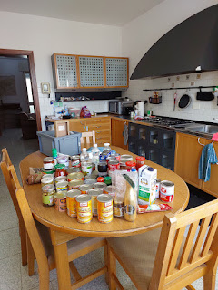

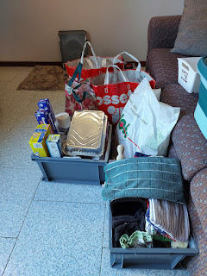

Asian Dinner #2: Egg Roll in a Bowl
Recipe here:
https://lcarecipes.com/egg-roll-in-a-bowl-crack-slaw/

The secret new ingredient that we tried for the first time (and LOVED IT) was a combination of ground chicken/turkey/pork and formed into a loaf within the packaging. I went over to the Lidl to look for something like ground chicken, and found this little gem that we had never noticed before. I seasoned it with salt and pepper, a little bit of onion powder, and some chopped red onion and garlic.

I threw in some rainbow cabbage mix and the rest of the mushrooms that were leftover from our Wonton Soup. We also had some cooked carrots, so I threw those in, too. And then, to top it all off, I added a fried egg on top. Cuz why not? IT WAS SO GOOD!!! We both agreed that this new ground meat mixture was a hit. It was so tender and perfectly delicious.

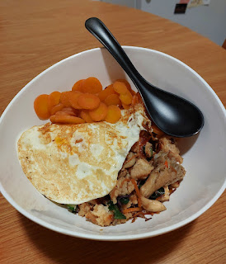

I took a break from packing one day to go to IKEA with my friend, Rachel McGovern. The nearest store is located in Padova, about 30 minutes east of Vicenza. I did the driving, and she did the cheering. :)

The goal was to do some recon on some furniture pieces we needed. I had already looked online ahead of time, which was super helpful because the IKEA stores are a beast - not only because of their monstrous size, but also in the sheer volume of stuff you have to sift through with your eyeballs as you wander through all the paths and rooms and levels.

Something I had not considered or put on my radar at all was this incredible table that Rachel pointed out to me. It could work perfectly as 1) a sewing/craft table, 2) a board game table, and 3) extra table space for when company comes.

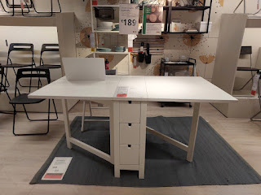

You can use the entire surface, or half of it, or tuck it all away, taking up very minimal space. Wow.

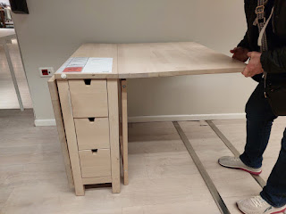

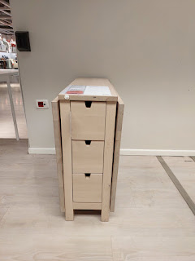

The wardrobes I had discovered online ahead of time turned out to be fabulous. Not only were they sturdy and offered lots of storage space for the two extra bedrooms (closets are not standard in Italy), but they were such a great price. $170 - and they even come with a built-in mirror, too, which saves some money.

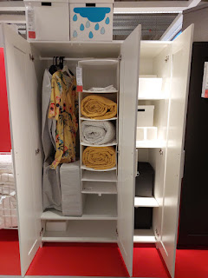

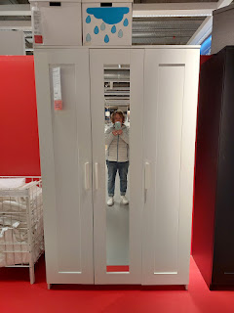

We've only done this once before, and that was 3 years ago when we bought our mattress locally, but there's a PROCESS to save you from paying the 22% tax on certain items in Italy (if you're willing to go through a rigamarole).

Essentially, you go to the box store (can't be an online store) and get a printout of the items you want to purchase. The printout needs to include the breakdown of the price of the item, as well as the 22% tax. Then you take the printout to the tax office on base. They look over the paperwork and verify the amount you would be responsible for, and then they send you off to get a bank certified check for that amount. (This is the form we were given to explain it all.)

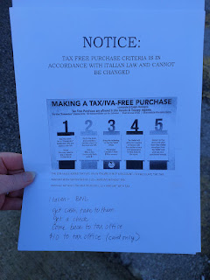

There are a couple of options for getting a bank certified check in Italy: Community Bank or BNL. Community Bank is a US based bank, but serves military personnel and their families overseas. They have ATM's and offices where you can go inside, just like if you were in the US. Buuuuttt....to get them to print out a check for you takes a WEEK!! For whatever weird reason, they have to send off the request down to Naples and then wait for it to get sent back up. Weird, right?!

Or, you can go to the Italian bank called BNL on the base, where they can print off a check right there on the spot (for FREE). You just have to get there early enough in the day because they close at 1:20. Yes, you read that right. 1:20. Not 1:30. 1:20.

On this particular day, things were hopping. While Scott was at work, I had an appointment at the IKEA planning & ordering center in Vicenza at the Palladio Mall, about 5 minutes east of our house. We had gone there the evening before, but we were told that we needed an appointment, so we grabbed the 11:30 slot for the following morning. Scott was at work, so it was up to me to get the ball rolling.

Because I'm an organized person, I was able to finish my appointment in 10 minutes (they typically block off a full hour for each appointment). I had all the information prepared in advance, and the girl helped me by efficiently printing out the form that I needed to take to the tax office.

This is what it looked like . . . you'll notice at the bottom that we saved about $200 by going through the rigamarole. Not too shabby.

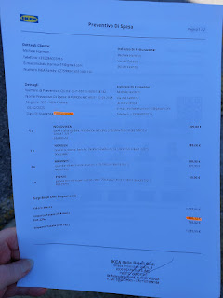

The tax office gave me the options between Community Bank and the BNL, but it was already noon at this point - and remember how the BNL closes for the day at 1:20? So I reached out to Scott via email (he isn't allowed to have his phone in the room where he works) and then I just had to wait for him to see it and get back to me. It took about 30 minutes before I got a phone call from him. He ended up coming over from Del Din (his base) to Ederle (the bigger base where I was) and we hustled to get everything taken care of at the BNL - with just a few minutes to spare before they closed.

The reason why we were in such a hurry is because this was on a Wednesday and we had reserved a moving van for 24 hours, starting on Friday afternoon. The plan was to go pick up our items at IKEA on Friday evening and then do the rest of the moving on Saturday. We needed to get all of our little duckies in a row because there were already
so many
things going on.

While I was waiting for Scott to respond to my email, I wandered around the food court area of the PX (Post Exchange) where they always have numerous vendors with their wares on display for purchase. The lady who makes super cute gnomes was there again - I hadn't seen her in a while. She had the cutest little cupid gnome and I decided to buy it from her. She wrapped it all up so lovingly, as the Italians always do, and while she was doing that, I took a few photos of her other darling gnome creations.



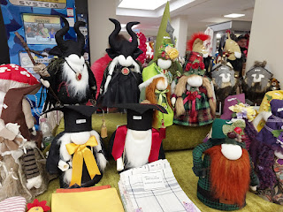

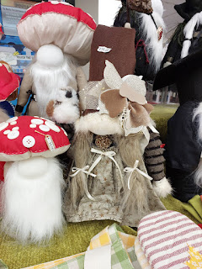

This is the one I bought - and because we don't have any cabinets or tables built yet (Scott is working on that a little at a time), he's just sitting on top of our microwave at the moment. He's about 12 inches tall, maybe a little more.

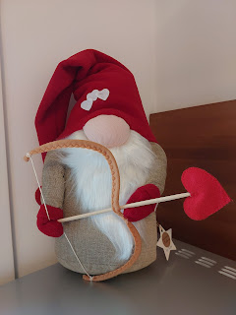

Once we finished up at the bank and the tax office, Scott went back to work and I went home to do some more packing and transporting stuff to the new house. I set aside a few outfits for the next 3-4 days, and then I hauled everything else over to the new house. The master bedroom already has built-in wardrobes there, thank goodness.

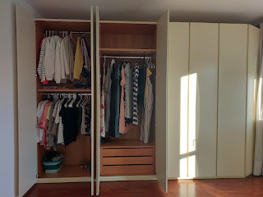

When you go to IKEA, it's always fun to pick up a few items in their little food market downstairs by the checkout area. On my visit on Tuesday, I had grabbed a bag of Swedish meatballs, some lingonberry jam, and a few packets to make the creamy gravy sauce that goes over the meatballs. To add some hearty fiber for dinner that night (Wednesday), I also cooked up a couple of sweet potatoes. This was an epic dinner - and it was all about creamy, flavorful, comfort food for the next two nights. Yumm!!

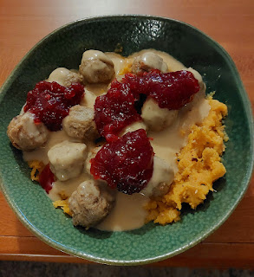

In the vast garage at the new house, one of the previous (American) tenants was a mechanic. But not just any mechanic. He was an orderly, organized, and possibly OCD mechanic. Look at this beautiful board of notes that he meticulously kept. I can't imagine ever wiping his notes away . . . they're just too pretty.

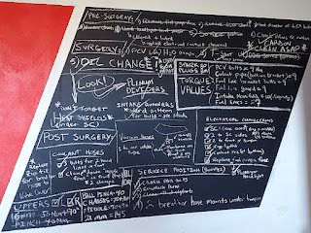

I spent a portion of the afternoon trying to organize the new kitchen somewhat. It was trickier than I thought it would be. On first glance, there are tons of cupboards. It would appear that there is more than enough space to organize your pantry items PLUS your dishes. But not so. We had a little bit more storage space in the old kitchen, versus this one. But it will be okay . . . I just need to be more strategic about every single cupboard. And I will probably need to get a hutch or something to house a little bit more of our stuff. But this is where I left off that afternoon . . .

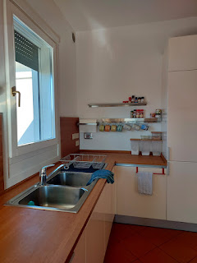

At the old house, we've lived next door to a huge abandoned building for the whole 3 years. I'm not sure how long the building has sat empty, but someone finally decided to spruce things up and make it into yet another apartment building. It looked like it may have been a school at one point, or possibly a large office building. Anyway, now there is a massive construction project going on. Every morning, the excavator starts up at 7:00 a.m., scraping, scooping, and dumping its contents into a dump truck. And every night, this is what I see out my bedroom window . . .

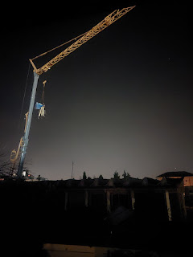

I've taken a few videos to send to Jack, who is absolutely mesmerized and enthralled by watching the construction guys do their giant work tasks. I was notably impressed one afternoon, as I watched the excavator operator tinker with several long metal trim pieces outside. He used his giant claw to pack and smush it all into the dumpster, but occasionally he would gently navigate the giant claw over to grab hold of one single piece of stray metal and then incorporate it into the rest of the tangled mess, like he's kneading some bread dough or something. He was one seriously impressive operator!

You can watch him here: (43 seconds)
https://photos.app.goo.gl/43Q9vv7jnmEnnZ7R9

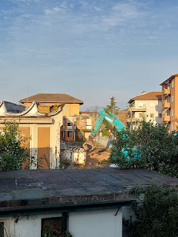

Friday afternoon came, and with that we picked up our rental van and set off for IKEA once more. At the customer service desk, the clerk was able to tell us exactly where to find each item on our printout. At first, we started off with just one furniture dolly. But then it became clear that we would need two.

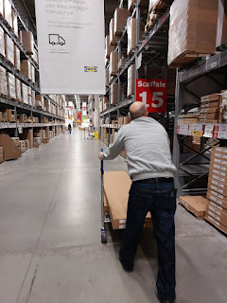

The dining table came with 3 long and very heavy boxes. The sewing table came in 2 dense boxes. And each of the wardrobes came in 3 long and heavy boxes, a total of 6 for just those 2 pieces. This meant a grand total of 11 long and heavy boxes, split between the two of us. I waited at the curb while he drove the van much closer for loading.

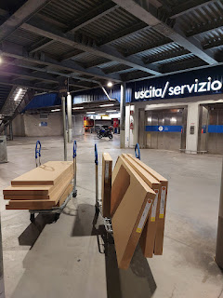

Everything takes longer than it should in Italy. That's why Italy teaches you patience. Just chill. Go with the flow . . . if there even is a flow . . . ha ha.

By the time we got over to the new house to drop everything off, it was pretty late - around 8:00 pm. We still hadn't had any dinner yet, either.

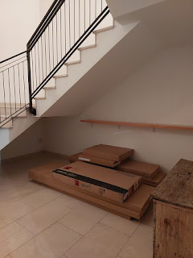

We ended up stacking everything inside the entry foyer instead of the garage, because when I went to open the garage side door with my key, the key broke off inside the lock!! I hardly did anything with the key though, it just turned like butter and then broke off . . . we sent a picture to Daniele to let him know right away.

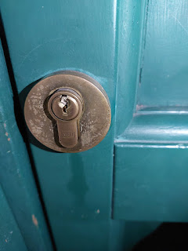

He was surprised but said he'd probably need to send a locksmith over to take a look at it. However, and miraculously, the next morning when we arrived with our crew of moving buddies, Scott was able to get the broken portion of the key out pretty easily. He let Daniele know, which made him super happy. So now, all we need to do is get a couple of new keys made, since Scott's garage key is slightly bent, too, signaling that it's about to die, as well.

Scott and his army buddies did the heavy lifting at the old house. First he took apart the beds, and then when Captain "A" and Chief Nunn arrived, they started hefting everything down to the moving van.

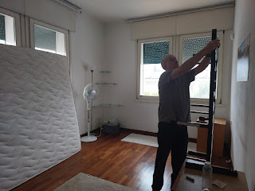

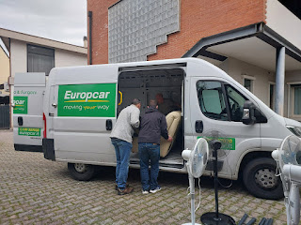

I focused on packing up as much stuff as possible for transport, so that all the willing hands had something to carry. Our friends, the Parkers, showed up with their whole family to help, which was so nice. So, with my car loaded to the rafters, and the Parkers' truck hauling the last few things, we made our way across town to catch up to Scott and his buddies who had already arrived.

The senior missionary couple, Elder & Sister Brown, also met us at the new house, since they live pretty close to us on that side of town. This meant we had MANY helping hands to carry everything up the 4 flights of stairs. We each still got our fair share of exercise, though . . .

But these guys bore the brunt of it all, getting not only the couch up the stairs, but eventually the washing machine, too. Scott had bought a new kind of dolly - with two sets of 3 wheels. It was pretty slick how they muscled that heavy thing all the way up to the top.

It's hard to see everyone, but from L to R: Captain "A", Chief Nunn (in the light grey sweater), Kevin Parker holding the back end of the washing machine, and then Scott and Elder Brown were on the pulling end at the top.

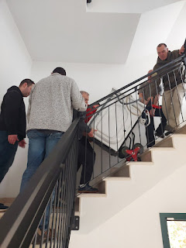

We got everything upstairs in hardly any time at all, with so many good friends to help us. After they all left, Scott and I got started with sorting things out and putting things away. We made another trip back to the old house to empty out the fridge and to grab some other miscellaneous items, now that we had emptied some transport containers to do so.

I went to the grocery store to pick up some things that could help us get through the weekend, and then came home and made us some dinner. This was one of those times when being in America would have come in handy. What I would have given to just have some quick dinner options . . .

I would have loved some Cafe Rio, or Kneaders, or even a Wendy's! But the only fast food options over here are pizza or kebab. Yes, they have McDonald's and yes, they have Burger King. But where's the Mexican fast food? Or a drive up window where you can grab some hearty and delicious soup?

So I made dinner instead . . . sauteed chicken to go with a few items that Sister Brown had given us (rice, butternut squash, and a tiny bit of chicken in a very tasty teriyaki/soy sauce mix). It hit the spot. Sitting on our recliner couch, with our feet up as we ate, we both quickly realized how sore we were, especially our throbbing feet. We could hardly wait to climb into bed . . .

Jacob called and we got to visit with him and Maisie for a bit. Jack and Hannah were still sleeping in back in Minnneapolis, so we had Maisie all to ourselves. She is such a cutie!! She was a mixture of stoic as she studied my face as I cooed and chatted to her, with an occasional smile that would light up the whole world. XOXO

She's also started rolling over from back to front now, and she's pretty fast, too. Her new favorite stuffie to cuddle with came from Grandpa John and Grandma Michelle recently. It's a big pink reindeer-looking thing.



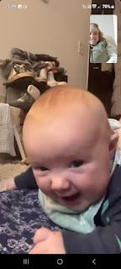

When she tired of laying on the floor, she let her father know. He scooped her up onto his lap and we continued chatting for a while longer.



One of my favorite moments . . .

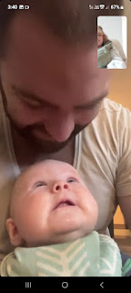

Eventually it was time to actually climb into that bed that we had taken apart, transported, put back together, and placed the bedding on once again. We were bushed.

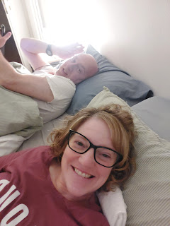

We slept so hard that night. I didn't even wake up to go to the bathroom . . . but that probably meant that I didn't drink enough water the day before. Anyway, we went to church (just 5 minutes away now) on Sunday morning, and had wonderful some meetings there with our dear friends. I shared my testimony about some incredible answers to prayers recently (we had stake conference last week, so this second Sunday was Fast & Testimony meeting instead).

Now, on Monday morning, I am hurrying to finish up this blog so I can get back over to the old house and get started on the rest of the cleaning! My goal is to get it clean in the next couple of days, as best as I can. I won't be able to do 100% of the cleaning, because the Army won't be picking up the 3 years' worth of borrowed furniture until the end of the month. But my focus will be on the nitty gritty stuff, like the kitchen and bathrooms, windows, and as much of the floors as I can get to. Scott will end up sweeping and mopping the rest of the floors once the furniture is gone.

I've already cleaned most of the kitchen so far. So hooray for that!

As I'm finishing up, Scott is busy building our new dining table in front of me. He's so awesome. He has the morning off because of the Super Bowl. Nobody needs to be at work today until 1:00 p.m., since the expectation is that several people would have stayed up all night to watch the game, with the time difference. He's using his time at home wonderfully, since he decided to sleep all night instead of staying up.
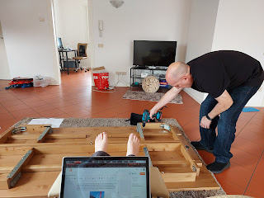

Later this week, we are flying down to Sardinia for Valentine's weekend, something we planned out weeks ago. We didn't want my 3 weeks over here to be ALL WORK . . .

And as soon as I get back from Sardinia, less than 24 hours later I'll be flying back to Idaho. Back to the teens and 20's and snow and winter . . . sigh. But it's all good. I came to be a part of this big move, and what a wise thing that was. We make such a good team. I can't imagine how Scott would have been able to do all of this by himself. Yep, as fast as these 3 weeks are flying by, I wouldn't have wanted it any other way. :)

