Back in Italy (For a Minute . . . )
Buon giorno! Ciao! I landed in Italy yesterday (Tuesday) afternoon, after being up for more than 24 hours straight. The travels all went great and I had no issues or delayed flights. Everything went as planned, thank goodness. I'm so grateful for a horizontal bed that I could sleep in last night and for a no-rush morning today. :)

I'll recap the past week really quick, and then I have some photos to share of our new house that we'll be moving into very soon.

Last Wednesday, I took my niece, Mari, and her dog, Ducky Momo, to a grooming appointment. Ducky is 13+ years old now, and was in dire need of some pampering. His fur was pretty matted, unfortunately, so the groomer warned us that she would probably need to shave him down. The alternative would have been an extraordinary amount of combing through all the tangles with a small pick, which would have been very stressful for him.

Ducky Momo before . . .

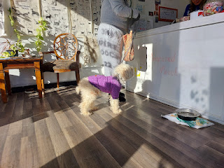

And Ducky Momo after . . .

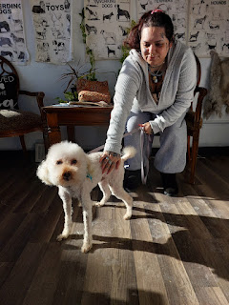

Because of the frigid temperatures in Eastern Idaho, Mari was worried that Ducky would be super cold. I offered to take her over to the pet store (while he was having his 2-hour appointment) so that we could find him an additional layer to wear. We did end up finding him something, and it did help, even though he still gets a little shivery no matter if he's inside or outside their home. Poor little guy.

I couldn't resist pulling over to park along the waterfalls in downtown Idaho Falls on a day when the sky was a bright, brilliant blue and the water was mostly frozen over.

Video of the Snake River and Greenbelt: (14 seconds)
https://photos.app.goo.gl/Da6FKSsnxXKwvS4UA



Looking up-river toward the temple . . .

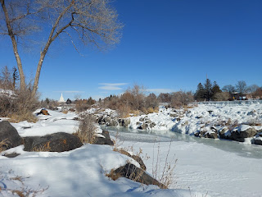

Later that same day, I met up with my other niece (on Scott's side), Vanessa, and we attended a session at the temple together. Jacob had sent me a link to a BYU devotional talk a day or two before my latest trip to the temple, and there were some really great points that offered a new perspective and helped me to connect a few "dots" with what we do in the endowment session.

This talk was given by Anthony D. Perkins, and here is the link to his message, entitled "Becoming God's Peculiar Treasure":
https://speeches.byu.edu/talks/anthony-d-perkins/becoming-gods-peculiar-treasure/

What I especially enjoyed, was how he connected some basic gospel principles to the five covenants, or promises, that we make in the temple. First, I'll just mention that his use of the word "peculiar" is not intended to be the modern definition (weird, odd, unique). He conveys a more ancient version of the word peculiar, as he explains:

"A second meaning of
peculiar
can be drawn from the original languages of biblical text. President Russell M. Nelson taught this meaning at a BYU devotional. He explained:
In the Old Testament, the Hebrew term from which
peculiar
was translated is
cgullah [segullah],
which means “valued property,” or “treasure.”
In the New Testament, the Greek term from which
peculiar
was translated is
peripoiesis,
which means “possession,” or “an obtaining.
”
6
Because the King James Bible missed this “valued possession” nuance, updated translations of the New Testament change “peculiar people” into “a people belonging to God.” "
Hopefully the snippet below will make more sense now, as you see the use of the word "peculiar" in reference to God's commandments and how they relate to the covenants we make in the temple. God's commandments are "treasured", and as we keep them, we "belong to God".

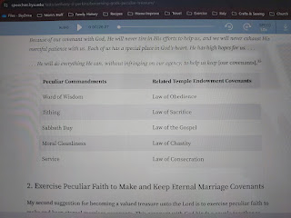

Vanessa, her daughter, Taylor (17), and me outside the temple that evening . . . (sorry it's a little blurry)

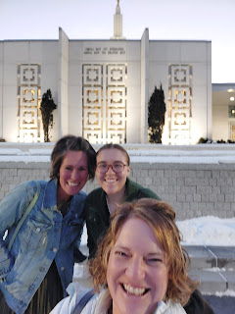

While my phone did not capture all of the beautiful colors in the sky as the sun was setting, it does give a sense of beauty and majesty with the striking lavenders and pale pinks.

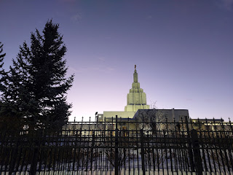

After our time in the temple, we drove over to a local pizza hangout spot called Leo's Place. It's a place where we used to take our own kids when they were growing up, and we've had many a birthday party there, especially with our boys. Vanessa's son, Caleb, and his family (Bethanne, Harrison, and Everett) also met us there. The boys had a grand ol' time, climbing around in the huge jungle gym area, and we could watch them through the big windows while we ate our pizza and salad and talked.

Caleb is looking at joining the National Guard in order to get the training he needs to be a cyber security expert. We had quite a lively conversation as I fielded several questions about our experience in the Guard all these years (38+ now). I'm excited for him, and I even told him that he seems like he was cut out to be an officer in the military this whole time. He's about 26 years old, so he'll be starting a little later than some, but he will offer some maturity and wisdom to everyone he ends up serving with.

I always enjoy some spaghetti squash in my life, and this version was both colorful and flavorful. I added some spinach, feta cheese, chopped tomatoes, and crisped bacon on top.

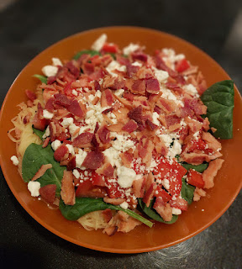

I had a fun video chat with Jacob and Hannah and the Minneapolis bunch one evening. When Jacob let me chat with Jack as he ate his dinner, I pointed out that he looked like he was wearing a bunch of bananas as a HAT. That sure made him giggle . . .

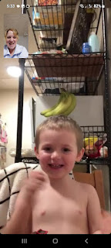

Maisie, meanwhile, was bright-eyed and bushy-tailed in her little entertainment saucer . . .



Before I left for Italy, I took Mari out to dinner again. I let her choose the restaurant and we ended up going to a Thai place called Krung Thep in downtown Idaho Falls. There were a few good options for a low-carb diet, including the edamame and this AMAZING soup!! It was a wonton soup, with chunks of carrots, celery, cabbage, onions, and a little bit of chicken and shrimp. It has seriously inspired me to begin a kick of Asian soups . . .



After church on Sunday, I was invited over to my friend ReNae Cunningham's house for lunch. She was also my taxi driver the following morning when I needed a ride to the airport. I decided that it was high time that I left the single digits behind for a little bit. In Denver, during a brief layover, it was a balmy 20 degrees, ha ha.



I'm not sure what the temperature was in Frankfurt, Germany, but I know it was warmer than 5 degrees!



And even though it had rained about 2 inches the day before I arrived, the sun was out and it was in the low 50s when I arrived in Venice. Kylie and Avery drove down from Aviano to see us, which was so nice! Kylie's parents had bought her a new phone and I-Pad for Christmas, but couldn't ship them overseas because of the whole lithium batteries thing. So I ended up carrying everything to her in my backpack, which she really appreciated.

Avery was her usual spunky self and she always makes me laugh. I was pretty hungry, so we drove over to a nearby McDonald's where we could all grab a bite to eat before we hit the road to go to our respective homes. They will be moving to Ramstein, Germany in May, where Kylie's new husband, Miles, will be assigned for no more than a year in order to get some qualifications for his next job in the military. They are still hoping to live in Florida sometime in the near future and settle down in the States again.

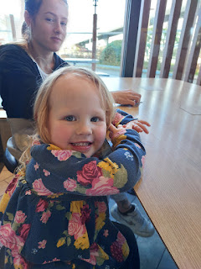

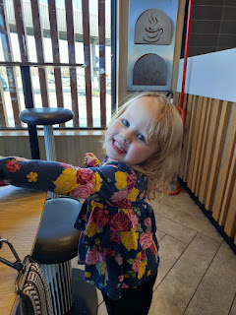

I really struggled keeping my eyes open on the rest of the drive home to Vicenza (only about 45 minutes). As soon as I got into the house, I climbed into bed for about 90 minutes and took a little nap. That helped tremendously! I had only gotten maybe 1-2 hours of sleep on the way over here. It's always so hard to sleep when you're sitting up . . . I have a really nice neck pillow though, and it does help a little bit.

After my nap, Scott drove us over to meet with Daniele, our new landlord, and to pick up our new keys!! Daniele and Roni, the realtor, walked us through the house and were very thorough in showing me everything, which I really appreciated. It's one thing to see pictures in the original listing, or a dizzying video that your sweet husband makes for you. But it's a whole different perspective when you get to stand in the space in person.

Plus, in the video that I shared recently (the one that Scott made), the old tenants had their stuff in all the rooms. But this time, the house was emptied out and was squeaky clean.

There are 3 bedrooms, 2 bathrooms, a dedicated laundry room, kitchen, living area, and balcony along the side of the house. There is also a HUGE garage with lots of shelving for additional storage out there.

It was dark outside when we arrived, so I didn't get to see much out in the yard. BUT, there is an outdoor BBQ and pizza oven that we can use, along with a fountain, plenty of yard to run around in, and Daniele said that YES, I can do some gardening!! I am so giddy and happy.

There are 4 flights of stairs to trudge up in order to enter the house from where the car is parked. I do, however, love the spacious entry area at the bottom of the stairs. It's like a ginormous "mud room", with space to organize your shoes (if they're wet or muddy), clean off, or even park a baby stroller inside. In fact, there's plenty of room to park a stroller, some bicycles, and lots of other stuff, too. It's literally that spacious.

The front door to our flat can be seen across the room in the photo below. (It's kind of in the shadows) This view is from the dining area (thus the low-hanging light fixture above Scott's head), looking toward the living room area. One of the bedrooms can be seen across the space, too, with the light on. The door opening behind Daniele on the far right goes into bathroom #1. Let's call it the "Shower Bathroom" . . . because it has the shower. Along the right-hand wall, there is a small "wing" with a middle bedroom, a bathroom in between, a laundry room, and the master bedroom on the right.

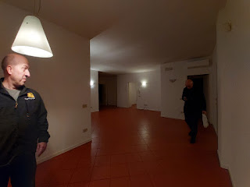

Another view of the living room area. The 2 doors just beyond Scott at the far end are: a walk-in closet on the left and the utility room on the right. The front door is next to the the utility room.

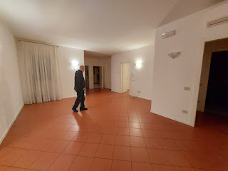

Another view of the living room area. It's an interesting shape, that's why I took so many different photos from different angles. I have to figure out where to put couches, a TV, etc.

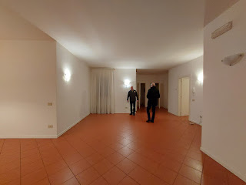

This is one of the bedrooms (the smallest one that's by the front door).

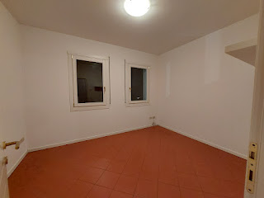

This next one is the view from the front door, looking into the living room area . . .

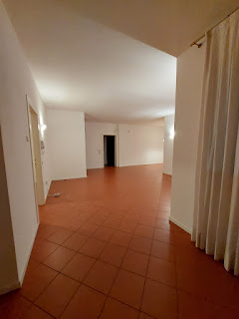

Video #1: Starting at the front door, peeking into Bedroom #1 and looking around the dining nook and living room area. (24 seconds)
https://photos.app.goo.gl/8S3Jrdeg64Areqta7

Video #2: Starting in the master bedroom, then the laundry room, Tub Room, and Bedroom #2.
(48 seconds)
https://photos.app.goo.gl/d4zPcZeuyM8A61LK7

The master bedroom, with LOTS of storage closets . . .

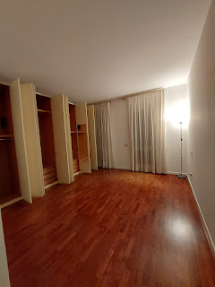

Master bedroom, looking back toward the entry door . . .

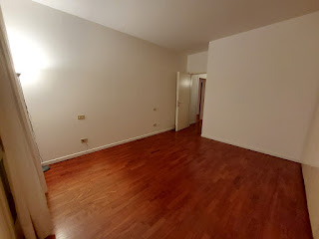

The laundry room is next to the master bedroom . . . It will be nice to have a dedicated room for laundry, instead of our current situation: a washer in the bathroom + dryer in the office.

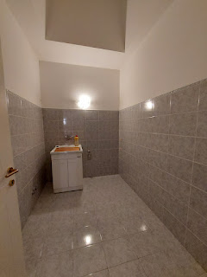

View of Bathroom #2 - aka the Tub Room. No shower in here, just a tub with a small shower hose attachment. This is the bathroom that's closest to the master bedroom. It has dual sinks, which is nice, and plenty of cupboards and storage.

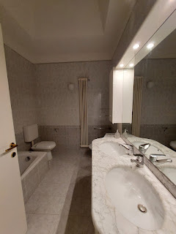

Another view of the same bathroom, just looking back toward the door . . . (the master bedroom and laundry room are to the left of this room, and a large middle guest room is to the right).

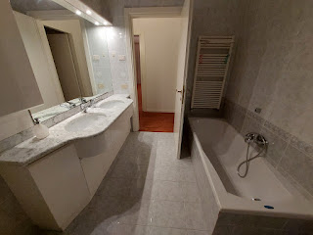

The middle bedroom/guest room . . . did you notice how the two extra bedrooms don't have any closets or storage? We will need to get some sort of wardrobe and a dresser for each of these rooms.

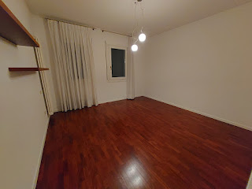

This is the Shower Bathroom . . . can you guess why? ha ha

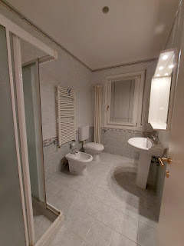

View of the same bathroom, looking back toward the door (and a hallway door). Notice that the dining area nook is all the way across. There's also a door that goes out to the balcony from the dining nook.

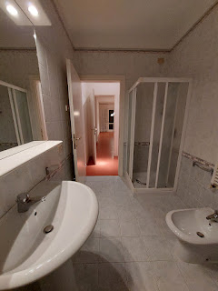

Another view of the first bedroom, the one that's closest to the front door.

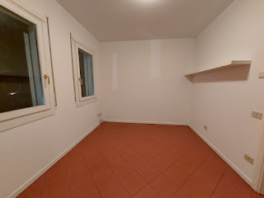

The storage closet by the front door, and next to the utility closet . . .

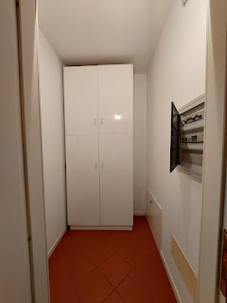

View looking from the Shower Bathroom toward the dining nook, which is also adjacent to the kitchen. That door at the far end leads out onto the balcony.

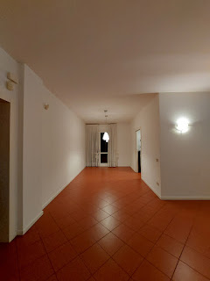

Looking toward the dining nook, the kitchen entrance, and the living room area . . .

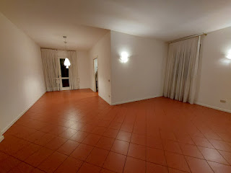

Aaannnd . . . the beautiful kitchen. I love that there is a window over the sink where we can look out and see the mountains. Plus lots and lots of cupboards, which will be great. The fridge and freezer are meant to blend in with the cupboards - they were opened up slightly because the power has been off for a few days. The oven is another tiny oven, darn it. BUT, there's a dishwasher to the left of the sink! Happy Day!!

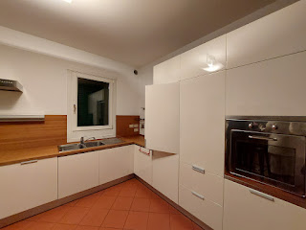

View of the opposite end of the kitchen. The fridge is behind me. One of the previous tenants wanted to build a bar, and that's where Scott is signing the papers for our new contract. Daniele is on the right and Roni, the realtor, is on the left. There's also a gas stove down at the end of the main counter.

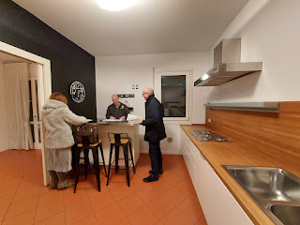

View from the kitchen sink looking toward the oven and the super cute chalk-painted wall.

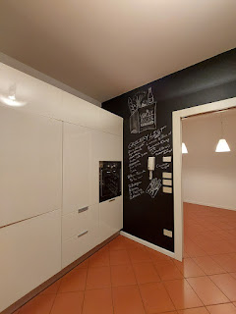

And lastly, the view looking from our front door all the way down to the "mud room" entry below. Yep, it's a ways down, ha ha. The daily trek(s) will keep our legs and tushies looking so good, though.

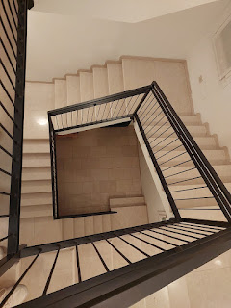

Just a few more photos to wrap this up . . .

Maisie decided to roll from back to tummy for the first time this past week. Jake said that he laid her down for a diaper change, and while he was gone for 10 seconds, she rolled over to investigate the crinkly package of wipes. What a cutie.

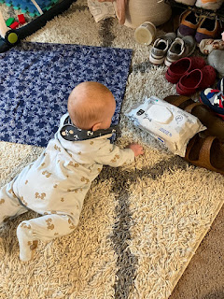

Maisie, asleep on the way home from church on Sunday . . . and holding on to her little toy "flute". XO

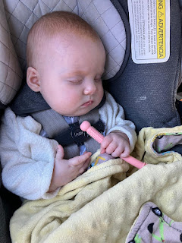

Maisie, in all her roly-poly glory . . . I love her so much.



Also, Amber and her family brought home a new friend for their cat Broski, who has been a little bored lately. This is a 1-year old rescue named Jellybean. She is very sweet, but very shy so far. They are hoping that soon the two cats will mesh together and become the bestest of friends.

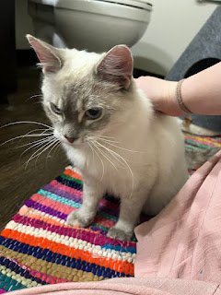

As for the rest of this week, I will be adding some color to the current state of our fridge - in the form of fruits, vegetables, and all kinds of fixins for some delicious meals. Scott's meals have become a little too routine and "stale" as of late, so I'm about to spice up his world again.

I will also be packing up some peripheral things in our house here, and shopping for furniture and furnishings for the new place.

Today, I'll probably be squeezing in one more nap, too . . . I'm still pretty bushed from traveling here with such minimal sleep. Ta-ta for now. TTFN.

