Back to the U.S. for Easter
I made it safely to Louisiana by Friday morning. This was after being awake for over 24 hours straight . . . It has been an extremely busy weekend, which is why I am so late in typing up my blog for the week. My husband suggested that I just share a bunch of photos and let the readers make up their own stories and explanations, ha ha. Maybe I'll add a few words here and there, but yes, this post will be a little less wordy for once.
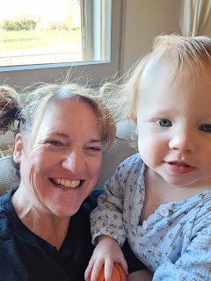

Monday:
I repotted our new plants and gave them a little drink. They are very happy in various sunny spots around the house and up on the terrace. Working in the dirt is immensely satisfying and gives me peace and contentment. :)

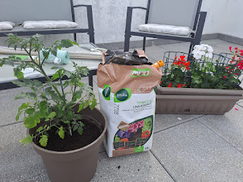

Tuesday:
Kylie and I had talked on the phone Monday and made plans for how I could help her in the next couple of weeks. She needed someone to keep an eye on Avery so that she (Kylie) could pack up and organize some things around Benson's house before he moves to Korea at the end of April.

I drove up to Aviano first thing in the morning and arrived at 10:00 a.m. I stayed all day and didn't get home until about 8:00 p.m. that night.

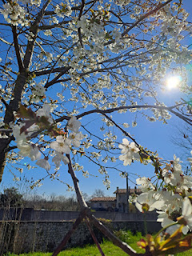

While Avery napped, I helped clean the bathroom.

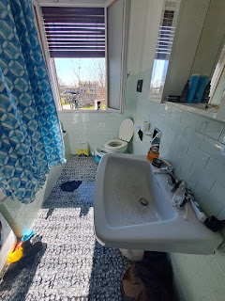

Kylie worked hard for hours, packing things up, throwing things away, carrying bags of stuff down to the garage, etc.

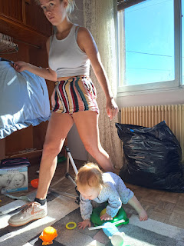

I enjoyed my job of being Avery's shadow. XOXO

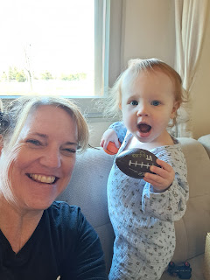

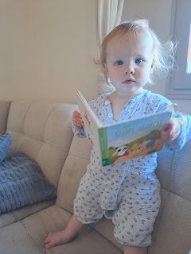

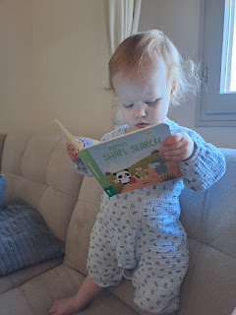

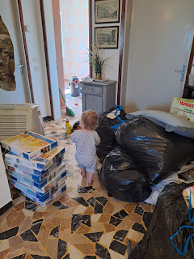

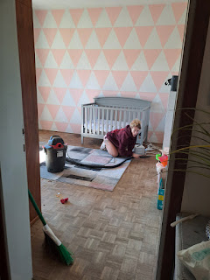

When Benson got home from work, he helped as well.

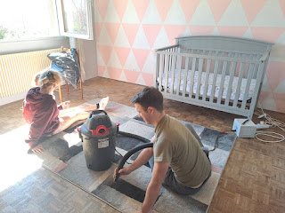

Video of Benson vacuuming Avery's feet - which she LOVED: (23 seconds)
https://photos.app.goo.gl/uJvSovmBDGNLqsoFA

Video of Avery walking around - she's getting really good now! (26 seconds)
https://photos.app.goo.gl/cJ2c2nPd6fX1zUpj6

After her nap, we enjoyed sitting out in the sunshine for a while, just listening to the birds and picking a few little flowers from the grass next to us. It was so relaxing and sweet to hang out with her.

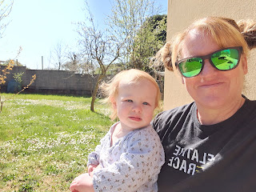

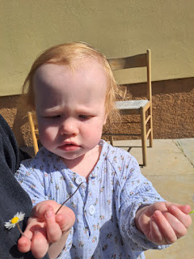

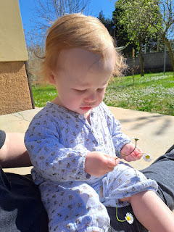

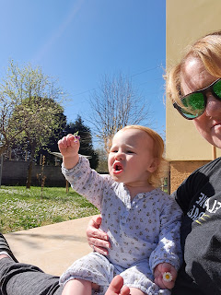

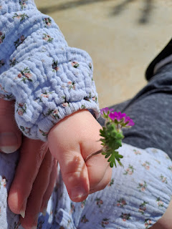

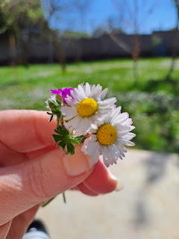

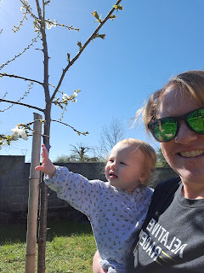

I took Benson out to dinner and it was nice to have that time together, just the two of us. We had a very meaningful conversation that I will treasure for a long time. We also had some tasty gyros, which made our tummies very happy.

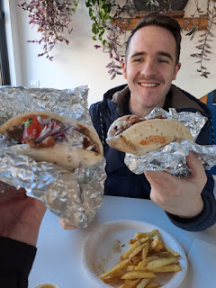

Wednesday:
Lots of packing and last minute "to-do" stuff. I was tired and by the end of the day I had a little bit of a swollen sore throat, which is usually a symptom of me just being run down. I let several things "go" from my list of expectations and just tried to focus on what mattered most. I knew that when I eventually get back from Louisiana, I'll only have Saturday and Sunday before company arrives on Monday (April 17th). I wanted to do a bunch of cleaning so I'd have less to do when I get back to Italy . . . but then I realized that when company is about to arrive, I always fly around the house getting everything clean at the last minute, too, so why do it all twice??

I had lunch on base with my new friend, Anya, who is from Ukraine. She is fun and upbeat and I really enjoyed having a bit of time with her before I would be gone for a week.

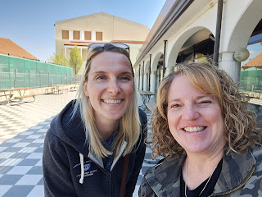

Later in the afternoon, I walked a short distance to have a massage with Evelyn, who is very smart and is getting certified with Shiatsu massage techniques. She did a Shiatsu massage with me that day. It involves more pressing (especially with her elbow!) and squeezing, rather than smoothing and "massaging". It's definitely different, but it worked to take care of the knots and the tension that had been building up.

I met Scott over at the Tabaccheria shop - sort of halfway between Evelyn and our house. It's a convenience store, but it's also a bakery and a hub location for Amazon deliveries. This time, I noticed the bakery section on the opposite side of the store . . . ha ha

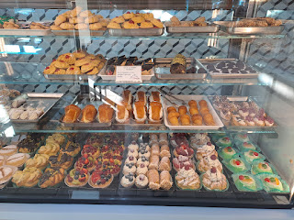

I got a canoli and a little cherry cake bite. We shared them together after dinner that night.

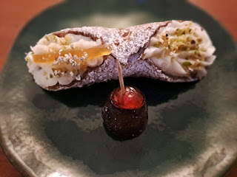

Thursday:
Up early . . . We left our house at 6:00 a.m. to drive to the Venice Airport and hugged goodbye at 6:45.

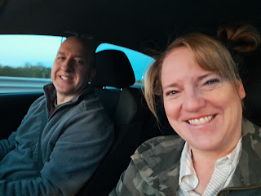

I flew to London with my eyes closed for most of the flight, since I was so tired. As I made my way to the next Terminal, I thought this older couple was just so precious as they walked along holding hands.

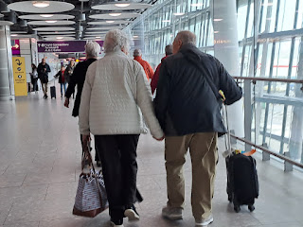

With a 3 hour layover, I had plenty of time to wander around London Heathrow and enjoy a nice lunch with no frenzied schedule to worry about. The items on the menu gave me a little chuckle now and then, just because of how the Brits describe something so differently than Americans do, ha ha.

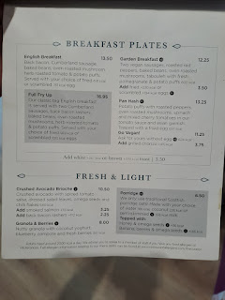

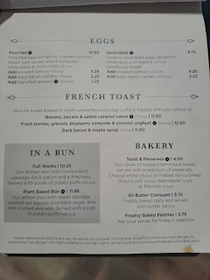

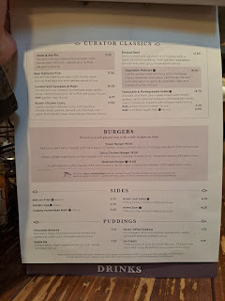

I got the standard fish and chips, which NEVER disappoints. I ate every single bite because I was so hungry. All I had had for hours was a banana.

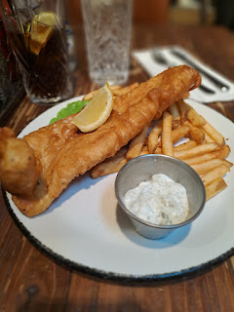

Just as I was getting settled in my seat for the long flight from London to Dallas, JACK called! And thank goodness, too, because I wasn't sure when I would get to talk to him that day with all my travels. It was his 2nd birthday!! He excitedly showed me his book about construction diggers and backhoes, and was pointing out the window at something that I couldn't quite distinguish. But what a doll. I'm so glad Jacob thoughtfully called ME - and at just the perfect time, too!

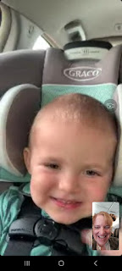

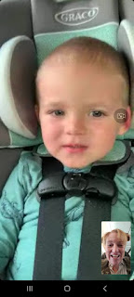

The plane was surprisingly empty . . . something I've never seen before on an overseas flight. I had the whole row to myself - - until an older couple arrived somewhat late and sat at the other end of my row, coughing nonstop for over 10 minutes. Once the flight attendants did their count of how many people were on the plane, we were free to move seats if we wanted to.

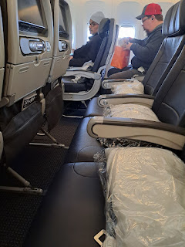

So I did. I moved up one row so I didn't have to sit so close to people that were still coughing nonstop, knowing that this was going to be a 10 hour flight . . .

This was literally how empty the plane was . . . I couldn't believe it! And it was a big plane, too. 3 seats on the left, then 4 seats in the middle where I was, then 3 more seats on the right. But it was only *maybe* 40% filled . . .

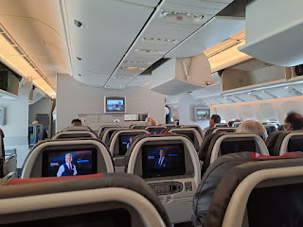

I wasn't sleepy for most of the flight, probably because it was daytime in the time zone that I was used to. I watched a couple movies, read some General Conference talks, listened to some General Conference talks, worked on my upcoming talk for Sacrament Meeting with Scott in a couple weeks, and eventually rested some by laying down across 3 of the 4 empty seats in my row. How nice was that . . .

Eventually we landed in Dallas and I went through customs relatively quickly . . .

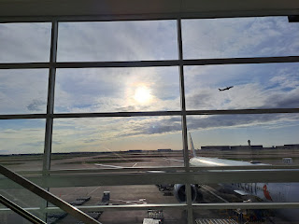

It took significantly longer to get my rental car vs. going through customs, but I appreciated the car I ended up with. A GMC Acadia this time. Super comfy and I always love driving an SUV. It just feels so solid and sturdy.

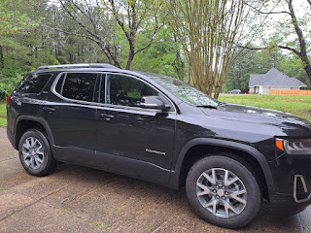

Because I had a sore throat the night before I left and I was so tired, I only drove one hour and stayed overnight at a hotel in Terrell, Texas. By the time I got into bed around 10:00 p.m., I realized that I had been up a little more than 24 hours by then . . . (10:00 was equal to 5 a.m. back in Italy)

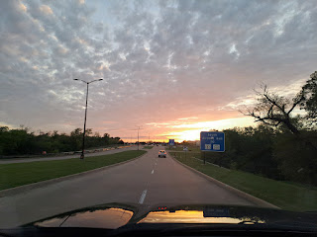

Friday:
I slept like a log for 8 hours in my comfy hotel bed and felt like a million bucks again the next morning. I woke up an hour earlier than I had set my alarm for, so I got showered and ate breakfast and got on the road sooner, as well. It was 2.5 hours to drive to Amber's house.

Video of me arriving and hugging the girls while they were watching Chronicles of Narnia: (7 seconds)
https://photos.app.goo.gl/NVHbKM2QKs562mgq8

(I didn't know Amber was videoing me . . . I thought she was trying to take a photo, ha ha)

Soon after I got settled in, we began tidying up the house and getting things ready for Abby's birthday party that night. This was her "friend party", a few days after her actual birthday (April 1st).

Gwen mostly just played with the balloons . . .

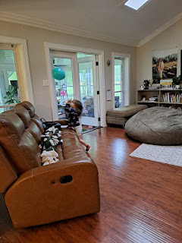

While Amber made the punch and other food items . . .

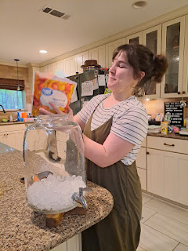

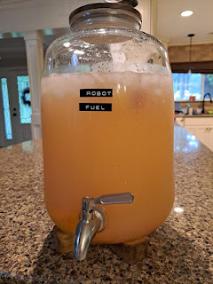

Abby wanted a Robot Party, so these are the cute party favors that she decorated. Inside were some treats and a little tiny Rubiks cube for each of her friends.

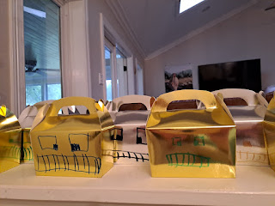

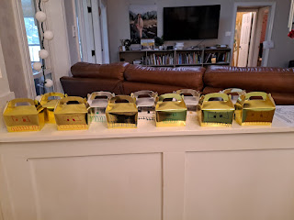

Abby and Gwen made silly faces . . .

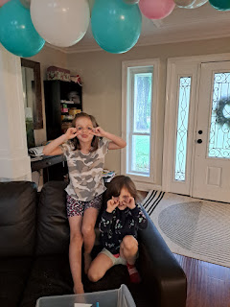

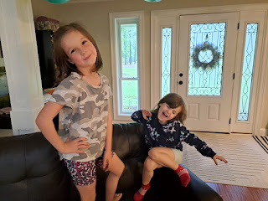

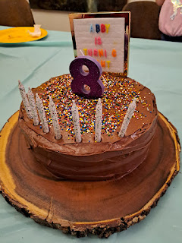

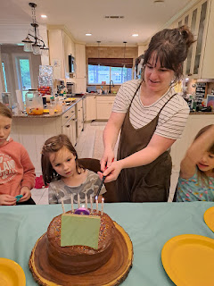

Happy Birthday (again) sweet Abby girl!! XOXO

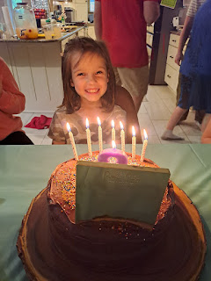

Video of all of us singing Happy Birthday: (29 seconds)
https://photos.app.goo.gl/ZNKjw8zbz3EX87cw8

She and her friends ran around and played or they all hung out in her bedroom and played with her new gifts (with the door shut). We could hear them laughing and giggling for hours while the grownups chatted in the living room together.

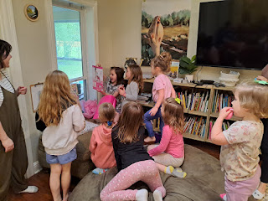

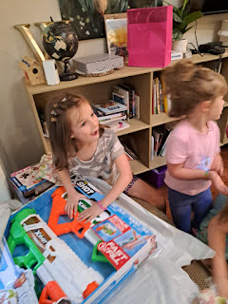

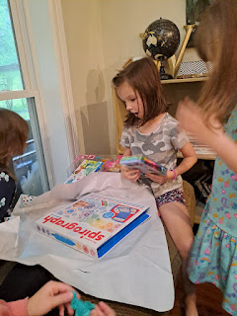

'Twas a very fun night. I was more than ready for bed when that time finally rolled around . . .

Saturday:
Abby and I made some cute little origami owls after breakfast.

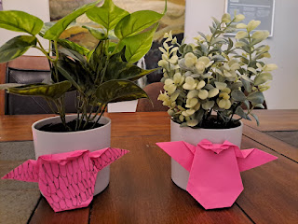

A little after 10:00 a.m. we drove to the north side of Shreveport to attend a Stake Primary Easter Activity at the DixieMaze Farm (owned by a church member). The girls were eager to have a pony ride at some point, but it was SO MUDDY everywhere after a few days of rain . . . It's a good thing we got to visit Chazzy and Dax at the beginning of the event, because we didn't end up doing a ride later on.

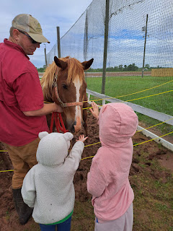

Inside the cute barn, an egg crate activity was set up for all the children, where they could decorate it with marker pens and stickers.

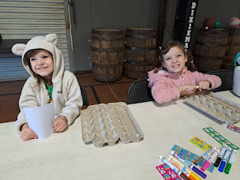

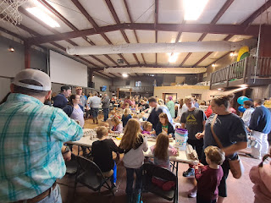

One of the ladies had made several boxes of tiny little Easter cupcakes for everyone . . .

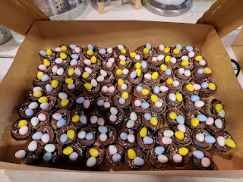

Which Gwen happily helped to eat up . . . (pizza was also provided for all the guests)

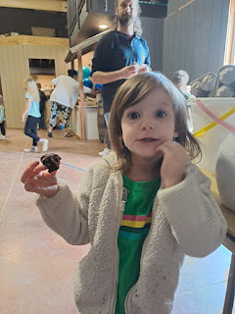

All the children 5 and under were invited to go outside first - to find some Easter eggs. Gwen had a pair of galoshes on, but I had to be careful where I stepped because I only had tennis shoes on . . .

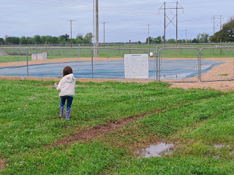

What a cutie!

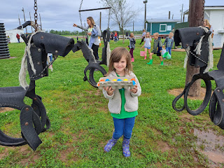

Abby's group was next, with all the children 6 - 11 years old.

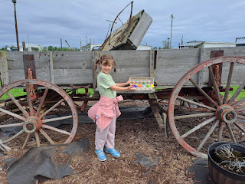

The farm also had a darling Cow Train for the kids to ride in for a lap around part of the farm.

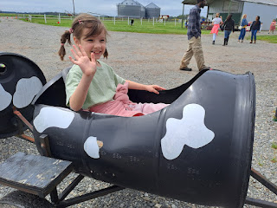

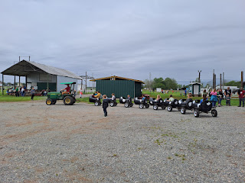

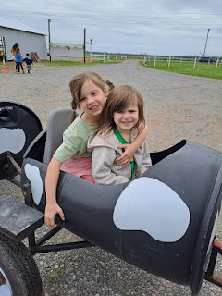

A jolly good day on the farm . . .

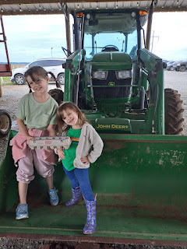

After a rest at home for a while, Amber and I took the girls into town to get some groceries. The girls had a TON OF FUN making up this ABC jingle in the back seat . . .

ABC fun: (57 seconds)
https://photos.app.goo.gl/ujSStMpTzWi6bmg99

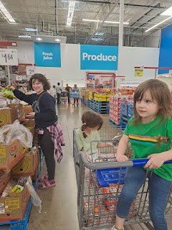

Around 9:00 p.m. that night, Weston's parents arrived into the Shreveport Airport and he went to pick them up. The girls were so excited that they just couldn't go to sleep, so we let them stay up until Nana and Grandpa walked in and could hug them and visit for a few minutes before going to bed.

Sunday:
Easter Sunday. What a lovely and sweet spirit filled my heart as I prayed before church, and when I sang Easter hymns at church I felt so close to our Savior Jesus Christ. With such a busy weekend, it was a little harder to focus on the true meaning of Easter, but going to church really helped.

After Sacrament meeting finished, Amber's ward had arranged for some beautiful artwork to be displayed in the cultural hall behind the chapel. Amber brought one of her paintings, too. (see below)

Amber stood and admired each painting as we moved closer toward the one she brought.

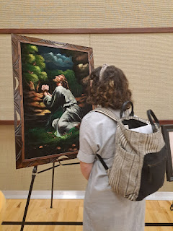

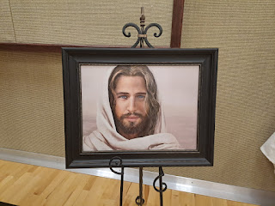

I got a little choked up listening to Abby and her friend Madeline as they talked about each painting. They would reach out and point to the marks in Jesus' hands, discussing what made those scars, etc.

L to R: Gwen, Madeline, and Abby

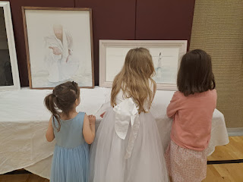

Here is the painting that Amber created and brought to display. One of the ladies in the ward was asking Amber some questions about it and complimenting her on all the hard work.

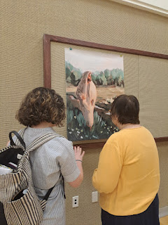

Abby and Madeline admiring a painting by Yong Sum Kim.

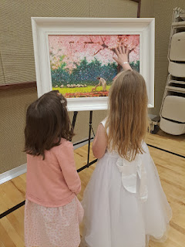

Very short video of Abby and Madeline: (3 seconds ha ha)
https://photos.app.goo.gl/UtWCJtzAVBUvutJT9

Gwen decided that some twirling in her dress was needed.

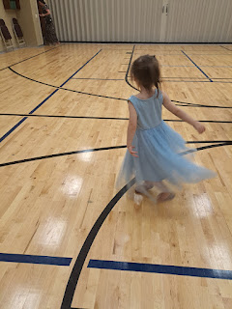

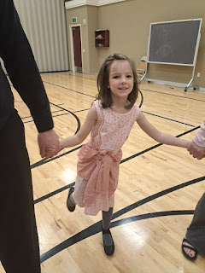

In the afternoon, we watched The Testaments of One Fold and One Shepherd, a one-hour movie that is just wonderful. It's based on actual events that happened during Jesus' life, including a portion of Him teaching the people in Jerusalem as well as visiting His "Other Sheep" in the Americas after His Resurrection.

You can watch it here on YouTube:
https://www.youtube.com/watch?v=fnFITzc3cuY&ab_channel=Hard-to-FindMormonVideos

It always makes me cry, but in the best sort of way. I love seeing when Jesus visits the people in North America and blesses, heals, and teaches them.

Amber made a delicious beef roast for dinner, with potatoes, homemade rolls and salad.

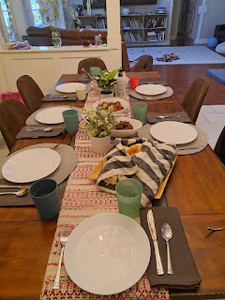

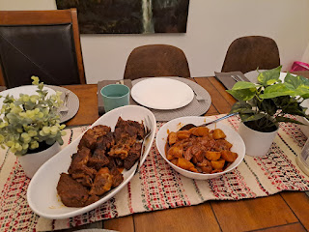

The girls had a bath and then I put curlers in their hair before bed. Super cute!

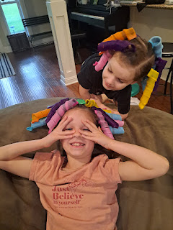

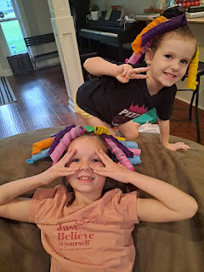

Video of Grandpa Mike playing a game with some leftover balloons: (28 seconds)
https://photos.app.goo.gl/b6nY8dQLpTBstQES7

It's been a busy week, but a wonderful week. I'm so glad I'm here in Louisiana, to be here for Easter, Abby's party, and also for Abby's baptism. (which I will write about next time . . .)

