Balboa Park & French Ancestor Night
Last Sunday, Charmaine dropped me off at the nearby Church of Jesus Christ of Latter-day Saints so that I could attend Sacrament meeting. There are some really nice people all around the world, and new friends to make anywhere you go. I found this to be true in the San Diego Ward when some people sitting nearby made it a point to strike up a conversation with me. The relief society president initiated a wonderful chat with me as the meeting ended. She had been sitting behind me and wanted to know if I was visiting or new. The more we talked, the more I realized that she is the type of person I would want to have as a forever friend. Next time I visit my sister, I hope to run into her again.

Charmaine picked me up after church and we made plans to explore Balboa Park, a huge area near the airport and the waterfront, filled with themed gardens, several museums, cultural exhibits, and the zoo. We spent a few hours there and only saw a small portion of what Balboa Park has to offer . . .

We parked near the San Diego "Lawn Bowling Club", something I had never heard of before, ha ha, and then we walked across the historic Cabrillo Bridge, which dates back to 1915, and down the lane toward El Prado. I'm not sure exactly what El Prado is, but from what I've read online, it is a collection of buildings that had their origins in 1915 for the World Fair that was hosted there. A variety of museums and restaurants are among its offerings, but the buildings themselves seemed much too fancy to just be resigned to a restaurant, in my humble opinion.
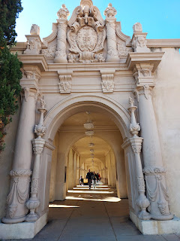

This very tall structure, as part of El Prado, is known as "California Tower", and you can pay to take part in a tour that includes going up to the top terraces. We didn't do the tour . . . this time . . .

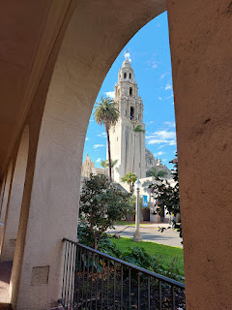

The other side of the California Tower is connected to what looks like a mosque or cathedral.

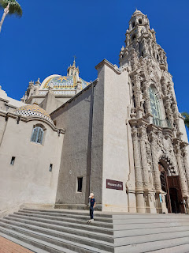

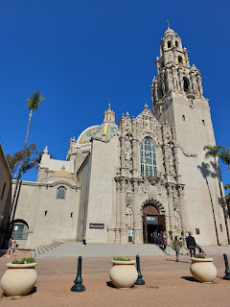

We walked past a few beautiful fountains and several interesting museums, including the Model Train Museum and the Museum of Us (an anthropological museum). Charmaine wanted to look inside the Mingei International Museum, which houses crafts and folk items from around the world. I particularly liked this collaborative weaving loom.

The instructions below explain the simplicity of the task: (click to enlarge photo)

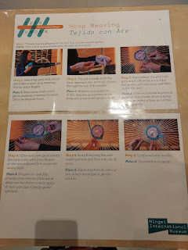

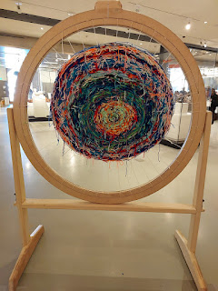

Outside the International Museum was another beautiful walkway with handsome arches and artistic views.

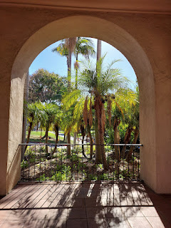

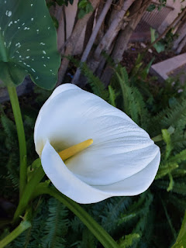

I could picture my grandchildren wanting to play on this clever alligator, made with a type of cement and several mosaic tiles.

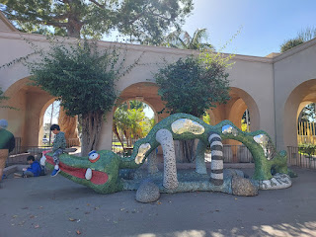

Next, we made our way over to the Kate O. Sessions Cactus Garden, with walking paths and trails that were all free to wander through at your leisure.
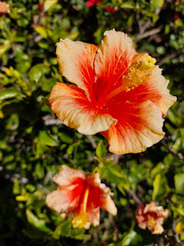

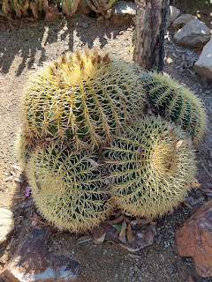

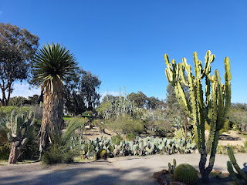

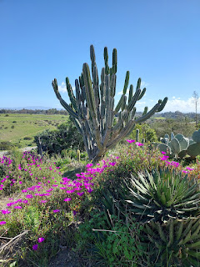

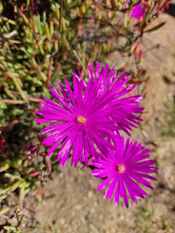

Charmaine and "me" . . .

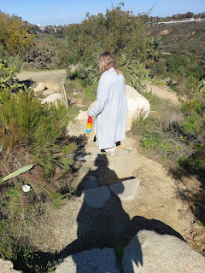

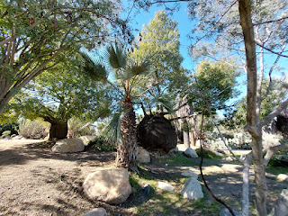

This was one of the most interesting trees I've ever seen . . . it looks like a cross between a Buddha and Olaf (from the "Frozen" movie).

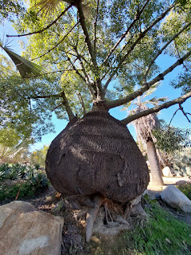

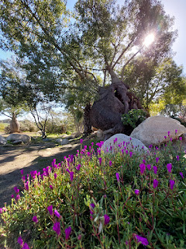

This was the hollowed out interior of that same Buddha-shaped tree . . .

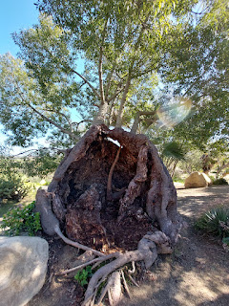

I enjoyed taking the time to notice the flowering buds and still-forming fruits that were miraculously attached to the most prickly and dangerous of plants. It seemed to be a metaphor for life . . . that even when life gets prickly and painful, beauty and new beginnings are still possible. We just have to watch for them and notice those small, yet meaningful, blessings in our lives.

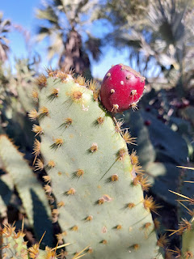

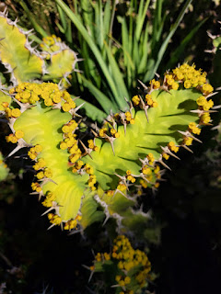

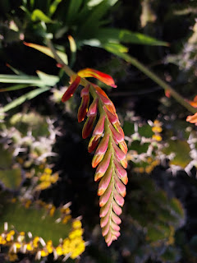

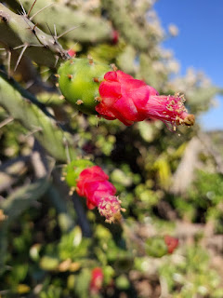

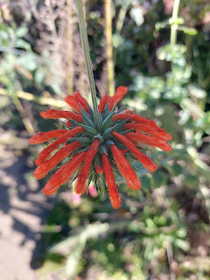

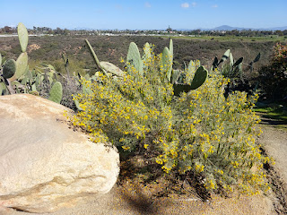

Charmaine mentioned that Dr. Seuss was from San Diego. It wasn't hard to imagine where he got some of the inspiration for the trufula trees and other illustrations in his famous storybooks . . .

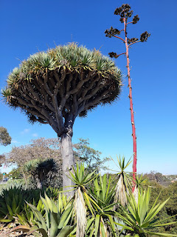

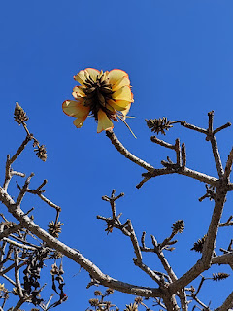

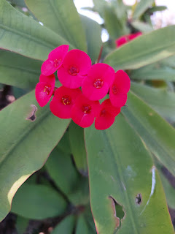

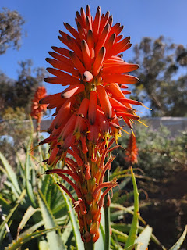

A perfect day to set up your easel and paint to your heart's content . . .

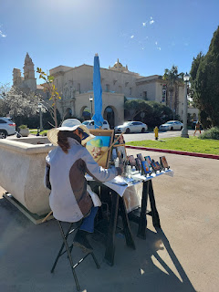

We walked past a peaceful demonstration where a group of people were trying to garner some attention and raise some money to help the people in Ukraine . . .

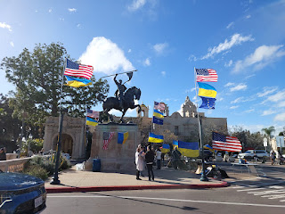

We could hear a massive outdoor organ recital nearby, so we walked over to investigate at the Spreckels Organ Pavilion. The organist that we saw was very talented, for sure. Sometimes, though, playing technically to show your skillset is not always the same thing as playing beautifully. It was still pretty cool, though. See for yourself . . .

Video of the organist on the Spreckels outdoor organ: (49 seconds)
https://photos.app.goo.gl/DrnN6qYU2EbJd5or5

Across the street, we stepped onto the Palm Canyon Trail, which led down into a gorgeous forest. I especially loved this tree, with its long roots cascading down the hillside in a magnificent display.

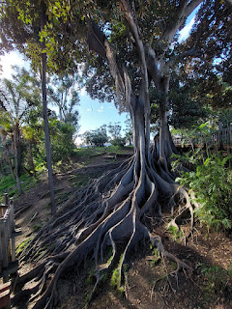

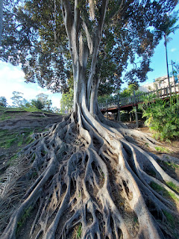

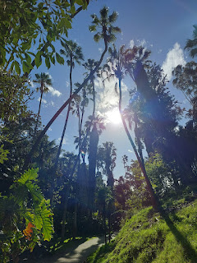

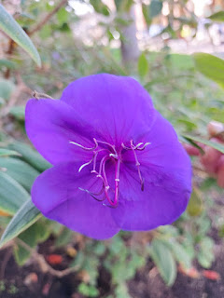

After walking and meandering around Balboa Park for several hours, we decided it was time to head on home. Once we got home, however, we decided that this would be the perfect evening to hop into the hot tub at their gated apartment complex. Even though it was a little chilly on the walk down the street, the water was perfectly heated and we ate our dinner IN the hot tub. We had leftovers from the night before. The stars were sparkling in the sky above us and it was such a perfect way to end the day.

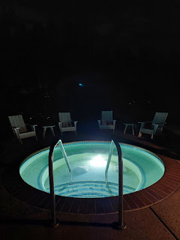

On Monday, the rains came in and lasted much of the day. More rain fell up north in Los Angeles and San Bernardino, though, causing rivers and mudslides to flow through the residential neighborhoods. We were luckier down in San Diego.

Up in Northern CA, my mom's beloved almond tree toppled over in her back yard, inadvertantly "pruning" (or "butching") another beloved tree - a Granny Smith apple. Thankfully, she thinks the Granny Smith will recover in time.

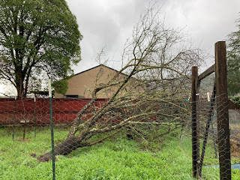

While I worked on last week's blog, Charmaine took a day off work and caught up on a few things around the house (laundry, tidying, etc.). After she made a grocery list for the week, we went grocery shopping together.

In one store, I was in charge of the cart as we waited to make our way up to the cashier. (Charmaine had slipped away to use the restroom.) I invited the man behind me to swap places and go first, because he only had a few things in his basket, whereas we had several things in our cart. He happily moved up, and I casually observed him as he placed his items on the moving belt. He was a comfortably dressed older man, maybe in his mid-60's, African American, and wore a handsome dark flannel long-sleeved shirt that was tucked into his jeans. I heard him asking the cashier how much some of the last few items cost. He indicated that he couldn't afford to some of those things, including a 1-pound chub of ground turkey for $7.19, and asked her to please put them back. That's when I thought, "Not on MY watch!"

I told the cashier that I would pay for his ground turkey, which caused a huge appreciative grin on the man's face as he excitedly acknowledged, "Thank you! Thank you so much!" He proceeded to the opposite end to begin bagging his few groceries. I leaned in and quietly said to the cashier, "I also want to get him a gift card." She pointed to where the gift cards were, and they were not within reach at all. The man behind me offered to help squeeze backwards in the line to grab one for me, but when he appeared to be struggling to locate the grocery store gift cards among all the restaurant and online gift cards, I had to squeeze through the line as well to assist in the search. When we finally located the right card and I squeezed back up to the cashier, she said, "You'd better hurry! He's already leaving the store . . ." We raced through the $57.19 transaction and then I ran out of the store, into the rain, and into the parking lot to catch up to him. I hollered to him, "Sir! I have something for you!" He turned around and saw me running toward him, waving a gift card. When he realized what I was giving him, he looked like he was going to cry. He just kept saying, "God Bless You. God Bless You. Thank you so much!" And then we hugged. It felt so amazing to be able to do that for him. :)

That evening, we put together a minimalistic French Ancestor Night that was super delicious. I say minimalistic because we didn't spend hours and hours planning it out, and we didn't prepare several menu items like I usually do, with a main dish, sides, and a dessert. We just had one menu item: Savory Crepes. But we did add all the fixings, though. We had caramelized onions, crumbled bacon, Brie cheese, sliced tart apples, smoked salmon, cream cheese, capers, fresh dill, spinach, Swiss cheese, cherry tomatoes, sauteed shallots, lemon zest, sauteed mushrooms, fresh thyme, and sliced deli ham. I made little index cards with possible "pairings", per Charmaine's suggestion, while she flipped the crepes in the pan. She invited us to load up our crepes with whatever combination of toppings we wanted, and once the cookie sheet was filled with our "loaded" crepes, she put them in the oven for about 7-8 minutes to help melt the cheeses a little bit.

It was so yummy!! I took a few videos and photos of our process so I could make them into a reel on Instragram & Facebook, but in case you're not on those sites, here are the inner workings . . .

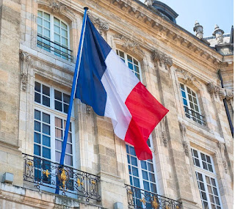

Video of Charmaine flipping crepes: (3 seconds)
https://photos.app.goo.gl/qMQ713ZQ9BtXof7NA

Video of our toppings and suggested "pairings": (23 seconds)
https://photos.app.goo.gl/XUkzDnExyypSYtQ2A

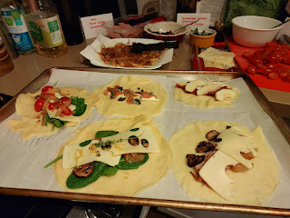

Charmaine, Trevor (Scott's son), and Trevor's amazing girlfriend, Olivia . . .

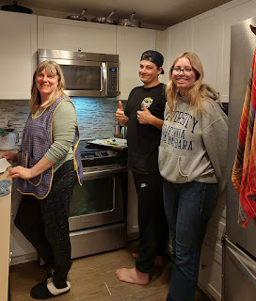

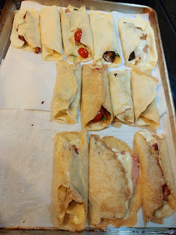

In my video reel, I included a map of the Strasbourg, France area where some of my ancestors came from. The Schnepps lived in Duntzenheim and Pfaffenhoffen, France. The Habers lived in Alteckendorf, France. And the Dutts lived in Schwindratzheim and Obermodern, France. All of these families are waaaay out on my Snider line, but I was able to visit some of these little towns and villages in the fall of 2021 when I traveled around Europe by myself for a month. The area surrounding Strasbourg is extremely beautiful, with rolling meadows and small hills, many vineyards, and everything is relatively close to the Rhine River.

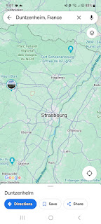

I also found some fun facts to throw into my little video:

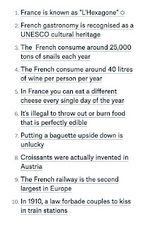

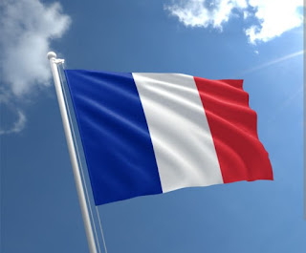

After we filled our bellies, we watched a very interesting show on Netflix called, "Live to 100: Secrets of the Blue Zones." I can't wait to watch it again with Scott, once we're in the same time zone. I packed up and organized my suitcase and then stayed up way too late chatting with Trevor before finally hitting the hay around 11:00 p.m.

Charmaine's Scott drove me to the San Diego Airport on Tuesday morning bright and early, and I had no issues with my flight home. Salt Lake City was a little colder than Southern CA, though . . .

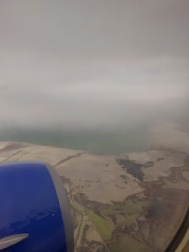

Instead of driving north to Idaho Falls right away, I drove 25 minutes south to stop in for a little visit with Scott's older sister, Sharon, whom I had not seen since Coy's funeral last May. Sharon transfered out to Utah from West Virginia last summer and she works as a pharmacy technician at the Sandy Walmart.

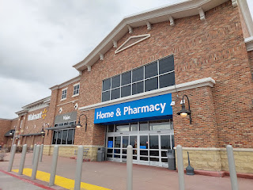

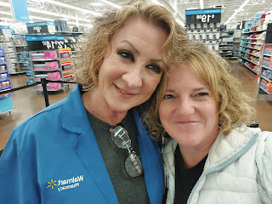

She has been going through some hard things in her life recently, and I felt like it was important to go see her face to face and to give her a warm hug. She really appreciated the visit and I felt like my mother-in-law was pleased in heaven, as well.

As for the rest of the week, I jumped right into getting caught up with phone calls, appointments, errands, cleaning, etc. as soon as I woke up the day after getting home. One of these things was to begin dog-sitting for my friend ReNae Cunningham, who is my dear friend that lives down the street from me. While they went on a trip to Southern Utah to visit the Red Rocks Temple Open House near St. George, I went over to their house 4x/day to check on their dog, Milo, from Wednesday through Sunday.

A gorgeous sunset as I came out of their house one evening . . .
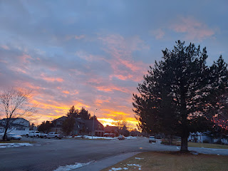

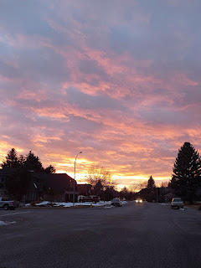

Milo, staring at me through the sliding door and waiting for me to let him back in, ha ha . . .

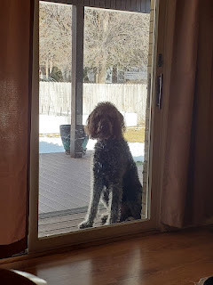

On two of the days, I took him for a nice long walk.

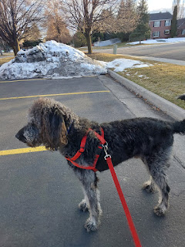

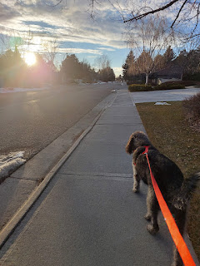

On the one day that it was just too cold for any human (or dog) to be outside, I took my laptop over and hung out with him for a little over an hour. From time to time, he would come over and just lean against my legs as I sat working on the Rawles Blog on their couch. What a cutie.

I made a couple trips up to Rigby, sharing a meal with Dad and Vernetta or just visiting them in between Dad's frequent naps.

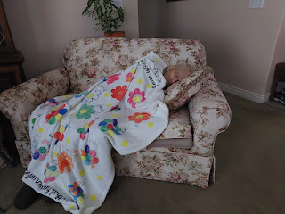

I'm also figuring out how to use the new Air Fryer that I recently bought. I'm trying to become savvy enough that I can appear to know what I'm doing when I bring it to Benson next weekend. This kind of kitchen appliance is right up his alley.

I made salmon for the first go, since I know Benson loves it so much. I followed this recipe:
https://downshiftology.com/recipes/air-fryer-salmon/

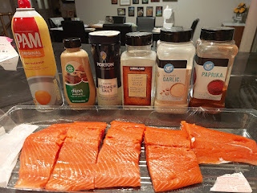

It was just "okay". The recipe said to cook it for 8-10 minutes, so I set it for 9. It didn't flake very easily when I checked it, so I mistakenly added another 4 minutes to the cooking time. I should have just done another 1-2 minutes. It ended up a little too dry and overcooked. Rubbish.

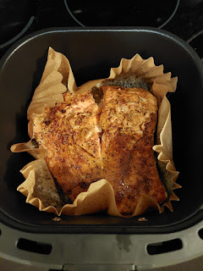

But the Brussels sprouts that I baked separately in the oven at the same time turned out amazing. :)

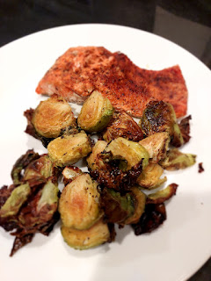

I'll keep trying some new recipes this coming week . . .

Scott and I met for our weekly Personal Finances Class over Zoom on Friday and had a wonderful discussion about many aspects of our finances. One of my favorite quotes from our lesson manual this week was this:

"The Lord blesses those who want to improve, who accept the need for commandments and try to keep them. He will help you repent, repair, fix whatever you have to fix, and keep going. Soon enough you will have the success you seek." Elder Jeffrey R. Holland (May 2016)

Another great quote was this:

"If we like luxuries or even necessities more than we like obedience, we will miss the blessings which he would like to give us." President Spencer W. Kimball (Former Prophet, 1982)

I have been very introspective this past week, trying to uncover why I do what I do when it comes to finances. While I don't do anything horrible or inherently wrong, there is always room for improvement. I am learning about myself, and in the process, the Holy Ghost is patiently teaching me and showing me better ways of using money with more mindfulness. I really love this class and I am learning a LOT.

Coming up: Valentine's Day, more family history projects, and a trip over to Mountain Home to see Benson for President's Day weekend.

body{
font-family: Arial, Helvetica, sans-serif;
background-color: hsl(0, 0%, 95%);
}
h1{
color:rgb(74, 157, 252);
}
form{
background-color: rgb(243, 250, 248);
text-align: center;
max-width: 350px;
margin: auto;
padding: 25px;
border-radius: 10px;
box-shadow: 5px 5px 15px;
}
#inTemp{
width: 50%;
text-align: center;
font-size: 2em;
border-radius: 4px;
margin-bottom: 15px;
}
label{
font-size: 1.5em;
font-weight: bold;
}
button{
margin-top: 15px;
background-color: rgb(236, 57, 26);
font-size: 1.5em;
border: none;
padding: 10px 15px;
border-radius: 5px;
color: white;
cursor: pointer;
}
button:hover{
background-color: rgb(182, 3, 3);
}
#result{
font-size: 1.75em;
font-weight: bold;
}
Temperature Conversion:

Celsius ➡️ Fahrenheit

Fahrenheit ➡️ Celsius

submit
// <! -- windows key and ; to get emojis --><br>
const inTemp = document.getElementById("inTemp");
const CtoF = document.getElementById("CtoF");
const FtoC = document.getElementById("FtoC");
const result = document.getElementById("result");
let temp;
CtoF.checked = true;
function convert(){
if(CtoF.checked){
C = Number(inTemp.value);
F = (C * 9 / 5 + 32).toFixed(1);
result.textContent = C + "\xB0C is " + F + "\xB0F"; // alt + 0176 for &#176;
}
else if(FtoC.checked){
F = Number(inTemp.value);
C = ((F - 32) * 5 / 9).toFixed(1);
result.textContent = F + "\xB0F is " + C + "\xB0C"; // alt + 0176 for &#176;
}
}

