Bassano del Grappa, Human Chess, and a New Baby
We have a new baby in the family!!
She is the sweetest, most precious little one, and I love her so much. Her name is Maisie Jean and she was born on
September 5th
in Minneapolis, Minnesota, weighing in at 7 lbs. 10 oz. and 19 inches long. She is Grandbaby #6 for us. :)

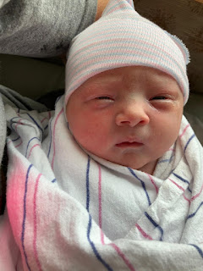

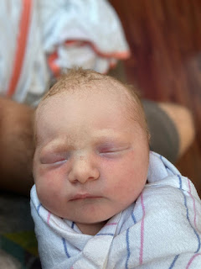

I was in Bassano del Grappa with my sister, Charmaine and her Scott, just sitting down in a local restaurant for lunch, when I got the news that she had been born. I immediately started bawling and then Charmaine came around to my side of the table to hug me. I was just so relieved that our granddaughter was HERE and that everyone was okay. I was also thrilled that soon I would be learning what her name was and I could connect with her more deeply. For so long, I have prayed for her in general, that she would be born healthy and strong and that all would be well. But I was about to learn her NAME . . . and that takes everything to a whole new level. XOXO

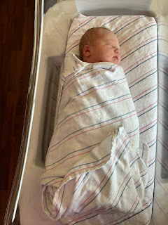

Hannah woke up around 4:45 a.m. on September 5th because her water broke. Nothing major was happening though, so they took their time and even started packing some snacks for Jack for when he would soon be in the care of a neighbor/friend. Eventually, they realized that her contractions were picking up speed and intensity, so Jake helped her out to the car and got her settled in. He went back into their apartment to scoop Jack out of bed and walk him over to the neighbor's home in the same apartment complex. This was around 7:00 a.m. Even though he was only gone for just a few minutes, by the time Jake got out to where Hannah was in the car, she was in a bit of distress. Things were happening!

They drove the 10 minutes to the university hospital and she was checked into a room right away. This was roughly 7:15 a.m. While the staff started filling up the tub for a potential water birth, Hannah was already dilated to 8 cm, and things were progressing quickly. They didn't even have a chance for the water birth, because at 8:00 a.m., and after only 4 pushes, Maisie was born!!

Hannah is so amazing. I spoke to her recently, after she'd had a week to recover, and I asked her how she was feeling after the delivery. She said she feels great! She said the labor and delivery were about as picture perfect as it could get, and she was feeling so grateful. She doesn't get morning sickness either. Wow. She was made to be a momma!!

Below: Maisie in her bassinet, Hannah recovering in bed, and Jack eating a snack, just hanging out.

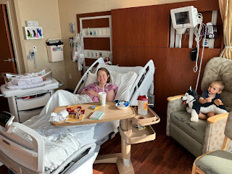

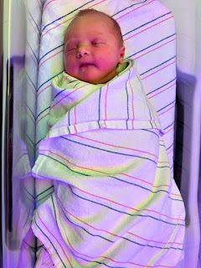

Jack, holding his teeny tiny baby sister . . .

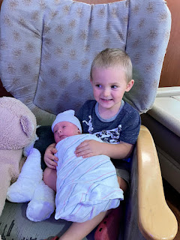

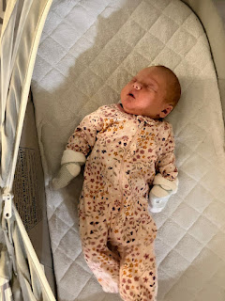

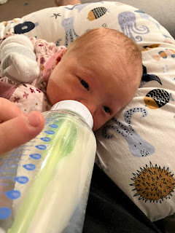

I love her adorable double chin and her facial expression . . .

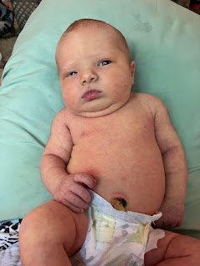

Jake and Hannah are so good at giving their babies regular "tummy time" where they can work on getting a strong neck right away. Even if Maisie struggles a little bit, and gets a little frustrated, they speak soothingly to her and encourage her for just a little bit longer before they scoop her up and give her a break and some snuggles. They are so patient and intuitive about their parenting. They seem to understand that a carefully planned and purposeful struggle can bring important learning and growth. What a metaphor for life . . .

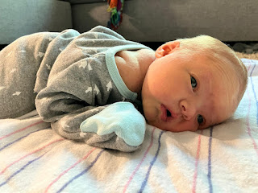

Sweet Jack . . . all worn out from the excitement . . .

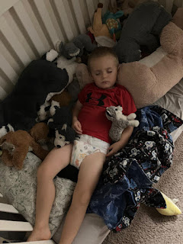

He also started preschool this past week! He is 3.5 years old and attends school on T, W, and Th mornings from 9:00 - 11:40.

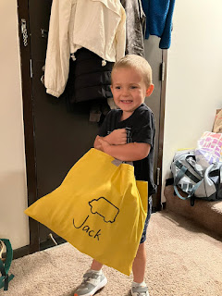

Miss Maizie . . . alert and happy . . .

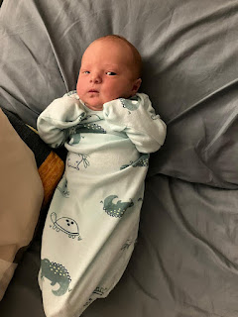

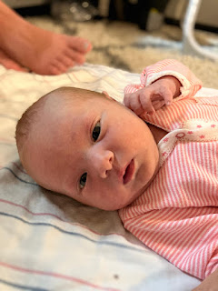

Video of Jack learning about his new little sister: (28 seconds)
https://photos.app.goo.gl/F3Sa9H5kXawh3yN96

Video of Jack holding Maisie for the first time: (32 seconds)
https://photos.app.goo.gl/gZp4zFN6FxPvsnKb6

They are adjusting well as a family of four and everyone seems happy and content. Maisie sleeps for 3 hours at a time through the night, mainly because of a technique that Jake and Hannah discovered. Maisie is always trying to suck on/eat/slurp her fists, which tends to disrupt her sleep. But if they tuck her in efficiently, making her comfortably snug inside her swaddle, then her hands are at rest all tucked in at her sides and she isn't distracting herself. They've had to try a couple different techniques with the swaddling, because sometimes she was able to wriggle out and then, once her hands were free, she would wake up and want to use them as a binky, which would subsequently lead to frustrations.

We are just so thrilled that Maisie is here, that her family is doing so well, and that they are thriving. I'm super baby-hungry right now, though, and I can hardly wait for this fall to pass quickly so that I can get over to Minneapolis and hold her in my arms. In the meantime, we are relying on video chats through WhatsApp, which isn't a perfect substitute . . . but 'twill have to be sufficient anyway.

More adventures to share . . .

As I mentioned earlier, we were in Bassano del Grappa on Thursday, September 5th. We had originally planned to visit the Vicenza Farmers Market that morning, but there was quite a lot of rain, and we didn't even know if the vendors would be setting up their booths in that kind of weather. So, instead, we had a nice lazy morning and then closer to lunch time, we drove over to Nove first, and then on to Bassano del Grappa. In Nove, we visited the pewter shop and then the ceramics shop, buying a few little things at each place.

I had read on Dr. Peter Matthews' website recently that there is a house in Bassano del Grappa that was most likely the home of the Bassano Family, from whom I descend. (Click the photos below to read a few lines from his website re: the house.)

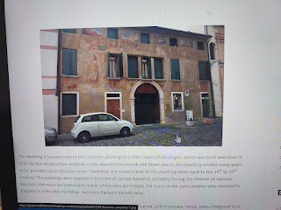

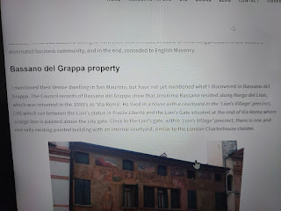

It was pouring rain in Bassano del Grappa, with a boisterous wind that made it difficult to stay dry even while under an umbrella. On the Ponte Vecchio Bridge (designed by Andrea Palladio in 1569), the wind drove the rain in and onto us, even though the bridge was covered!

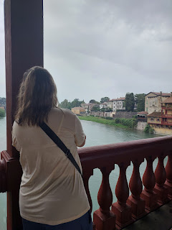

Scott and Charmaine, trying to stay dry while on the covered bridge . . .

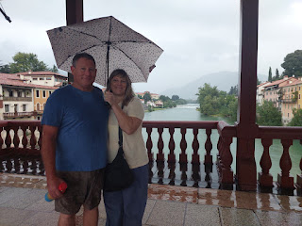

Charmaine and me . . .

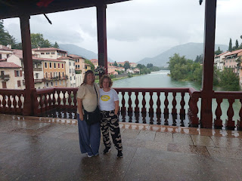

For lunch, we ate at a small bar/restaurant on the west side of the Ponte Vecchio Bridge, called Birreria Lowen. Hardly anyone was open at 2:00 pm on a weekday, but this place was. I ordered a really delicious bruschetta pizza with grilled vegetables, spicy salami (basically pepperoni), and a couple different types of cheeses. I would 100% eat there again. Also, this is where I got the news that Maisie was born.

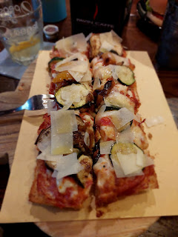

After lunch, the rain paused for a while, which was much more enjoyable so we could explore some more on foot (with less stress).

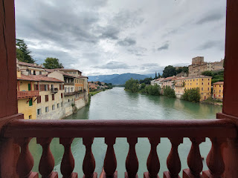

We began walking toward Via Roma, the street where the Bassanos lived.

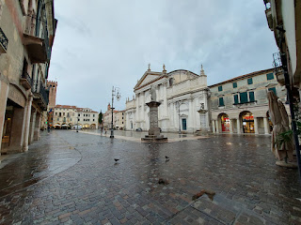

We had to cut through a couple of piazzas on our way first . . .

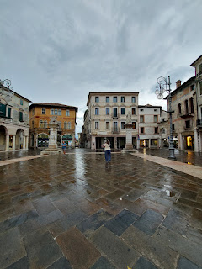

A central part of Via Roma, where we turned to the right (or south) . . .

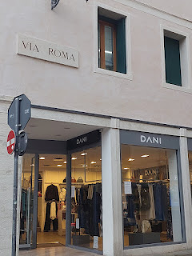

There is a little square near the south end of Via Roma, with a memorial tribute to Vittorio Emmanuele II. I don't know who he was, but it's an important marker to the proximity of the Bassano family home.

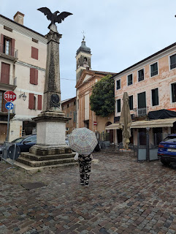

On the right (in the photo below) is what used to be a little church called Chiesetta dell'Angelo. (Now it is more of a museum and a cultural event center for musical concerts, etc.) The Bassano house is directly to the left of the church (next door). To clarify, if you're looking directly AT the church, it's the darker terra cotta building on the left. I just discovered on the internet that the Dal Ponte family (also known as the Bassano family) contributed significantly to the artwork on the inside of this little church, which was originally built in 1384.

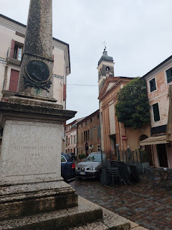

The Chiesetta (or Little Church) and the Bassano home next door) . . .

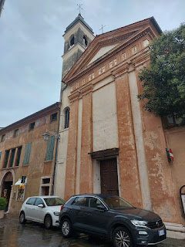

The VERY likely Bassano house, with still visible frescoes - including some musicians and the like - on the exterior . . .

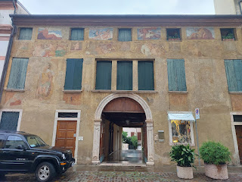

A closer look at the arched entryway that leads back to a good-sized courtyard . . .

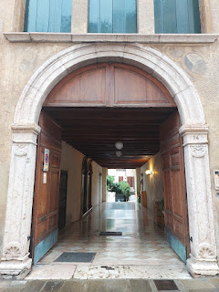

Current names on the door buzzers for this same address . . .

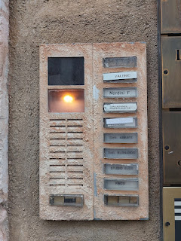

Inside the covered walkway leading to the inner courtyard . . .

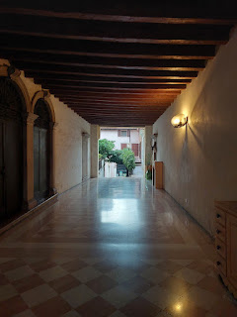

Doors on the left inside the covered walkway . . .

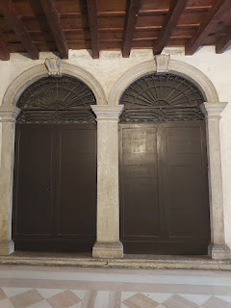

This looks like it used to be something important, but now the inscription is not legible anymore, sadly. It is also located in the same covered walkway . . .

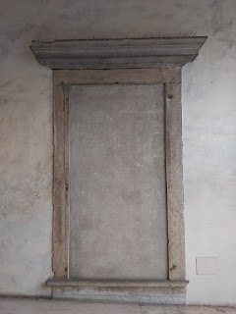

Charmaine and Scott, ahead of me, walking down into the courtyard . . .

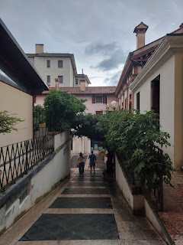

I was fascinated by the beautiful tree that arches over the path leading down to the courtyard.

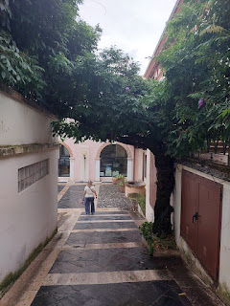

It twists upward and seems to have been here for a long, long while . . .

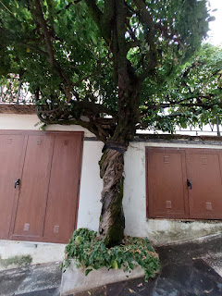

There is also an old well, or cistern, in the courtyard . . .

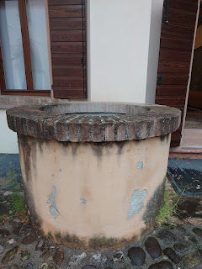

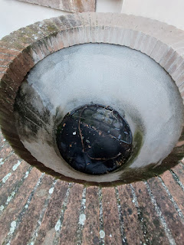

Back in the 1400's and 1500's, an Italian family would have likely had multiple families living in the same communal home and courtyard. Nowadays, especially in America, we like our own private space and it's harder to share our space with extended family members. But back then, it was a common practice to stay together and work together.

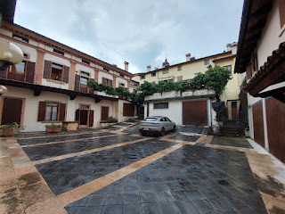

As I was still taking photos and documenting the space, Benson called. I never tire of hearing from him, so I put him on speaker and kept taking photos while we chatted. It was starting to sprinkle again, and we were ready to head back to the car, though. I still wanted a video before we left, so I borrowed Charmaine's phone to take a video while I handed my phone to her so she could visit with Benson for me while I documented our walk up the path.

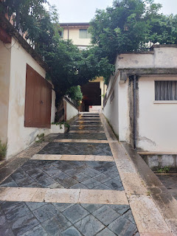

Here's the video as we walked back up the path from the courtyard, while talking to Benson in America: (32 seconds)
https://photos.app.goo.gl/U1dh9ipYWkLMCFX68

One of the two main entry doors next to the street in front, there to close off the arched entrance if needed.

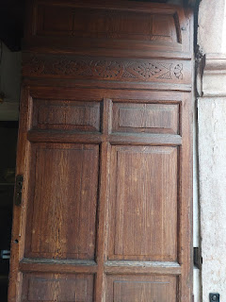

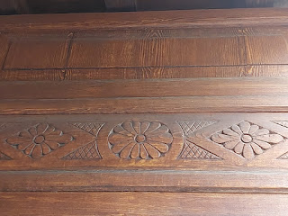

It was so wonderful to be able to share a new piece of our Bassano history with another family member. I had shared a couple of things with Amber and her daughters, Abby and Gwen, last October, but I didn't know about this house at that time. I wish that I had known, because they would have loved to see it in person, too.

As soon as we got home, Jacob called to let us see Maisie as they held her in the hospital room. She was so sweet, and I was grateful that I could talk to her and tell her how happy I was that she was here, and how much I love her. XOXO

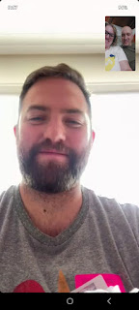

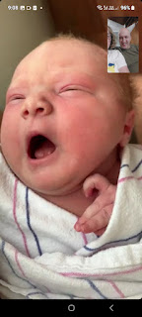

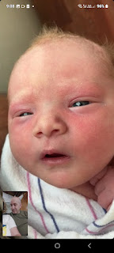

Friday, September 6th:
Charmaine's 54th birthday!! For 10 days every year, we are the same age, up until the day of her birthday. I took her (and Scott) to lunch at one of my favorite places - NaturaSi in Dueville. It's a health-food store with a buffet-style cafeteria, along with the most delicious foods to choose from. You put everything that you want on your tray, and then they weigh each plate at the end to determine what you owe. This was the first time that I had to put a little piece of fish on a separate plate to be weighed, and I'm not exactly sure why that was . . . (pssst - it wasn't that good anyway.)

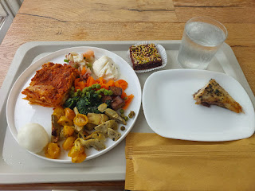

Charmaine, the birthday girl, sitting down to eat. She and Scott enjoyed this place a lot and they were very happy with the variety of offerings.

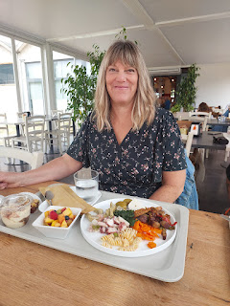

After lunch, we drove to Breganze so Charmaine and (her) Scott could enjoy a wine tasting and tour of a family-owned vineyard. The name of the place was Firmino Miotti. What made them a unique experience, per Charmaine, is that they harvest grapes from local indigenous plants that have been in that specific area for many generations, which then gives the wine a distinctive flavor.

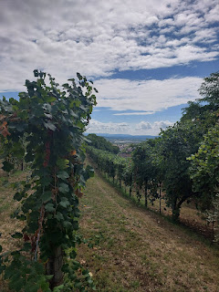

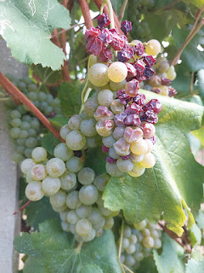

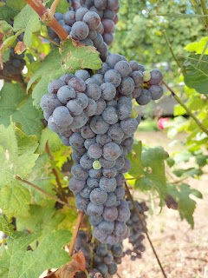

I've never participated in a wine tasting tour before, but it was interesting and informative.

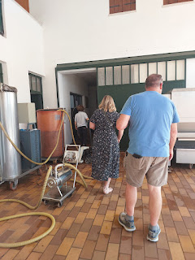

Franca basically runs the whole operation right now. She does everything from the testing, the pressing, the bottling, the shipping, the publicity, the tours, etc. The only thing she doesn't do is pull the weeds and pick the grapes. They hire locals to come take care of those tasks. She partners with a restaurant in Berkeley, CA and has flown over to San Francisco to meet with the buyers from time to time. She also sells to a restaurant down in L.A. But everything else stays in Italy, she said.

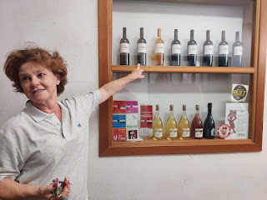

She showed us the cellar where everything is temperature-controlled . . .

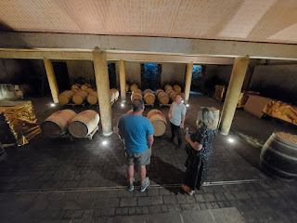

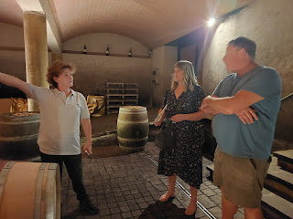

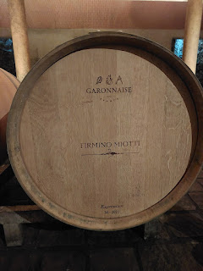

And then she took us to the tasting room, complete with a table where we could sit down and rest.

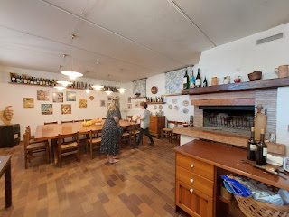

While Charmaine and Scott looked at the brochures to choose what to sample, I decided to take some photos of their experience, and to just kick back and watch.

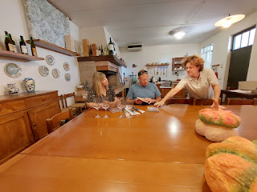

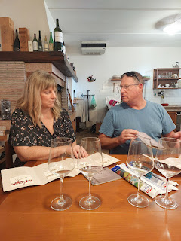

They tried a few white wines . . .

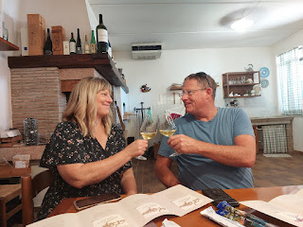

And also a few red wines . . .

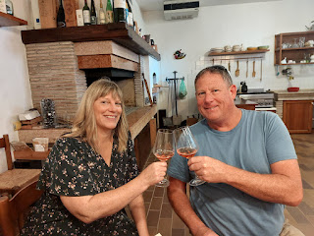

They chose their favorites and bought an entire case for roughly $80. They said that at this price, it was a STEAL, compared to a good quality wine in the U.S.

On our way back to the car, Franca explained a couple more things while they stood in one of the rows of grapes, and I took one last photo of them. They sure had a good time!

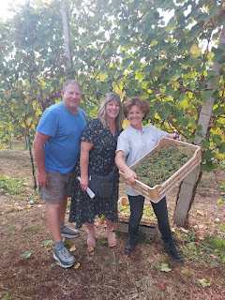

(Side note: I needed to go potty before we began our drive back to Vicenza, but when I walked into the guest bathroom at the winery and saw the squat toilet on the ground, I said NOPE! No way. Not gonna do it. And then I just held it all the way home, ha ha.)

Later that evening, we ALL went to a very special performance that only takes place every 2 years: a Human Chess Tournament in Marostica (close to Nove, Bassano del Grappa, and Breganze).

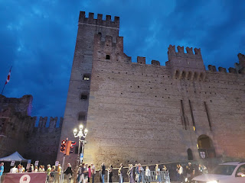

We entered through the arched gate of the Castello Inferiore (Lower Castle), built in 1312. Wowzers. The upper castle sits on the hill above Marostica, not seen in these photos.

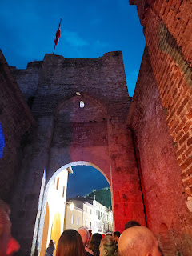

Charmaine and me, just before the program began . . .

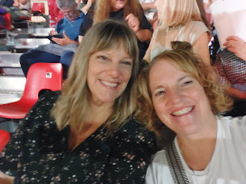

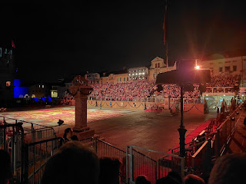

Video of a portion of the preface: (1 minute, 11 seconds)
https://photos.app.goo.gl/meBUojZhfTDUiTML7

The story goes like this: (as per the English translation on our printed program)

The year of the Lord 1454. In the darkness of the night, the Master of the Field, Zuan del Lovo rides across the square on the back of his steed. The shadow seems to spring out from the darkness of time. He stops in front of the Castle and signals with the torch.

Video of the entry of the Master of the Field on horseback: (40 seconds)
https://photos.app.goo.gl/qmy4HqfXfQdwLZ6h6

Promptly, the pedestrian door moves away and the banner carrier comes out, proudly waving the banner of San Marco. It is the daily ceremony of ownership of the territory. Meanwhile, the soldiers are placed beyond the battlements. The commands of the Captain of the Castle come thundering. Hearing the order, "Fogo!" Fire, two flaming darts start from the bastions, aimed at hitting the basalt edges of the large chessboard which is set on fire.

Video of the fiery arrow that lights up the chess game square: (22 seconds)
https://photos.app.goo.gl/RQcrTD6RrUYgP5gx8

When the flames go out, it is now dawn. The square suddenly comes alive. In fact, it's market day. Dealers arrive pushing their carts, and immediately crowds flock among the merchandise stalls; peasants, noblewomen and curious gentlemen.

Some gypsies and friars begging also walk here and there with their donkeys. Here come the comedians and acrobats of the "Compagnia dei Comici", who in no time at all set up their own stage. The Arlecchino and Columbina masks immediately entertain the public.

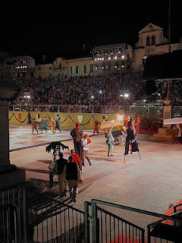

Video of the royal procession entering on horseback: (14 seconds)
https://photos.app.goo.gl/RJF32V1xQTXFjhiT9

Video of the townspeople and jesters entering the square for the morning market: (8 seconds)
https://photos.app.goo.gl/zQJ4B8NkS74CqP3N8

Swords by their sides, some young aristocrats also proceed in the crowd. We can notice on one side, the Vallonara family in a green brocade doublet, led by Vieri, a knight of the Order of Rhodes. On the other side, the Angaranos are advancing in a red overcoat. They are headed by Rinaldo, known as "Spadaforte".

Any little reason is good enough to ignite the two factions and here is the spark! Lionora, the daughter of Chief Magistrate Taddeo Parisio, arrives in a sedan chair, escorted by the nurse Prudenzia.

Video of Lionora's grand entrance: (16 seconds)
https://photos.app.goo.gl/BFPVeZcQ4gee1Snx6

Everyone stops. It is said that the girl is as beautiful as a "musk rose", but very few have seen her face.

The young woman proceeds with the curtains drawn back and it takes just a moment for Vieri and Rinaldo to see her and become bewitched by her beauty. A quarrel breaks out between the two rivals, who draw their swords and begin to fight. The begging friars intervene instantly and Arlecchino, with his funny jokes, invites the musicians to soften the atmosphere. Immediately some commoners improvise a dance to the playful rhythm of tambourines and rattles, followed by the "Zanni" clowns.

Video of some of the dancing in the square to "lighten the mood": (10 seconds)
https://photos.app.goo.gl/CMGe382hgQQEGgYV9

Suddenly, we can all hear the anguished toll of the civic bell and all gaiety is extinguished. Even the morning light seems to fade away in the face of the tragedy that is looming upon the scene.

There is a rumor among the local people that Vieri and Rinaldo intend to fight in a mortal duel with a "pointed and sharp weapon", in a few words - a sword, and thus ensure the privilege of marrying Lionora. Blood will run in the town.

In a flash, the retailers put away the goods and leave the square. Even the comedians hurry up to dismantle their stage and seek escape.

Meanwhile, the trumpets play and the drummers come out of the castle in full formation, followed by the flag bearer with the banner of Venice, and the delegate of the "borghi" with the banner of Marostica.

Video of the drummers coming out of the castle: (18 seconds)
https://photos.app.goo.gl/GFhYp9HVH8ACpBUv5

The Master of the Field, Zuan del Lovo also appears on the scene with his knights riding fiery steeds. Here comes the Chief Herald, who reveals that by the will of the Magistrate Parisio, the duel will be a bloodless challenge in the form of a game of chess.

Video of the Master of the Field coming out with his knights: (22 seconds)
https://photos.app.goo.gl/64bBcME4APPifmad8

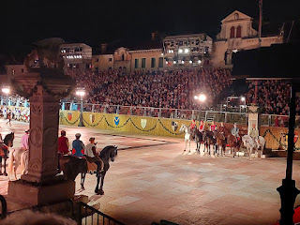

Preceded by the Master of Ceremonies, the Venetian court then arrives in the square. The noble Magistrate Taddeo Parisio has on his side both his beautiful daughter, Lionora, and his haughty sister, Oldrada, the young woman who will marry the loser of the challenge. Following behind them, we can admire a sumptuous parade with: the nurse Prudenzia, the handmaids, the pages, the clerics, a crowd of noble courtiers and the grotesque figure of the jester.

Video of Magistrate Parisio entering with his daughter and his sister and their entourage: (33 seconds)
https://photos.app.goo.gl/2ftrEnQ2GCsYQgEv9

From the stage podium, Messer Lunardo da Fiatolongo, the court secretary and historian, recalls the ancient Veronese edict issued following the tragic story of the Montagues and the Capulets. He therefore forbids challengers to compete for Lionora's "beautiful soul" with a duel to the death. Thus he proclaims that the challenge lies in the noble game of chess with large and living pieces. Finally, he arranges for both the aristocracy and the people to attend the game, and for a military demonstration, lights, and merry dances. The event will be run again after 500 years to the greater honour and glory of Marostica and the Serenissima.

In unison, all those present stand up and pay Venice the customary homage to the cry of "San Marco and the Lion, you with us and we with you always."

As the historian takes his place among the court dignitaries, the civic bell returns to strike its eerie note.

Soon after, we can hear the roar of the cadenced steps of the "zente d'armi", the armed men of the castle, who enter the square for their demonstration. The first ones to appear are archers and crossbowmen, then it is the turn of the veterans, the halberdiers, and the "Schiavoni" infantrymen, who perform impeccably by singing the "cantalonga".

Video of the infantrymen singing their song: (33 seconds)
https://photos.app.goo.gl/zEzmmFjWBi8YbetcA

The chief herald regains the podium and calls the challengers to take position for the game. Vieri enters, escorted by his father, Cante da Vallonara, plus a large group of squires, ladies, bridesmaids and pages. On the other side, Rinaldo advances, accompanied by his father, Rambaldo d'Angarano and a procession of knights, gentlemen, ladies and maids.

The two factions bow to each other and reach their stands. The chief herald then invites the embassies of the host towns to introduce themselves and take their seats. Venice, Verona, Este, Montagnana, Padua, and Vicenza parade themselves, along with the delegation of the city of Florence.

Video of the entrance of the embassy of Vicenza (!!): (41 seconds)
https://photos.app.goo.gl/cwC7SEMLeFNTwwM87

The Chief Herald then calls the people in charge of the "Borghi" of Marostica. Soon after, those districts also parade one after the other.
(Borghi are neighborhoods, I think)

The representatives of the three major guilds also bow to the Magistrate: the guild of straw art, the guild of ceramics, and the guild of cherry growing, with pretty girls carrying baskets full of the red fruits.

Next there are several "demonstrations" - the flag bearers of the various militias, drummers and trumpeters, etc.

Video of the flag bearers entering the square: (25 seconds)
https://photos.app.goo.gl/L3XqGMJ7xFkxNunR7

Video of a portion of the flag bearers' performance: (43 seconds)
https://photos.app.goo.gl/qoACnCzD44nkw86WA

Video of another short section of their performance: (21 seconds)
https://photos.app.goo.gl/qtGiZ8xyVo8A7TFx5

In the end, the Minor Herald gets on the podium to dictate the terms of the match between Vieri and Rinaldo. He explains that deciding who the first move will go to, will be placed in the gentle hands of Lionora. The referee of the dispute will be Taddeo Parisio himself.

Then, he orders those present not to dare to bother the players or to side with one or the other, under penalty of whipping on the "postergal", that is - the backside.

At this point, in an unreal silence, the Master of the Field, Zuan del Lovo returns to the competition and on the back of his steed throws the gauntlet at the feet of Taddeo Parisio. The gesture is ostentatious and made more dramatic by the pressing toll of the civic bell.

A page retrieves the glove and the magistrate shows it to everyone. Darkness falls on the square. It's time for the challenge.

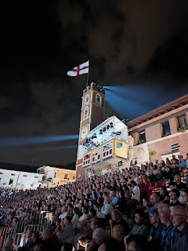

A powerful symphony and suddenly the door of the castle opens wide: in the opalescent light, the 32 living pieces emerge. They are very tall and proud; almost alien to the world. They proceed all together up to the box seat of the M
agistrate, praising Venice to the cry of "Lion!" and then they take up their places on their allocated squares. Whilst the big bell strikes once more. Now the view is breathtaking.

Video of the chess pieces entering the square: (22 seconds)
https://photos.app.goo.gl/e2PYgPQ4Jpy9ST226

With a dull rumble, the ram's chariot arrives in the square where the contest will take place, while a captain carries the precious chessboard.

Video of the pieces taking their places on the chess board and the chariot approaching the Magistrate:
(1 minute, 14 seconds)
https://photos.app.goo.gl/EoT3UP6ypuyaM5Jm7

The Herald introduces the request for the wedding from the fathers of both the challengers. This is the formal act that begins the dispute.

Madonna Prudenzia, who is Parisio's sister-in-law and faithful nurse of the beautiful Lionora, is very anxious. She, too, secretly dreams of such a tournament for her own hand, but at this moment in time she only cares about the fate of her ward.

Meanwhile, Vieri and Rinaldo, the two rivals, get on the ram's chariot assisted by some helpers. Everyone waits for a gesture from the Magistrate to start the challenge.

Taddeo Parisio descends on the giant chessboard to revere the noble guests present at the battle of love. He senses that his daughter's heart beats for one of the contenders, but he doesn't know which one. It will therefore be love itself to guide the gaming skills of the opponents.

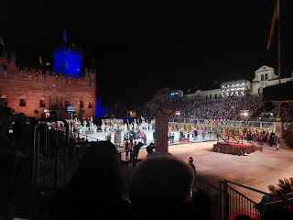

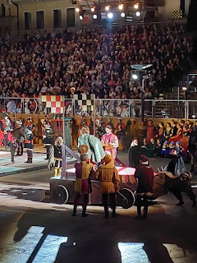

The Heralds prepare to commentate on the chess moves. The players stare at each other in the eyes, unmoved. Soon, they begin. Thus begins the most epic, chivalrous duel in history. Move after move, the game develops according to the ancient rules of chess. The captured pawns overturn the banners and leave the board; the others give life to exceptional chess combinations.

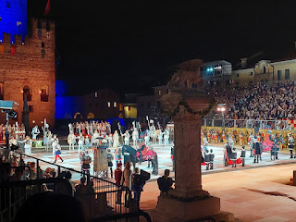

Video of some of the suspenseful chess moves during the game: (1 minute, 23 seconds)
https://photos.app.goo.gl/TH5LTGn7Wq9Rv72Z6

Video of the white queen making yet another intimidating move: (39 seconds) *We thought at this point that White was about to win. But alas, they did not.
https://photos.app.goo.gl/iMqBLp1YsyGMu4eJ9

In the end, for one of the two players, the circle closes and it is "Checkmate!"

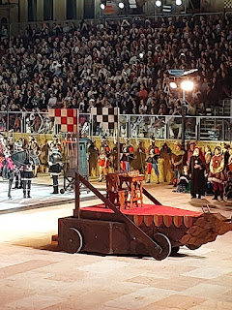

The big town bell fills the air with its deep toll. The contender who won is Vieri da Vallonara. The young man appears to be happy, but the loser Rinaldo is also satisfied. Both fought with courage and loyalty and are now awaiting their prize.

Taddeo Parisio rises from his seat and invites Lionora and Oldrada to place their hands in his so he can give them to the winner and the loser. The faces of the girls betray fear and hope for the future.

Video of Parisio walking forward with his daughter and his sister: (11 seconds)
https://photos.app.goo.gl/GzhiavkmBs6qbaGY8

The moment is magical. Taddeo Parisio raises the blade of the sword offered to him by a commander and places it flat on the shoulders of the newlyweds, who bow their heads. The weddings are blessed and sealed forever. All tension has now disappeared. The four young people appear genuinely happy, while the great bells of the town chime in celebration. It is a riot of exultation and happiness that seem to have no end.

Video of Lionora and Vieri's marriage: (35 seconds)
https://photos.app.goo.gl/51ebzeS4vDY8Btxh7

Video of Lionora and Vieri marching forward as the bell announces their wedding: (8 seconds)
https://photos.app.goo.gl/3XDmda7MAsAhvHVJ8

Unexpectedly, the girlfriends of the noble brides gaily invade the square and start dancing. Even the flag-wavers of Figline Valdarno take to the field to celebrate with virile impetuosity and it all becomes a riot of twirls and virtuosity.

Video of the girlfriends of the noble brides dancing: (28 seconds)
https://photos.app.goo.gl/FD5kiJjTGkvUmAo66

No one has the time to catch a breath before the riders are already moving onto the giant chessboard for the last carousel. The proud battle steeds proceed in an orderly fashion. From their hooves, sparks appear!

The doors of the Castle open wide again to let all the protagonists of the story back out, onto the square. One after the other, more than 600 people who took part in the show swarm out, solemn and festive. They go around the game arena, greeting, throwing kisses, and finally they arrange themselves on the large chessboard.

It is an impressive parade, but even more is the gathering in the square: a magnificent sight!

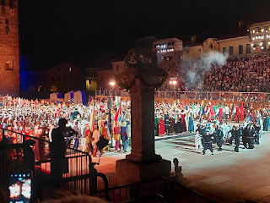

Video of the various groups majestically re-entering the square: (1 minute, 29 seconds)
https://photos.app.goo.gl/hYhbAmP3yZJjzPhMA

Video of the last of the 600 participants joining the throng (I love the drummers): (31 seconds)
https://photos.app.goo.gl/7A9pVqa7eSY4vWjv6

Then suddenly, a group of archers advances toward the castle and releases some incendiary arrows. Immediately, tongues of fire flare up. A thick, reddish cloud of smoke rises, and suddenly, a display of fire comes out of the battlements, like a sort of coronet of sparks. In a flash, the flame explodes in a cascade of sparks that bounce down 20 meters below onto the wooden drawbridge and spill out into the moat. While the fire dies away, the applause of the audience is ignited. Marostica's Chess Game is over!

Video of the archers launching their flaming arrows toward the castle: (24 seconds)
https://photos.app.goo.gl/kdhEM1yA4DSbaLgw6

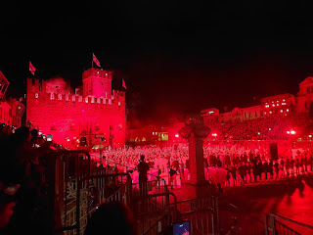

Video of the finale - fireworks show: (1 minute, 31 seconds)
https://photos.app.goo.gl/CugKsrwbkZCzurwf9
**Note: the last 10 seconds or so of this video might be a little boring . . . I wasn't sure if more was about to explode to ooh/aah the crowd, so I kept the camera rolling. But nothing actually happened, lol.

And that's THE END. Finito.

The whole performance took about 2.5 hours from start to finish. It was captivating and fun, although a little bit long. Also, if I had had a more comfortable seat, I could have stayed a tad longer . . .

It was a once in a lifetime experience and one I will never forget. I loved all the pomp and circumstance, the flag bearers, and the drummers. The actual chess game was extremely suspenseful and exciting. And we enjoyed watching the pieces go down, one at a time.

That's all for this blog post. More to come next week, including: a trip to the Dolomites, a cave tour, and a day at the beach in Chioggia. Eventually, I'll get to our trip to Croatia and Slovenia, along with a subsequent and incredible day in Venice. Peace out.

