Cake Boss and Acts of Service
First things first - pictures and videos of all the grandbabies this week. I guess I'll go in order of oldest to youngest. :)
Abby is now on a nice and long Christmas break. She was reportedly very excited to sleep in and relax, but the very next morning, she went in to wake Amber up at 6:45 a.m. As she knocked on the bedroom door, she announced, "Mom, I'm ready for an art lesson!"
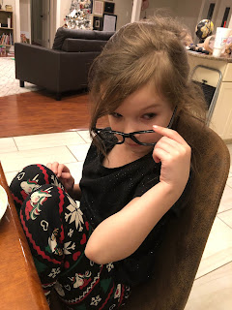

Amber took Gwen to Abby's school Christmas concert. I just love this picture of all 3 of them!

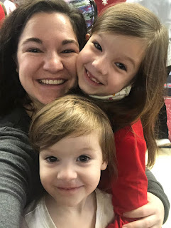

You can see Abby singing in her Christmas Concert - she's in the group on the far right, standing in the front row wearing a red dress.

Click to see the video: (1 minute)
https://photos.app.goo.gl/kwQUaA2mzPsRJrMG8

Jack is so close to cutting his first teeth, loves to jibber jabber, and seems to be growing up so fast!

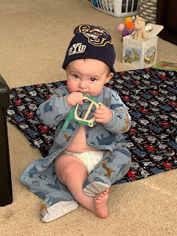

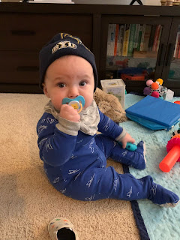

Video #1: Jack is practicing to be the Little Drummer Boy (21 seconds)
https://photos.app.goo.gl/rMpfQ4W69AY5vDSp6

Video #2: Jack loves his shoe so much that he tries to eat it (20 seconds)
https://photos.app.goo.gl/Ye3YWrRxfeppUrqa6

Video #3: Jack spitting with all the gusto he can muster (12 seconds)
https://photos.app.goo.gl/GfTaBH1GzPi5Zjvu6

Video #4: Jack can hear the sound of his mom mixing up his bottle from a mile away (45 seconds)
https://photos.app.goo.gl/QdRnBsyn6gbYq8xb6

One last photo of Jack -

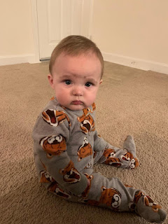

We also got one photo of Avery this week. With her cheeks so filled in, it seems like she's eating well and growing well. She seems to be such a happy little girl. :)



On Tuesday, I met with the other young women leaders that I serve with, and we put together Christmas gift bags for the girls. We made 40 bags in all, which was enough for us to have one, too. That was nice!

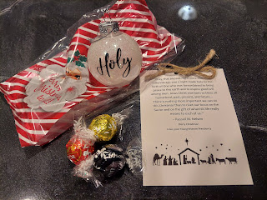

While I helped get the glitter inside each ornament ball, the other ladies were working hard to get the vinyl word "Holy" off its sticky backing and carefully onto each ornament.

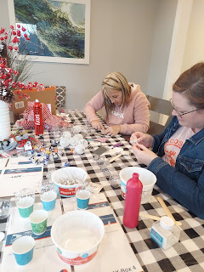

To get the glitter inside, I used hair spray. Using the internet as my guide, especially YouTube, I bought a bottle of hair spray that has a spritzer cap, one that you can unscrew and remove. Then I drizzled about a teaspoon of liquid into each ornament ball and rolled it all around to coat it evenly on the inside. Then, using a tiny funnel, I poured a teaspoon or so of white glitter inside and shook it gently to distribute it all over. It was really fun, and quite easy to do. I think for next year, I would like to make some beautiful dark red ornaments with glitter on the inside.
Later that night, I dressed for success in my ugly Christmas sweater and elf stockings to head over for the Young Women's Christmas Party at the church.


The girls each found a decorating partner and chose a popsicle stick with their assigned Christmas theme to decorate their cake with. Below, Jessie and Abi are pondering how to proceed in making a 3-D Grinch cake . . .

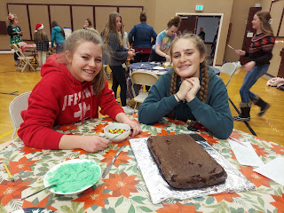

This is the finished product. They had 30 minutes to complete their cakes, and then we all took a little tour by walking around to admire everyone's hard work.

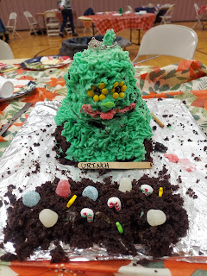

Elves/Toy Shop theme

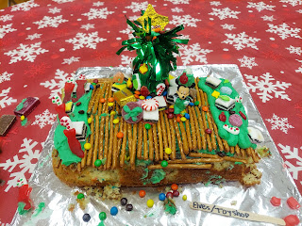

Caroling theme

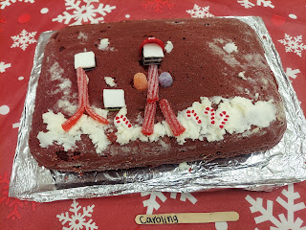

Christmas Tree theme

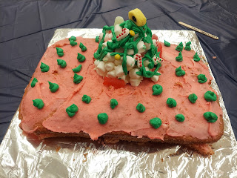

Ugly Sweater theme

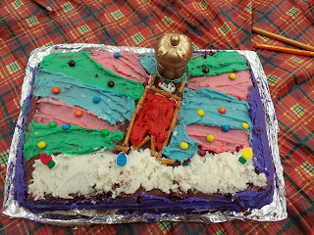

Santa Claus theme

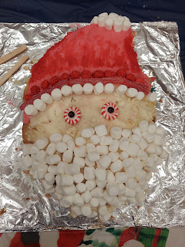

Snowman theme (these girls took it a step further by making their snowman into a Bob Ross snowman, and he's painting a happy little tree)

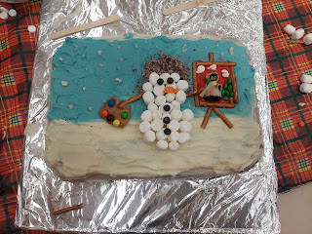

Winter Wonderland theme (I forgot to mention that each team was assigned a random object that they had to incorporate into their finished product somehow. In this cake, the zebra was the extra)

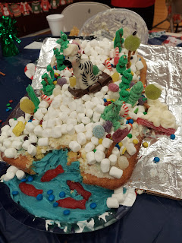

Gingerbread Man theme

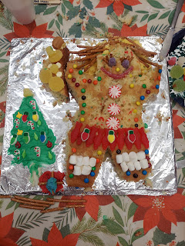

As we took a tour around the gym, we ended at the Grinch cake. While we were busy touring, he decided to topple over. Abi and Jessie thought it was hilarious as they tried to smush his face back on.

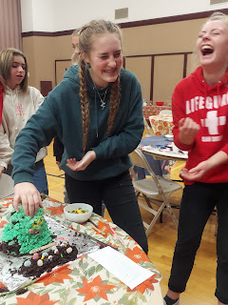

It didn't exactly work . . .

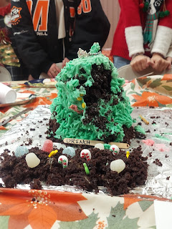

All of the YW leaders: (L to R) Kayleen Steel, Lucy Blatter, Megan Smith, Amanda Whipple (the YW president), me, Rebecca Eastman, and Brittany Croft

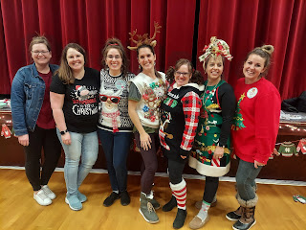

I work with Megan in my class of 11-13 year olds. She is a HOOT!! She landed a great teaching job at Idaho Falls High School as the Drama and English teacher, and the kids all love her. She is a bundle of energy, knows ALL of the fun songs EVER and can sing all the words, and she knows pretty much every book that's ever been written and can converse in a fun and engaging way with all the girls. I'm so grateful to serve with her. :)

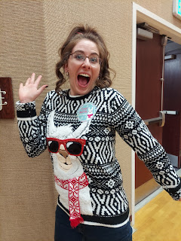

Here are all the cakes together at the end.

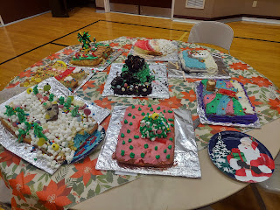

We had a great turnout! The girls had a blast and they really enjoyed the Christmas gifts we gave them, too.

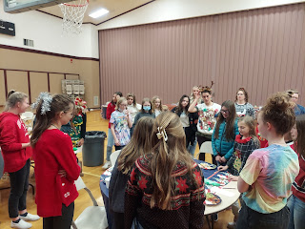

Throughout the rest of the week, I had ample opportunities to do loving acts of service for family, neighbors, and friends.

I baked some loaves of apple cinnamon bread and delivered them to some close friends. We kept one loaf for ourselves, and after Scott tried a slice, he reported, "Oh My Gosh! If there is only ONE food that I can have for the rest of my life, it would be this!!" Good to know . . . :)

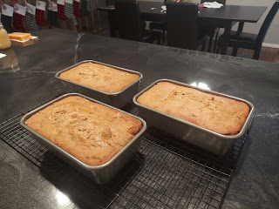

My neighbors across the street, the Kloaks, had a new baby on Wednesday. The dad couldn't go to the hospital for the birth (c-section delivery) because he was sick with a cold. So he stayed home with their two older daughters. I took some taco soup over to share with them, and we enjoyed the rest ourselves.

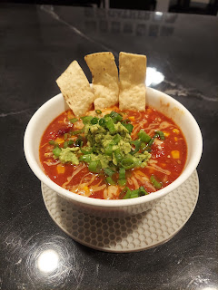

When I texted Marie (my massage therapist) to make sure she was home so I could bring her a jar of homemade applesauce, she was home, but apologized and said she had been too sick to shovel the walks. I told her no problem! Scott and I loaded our shovels into the trunk of our car and drove over to take care of it ourselves. We tried to be really quiet so she wouldn't hear us.

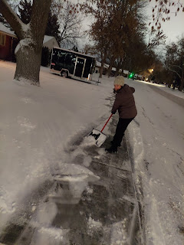

After we finished and I rang the doorbell, she noticed the freshly shoveled walks and marveled, saying, "I don't know how that even happened!" I didn't say a word. :) Poor thing - she's been sick for 2 weeks now with a horrible sickness and cough. She had two separate covid tests, but both came back negative. I hope she gets better soon, especially before Christmas, and also so she can get back to work! If she can't work, she is losing a lot of precious income . . .

On Friday, I had the privilege to spend the day with Scott's dad, Phil, while Coy was at the hospital around the corner having a hernia repair surgery. In his older age, he needs someplace more comfortable than a hospital waiting room, so I was happy to be that place.

I made a nice fire first thing in the morning so he could have a warm cozy place to hang out.

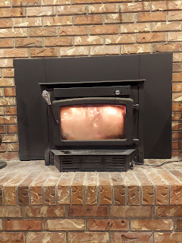

He was happily entertained by watching episodes of Matlock, taking a couple of naps, and reading his book.

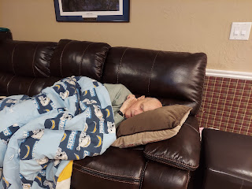

I even taught him how to play Mancala, and we played one round of Uno before Scott got home from school.

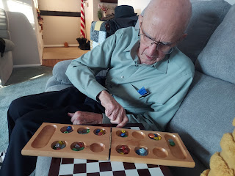

I made a giant pot of Chicken and Wild Rice soup, and after we shared a relaxing meal together, Scott headed over to the hospital to check on his momma.

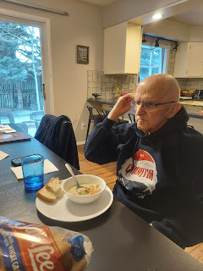

Her surgery had been delayed by several hours due to all the other surgeries on the schedule for the day. It went very well, though, even though they ended up having to do 2 hernia repairs instead of just the original one. After some time to come out from that sleepy fog and the inevitable nausea that can accompany general anesthesia, she was finally well enough to get up and get dressed to be discharged.

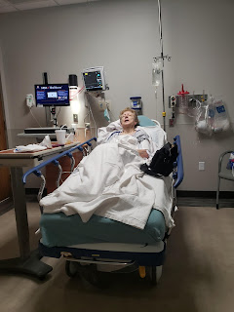

Scott brought her over to our house, where we did a car swap. I drove Mom in our car up to Rigby, while Scott drove his dad in their truck. We got Mom safely into the house, where, after a brief rest to work through another wave of nausea, I was able to help her get ready for bed and get all tucked in for the night.

Today (Saturday), I am happy to report that she is doing much better. Her head is clear once again, which does a lot of good for a person, and even though her tummy is tender and a bit sore, she got on her treadmill and walked for an entire mile! (The discharge instructions told her to do some walking by the following day.) She is a Super Woman for sure!!

Friday night, Amber and Weston's water heater decided to give up the ghost. After leaking all over everywhere, they caught notice of what was happening and worked quickly to get it drained properly and removed from the house altogether.

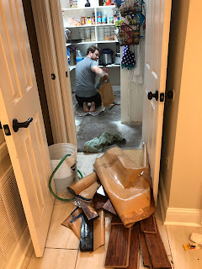

There was a little bit of water damage to the kitchen cabinets on the other side of the wall from the pantry, so they are pondering what to do about that. Not the best time to be without hot water . . . but thankfully they also have a mother-in-law suite across the carport, and it has its own water heater over there. It shouldn't take long to get another water heater installed, but it's what to do about the flooring and cabinets that will likely take some time to replace or repair.

Scott and I are getting all packed up today so that we can hit the road tomorrow after church. We'll be driving down to Louisiana for Christmas - and to surprise Abby and Gwen, who have no idea we're even coming! :) That part will be the BEST!!

We opened up our big gifts from each other early, so we don't have to haul them across the country and back. Scott bought me a new sewing machine, and I bought him (and us) a pair of snow shoes.

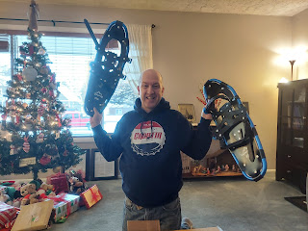

I like to cross country ski, but he doesn't. We've been snow-shoeing once before and we both loved it! It's a workout, but it's also an easy workout, even though you get all kinds of sweaty burning lots of calories. I figured this would be a nice gift to the both of us if we could do some snow-shoeing together this winter. There are plenty of beautiful places nearby to hit the trails and get out in nature.

We packed up the rest of the gifts to take with us for Amber's family and for Jacob and Hannah and Jack, who we will see on our way home. (They'll be in Utah visiting Hannah's family for the holidays)

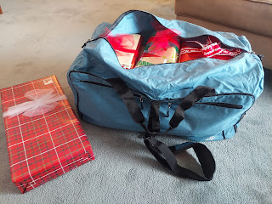

Everything fits into this giant duffel bag, all except for one lone gift. We've been rounding up some other items to haul out to Louisiana for Amber and Weston, too, . . . things that got left behind when they moved and they just didn't have room to take with them at the time. So we'll have a full car going out, but that's okay. We're happy to be a courier service if it means we get to see family at the same time!

Happy Holidays! And Merry Christmas!

