Christmas Prep & A Christmas Party
Not much has happened this week, to be honest. So, this post will be simpler and shorter than usual.
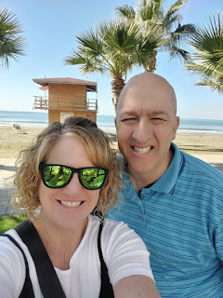

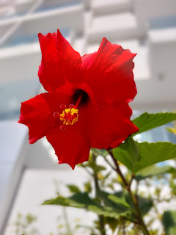
After my wonderful visit with Scott, I got back to Vicenza on Wednesday afternoon, following an unexpected overnight in Vienna, Austria. My flight was delayed coming home, which caused me to miss my connection to Venice. This time, however, Austrian Airlines was fantastic (as compared to RyanAir). They rebooked my flight, gave me a voucher for a free night in a hotel within walking distance from the airport, which also included a free dinner at the hotel and a free breakfast. They also gave me an "essentials kit", which had some basic toiletries and a white t-shirt (to sleep in, I assume?).
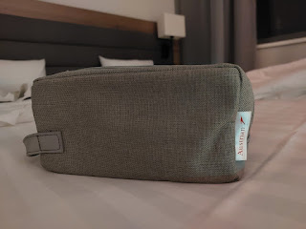

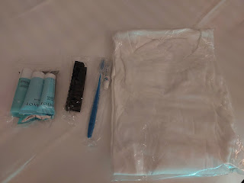
Never at any point did they make me feel like this was my fault, nor did they ask me to pay for anything out of pocket. They took excellent care of me, for which I was very grateful. I had a nice dinner from the hotel lobby - which was a buffet of various casseroles and soups to choose from. I had a quiet room to retire to, and a BED to sleep in! How nice.
I got a call from Benson just as I was getting into bed, so we ended up chatting for about 45 minutes. He is doing very well . . . he just had some things he wanted to share with me, which is always welcome. A co-worker of his had commit suicide recently (Mountain Home AFB) and the memorial service had taken place that morning. It brought back some feelings he needed to acknowledge from a very dear friend's passing last year (also by suicide and also in the military). I'm glad he knows that he can call me and that I am here for him. We are both looking forward to hanging out over Christmas with all of his siblings and their families.
True to my nature, I woke up WAY before my alarm was set to go off the next morning, so I headed to the airport a little before 6 a.m. It was just a short walk through an underground tunnel, which was nice because it was so cold in Vienna that it produced a few snow flurries in the air!
The airport was pretty empty at that early hour . . .
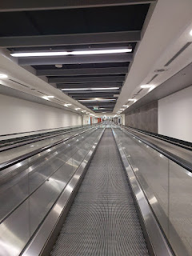
I had fun walking around and finding a few little tiny treasures to bring home with me for some fun plans during the holidays. Amber and I have been planning a few ideas for a variety of family games to play, like "Minute To Win It" games, that we can do when the gang is all together for Christmas. I found some really fun prizes to add to my collection (mostly interesting and random food items, ha ha).
Everything went smoothly to get home to Vicenza, including riding the military shuttle bus back to the base where I had parked my car previously. Yay!
It was a whirlwind once I got home, though. I had to hurry and shower, get some groceries, wash some laundry, get unpacked, and hurry to the dinner on base and teach my Family History class - - all within about 2.5 hours from when I got home. It was nice to crawl into bed that night and get some sleep.
The next day (Thursday), I woke up full of energy and motivation, which was great! I organized 4 boxes of miscellaneous items to ship home, so I don't have to haul those things in my suitcases in a couple weeks. The boxes included some stocking stuffers for Christmas, all the random prizes I have been collecting in 3 countries for our upcoming Game Night, and a few heavier items that were better to send in a flat-rate box. It felt so good to get those things out the door and on their way to Idaho!!
That evening, I rode the bus into downtown Vicenza to have dinner with Nell and her husband, Mike, as well as the elders (missionaries). She fed us a delicious Thai dinner, with Pad Thai, Coconut Curry Chicken Soup, and Salmon Patties. Yum!! She was so thoughtful to think of me and invite me over. It was especially nice to not have to cook when I still needed to get a few more groceries after I had completely cleaned out my fridge before my trip to see Scott.
On Friday, I walked to a massage appointment, which was so needed. I know I've said this before, but I am just always so impressed to see the older people out and about in Italy. No matter how cold it is, or how rainy it might be, they are still outside and happily going about their business.
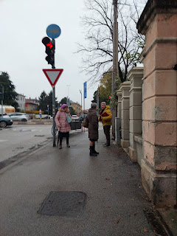

Video of a guy in his 80's riding his bike down the street, without a care in the world: (4 seconds)
https://photos.app.goo.gl/yibhtNdHtQkFYaaN8

I had to smile when I got to the building for my massage. When I rang the buzzer for Evelyn (at SpaLab), I saw a hilarious name further down the list . . .

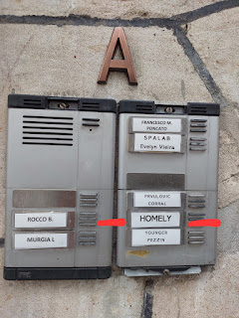

And when I walked back home, I smiled again when I saw someone's poignant addition to all the graffiti on the walkway going under the road. ("Disco Yes") Of all the things to write . . . ha ha.

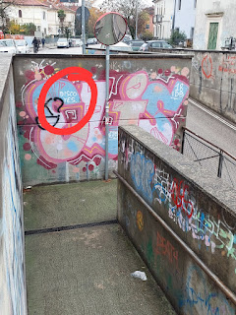

I drove over to Del Din, the smaller base in Vicenza where Scott usually works. I needed to check the mail and pick up a package. It was fun to see how they dressed up the Army Tank that sits on the corner at one of the intersections.

Video of the tank as I walked up to it: (11 seconds)
https://photos.app.goo.gl/EsdbVx4wRWeobrEC7

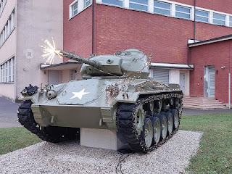
I ran a few more errands and then rested for a chunk of the day before we had the Ward Christmas Party that evening. It was so nice to mix and mingle with everyone, to eat food that I didn't have to lift a finger to prepare, and to feel uplifted in spirit by the time I left.
I had some turkey, ham, a miniscule portion of mac & cheese and funeral potatoes, smoked salmon salad, chopped fruit with coleslaw as a salad, and the yummiest chocolate cookie with a minty square on top. I also got a tiny portion of a dessert that I don't even know what to call it. But it was so amazing!! It was like bread pudding meets up with a cinnamon roll in a twisted shape, with some gooey pumpkin and spices on top. Dang, I need to figure out who made that and get their recipe.
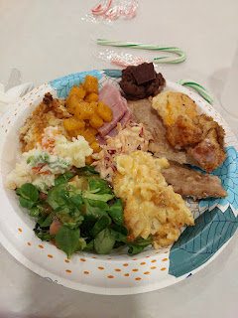

There were about 100-125 people that came to the dinner and party, many of whom wore their best Christmas sweaters, ha ha. I don't have one here in Italy, sadly, but I'll be wearing it when I get home to Idaho.

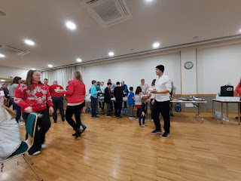

After dinner, they rounded up all the Primary children and then presented a sweet little program for everyone. They portrayed the Nativity scene, complete with Wise Men, angels, sheep and shepherds.

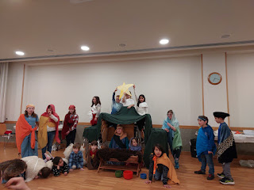

The primary leaders had printed out the words to a couple of songs and then asked the audience to assist the children in singing the verses while they acted out a few portions of the words.

Video of the beginning of the first song called, "The Nativity Song": (15 seconds)
https://photos.app.goo.gl/NZtVvKiYAPQVG38t9

The words include:
This is the season beloved of the year.
Sing a rhyme, Christmastime soon will be here.
Tell the true story of Jesus' birth,
When, as a baby, he came to the earth.

There are additional verses about the new star, the stable, the shepherds, and the humble parents.

The last verse reads:
See the sweet mother, Mary so fair.
Joseph, who guided the donkey with care.
See the dear baby of Bethlehem,
Little Lord Jesus, the Savior of men.

While everyone around us sang, I tried to keep this little girl occupied so she didn't get into mischief. Her mother is the primary chorister and was therefore busy leading the songs for the special program. Seated on the floor in front of me was the Primary President, Emarey, who was trying to video the whole thing. Emarey's daughter, Mabel, was playing the part of Mary. But this little one, a 3-year-old twin, kept trying to put her hand in front of Emarey's phone as she was recording. So, I devised a distraction.

We had way too many packaged candy canes on the tables, so I started peeling off the plastic wrappings and had her break the candy canes into little pieces. Then I showed her how she could build a little candy cane house and a few other options. It worked nicely, ha ha.

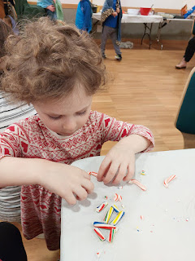

On Saturday, I had to push myself to take care of a couple things, even though I really didn't want to. I am almost out of face lotion, and even though I only have two weeks left here, it could literally run out at any moment. Unfortunately, I can't find any Burt's Bees face lotion in Italy, so I had to do some research and figure out where I could go to find a sensitive skin replacement that didn't cost me an arm and a leg.

I walked 35 minutes each way to get a new face lotion. And lucky for me, it only cost me $16. The lady at the store took me to the expensive section first, where she was showing me some options that ranged from $60 - $128. Yikes! But thankfully, I was prepared. I showed her a screenshot on my phone of a specific brand I was hoping to find, and she knew right where to find it. It was on the opposite side of the store, and far away from all those expensive brands, ha ha. I was much happier to spend $16 for an experiment, and a temporary one at that! Once I get back to the states, I can find my favorite Burt's Bees face lotion at Walmart or Target for about $12.

I enjoyed my walk to and from the cosmetic store, though. With the Christmas decorations up, Vicenza looks even more beautiful.
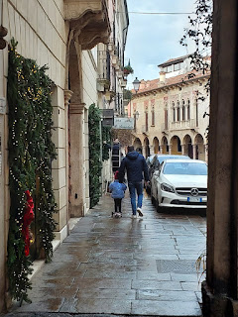

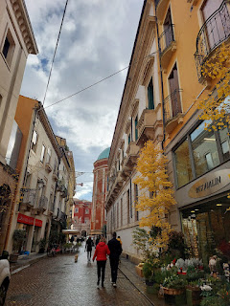

Hey Mom - this one's for you: I learned that there is an Italian tradition to put Baby Jesus in the Manger on Christmas Eve. How fabulous to learn this because that's what our Snider family tradition was growing up, as well! And our Italian ancestry is through your line, Mom! How cool is that! I had to ask around about it because I saw this beautiful Nativity scene near the main piazza in Vicenza, and it was clear that someone very important was missing . . .

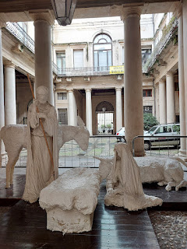
"
When the first star appears in the evening sky on Christmas Eve, every family sets lighted candles in their windows to light the way for the
Christ Child
. They light candles around their presepio and pass the figure of the Baby Jesus from person to person, finally placing it tenderly in the manger."
(Presepio, or Presepe = Nativity scene)
In the piazza, I came across this guy playing a pretty amazing guitar solo: (33 seconds)

https://photos.app.goo.gl/mfuD1MNgUBri7YSq9
That same day, I was also on the hunt for some Mason jars so I can make some applesauce before I leave Italy. This is going to be my Christmas present for Scott. He loves applesauce and especially the homemade kind. Well, even though there are several good quality jars to be found in Vicenza, they don't sell canning-quality lids. So, after three stops at what I thought would be promising stores, I had to give up and just order some canning jars and lids on Amazon Italy. My supplies will arrive in a few days . . .
For some reason, I was just wiped out that day. Each time I got back from those "forced" errands, I felt like I could just sit in a chair and veg out for hours. I did rest in smaller chunks, and then I made myself get up and do a little bit more each time.
I rounded out the day by making two phone calls, each of which lasted for TWO HOURS, ha ha. It was totally worth it, though. First, I called my cousin, Valorie, whom I hadn't talked to in over 3 months. We write occasionally back and forth, but it was so good to get caught up and make sure she's doing okay.
Then, I called my wonderful friend, Jenn, in Ukiah, CA. We talked about all kinds of things for another two hours. We could have talked even longer, but it was around 10:45 p.m. when we decided to call it quits. What a fun evening of connecting with two people that matter a great deal to me.
On Sunday morning, I shared my testimony in Sacrament Meeting. I mentioned that I've been reading in the book of Jacob in the Book of Mormon this past week, and specifically in chapter 5. This is a lengthy chapter that tells of an allegory (or symbolic story) of vineyards and olive trees, likening them to various groups of people over the course of many years. Jesus Christ is the Lord of the Vineyard, and His devotion to the olive trees (us) is so profound and powerful. He strives constantly and consistently to prune (us), to dig about (us), to nourish (us), to transplant (us) if needed, even grieving many times over certain trees in various portions of the vineyards when they fail to produce good fruits.
I shared that when I was 18 years old, and wasn't making the best of choices at the time, I had stayed the night where I shouldn't have been. I got up early the next morning to drive over the mountain (from Boonville) to get to work on time. I was driving on those curvy mountain roads in the dark on a cold January morning, when I misjudged the curve and ended up rolling over and down the hillside. Miraculously, I was not injured, and after climbing up the hillside to the road, I began walking in the pitch dark back toward Boonville. I was so scared and afraid, and I felt so alone. I began to pray and immediately felt the warm embrace of the Savior, comforting me with love and a peaceful feeling, even though I didn't feel deserving of any of it.
This goes to show an important lesson that the MOMENT we turn to Jesus, He is RIGHT THERE. He is the Master Gardener, and I am so grateful that He has carefully and lovingly pruned me, digged about me, nourished me, and loved me all my life.
I also taught my Primary class (of 4-year-olds) about how Jesus is the Light of the World. It was a good Sabbath Day.
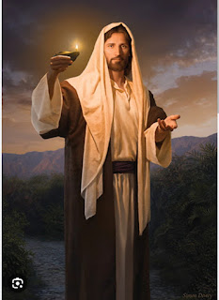
I am so proud of my daughter, Amber, and the huge list of things she has been working hard on recently. She has been painting wooden rounds with Nativity and Christmas scenes for several days, preparing to place them up for sale this coming week (Dec. 6th).
Everything will be available on her website:
www.amberwhitworth.com
In case you are interested in something, just know that last year, everything sold like hotcakes.
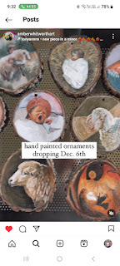

Abby also wrote a darling poem about Fall. (click photo below to enlarge)

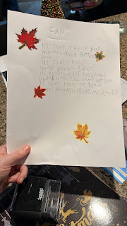

Meanwhile, Jack has been having tons of fun this fall. How do I know this? Well, see for yourself.

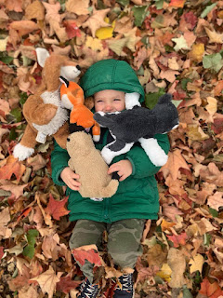

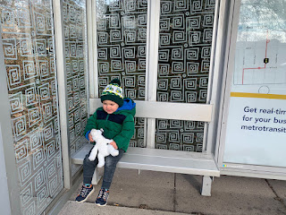

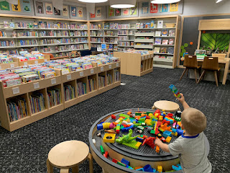

Video of Jack shoving noodles in his mouth and giggling: (17 seconds)
https://photos.app.goo.gl/7HfvxzcfN57tcHqw6

Video of Jack painting with a paintbrush: (53 seconds)
https://photos.app.goo.gl/qjCW4upMMA4mP3Yz8

Video of Jack painting with his fingers: (22 seconds)
https://photos.app.goo.gl/4KT6983ZxbakAojK7
I can't wait to see him in a couple weeks!! We are gonna have so much fun.
Tomorrow (Monday), I will get to see Avery again. Yay! I am so excited. I'll be sure to share photos in the next blog post.
The sun was shining this afternoon, so I decided to get out and go for a stroll. There is a street not too far away that is named Via Bassano. And I needed to see it.
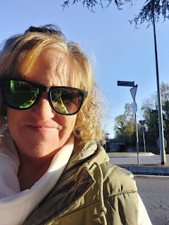

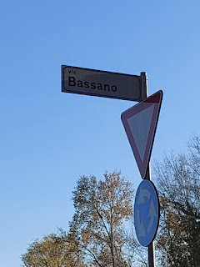

These berries made me extremely happy when I saw them on my way home. They just seemed so Christmasy. :)

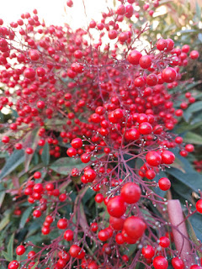
Have a wonderful week everyone! XOXO

