Doing Family History 24/7
I wish that's what I could do literally nonstop: family history, family history, and more family history. I wish I didn't have to eat, sleep, clean, get groceries, do my laundry, pull weeds, or pretty much anything else. (Except for sewing . . . I do love to sew) My trip to CA was filled with opportunities to do so many things with my family history, and I was sad to get in my car and drive far away from all of it.
But . . . I am working on two huge projects relating to my family history while I'm now at home in Idaho. The first one is to digitize the 2,000 +/- slides that I brought back with me. My dad cautiously allowed me to take all of them up to Idaho, and I know that he has a huge amount of trust in me to take good care of them. And I will!
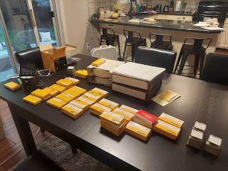

I spent a good portion of the day on Friday organizing all the boxes (or batches) of slides. Some of them were in the wrong box and mingled with slides from a completely different year. Many of them were out of order within each box, so I sorted them and put them all in chronological order while I watched America's Got Talent on my laptop. Now they are all ready to be digitized and saved for future generations!

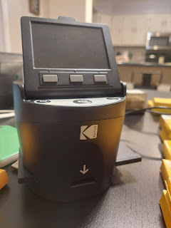

My friend, Steve Meyers, has a slide scanner/digitizer and he is letting me borrow it to get this huge project done. He showed me how to use it and it really is pretty simple.

Video tutorial of how to use it - - -

Part 1: (3 min, 1 sec)
https://photos.app.goo.gl/zzPq4T3Bvhgm9sws8

Part 2: (2 min, 37 sec)
https://photos.app.goo.gl/P3xhREMw9NcV6CzD8

Saturday, I captured several batches of slides and converted them to a digital image over the course of a few hours. All while watching America's Got Talent.

The second family history project that I'm currently working on is to write the next Rawles Roots Blog and Newsletter. I need to get it all taken care of and launched before I go back over to Italy in a month. I started writing it on Friday and got a good intro so far. I'm trying to share what I experienced (through my great-grandmother Kate) while in CA and all the connections that were made in the process. I also plan to put together a timeline of Kate's life, and do a spotlight on her oldest son, Darrel. I've also received a request to add in a recipe column with old family favorites.

No shortage of fun going on at my house this week! :)

Last Sunday, I had a wonderful second visit with my Grandma Doris. I chose to wait to share it because there was already so much going on in the last blog post and I didn't want it to get swallowed up in all the other stories.

My mom picked Grandma up and brought her back to the house for a couple hours. It always takes a bit of careful effort to get her into the car and out of the car. This time we had to be extra EXTRA careful. Grandma is pretty sore (and black and blue) from a fall soon after we visited her the week before. She fell in the bathroom, or on the way to/from the bathroom and received a substantial laceration above her left eye, as well as plenty of bruising on the left side of her body. She could have used a couple of stitches, but the house director was concerned that if she got stitches, she would be irritated with the bandaging or the stitching and would possibly try to remove it all. So they decided to use butterfly bandages and keep a close eye on it instead. Grandma gets fidgety and fussy with bandaging because of her dementia, especially at night.

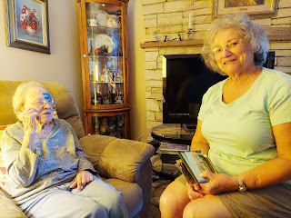

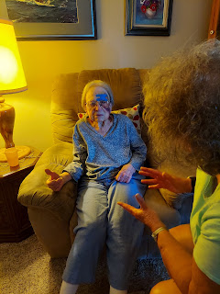

At one point, Grandma mentioned how much her left leg was bothering her, so we arranged for an ice pack and Mom held it on for several minutes, which brought some soothing relief to the swelling. What a kind nurse!

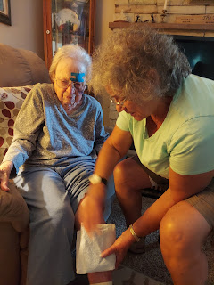

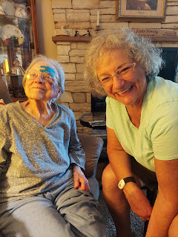

She has a huge knot on her left calf, which not only looks painful but also IS painful. Poor thing. It's so hard to be 101 years old with tissue-paper thin skin and a tendency toward falling. Bless her heart!

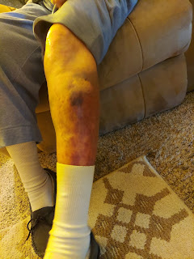

In spite of her discomfort, we looked at a few of Grandma's old picture albums again and talked about her travels through Europe. One cute picture that we found was this one of her in a gondola in Venice, Italy! (1987)

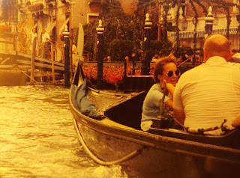

I looked back through my photos from last fall (2021) and found one of me in a gondola as well, and we laughed over visiting some of the same places.

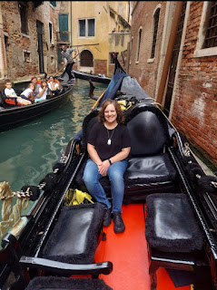

When it was time to help her get back into the car to go back to her assisted living home, I bent down to hug and kiss her in the front passenger seat. As I did so, I choked up and started crying. I didn't expect that at all . . . but I just had a strong feeling that this might be the last time I saw her on this earth. She was so tender and sweet, wiping away the tears that were streaming down my face. As she lovingly caressed my face, she kept saying, "Ohh, you sweet young lady." I didn't want to say it out loud (the thought that I had of not seeing her again in this life), but the entire exchange was the sweetest and most beautiful thing ever. She stroked my hair, gently pushing my bangs out of my teary eyes, and just kept pulling me toward her so we could press our cheeks together for a good long moment again. It was really hard to walk away after that. I went into the house and cried some more.

The only other time I've had that happen to me was with my Aunt Juanita several years ago. She had been slowly declining in health for a few years, so on one of my trips up to Oregon to see Grandma Lillian, I made it a point to stop by to see Aunt Juanita as well. She was my dad's older sister and we used to have the BEST talks over the phone and in person. There was never any mincing of words with Aunt Juanita. We usually skipped the small talk and just jumped right into the juicy and deep stuff. She typically had questions for me about my religious beliefs and what happens to us after we die. She was Presbyterian and I learned that we really have a lot in common with what they believe. She always made me feel like I was somebody important and worthwhile and amazing. She was such a dynamic conversationalist and I sure miss her.

Two of my dad's older sisters: Donna Brown Rosetta (on the left) and Juanita Brown Slay (on the right)

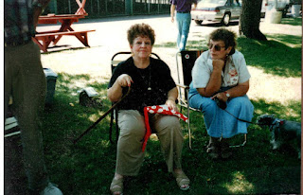

*Note: Grandma Zoe (my dad's mom) was first married to Wallace Brown. She later divorced him. My understanding is that he kept deserting them and leaving them for months at a time without any source of income or provisions. My Aunt Juanita told me once that they had to forage in the forest for food many times. Eventually, Grandma Zoe met and married my Grandpa John Snider and soon after, they had my father. That means that my dad's older siblings are his half-siblings if you really want to get technical.

Anyway, I had that same feeling as I hugged Aunt Juanita goodbye. I remember my kids were with me, too. Scott was in Iraq and I wanted to drive out to CA for Christmas. We chose to go up to see Grandma Lillian first, and we all slept in her little RV trailer in Aurora, south of Portland. We took her to church for the first time and it was wonderful. I remember feeling like that was a monumental moment, taking her to church and helping everyone to see her and meet her in person and trusting that she would be in good hands after we left.

Then we drove south to Albany, Oregon where Aunt Juanita lived. After a lovely visit with her, we hugged her goodbye for the last time, and as I got into the car to continue our drive south into CA, I got all choked up. I remember crying as the realization hit me that I probably wouldn't get to see her again in this life. She died on 2 Nov 2012. Our visit was in December of 2010. I still have her phone number saved in my cellphone contacts and I haven't been able to delete it even after all these years.

On Monday, the day before I left Ukiah to begin my journey home, I met my Dad at the Ukiah Cemetery. First, we found Aunt Naynee's grave so we could place a flower on her headstone.

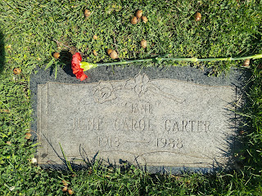

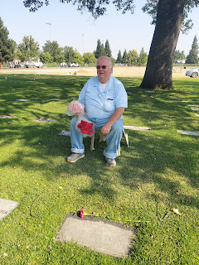

While Dad sat on a stool to rest his back, he began sharing some of his favorite stories of his Aunt Naynee. First, let me back track by saying that her real name is June Carol Rawles Carter. But she went by the name "Jane". As I recall, the name Jane transitioned to Naynee because her little nieces and nephews couldn't pronounce "Jane" or "Janie", so it became "Naynee". She was by far the beloved Aunt from what I gather.

When she was young, Bill Carter asked for her hand in marriage and she was excited to accept his proposal. But her father, Eugene Carlton "Bob" Rawles, didn't approve for some reason, so she had to decline. I think it broke her heart but she wanted to honor her father at the same time. Bill eventually married someone else, but Naynee never married. Instead, she became the world's best aunt to all of her nieces and nephews, including my father.

Years later, I believe Bill's first wife had passed away and he found Naynee once again. This is where the audio story below begins . . .

Here is a whopper of a good story of the day my parents got engaged: (1 min, 20 sec)
https:/www.familysearch.org/photos/artifacts/157124303?cid=mem_copy

Wow. What an amazing woman she truly was. I have fond memories of her as well. She had a gift of making you feel like you were the most important person in the world when you were with her. She made beautiful and delicious dishes in the kitchen, of which I enjoyed very much. She had a train set that she'd let us play with when we visited her, and I remember her very organized strawberry patch out front. It was in one of those circular garden beds, with several terraced levels. She was always so sweet and kind, but always a lot of fun with a twinkle in her eyes at the same time.

There were the usual herds of deer in the cemetery, something that is always enjoyable to see. I like that they find the cemetery so peaceful, as do I.

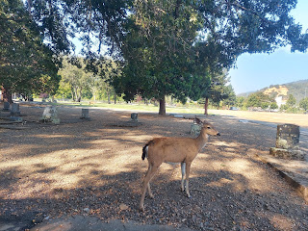

Video of some deer blocking our way to the next headstone: (14 seconds)
https://photos.app.goo.gl/RWwGncNLiBhjV12MA

This is the headstone of my great grandparents, "Bob" Rawles and Kate Orr Rawles. Dad and I counted out the correct number of pink carnations for their 4 daughters and then 3 red carnations for their sons. We added a pink one for Kate and another red one for "Bob".

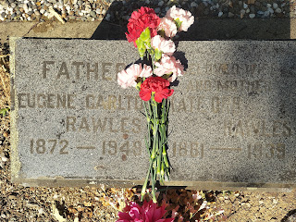

It was nice to take the time to visit Kate's grave, her final resting place on this earth. I am so grateful for her loving influence and promptings over the past few weeks.

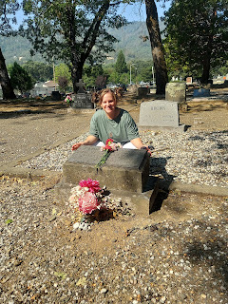

This suburban must come to the cemetery regularly . . . because as soon as they pulled up, the deer came running over. It might have had something to do with the person in the driver's seat flinging out whole entire slices of bread, one at a time . . . ha ha.

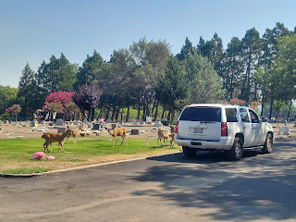

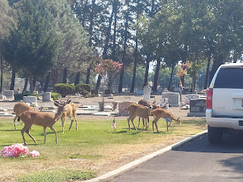

We visited my Uncle Ronnie's grave, my mom's younger brother who died of cancer shortly after he graduated from high school back in 1963.

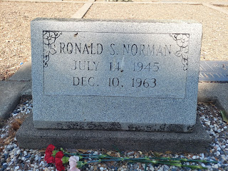

And these are my 3rd great grandparents: Frances B. Butts and Sindereller Roberts Butts. Their daughter was Mary Ellen Butts, who later became Kate Orr's mother.

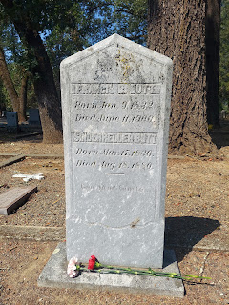

The last stop we made was to put some flowers on my dad's classmate's grave, Charles Crain. Charles left soon after they graduated from high school to join the U.S. Army. He arrived in Vietnam on 1 July 1967 and died in combat the very next day. My dad said they had been good friends since they were 6 years old.

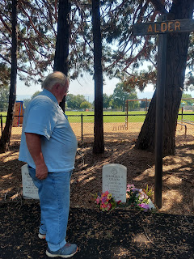

The one area of the cemetery that we ran out of time to visit was my dad's parents: John A. Snider and Zola Rawles Brown Snider. I had a date with my friend Jill to meet her for lunch . . . Sorry Grandma and Grandpa! I'll catch you next time . . .

I met Jill at Ellie's Cafe, my favorite restaurant in Ukiah. I decided to be brave and try some tofu on purpose. I've only had it a couple of times, and usually it was just by default because it happened to be in a soup or something else I had ordered. I don't hate it, but I just haven't been super drawn to it either.

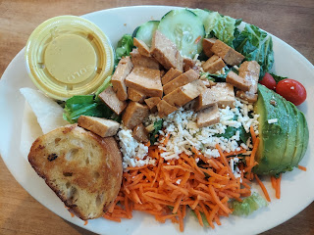

I ordered the tofu and avocado salad and it was amazing! The honey mustard dressing was great on top, it had some feta cheese, and the tofu had been soaked in something Asian-y. I loved it!

We had a wonderful visit for the third time, and she told me that she really appreciated the advice that I had given her and that she really wanted to move forward in her life. I am continuing to pray for her and hope that she finds peace and happiness and love (again) in her future.

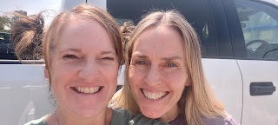

It was hard to leave my Mom on Tuesday morning, but at the same time I was eager to hit the road because I had plans to meet my cousin Valorie in person that day. We've been pen pals for the past year and a half and I don't remember ever meeting her in person before, although it's possible that we were at the same Rawles Reunion at some point years ago. I would have been young at the time and wouldn't have paid much attention to the "older folk".

She lives in Portola, CA, which is far away from any big city. From Truckee, it's an hour north. To get back on my route again after my visit with Valorie, it was also an hour southeast to Reno. There are lots of mountains surrounding Portola and the views were very pretty. Last year they had a big fire that came too close for comfort and she almost had to be evacuated. This year things seem to be a little quieter . . .

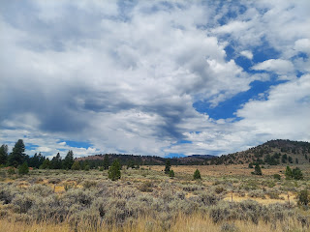

Some interesting facts about the valley just outside of Portola - - on a marker at the rest stop just east of town.

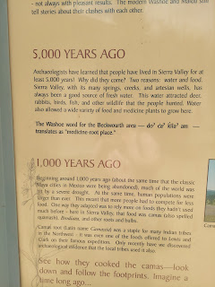

I drove up to her house and she immediately came outside to hug me. It was wonderful to be with her after we have shared so much through our letters. In a lot of ways we are kindred spirits and I appreciate how spiritually-minded she is. She turned 80 on May 28 so there is a big age difference, but it doesn't seem to matter very much. She is very sensitive to feeling close to our deceased ancestors, as I am. We sat in her living room and visited for a little over an hour before we went into town for a late lunch together.

Views of her living room and kitchen areas. She keeps a very nice home and it felt very peaceful there.

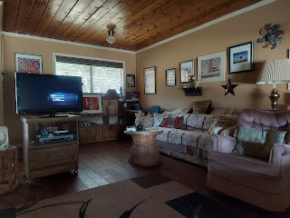

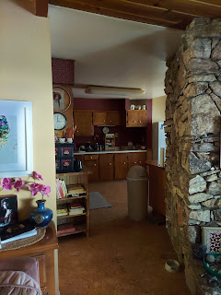

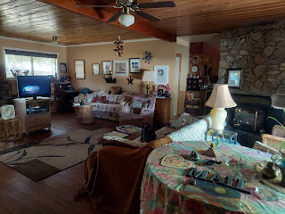

She took me to a cute Mexican restaurant and even bought my lunch! I had already offered to buy hers, but she wanted the honor of buying mine since I came "all that way" just to see her. What a kind and thoughtful cousin! The food was delicious and I ate my shrimp and fish tacos all up.

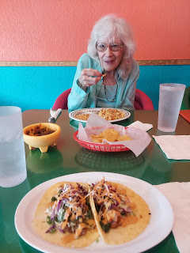

After we visited for another hour at the restaurant, it was time to go. We had our picture taken and then I dropped her back off at her house and said goodbye. Goodbyes are always so hard . . . I will miss her. But I know we will continue to correspond through snail mail. :)

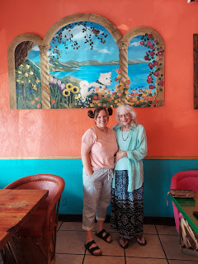

Three hours later I arrived at my hotel in Winnemucca, Nevada, got some dinner and went to bed.

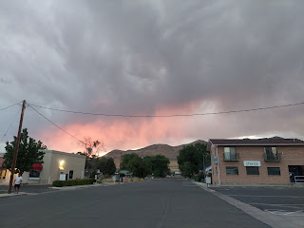

The following day I stopped at the California Trail Interpretive Center just outside of Elko, Nevada. I had seen it on my way out to CA and decided to stop on my way home. It was a fascinating and informative museum with all kinds of facts and stories related to the pioneers that headed west in the 1800s.

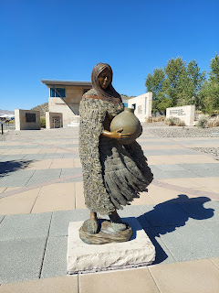

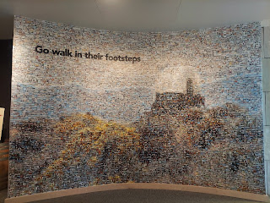

A close-up of the tiny little photos that make up the mural in the photo above . . .

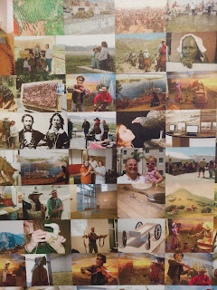

I was surprised when I looked up some of my ancestor's surnames on the pioneer database and didn't find anyone. But I was even more surprised when I typed in "Harmon" and hit the jackpot!

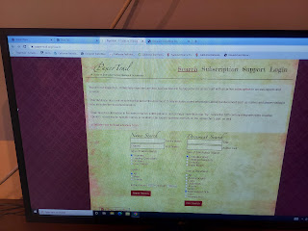

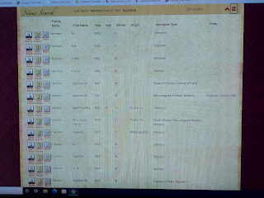

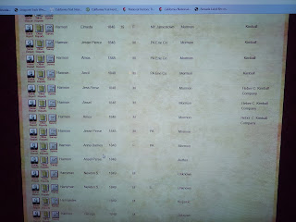

There were several exhibits relating to the Donner-Reed Party that got stuck going over Donner Pass. Not only is it incredibly fascinating to read about in general, but my mother-in-law has relatives that were part of the Donner-Reed Party. I can't remember the relationship exactly, but I think it was a sister to her direct Murphy ancestor that was part of the group. Her name was Mary Murphy and she survived the brutal and traumatic events on top of the snowy mountain.

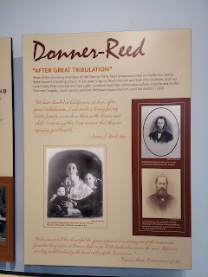

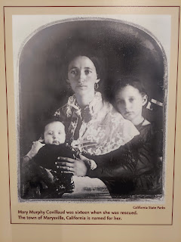

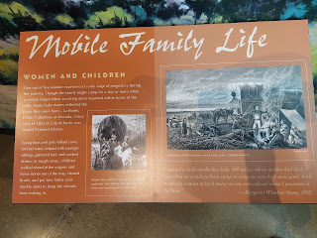

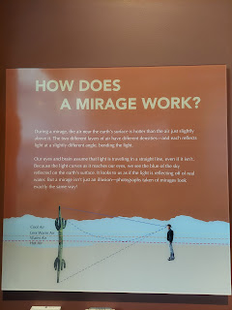

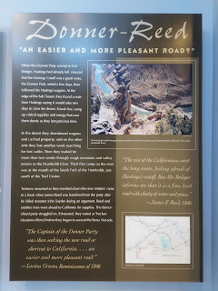

I don't think this John Snyder was related to all our the John Sniders in my family tree, but how interesting about this one . . .

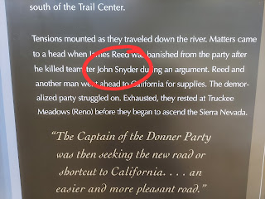

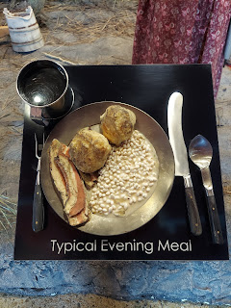

There were several life-like scenes on display . . .

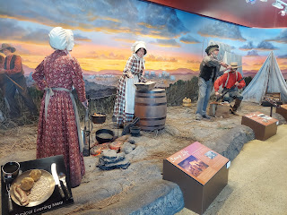

And they had so many fun activities for the kids to do. This one, for example, allowed for you to choose carefully how to fill your wagon. Each item represented something important and much-needed for the journey across the plains. But you couldn't fit everything.

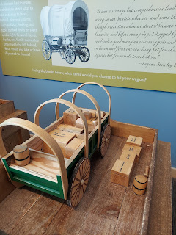

Another area had a surface for the kids to build a log cabin out of Lincoln Logs, with some tips on how a cabin was erected in the 1800s. There was a place for the kids (or adults) to practice panning for gold, too.

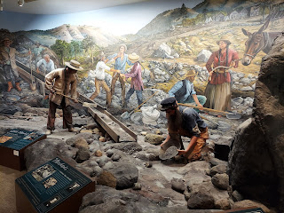

Below was an opportunity to practice your Morse coding skills.

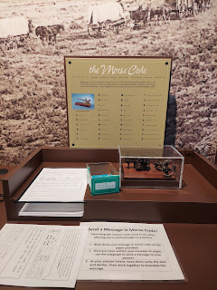

A scene of sadness . . . all too often on the California Trail, death would occur. And too many times it was a little one that died. I can't even imagine having to bury my baby under some rocks, knowing that the coyotes would come in the night to investigate.

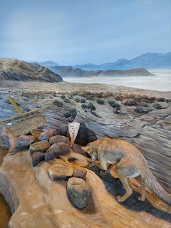

Mention was made of the invention of the Odometer, which helped the trekkers to count their mileage more efficiently. In this display, they listed Orson Pratt's name as the designer of the odometer, but they didn't mention Appleton Milo Harmon as the first builder of the odometer. Appleton was Scott's 3rd great grandfather, if I recall correctly.

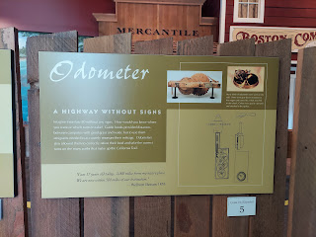

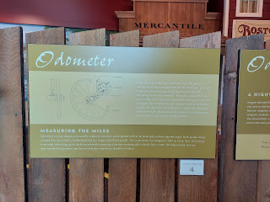

Behind the cash register was this beautiful quilt. I loved the actual braids hanging down the backs of each of the Native American women. (made from yarn)

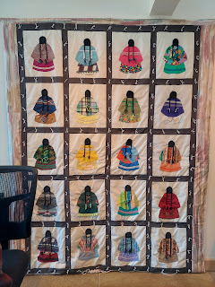

By the time I got home in Idaho Falls, I was so sick of driving. My arms were sore from holding the steering wheel, my neck was sore from holding my head up (ha ha), and my lower back was pretty grumpy as well. Even though I didn't have much of anything in my fridge, I didn't care. I didn't want to get back in the car at all that night. So I just scrounged up some soup for dinner and then soon after, went to bed.

The rest of the week is pretty much a blur. I've been rotating between digitizing slides, pulling weeds, running errands, and settling in.

I had an appointment to attend the temple Friday morning, which I'm glad I made. It felt so perfect to be in the temple after all of the new family history memories that I made on my trip. Our loving Father in Heaven's beautiful Plan of Salvation, otherwise known as the Plan of Happiness, is centered around the family. Everything comes together in my mind and in my heart when I attend the House of the Lord.

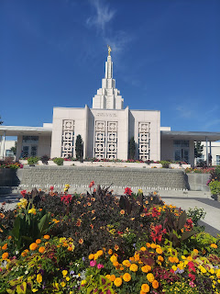

My wonderful neighbors are always so helpful to me while Scott is gone. Their son, Jackson, takes good care of my lawn, and just added the rain gutters to his list of responsibilities. I noticed that the gutters were filling up with leaves that were dropping from the big tree out front, so I asked him if he wouldn't mind clearing them out for me. Absolutely, he replied.

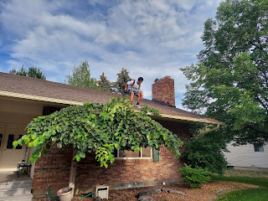

He climbed up on the roof with a leaf blower attached to his back and got all the leaves out in a jiffy. When I asked him how much he would like to be paid, he said, "Maybe $20? No . . . how about $15 because it really wasn't that hard at all." I responded with, "Okay, well how about we make it an even $20 for the risk factor of you getting up on the roof?"

As he left, I thanked him for all of his hard work. I said, "You're becoming my little Handy Man while Scott is gone!" He told me, "I'm happy to help. If you need anything at all, you just let me know!" What a nice young man.

My lawn recovered SUPER WELL while I was gone for 2 weeks. The company that we hired to fertilize did a good job, and the grub control that they put down worked really well! The grubs had eaten the roots of approximately half of my front lawn and it looked TERRIBLE. But once we killed the grubs and fertilized the lawn, now it's lush and green again. So much so that Jackson had to bring their riding lawnmower over with a raking attachment to scoop up all the extra piles of lawn clippings that kept shooting out as he used my mulching lawnmower. (We don't typically bag the clippings, we just use the mulcher and then all the clippings help to feed the lawn.)

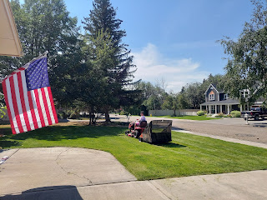

I had another cute visit with Jack Jack on Friday. He had just woken up from a nap but was instantly full of smiles when he saw my face.

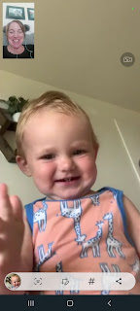

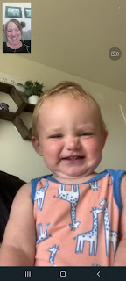

Being a grandparent is the best thing in the whole world. :) XOXO

