Family History Makes Life Better
There's a Primary song at church that is a familiar favorite. It is simply called, "Smiles," and the lyrics are very straightforward:

"If you chance to meet a frown, do not let it stay.
Quickly turn it upside down and smile that frown away.
No one likes a frowning face. Change it for a smile.
Make the world a better place by smiling all the while."

Halfway through the week, a personal challenge (of me feeling a little grumpy) was conquered in the form of doing some family history. I had been asked to help with an elementary school presentation by sharing some of my knowledge and experiences in Italy. The librarian at the school (up in Rexburg) had reached out to me (through my friend Andrea Garner, who is the school secretary) last week, and I was trying to get things lined up the day before the presentation. The children were invited to "read around the world" and get their passport stamped as they went from station to station, reading books from those countries.

My job was to provide a few items on a display table and be available to answer any questions about Italy. Before I left for Boise last weekend, I put together a Google photo album with a variety of scenes and interesting items from Italy, ones that I thought the kids would especially like. This week, I wanted to get the photos printed here in town and then laminate them for my presentation. But I might as well have tried to climb Mount Everest with how things were going on Wednesday . . .

First, I couldn't get the downloaded photos to copy onto my thumb drive. I tried with all of my meager tech savviness, and eventually had to reach out to Scott to accomplish this seemingly simple task. He had to log into my computer remotely from the other side of the world to get it taken care of. It turned out to be a fussy little problem with trying to unzip the storage folder on my Chromebook (laptop). Then, I took the thumb drive to the same Walgreen's that I have used a few times in the past for printing photos from my personal device. But this time, the kiosk didn't like my thumb drive. So I took it over to FredMeyer, where it *almost* worked out. I saw my photos on the screen for about one second before it, too, had a problem. It seemed that the problem might be some random photo or file on my thumb drive . . .

As I began to drive home to transfer the photos to a totally different thumb drive, I called Scott with an update. He suggested that we just do an online photo order through Walmart so I don't have to keep driving all over town. He started working on the order as I drove the rest of the way home. But then, as he was ready to finalize the order and click "submit", I noticed that all the photos were tiny little 4x6's . . . I wanted 8x10's so that the photos were really visible. He pointed out that the 8x10's were about $3/each. I had 40 photos to print. He said, "Do you really want to spend $120 on this presentation?" The obvious and disappointing answer was, of course, no.

We placed the online order for 4x6's and I waited almost 2 hours before going over to Walmart to pick the photos up. When I went over to the photo counter, however, they could not find my order anywhere. It wasn't even in their online system! They asked if I had received a confirmation email . . . umm, yes? But it would have gone to Scott's email in Italy and he was now asleep for the next several hours. Even if I could have hacked into his email, it would have sent him a message to allow me to continue to hack in, and how would he do that when he was fast asleep?

I went home, thoroughly frustrated at this point. I made plans to transfer the data to a new thumb drive and then drive back to Walmart to do the order in person at their kiosk after I finished pouting. As I was driving home, my mother called with a family history question. Switching gears to help her figure something out proved to be the perfect medicine to cure my annoyed state of mind. She had found a burial record for my 2nd great grandmother, Maria Margaretha Schmid(t). We didn't previously know where she had been buried, but my mom found it on Find-a-Grave! She needed help getting it saved in a different place than the website she was using, and it sparked all kinds of new and curious questions for both of us.

Where was this place where Maria was buried? How close was it to where the rest of the family was living? I marveled at the photo of her headstone and tried to distinguish what it said in the fine print. (I'm still working on that . . .)

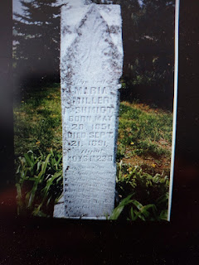

It was definitely the perfect distraction for my then-impatient mind and gave me something better to focus on besides how annoyed and frustrated I was. By the time we figured some things out and finished up the phone call, I was ready to go back to Walmart and get this taken care of, once and for all. I was tired of running in and out of stores, back and forth, and all over town for just a simple task of printing out some photos.

When I got back to the store, I had them check one more time to see if my order had gone through before I sat down to start a whole new one from scratch. Yep! It was all done and printed and ready to pay for. The guy told me that over the holidays, it would often take about 3 hours for their overloaded system to even send them a notification to print an order. It seems that the system may still be overloaded because the timeline that day matched up with the time it took from when we placed the order to when it was ready for pickup. About 4 hours total. I was just super grateful that the order was done and that I could go home and stay home for the rest of the day.

I wrote little notes on the back of the photos, noting the location of each one, and then I got them laminated the following day. *Note: I did get just ONE 8x10 print of Vicenza, since that is where everything begins and ends for me in Italy. Everything turned out just fine for the presentation that evening.

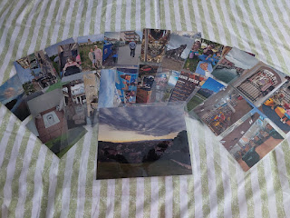

In addition to the reading stations, there were a few more of us set up with our special displays in the gym. We represented Italy, Antarctica, Guatemala, Tahiti, and Mexico. My friend, Andrea, took a photo of me, but unfortunately, my sweater dress makes me look much larger than I really am . . . but it was sure comfy! ha ha

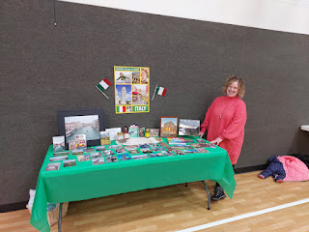

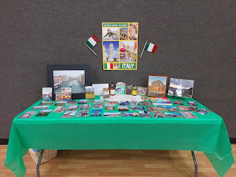

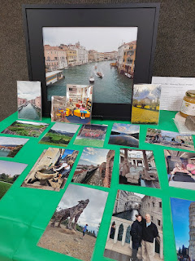

The most popular photo BY FAR was the wolf photo (above), where I am standing there looking up at him. Everyone wanted to know more about this unusual scene. I told them this story:

In 2018, there was a huge storm in Northern Italy that took out MILLIONS of trees. A local artist decided to make a giant wolf and a giant eagle out of the bits and pieces of shredded trees. Somehow he was able to get each of them up on top of separate mountains and now, people like me can hike up and see them. He took something that had been destroyed and made something beautiful in its place. Now they are pieces of art!

The kids really loved that story. I also brought a painting of a local building in downtown Vicenza that my daughter, Amber, made for me for Christmas.

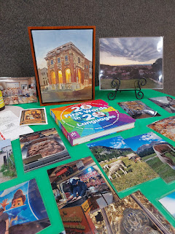

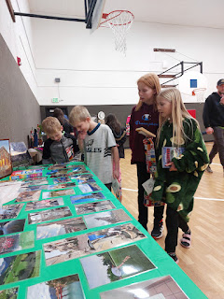

Andrea sent a few of her friends and colleagues in to meet me throughout the evening. She was busy serving pizza in the kitchen so I only saw her at the beginning and the end of the activity. At one point, a lady came in to visit with me, saying that Andrea had sent her in to say hello to me. We visited a little bit, and I showed her a few photos and we chatted about them briefly. Then I asked if she was a friend of Andrea's or did she teach at the school? She answered, "I am the principal." OH! Ha ha . . . well, that was nice to know.

On a side note, I am still listening to the audiobook by Sahar Qumsiyeh. I knew that Andrea knows her personally because they serve together in the Stake Primary Presidency in Rexburg. After the evening wound down, Andrea came to sit outside in the car with me before I drove home. I asked her if she could please reach out to Sahar to see if we could somehow meet in person soon. I just want to hug Sahar. I have actually met her once, but it's been several years. Shortly before Scott began teaching for BYU-Idaho, they had a family picnic so everyone could get to know everyone in the math department. I met Sahar then, but it's been maybe 7 or 8 years since that day . . . and I didn't have a clue as to her background and life story at that time.

Andrea messaged Sahar that night and we are making plans to go out to dinner in the near future. I can't wait! In the meantime, Andrea pointed me to an article that was written by Sahar soon after the recent war broke out in Israel last October. Here is the link:

https://www.sltrib.com/opinion/commentary/2023/10/17/sahar-qumsiyeh-pray-everyone-holy/

She used to have a blog that she was regularly posting on, but she took it down because the university warned her not to be so public with her opinions during the current war. That would be so hard . . . to be respectful of your employers, but also wanting to share your insights and your experiences about your people on the other side of the world, too. I really feel for her. I do understand, though, the need to tread lightly and carefully when you work for a major employer, like a university. There are too many people that would take it the wrong way, or assume that the university, as a whole, shares your opinions. What a tricky situation to be in.

This is another article about her that was written the year before:

https://magazine.byu.edu/article/a-heart-of-flesh/

Learning about Sahar and her background has taught me to be more aware of and more open to BOTH sides of a conflict and not to jump too quickly to my own conclusions, based on what the media is feeding to me. As I've seen before, the media chooses what to portray, without telling the whole story, and what a sad way to educate people with only a portion of the truth.

For example, when Scott was deployed to Iraq the first time, back in 2004-2005, the Iraq War was front and center on the news every single day. The main points I remember hearing repeatedly were: 1) Here's how many soldiers died today, and 2) Why are we even over there? What a waste of our time, our money, our resources, and our servicemembers' lives.

But in fact, from Scott's perspective, they were doing some pretty great things over there. They were building trust, relationships, schools, and lives. They were teaching the Iraqi men some viable and profitable career paths, such as how to be a firefighter. They didn't yet have a skill to earn a living for their families because Saddam Hussein wanted every able-bodied man to serve in the military. But after Saddam went into hiding and was eventually captured, their country was in shambles and they needed to be able to put food on the table for their families. So our U.S. Military taught them a variety of skills and practiced with them for days until they were qualified to go out and perform their work successfully. We gathered school supplies and shipped them over, and I have pictures of Scott helping to hand out the supplies to the schoolchildren. The joy on the faces of those kids was unforgettable. Scott and the other soldiers were making friends with the children in other situations, too. As he performed watch duty on the tower, the children would come up to the fence and ask for water. They would also want to trade things for something the soldiers had, such as a watch or a trinket of some kind. They would smile and laugh as friendships were built. This may not seem like much, but those children are the next generation. As they had regular positive contact with our military personnel, they began to trust and respect and enjoy their company. This had the potential to stay in the hearts of those kids as they grew up and remembered how nice our people truly are.

NONE of these things were being reported on the news. It was all about the destruction, chaos, lives lost, and money being wasted. But I knew better because I had a guy on the inside. I am choosing to apply that same principle to the current situation on the news. If all we know is whatever the media is choosing to feed us, then we are only getting a portion of the whole story. Just keep that in mind . . .

Okay, on to lighter things . . .

That phone call from my mom really turned the tide for me for the remainder of the week. I stayed up late that night going through a storage tote full of photos and other items that belonged to Scott's parents and his grandma Helen Harmon. I've been needing to start on this HUGE project ever since the funeral last May, but for one reason or another it kept getting postponed. Until NOW. This massive project of love has now commenced.

Here are just a sampling of some of the photos I came across that night . . .

1. Upper left: Scott. Upper right: Gordon on the little bike, Scott on his dad's back. Lower left: Scott giving the dog a ride. Lower right: Gordon and Scott having a bubble bath.

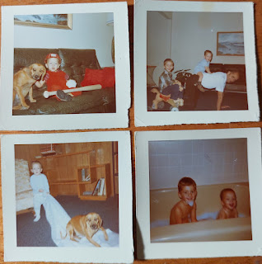

2. Phil and Coy (holding Scott).

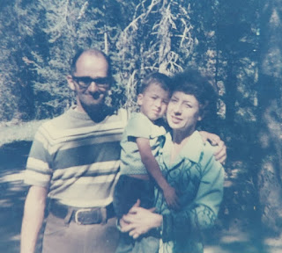

3. Coy and Phil.

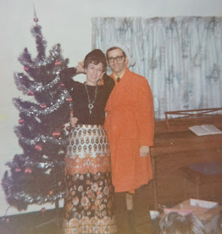

4. Helen Gordon Harmon (Phil's mom), Coy Michie Harmon, and Philip M. Harmon. I just love Coy's snazzy white boots! :)

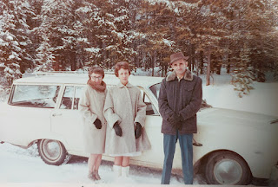

5. Philip Harmon @ 2 years old.

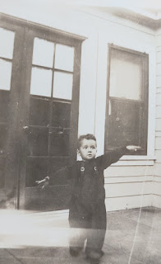

6. Wesley LaVeir Harmon, Phil's dad.

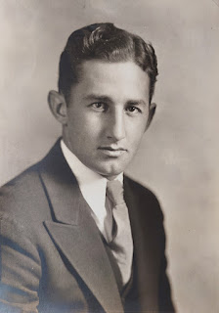

7. Philip Harmon, about 8-9 months old.

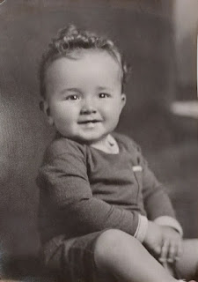

8. Back left: Frank M. Harmon (Scott's great grandfather, and father of Wesley Harmon), along with Frank's siblings.

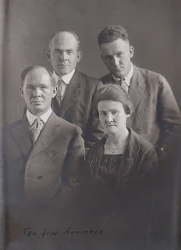

9. Julia Ann Stringham Harmon and Hosea Frank Harmon (Scott's 2nd great grandparents, and Frank's parents)

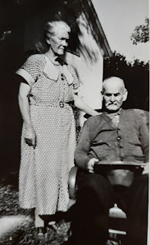

10. Frank Harmon (back left)

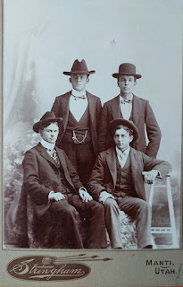

11. Grandma Helen Gordon Harmon, at 6 months old in 1910

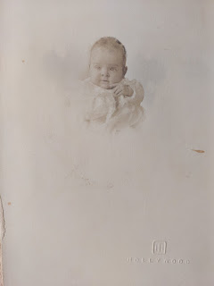

12. Phil & Coy Harmon, with their 3 daughters: Carol (left), Bev (middle), and Sharon (right)

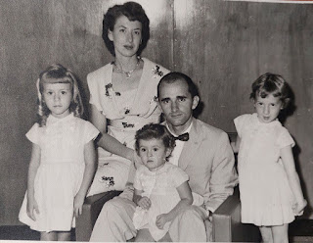

Aren't they just precious? And there are other photos that I've come across that reach back into the late 1800's, too. How exciting!

I've been pulling photos out of photo albums and forming them into organized piles, sorting by individuals and family groups. When I'm ready to take them over to the FamilySearch Center to scan, they are now in ziploc bags and labeled. My work will go much faster when I can scan by smaller groupings.

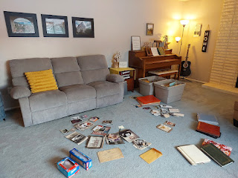

On Saturday, I took a big step into moving this big project forward. I took one large photo album to the FamilySearch Center across town and began scanning the many pages of photos.

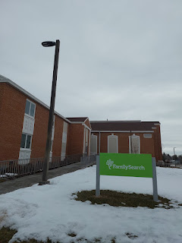

I got about 200 photos scanned and individually cropped in just over an hour. These pages of photos are not that easy to work with. The paper that the photos are glued to feels like a very old, and fragile, construction paper texture. Thankfully, there is a perforated edge on the left that allows me to very carefully pull out one page at a time to lay on the flatbed scanner.

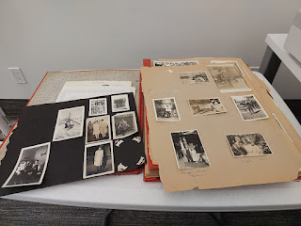

The scanner allows me to "select" each photo individually and then tell it to scan each one separately. The alternative would be that it would just scan the entire page, which would make it a bit of a chore to work with only one photo from that page. The whole process that I'm using goes pretty quickly, all things considered.

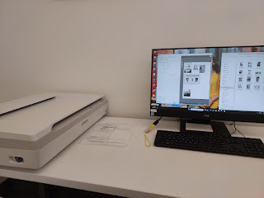

Another family history plug: I didn't realize the extent of how much Avery looks like Benson and me both. But when this side-by-side popped up on my laptop screensaver recently, I melted. XOXO

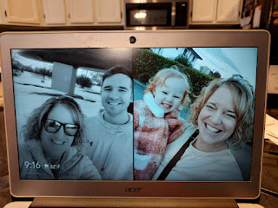

Sorry for that "squirrel!!" moment . . . but I just thought it was cute.

After I got done at the FamilySearch Center, I scurried off to Rigby to pick up Dad and Vernetta so we could visit the cemetery up in Rexburg. It was Coy's 91st birthday and we had some flowers to place on her grave.

That morning, I had just finished making the bed and was in the middle of my morning prayer when a series of thoughts started popping into my head. I wasn't even thinking about the trip to the cemetery yet, because I had a few other things on my brain. But all of a sudden, this thought popped into my head: "You should take a shovel with you to the cemetery so you can shovel a nice path for Dad over to the headstones. It will make it safer for him to walk over there from the car." Wow - what a brilliant idea!!

And then another idea popped in: "And you might consider bringing a chair for Dad to sit in. If you and Vernetta will be placing flowers and taking a little time, he will get tired and will need a place to sit down." Wow - another brilliant idea.

And then another idea popped in: "If Dad is sitting in a chair, he might get cold, so you should probably bring a blanket for him as well." Wow - another brill - - - wait a minute . . . I know exactly who this is . . . it's COY!! She knew we would be going out to the cemetery that day. She also knew that the snow was deep. She also knew that Phil tires easily and that he is always cold. She also knew that her best shot at getting my attention was probably going to be in the middle of my prayer when I wasn't running around in a whirlwind like I often am. She is very clever and very wise.

A little while later, I was able to share what had happened with Scott. He agreed and said, "That is 100% my mother!!"

And boy, was she right.

There were about 18 inches of snow on the ground at the Rexburg Cemetery. I would have never thought of bringing a shovel that day, because I had lots of other details in my mind - mainly relating to getting those photos scanned. It would have been messy, dangerous, and tedious to get Dad over to the headstone. And Vernetta was wearing CROCS!

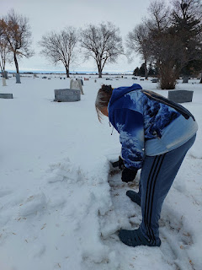

I did most of the shoveling to clear us a path over to the family headstones. However, I like that it looks like Vernetta did all the work, though, since I was the one taking pictures during her shifts. :)

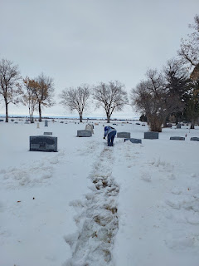

We had Dad wait in the car until we got everything set up . . .

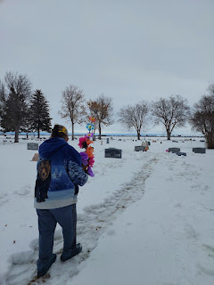

And then I helped him carefully navigate over to where he could sit down for a few minutes. Unfortunately, I didn't clear a very wide path, so he got to walk down the flat path while I tromped through the 18 inches of snow off to his right, ha ha.

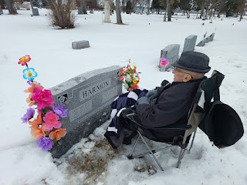

I unburied Jonny's headstone next to Coy . . .

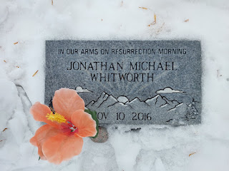

And then I requested a photo with all of our feet next to the headstone . . .

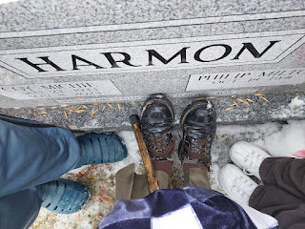

I enjoyed picking out some silk flowers from Hobby Lobby that morning before I started scanning the family photos. When I asked Scott what color of flowers I should look for, he simply said, "Something bright to contrast with the white snow." Got it. Coy always loved a bright coral flower, as do I.

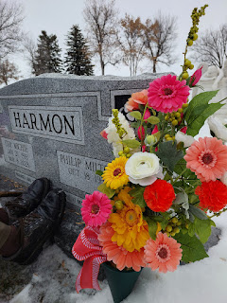

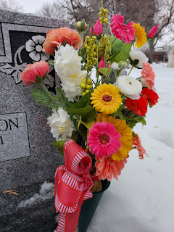

Vernetta wanted a selfie of the three of us, so I set up my phone on a nearby headstone and turned on the timer for 10 seconds. I pushed the button and then ran over through the deep snow to be ready before the shutter clicked . . . not bad for just one try!

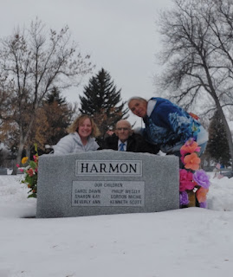

After we got the photos that we wanted, and had a moment to enjoy the setting, we helped Dad get back safely to the car and then off we went to get some lunch. We didn't have to go far to get to Panda Express, which Vernetta was pretty excited about. Dad loves shrimp, so he was pleased with that option.

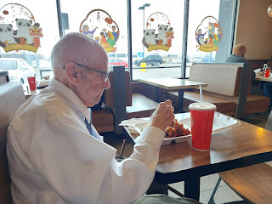

As for the rest of the day, I spent much of it on the phone. I wanted to share my special experience from my morning prayer with Scott's siblings, so I reached out to each of them throughout the day and had some really great conversations.

One other item with family history from this past week has to do with my cousin, Loreena Hester. Her mother's family, the Eichins, come from Germany, and we have discussed them previously as I have helped her with some research. Well, as Scott and I have been making plans for a road trip in March, I realized that we needed to slim our plans down and simplify things. And as we came to that conclusion, it dawned on me that the area we would be sticking to was really close to where Loreena's family used to live! Her people come from Schopfeim, Germany, which is just over the border from Basel, Switzerland. And as I zoomed in on Schopfeim, I saw that there is a small suburb on the southeast named Eichen! It is spelled slightly different than her family name of Eichin, but she said this is the same exact area where her grandfather came from.

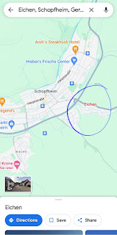

I reached out to Loreena to let her know I would be in the Schopfeim area in March and she is just so thrilled. We will be figuring out in the coming weeks what some locations are that I could check out and take photos of for her.

To sum up my week: It wasn't a bad week until the day I struggled getting those photos made on Wednesday. That's when I felt frustrated and grumpy. But when my mom called with a family history need, that quickly helped me to switch gears and then to move forward with purpose and joy.

Connecting with our ancestors gives us perspective as we see a life lived through photos, letters, and accomplishments. It helps us to remember that we are not alone, that today is just a smidgen of our entire existence, and that we are all connected through God's infinite family.

Just a couple of final photos of Jack . . .

What a sweetheart he is . . . just sitting there reading a book by himself. :)

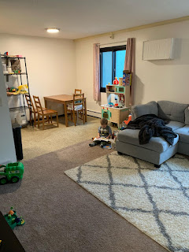

And tonight (Sunday), he was hanging out watching Daddy make dinner . . . I can just hear him saying, "Cheeeeese" . . . ha ha

