Fun in San Diego
I've been way too busy playing with my sisters in San Diego to sit down and type up a blog post. I can't think of a better excuse for procrastination . . .
It's been really fun hanging out with BOTH of my sisters and doing a variety of activities. In the photo below, from L to R: Melanie (my younger sister), her son Caleb, her husband Mike, her daughter Mandie, Charmaine in the far back on the right, her Scott (because I have a also have a Scott), and then me.

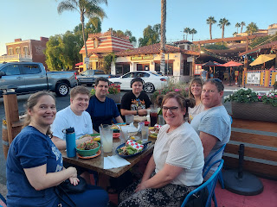

Thursday:
I drove down to Salt Lake to catch my cheap flight on Southwest Airlines down to San Diego. Everything went swimmingly in spite of a few other airlines across the country being on strike . . . thankfully my airline wasn't on strike.

View of the Great Salt Lake from the air - -

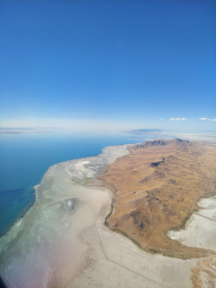

A very large and very green golf course coming into San Diego - -

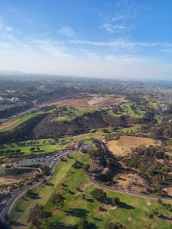

Charmaine picked me up and took me back to their apartment, about 20 minutes from the airport. She made some seasoned trout for dinner with broccolini - something I've never had before. I liked it more than regular broccoli!!

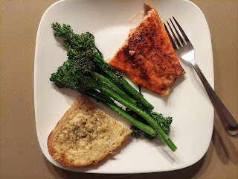

Friday:
While Charmaine was at work, I did a whole lot of resting. I woke up suuuper tired, even a little bit dizzy, like that my body has been overworked lately or something, ha ha. Go figure! So I just laid low and rested all day long. That helped a LOT!!

Charmaine has held onto this little note that I made for her several years ago, and even took it with her when she moved down to San Diego earlier this year. It sits in her kitchen windowsill.

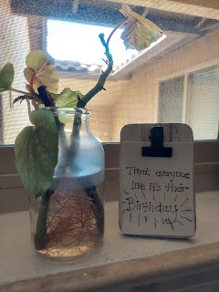

By late afternoon, my sister Melanie and her family had arrived into town. Shortly after they got settled into their hotel, they came over to pick me up to do a little bit of exploring before meeting Charmaine and Scott for dinner.

First, we stopped off at the Mission Basilica San Diego de Alcala, situated on a hill overlooking a portion of San Diego and the valleys below. The mission began in 1769 after some Spanish explorers arrived, including a couple of Catholic Fathers who had a prayer meeting on the very spot where we stood 253 years later.

If you look closely, you'll see Caleb and Mike, Melanie's son and husband, on the opposite side of this huge cross monument.

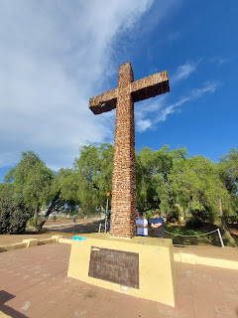

Mike and Caleb hiked up the hill with me to check out the Mission structure, while Melanie and Mandie stayed behind to care for Mandie's service dog, Fizzy. (Fizzy doesn't have a front left paw, so he hobbles on 3.5 feet and therefore cannot walk as far as one might hope for.)

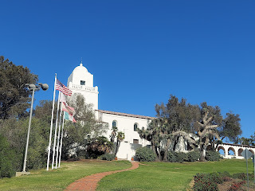

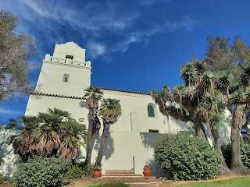

At the mission, we were able to peek inside the main structure, but could not go on a tour because it was closed for a wedding about to take place. We saw the cute bride and groom outside with their photographer. These old wooden beams are the original beams from when the church was built in the early 1800s.

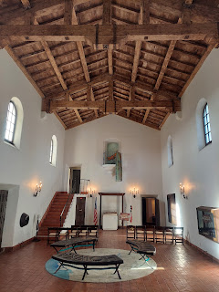

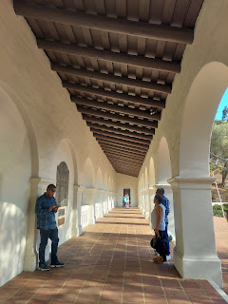

Next, we drove over to Old Town San Diego to visit the Mormon Battalion Historic Site. In 1846, 500 men were recruited to assist the U.S. Government in providing men to beef up their support during the Mexican-American War. The prophet at that time, Brigham Young, promised them that if they would stay close to the Lord and keep the commandments during their march, they would never have to engage in battle and they would be protected. They did, and they were.

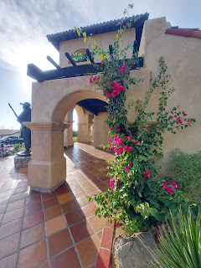

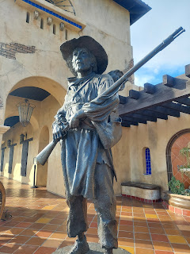

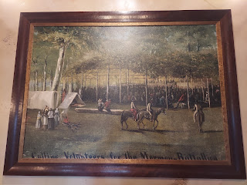

Some of the statistics regarding their march down to San Diego.

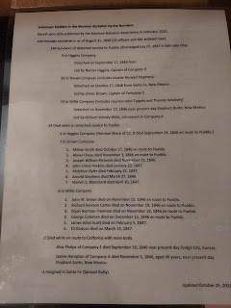

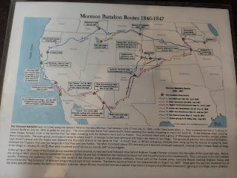

The placard says: "Brigham Young admonished Mormon Battalion soldiers to take Bibles and copies of the Book of Mormon similar to these along on the march as part of their equipment. He instructed them to live the teachings of Jesus Christ and place their faith in Him."

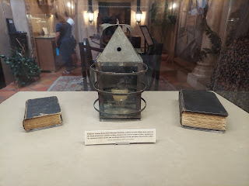

Below: "This canteen was used by Private Jacob Earl on his march through the desert. One of his fellow soldiers in Company E, Sergeant Daniel Browett, wrote that the soldiers sometimes traveled sixty miles between watering holes 'with one pint a day in our canteens to wet our dry lips caused by the heat of the sun and clouds of dust from a moving crowd.' Years later, Earl painted a mountain lake on one side of his canteen and a snow scene on the other. He displayed the canteen in his parlor as a memento of the march."

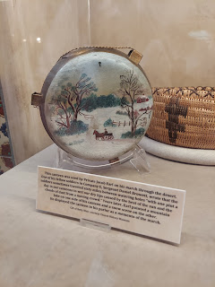

We did a 40 minute tour that included moving from room to room, watching short film clips, with each room being staged to look like a part of the story. (the town of Council Bluffs, a military fort and store, a campfire out in the brush, etc.)

I was hit pretty hard at one point when, in the movie, a woman was caught off guard when her husband announced he intended to go serve in the military for whatever length of time was needed. Her eyes filled with tears and she was distraught that he would have to leave her . . . after that I was a goner and every little thing set me off from that point forward, filling my own eyes with tears.

One of the heartwrenching stories was that a 9 year old boy really wanted to go with his father, but was told he needed to stay behind to help his mother. The boy slipped out anyway and tried to catch up to the marching convoy, but it took him 8 days to catch up to the group!! Can you even imagine??? How did he survive without food or water? How and where did he sleep? How did he know which way to go? What did his mother think when she discovered he was missing? I hope the father sent a letter home as soon as he could to let that poor mother know that their son was alive and well.

In the outpost room, they asked for a volunteer to try on all the gear that the men would have carried on their march. I jumped up and happily volunteered to put everything on. (With my piggy buns, the hat couldn't go on straight, but we did the best we could . . .)

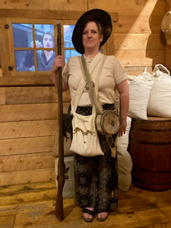

I was struck by the faith of these men, and the blessings that were given to them for their sacrifice. Not only were they given ample funds from the U.S. government for their service, which helped the Saints as they desperately needed money to implement their own march west (after being kicked out of the state of Illinois), but it gave them some unexpected blessings as well.

About halfway into their march, they had walked about 48 hours with no water, as they had run out roughly two days before. When they finally reached a nasty watering hole, a stanky and stale large puddle in the middle of the desert that was teeming with bugs and algae, they drank from it as if their lives depended on it! In one movie scene, a little boy who was part of a family who came along (the few wives who accompanied their husbands served as cooks and laundresses) said to his father, "How do I get a drink without swallowing all the bugs?" His father didn't even miss a beat as he answered between gulps, "Just sip through your teeth, son. The bugs can't get through that way." Wow.

Soon after drinking all that nasty water, several people began to get sick. Very sick. No shock there . . . It was finally decided that the portion of the company that was the most sick and couldn't continue on the march would be sent off to Fort Pueblo, Colorado, a shorter march but in a completely different direction. They would stay there and rest for a season and then go back to Council Bluffs, Iowa to reunite with the main body of the Saints and prepare to hit the dusty trail once again with the destination being Salt Lake City.

By the time they did arrive in Fort Pueblo, a few more people had died along the way. They were warmly received by the people in Pueblo, and revived back to health. Here is where the miracle took place: while resting and recovering, the locals taught them some ditch irrigation techniques and how to plant crops in less than desirable conditions. The following year (1847), as the large group of families arrived in Salt Lake City and saw the parched ground and desert conditions, they were able to employ those ditch irrigation techniques and plant their crops. It literally saved their lives!

Sometimes in life, we also have unexpected hard times befall us. We suffer and have to veer off course from our original destination or goals. But sometimes, there are miracles to be found in those detours. If the soldiers and family members hadn't gotten sick, they wouldn't have needed to veer off course and head to Fort Pueblo. They wouldn't have learned those life-saving techniques to grow their food, and they would have perished in Utah. Plain and simple. If you are in the middle of a detour of your own right now, please keep your faith and hope alive and watch for the miracles to unfold. You might not recognize them at first, but be patient and you will see.

At the end of the tour, we got to go outside and pan for gold. If we found a gold nugget, we were allowed to take one home with us. I found several nuggets, and ended up just choosing the biggest one to take with me. :)

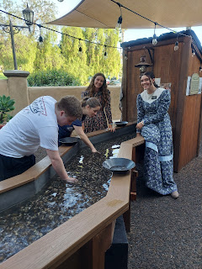

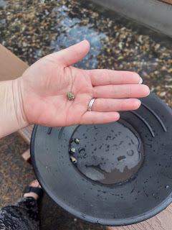

They also took our picture and emailed it to us. It took Melanie a long time to keep a straight face long enough for them to snap the photo, with Caleb encouraging her the entire time. Then we found out that he was the one smiling in the photo! What a guy, ha ha.

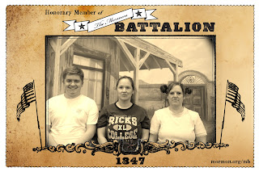

It was really great to visit this special place and learn more about those faithful soldiers and their families. Oh - one more thing. As they arrived in San Diego, they stayed for a little while and helped re-introduce brick-making into the community there. They helped build some water wells and other structures including at least one church. They were so well-loved that when it came time to leave, the people begged them to stay. The locals even made a petition and collected several signatures to try to get the Mormon Battalion to stay. Ultimately, they did have to leave and get back to their families and try to help them get across the dusty trail to the Salt Lake Valley. But they left a good legacy behind.

Next, we walked a couple blocks away and met up with Charmaine and Scott for dinner. There are the most beautiful flowers down here! This one is very common in Southern CA, and I learned that its name is "Bird of Paradise."

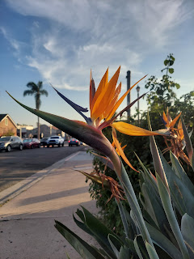

(Same photo as the one at the top, but with more context now) This was in Old Town San Diego. We ate at a restaurant called Cafe Coyote.

After dinner, we walked across the street to the Coldstone ice cream parlor, and used one of Charmaine's gift cards from her previous employer. Thanks Fetzer!

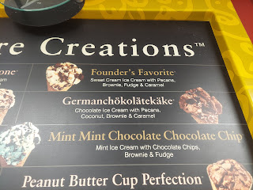

I chose German Chocolate Cake ice cream, my favorite! The sign above has a little different spelling though.

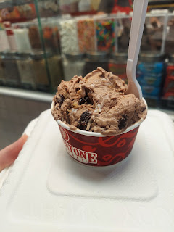

We mosied slowly down the streets of Old Town while eating our ice cream. I would like to come back here again and explore the area further.

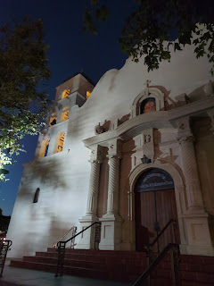

We found a little nook near the entrance of the Old Town State Historic Park where some live music drew us in.

Video #1 of the musician: (14 seconds)
https://photos.app.goo.gl/TuXVneB8Gm6FqaCn8

Video #2 of the musician (and Charmaine): (16 seconds)
https://photos.app.goo.gl/EVMGdjjpyuBrQSV46

Saturday:
Charmaine and I went to the Birch Aquarium in La Jolla, while Melanie and her family went to Sea World. The fish and marine life were stunning and so photogenic! I had a lot of fun there.

Baby seahorses - so tiny and cute!!

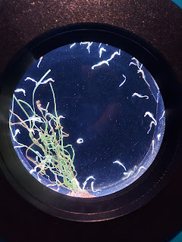

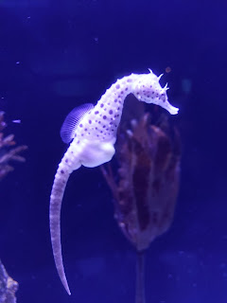

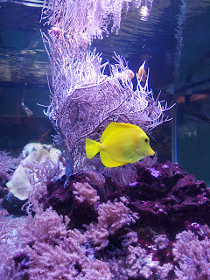

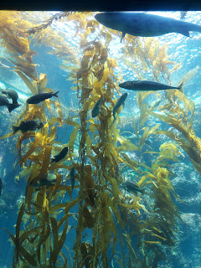

For the rest of the photos and videos that I took, click here:
https://photos.app.goo.gl/FS6jr9CC5R46yYwx7

After we spent a couple hours at the Aquarium, we got some lunch at a Poke Bowl place near the Asian market area. We had fun looking at all the stuff in the Asian grocery store, choosing a few interesting looking fruits and vegetables to take home.

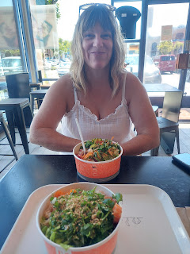



Also, we just happened to drive past the San Diego LDS Temple on our way to the Aquarium. Wow, it is so huge and beautiful! And it's right next to the freeway.

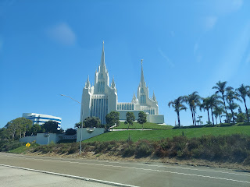

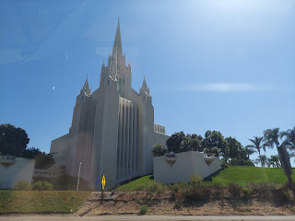

Sunday:
We carved out a day to spend with Charmaine's daughter, Mari, who lives up in Los Angeles at a sober living house. It's quite a chore to get through all the traffic between San Diego and Los Angeles, so we put Mari on a bus to Anaheim and then we picked her up there.

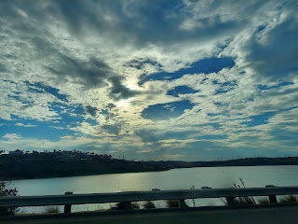

We took her to a nearby art museum, Bowers Museum, touted to be the finest in the area. It had some fascinating pieces in there for sure!

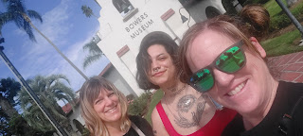

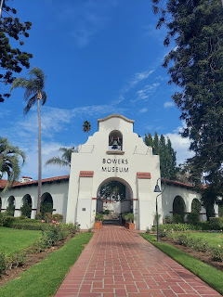

I was touched by this sculpture of an Indonesian woman and the description next to her.

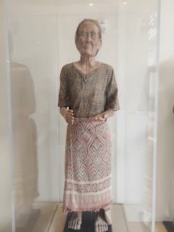

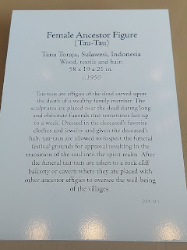

They also had a special exhibit entitled "Aging as Art", a photography display that is focused on the elderly throughout the world.

This sweet photo says: "Maybe a confession, or just gossip, there's always time for a visit and some friendly conversation."

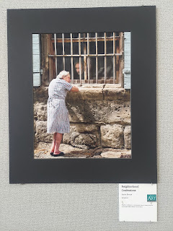

And this beautiful lady is holding up a photo of her and her husband when they were younger. The caption next to the photo said: "David was in the Navy. He first saw me and said, 'That's the girl I'm going to marry!' In those days we didn't hang about. Decisions were made. Life was precarious."

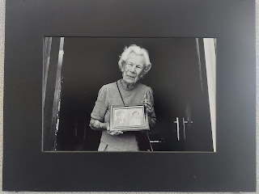

I loved these ancestor towers. I can't remember what the description said, and I didn't take a photo of it either. But the essence was that when a loved one passed away, they would carve their likeness onto the tower and that the ancestors were watching over the community through the statue and would keep evil spirits away.

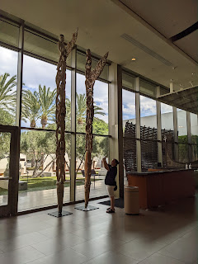

The paintings were exquisite upstairs. This was one of my favorites - I just loved the colors and the grace and beauty of this dancer.

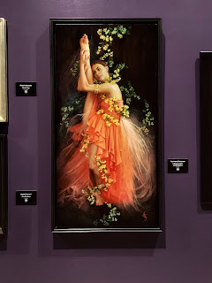

This scene made me curious what the family's story is . . . are they homeless? Are they being dropped off to go to work early in the morning? There was no explanation . . .

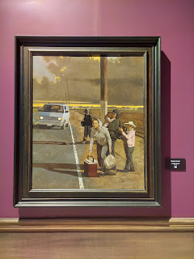

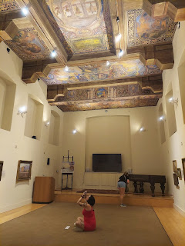

This guy looked like he needed a bathroom . . .

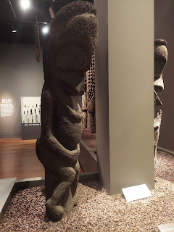

To see more, click here:
https://photos.app.goo.gl/FvCwXxg35iWZwgz88

Outside, after our tour, I tried reeeeallly hard to get the sword out of the stone . . . to no avail.

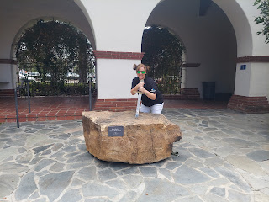

Next we drove over to the Anaheim Packing District, which used to be the Sunkist Packing Plant. Now it is a trendy and huge indoor food court with all kinds of booths to be sampled.

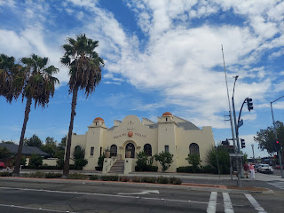

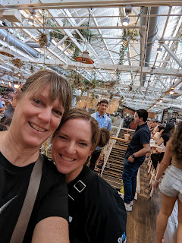



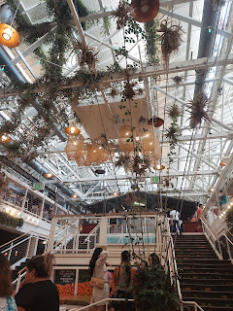

Charmaine and I chose the French restaurant upstairs so we could get galettes (savory French crepes), while Mari chose Asian noodles wtih shrimp. She wasn't fond of the crowds of people and the noise level, so she opted to go sit in the car with the A/C running while she waited for us. We got our food and ate it indoors, then walked back to the car to meet up with Mari again.

Mari ended up coming back with us to San Diego because she was upset from something that had happened the day before. One of the girls in her sober living house had overdosed on some drugs and almost died. She was in the hospital and as far as I know she is expected to live, but her situation is not great. This was a girl that Mari had gotten close to in the house where they live, so it hit her extra hard.

We made it back to San Diego safely after a very long day. We had gotten up quite early, around 6 a.m. to begin the drive north to pick up Mari, so it was nice to be home once again. We invited Melanie and her family to come over and eat dinner with us and swim in the pool that is part of the apartment complex here. The complex is quite large and has more than one pool to accommodate so many residents. We chose the clubhouse area, with 3 large pools to choose from. It felt like a beautiful resort!

We waited until the sun was sleeping (it's been extraordinarily hot down here!!) and then we swam by moonlight. It was delightful!

At my encouraging, we tried to pose like we were a synchronized swimming team. What do you think? Will we win any awards?

L to R: Caleb and Melanie, Charmaine and Scott in the back, and me on the right



I also tried to capture the palm trees and the frolicking mermaids, but it was hard to get the camera to focus on both while it was nighttime. We had a super fun time and got nice and cooled off.

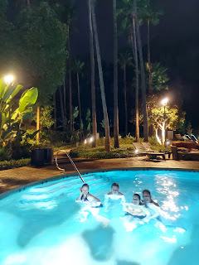

Monday:
(Labor Day) Just before lunch, we went to the beach at La Jolla and met up with Melanie and her family there. The logistics were a bit difficult, since it was a holiday weekend in San Diego plus the temperatures were so high, which meant EVERYONE wanted to be on the beaches to cool off. Parking was nonexistent, which we had anticipated and Melanie also verified this over the phone after they had driven around for over an hour and couldn't find a single parking place anywhere near the beach. We set up an Uber ride for the 3 of us and they picked us up in about 5 minutes and dropped us off at the beach parking lot about 20 minutes later for $23 total. Nice!

We had the best time!! The beach was packed, and so was the ocean. But it didn't stop us from having fun and enjoying ourselves. :)

Caleb wanted to dig a giant square hole in the sand, so they purchased a heavy duty shovel to accomplish the goal.

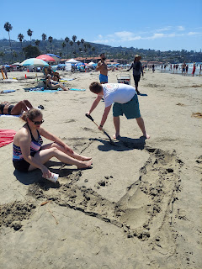

Mandie introduced her furry service dog, Fizzy, to the ocean. He seemed to like it!

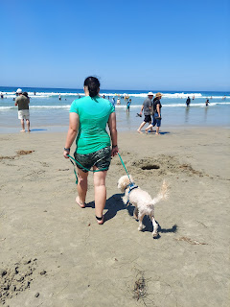

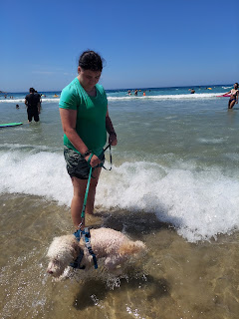

The water was gorgeous and so refreshing.

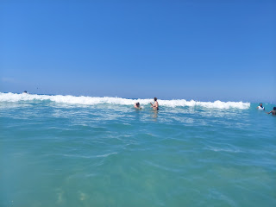

Scott and Charmaine - jumping through the waves as they crashed over them.

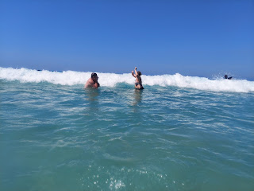

Mandie - attacking the waves like a pro.

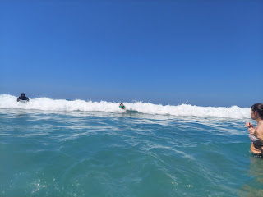

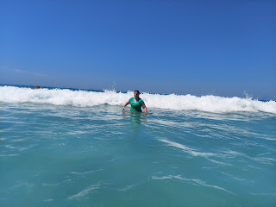

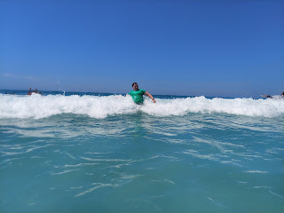

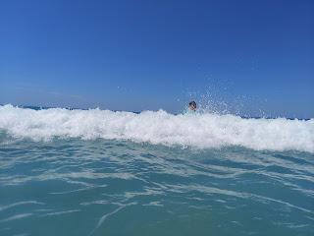

I got a couple videos of our fun in the water, too. I brought my waterproof phone protector that I can wear around my neck on a lanyard and was able to go pretty far out to get some pics of Mandie, Charmaine and Scott.

Video #1: (5 seconds)
https://photos.app.goo.gl/kgdrR1iwRCcx5uSm8

Video #2: (39 seconds) *The sun was bright and I thought I had pushed stop as I was done recording, but it kept going, ha ha.
https://photos.app.goo.gl/ucPuGA5Wn3F98fiVA

Video #3: (6 seconds) Charmaine got a video of me heading out into the surf. We could go quite a ways out and still just be about hip-depth.
https://photos.app.goo.gl/oTSF6LBpUb3Qfj6e9

We stayed for a little while longer after Melanie and her family left, just because it was so pleasant and fun to be there. I got a little bit of a sunburn, but nothing too bad. The temps down here have been in the 90's with about 50-90% humidity. In Los Angeles it was 100 degrees the day before.

While the 90's don't sound too catastrophic, San Diego typically experiences temps between 60-75 degrees year round. So this is unusually high and unusually lengthy as the days wear on. And on the news, there have been threats of the possibility of rolling blackouts because the energy grid is being taxed so much. They said that Southern CA was experiencing about a 10% deficit in the ability to provide electricity to the residents and weekend visitors in this lengthy heat wave. So far, we still have power, and I am very, VERY grateful.

Tomorrow morning (Wednesday), I fly back home. I'll land in Salt Lake and pick up my scorching car to drive north up to Idaho. Thank goodness for air conditioning! Idaho Falls is having a heat wave of their own, with temps pushing 100 degrees several days in a row. Tomorrow is supposed to be the last 100 degree day (hallelujah!) and then it will start tapering off for the season. I'm not looking forward to my stuffy and hot house when I get home, but I AM looking forward to those cooler Idaho nights to cool off my house overnight . . .

I don't have many pics of the Grandbabies to share lately - - - people are just having way too much fun!

Here's what I do have.

Amber's Family:
Weston's boss, Dr. Larson, hosted another Mexican cruise for all the employees and their families, so that's where they've been on this long holiday weekend. I believe they are home now, as I'm writing this. :) So far, I've gotten these photos below of their adventure.

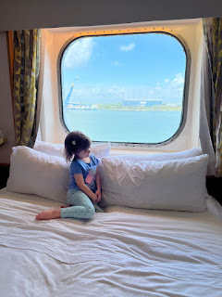

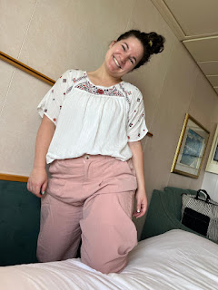

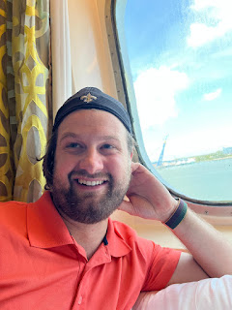

Gwen was too grumpy to participate in this family photo . . . she'll regret that later.

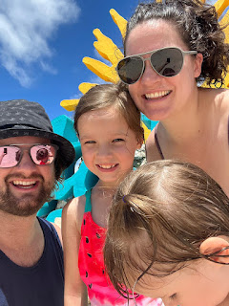

Jacob's Family:
Hannah began her Master's Degree a couple weeks ago. She'll be doing one class at a time for now, and each one is about 7 weeks long. Her Bachelor's was in Special Education, and her Master's will also be in Special Education, but with an emphasis on Behavioral Analysis. She's enjoying it so far, and is able to work around being a wife and mother. What a great young lady she is!

They recently attended a baseball game with Jack. Looks like he enjoyed himself!

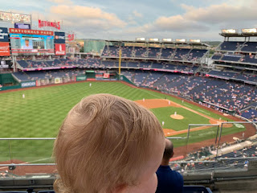

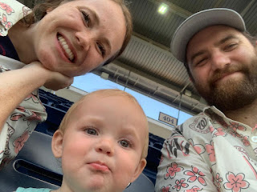

I've been told that Jack loves his stuffed animals in a very profound way. I recently got him a coyote hand puppet when I visited the CA Trail Center in Nevada. It was soooo soft and plush, so I couldn't resist. Jacob sent me this photo a few days later, adding that, "This is how he's been sleeping since he got the coyote."

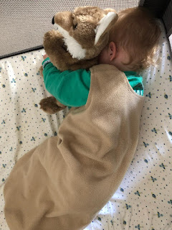

Video of Jack still sleeping hard, even though it's time for their morning bike ride. Jacob takes Jack in the bike trailer as a mobile support station for Hannah as she's been training for a half marathon. He (Jack) is usually up and attem sooner, but this one morning he must have been extra tired.

(19 seconds)
https://photos.app.goo.gl/CXVMmrohnfs614UKA

Video of Jack going down the slide by himself. He really doesn't seem afraid of much. (8 seconds)
https://photos.app.goo.gl/4uL7pkKbnKXtxFHU9

Slow-mo video of Jack going down a slide made of rollers: (14 seconds)
https://photos.app.goo.gl/4QYaz4AkyerwcG4d6

Video of Jack from today, with this caption from Jacob: "Not sure about the new co-worker."
(24 seconds)
https://photos.app.goo.gl/dDQ6saW3DJjP41ba7

Benson's Family:
Haven't heard much from Italy but I'm looking forward to seeing them again soon.

Video of Avery climbing all over her momma. (38 seconds)
https://photos.app.goo.gl/nEm4YjM3F2CRSvFPA

Video of Avery trying to get Kylie's phone again, ha ha. *I can't remember if I already shared this one. If I did, sorry! (13 seconds)
https://photos.app.goo.gl/Hf9MyTEU22MPpf4n9

