Grandma Doris the Roller Skater
I made it to California! I did great on the two-day drive and now I'm getting all settled in. I'm so excited to see and spend time with family and friends!
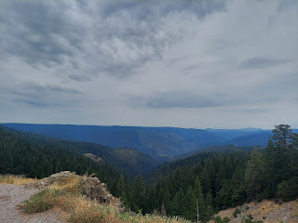

Other than an hour of substantial rain at the top of Donner Pass, combined with a traffic jam also near the top - due to an accident ahead of me, the drive to California was pretty uneventful and pleasant.

I left early Thursday morning and drove from Idaho Falls to Winnemucca, Nevada, which is roughly 7 hours of driving time. I had lots of time to listen to music, make some phone calls, listen to some powerful and life changing podcasts, and had some time to think about life.

A majestic scene somewhere in Nevada along the way . . . it was surprisingly beautiful!

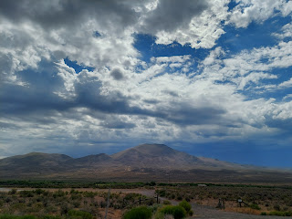

I even got to try a new flavor of Coke Zero called Starlight. It was very interesting . . . the ingredients included some fruit juices as well as some vegetable juices . . . All in all, I think I'm a fan.

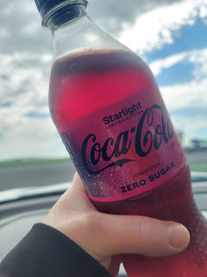

I made good time, having gotten off to an early start, and arrived at my hotel at 2:30 p.m. It was roasting hot outside, a solid 98 degrees, so I decided to hunker down in my room and watch some TV while I tried to cool off.

I ordered a delicious Cobb salad from a restaurant about 2 minutes walk from my room, and even braved the heat to walk a mile (round trip) to purchase a fly swatter. There were a couple of flies in my room that did not understand what personal space means and I didn't want them landing on my face during the night. Ironically, by the time I got back with the fly swatter, I never saw either of them the rest of the night! I think they flew out the door when I opened it . . . ha ha.

I dipped my legs in the pool for a bit after my walk, not wanting to put in the effort to fully go swimming, especially once I got a chance to see the condition of the pool . . .

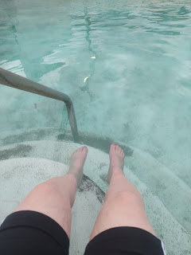

And I didn't stay out at the pool for very long, with this skyline that was looming above. When the first lightning struck, I hopped out and went back to my room.

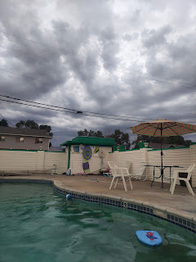

The following morning, I woke up earlier than I wanted to, ha ha. My brain said, "Let's get going!" So I got up, got ready and left around 7:30. As I said earlier, the only issue was the rain going up and over Donner Pass. I had both hands on the wheel for about an hour and everyone around me had slowed down to about 45 mph because of the amount of water on the road.

I decided to take the scenic route and left I-80 to take Hwy 20 West instead, which led me through Grass Valley over to Marysville and Yuba City. There was a bit of road construction on that route, with some one-lane roads where we had to stop and wait our turn to follow the pilot car.

A scenic pullout on the way to Grass Valley - -

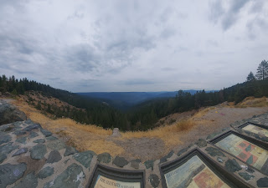

I stopped for lunch in Marysville, a place that I remembered visiting in my childhood. I think we also took our kids here a time or two when we drove out to visit our family in CA. This park has a huge lake, with geese in clusters all along the paved walking path around the lake.

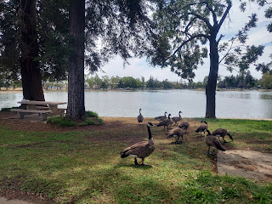

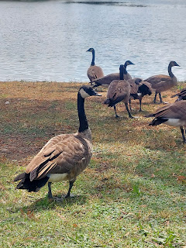

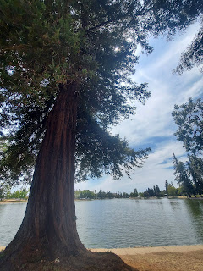

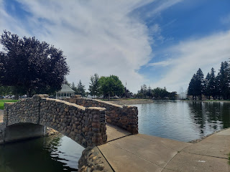

Video of the lake area: (26 seconds)
https://photos.app.goo.gl/ZszBUTRE3BK48GZZ9

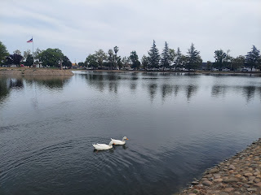

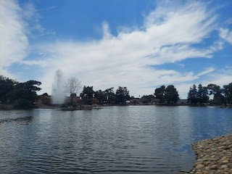

It was refreshing to get out of the car for a while and take a scenic stroll. :)

It's always a good feeling when I drive into the Ukiah Valley. It is a special place, a sacred place to me, because it's the land of my ancestors. My father's people settled here in the 1850's and have been here ever since. The Rawles family arrived in 1858, and the Orr family came soon after. Other family names that have been here for a long time include: Snider, Tarwater, Butts, Baugh, and Lambert. In the local cemetery, I have direct ancestors buried here that go all the way back to my 3rd great grandparents.

When I arrived at my mom's house around 4:00 p.m. on Friday, she had several hugs to give me, ha ha. A big one from herself, one from this person, and another from someone else to be passed along. She was so excited to visit and to hang out, it was really sweet.

We made a chef salad for dinner with some veggies from her garden along with her signature homemade thousand island dressing. It really hit the spot after a hot day and a long day of driving! I didn't last much longer after dinner, being very tired after waking up around 5:30 a.m. and then driving all day. It was time for bed.

Saturday was a great day! We had a Girls Day as well as a Girls Night out. We went to the nearby Health Club where my mom has a membership and we swam and lounged by the pool for the entire afternoon. It was so relaxing and wonderful.

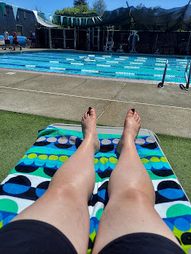

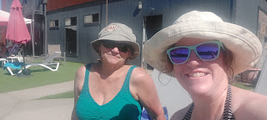

I got a short video of my mom swimming some laps. She always has such a graceful swimming stroke and I always enjoy watching her. (16 seconds)

https://photos.app.goo.gl/4uLfVPfsC6mTGdut5

After we came home to change and freshen up, we went out to dinner at her favorite restaurant: The Broiler Steakhouse out in Redwood Valley. It's just around the corner from the house she grew up in.

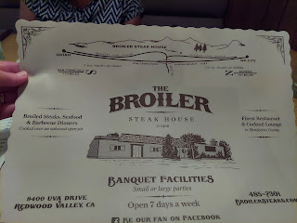

She bought my dinner, wanting this to be an early birthday gift. I ordered steak and grilled prawns, with a baked potato and house salad. It was really delicious - but obviously way too much for one meal, ha ha. I have plenty of leftovers that came home with me . . .

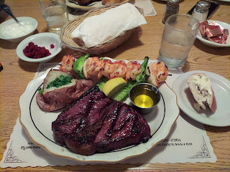

On our way home, I asked my mom if we could stop by my friend Jill's house so I could surprise her. She is one of my childhood friends, one of my two first friends as a member of the Church of Jesus Christ of Latter-day Saints (the other friend being Emily Fawson Flake), and yet I haven't seen her in decades. She did quite a double take as she answered the door and saw us standing there, and then realized that it was really me! :)

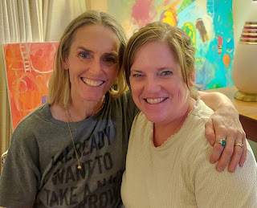

This is Jill with her hairless cat named Ken. I had never seen one in person before, let alone touched one, ha ha. His skin was very warm.

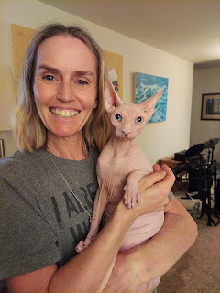

This is a rough month for Jill, because it's the one year anniversary of her husband's death last August 23. He had a medical issue - some infection as I recall - that couldn't be cured or reversed. He died about 3 weeks after his diagnosis. She is dealing with all the memories right now of everything that happened one year ago, including the sounds of machines beeping in his hospital room, the lights flashing, and just too many things. She has had some serious anxiety to deal with, but somehow still manages to be a mom, plays piano in a local band, and produces artwork that goes on display in the gallery here in Ukiah.

We are planning to get together again on Friday to spend a little more time together. I am looking forward to that very much. She has two boys out on a mission right now, one is in Iowa and the other is in Michigan. Their father died while they were already out serving as missionaries, but they are due home very soon. She also has a 16 year old daughter who is still at home and will start the new school year in a couple of weeks.

It was great, though, to visit with Jill for that hour on Saturday night because there is never enough time to visit when we're at church. It was wonderful to see her at church on Sunday morning and to know that we had already connected on a deeper level.

I saw several friends and important influences in my life while at church today. One of those friends was Marie McKell, along with her husband, Jim, who used to be my bishop when I was a teenager. Marie was my young women's leader back then, and she treated me with a Christlike and unconditional love when I got pregnant during my senior year of high school. One of the things she did was this: we were learning how to quilt as a YW class. Not just to MAKE a quilt, but to learn how to stitch (by hand) ON the quilt AND to attempt to sew in a straight line. I still remember how pathetic my line of stitches was . . . the surprise came, however, when the quilt was all completed and put together and then she presented it to ME!! She said that she knew I would need the love of our class members in the months to come and that their love could be conveyed to me through this beautiful work of art being wrapped around my drooping shoulders. WOW.

Marie is getting up there in years now. She is white-haired and probably close to 80 years old, maybe more. Her husband, Jim, was a wonderful bishop in my youth. I remember when I told him I had "messed up" and I cried and cried as I confessed to him, he cried right along with me. He was so soft-spoken and gentle, but he comforted me and helped build me up during our visit. I have never forgotten that.

I also saw my friend Grace Johnston. She is currently serving as the Relief Society President in the Ukiah Ward, but I used to live with her for several months back in 1990.

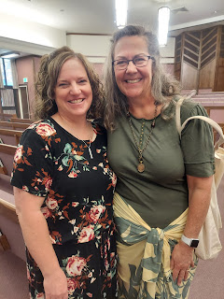

After my daughter, Chelsea, was born in October 1989, I was in a world of turmoil on the inside. For anyone who has ever placed a child for adoption, it's like you have had a death in your family and now you have to figure out how to move forward. I really struggled for several months after Chelsea was gone. I started dating someone that didn't have the same standards that I had been raised with, standards of chastity and purity.

I wanted more independence from my parents so I moved out of the house and moved in with Grace. She was a young single mother at that time, and was happy to have a housemate and friend. I somehow stopped going to church during that time, too. I felt lost. I was hurting and I felt tarnished, unworthy, and just oh so lost. I think the shame of having a baby out of wedlock had set in and I didn't want to have to see anyone that I might have disappointed. It was easier to just steer clear of everyone at church.

After many months of dating Miles and avoiding going to church, I began to recognize the obvious void in my life. I started reading the Book of Mormon again, which began to fill my heart with the love of Jesus Christ. The misssionaries had also stopped by regularly during those months to check on me and invite me to church. It was around this same time that Grace let me know that it wasn't working out anymore for me to live there with her. She probably recognized that I wasn't living in the way that I should have been, but didn't want to say those exact words to me. She ended up being the catalyst for several miracles just around the corner in my life.

Because she asked me to move out, I took a good hard look at my life and the lack of direction I had at that time. I decided to break up with Miles, move back home, and make an appointment to see my bishop again. My bishop then was Bishop Stevens and he was filled with much inspiration in my behalf.

Around this same time, my good friend, Kohlyn Garrison, had called and asked me if I would like to be her roommate up at Ricks College (now BYU-Idaho in Rexburg). Boy was I ready to get out of town and try to do something with my life!

When I met with Bishop Stevens, I needed an ecclesiastical endorsement to apply for and enroll in a church-owned college. An endorsement basically says that I am worthy to be a part of the life and educational pursuits of a church-run school, that I am a good human being, and that the bishop approves of me being there. He told me that normally I would need to wait a full year before I met the requirements for worthiness (because of some bad choices I had made in recent months), but that he felt strongly that I needed to move up to Idaho right away and prepare to have some spiritual opportunities. He decided to give me the approval that I needed, because he was moved by the Spirit to do so. This turned out to be a massive miracle that I just barely connected in my mind a couple days ago, while sharing this story with my mom.

If Bishop Stevens had done what he was supposed to do "by the books", I would have never met my husband. Scott was about to enter his final year at Ricks College, and would then graduate and move on to ISU in Pocatello the following year. Instead, I met Scott within a few days of my arrival in Rexburg and we became dear friends throughout the fall semester. By January 3, 1991, he asked me to marry him and I said yes.

The other advice that Bishop Stevens gave me was this: inevitably there would come a day when I would get serious with a wonderful young man, a worthy young man. He advised me to share my history with this young man when the time felt right, instructing me that it would promote honesty and integrity in our marriage and give us a chance to grow closer together. He warned me, though, that if I told this young man about my past and he didn't want to still be with me, then I should walk away and never look back because this was not the man for me.

Well, that was some amazing advice and it definitely did strengthen my relationship with Scott. He is the best thing that has ever happened to me, besides my parents agreeing to meet with the missionaries when I was 6 years old, which led to our family joining the Church of Jesus Christ of Latter-day Saints. Scott has always been so kind and accepting of me, overlooking my faults and sins, and has simply loved me unconditionally. He is a miraculous person and I am so grateful to have him in my life. I am most especially grateful that we were sealed for time and all eternity when we got married in the Oakland Temple on 13 June 1992.

After church, Mom and I went across town to visit Grandma Doris, who is now 101 years old!! When we arrived, she was a little rattled because it's just hard to be in a care facility where you wish things could be better. When you have dementia, everything (especially perception) is amplified and at times it is even inaccurate. Grandma, bless her sweet little heart, is in this state of mind quite often. The staff is highly respected and revered in the community, but that's not how Grandma sees things sometimes.

It didn't take long, though, before her frustrations melted away because we came with love and smiles and hugs for her.

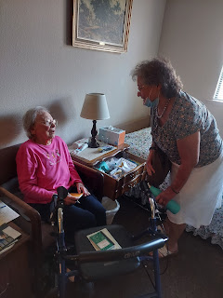

She was excited to share some of her postcards with me - ones that I have sent to her as I travel around the world, including this one from Agadir, Morocco. She wanted to practice pronouncing Agadir correctly with me. She had been pronouncing it as, "agga-dirr", but I taught her that it is pronounced "agga-DEER".

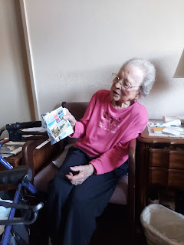

After we looked at some world maps and talked about some of her travels to Europe in days long gone, we went on a field trip outside to sit in the shade and continue our visit outdoors.

Video #1: Helping grandma walk outside (19 seconds)
https://photos.app.goo.gl/h3koPNfqdMU4Z7Km6

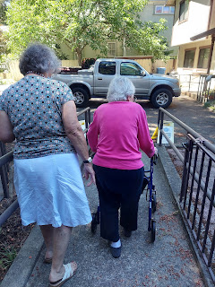

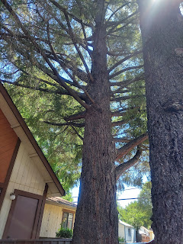

Recently, Mom found Grandma's old autograph book from the 1930's, with several poems and cute sayings from her closest friends back then. There were even some notes from a few family members! Mom had already looked through it with Grandma before, but it's always nice to go through it again. Especially with someone whose mind isn't what it used to be and may not even remember!

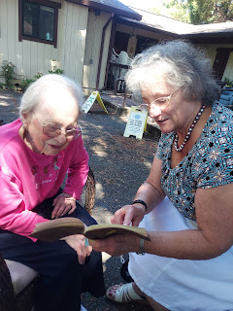

Video #2: Grandma and Mom introducing the autograph booklet and sharing some info about Grandma's Uncle Louis Jones, brother to Leon (my great grandfather, who was also deaf).
(1 min, 35 seconds)
https://photos.app.goo.gl/Gt3gXi6PsF8BxiVd8

Video #3: A memory of Grandma when she used to work at the cigar factory in Jacksonville, Florida.
(31 seconds)
https://photos.app.goo.gl/KM7EsnF3yH7He7Aa7

Video #4: A cute poem from one of Grandma's friends named Wetona. (43 seconds)
https://photos.app.goo.gl/Qp8kJ7RSxuzvGB4i6

Video #5: "Yours till the mayonnaise sees the dressing." (29 seconds)
https://photos.app.goo.gl/xDAHs8HB5QtLzRE98

Video #6: "My heart is like a cabbage." (36 seconds)
https://photos.app.goo.gl/C3kmpTaB5LBVdttN7

Video #7: Grandma describing how she loved to go ROLLER SKATING as a young lady.
(1 min, 56 seconds)
https://photos.app.goo.gl/YC7Ee8LbCvZQYqTd6

Video #8: Grandma trying to explain about a man she met named Roland, who was in the military.
(1 min, 4 seconds)
https://photos.app.goo.gl/CCeoLKKxp5wHna5y7

Here are a few more photos from the autograph book.

From Linton H. Norman (her 1st husband and my Grandpa)

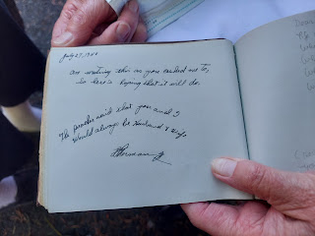

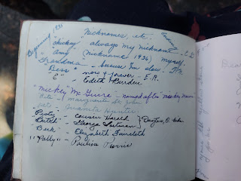

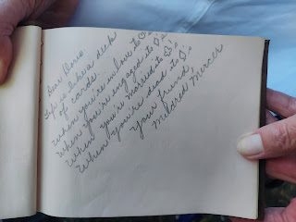

From Grandpa Linton Norman's sister, Linnie Ruth - -

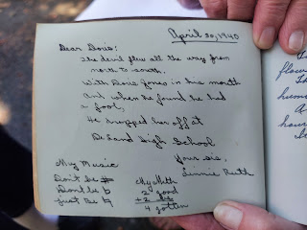

This is what sparked the conversation above about roller skating.

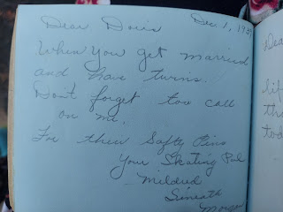

From Grandpa Linton Norman's sister, Thelma Norman - -

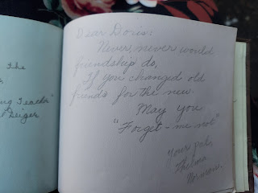

And how amazing is this - - a little note from each of Grandma Doris' parents!! My GREAT-Grandparents!! And in their own handwriting!!

Dad: Leon Jones
Mother: Christina Miller Jones (they were both deaf)

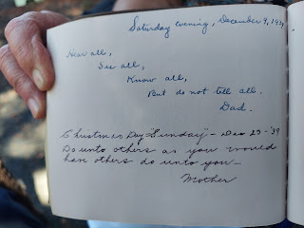

All too soon, it was time to leave. We spent almost 2 hours with Grandma and had covered a lot of topics. We didn't want to wear her out too much . . . (or ourselves) . . . it becomes a little taxing on your throat when you have to say everything extra loud so she can hear you . . .

What a beautiful lady she still is at 101 years old. Wow. She is amazing! I think the most remarkable thing about her, in my opinion, is that she is still SO curious about EVERYTHING. She wants to know where did this come from, how do you spell it, how is it pronounced, and everything else associated with it. She may not remember the information, but she sure wants to know it!

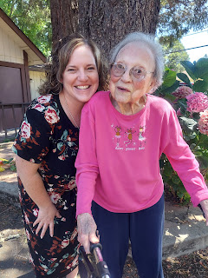

At the end of the day, I drove up to Willits to have dinner with my Dad and Michelle, and to meet two of their best friends, Steve and Kathryn. Michelle put together a fresh and flavorful spread of ingredients to build-your-own antipasto salad, with greens, pepperoncinis, marinated artichoke hearts, fresh mozzarella, pepperoni and salami, green olives, and a variety of dressings. Kathryn brought a sugar-free cheesecake with homemade cool whip and fresh strawberries and blueberries. It was all so delicious!!

We played a fun dice game called Zilch. That's when things got REALLY animated, ha ha. Kathryn was the life of the party for sure, keeping us all in stitches. We laughed and laughed as we played. I almost won, but Steve beat me out at the end. We also had a deep discussion about family history, and I did my best to answer all of Steve's well-thought-out questions. He really has the desire to do more on his family tree, but has been spinning his wheels for a while without knowing how to proceed. I hope I was able to get him going in a good direction. I also offered to help him over Zoom or a video call from time to time if he needed help. So we'll see . . .

It was finally time to head down the mountain around 9:00 p.m. It was time to get out of the deep forest and get home and into my bed. I always lose confidence, though, in how to find my way out to the freeway from Dad's house, since the area is so remote and off-grid from any GPS. There is no cell reception out there, either. So if I accidentally go down the wrong dirt road, I'd have to find the way on my own because I wouldn't be able to call anyone for help.

I asked my Dad if he wouldn't mind drawing out my route on a piece of paper before I left. He offered something even better! He said, "How about I hop in my car and lead you out myself?"

Yes, please!!

(Blurry because the road was bumpy, but you get the idea . . .)

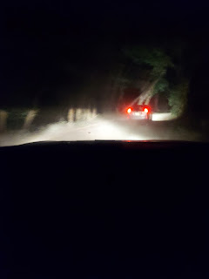

What a thoughtful and wonderful Dad to do that for me! I did get a little teary as I followed him through the dark forest and on to safety. It was reassuring to have him lead me out and it was comforting to feel like I had a protector. I am truly grateful to have such a kind and caring father. :)

