Happy New Year!!
Wow, another year is starting already! Funny how that happens . . . every 365 days, another calendar year begins. "Old Reliable", ha ha.

This adorable lady is my beautiful Mom on New Year's Eve. She went out with some friends to the local senior center for an evening of dancing and fun to ring in the new year.

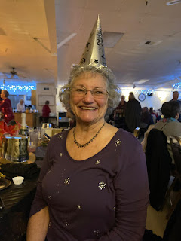

And I hope this double rainbow that stayed with me for several miles along the Columbia River (as I drove home from Portland after Christmas) is a gentle sign of what 2025 might bring . . .

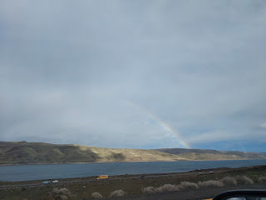

Along with many of you, I like to think about some things that I'd like to accomplish in the new year. There will be many changes for me in 2025, so most of the things I'll be accomplishing will relate to those changes and the basic navigation through them. But IN ADDITION TO the things that I am compelled to keep up with, I would like to focus on a few extra things of MY CHOOSING.

1. I want to research the origins of my Snider Family this year, with the goal to find out where they came from before they immigrated to the U.S. This is my paternal line, and all I know is that they came from "Prussia", which is not even a solid place necessarily, because its borders changed so frequently. If I find out that they came from Germany, Austria, or Poland, I will be in close proximity to these places and can visit an archive or a special ancestral place that gets discovered along the way.

2. I want to get back to some basics (i.e. sewing, gardening, cooking, etc.). I will be bringing some sewing and crafting supplies to Italy this spring when we get to do a shipment of household goods as part of Scott's new job. Also, at our new house in Italy (more on that in a minute), there will be some gardening opportunities and I am looking forward to this so much. There is something so healing and needful about shoving your hands in some dirt, planting something, nourishing it, and watching it grow, then harvesting the "fruits" at the end of its season.

3. Per the suggestion of Sister Pyne, a young lady from my Vicenza Military Ward who is serving as a missionary in Wellington, New Zealand, I have chosen a word to use as my guiding influence throughout the upcoming year. She sends out a weekly email and in her latest one, she invited everyone to choose a word that can help us this year. I'll share a little bit of her email that really touched my heart.

I recognize that this is a very difficult time for many people. There are those that we wish could be with us. It is a time when loss and absence may feel stronger. I implore with you to turn to God. In the suffocating moments of loneliness and despair, know that there are angels 'round you. You are not alone. Christ understands. He's felt this exact thing. He wishes to grant you comfort.

Don't forget that there's a plan.

My talents and strengths are unique to myself. So are my trials and weaknesses. I am on my own journey. So long as that journey moves me forward and to Christ, I'm doing exactly what I'm supposed to!

If other people have the appearance of performing at a higher capacity than I am, that's fine! Good for them

God and I are a team. We're making the Best Sister Pyne there is. But we recognise that it takes time.

We had dinner with the Turketo family last night. They have a family tradition of individually picking a word for the year. My invitation to you is to do the same. Take 2025 as an opportunity to focus on something important to you. However, I issue a warning: one year Brother Turketo picked the word 'consecrate' and then he was called as Stake President. So, watch out.

2025 is the only year that I will be a missionary the entire time. All 12 months I have decided to give to the Lord. The word I have chosen relates to this magnificent opportunity and calling.

I hope you each find a word that speaks to you. Focus on it this year. Let it build you and give you strength.

Some suggestions to get you thinking: disciple, light, truth, patience, enough, hope, strength, peace, effort, reach, serve, charity, lift, sanctify, connection.

So many profound things that she wrote . . . they may not have seemed profound to her as she wrote them, but they penetrated deep into my heart. I was feeling low on New Year's Eve. I was alone and I felt lonely. The house was quiet, a little too quiet. I think because I had been in the middle of a whirlwind for so long, that when it finally quieted down, I had nowhere to hide from the feelings and emotions that I had been stockpiling for a while . . . it was time to stop running and start facing them. It was difficult, but important.

When I read her email the next day, it hit so hard in all the right ways.

I began giving some serious thought as to what word I could choose to focus on for 2025, and to let it guide my actions, my words, and my choices. I finally settled on the word "celestial". Our prophet, President Russell M. Nelson, has invited us recently to "Think Celestial", so this would partner well with his invitation.

Celestial - in a spiritual sense - means something that is divine and heavenly. God and His Son Jesus Christ dwell in the Celestial Kingdom of Heaven, so there is sort of a subliminal invitation that if we want to be where They are, we need to be worthy to do so. How do we become worthy to live with God and Jesus Christ? By doing our best to become like them.

To think celestial, it means we want to rise above our natural tendencies to judge, react, gossip, respond in anger, etc. We will instead strive for more patience, more inclusion, kinder words, and a calmer demeanor. As we THINK celestial, we will inevitably BECOME more celestial in our behavior, in our attitude, and in our everyday interactions. Our consistent efforts to become more Christlike will, in the end, give us more worthiness to also be where God and Jesus Christ are.

In the first couple of days after choosing this focus word, I already had a few chances to put it to good use. Thank goodness for the Holy Ghost, who helps us to remember what we said we would do. Thank goodness for His gentle nudges to think more kindly toward someone who may have offended us, or to find a better way to express our frustration, and to show mercy and patience with their imperfections. Thank goodness for the Holy Ghost, who teaches us and helps us become more than we could on our own.

I wrote Sister Pyne late last night before I went to bed, to thank her for her inspiring words and to share what word I had chosen and how it's already helped me. To my surprise, she wrote me back within just a couple of minutes!! She only wrote a few short lines ("This is the sweetest thing! Thank you so much for sharing. I hope you and your family are well."), but I was happy to know that she had read my grateful words.

On to other things . . .

When I left Portland the morning after Christmas, I was worried about those dreaded mountain passes again and whether I would need to put on the brand new tire chains I had just bought. While it's always good to be prepared, thankfully, I did not need to use them at all the whole way home. There was fresh snow on the sides of the road near La Grande and Baker City, but the roads were nothing more than damp in those stretches. I was so relieved . . .

I made good time to Meridian, Idaho, where I stayed the night again with Jeff and Sherry Haines. I went to bed super early because I was so exhausted from so little sleep the previous two nights.

The next morning, I met up with Benson in Mountain Home as I continued my drive back to Idaho Falls. I helped him to jumpstart the car that he's been using (Weston's Elantra) and he told me that he figured out what the problem has been. There's a sensor pad thingy-ma-bob attached to the brake pedal, and it is wearing out. He discovered that after each time he parks the car and turns the motor off, if he gently places his foot underneath the brake pedal and lifts it ever so slightly, then the brake lights will shut off properly instead of draining the battery. He had just forgotten to do that this one time, ha ha, so I had to drive all the way down to the base (about 25 minutes south of the freeway) to rescue him with my jumper cables.

Then we caravanned back into the city of Mountain Home (closer to the freeway) and had brunch together at a restaurant called Frankie's Burgers. We had the best chat while we waited for the food and it continued even as we ate it all up.

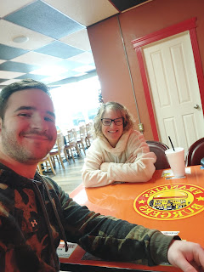

He is not getting the best treatment from the Air Force in Mountain Home, unfortunately. But he has a good attitude and is still making plans for his future. If he doesn't get the transfer that he put in for a month ago (to South Korea), he will just finish out the 8 months that he has left in his current one-year contract, which goes from September 1st to September 1st. It is unlikely that he will go to Korea, because he should have heard by now that he's been approved.

He is thinking that he wants to live here at our house later this year, and go to school using some of his GI Bill. He would like to eventually work for an airline somewhere. While I am not a fan of having a German Shepherd (who sheds profusely) live in my house, I
AM
a fan of Benson and I will forever be rooting for his successes in life. Carpets can be cleaned or replaced, which is something on our to-do list for this house anyway. Furniture can be replaced if needed, too. But Benson is trying so hard to succeed in life, so I am choosing to put
him
above my dislike of pet hair . . . :)

Benson's happy face while standing patiently in the rain while I took this photo for Amber . . . (these are the gifts he was supposed to open up in Portland if he had been able to join us there)

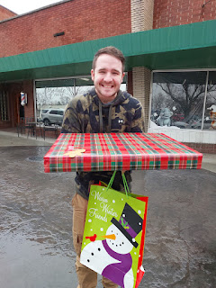

New House in Italy . . .

I don't think I mentioned this previously, so please forgive me if I did already . . . The morning after I arrived in Idaho Falls after spending Thanksgiving in Minneapolis, Scott told me he wanted to potentially move to a different house. The way he told me was this: I received an email from him while he was at work (and while I was sleeping that night). In the subject line it said, "I Love You". And in the body of the email, the first line simply said, "Please do not freak out." And then he pasted in a link to a house that was on the market for rent . . . And that was it.

I did kind of freak out.

I didn't want one more thing on my plate. I was tired because I had been sick while visiting Jake and Hannah in Minneapolis. I hadn't even unpacked my suitcase yet. My niece, Mari, was texting me early that same morning because she wanted to come over and do several loads of laundry. It was starting to feel overwhelming and I was just barely waking up to start my day!

I told him I didn't want to move. He explained that with this new job, they are going to give us a stipend of $2,000 per month for housing. If we spend less than that, we can pocket the difference. Currently, we've been spending $1,900/month for the past 3 years. He had already asked our property management lady, Silvia, if the rent could be lowered, but she didn't respond to his request. So, he figured that if we could move to someplace where they're only charging $1300 or $1500, then that's quite a chunk of money that we would have leftover to do whatever we want with.

I had plans to go to the temple that night with some friends from my ward, and I knew I could pray about this in the temple. I also prayed throughout the day for humility and the ability to know if this is what Heavenly Father wanted us to do. Maybe I was slamming the door on the idea because I was so tired and overwhelmed, but I also wanted to do the right thing and for the right reasons.

I felt the comfort and peace that I needed as I attended the temple that evening. I felt stronger. I felt content. After I got home, I was able to send an email back to Scott, letting him know that while I preferred to NOT move, that if we found something we could BOTH get excited about, then I would consider it.

Over the course of the next couple of weeks, he would send me a listing or two every couple of days. I was grateful that he didn't push me too much by sending several listings per day. We began to hone in on what our criteria was and what was important to each of us.

Midway through my visit with Amber and her family up in Portland, we found a place.

It is much closer to the base where Scott works (Del Din) and is also closer to church. It will be a quieter, more rural experience overall. We will lose one bedroom and one bathroom, but the layout seems to be a good one, especially if our kids come to visit. Instead of having one guest room upstairs and the other one on the main floor, both guestrooms will be next door to each other. Jake and Hannah will appreciate this because they will be closer to their little ones.

Scott made a video as he met with a realtor and Daniele, our new landlord. Daniele and his father take care of all the landscaping and gardens, and the father will live below us. We have the top floor, while the father is on the first floor. We have our own entrance and a large garage with lots of shelving for storage. There are also several paved walking trails in the area, and a view of the mountains from the side terrace that runs from the master bedroom all the way to the kitchen.

Keep in mind as you watch this next video that you might get dizzy . . . Scott wasn't thinking about keeping the camera steady and making sure it will be a meaningful experience for the viewer(s). But it will give you a little idea of what the new house is like. *Note: the furniture in the video will not stay with the house when the current tenants move out at the end of January. We will be getting our own furniture and furnishings.

Video of the new house: (6 minutes, 43 seconds)
https://photos.app.goo.gl/SWQgXW92dp8Jwe5x5

Video of the driveway and the garage: (15 seconds)
https://photos.app.goo.gl/cmuP2DGQepPCpoR2A

Daniele is the man that you see in the videos who is speaking really good English. The lady is the realtor, but she doesn't speak any English.

We recently bought me a plane ticket to fly over to Italy for 3 weeks so I can help with the move into our new house in February. As soon as I get back to Idaho, I will hang out there until we get our Italian Visas sometime in April.

I gotta say this before I forget to record it somewhere . . . I've been fighting this whole change of plans (in my heart) for a while now, and I'm still trying to fully reconcile myself to what is about to happen. There
are
elements that I am looking forward to: being with Scott full-time, the nicer weather, the walkability, the opportunity to explore and see new things that you don't see in the U.S., etc.

But there are also things that I have really struggled with: being far away from my children and grandchildren (plus friends and neighbors), being away from our home and the projects that I need and want to work on, not being able to plant a garden for several seasons in a row, and being surrounded by people who don't speak English.

I try to make the most of everything that I encounter in life, but as people come up to me at church, in my neighborhood, and chat with me on the phone, I find myself constantly down-playing the fact that we're about to live in Italy for the next long while. Why do I keep doing this? I think part of it is because I feel guilty - several people have told me flat out that they are envious of our adventurous life in Italy. I don't want to come across as "braggy" or insensitive to the fact that many people are struggling financially, and some don't even like their current job and they wish for something better.

I have said to Scott many times that money isn't everything, and that I value being closer to family over making a bunch of money. But then I had a pivotal conversation with my neighbor, Bryant Hafen, last week. I was just heading off to the gym when he stopped by the rental house that he's been fixing up next door to me. (They are the owners and landlords but they live a couple streets over.)

As I visited with him and answered his questions about our upcoming plans, I found myself repeating the same old broken record phrase (to downplay our plans), "Well, money isn't everything and I would much rather be here and closer to our family..." His response flipped an unexpected switch in my brain and in my heart that needed flipping . . .

He basically said: "I know money isn't everything, Michele. But in today's world, money sure helps a lot. If you're about to make a lot of money, maybe there's a reason for this. Maybe this is God's way of setting you up to be able to help others down the road, probably your own family, and especially your own children. How wonderful to be given this gift and to have such a great opportunity. I'm truly happy for you!"

WOW. I hadn't ever considered the thought that maybe this was a GIFT from God, my loving and kind Father in Heaven. I've been acting this whole time as if it were a burden. It was the opposite of what I wanted to do. An inconvenience. A hardship. But to consider the possibility of this being a GIFT truly rocked my world. I am still pondering and working through the whole idea. I have a ways to go with getting rid of the perpetual "chip on my shoulder" and negative attitude that I've been feeling for the past couple of months, but I am confident that in the near future I will make it over to the other side of this obstacle, where happiness and joy reside.

I feel like my upcoming trip over to Italy will help me quite a bit. I will be able to help us move into a new house. I will be able to "nest" and start making our house into a home. And I am confident that this will be very healing and uplifting to my feeble heart.

*Note: I know that this might seem trivial to some people, like how can a person complain about a chance to live in Italy?!? But seriously, it's more complex than what it might seem like on the surface. Everyone has something that they're struggling with and trying to figure out. So many scenarios and things to consider, no matter who it is and what they are going through. It's always a good idea to give people some kindness, some support, a listening ear, and not judge them based on how you would handle the same situation.

Sisters in Idaho Falls . .
.

My older sister, Charmaine, flew from San Diego up to Idaho Falls to spend a few days with her daughter, Mari on Christmas night and for the next couple of days. She helped Mari to overhaul her entire studio apartment and get more organized. She even helped Mari to build a new bed frame, one that has a headboard so her pillows don't keep falling down off the end, ha ha.

I left Portland a couple days earlier than originally planned so that I could see Charmaine, too, and also take her down to the airport in Salt Lake City to fly home. (She got a swinging deal if she booked two separate one-way tickets - fly into Idaho Falls, but fly home from SLC.)

We walked around by the waterfalls downtown and wandered through the Japanese Friendship Garden across the street. It was so festive and beautiful with all of the Christmas lights still up.

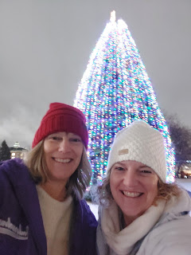











I loved the clouds that blanketed the lights from the city and caused a soft glow in the sky. And I loved how vibrantly the temple shone along the Snake River and the Greenbelt area.



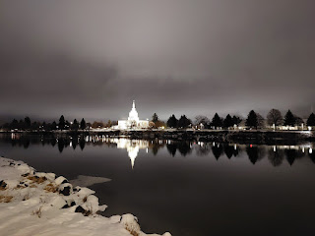

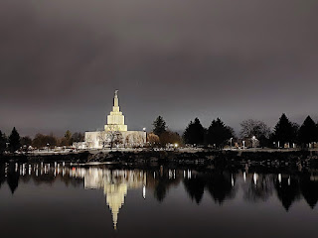





We ate dinner at a new-ish restaurant called Hokkaido Ramen House. While I am not usually one to choose a carbolicious noodle place, I saw several options on their online menu that looked so good!! Besides, this was Charmaine's top choice, and I wanted to prioritize her input.

I ordered a soup with shrimp, seaweed, lemongrass, soft-boiled eggs, bamboo shoots, etc. and I asked them to put the noodles in a separate bowl. I never even touched them because the soup filled me up all on its own. It was incredibly delicious and I can't wait to go back!!



After Charmaine finished putting the new bed together the following morning, we drove down to Salt Lake. It was really windy, with some snow and slushy ice on parts of the roadway, which meant I had to keep a firm grip on the steering wheel the whole way. We passed a car that was completely upside down in the snow on the side of the road, with an ambulance and police cars on the scene . . . I hope they were okay!

We drove into downtown SLC and walked around the City Creek Mall, got some lunch at Cafe Rio, and went across the street to Temple Square briefly. The temple down there has been getting a MAJOR overhaul for the past few years. They've been updating all the older systems (heating, cooling, plumbing, etc.), but the biggest overhaul has been to make the temple earthquake proof! Yes, Utah does get earthquakes . . . I think they're still at least another year out before the project will be completed.

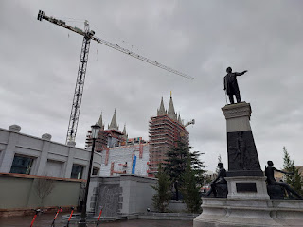



Even though the temple is covered in scaffolding, they still hung the usual Christmas lights around the perimeter of Temple Square, and there was a beautiful Nativity scene floating in the pond. I loved the reflection of the temple in the water . . .



A family asked Charmaine to take their photo outside the City Creek Mall, and I thought she looked so cute so I stole a photo of her . . .

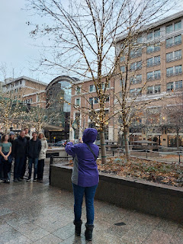

All too soon, it was time to drop her off at the airport to fly home . . . Dang it. But it was fun for the short bit that we did have together.

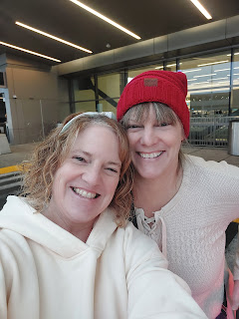

I had chosen wisely ahead of time by not driving all the way home to Idaho Falls that same night. It would have been a drive that was completely in the dark, up and over Malad Pass, with snow, slush, ice, and wind. Blech. I had already reached out to my friend, Marilyn Garn, who lives in Centerville, just north of Salt Lake, and she happily agreed to give me a bed to sleep in for the night.

This is a photo from a year and a half ago, when she stopped by my house in Idaho Falls for a visit.

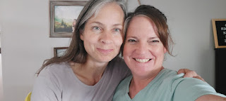

We talked for HOURS and HOURS at her home and it was so great. She was having some struggles in her family and I was able to offer some perspective through some of my own life experiences. She was so grateful. I feel like I was meant to stay at her house so that I could help her. Really, it was a win-win because I had a safe place to lay my head that night, too.

I left early the following morning so I could get home in time for church in Idaho Falls at noon. It's about a 3 hour drive from her house to mine.

I chatted with Scott for a while as I drove home, and I carefully grabbed a photo of the fog in the distance to my right that engulfed the huge mountains for miles. There were several places where I couldn't see more than maybe 100 feet in front of me on the freeway. I didn't like those sections very much. *This wasn't one of those sections* . . . ha ha.

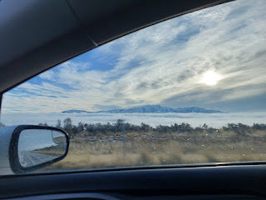

From Tremonton, Utah all the way to the top of Malad Pass, I was driving through deep and thick fog. I stayed mostly in the left lane because nobody was ever in that lane. As I made my way along, I would come upon some red tail lights in the right lane from time to time, but without much warning. I wasn't driving super fast, but the fog was SO THICK! I figured I was better off to be in the other lane so I didn't have to do any sudden maneuvers.

At one point, I was singing at the top of my lungs as I listened to a song called, "It Is Well", by Bethel Music. Singing those words "It is well with my soul" over and over as I carefully navigated through the fog was very powerful. I was extremely grateful when I got up and over Malad Pass where the skies were blue and clear the rest of the way.

Here is a link to the song on YouTube:
https://www.youtube.com/watch?v=YNqo4Un2uZI

While it may seem to some that this song is a little dramatic, try driving through fog as thick as split pea soup and suddenly it becomes your lifeline . . . This lady's voice is so beautiful. It's also a video that's been viewed 108 MILLION times. So it might be worth your time.

The following day, I tried a new recipe that I was craving in between all the company coming and going. While I am not a huge fan of tuna, I just really wanted a gooey tuna melt sandwich on sourdough. This recipe turned out to be INCREDIBLE!!

https://therecipecritic.com/tuna-melt/#wprm-recipe-container-98096

First, I made it into a grilled sandwich, but the cheese didn't melt enough before the outsides of the bread started getting brown. So the next time(s), I made an open-faced tuna melt under the broiler in the oven. I LOVED IT SO MUCH.



The next round of company was my younger sister, Melanie, and her son Caleb. She was bringing him up for his first experience of college after many years of health issues, setbacks, and disappointments. He was beaming the entire time! He'll be attending BYU-Idaho in Rexburg, about 40 minutes north of me.

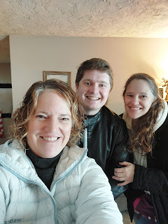

He has been working really hard back in Arizona, carefully saving his money and preparing for some "adulting". He brought his own car up to college, a beautiful one too, and has been adjusting to driving on the snowy, icy roads right out of the gate! So far, so good.



They only stayed one night with me before needing to scurry off to Boise for a family wedding. Mari joined us that night too, as she had been hanging out with me all day while doing her laundry. We all played a game together and stayed up way too late . . . ha ha. But it was really fun - and it was good for the two cousins (Mari and Caleb) to get reacquainted again, since it had been a while since they'd last seen each other.

In between washing all the bedding from the family visits and fun, I decided it was high time to get caught up on some cleaning. I still wasn't fully settled in from when I arrived home on December 3rd, and there was much to do. The family room downstairs was needing some serious cleaning because of a little incident when Amber and her family stayed here during Thanksgiving. They had started a fire in the wood stove downstairs, but oftentimes the first fire of the season backfires because of an inversion. This is when the cold air from above suppresses the warm air below (from the emerging fire), and subsequently the smoke ends up filling up the room instead of going up the chimney. The way to avoid this is to light a few candles in the fireplace first and let them gently penetrate the inversion of cold air. Once you see that the heat from the candles is billowing upward, then you can move on to Phase 2 and light the actual fire.

The smoke from this unfortunate Thanksgiving fire filled the entire family room and left a lingering campfire smell all throughout the house, but most especially downstairs. My neighbor, Kim, had given me a special Christmas gift to help with the smoke smell. It's called a Lampe Bergere (French). It's a glass bottle with a rope wick and you can choose the scented liquid (mixed with rubbing alcohol) that gets poured inside. It's supposed to eliminate all kinds of odors, including smoke, pets, fish, etc.

It did a really good job, but it still smelled like smoke each time I went downstairs for something. Scott and I ended up ordering a really nice air purifier from Amazon and it finished up the job quickly. Now it smells much better in the family room and bedrooms downstairs.

Meanwhile, all that smoke also left quite a coating of dust that needed to be addressed . . . so that's what I did before the next round of company arrived the next night. I dusted and vacuumed the entire downstairs and it felt great to be able to check that off my list.

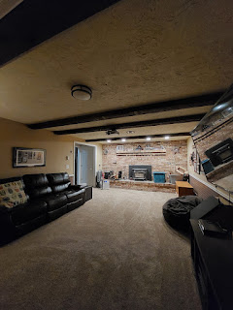

However, I noticed that the main lights in the family room had burned out, and when I grabbed a step-ladder to replace the bulbs inside, there were no bulbs to be found. Instead, each light fixture housed a transformer that powered the LED light. Hmmm. Now what?

After discussing options with my neighbors, Don Blatter and his son Stephen Blatter, along with Scott the next morning, we decided to order some replacement fixtures. I strongly suggested to Scott that we aim for something that requires light bulbs so that ANYONE can replace the bulb when it burns out. I don't want any additional complicated things in this house (or outside as well) that I have to call in a whole team of people to help me take care of when my husband isn't here to do it. Simple and easy. That's what I want.

Plus, the light fixtures on my front porch needed to be replaced. Stephen Blatter had already replaced the same type of fixtures on either side of my garage door last September when they died, so he offered to install some new lights for me again (which he already did and they look great). Out of four identical fixtures that we began with, there was only one surviving light left . . . the one on my front porch. It was only a matter of time before it, too, died and I didn't want that. But thanks to Stephen, I can feel safer in my own home at night. These were also the same type of light fixtures that when the unit dies, the whole thing is kaput. What a waste of a purchase in my opinion . . . now they're just gonna be part of a mountainous heap in some landfill.

Anywho, there was a lot going on in a very short span of time . . . but I'm getting things taken care of around here, one thing at a time.

Last Friday night, two amazing young ladies from my Vicenza Military Ward, Emily and Sarah McGovern, flew into Idaho Falls at 10:00 p.m. all the way from Italy. They spent the weekend here with me in preparation for starting school at BYU-Idaho this week. They arrived with a TON of luggage, ha ha. I think they brought something like 2 50-lbs suitcases EACH, plus 2 carry-on sized suitcases EACH, plus a couple of smaller duffel bags EACH, plus their backpacks.

Sarah (on the left) is 18 and will be starting as a freshman at BYU-I.
Emily (on the right) is almost 22 and will be a junior this semester.

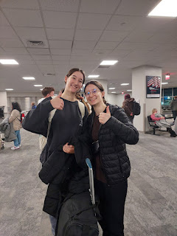

They come from a wonderful family, including their mother and my dear friend, Rachel. All of them know how to work and contribute and get things done, and they're also happy, kind, and gentle souls. The next day after their late arrival, when we had a big snowstorm and several inches of snow, they wanted to jump right in and help me shovel the driveway. They also washed the dishes after every meal or loaded things into the dishwasher, and they were always offering to help with this or that.

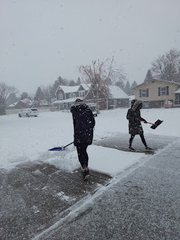

This is the entire McGovern Family . . . Emily is on the far left, and Sarah is in the white dress in the middle. Sarah's twin brother, Andrew (light blue shirt), is currently serving as a missionary in the Tempe Arizona Mission. Their father, Ben, is a dentist in the US Army.

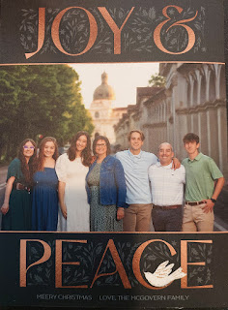

In the middle of this busy weekend, Caleb made it all the way across the state by himself after their family wedding in Boise, even with snow coming down and some iffy roads on the way. This was another first for him. When he stopped by my house for a short break, we scrounged in the fridge and freezer for something to feed him before he continued on to his new dorm room in Rexburg. He hates shrimp, which is what I was planning to make for dinner, but we found some dino chicken nuggets instead, and that brought a smile to his face.



Monday morning began with blue skies and crisp temperatures outside and it stayed that way all day while we got the girls moved up to Rexburg. Thank you, Mother Earth. The girls hauled up all of the stuff that Emily had been stashing in my craft room downstairs since last spring, and they stacked it into neat piles in the garage while I went to get the U-Haul pickup truck across town.

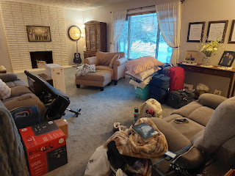

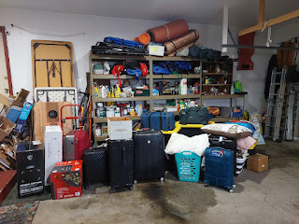

We managed to fit 3/4 of their stuff in Truckload #1 . . .

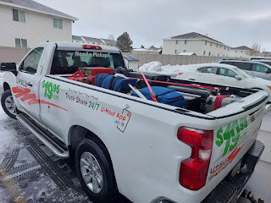

After unloading it into their new room off campus, we drove back down to Idaho Falls to grab the last few things. We decided that it
should
all fit into my car and that we could turn the truck back in a little early, so that's what we did.

Emily and Sarah, bagging up some loose items to be more easily transported . . .

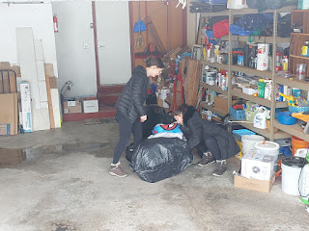

We decided to eat lunch at Panda Express, especially after Sarah's face lit up when she learned that there was one right next to Walmart, which was our next stop. They had already done a great job of planning out their first week of meals together on Sunday (the day before), so they had an efficient grocery list all ready to go.



So . . . everything DID actually fit into my car . . . it was just a bit snug in the back seat where Sarah sat. She was such a good sport though.

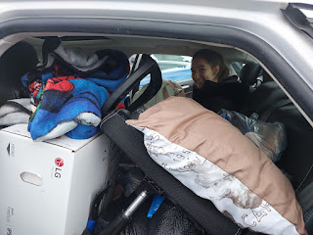

Once we got all the remaining things dropped off in their new home and hugged goodbye for now, I met up with Caleb again and we grabbed some ice cream (per his suggestion) at a cute place in Rexburg. It's called SugarBeast (!!) and it's right across the street from Heritage Manor, the apartment complex where I stayed in 1991 and where Melanie (his mother) stayed several years later as well.

It's in a beehive shaped building on the corner of campus and is filled with old-fashioned ice cream churners, along with lots of sweet AND savory items for purchase. Caleb and I both chose the Oatmeal Cream Pie flavor of ice cream, described as: Cream cheese ice cream with cinnamon and cloves, filled with our homemade oatmeal cookies. It was REALLY good. Carbolicious -
yes,
but I'll make up for it in the coming days. :)



The downstairs of SugarBeast was super cheery and bright . . . and there's even some additional seating upstairs where they have regular karaoke nights! College will be so fun for these three young adults. I'm so happy for them and I hope they have a great semester!

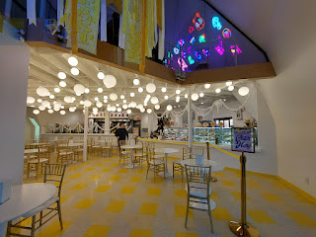

And Lastly, the Little Ones . . .

Miss Maisie is still just as cute as a button.

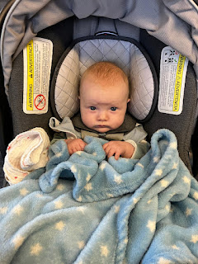

Jack, helping to scrape off the snow in Minneapolis . . .

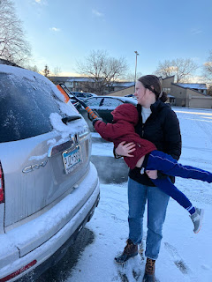

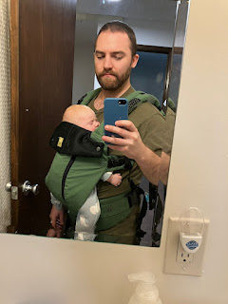

Above and Below: Jake, practicing first at home with the new front carrier before they used it for real at the airport . . . They flew out to Utah to spend some time with Hannah's family during the Christmas holiday. Maisie appears to like it very much.

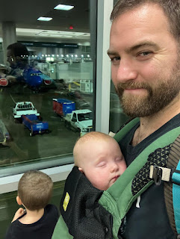

To get the cheapest flight, they landed in Salt Lake City at midnight on Christmas Eve, where they had arranged for a hotel closeby to rest for the night. This was their "Merry Christmas" photo the following morning, where Hannah appears to be hiding behind Maisie, ha ha.

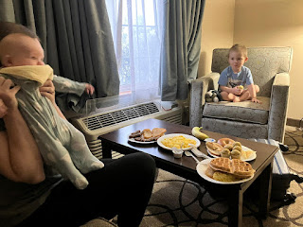

Jack has LOTS of little cousins to play with on Hannah's side of the family. His father, Jake, is in the middle of this next photo, completely engulfed by all the kids, LOL.

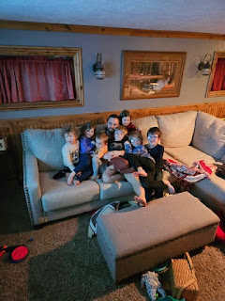

Maisie and Jack XOXO . . .

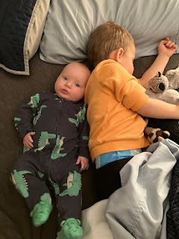

When Jake shared this photo in our family group chat, Amber's response was: "What's she praying for?"

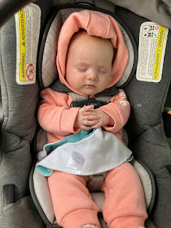

The weather was a bit more temperate down in Scipio, Utah, where Hannah's parents live on a ranch. Jack loves visiting all the animals and riding on the tractor with Grandpa Bob.

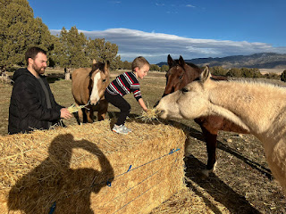

Maisie - looking all bright-eyed and bushy-tailed . . .

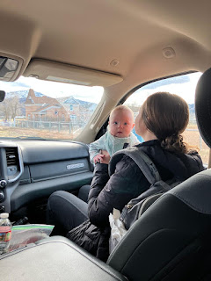

Video of Maisie with her dancing kicky legs as Jake sings "If You're Happy & You Know It" to her:
(13 seconds)
https://photos.app.goo.gl/bNE7TXMjyKuo9iga8

And finally, Abby and Gwen got to work on their mosaic kits that I had given them for Christmas, all the way from Ravenna, Italy (the mosaic capital of the world). They had a great time choosing the pieces of stone and glass to put in place. The girls are back in school as of yesterday and everyone is doing great.

