Hurkle-Durkling & A Trip to Boise
The Scots have it right - - they created a phrase to represent something that we ALL wish we could do every single day during the winter months: "Hurkle-Durkle".

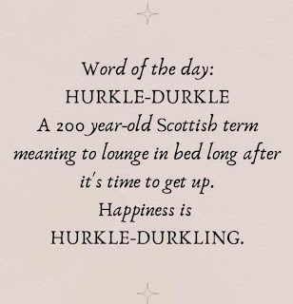

This is definitely something that my dear husband enjoys doing, especially on the weekends. He likes to climb into bed an hour early, and then stay in bed a good hour after he wakes up. How precious. :)

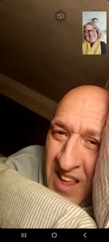

A recent idea that Scott's sister, Carol, and I came up with is to write letters to their father instead of trying to make phone calls to him. Dad doesn't enjoy talking on the phone, but he LOVES to read. He has always been an avid reader, and even now, at his advancing age, reading is still a big hobby for him.

Scott wrote the longest and most beautiful letter to his poppa last weekend. He emailed it to me and then I printed it out to deliver in person. He gave lots of details about what he's doing at work lately, and some of the things he's doing in his spare time, too.

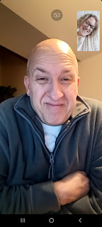

Here is a portion of his letter:

"Outside of work, I'm pursuing computer programming and geodesy, the study of coordinates on Earth. I've developed mathematical algorithms and programs to aid in my work. One area of focus is converting between latitude, longitude, and the Military Grid Reference System (MGRS), a standardized coordinate system used by military forces worldwide. This has proved invaluable in handling maps and locating friendly and enemy units. This past weekend, I delved into a new mathematical approach to
determining coordinates on Earth.

"Specifically, I explored the problem of identifying the starting point of a journey when given the location of a distant endpoint, along with the direction and distance between them. This problem has significant implications for navigation and rescue operations. I conducted an extensive search online to determine if a solution already existed but found no suitable algorithms. This prompted me to embark on developing my own solution and procedure. After extensive research and calculations, I finally reached a breakthrough yesterday.

"I've been getting pretty good at taking care of myself. I've been enjoying cooking for myself and doing laundry. It's amazing how quickly the days are going by as I eagerly await Michele's return in March. She's been keeping me up-to-date on everything that's been happening in Idaho, including the frigid winter weather and the impressive snowfall. I hope you're staying warm and cozy, Dad. And I hope you and Vernetta are having a wonderful time together."

When I delivered the letter to Phil, he sat down in his office and began to read it immediately. I found out later from Vernetta that he read it a few more times during the week. I would imagine that as Dad's mind and memory gives way to forgetfulness more and more, having something in a written format is helpful so that he can refer back to it if he forgets something. What a simple, but genius idea.

Here he is, in his comfy office chair, reading Scott's unusually lengthy letter.

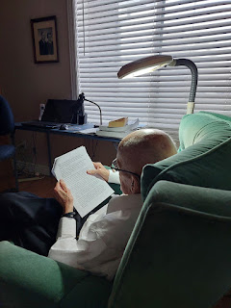

Earlier that same day, I recorded the choir singing a beautiful song at church. The primary children sang the first verse, the young men and women sang the second verse, and the full choir sang during each chorus. (Note: it's okay to record something in Sacrament meeting, or to take a photo, as long as it's okay with your Bishop and as long as it's not during something sacred, like the passing of the Sacrament, or during a prayer.)

The song, "I Am a Witness": (2 min, 21 sec)
https://photos.app.goo.gl/oATt2pKNsRxSN9JY8

I wasn't planning to record it at first, but something told me to do it, so I did. I later shared the video with some of the mothers of those sweet children, and they were so happy that I captured the video. One of them even told me, "Oh my goodness! Last night I went to bed wishing that I had a video of the song! This is the best surprise ever!!!! This is also probably the last song that I was able to play with my mom conducting and the children singing! It was a special moment!" (She, Melissa, was the pianist, and her mom has been the choir director, but was just called to be the Stake Young Women's President, so she won't be leading the choir anymore.)

Another mom wrote me back and said, "Thank you for sharing this!! It made me cry!"

I was humming the song over and over the rest of that day. It is such a beautiful song with such beautiful lyrics.

Early in the week, I got to chat with Jack while he was playing in the bathtub, ha ha. He was pretending to be an orca whale, diving and splashing and making all the whale sounds . . .



He pooped in the tub shortly after all that play . . . LOL . . . but his parents got him (and the tub) all taken care of.

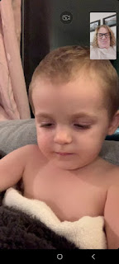

Jack loves to play "Duck, Duck, Goose" with his mom and dad, who are very tolerant participants. Jack goes around and around them, touching them on the head as he says, "duck, duck, duck, duck . . . "

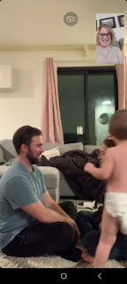

And when he decides to say "GOOSE!" he whacks them on the head and then runs over to the other parent and does the same thing before running away. He likes to have TWO gooses . . . LOL

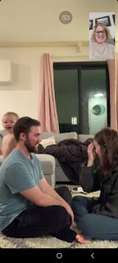

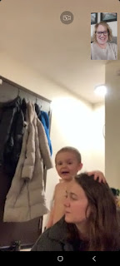

I loved seeing this post on Amber's social media feed during the week. Abby is such a wonderful girl! She has a robust appetite for reading, but has such a love for many other creative, innovative and intellectual pursuits. She is such a delight.

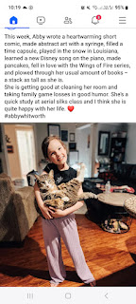

Abby and Gwen have also been attending an aerial silks class, something they were amateurs with already at home, but now they are learning professional skills from their amazing teacher in Shreveport.

Video #1 - Abby with her instructor. (6 seconds)
https://photos.app.goo.gl/9HaBzhvEMYLGrxSd6

Video #2 - Gwen with her instructor: (27 seconds)
https://photos.app.goo.gl/jdr28pku7qiHzj2MA

I went to the temple on Wednesday, first thing in the morning. I felt "filled" by the time I finished and walked back out to the car. It felt like I did something meaningful and strengthening, a feeling that would end up carrying over into the rest of the week.

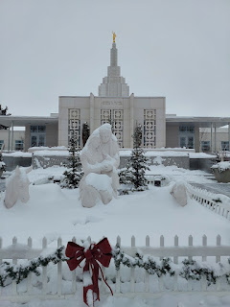



On Friday morning, I drove to Mountain Home and Boise on the other side of the state. The roads were good all the way to the Air Force Base.



That's where I learned that Benson had received approximately 9 inches of snow just a couple days before I arrived. They even got a "snow day" on the base and everybody got a day off from work. When I pulled up, the only place to park was out in the street on the other side of the snow berm. Benson had to grab a shovel and clear a path so I could walk up to his front door, ha ha.

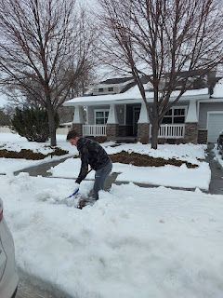

I spent a couple hours with him before he needed to go to work. We hauled in all the "loot" I had brought for his new home. He previously had no rugs, so that was the first order of business. We placed rugs at each door and a large area rug in the living room. I had also found a very nice rubber "tray" to hold dirty and/or wet shoes when you come inside, which we placed in his front entryway.

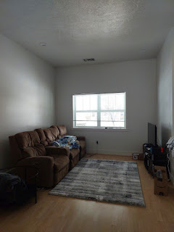

New rug for the hallway . . .

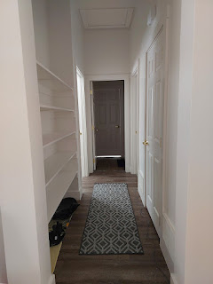

And by the following day, an Amazon order had arrived, so we arranged a few baskets on his hallway shelves for storage.

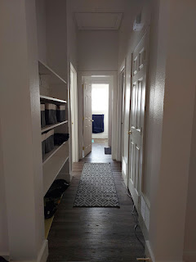

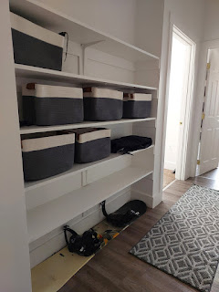

Over the course of the weekend, his master bedroom went from this . . .

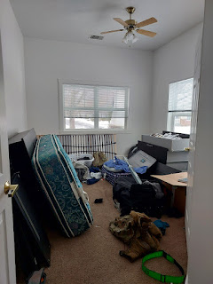

To this . . .

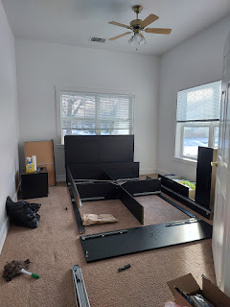

To this . . .



Hooray!! He doesn't have to sleep on the living room couch anymore!! We had a great time arranging and building things together, listening to music and chatting away while we worked.

On Saturday afternoon, we took a little time for some Show & Tell around the base. He showed me where he works, including this F-15 engine model (for training) outside the shop.

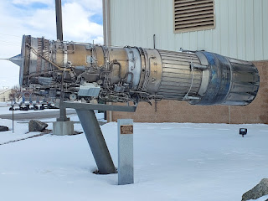

I got to see a couple of F-15's out on the tarmac . . .

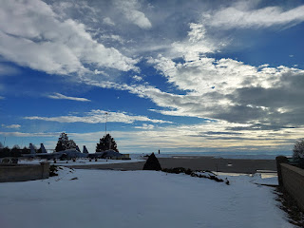

And then, as we leisurely cruised around the base, we discovered a cool park with several jets to check out. We found a place to park and then we tromped through the snow to see several of them up close.

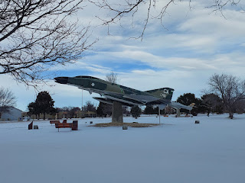

A B-2 bomber . . .

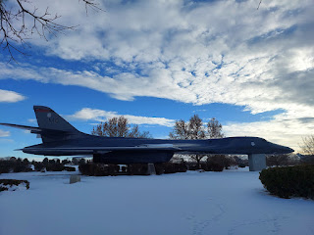

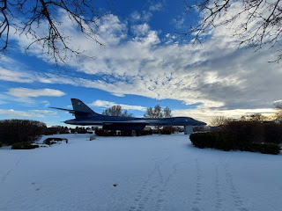

I had fun experimenting with a few photo-enhancing features on my phone . . .

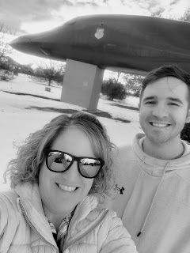

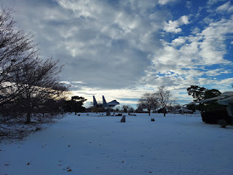

Click to enlarge and to read the photo below. It describes the F-111 and their purpose during the Vietnam War.

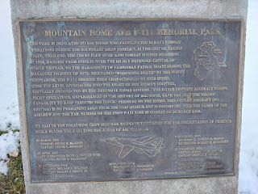

This is the F-111 . . .

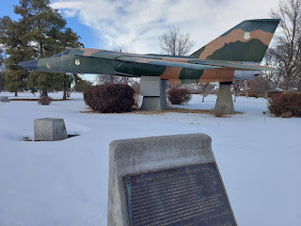

Our first view of the F-16 . . . (more on that in a minute)

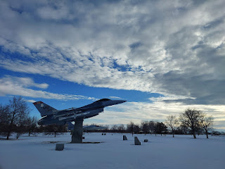

This is what he is currently working on now . . . the F-15.

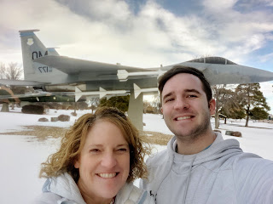

A description of the F-15 . . . (click to enlarge)

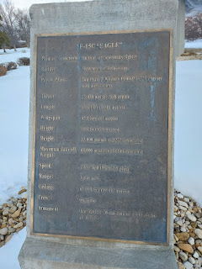

Another view of the F-15 . . .

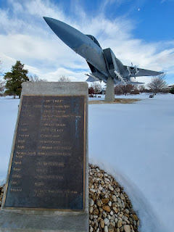

A bit more of the story on the F-15 . . . (click to enlarge)

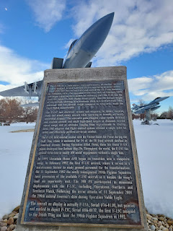

Here's that handsome F-16 . . . and yes, the snow was pretty deep in places . . .

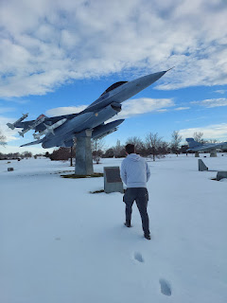

A description of the F-16 . . . (click to enlarge)

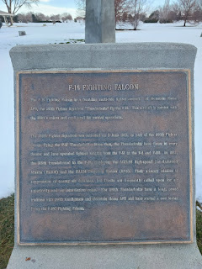

The clouds that afternoon were pretty spectacular . . .

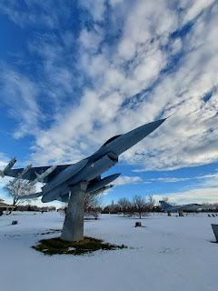

After we were done hiking around in the snowy park, we drove over to the Commissary and got Benson all loaded up with some groceries that he had been lacking for a while. Without a car, he has just been getting small amounts of items at a time because he then has to walk it all back to his house through the snowy streets. He told me how one time he was carrying a case of Monster drinks home, along with a couple other bags of groceries, and then the cardboard handle broke, sending all the cans sprawling across the road. Poor guy. But now he's all stocked up on meats, veggies, a mop, and several pantry staples - like spices. :)

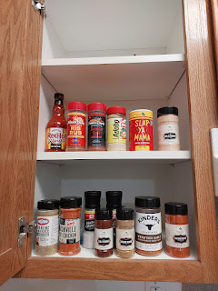

I drove back and forth from Boise to Mountain Home each day, staying with Mike and Carol (Scott's oldest sister), and then traveling to the base to help Benson and spend time with him, too. It's an hour each way between Benson's house and Carol's house. On Sunday, I made an extra trip, but it was worth it.

I drove to the base to attend church, which is actually located just outside of the security gate. I received help from a person right away when I mentioned I wanted to transfer Benson's church records from Aviano, Italy to Mountain Home. The ward clerk took me down the hall to his office and helped me get that taken care of. He said they would read Benson's name in Sacrament Meeting (just a few minutes later) to announce him as a new member of their ward. That was a "first" for me, and a very special opportunity for me as his mom.

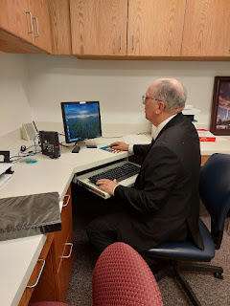

I wasn't 100% sure if I would stay through Sunday School after Sacrament Meeting or not, because I knew that Benson and I only had so much time to work on assembling his bed before we had to get back to Mike & Carol's house for an early dinner. I decided to wait and see how I felt by the time Sacrament Meeting was over. That's when I had the feeling that I shouldn't leave quite yet . . .

Sunday School was great, and the ward there is great. I found out that the ward consists of half military families and half Mountain Home residents/families. The older couple that spoke in Sacrament Meeting mentioned how the husband was a 5th generation resident of Mountain Home, and that his 2nd great grandfather planted the first tree in town. Wow. Lots of farmer and ranchers in this area, for sure.

At the start of Sunday School, they had me stand up and introduce myself. I shared that I was visiting from Idaho Falls and that my son's name was read out loud in Sacrament Meeting as a new member of their ward. As I was just about to walk out the door after class, a man (maybe mid-30's) flagged me down. He was hobbling along with crutches after a recent surgery, but he introduced himself as Jeremy Jackson, the Elders Quorum President. He wanted to know a little bit more about Benson and where he worked on the base. He told me that he was a Flight Crew Chief on the Air Force Base. He reassured me that the ward makes it a point to reach out and welcome these young single soldiers, but that they never try to make them feel pressured to come to church. He said they just want the soldiers to feel welcome, to know that there are people who care, and that if there's anything they can do to help them - they will do it. He was so kind and gentle as we spoke, and I even got a little teary.

I don't expect Benson to come to church any time soon, and that's okay. He is a wonderful young man and I love him 100%. But I've also had a couple of recent prayers where I very quietly and timidly mentioned to Heavenly Father that it would be so nice if there could be someone in Mountain Home who can keep an eye out for my son, who can be his friend, and who can be a positive influence on him. As Jeremy Jackson spoke to me about what they will try to do - to be a friend to my son - I realized that THIS is why I felt like I shouldn't leave church early. I needed to have this exact conversation and to recognize that God heard my tiny little timid prayer.

I let Benson know about Jeremy and my impression of him when I got to his house a few minutes later. He was visibly relieved to hear that no one was going to try to "corral" him into coming to church, and seemed pleased that this Flight Crew Chief sounded like a really nice guy.

We made lunch with his new groceries and then we began working on his bedroom and putting a portion of his big bed together. We paused half-way into the process of the assembly so that we could drive the one hour to Boise for dinner.

Carol's grandkids absolutely adore Benson. He lived there for about 3 weeks back in September and into early October until he could get moved into his new house. Every Sunday for the past several years, Mike and Carol host a family dinner. They have several children and grandchildren that also live in the area, so they all come each week. When Carol mentioned to them that Benson would be joining them for dinner shortly (we were running a little late), they got so excited. Nellie is 5 years old - and when Carol said that Benson's mother would also be coming to dinner, Nellie said, "Benson has a MOTHER??"

Benson helped Mike get his old (and huge) Swiss-German music box down from a bedroom closet so that the grandkids could see it and play with it. It was quite a special music box that Mike's grandfather brought home from Europe many years ago.

Below: Grandpa Mike, with Nellie Price in front of him, granddaughter Camilla Aston, and Kim Price, Mike's daughter.

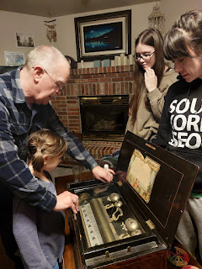

Benson hung out for a loooonnnng time on the floor with Nellie and the other cousins. They laughed and talked and laughed and played games for a good long while.

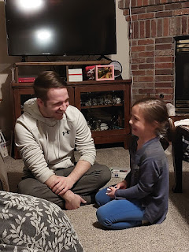

Anna Price, another granddaughter who was born with several disabilities but who also overcame them and is just an amazing and super bright young lady, enjoyed hanging out with me for the evening. :)

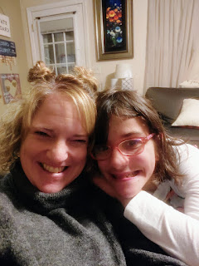

After dinner and dessert and all the visiting, Benson and I drove back to Mountain Home so I could drop him off for the night. We listened to some 80's music on our drive and sang a few of the songs together.

My wonderful friends, Jeff and Sherry Haines, are also in the Boise area now. They live about 20 minutes away from Mike and Carol, which is a lot closer than Italy. Jeff needed to pick up some prescriptions on the base (he is former Air Force), so we arranged for them to stop by and meet Benson on Friday.

Jeff Haines, Benson, Me, and Sherry Haines

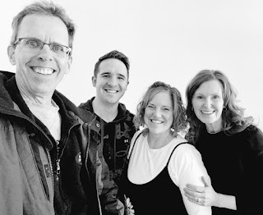

Then, on Saturday, I drove to their new house in Meridian, where we sat and visited for a couple hours. Sherry made some taco soup, which was super yummy, and I got to meet her older sister, Sandy, as she joined us for the meal.

Sherry and me . . .

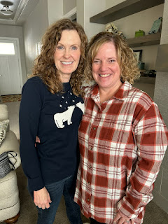

Sherry had brought home some beautiful pottery from Poland, which she used for our soup.

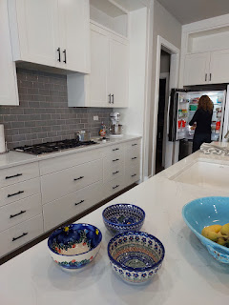

I love their open floor plan and how everything just flows and blends so nicely.



On Monday, I drove all the way home to Idaho Falls, stopping in Mountain Home one more time to help Benson finish building that big ol' bed. It was a really wonderful weekend and I'm so glad I was able to go. I have carpal tunnal issues in my forearms and it really flares up when I drive, but it was all so worth it. I just took some Advil and used my massage drill every day to beat that pain out of my arms, ha ha. I wouldn't have traded those experiences for the world.

The drive home was uneventful. It sprinkled a little here and there, but the roads were clear, thankfully.

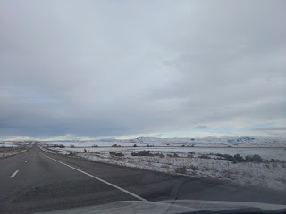

I listened to this audiobook the whole drive home. I'm not quite done, so I will continue the rest as I drive back and forth to Rigby this coming week. It has been incredibly enlightening!!



The author is in the Math Department at BYU-Idaho and I met her several years ago when Scott was hired as a professor there for three years as a visiting faculty. What an amazing background Sahar has: She was born very close to Bethlehem, in a place called Beit Sahour. She tells how legend has it that when the angel appeared to the shepherds at the time of Jesus' birth, it took place in Beit Sahour. She received a bachelor's degree in mathematics from Bethlehem University, a master's degree in statistics from BYU (Provo), and then a PhD in statistics from the Middle East Technical University in Ankara, Turkey.

She tells of her own experiences growing up as a Palestinian Arab in Israel, with all the turmoil and persecution they have endured for decades. She was born the same year as me (1971). She gives background stories on her grandparents, some of which made me cry. I hope and wish that someday, in the not-too-distant future, that the Palestinians can have their own land and not be attacked or jailed or have their freedoms reduced to nothing. I hope they can receive a sense of identity and be allowed to fly a flag that represents a place to call their own. Side note: I do not subscribe to terrorists and extremists, but I also understand that sometimes people are driven to breaking points over time and that God will be the ultimate Judge.

I only made one quick stop on the way home to use the bathroom and to stretch my legs for a few. I walked around the parking lot at the rest stop and enjoyed the snowy views of the mountains and the Snake River off in the distance.

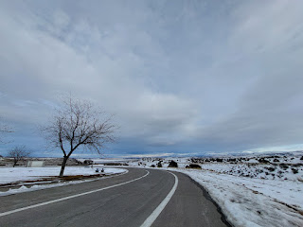

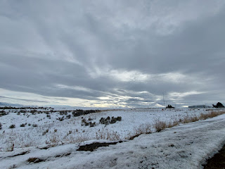

For my lunch on the way home, I stopped at a Wendy's. I ordered a chicken sandwich with a lettuce wrap instead of the typical hamburger buns, along with a cup that I could fill with whatever I chose at the soda machine. I picked a couple flavors of Coke Zero and filled up my cup for the drive, only to notice once I got inside the car that it looked like I had murdered someone . . .

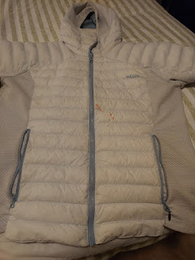



The red dye in the Coke Zero had somehow splattered all over my jacket as I filled up my cup. I could hardly wait to get home so I could try to figure out how to get those terrible stains out . . .

Oxy Clean to the rescue!! I sprayed some of the stain remover all over the red splatters and threw it into the washing machine. I am happy to report that all is well. My jacket is as good as new. I am so happy.

Have a great week! XOXO

