I Guess Covid is Still a Thing
I thought for sure that after all this time, maybe Covid had diminished in potency to be nothing more than just a feeble cold. And for some people, maybe they are lucky enough to experience just that. But not me. Not this time.
After being sick for an entire week just two weeks ago, I thought I had "served my time", and that I didn't need to worry again. But after just one week of feeling good, I got hit again. Monday and Tuesday I only had a scratchy throat - with no other symptoms. But when I woke up Wednesday morning, I was down for the count. I had a runny nose, lots of congestion, and a cough. I felt like garbage. Thursday, more of the same, but with more coughing. I went through too many boxes of tissues to count. Thankfully, I had stocked up at Sam's Club recently, and still have plenty of extra boxes down in my storage room.

I used everything I had on hand: cough drops, decongestant medicine, herbal tea, my inhaler, warm foods, cold foods, soups, more canned peaches from my basement, and had my diffuser set up next to me wherever I was at all times.

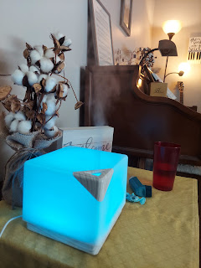

Friday, my face was a little less congested, but I still had that annoying cough. The kind of cough that you hope you don't throw up from coughing so much. My inhaler was only working for about an hour each time I used it, but I didn't want to overuse something like that. Friday night, I cried out of frustration when I couldn't go to sleep from all the coughing. But tears don't help in a situation like that. When you cry, you cause more drainage, which then causes more coughing. I was feeling a bit hopeless . . . but eventually after a heartfelt prayer, I was able to settle down and get to sleep. I slept really well, which was quite a miracle. And when I woke up, I decided to go to the doctor and see if there was something he could do to help me.

As it turned out, I tested positive for Covid. This was my second time to get an official diagnosis, but I gained an important perspective. Now, I understand more about how my body reacts with Covid and in the future I will be more able to recognize the symptoms of Covid for myself. Both times that I tested positive, I needed an inhaler and a steroid to help with all the coughing. And when I look back to what I experienced in December when I was in Italy, I'm 99.9% sure I had Covid then, too. I had very similar symptoms and I needed a steroid on top of my inhaler then, too.

I've had 4 rounds of Pfizer immunizations for Covid, and I do believe they have helped prevent far worse symptoms in the times that I've gotten sick. I can't even imagine what it would have been like if I had never gotten immunized. I probably would have landed in the hospital . . .

But the GOOD NEWS is that the steroid has helped tremendously since yesterday (Saturday) and I am feeling MUCH BETTER today (Sunday). What a huge relief!! I am so grateful for modern medicine and technology and capabilities. We are so blessed to live in this era of time. :)

BESIDES BEING SICK . . .

Monday:
I got my teeth cleaned at the dentist and NO CAVITIES. Hooray! I also got a new dryer for my laundry room, thanks to a good friend from church. Stephen Blatter and his son, Brad, came over in the morning to remove the old one and tuck it into the garage temporarily.

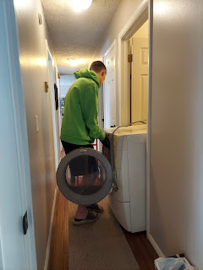

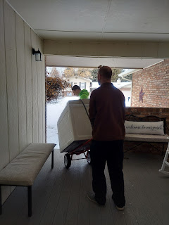

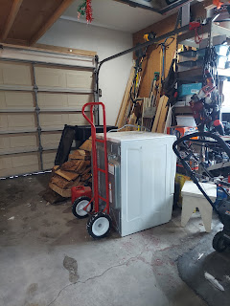

Later, in the afternoon, we drove across town to pick up the new one and bring it back to my house. Stephen wisely wanted to hold onto the old dryer just in case the new one had a cord that didn't fit into my outlet. He was spot on! I didn't know this was a thing, but a lot of people grab the old cord to use on a newer appliance because it fits into their outlet, and it's less hassle than to change out the outlet. The dryer we picked up on Facebook Marketplace didn't even come with a cord, ha ha. So we grabbed the one off the old one and used that instead. All is well.

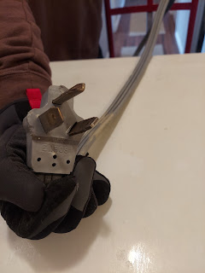

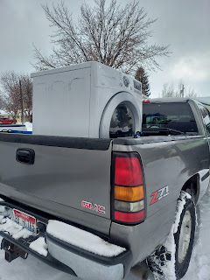

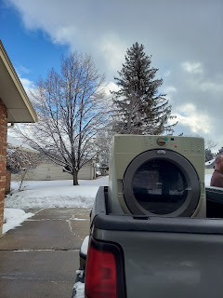

While Stephen and Brad took care of the dryer, I went outside and shoveled all the snow off my driveway and Ellen's next door.

In between all the comings and goings for the dryer installation, I finished up my Rawles family blog and got it launched. It's always such a huge undertaking, but I know it's for such a good reason and that's why I keep doing it. Not only did I get the blog published on Monday, but I had to print out 40 letters to mail - directing family members TO the blog, fold those letters and stuff the envelopes, stamp them and mail them off. I also emailed about 50+ other family members that I had an email address for, with the same welcome letter, directing them TO the blog. I also printed out the entire 22 page blog for my cousin, Valorie, who doesn't have any internet or computer capabilities, and mailed it all to her.

Here is the link to the latest Rawles Family Blog, in case you are interested:
RawlesRoots7.blogspot.com

By dinner time, I was starving. I had only had some cereal for breakfast and a piece of toast for lunch, and that was it for the entire day. So I grabbed a shredded pork salad from Cafe Rio and I ate the ENTIRE THING!!

Short video of the lady using the tortilla press at Cafe Rio - I wish I had one of these!: (22 seconds)
https://photos.app.goo.gl/pSRjKNVt6U9QsX9s9

Once my tummy was happy, I started cleaning up from the busy day. Being upright certainly helped since my tummy was a little TOO full, ha ha. I swept the floors and mopped them to clean up after all the footprints we tracked in and out due to the freshly fallen snow outside. I used Clorox wipes to clean the new dryer, inside and out, and then sat back to admire . . .

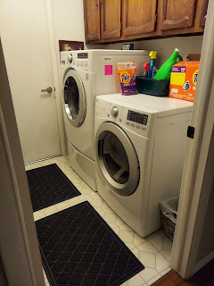

Tuesday:
I got up early to clear even MORE SNOW that had fallen during the night. And then I drove across town to meet my friend, ReNae Cunningham, at the temple to do some work for those family members who had just received their baptisms the week before. Even though my throat was scratchy, I felt just fine, so off I went.

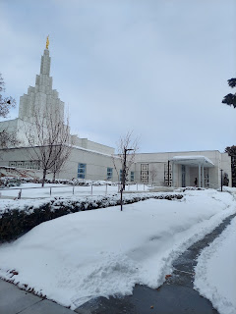

Afterwards, I hurried home and showered, ate a little snack, then drove up to Rigby to pick up Coy and Phil, my in-laws, to take them to the Rexburg Temple. I was so excited to go to the temple WITH them - it had been years since we had all gone together. And what a lovely time we had. Mom was dealing with some sciatica issues in her left leg, but she was a trooper and made it through the entire session in one piece.

The wind was blowing something fierce that day, and man it was COLD. But I somehow convinced Mom and Dad to pose for just a moment outside the temple doors, where they were somewhat sheltered from the blasting wind, long enough to take a picture of them together. They are SO CUTE!



They took me with them to eat a late lunch at the local Applebees and we had a nice visit over a tasty meal. Once I got them safely home (and myself as well), I decided to forego my earlier ambition of clearing more snow outside and just relax inside instead. I had been going and going and going and now I felt like I should just slow it down and rest at this point. So I did.

Wednesday:
Sick.

Thursday:
More sick. But also RootsTech began!! This is the largest worldwide family history conference in the world and I absolutely love it each year. I watched a little bit of it in the morning and did some of my own research in the afternoon.

Jordin Sparks was a keynote speaker, even though it was more like an onstage interview with the emcee. She is such a beautiful human being in so many ways. I remember when she won American Idol several years ago, as well. She is still the youngest winner out of all the seasons of American Idol. She sang 3 songs onstage, intermingled with her interview at RootsTech. She has such a pretty voice. Here is the link to a song she shared on Thursday, because she really connected to the role she played in the Broadway musical, "In the Heights", since she had just become a new mother herself.

Video of Jordin Sparks singing "She Used to be Mine": on YouTube
https://www.youtube.com/watch?v=hgYilXyMHp0&ab_channel=Speezyland

I also had a 20 minute online consultation on Zoom with a professional genealogist that I had scheduled in advance. I didn't want to miss out on that just because I was sick, and it was free, so I did it anyway. She gave me some good tips about what to do to help me advance in my Snider family history work. I have been following through on her advice these past few days. Crossing fingers that I can figure out soon where my Snider ancestors came from before they arrived in the U.S. . . .

When I went to bed Thursday night, I prayed tearfully to be blessed enough to be able to get my bloodwork done the following morning. I was supposed to get it done one week before I leave the country, and I had intended to do it Wednesday morning . . . and then Thursday morning . . . and now Friday morning was the last possible option left.

Friday:
When I woke up, I felt a little better. Enough, in fact, that I hopped right into the shower and then headed off to get my labwork done. I wore a mask and thankfully my nose and my cough cooperated enough to where I didn't raise any eyebrows. I had to go in fasting, so I couldn't take any medicines until after I could eat, so that was a worry for me. But I managed to get it all done and get home before my symptoms worsened. I feel like this was all in answer to my prayer. Like I had a little protective bubble over me, to lessen my symptoms just long enough to get this thing taken care of. I felt a huge relief that I was able to go.

I watched some of RootsTech again during the morning. Steve Rockwood, CEO of FamilySearch, shared this quote on the big screen:

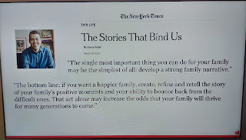

It's so true. Knowing who we are and where we come from really makes a difference in our lives today.

The keynote speaker for Friday was Sean Astin. You might recognize him from his role in Goonies, Rudy, or in Lord of the Rings. He shared some amazing personal stories that really touched my heart during his interview. You can watch the entire thing here:

https://www.familysearch.org/rootstech/session/main-stage-general-session-3

*Sean comes onto the stage at roughly 10 minutes in . . .

I also started watching Little House on the Prairie this week. I decided that after being consistently frustrated with some of the other shows I continually subject myself to, just to have some form of entertainment, it was time to make a better choice. I felt right at home, stitching lovingly on Abby's baptism dress, and watching a show from the late 1800's.

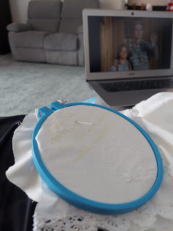

I particularly loved this one episode (Season 1, episode 4 "The Hundred Mile Walk") because it felt like it really applied to my life right now. Charles, the main character and father (played by Michael Landon), was so excited for their first harvest in their new home. The wheat was ready to be gathered and the anticipation of the money he would bring in was so joyful. They had worked so hard and now it was time to reap the rewards. But then an unexpected hailstorm came and destroyed all the crops. (or so he thought) Everyone was so devastated, and yet they knew as a community that the men would have to travel potentially a great distance to find work for a season so they could provide for their families during the next winter. So off he went.

He picked up a couple friends along the way and found work in a rock quarry about 50 miles away. He was gone for several months, doing back-breaking manual labor the entire time, but getting stronger all the while. Meanwhile, his wife back home (Caroline), had discovered that the wheat wasn't entirely lost, and could, in fact, be somewhat salvaged. She gathered several women from the area and explained that it wouldn't be easy or quick work, but it would be worth it in the end. They had to rake through the rubble and find the occasional stalk of wheat to gather into an eventual small bundle. They tied each bundle together and made stacks. Eventually they had to pound and thresh the wheat to loosen the grains, then gather up the grains and have it milled into wheat that was usable for baking. It was quite a process, but how amazing that they all worked together to salvage what they could. All was not lost.

The parallels that I found in my own life were that I was trying to do so much, and I felt so discouraged because I was sick. I felt like I wasn't going to be able to get things ready in time before I leave in a few days. But, in fact, I was still doing a little here and a little there, and I was making a small amount of progress. I just didn't realize it. I felt more hopeful because of this particular episode, and it helped me to see that all was not lost for me, either.

On the other side of the world, Scott - along with several other ward members - drove down to Rome to go to the temple there.

He called me during the drive down, and turned the camera around on the phone so I could see the roads and tunnels as we chatted.



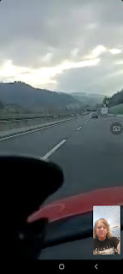

The beautiful Rome, Italy Temple



He stayed in the temple patron housing next to the temple, and his two bunkmates were Italians. A man in his 50s was from Sardinia and spoke no English. The other was in his 20's and was from Naples. He could speak some English, which was nice.

Scott mentioned how beautiful it was down south, and that everything was in bloom down there.

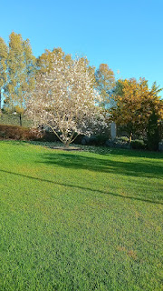

He also shared with me how much he absolutely loved the changes to the temple endowment session, calling it "life-changing" and beautiful. I'm so glad he could go, and that he also got home safely. It's a 5 hour drive each way.

Saturday:
Went to the doctor first thing in the morning. Spent two hours there . . . Picked up my prescriptions and noticed almost an immediate change once I took the steroid pills. My coughing went from almost constant to practically zilch . . . for the rest of the day! I was still blowing my nose, but not quite as often. I worked on Abby's baptism dress and finished the embroidery work. It looks so beautiful! Now I just need to secure the edges and sew the pocket lining back together and it will be all done. :)

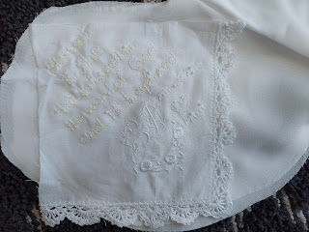

I keep having to cancel so many things lately because of all this sickness. One of the things I had to cancel was my pledge to help at the soup kitchen on Tuesday with some ladies from my ward at church. It just felt like it was too soon after a covid diagnosis to be out in such a public setting, but how disappointing. Assignments for our ward to help at the soup kitchen only come up a couple times a year, and this was one of those times. As I messaged my friend, Jen Anderson, to let her know I couldn't make it, and why, she offered to drop off some dinner to me that evening.

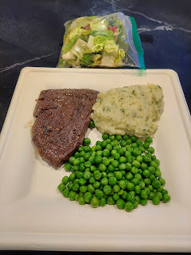

What a good friend. The food was delicious and really hit the spot. Doesn't it usually though? When someone else cooks it, it always seems to taste better, ha ha.

After I finished eating, I heard some commotion out front. I looked out and saw the Parkinsons clearing my driveway from another round of recent snow. She had called to check on me earlier and I told her that I had Covid. Ben brought the snowblower, while Kim and their younger son, William, got to work with shovels. They are such great neighbors and friends. :)

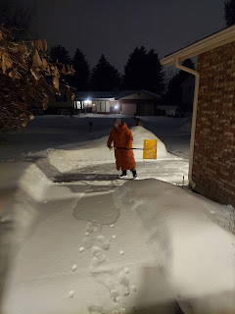

My Sweet Grandchildren . . .

I just learned that Avery is now WALKING!!! Omigosh that's so exciting!! We're gonna have a video chat this week, and I'll find out all the juicy details.

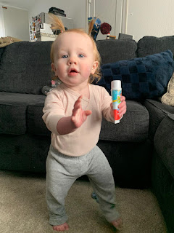

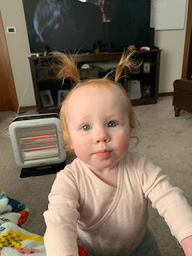

Making sad/grumpy faces together, LOL

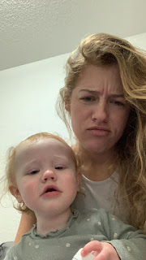

Jack looks more and more like his mother every day. Here is proof . . .

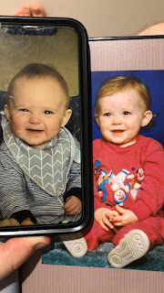

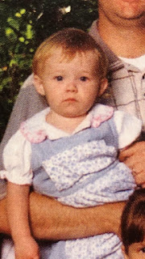

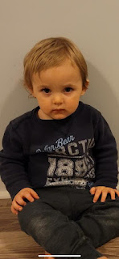

During a video call on Friday, Jack was doing some table dancing . . .

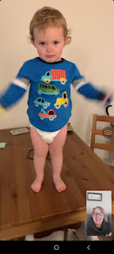

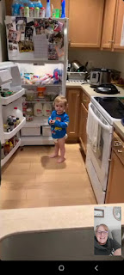

He is also starting to say some clear words now. In this next video, can you hear what his first thoughts are about when he wakes up in the morning?

Jack's morning concern: (32 seconds)
https://photos.app.goo.gl/NdQK8tpQ6pTWhiP5A

And here he is, writing in his little journal: (16 seconds)
https://photos.app.goo.gl/wMaQruVswXoKrMiH8

Amber and her family had a little scare in the middle of the week down South. With all the crazy weather across the country, they had a tornado warning and had to take shelter in the middle of the night . . . .

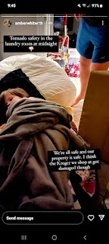

All turned out well, thankfully.

Amber shared this cute photo of Gwennie this week. She explained: "I forgot to dress Gwen up for Dr. Seuss's birthday but it looks like she's having fun anyway. Yesterday she brought me "One Fish Two Fish Red Fish Blue Fish" and said, "Hey Mom, did you know this was written by Theodore Seuss Geisel?"

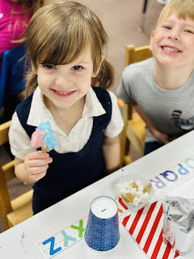

Soon, I will be reunited with this handsome guy. I can't wait! (He was giving me a video tour of all of the stuff I left behind in Italy so I can know what to pack this week.)

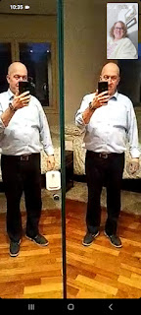

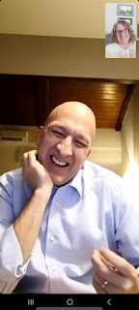

And finally, someday I will make this and place it proudly on display.

