I Never Met a Sunset That I Didn't Like
I think I already mentioned this last week, but we have had the most magical and beautiful sunsets every single night lately! It's really quite astounding that we've had so many. I've even started to look forward to each sunrise and sunset now, because each morning around 7:15 or so and every evening around 5:00 or so, the sky is painted all sorts of brilliant colors. I just love it!!
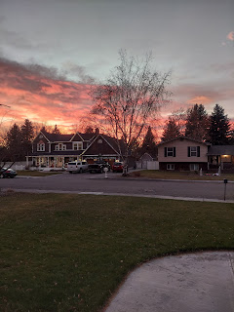

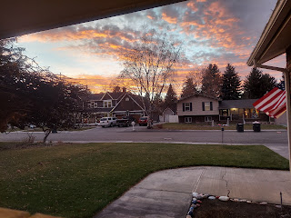

The past week has been a good one. A little slower for the most part, and yet I've gotten a lot done in that time.

Monday:
I went grocery shopping and happened to park right next to this beautiful motorcycle.

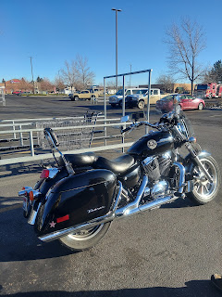

Then I ran into its owner, who happened to be Jasmine's dad!! He had finally reached a financial settlement from an accident he was in a few years ago (he got hit by someone else - and badly too), and had always wanted a bike apparently. So, he found this beauty for a great price! We visited for a bit, then hugged goodbye and off I went to get my groceries. I was able to catch up with Jasmine the following day as well. She is working hard down in Utah, splitting her time between 2 jobs and trying to be a mom to 3 year old Luke, too. Her husband, Brandon, cannot work full time due to his epilepsy condition, but he is receiving very good medical care down there and hopes to gradually improve his overall health with the brain implant that he got this fall. I hope it all works out for them because they deserve it!

With fresh vegetables from the store, I was able to put together a tasty dinner Monday evening. Sautéed shrimp over spaghetti squash and spinach, alongside roasted butternut squash and sweet potatoes, as well as another round of roasted Brussels sprouts. Yum!

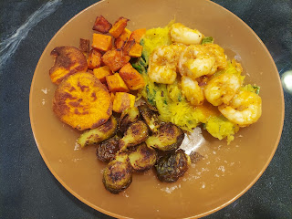

I went to Hobby Lobby to get 3 photo frames. I found what I came for right away, but then the whole rest of the store was staring at me. I sent Amber this photo with the text: "Don't get distracted. Stay focused!" She knew instantly that I was in Hobby Lobby. :):):)

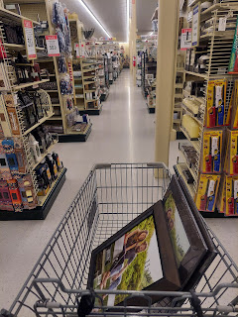

I'm happy to report that I got out of the store soon after, with just the 3 frames. Nothing else. Whew! That was a big accomplishment. :)

Tuesday:
Jack started out the day by reading and studying all the ingredients for his favorite snack.

Click here to watch: (5 seconds)
https://photos.app.goo.gl/3z1x2UrWML3s18Eb9

I started out my day by having a Young Women's presidency meeting for about 2.5 hours. :) We did get a LOT accomplished, by the way.

Later in the afternoon I had a much-needed video chat with Chelsea in Denver.

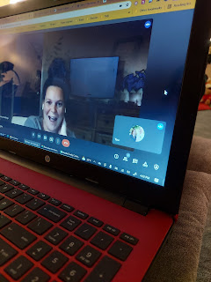

It lasted almost 2 hours! But we got caught up on a lot of things, including her (sort of) new job as an admissions counselor for a coding university. What is coding, you ask? Well, you'll have to look it up because I don't know that I can explain it very well. It's basically a mathematical computer language that allows you to write programs for all sorts of things. At the university where she works, they teach a variety of coding for both the "front end" and the "back end".

As Jacob and I were messaging back and forth, he explained it all to me in a much better way. Here are his words:

"Front end in a general sense means what the end user sees. Like if the business was a restaurant, "front end" would be the greeters, menu, wait staff, etc.

"Back end in a general sense is where the storage and computing happen. So in that analogy, "back end" would be the kitchen and ingredients delivery people.

"So for a website example, churchofjesuschrist.org's front end team would be designing the apps you can click on and making sure it looks good, is user friendly, and all the clicks and drags and user inputs function correctly. The back end team would handle all the data storage of usernames and passwords and providing the computations to make the website run quickly and efficiently and protect it from hacking."

So there you go! Chelsea really enjoys her job, too, which is wonderful! :)

After a quick dinner, I ran off to our young women activity, which was at Megan's house this time. We each made a Christmas ornament, either with wood burning tools, or we made a string art ornament. I chose the string art - which begins by choosing a pattern and taping it onto a piece of wood, tapping in several nails in strategic spots on the pattern, and then wrapping string back and forth in an organized fashion to create a very visually appealing finished product!

Allie and I worked on our string art together.

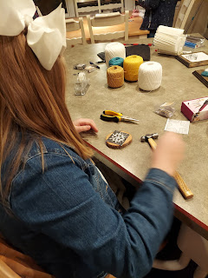

Charlie made an amazing ornament with some extremely intricate wood burning skills.

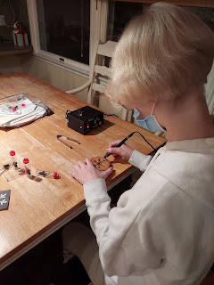

Our finished ornaments: Mercedes, Allie, me, Charlie, and Sophia

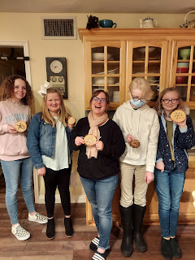

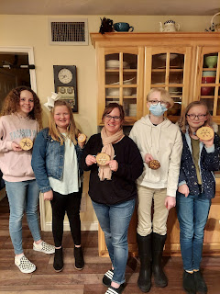

Linnea was very patient as she carefully created her wood-burned ornament, while Brielle was there for moral support. :)

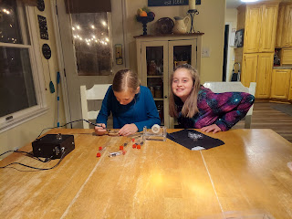

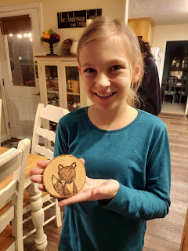

Here is my finished ornament. Don't look too closely, ha ha. I have some creative ideas for what to do next time . . .

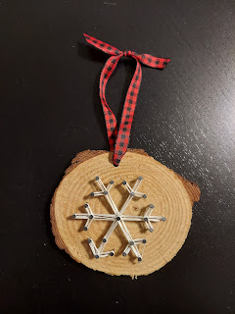

Wednesday:
I put my brain to work first thing in the morning by creating an organized map for when we take the youth Christmas caroling this coming Tuesday night. We have a list of homes we would like to visit, but they needed to be organized into a fluid route since we will have 1-2 trailers full of teenagers sitting on bales of hay. It's not very easy to turn around when you're pulling a trailer! I shared the route map with our YW president and also with the Bishop.

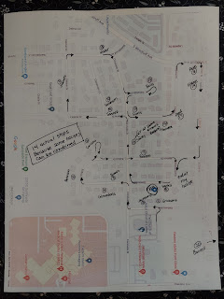

Then I set to work making my December cupcakes. I knew I wanted to get them done early this month, but we also had some appointments set up that afternoon with some of the new girls that will join our class in January. I thought it would be nice to give them a cupcake as we went to visit them for the first time.

After the chocolate cupcakes were baked and sufficiently cooled, I prepared for the accessories.

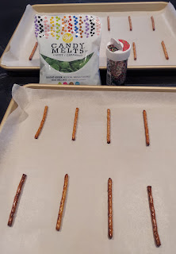



I always copycat something from the internet. I'm really not that creative on my own . . . I mean, let's be honest here. They sure turned out festive though!

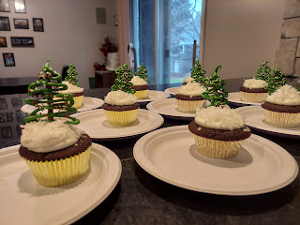

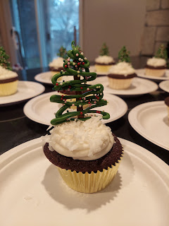

This is the quote I printed for each girl.

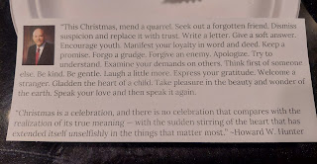

After several appointments back to back, Scott and I went over to help a family in our ward. They were moving from one apartment in their complex to a bigger apartment within the same complex. But they needed a few things hauled to the dump.

We loaded a rocking chair, an old mini deep freezer, and a bunk bed into the back of our truck and hauled them away. Here's Scott acting like he's the Hulk . . .

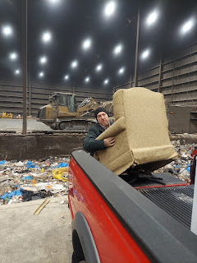

Once the items were dumped, we drove down the street to a nearby Fiesta Ole. I used to take our kids here pretty often when they were little. Not much has changed in all these years! It looked a little more sparse with the seating options, and it was quite run down and looked like zero renovations had been made in the past 15 years. Sadly, the food took about 20-25 minutes to be prepared for us as well. We only ordered one small burrito each. Even though it was fun when the kids were little, I probably won't go here again in the near future.

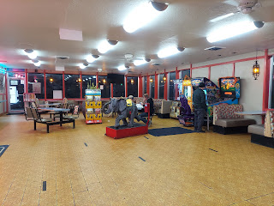

I squeezed in one more YW visit, with a couple girls from my class presidency, and then I was done running around for the night.

Here are a couple funny videos that I saved from Tik Tok at the end of the day.

Mission Impossible Baby: (19 seconds)
https://photos.app.goo.gl/PFv6fGLod2ePRUui8

A dad cleaning the house w/ lightning speed: (35 seconds)
https://photos.app.goo.gl/2kXcFj45AjwbESMs9

Thursday:
Jack had some impressive soprano singing to share with the family.

Click here to watch: (20 seconds)
https://photos.app.goo.gl/WzLGsJhPCkHntgVN9

I started out bright and early with a physical therapy appointment at 8:00 a.m. They told me to arrive 10 minutes early, which I did, but the door was locked. (LOL) I had to call them from outside in the cold to come unlock the door. They are pretty sure I have plantar fasciitis in my left foot, although it's a vague condition to diagnose. So we're going to treat it as though I have P.F. for 2 weeks. If the symptoms improve, then great. If they don't improve, then we move on to something else.

Next, I went to get my hair cut. I always love visiting with Tessa as she cuts my hair. She is a good person and has a good heart.

After I got home and could shower and get dressed, I took the truck over to the same family in my ward who are moving. They needed me to pick up a desk at Deseret Industries and bring it over so we could place it in the new apartment. Only WOW - that thing was HEAVY!! We had to call an extra body over to help us carry it, and we still struggled quite a bit. It was quite the chore to get it inside because it didn't fit into the front entryway, due to the layout. So we had to carry it all the way around the building to the back entrance and barely got it in through the sliding glass door. It wouldn't fit into the bedroom either, but after tinkering with some screws on the desk feet and also taking the bedroom door off, we FINALLY got that bad boy settled into its new home.

This photo does not properly show how long the desk truly was, NOR how ridiculously heavy it was. My forearms still hurt 2 days later from hefting it all that way. But I'm glad I could be there to help a friend out. :)

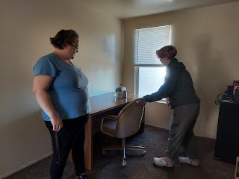

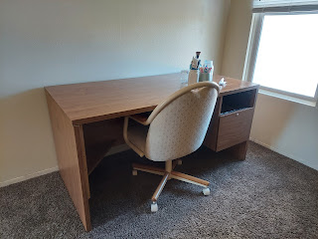

I got this photo of Avery while in the middle of moving that desk. I bet she would be a whole lot easier to carry.

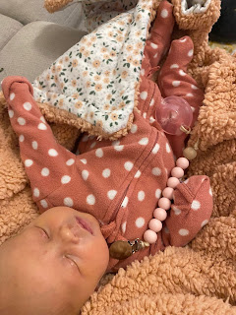

Also in the middle of trying to unload the desk from the truck, I spoke to my mother-in-law, Coy. She had called me with a couple of questions earlier that morning, but I noticed that she didn't sound very well. She was at the doctor's office when she first called, so my worry-o-meter jumped up right away. I messaged Scott at school to let him know that something was up, but I didn't know exactly what. She had been filling out paperwork, thus the questions for me that morning, but she didn't have time then to explain why she was at the doctor's office to begin with.

So Scott messaged his sister, Bev, to see if she knew anything. She didn't. So we made plans to go up to Rigby after Scott got home from school so we could check on her and see if she was alright. She was. :)

When we arrived at their house, she was downstairs happily playing the organ.

Click here to see her cute little fingers and feet at work: (24 seconds)
https://photos.app.goo.gl/BxXVLz2ssLcGgXVaA

Turns out that her croaky throat had been croaky for a few days by that point, and yet she felt just fine. However, she does have a surgery scheduled for Dec. 17th to repair a hernia that is being unruly. Well, now that we had the reassurances that we needed as to her immediate health and wellness, we could sit back and just visit for a while, which we did.

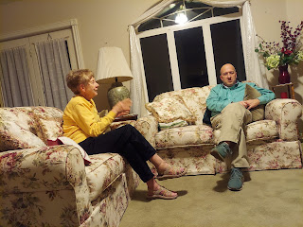

Eventually, it was time to come home and tuck ourselves into bed, which we did.

Friday:
I focused on getting caught up around the house for most of the day. I was able to get one way tickets for our trip to Cancun for our 30th anniversary (next summer). I know that sounds funny, and how I wish I could just retire to Cozumel and live happily ever after, ha ha. But strangely, the tickets were cheap to get
down there
, but ridiculously overpriced to try to come home. So for now, we just bought tickets to get there and we'll figure something else out at some point as to how to get home.

I did some laundry, including our washing our bedding, cleaned the kitchen, swept, worked on a computer project, etc. It felt really good to just be at home doing stuff.



While I tinkered around, cleaning and organizing, I talked to my friend, Jenn, (in CA) for a couple of hours. She is great to talk with about any kind of deep stuff. We can just jump right in and talk about Jesus, or the state of the world, or worries and concerns that we have. She is such a good person and has such good intentions in everything she does.

I also spoke with our family friend, Stephanie, who grew up with our daughter, Amber. We talked for about 45 minutes about the Afghan evacuees that she's been helping and working with for the past few months. Wow, she is doing some amazing work down in New Mexico on their Air Force base. We are hoping to swing through there on our way home from Louisiana for Christmas, and see firsthand how they are helping the evacuees there, and maybe even get to meet some of them and serve them somehow.

I also got one more photo of sweet Avery this week. I assume she is doing well, based on how round her little cheeks are. She has strawberry blonde hair, too, which is simply darling.



Saturday:
Jack shared his happy little smiley face with us to start the day.

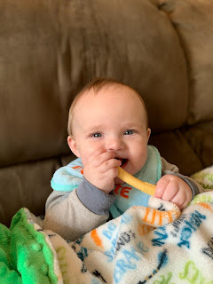

While Scott had Army in Pocatello for the weekend, I worked on several misc. projects around the house again. One of the bigger projects I'm working on is to take 14 of my blog posts from the past year and a half and turn it all into a book. The idea came after I spoke to my cousin Valorie last weekend. She is 80 years old, and even though her mind is sharp as a whip, her body is failing and won't allow her to travel. She doesn't have the internet at her house either, but she LOVES writing letters back and forth with me on a regular basis and she REALLY loves when I share details about my trips and my family history research. So, with Scott's help, we are formatting all the travel blog posts and will be putting them into a book form. I will send one to her, and keep a copy for myself. It will be time consuming and tedious work, but it will be oh so worth it!

Jacob and Hannah took Jack to see the lighted Christmas parade on the Potomac River last night. It looked really fun!





They even sent a picture of Santa "tubing" behind a boat! The photo didn't turn out well enough to post here, but just picture that adventurous Santa for yourself. :)

Jack is getting really good at scooting around. Here is a video from yesterday (Saturday). It's super cute because you can tell he's working really hard, but he stops to lay his head down for multiple rest periods along the way. So precious.

Watch him here: (1 min, 4 sec)
https://photos.app.goo.gl/frMMhSHB49wP7FWWA

After Scott got home from Pocatello, we made a Bacon Cheddar Cauliflower Chowder, and then we watched the evening session of stake conference. Our visiting general authority was Elder Benjamin DeHoyos. He is a very sweet man, with a very thick Spanish accent, having grown up in Monterrey, Mexico. We enjoyed listening to the spiritual messages together downstairs, all cozied up in our blankies.

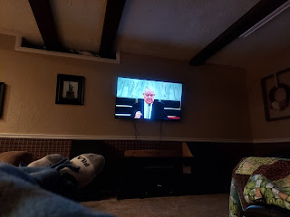

Last, but not least, I joined the Tik Tok revolution this week. Yes, there are some videos that I'd rather not see, but I am learning very quickly how to steer away from them. As I "heart" the ones I like, the app is rapidly figuring out what kinds of videos to show me. :) (clean humor, funny children videos, dance videos, fun food ideas, etc.)

Here are a few of my favorites so far.

Video #1: (1 min, 4 sec) How to make peppermint hot cocoa cups (to stir and melt into your hot water)
https://photos.app.goo.gl/7T8yktQM4fMF7hAQA

Video #2: (1 min, 4 sec) Setting up 300 drones to create a Christmas light show in the sky
https://photos.app.goo.gl/52Axk611sLCxDcqe6

Video #3: (13 seconds) Normal people sneezing
vs
Dads
https://photos.app.goo.gl/QjP2H68fyStxu5ZZ7

Video #4: (25 seconds) A brilliant way to make a breakfast sandwich
https://photos.app.goo.gl/UNhrZTDGfGrjoiJP7

Video #5: (20 seconds) If people could slide along everywhere instead of walking
https://photos.app.goo.gl/mbmpfxDhGYGmf7L38

