It's Carnivore Season
Not only is it summertime, but it's been a week full of celebrations for the birth of our nation. Plus, I just did the math and in 4 years' time we will celebrate America's 250th anniversary!! That will be a whopper and a humdinger of fireworks, barbecues, and family gatherings to come . . . I can't wait!!
To celebrate our nation's 246th birthday this week, I went with my good friend, Barb Vance, to our local July 4th Parade in the morning. Her daughter, Abi (dark shirt) and friend, Jessie Larsen, came with us as well.

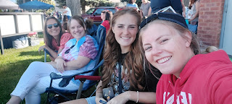

Barb and I rode in the back seat of their Jeep, so that the cool kids could have the front. :)

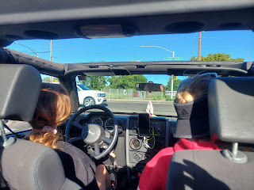

After a few fly-overs by a trio of Air Force jets, the parade began. There were 120 entries in all, but it only took about 90 minutes for the parade to be complete. We were comfortable in the shade with our camp chairs, occasionally getting some candy thrown our way.

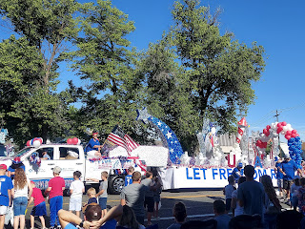

The theme for this year's parade was "Let Freedom Ring". I thought the floats were festive and well decorated, and I enjoyed being there very much.

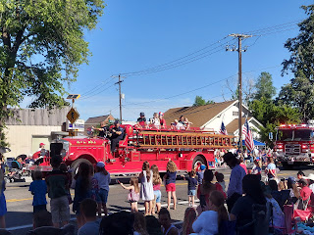

We saw old fashioned fire trucks, as well as the current rodeo queens and princesses.

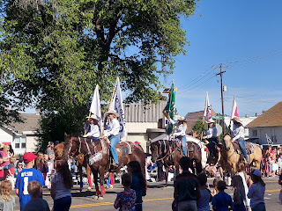

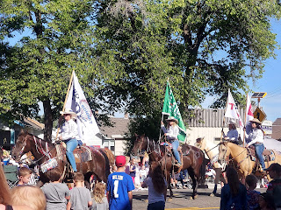

I liked the beautiful decor on this next float, but I wasn't sure what "Stand up for Idaho" meant. Something tells me it might be linked to a political stance . . . but I still liked the float.

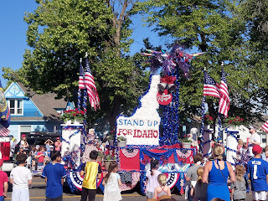

I ALWAYS love the marching bands - I think they are my favorite part of any parade!! My secret dream when I was growing up was to be a DRUMMER . . . I haven't fully realized this dream of mine yet, but it's not exactly dead either . . .

Video of the Idaho Falls HS marching band and student body float: (31 seconds)

https://photos.app.goo.gl/iVZF1V6mVMQK8bDU6

Video of the Skyline HS marching band & cheerleaders: (47 seconds)
https://photos.app.goo.gl/QGXXscKMXxkKXh9V7

(Skyline HS is the school where Scott has been teaching for the past couple of years before he left for Italy - it's also his favorite of all the area high schools where he's taught so far)

And if you're from Idaho, ya gotta have a tractor or two in the parade!! This short clip was hilarious because I happened to catch the driver revving up his engine - and it was quite loud - and you can see several spectators JUMP because it surprised them so much! :)

Tractor video: (9 seconds)
https://photos.app.goo.gl/kLMKDi3hAuZCAEHa7

Once the parade was finished, and after I got home, I was able to connect with Scott over a video call.

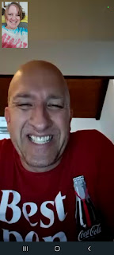

I was grateful that I went to the parade because I had been feeling a little disconnected from everything, ever since I got home from Italy. I didn't feel like I "belonged", even though that might be too strong of a word. I felt like I was on the outside, looking in . . . I wasn't sure how to celebrate the 4th of July or who to celebrate it with. Most people are with their families, barbecuing, swimming, playing games, maybe even camping together. I felt like I had somehow abandoned all of my military friends (and Scott) back in Italy and that I should be back over there with them. So yeah, it felt weird.

I knew that I didn't want to stay up late to watch the fireworks this year, since I was still trying to fix my nightly sleeping issues. But that simple choice to attend the parade really helped my morale and helped me truly connect to the holiday. I went over to my friend Jen's house for a BBQ dinner at 5:30 and they always make me feel like I'm part of their family. It was a great way to wrap up the day!

This is a photo that I took last year from our amazing location along the Snake River in Idaho Falls. Charmaine and (her) Scott flew up to stay with us for a few days and we all had a wonderful time!



I do really truly appreciate the significance of the 4th of July. I am infinitely patriotic and am easily moved to tears each year as I attend Independence Day activities. This year was different, but still a good one.

The rest of the week was a blur of getting groceries and supplies for Girls Camp, and cooking a TON of meats relating to it, as well. I have spent about $700 of my own money just on camp groceries this week - but I will be reimbursed 100% so that's nice. :)

Here are some snapshots of my week - the errands, the full carts, full trunks, and the cooking of so many MEATS!!

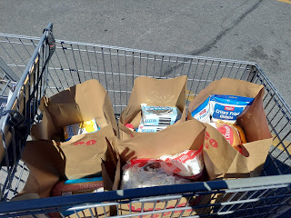

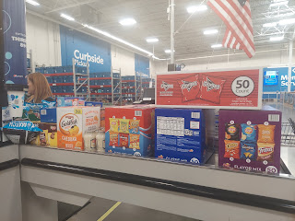

For the Carnivore Fest of 2022 (a.k.a. Girls Camp), I have cooked 15 lbs of taco meat, shredded 3 large rotisserie chickens, and then cooked 3 crockpots' worth of pulled pork (15 lbs).

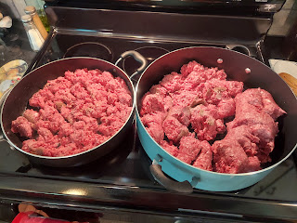

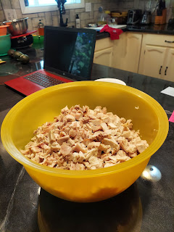

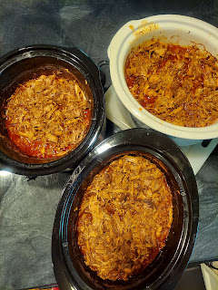

It's been a whirlwind of making messes, freezing all the pounds of meat, and then cleaning up after myself, ha ha. We cooked a total of 30 lbs of pulled pork, but another lady in our ward cooked the other 15 lbs of pork over at her house. (For which I am extremely grateful!)

I still have a LOOOONG list of things to do before Tuesday night, since we are leaving first thing Wednesday morning to drive up to Girls Camp. The camp we are using is a former boy scout camp, with all the amenities such as a lodge & kitchen, water, electricity, a small lake with canoes, etc. We will be sleeping in tents and I am bringing a cot to sleep on. The girls will be rotating around camp on Thursday, doing some outdoorsy activities such as archery, whittling with knives, and shooting BB guns and 22 rifles with some local certified gun experts, so that should be fun!

My job is to keep everyone's tummy happy and full. For 45 people. For 3 meals a day. No biggie, ha ha. I know I will have a fun time (because I always do), but right now I'm just looking forward to it all being over . . .

In the middle of all the prep work I've been doing, I found some time to be with friends and family this weekend. On Friday, I spent 4 hours with our friends, Rich & Andrea Garner, up in Rexburg. They have expressed an interest in coming to visit us in Italy this fall, so I went to their house to discuss details and find out what they would like to do when they come. Rich has had a lifelong dream of visiting Pompeii, so we are trying to figure out how to do that, since it's quite a long drive to get there. I don't know much about Pompeii either, so I'd like to learn more about the history of the area. It's about 2.5 hours south of Rome (maybe more like SE of Rome). We definitely want to visit Rome together and spend a couple days seeing some of the more famous sights, and we have a tentative plan to make a day-trip to Pompeii one of those days and then go back up to spend the night in Rome. They have a lot of homework to do to narrow down all the possibilities that they can reasonably fit into 10 days. We are just excited that they will be coming to stay with us!

While I was with the Garners, Jacob called on a group video call through WhatsApp. Scott was asleep already, but I joined in and so did Amber and Weston and the girls. Jack was eating his dinner at the table with Jacob and Hannah, and was very smiley.

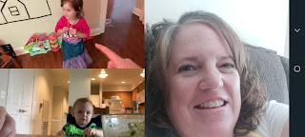

At one point, Abby came over to wave to Jack and say hello. When Jack waved back to her, it just melted Abby's heart! She is so enamored with her little cousin and it was so sweet to see her reaction. XOXO

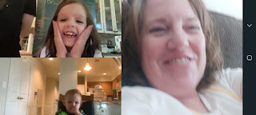

Scott's been working on a solution to keep the heat down in the upstairs bedroom over in Italy. First he bought a pop up canopy shade and anchored it underneath the paver stones that are on the rooftop terrace. But within 24 hours, a storm came up and ruined everything. The wind was trying to launch the shade canopy like a parachute, and even snapped one of the poles in half! So that idea was shot.

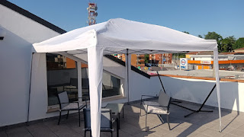

After some contemplating, he decided to affix some window tinting to the upstairs windows and terrace door. It looks like a mirror from the outside, and it has a shading effect from the inside. Here he is standing outside the terrace door, with a glass window the entire length of it.

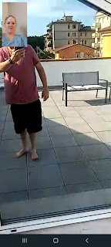

The biggest problem we were having with the upstairs bedroom windows is their shape. It's not a shape that you can easily hang blinds or even curtains . . . but the window tinting will work well and keep the heat down during these hot summer months.

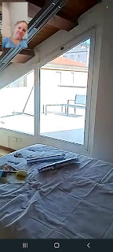

Saturday, I drove up to Rigby to spend the afternoon with Phil and Coy, along with Scott's oldest sister, Carol and her husband, Mike. Mike and Carol are visiting for the weekend from the Boise area. Coy texted me around the time I was ready to drive up there and told me she needed to get some groceries at Broulims, the main grocery store in Rigby. I offered to just meet her there, since I needed a few things myself!

We had a nice time caravanning around the store together, Mom, Carol, and me. :) I like to call it "Girls Day Out."

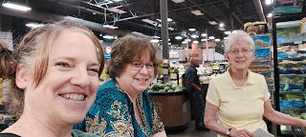

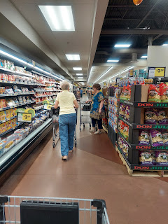

Back at their house, Mom made a chicken dinner using her air fryer (I need to get one of these). While she worked on a couple things in the kitchen, I read to her from the dining table out of the binder I just received a couple nights ago from my cousin, Cara Anstead, in CA.

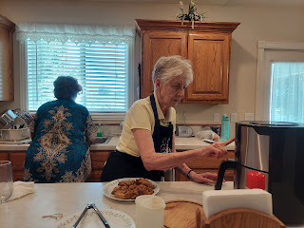

It's the biography of her mother, my great-aunt Polly. Polly is the older sister of my dad's mother, Grandma Zoe. And Polly isn't her real name. Her real name was Norma Rawles Frye, but according to the biography, there was an uncle who came to visit them from time to time and when he did, he'd take little Norma on his knee and bounce her around while singing, "Polly Wolly Doodle All the Day". Eventually, she became known as Polly. :)

It's been such a wonderful read so far . . . I am definitely getting to know my great grandparents, "Bob" Rawles and Kate Orr Rawles, through her writings. I love the STORIES about my ancestors just as much as I love seeing their photos. Through the stories, they come alive and I feel like I know them a little bit better.

We have fun in our family group chat on a regular basis. Sometimes photos like this just pop up with no explanation. (Jacob on the left, Benson on the right) (Probably taken around 2014)

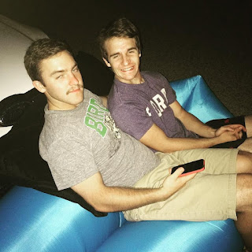

And then Jacob will respond simply by sending this:

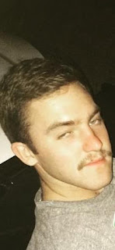

HA HA HA HA :)

We got some great pictures and video of Avery this week - she is sitting up on her own now. Hooray!!

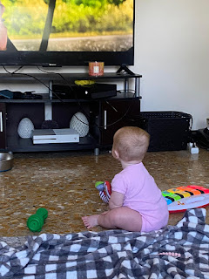

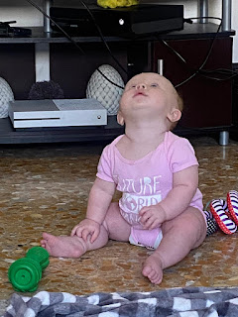

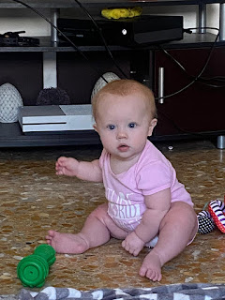

Video of Avery playing with an upright toy that I bought for her from the Bimbo Toy Store, ha ha:
(45 seconds)
https://photos.app.goo.gl/Hhj13eKYE1qQriwx9

And Jack got a few more immunizations this week, since he is 15 months old now. Jacob sent us this cute video compilation, entitled: "Scenes of a boy driven to madness waiting for his shots." ha ha

Jack video: (26 seconds)
https://photos.app.goo.gl/j2Y9rPH7gTqv6zpd8

This photo was taken the next day. When I inquired as to what was making Jack so sad, Jacob said Jack wasn't sad, he was just squinting from the bright sun. :)

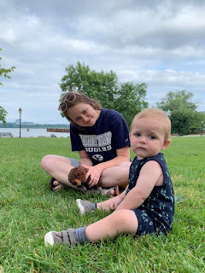

Jack was also helpful in cleaning their church building on Saturday.
Video: (6 seconds)
https://photos.app.goo.gl/XgTZcbcx95NYiEqYA

This video is one of my all time favorites of Jack - Jacob shared with us that Jack had been sitting out on the balcony watching the construction workers for most of the morning. I love his attention span and how intrigued he was with what was going on below. What a sweetheart.

Video: (13 seconds)
https://photos.app.goo.gl/sKtofbXkwnq1EdFU7

And here is a sweet photo of Gwennie, holding her precious pretzel bites and eating them up by the gallon.

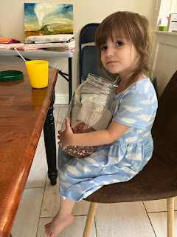

From what I hear, Amber and the girls are going to DRIVE up to Idaho before the end of the month and will visit us for a few days prior to their Whitworth Family Campout in Malad, Idaho. Hooray!! I'm so excited to see them again!!

Today in Relief Society class (for all the women 18+ in our church), we were discussing Elder Holland's recent conference talk, "Fear Not: Believe Only!" where he talks about hope - specifically where hope comes from (our Savior) and how to have hope in your life no matter the struggles you might be going through. There was a dear sister, a dear friend of mine, Aubrey, who shared something really personal at one point. She told us how when she was growing up, her parents placed much more emphasis on LOOKING good to everyone around them at church, rather than feeling good about their spiritual journey on the inside. As an adult, and particularly right now in her life, she is struggling with finding her own strong spiritual foundation and what that looks like. She admitted that it's hard for her, wondering what she can ask at church - in a public setting - and not worry about offending someone, or being judged for her concerns. It was very raw - the things she quietly shared in our class, and it really affected me deeply.

First, I was moved to great compassion and empathy for her, feeling a deep love for her and also having concerns that she's struggling so profoundly on the inside. It affected me for the rest of the class time, so much so that I didn't dare open my mouth to contribute in any way because I knew I would start crying.

One of the exercises that the teacher directed us to do at the beginning of class, was to spend 2 minutes writing down all the things we are grateful for. Then, after all the wonderful comments and content of the lesson, she asked us to do the same thing again - to write down a few more things that we are grateful for, over the course of 2 minutes.

My list in Round One was full of good things, things we commonly recognize as gifts in our life and things to be grateful for. But Round Two was quite different. Take a look at the last 5 things I wrote down.

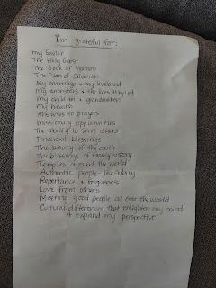

I was asked to say the closing prayer, and I knew it wasn't going to be easy.

As soon as I uttered the words, "Dear Heavenly Father . . .", I couldn't speak for a good 45 seconds. I was trying so hard not to burst into tears . . . It took me forever to speak the things that were in my heart: praying that we can be more mindful of those in our circle who are struggling with spiritual questions, that we can help them and love them and care for them on their difficult journeys, that we can love with a Christ-like love and be more in tune with others' needs, etc. I was literally weeping through most of the prayer.

As I tried to describe what happened to Scott on a phone call after church, I told him that I must have taken my responsibility of giving the closing prayer VERY seriously. Usually we have somewhat of a lighthearted prayer at the end of a class, asking for simple things like: please help us to go home in safety, please help us to remember the things that we have learned and to incorporate those things into our daily lives, etc. But this time, I had heavier things in my heart and I couldn't just gloss over them. It felt like I was pleading with the Savior and with our Heavenly Father on behalf of these sweet sisters in our ward and in our care, including Aubrey. Especially Aubrey. And because it came from such a deep space in my heart, I couldn't hold back the tears as I tried to utter the words out loud. It was very powerful . . .

As soon as the class ended, I made a beeline across the room and fell on Aubrey's shoulder, just weeping and weeping. I told her how much I love her, and how brave she was to share what she is going through right now. I showed her my gratitude list and how HER name was the first thing I wrote down when we were asked to add to our list of things we were thankful for in that second round. She cried with me and held onto me for a long time. THIS is what it means to bear one another's burdens, to mourn with those who mourn, and to have charity for one another. Charity is the pure love of Christ, and I definitely felt it today. I am so grateful that I could be in our Relief Society class today, to connect with my friend Aubrey, and to share my testimony through a heartfelt prayer, pleading with our Father to help us to help those whose heads hang down in despair.

Now if I can just keep my head up through the stress of the next few days, and have some positive experiences at Girls Camp, I will have had a successful week. And I will report on everything when I get back. :) XOXO

