Italian History, Flowers, and a New Book Project
First things first: I need to catch up on all the grandbabies!!
I don't have any new photos of
Avery
to share from the past week, but hopefully next week I will . . .

Jack Jack - -
he's turning into such a little boy now! I just love the expressions he has on his face.

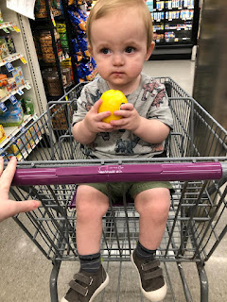



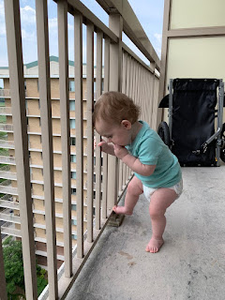

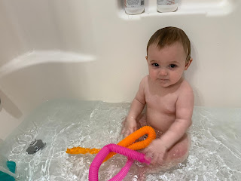

Short Video of His Royal Highness sleeping with his discerning sceptor poised and ready: (8 seconds)
https://photos.app.goo.gl/Nc7irHoN3iiVDAyd8

Abby - -
She just finished 1st grade on Friday!! Hooray!! Not only is she super smart and the best reader on the planet, but she is doing amazing things in the fashion industry as well. She says she wants to be a fashion designer when she grows up, and I can see she is well on her way. Way to go Abby!

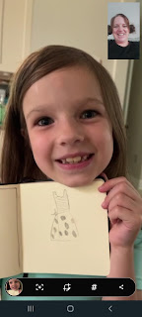

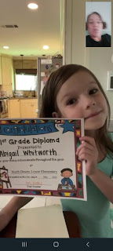

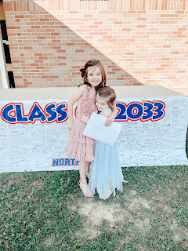

Abby's school had a special musical concert mid-week, and Amber enjoyed it so much! She got a little choked up hearing all the beautiful songs that the children sang, and it's easy to see why with this next video: (1 min, 24 sec) "Oh Mom, you're the bestest Mom!"

https://photos.app.goo.gl/Hx91hhZxAaBnPWo49

Also - Abby gave me this fantastic goofy grin last week . . .



Gwen - -
Gwen is being Gwen, no surprise there, ha ha. Amber wrote the following in our group chat: Invention idea - a large tube of stretchy fabric that I can put over Gwen to hold her arms down in a public restroom so she doesn't touch everything. "The Sanitary Swaddle". Scott responded, "She is just building her immunity." To which Amber replied, "The dirtier the restroom, the more likely she is to find something shiny behind the toilet tank."

Gwen also graduated from preschool this week! Hooray! She will start kindergarten in the fall and has become a very good student these past few months. She is also counting higher and higher now, getting all the way up to 69!!

Video: (20 seconds)
https://photos.app.goo.gl/QeHnTLRiCEMq4w4V8

Amber celebrated her 28th birthday on Wednesday!! I asked her to please take a photo with the girls kissing her cheeks and then share it with me. It turned out so darling!!! What cuties. All of them!!

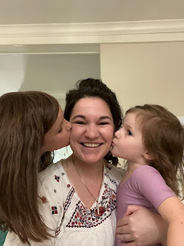

One more rewind: When we shared the photo of Scott in his new bishopric with our kids last Sunday, Jacob came back with "Are you guys the pepperoni 1st ward or 2nd ward?" LOL

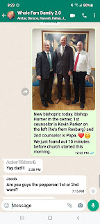

Monday:
We met up with some friends for dinner in the downtown area of Vicenza, an area that we had not been to yet. Wow, talk about some amazing history!!

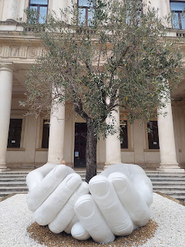

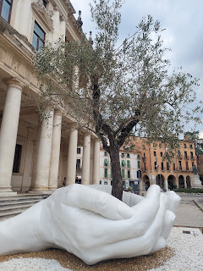

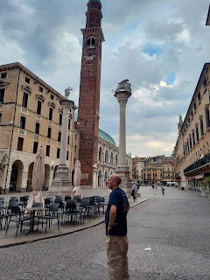

We walked around for quite a while trying to find a restaurant that was open on a Monday. Apparently, many restaurants are closed on Mondays around here. Sometimes Google was correct about which ones were open, but sometimes it was not . . . so we walked some more . . . at least it was beautiful!

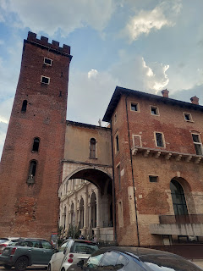

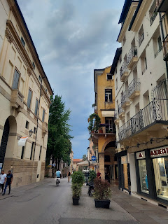

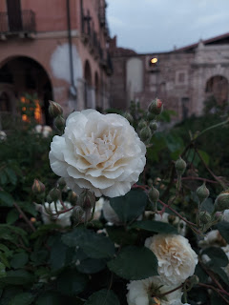

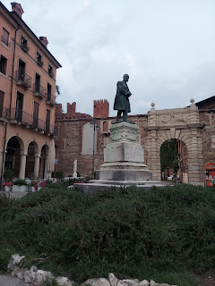

Cool story about this bunch that we went to dinner with: Robin (back left) and her husband (not shown) live in Harpers Ferry, WV and are in the SAME ward as Scott's brother Gordon!! And Eric (top middle) - who is Robin's little brother - also lived in Gordon's ward for a while before he joined the military and eventually married Erica (center). He recalls "Bishop Harmon" (Gordon) with genuine love and fondness, saying that he always knew that Bishop Harmon loved him and cared about him. Robin came all the way to Vicenza to play in Italy one last time before Eric and Erica move back to the States next month. It was a fun little reunion of sorts. :)

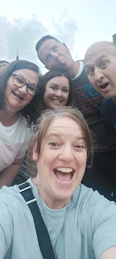

It was a beautiful evening and we were glad we could get out and see the sights together.

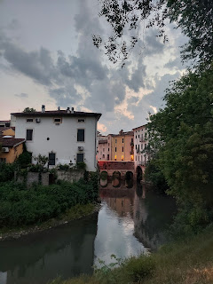

Tuesday:
At the end of the day, I was able to teach a room full of young women and their leaders how to do some family history. There were about 15 girls, and maybe 5 adult leaders. It was fantastic!! I always love helping someone learn how to explore their tree and learn some navigation skills at the same time. The Young Women President thought it went so well that she wants me to do a follow-up lesson in a few weeks!! That makes me so happy. :) I wish I had thought to get a picture, but there was just so much going on . . .

Wednesday:
Amber's birthdayyyy!! We were able to connect several times this week, which was wonderful. She is such a lovely human being and I always feel uplifted every time we talk. As Scott and I were out on an evening walk and I was telling her about the night before when I helped teach the YW about family history, she had a monumental idea come to her! She wants to collaborate with me to create a book that teaches families some basics of doing their family history. It will have a thread from a personal story in my life that creates a nice flow for the book and we have already begun setting the whole thing up!! SUUUUPER EXCITING!!

Some of the beautiful flowers on my walk that morning, and a few from my walk with Scott that evening.

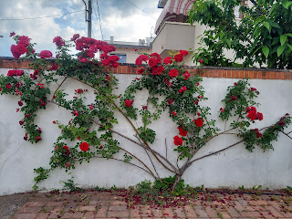

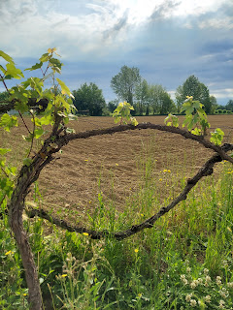

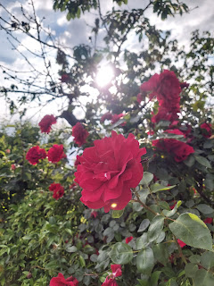

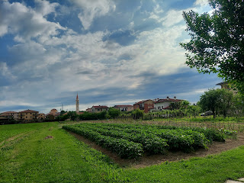

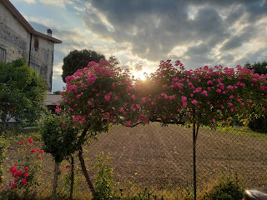

To see more of the flowers I keep finding in Italy, you can visit this ongoing photo album:

https://photos.app.goo.gl/i4RGiVYYiVicd4Ln6

Thursday:
After several days of struggling with a health issue, I decided to ask Scott to give me a priesthood blessing. I think my thyroid is "off", which has been causing some extreme fatigue, brain fog, and a serious lack of any motivation whatsoever on most days. Even the things that I truly enjoy doing (like getting out and seeing things around me, or going shopping) I couldn't get myself to do. It just seemed to be too much and I would just make excuses in my mind to stay home and rest. I felt so sleepy all the time . . . I remembered that my lab results came back the first week of April and my Dr. told me she wanted me to cut my thyroid medication in half. It wasn't that I was in a critical situation, she told me, but she would just feel more comfortable in doing a lesser dose, based on my bloodwork. As we have played around with my thyroid medications for the past couple of years, they have instructed me to be patient as I wait for improvements with any changes we make, telling me that it takes about 6 weeks to see a noticeable difference.

Hmmm, 6 weeks, eh . . . well that's right about now - while I'm in Italy having all these terrible symptoms!! I decided to ask Scott to give me a blessing since I knew that I didn't like feeling this way - incapable of doing much of anything and oh the exhaustion . . . It was all I could do to muster the strength to teach the YW about family history on Tuesday night. I also decided to start taking my previous dose of thyroid medication because I felt fantastic when I was at that dosage, and then I will try to reach out to my Dr. office to discuss the matter further.

Scott gave me a comforting blessing before we went to bed, and I felt at peace in the matter. I decided that the next morning I would go back to my "normal" dose until my Dr. tells me otherwise.

Friday:
I woke up feeling refreshed and ready to do several things that I hadn't felt like doing all week long. What a blessing to have the energy and clarity to get some things accomplished!! I did all of our laundry, I worked on my talk for Sunday, I ran some errands and found some new clothes that I desperately needed, I mailed a birthday card to my almost-80 year old cousin, Valorie, and even worked on some family history for a couple of hours! And I didn't feel like I was going to collapse from exhaustion!! I knew that Heavenly Father was blessing me and I was oh so grateful. :)

I even baked another round of chocolate chip cookies for our Ward Dinner that evening. And this time none of the cookies got burned. Yay! The trick was to only use one pan in our tiny little oven at a time, instead of 2 pans, even though I was rotating them the last time. It took a long time to finish up 4 1/2 dozen cookies when I could only bake 8 at a time, but thank goodness for air conditioning to offset the warm oven all afternoon . . .

The Ward Dinner was lovely. There were a lot of families that came and we had fun visiting with everyone for over 2 hours. The Elders Quorum cooked up some hamburgers and hot dogs, and the ward members filled in the meal with salads, chips, and desserts (such as my chocolate chip cookies). The dinner was held in the picnic area behind the Ederle Inn on base - which is where Scott and I stayed for all those weeks before moving into our house.

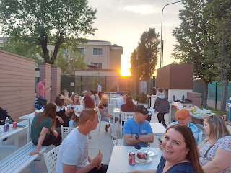

Saturday:
Scott and I went for a nice long morning walk -
early
- before it got too hot. It's been toasty here! It only cools off to the mid-60's at night and by 8:00 a.m. it's already jumping up into the upper 70's with the sun beaming down on you and causing you to melt. We've been in the upper 80's all week, but if you add in the humidity, it makes you feel like you're constantly sweaty and in need of a shower, ha ha.

We also did a little bit of clothes shopping together, since Scott was in need of some shorts. I had found an awesome store the day before with super cute clothes at very affordable prices. We got him 3 pairs of shorts, at roughly $12-15 each, and a couple of t-shirts at $8 each. Happy day! (The store is called Kiabi and they have a website:
www.kiabi.com
)

From there, we went back to our other new favorite store, Emisfero, and purchased a patio furniture set that we can use up on the roof for those lovely Italian evenings. While he bought the patio set and got it out to the car, I was doing some grocery shopping in the same store, since I hadn't been to that section of Emisfero yet. I had spent time beforehand getting a menu plan in place, and organizing my grocery list.

Something different over here is that when you are selecting any produce at all - well, the ones that aren't in bags or packaging - it is MANDATORY to wear a glove to handle any fruit or vegetable. They have stations all around the produce section with gloves for you to grab. This helps to cut down on spreading germs as people are constantly handling everything.

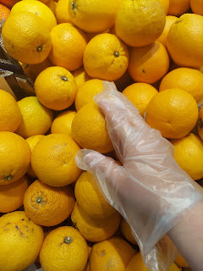

Then, you are required to go to the weighing station and get a barcode that shows the price for that particular item. Next to the oranges is a number pertaining to the oranges. So when you go to weigh them in the biodegradable bag, you just push the button with that number and it kicks out a little sticker with the barcode and price for that item.

Every fruit or vegetable has its own number and you take care of getting the price stickers before you go up to the register to pay for your stuff. If you forget to get the sticker, you either have to hold up the line and go all the way back to the produce section for the ticket, or you can choose to abandon the item up at the register. Trust me, I've had both of those scenarios happen to me. Well, actually, they both happened during this
one
outing on Saturday, ha ha . . . I ran back to weigh the carrots, and then by the time I got back, Scott told me that I had forgotten to weigh the head of lettuce and they decided to just set it aside so I wouldn't hold up the line anymore, ha ha. Sorry everyone! (sheepish grin)

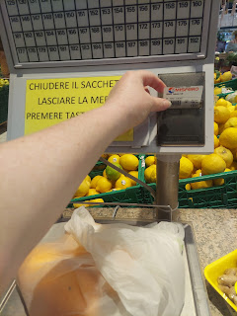

Emisfero also has a very cool juicing station near the produce. It smelled AMAZING with all the citrus wafting in the air. I'm not much of an orange juice drinker, but if anyone loves freshly squeezed orange juice and is planning to come visit us in Italy, then we will plan a field trip to Emisfero just for this. :)

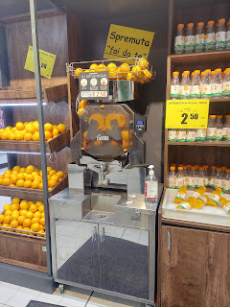

For the rest of the afternoon, I worked on my Sacrament meeting talk while Scott tinkered on the computer and started assembling the patio furniture.

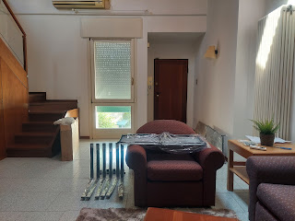

Amber and I chatted again about our book plans, and she showed me some sketches she's been working on for some of the pages. She is so incredible and I am in awe of how wonderful this idea is of hers!!

Weston brought in one of the kittens that they have been caring for, and apparently she loves to be carried in a baseball cap. She looked so content and lazily blinked some long blinks with some very sleepy eyes. So cute!

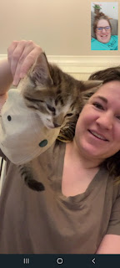

After dinner, Scott and I scurried across town to this spot that a friend had sent me the link to. A field full of red poppies!! The sun was setting fast and we barely made it before it went down for the night.

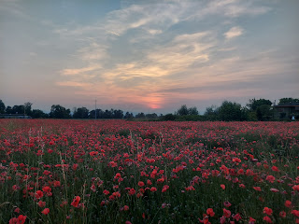

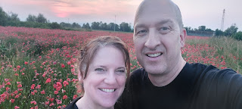



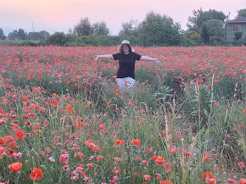

It is so fun to be here in Italy!! I am grateful for every single part of being here. Some days are busy and hectic, some days are more productive but less hectic, and some days are just not so productive at all. But it's not much different than life back in Idaho for the most part. We get groceries, we cook meals. We do laundry and clean the house. We go for walks and run errands. We get together with friends, and we serve in various capacities at church. We talk on the phone with family and loved ones, and send letters or cards from time to time. It's a good life and a blessed life.

Sunday:
I drove myself to church for the first time, with lots of roundabouts and turns and one accidental mistake that I quickly corrected. Scott went to church quite early because he's in the bishopric now and has some new responsibilities. Thankfully he is a tech savvy guy because he was able to print off my talk in the clerk's office at church once I sent the text to go ahead and do so from home. I had made a few last minute changes, but it finally felt ready and complete.

Here is the link to my talk:
https://docs.google.com/document/d/1xCfxMZ0a5LQGPnNHmTv4PSwwsvAwcNL5lmfMjAolN9I/edit?usp=sharing

When I got to church, Sister Butterfield greeted me enthusiastically in the hallway and wanted to get a picture with me. We were both speaking in church today, but her situation was extra special because this is her last Sunday of her mission to Italy. She heads home and back to the rest of her life on Friday!! She is a wonderful young lady and I am excited for her to move on to the next phase and find happiness in her future.

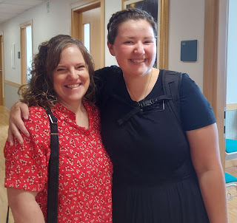

One final photo - - the finished patio furniture is now up on the terrace. We have a place to relax, to gather with friends and family, and to make plenty of memories here in Italy. Ciao!

