January: Off to a Quiet Start
Between rounds of snow, plunging temperatures, and new soups to sample, the past week has been both relatively quiet and productive at the same time.

There have been several beautiful sunrises and sunsets . . .

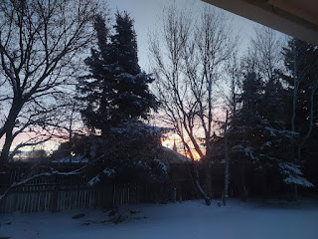

I've also had the usual amount of things break or malfunction while Scott is on the other side of the world . . . Besides the printer and my older laptop in the office needing a sledgehammer (!), the main lights in the family room downstairs died and needed to be replaced.



Thank goodness for my friends, Stephen and his father Don Blatter, who know their way around electrical work. Don is a retired master electrician, and his son has been taught well. Together, they not only replaced the old light fixtures (that had LED lights + transformers instead of actual light bulbs), but they also permanently changed an odd 3-way light switch that never made much sense in the 18 years that we've lived here.

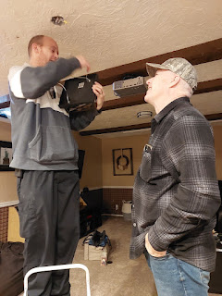

I attended the temple on Thursday, which could not have come at a better time . . .

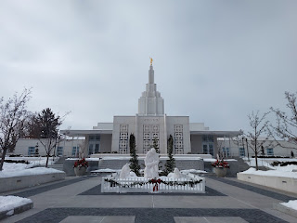

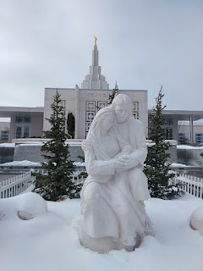

I had had a very uncomfortable conversation with my niece that morning, where she asked me to help her with something that essentially meant I would have to participate in something dishonest. It didn't go so well when I told her I couldn't do that . . .

When I drove to the temple a couple hours later, I was distraught and unsettled. After I changed into my white dress and sat down in the chapel to wait for the session to begin, I found myself riveted by the painting that was hanging in front of me, on the wall behind the organist, who was playing a series of quiet and soothing hymns. (Artwork by Minerva Teichert, 1939. Entitled, "Rescue of the Lost Lamb")



It was as if I was meant to be there at that very moment. The scripture from Luke 15:4 came to my mind: "What man (or woman) of you, having an hundred sheep, if (s)he lose one of them, doth not leave the ninety and nine in the wilderness, and go after that which is lost, until (s)he find it."

Not only did I need to be reminded that Jesus loves my niece, but that He loves each and every one of us equally. I have been a "black sheep" more than once in my own life, and He has never stopped loving me. I needed to be reminded that we are all in need of His perfect love, even though we are less than perfect humans.

Even yesterday (Monday), when I still had an anxious and unsettled feeling as she and I worked through some final stages of our disagreement, along with the inevitable and lingering hurt feelings, I found another evidence of how the Savior's love really does heal all wounds.

I was driving around town, running a few short errands (to the dump to offload a trunk full of cardboard to the recycling bins, to a nearby restaurant to get some gift cards for Stephen and Don Blatter, and to the post office). I tried listening to several different genres of music, but they all quickly became annoying to me. I felt frustrated and discontented.

The Holy Ghost quietly suggested that I listen to a general conference talk from last October. So I did. I started at the beginning and listened to a few talks before I arrived at the one that I needed to hear ("God's Favourite" by Elder Karl D. Hirst).

Elder Hirst shared how he has made every effort to make each of his children feel as if they are his favorite, and he likens this to how we are all a favorite to our Father in Heaven.

These are a couple of my favorite quotes from his talk:

"However misshapen we might feel we are, His arms are not shortened. No. They are always long enough to reach our reaching and embrace each one of us."

"I wonder, if Jesus were to choose a place where you and He could meet, a private place where you would be able to have a singular focus on Him, might He choose your unique place of personal suffering, the place of your deepest need, where no one else can go? Somewhere you feel so lonely that you must truly be all alone but you aren't quite, a place to which perhaps only He has travelled but actually has already prepared to meet you there when you arrive? If you are waiting for Him to come, might He already be there and within reach?"

This conference talk spoke directly to my heart and brought peace to my soul. I felt my anxiety melt away, and my discontentedness disappear. I felt calm and renewed, filled and loved. I was able to connect better with my niece later that afternoon, and the day ended with me bringing some freshly baked brownies over to her and holding her in a long embrace.

I decided to tackle the craziest room in the whole house and try to get it under control. I spent portions of a few days in making a bigger mess, to then redesign the space, and then clean up the mess. In the process of going through some of the items that landed at our house after Scott's parents passed away, I rediscovered some oldie-but-goodie photos.

1) Scott, holding Amber as we visited his parents in Yellowstone National Park. Amber was just over a month old at the time, and his father, Phil, was a Park Ranger during the summer months up there.

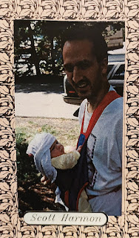

2) Amber, posed with some teddy bears at Phil & Coy's house, that were larger than she was. Her first Christmas (1994).

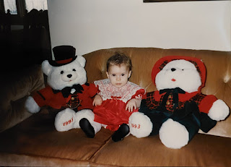

3) Amber, being carefully spoon-fed by Scott. He didn't want her reaching out and trying to grab the spoon, so he placed a dish towel around her first, securing it with a safety pin in the back. Then he layered a bib over the top and she very politely allowed him to feed her.

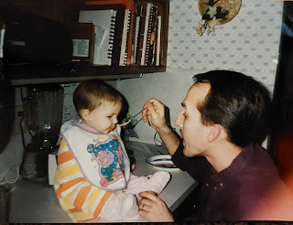

4) A photo of Coy before she was married, probably in the early 1950s - since she was married in 1955.

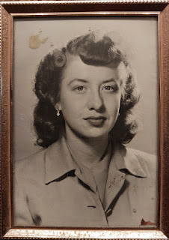

5) And a sweet photo of Phil and his mother, Grandma Helen Harmon, sitting on the couch at our first house on Michelle Street in Idaho Falls. This would have been around 1998-2000.

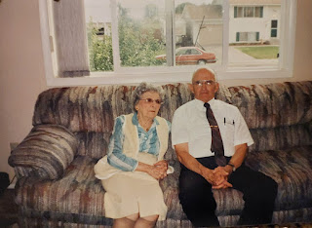

The craft room has become a "catch-all" for so many things these past couple of years. There was even a GIANT stack of totes and boxes that belonged to Emily McGovern, and had been stashed here in between her semesters at BYU-Idaho. But once she and her sister, Sarah, cleared it all out last week, I knew I needed to get to work and try to get this room back under control.

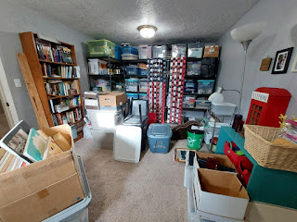

It was a modge-podge of family history, ancient and current memorabilia, crafting & sewing supplies, and even a whole slew of items leftover from Jake and Hannah's wedding reception in 2019.

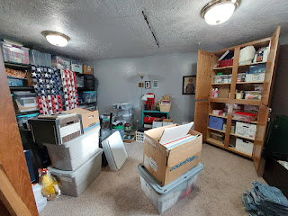

I made piles of: 1) throw away, 2) donate, and 3) set aside to send to Italy in our upcoming shipment of household goods.

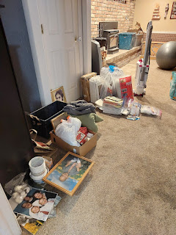

This is the finished (for now) version . . .

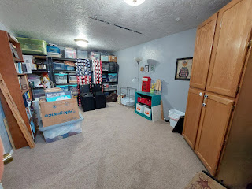

I couldn't fit all of Phil & Coy's stuff on the shelf I had cleared out, so there are a couple of grey totes stacked on the floor still. Also, Amber left behind a huge box of canvases and a giant bin of yarn that will eventually make it up to Portland. Those are also stacked on the floor for now, too.

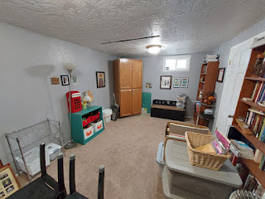

I took more than one carload of "shtuff" to the Deseret Industries ("D.I.") thrift store in town to donate.

And I have a growing pile of things to be organized and packed up for Italy in the coming months.

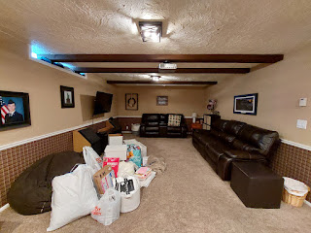

To get out of the basement and "into the light", I made a trip to my favorite craft store, Hobby Lobby. I took several photos of things that "spoke to me", things that gave me some ideas for decorating, and the photos are something I will refer back to later, when needed.

Part of what is helping me to become more invested in the fact that I'll be moving to Italy soon, is figuring out how I can make our new house a home. I am in the nesting phase right now, something that brings connectivity, continuity, and stability to a heart that's been in turmoil. I want to bring some things to Italy that are important to me here, such as sewing/crafting supplies. But I also want the style of our home there to be somewhat connected to our home here. I want a few familiar things, but mainly I just want SOFT. I want to create soft, plush textures sprinkled all around our home in Italy.

The textures of Italy don't really say "soft" to me. The floors are hard tile or hard wood. There is a lot of terra cotta, metal, and wood. My #1 goal is to bring softness and coziness into our new home, so I have already started hunting for (and finding) some soft storage baskets, plush throw blankets, etc. This nesting phase that I'm in right now is definitely helping me to look forward to the next chapter of our life together.

One of the things I've been perplexed by is that I am trying to plan how to decorate the 3rd (and smallest) guest room in the new house. It will primarily be used by our grandchildren when they come to visit, so I want it to be a happy place for them. But how do you decorate for some serious girly-girls, but also for a very manly boy who loves dinosaurs and all things construction??

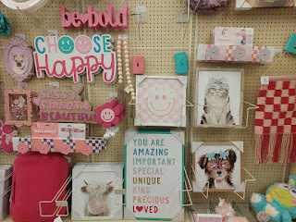

I took some photos in Hobby Lobby of some things that stood out to me, or that made me laugh. As I studied all the photos on my laptop later, an idea emerged. I think I will make the room theme be about animals. I can use a mixture of wall art: the cow blowing a huge bubble from her pink bubble gum, the enthusiastic dinosaur riding in a car, etc., PLUS some fun stuffed animals placed around the room that would delight both the boy(s) AND the girls.

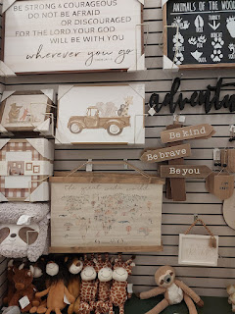

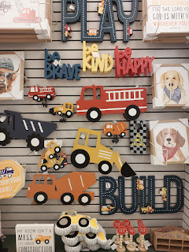

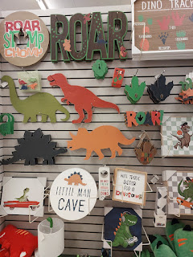

I like the soft colors that are in a lot of the wall art in Hobby Lobby . . .

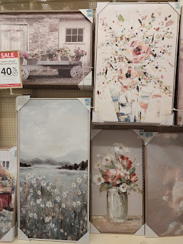

Hey Melanie (my sister), this next photo shows the giraffe reading the newspaper on the "pot", ha ha. I bought this for our future bathroom in Italy and as I told her about it over the phone, we laughed and laughed.

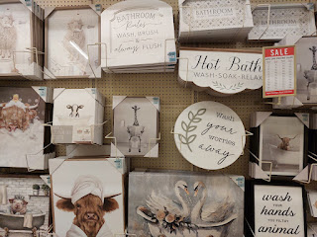

Side note: The reason why I'm obsessing over wall art is because we've only had like 2-3 pieces of art hanging in our entire house over there for 3 years. I am eager to make our next house feel like we are actually living there. And later on, I can bring some of those things home to Idaho and add them to our decor here, or I can sell them to the new families that are moving in as we're leaving.

Amber shared this hilarious post on Facebook recently: (Side note: Gwen is 7 years old now, and she is so precocious and delightful.) (Also, I could really use her expertise right about now, too.)

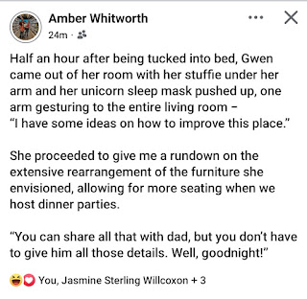

I took Emily and Sarah McGovern out to dinner last Friday night, because it was Emily's 22nd birthday. I let her choose where to eat, and she chose a restaurant called the Red Rabbit Grill. The food was good and we had a great visit. I ordered skewers of shrimp, a house salad, and some sweet potato fries. :)



It started snowing (hard) while we ate our food, and we watched through the window with incredulous eyes as the cars outside became covered by all the frozen white snowflakes in what seemed like a moment or two. After we finished our meal, I drove the girls to Walmart on the north side of Rexburg so that they could get some needed groceries. Once I dropped them safely back at their apartment building, I carefully made my way home to Idaho Falls in the snowstorm. It snowed late into the night and was quite beautiful to watch from the warmth of my dining room.

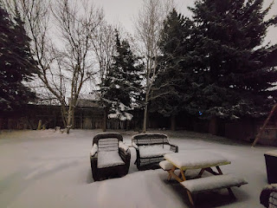

Video of the snow: (8 seconds) Even though it was late at night (10 p.m.) the sky was light enough outside that it seemed as if it was just late afternoon.
https://photos.app.goo.gl/YZjRBfQtJ5qnC7Cp8

I went out first thing the next morning to shovel about 2.5 inches of snow before hopping in the shower to start my day.

Video that I made for Abdel (my "son" in Morocco) so he could see how much snow we now had.
(18 seconds)
https://photos.app.goo.gl/vzF3A11LaDTPkxm99

Later that same day, as I was breaking down a huge pile of boxes in the garage, my son Jacob texted me and asked, "Whatcha doing?" So I sent him this photo and it sparked a fun texting conversation between us for the next several minutes.

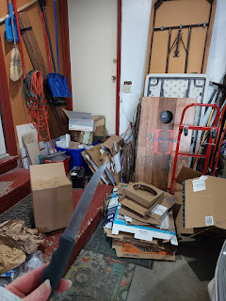

Walking to and from church early Sunday morning, I marveled at the crisp and beautiful white layers on the trees and branches everywhere. The dense fog had essentially frozen onto everything, making for some stunning photography opportunities.





The wintry weather called for some hearty wintry soup. I made a chicken soup, filled with vegetables (carrots, celery, red onion, and kale) and just a little bit of orzo pasta.



Jake and Hannah, along with Jack and Maisie, have all been sick for the past several days. Hannah got sick first, with Jake getting sick just as they needed to fly home to Minneapolis from Utah after the New Year. When we had a lengthy video call last night (Monday), I could hear Maisie's raspy breathing as Jake carried her around, poor little honey. They've all had a fever, congestion, coughing, and all the other symptoms of crud. Because Hannah got sick first, she was the first one to bust out of that sickness jail. Meanwhile, Jake is almost done, but the little ones are still in the middle of whatever crud they all ended up with. Bless their little hearts!



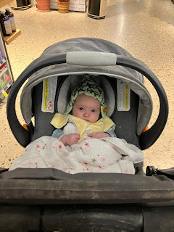

Maisie, prior to getting sick, and just happily smiling at whoever took this photo . . . XOXO



I hope y'all are surviving the winter cruds that have been going around. I'll be praying for you. XO

