Jury Duty? I'm So Sorry But . . .
I FINALLY got summoned to Jury Duty after 30+ years of marriage and then it happens to be while I'm across the world in Italy!! Hilarious. A couple of weeks ago, I got a notice in our forwarded mail that my jury service was due to begin on Nov. 1st, along with a web address that I could use to login and respond to the summons. Thankfully, there was a question regarding undue hardship and what my reason is for asking to be excused . . . One of the questions asked me how many miles it would take to get to my local courthouse. Ummm, 5,000 and something. More or less . . .
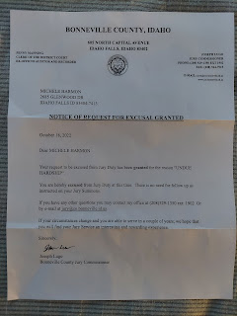

Hooray for expedited and efficient online forms because within just a few minutes I got an email AND a text stating that I had been officially excused from my service. And then a couple days ago, I got the paper version stating the same thing through snail mail, too. Way to go Bonneville County!!

As for the rest of the week, I worked hard on Avery's birthday gift and made some big progress. ALL of the pages are done now, they just need binding (with bias tape) around the edges. Here is the last page that I finished - -

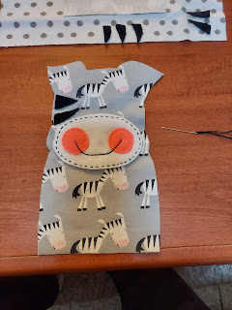

It's a zebra puppet that you can remove from the page (velcro on the back) so she (the zebra) can eat some yummy grass.

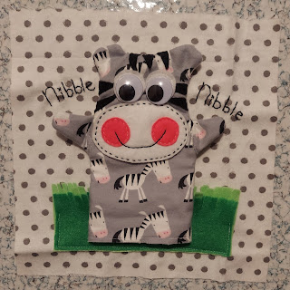

This was my inspiration that I pulled off the internet. Thank goodness for clipart, ha ha.



The LAST phase of this project is to bind each page, and make the outer cover with a tab to close it up. Then it will be ready for gifting to my youngest grandbaby on her birthday. Hooray!

I had a recurring problem with my pinky toe again during the week. It flared up again and got so itchy I thought I would like to amputate it rather than to suffer one more night of hardly any sleep. I was able to get in to see a Dr. at the Health Center on base mid-week to get some help.

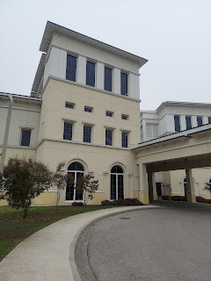

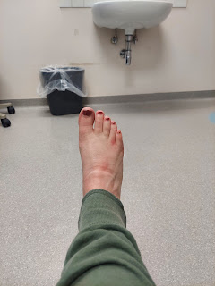
Below: A very poignant sign in the lobby at the Health Center . . . and also interesting that we have to say this out loud . . .


The Dr. diagnosed me with a fungal infection and prescribed some cream to help clear it up. She said it's very common over here with how high the humidity is. She also prescribed a powerful antihistamine to help me sleep better at night, since it seems to flare up significantly when I'm trying to rest. The night before my doctor visit, I stuck my foot out of the covers all night so it wouldn't get too warm and then get ridiculously itchy. But then a lone mosquito found my foot and decided to attack while I was unconscious . . . how rude. So then I was doubly itchy. Anyhow, the antihistamine was indeed very powerful. The whole next day I felt like I was still drugged somewhat. I didn't like that, but I did like the sleep that I got.

My goal for the week (besides Avery's book) was to get out of the house each day for a walk. My intent was not to have the walk be used for serious exercise, but instead it could be a fresh air and recreational exercise. (I was already exercising first thing each morning with my usual YouTube videos.) I was really struggling emotionally with Scott being gone (more on that in a minute), and it surprised me with how deep my feelings were. I was confident that if I could get outside and enjoy the fresh air once a day it would be beneficial. (This was early in the week before my pinky toe got all kinds of agitated.)

I started the week strong on Halloween by walking a mile each way to get some supplies for Avery's book down at the Tricot Cafe craft store.

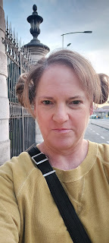

Halloween night in Italy on my way back to the house.

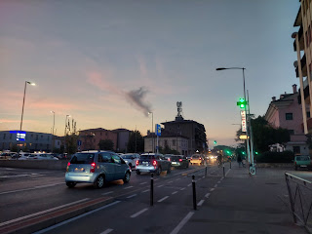

I finished gathering the last of the laundry up on the rooftop and took my time looking up at the night sky. It felt calm and peaceful to see the moon up in the sky.

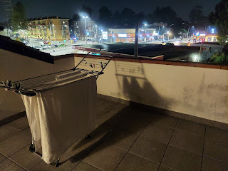

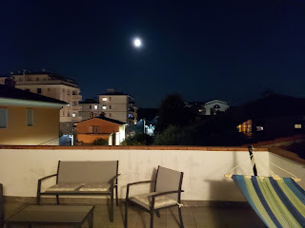

As I was up on the roof, I saw a group of children and their parents heading out to go trick or treating. I was curious about what the procedure is in Italy, because everyone lives behind locked gates and locked buildings. How do you even access the treats?

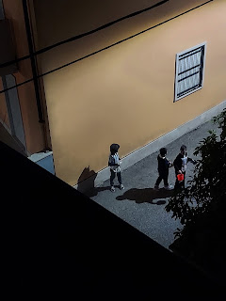

I finished grabbing my laundry and came back inside, bringing it downstairs to fold. Right away, I heard the large group of trick-or-treaters walking by under my kitchen window, so I went over to the window to observe. They saw me up above and waved, calling out in Italian. I enthusiastically waved back. Then they came over and pressed the buzzer on the gate below where I was standing. That's when I realized that they wanted some candy from me and they thought the buzzer belonged to me!! ha ha

I felt terrible because I didn't even buy any candy this year. My neighbor, Zhanna, told me that last year they only had one single person ring their buzzer for candy, so I figured why bother. Now, with this eager group staring up at me from the street below, I could only shrug and try to indicate that I didn't have any candy for them. I'll do better next year.

I think that next year, I'll get some candy and either A) sit outside with a bowl of candy for passersby, or B) put a sign next to my buzzer (with Italian wording) to indicate they are welcome to buzz me for some candy and then I'll bring some down. Our buzzer only rang 2x the entire night. I didn't answer because I didn't have anything to give . . . but I'll do better next year.

On Tuesday, I did a LOT. I surprised myself at how I was able to burst out of those depressive shackles that were binding me down and what I was able to do with that little bit of newfound emotional resilience.

Throughout the week, it became apparent to me that I had been feeling
invisible
that first weekend when Scott left. I'm over here in Italy every 90 days trying to make friends and get more and more comfortable. And then, as soon as I'm getting nice and comfortable, I have to leave and start all over again by going home to the U.S.

Back in Idaho, I have roots and friends and comforts, but at the same time my best friend (Scott) is back in Italy! When I go back and forth all the time, it's hard to keep up with friendships. It's hard because when I'm out of sight, life goes on without me. It's hard to keep up on all the details when I keep leaving people behind. And that's when I realized that when Scott left to go to Morocco, I felt even more invisible. Who sees me in Italy? Who is thinking about me if he's gone now too? Suddenly I felt very alone, and I didn't like that feeling at all.

What I came to realize this week, or at least be reminded of, is that even though people come and people go, my Heavenly Father sees me. His Son, Jesus Christ, sees me. They are always there for me no matter where I am or what circumstances I am in. I wasn't lost or forgotten. I was just temporarily separated (mostly from Scott).

Miraculously, around the same time, I started getting some invitations to do a few things with friends over the next week or so. I was getting daily texts from my friend Andrea. Lasina reached out to set up a lunch date. I was invited to go with a group of ladies to do a tour of a nearby olive orchard (next week). I think Heavenly Father inspired these friends to reach out to me so that I didn't feel so alone.

And my son, Jacob, called so that I could have a great little chat with this guy.

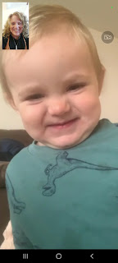
I found it interesting that we both woke up to a dense fog in the morning, even though we are far apart from each other. Jack wanted to show me what it looked like from his balcony in Washington DC. What a cutie!
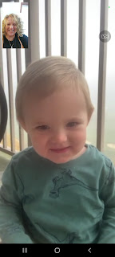

Jacob helped me with a cooking question that I had and together we figured out a solution. (regarding roasting Brussels sprouts with olive oil and lemon juice and not having it burn while sauteeing them in a pan) I was making a surprise dinner for my friend Andrea and her daughters. She was having a hard time with several things going wrong all at once, and I decided to lighten her load for a night or two by bringing a prepared meal to her. I checked with her to see when she would be getting off work and then I met her in the parking lot outside her office. She was surprised, but gracious with receiving my gift. I told her that this is what we do back in Idaho Falls in my neighborhood. If someone is having a hard time, we do what we can to lighten their load and show that we care. :)

I made some mini meatloaves with roasted Brussels sprouts for their family. Yum!

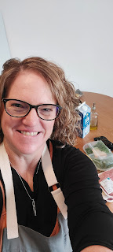

I also stopped at the Bimbo Toy Store again for a couple more things to spruce up my meager supply upstairs. Whenever the need arises, I just want to be READY!! My parents can probably attest to the fact that my secret middle name is PREPARED.

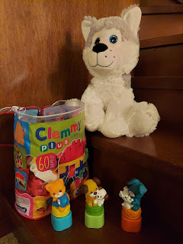

On Wednesday night, I had a very interesting conversation with my cousin, Valorie. She is a self-professed hippie and is deeply spiritual. Whenever I find myself thinking about her a LOT, and then I call her, she tells me she had been thinking a lot about me too! She doesn't have any internet (hiding from the IRS - LOL), so I can't text her (no smartphone). I have to write her a letter or give her a call. This time, I gave her a call.

Thankfully, Scott set up an extra phone for me over here with an Italian number and I have 300 minutes that I can use each month to call internationally. This is SO HELPFUL when I need to contact a U.S. based business or a friend or family member who doesn't have WhatsApp. With Valorie, I call her first (25 cents for one minute) just to let her know I'll be calling her on my Italian phone. I don't want her to think it's a telemarketer and then not answer . . .

We talked about lots of things and got caught up on the goings on for the past 6 weeks or so, and then she told me something that I wasn't quite sure how to digest. She had been sick with the flu for several days and was resting and recovering during that time. One day, she woke up from a nap and felt very strongly that she needed to get some things in order. She is 80 years old, her health is not that great, and she is pretty sure she's having a relapse with her breast cancer, but doesn't want to go through the rigamarole of getting treatments for it again. She just wants to live her life in peace until it ends.

This is Valorie when I had lunch with her on my way home from CA in August.

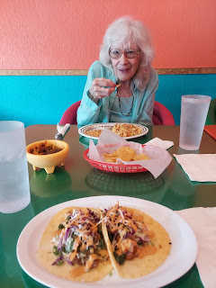

She felt like she needed to clean out a couple areas within her home, write 8 letters, and prepare her own obituary. She is an avid believer in astrology (which I am not) and has had a lifetime of serving clients and putting together their "star chart", etc. She told me that both of our planets and stars were aligning for the next 7-10 days and that one or both of us would be dealing with some sort of tragedy. She said it would be family based, and that it could possibly be connected to our (individual) childhood. She added that it would be a sorrowful time, but that it would also be evident that it was meant to be and that everything would be okay in regards to it. Wow, . . . um . . . I'm not sure what to say . . .

She reassured me that she felt like she was ready to go when the time came. She did what she was prompted to do and so whatever needs to happen can happen now. Now I'm not a believer in astrology - mainly because I don't understand it at all and it doesn't seem doctrine-based with anything I've read in the scriptures or been taught at church. But I AM a believer in personal revelation and the ability to receive direction from God in our life. So I was trying to reconcile what she was saying with what feels right in my heart as far as truth goes.

We agreed to check back in with each other after the 10 days go by and see how everything went. She felt so strongly about it all . . . it was a bit unnerving. She also told me that the 8 letters that she wrote were for the most special people in her life, including ME! She has a plan in place with her neighbors and a friend who check on her regularly. If Valorie dies (at any point, not necessarily in the next week), the letters are all ready to be mailed by her neighbor, and there is a phone tree in place to notify people of her passing. Wow.

It was hard to let go of the one thing she said - that it could be either of us who might experience this profound loss in the next few days. I began thinking feverishly about each of my family members and who I might need to reach out to one more time . . . But at the same time that my mind began reviewing and assessing when I spoke to each family member the last time, I also felt a calmness like that everything will sincerely be okay. I am not in charge of giving life or taking it away. Because I am not in charge, and because it is out of my control, I should not worry too much about it. Just let it happen naturally and trust in the knowledge that I will be reunited with my loved ones in the end. It will all be okay.

I'm writing about it here because I wanted to go on record in advance - - - should anything happen. It sounds all gloom and doom, but it's not about that. At least, that's not the sense that I got from Valorie. It's more about her listening to the prompting to prepare, and then getting those preparations done. When you do all you can to prepare, then you can relax and breathe and just let life happen naturally. It will all be okay.

On Friday, I went out to lunch with my friend Lasina again. I picked her up this time and we drove to the same place as before, NaturaSi in Dueville, a natural food store and cafe. I accompanied her as she picked up a few items around the store first, since the cafeteria wasn't quite open yet.

Lasina chose some buns for a "hamburger & onion rings date" she had planned for her husband this weekend. I am learning about some yummy products to try in Italy because of her . . .

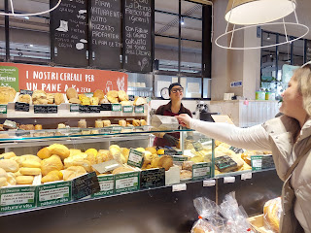

Here was my lunch tray this time. On the far left: I tried some polenta (which is VERY popular in Northern Italy) - it was "okay". Next to the polenta is a large green meatball. It was AMAZING!! It was a spinach and pesto meatball and was absolutely divine.
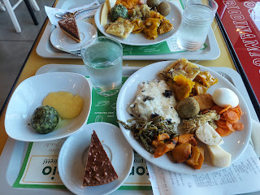

In the middle was a slice of pie that was more like a multi-layered chocolate and hazelnut cake. I mostly just ate the top half with the chocolate, ha ha.

And my favorite 3 things on the big plate were: the crepe with mushroom gravy, the very soft fresh mozzarella chunk, and the pumpkin ravioli. Super yummy! I got more than I should have this time and couldn't eat it all. The crepe threw me off I think. Last time I focused on getting a bite of this and a bite of that, but the crepe was an entire serving just by itself. Live and learn.

After a lovely visit with Lasina and after I dropped her off at home, I drove over to the mall to look for some winter clothes. When I packed my things to come over to Italy back in September, the weather was still quite warm and I didn't pack very many items for winter. I figured it would be smarter to buy some things here and just keep them here so I don't have to haul so much stuff back and forth all the time.

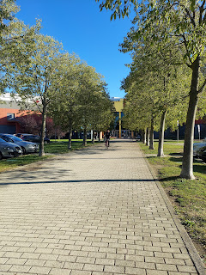

I found some cute things at a store called OVS. I'm not sure what it stands for . . . but I got some turtleneck shirts with cute black stripeys, a beautiful beige sweater, and a nice warm layering shirt that I think I'll be bringing back to Idaho with me because it feels so cozy and delightful. (I know I'll be needing that during the frigid arctic months!)

I also stopped by the Leroy Merlin store (Home Depot) since it was nearby. I was specifically looking for a rug and a shoe basket to put inside our front door. We don't have an area to drop off wet or dirty shoes, or to place a wet umbrella either. I found a rug, but no baskets yet.

I also found Christmas in Italy! (in Leroy Merlin's at least)

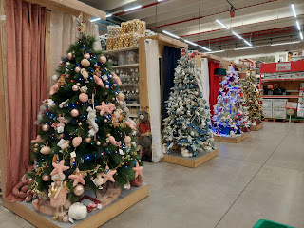

I can't wait to experience Christmas in Italy. Never in my life have I dreamt I would get to experience something like this. I'll let you know how it goes.

Time for Grandbabies . . .

Well, mostly just Jack for this week. :)

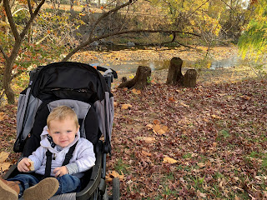

Jacob sent this to me. What a sweet face, even though he's so sad. (not sure why . . .)

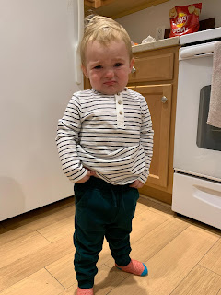

And a super precious video of Jack watching the construction crew down below again: (17 seconds)
https://photos.app.goo.gl/9LVgSgdCJeQ3GNXS7

That kid is a thinker. He's an observer and a thinker. And he will grow up to do some amazing things, I'm sure. :)

So the summary of this week goes something like this:

Life is going to throw some curveballs at you. Some you will see coming. Others not so much.

Don't ever forget your worth. You are precious and priceless in the eyes of our Heavenly Father. You are not alone even though you might feel like you are.

If you are feeling low in spirit and your emotional well-being is lacking, do something to lift your spirit up. Take a walk, get out in nature, listen to music that makes you feel good, treat yourself to a donut. Whatever it takes. Fight through those negative feelings!

No matter how bad your life may seem, there is always someone worse off than you. See what you can do to serve them. By giving service you will not only lift someone else's spirit, but you'll lift your own as well.

Be good to yourself. Be kind to yourself. Be good to those around you. What goes around, comes around. :)

The End.

