Lather, Rinse, and Repeat
I have an ongoing list of things to be working on before I leave my house again for a season. It seems like as soon as I'm able to cross something off my list that I've completed, a new task appears on my list to replace the one I just crossed off.
The main categories that I just shuffle between all day/every day are: work on the yard, work on the Rawles Blog & Newsletter, work on Avery's Quiet Book, clean or tidy something inside the house, repeat, repeat, repeat. I run errands, I get stuff done, I'm networking with people over the phone, and I'm counting how many hours I have to work with each day. Some days I postpone a meal until a task is done so that I can truly relax while I'm eating, but once in a while that means I'm not eating dinner until almost 9:00 at night.
I did finally finish my second edition of the Rawles Roots Blog and Newsletter. It was a monumental task with many details, but I am grateful that everything finally came together and now it is done. If you would like to take a peek at it, here is a link.
https://rawlesroots7.blogspot.com/2022/09/a-tribute-to-kate-orr-rawles-darrel.html
I had two days in a row (Thursday and Friday) where I felt low in spirit and I was definitely struggling. At the end of the second day I evaluated myself a little more deeply and had a good talk with my mother-in-law where I realized part of the problem.
I am typically very task-oriented and I get great satisfaction out of being productive and accomplishing things. But I think I was so worried about these past 3 months of being apart from Scott that I ended up overloading my schedule. I think somehow I figured that if I just keep busy then I won't feel the "feels", or in other words, if I work harder than usual then somehow I won't have time to get lonely and wallow in self-pity. So that's what I've been doing. For a long time . . .
As soon as I got home at the end of June, I launched into all the preparations for being the cook at girls camp 10 days later. After camp, I was on the receiving end of Amber and her family driving across the country to spend a week here with me. (Don't get me wrong - that was so much fun!!) Then I drove out to Northern CA for 2 weeks and packed every single day from beginning to end with as many wonderful things as I could think of. And it was amazing! Then I came home and started pulling weeds and working around the house again, not to mention the 2100 slides that I got digitized. Then I flew out to Southern CA to spend a week with my sister and her family. Then I came home again and now here I am, cramming in all the last minute chores to get the house and yard ready to leave yet again . . .
I finally had a teensy weensy epiphany. The epiphany made me realize that my underlying goal was to avoid feeling sad and lonely, but it came and hit me like a ton of bricks anyway. I'm also realizing that it's okay to feel sad and lonely, and to allow myself the space to feel the "feels". I don't like to feel those depressing feelings, so it's hard to let myself acknowledge them. But I'm feeling much better now after I gave myself some time and space to note what I was feeling during those two long days.
Prayer helps a lot. Asking for comfort, strength, peace, and any motivation that I need that day is helpful. Going to the temple helps. Listening to talks from General Conference helps. Talking to loved ones on the phone helps. Going on a scenic drive helps. Singing loudly in the car helps. Giving myself time and patience also helps.
The little scenic drive that I went on was just what I needed. I intended to find a giant field of sunflowers that my neighbor had told me about recently, but I think their season was done and therefore the field was already cleared out. What I found instead was a photo opportunity that I didn't expect, but one that turned out to be oh so beautiful.
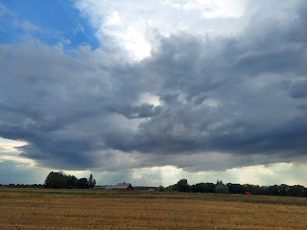

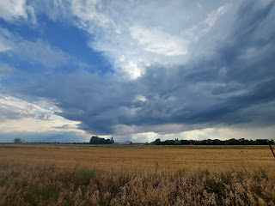

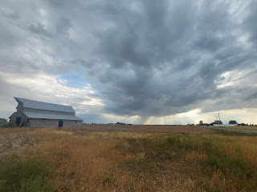

If you look closely, you'll notice that in spite of the dark stormy clouds that were pressing in from above, there were several rays of light spilling out from underneath. The light found a way to bust through that oppressive darkness and still shine anyway. I feel like that's a metaphor for me this week. We all have hard things to go through in this life, but if all we do is focus on the darkness we will miss seeing the rays of light that are so beautiful and uplifting. The stormy skies showed me that it's okay to have a little cloudiness in our life, that it teaches me something. The rays of light are a reminder that my Savior Jesus Christ is always right there and I can lean on Him to help me through whatever I'm going through.

I am grateful that my time away from Scott is coming to an end. I am so grateful to be married to this man. He is just such a wonderful human being. He is kind, he is funny, he is supportive, he is a warm blanket on a cold evening. I realize that not everyone has this type of luxury. Some of the people that I love have lost their spouse, or are getting divorced, or haven't found Mr. Right quite yet . . . I don't wish to offend those individuals, or be too whiny. I'm just acknowledging what I have been going through over the last several days.

After I took some photos out in the countryside around Idaho Falls, I drove around and listened to the same song over and over and sang the words as loud as I could until tears began to fill my eyes, which also provided a gentle release of some of my pent up emotions. (The song was "Without You" by Luke Combs) It's about the people that support me and allow me to be who I am. The love of family is irreplaceable and I am so grateful for all of my family, both near and far. Especially Scott.

After I let myself feel some "feels", I drove into town to pick up a pulled pork salad from Cafe Rio and brought it home to eat while I watched a show. I got a call from my sister, Charmaine, right as I was pulling up to the drive-thru to order my food. It's always nice to have someone to pick me up and dust me off, sending me on my way again with more strength than I had before.

I'm grateful to be feeling better. I feel stronger, more capable to get through the day, and more at peace. I am grateful for answers to my prayers.

Here is a random sampler of some of the things I've been working on this week.

I went to the local Trackside Mall, an antiques emporium, to hunt for some gold frames for Amber. She is working on several small paintings of Jesus and is looking for 8x10, 5x7, and even smaller frames, especially interesting or unique ones. I found a variety for her, including this one.

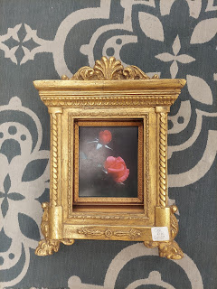

I also had fun sharing photos of interesting objects for sale at the emporium. She got a kick out of the things I sent her.



I trimmed down all of the perennial plants around the house, getting everything ready for winter.

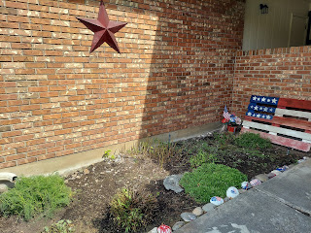

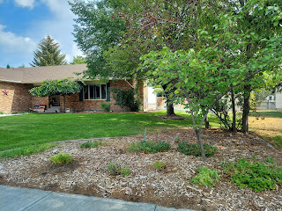

I cleared out a bunch of weeds surrounding this tree. It looks so much better now!

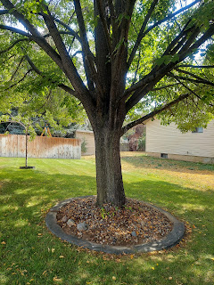

I went to the Idaho Falls Temple one last time until the New Year.

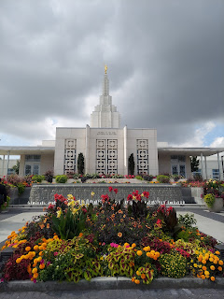

I've been doing several sewing projects. I made a new cushion for this bench that was on clearance recently (only $37!!)

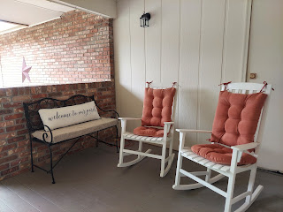

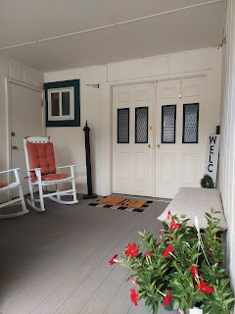

I had enough fabric to re-cover the cushion on another bench that I've had for a long time. It was looking pretty old and worn, but now it has new life.

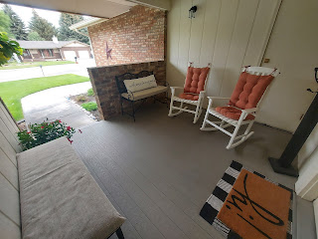

I squeezed in some detail work for Avery's Quiet Book, too. This is a counting page with 10 cupcakes. I sewed the right number of tiny little buttons on each frosting "topper" and added velcro so each "topper" can be removed and manipulated.

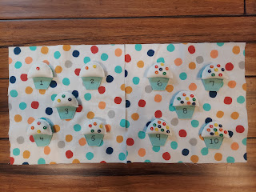

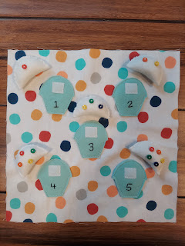

I harvested a boat-load of rhubarb again, and made two pies this weekend. I've been sharing slices of pie with family and friends before I leave.

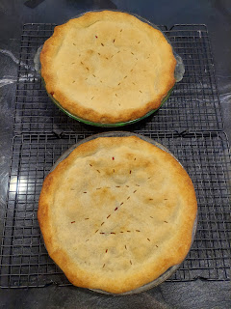

And Scott made it back to our house in Italy, so we finally could see each other's faces on a video call for the first time in 3 weeks. Hooray! Thank you, Italian Wi-Fi. You're the best.

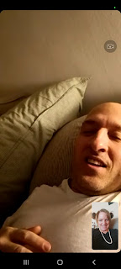

He sent me a picture of the view through the front bus window during his 11 hour bus ride home.

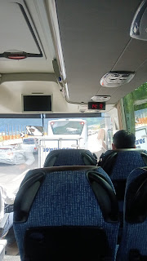

He also sent a short video of some gorgeous mountains somewhere between Germany and Italy.
(6 seconds)
https://photos.app.goo.gl/zQz7xU53YbRQqaZd7

Last but not least . . . Grandbabies :)

A super cute picture of Kylie and Avery

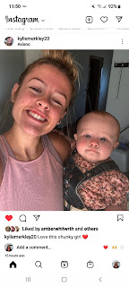

Jack is quite the explorer these days. Jacob reports that Jack likes to walk around their building like it's just an extension of their apartment.

Video of Jack trotting down the hallway: (19 seconds)
https://photos.app.goo.gl/paK74DV82qmbqd8RA

Video of Jack playing in a box of dried kidney beans. Note that most of the beans are out on the floor.
(18 seconds)
https://photos.app.goo.gl/k4Ur3gRrJjwmzVEz8

Video of Jack following a white butterfly amongst the beautiful red flowers. (11 seconds)
https://photos.app.goo.gl/cxtuAXeHAVxBGV4w5

Jack trying to eat rice with his hands. Life is so hard.

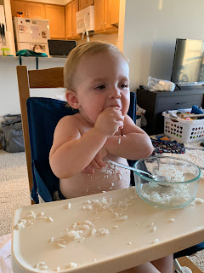

And our personal favorite - - -

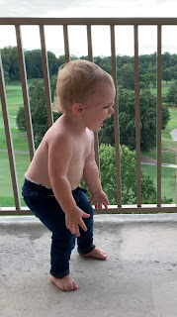

When I asked in our family group text what he was yelling about, Jacob gave us a one-word explanation.
"Truck."

So we really have no idea, ha ha.

Gwen got an award at school this week for being a good example and doing the right things. Yay Gwennie!! (She's the unsmiling cute girl in the red shirt and khaki pants in the middle) LOL

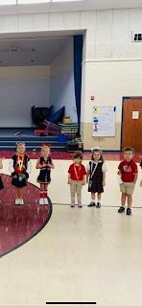

And Abby has been involved in a cheerleading clinic and was able to perform at the local high school football game during half-time.

Video of Abby playing a hand-clapping game with her friend. They are seated on the ground in the video. Amber said: "Abby's playing Johnny got hit by a UFO, all the way to Mexico. Number 9, number 9, creepy crawlers up your spine. Dot, dot, ELECTRIC SHOCK."
(18 seconds)
https://photos.app.goo.gl/4xBqPc47uee2FjNaA

And here is the darling video of their half-time performance. (1 min, 5 seconds)
*Abby is the girl being lifted up at the far right end of the field, within the first few seconds of the video. She is closest to the goalpost.

https://photos.app.goo.gl/JXxFijLxwVWNmuRu9
Amber said it felt like there were hundreds of little cheerleaders and it was hard to pick out where Abby was. But Abby had a blast! Football is HUGE down in the south and Amber said they had a fun time attending the local high school game for North Desoto. ND crushed Loyola Prep. When they left after half time, the score was 42-7.
And that's it. That's all I've got.
My next blog post will be from Washington DC. WITH JACK!!! I can't wait!!!

