Literally a Blessing to Be in Italy
Ciao! I arrived safely in Italy on Friday, August 30th and my sweet husband was there to pick me up at the Venice Airport. By the time we got home a short time later, I immediately laid down on the bed because my head was spinning and I was pretty exhausted. Once I got comfortable, tears sprang to my eyes because I was so utterly relieved that I had made it. There were times during the previous 24 hours that I wondered if I would even make it through the next hurdle . . .

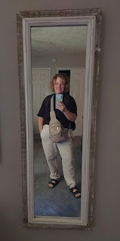

I was a little sick in the 2 days leading up to my trip, but I somehow managed to squeak through and get everything done, which was nothing short of a miracle. Last Wednesday, I was in bed for the first half of the day because I felt like lead and had no energy whatsoever. I prayed that I could be allowed the strength to accomplish some of the things that were on my list before I left for several months, and by early afternoon, I felt a motivating surge of energy that allowed me to get most of my chores done before bedtime that evening. I was extremely grateful for that blessing. :)

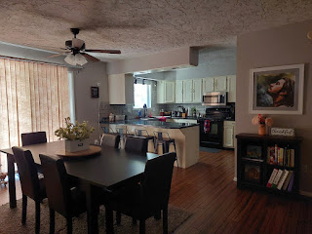

It's always hard to leave the home that I love so much, but at least I left it nice and clean . . .

I was a little slower in my pace during the hours leading up to my departure on Thursday, but I didn't feel too yucky, or any worse off than the day before. But as soon as I got to my gate at the Idaho Falls Airport, that feeling of being a massive dead weight returned. I was so exhausted as I waited to board the plane, that I couldn't even summon the energy to scroll through my phone for entertainment. I just sat there, resting my heavy head in the palm of my hand until it was time to shuffle onto the plane.

I made it to Denver. I made it to my next gate. I rested as best as I could for an extra 45 minutes as the flight to Frankfurt was delayed. Each step of the way, I somehow made it even though I felt like my whole body weighed 500 lbs and that I could probably sleep until Christmas morning.

On my 9 hour flight from Denver to Frankfurt, Germany I tried to watch 3 different movies, but after switching from one to the next, and then being disappointed each time, I decided to turn the screen off and just close my eyes. I have a new travel pillow that worked really well this trip. I felt snuggled and secure in a vertical position, and I'm pretty sure I slept solidly for 3-4 hours. It felt so good.

Here's the Amazon link to the neck pillow that I bought:
https://www.amazon.com/dp/B0D45BW919?ref=ppx_yo2ov_dt_b_fed_asin_title

The dinner they served on Lufthansa was impressive and quite tasty. It consisted of a quinoa salad, chicken and rice, a roll, cheese and crackers, and a little serving of some sort of crumb cake. I didn't eat the crackers or the roll, but I ate everything else and I loved all of it.

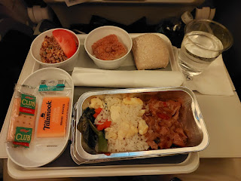

When we arrived in Frankfurt, it was now Friday, August 30th at 11:00 a.m. The pilot managed to make up those 45 minutes in the air so that it didn't have any effect on my next flight. I had been worried about missing the last leg into Venice, but now I could relax a little instead.

Going through customs in Frankfurt was about as painless as it could be, which I was grateful for. Other than lots and lots and lots of walking to get TO the customs line, the line itself was pretty non-existent. I was the first person in line, and only had to wait about 1-2 minutes before I was beckoned forward to get my passport stamped. I headed to my gate, and then flopped into a seat to rest yet again until it was time to board the next plane.

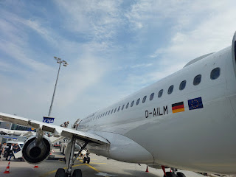

My last flight was short, only about 90 minutes long. The huge, puffy white clouds over the Alps never get old. I rested my head against the window and listened to some music through my ear buds, alternating closing my eyes to rest and occasionally opening them to look down at the views below.

Somewhere over Switzerland . . .

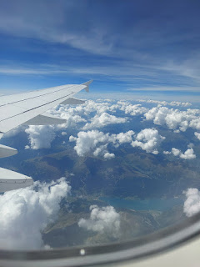

Preparing to land over Venice . . .

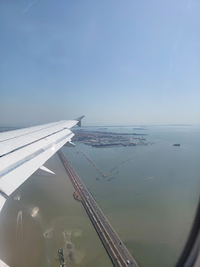

By the time Scott picked me up in Venice and drove me home, I was so trashed. When we walked into the house, I headed straight for bed so I could lay down for a while. Upwards of an hour later, I groggily opened up my eyes so Scott could offer me some water and a light snack. That hour of closed eyes, on a solid bed that WASN'T MOVING, helped tremendously.

Over the next 24 hours, though, I struggled with bouts of dizziness and nausea, and a killer headache that gripped tightly around my entire head. On Saturday, close to lunch time, I felt a prompting to ask Scott to give me a priesthood blessing. At first, I dismissed the thought, reasoning that I've been "sicker" before, so I shouldn't ask for a blessing when I'm not "that bad". But when the thought kept coming back and wouldn't leave me alone, I knew better than to ignore it.

With tears welling up in my eyes, I asked Scott if he could give me a blessing. "Of course," he gently replied, helping me to sit down on the couch in the living room. During the blessing, he laid his hands on my head and said a very sweet prayer to God in my behalf. He not only prayed that I could receive proper nourishment and receive strength to restore my equilibrium, but he also prayed that I could be made whole so that I could continue to serve the people around me - something that I always long to be able to do. I never want to be compromised for too long, or out of commission to the point that I can't do things to help people around me. That would be a very dark day in my world if I couldn't help someone . . .

After more hours of rest throughout the remainder of Saturday, I began to feel the dizziness ease up quite a bit by early evening. I slept pretty well through Saturday night, and today, on Sunday, I feel like I'm at 95% capacity again. I'm still a little weak, and I still feel the occasional "buzz" from the dizziness that tries to lurk in the shadows, but for the most part, I feel like my energy is returning and with that, my appetite! I went 3 days without hardly eating. Today, I am almost constantly hungry. I chose not to fast today, even though it was a Fast Sunday (normally we go without food/drink for 24 hours on the first Sunday each month), because I am trying to restore my electrolytes and my overall health. I can choose another day in the near future to fast, at my convenience.

As I was getting ready for church this morning here in Italy, I was thinking back to that prompting yesterday to ask Scott for a priesthood blessing. I wondered why that prompting was given . . . after all, I've had worse situations before, so why would I need a blessing in this "lesser" circumstance?

Thoughts began to flow into my mind and into my heart, teaching me something that I had not considered before. When I am at home in Idaho Falls, I am typically in "work mode", usually out of necessity. There are more chores to take care of there, such as pulling weeds, maintaining the house, hosting children and grandchildren, etc. I was taught in my youth to work, and to work hard, so I try to put any annoyances or complaints aside in order to just get the jobs done. I roll up my sleeves and plug away until either the job is done, or I reach a reasonable stopping point. I don't typically shy away from things that need to get taken care of. I try to adapt to what needs to happen, and then I break it down into manageable chunks so that I have clear steps, including a starting and ending point.

Coming here to Italy, though, means that suddenly I don't have to shoulder everything alone anymore. I have a husband to help me and to shoulder a portion of the load that life brings. When I arrived, all kinds of exhausted, I was not thinking yet about how there were TWO of us to deal with life's curveballs. I was still in the mode of "I gotta", and "I needta", and "I should justa"...

But by asking for a priesthood blessing from my husband, I was essentially asking for help and humbly admitting that I can't do this life all on my own. I was also acknowledging to my Father in Heaven that I needed His help. It takes a certain amount of humility to be able to ask for help. But more importantly, He wanted me to know that I don't need to "do" life alone, that I have a husband, access to the priesthood of God, and God Himself to help me with whatever is weighing me down. And yeah, I was feeling weighed down with those 500+ lbs . . .

Suddenly, I didn't feel so alone, or that I needed to have Herculean strength on my own, and that it was okay to get some help. Help was available to me. Love was available to me. The priesthood of God was available to me. Healing was available to me. Rest from my weariness was available to me. And happiness on the other side of the illness was waiting for me.

I ruined a perfectly good makeup job this morning as I went into Scott's office to tell him about this whole thought process. But it was a good practice run to share everything with him first, so that during the Fast & Testimony Meeting at church, I could get up and share a shorter and more succinct version (with less tears) ha ha.

I am confident that I will be in good shape by the time my sister, Charmaine and her partner Scott arrive in Italy tomorrow (Monday) and that we can have a lovely 12 days together in this beautiful corner of the world. The temperatures have been scorching for several days, and I'm not usually here until later in September when things cool off a bit more. But we will find ways to beat the heat and to even hide from the heat.

In other news . . .

I did a quick book-scanning project last Monday at the FamilySearch Center in Idaho Falls. At the recent Rawles Family Reunion, my cousin, Jeff Vargen, loaned me the family history book that his elderly mother had made, so that I could scan it and glean some genealogy from its pages. I haven't used this tool at the Center before, but it was pretty cool.

I had to use some yoga poses to stretch some of the pages nice and taut . . .

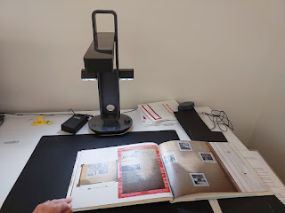

Checking the screen to my left, I could identify if the book page was lined up within the onscreen "box" or not, and to see if any adjustments needed to be made . . .

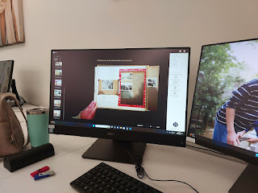

Once it all looked good, then I could tap the clicker with my foot so that my fingers could continue to hold the pages nice and taut for a good scan . . .

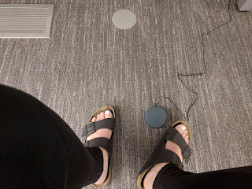

It was so cute - there was a conversation that was happening a little ways across the room in the FamilySearch Center . . . an older gentleman who was a volunteer missionary was helping this guy figure out how to use some of the equipment. He wanted to convert an old camcorder tape to a digital format, but needed a little more guidance in the process. The older missionary was saying things to him like, "Did you ever drive a '67 Ford? Or a (whatever year) (whatever model car)? Well, how did you save your favorite radio station on the dash? Yeah - by pushing a button. And that's all we're doing here, too, is pushing buttons. Sure, ya gotta push the right ones, but it's all the same process. Don't you worry, I'll show you which ones to push." How sweet is that.

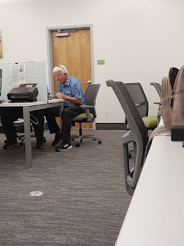

I also found a couple of fillers for a spot in my living room that needed a little pizazz. I needed something with some height, some oomph, and I didn't know exactly what I had in mind, but I knew that Hobby Lobby would have several good options. I carefully browsed the store and brought home a tall vase with creamy gold and taupe floral stems, a tall lantern with a battery-operated candle that sits inside, and a little green plant to nest inside a metal serving tray. (I already had the "Welcome Home" sign)

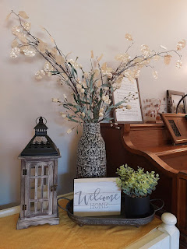

I really like how it turned out . . . and I look forward to cozying up on the couch next to this table in the upcoming winter. This is my favorite spot in the house, on the soft grey couch with my feet up on the footrest, and a lovely view out the living room window. Usually, I sit here and type on my blog every week.

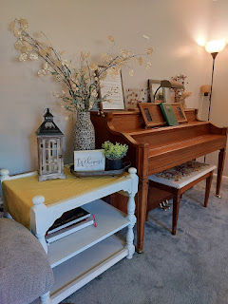

For my birthday on Tuesday (Aug. 27), I attended the Idaho Falls Temple with my friend, Barb Vance. We sat and whispered quietly together in the Celestial Room after the session was done. I really felt the love and the power of God in my life from attending the temple that day. I knew that it would need to carry me for a while until we can get down to the Rome Temple in October.

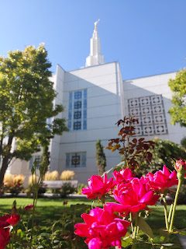

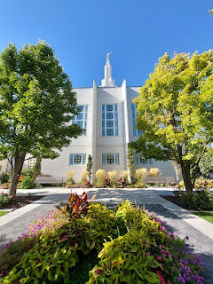

I also went out to eat with my niece, Vanessa, and some of her family. They had me over for dinner last Sunday, too, (in Rigby) because we celebrated a dual birthday for her daughter-in-law Bethanne and for me. Bethanne's birthday is on Aug. 25th and she is such a wonderful person. I have always felt a lot of love in my heart for her ever since she married our nephew Caleb, roughly 5 or 6 years ago. She and Caleb lived in our house for a year while Scott was serving in Saudi Arabia, and I quit my job to do some couch-hopping (a.k.a. family visits all over the country) for about 8 months. (2019-2020) I love that our birthdays are so close together every year. :)

My Dad messaged me in the days leading up to my birthday, asking if there was a way he could honor me or celebrate with me somehow when I was about to leave the country. I suggested that maybe he could place some flowers on a family member's grave in my behalf and then send me a photo. So he drove up to the Laytonville Cemetery to place some bright and beautiful flowers as a birthday gift to me. XOXO

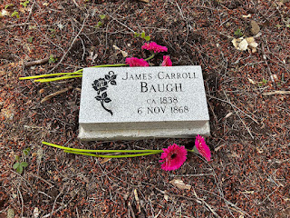

Apparently, this was the FIRST TIME he's EVER placed flowers on a headstone in 76 years!! When I asked him how this was true, he said, "I've just always watched other people place the flowers and I just stood back and let them." He also added that he wasn't allowed to attend the funeral for his grandmother, Sarah Jane Baugh, when he was 7 years old. Everyone thought he was too young for such a thing . . .

He also shared that Sarah Jane's favorite dessert was peach pie and he remembers a birthday celebration for her, when she turned 88 (in 1954). Someone (I think it was Grandma Zoe) had placed 88 candles in the peach pie for her to blow out, which was pretty difficult as he recalled.

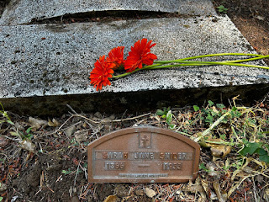

Well, I'm so glad he had the opportunity to have such a beautiful "first" . . .

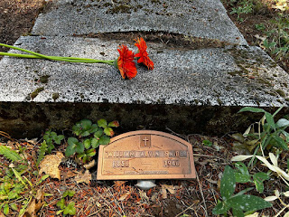

Meanwhile . . . Amber has been loving the sweatshirt-wearing weather in the PNW (Pacific NorthWest). She shared this photo recently - mentioning that she got caught in her first rainshower while out and about and that Weston had to come and rescue her . . .

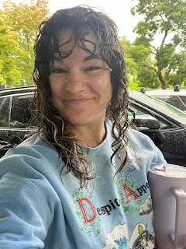

They love having evening swims as a family in their community pool at the apartment complex, too.

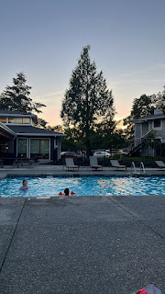

And Jack has been harvesting and munching on some late summer garden treasures, like this giant carrot . . .

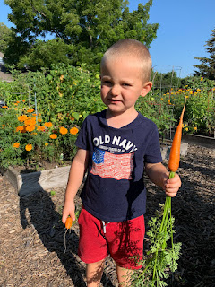

He had a great time riding on this interesting carousel horse with guilded decor . . .

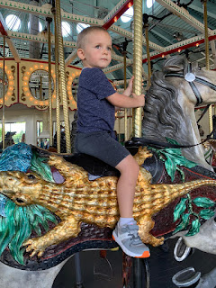

And his parents continue to take him to the local library often, where Jack enjoys learning about dinosaurs, whales and other sea mammals, and whatever else. He is one smart little boy!

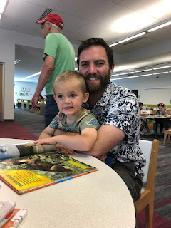

Hannah is doing well, as per Jake when I spoke to them on my birthday. She is due on September 4th, but has only had just a handful of occasional contractions. There is a University Hospital about 10 minutes away from their apartment in Minneapolis, where there are several midwives she's been seeing throughout her pregnancy. One of them will be the lucky assistant for whatever day our little granddaughter decides she's ready to come join the Harmon family. We are so excited to meet her and we'll be sure to share details and photos when that day arrives. XOXO

In the coming week, my sister and "her" Scott, plus me and "my" Scott, will be going on some fun adventures together. Stay tuned for a great blog post next week . . .

