Lost Luggage, Weeds, and E.Coli
Sounds depressing, right? Lost luggage, weeds, and e.Coli . . . Well, even though each of those things were a bit discouraging, I am doing great! I am happy and thriving. :)

(In the air getting close to Idaho Falls)

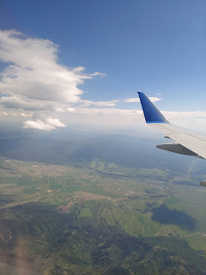

I was able to travel all the way home on Tuesday, without any tummy issues to speak of that entire day, which was a huge blessing.

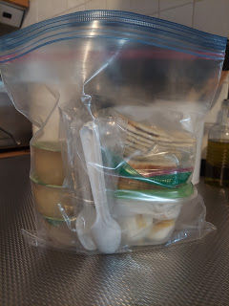

I packed some essentials to snack on, such as applesauce, saltines, a couple of bananas, and a couple of boiled eggs (peeled and ready to go in a small protective container, along with some salt in a ziploc bag). When they handed us our lunch tray on the long flight from Munich to Denver, I was so happy that I could eat a few bites of the pasta with tomato sauce and didn't have any disasters happen afterward!! Plus, it tasted so amazing . . .

There were a few other miracles that happened that day, as I hustled to make each connecting flight. When we left Venice, we were 30 minutes behind schedule. I already had a tight connection in Munich (only 50 minutes), so my window of opportunity was now chopped down to just 20 minutes to get from one plane to the next. Yeah, right . . .

But when we got off the plane in Munich, someone was waiting for the small group of us that needed to catch our next flight to Denver. He had a sign saying, "Denver" and indicated for us to come stand next to him as he checked our boarding passes. Then he sent us off with another young man who DROVE us across the airport tarmac in a
private van
, taking us to our own
private passport control office
, then zipping us across the tarmac once again to get us close to our gate. He accompanied us up to the airport level that had the final passport control area, he secured us a spot at the
front of the line
, and then our gate was just beyond that checkpoint. We made it! Amazing . . . Yeah, the Munich airport might be huge, but they are EFFICIENT!! Good job, Germany!!

The 9.5 hour flight took off only 10 minutes behind schedule, with all of us on board that needed to be. I watched a couple of movies, read a magazine, and rested. All was well. :)

When we landed in Denver, I had 1 hour and 40 minutes to get through customs and catch my last flight going to Idaho Falls. I figured that was plenty of time . . . but then again, it's Denver. Ugh.

We stood in line for over an hour just to get through customs. By this point, I had received a text that my next flight would begin boarding in 15 minutes!! I hadn't even seen the customs agent yet! And I didn't know which terminal I was in, or which terminal my next flight was in . . . There was also a bit of confusion when I moved on to the next area, which was a customs baggage claim area. They were telling me that I needed to retrieve my luggage before moving on. But I was thinking, "why would I need to collect my luggage when it should be checked all the way through to my final destination??" Plus, there were like 20 flights' worth of luggage all piled up on one baggage carousel, so much so that several suitcases were falling off onto the floor. I did a really fast lap around the entire carousel and didn't see either of my 2 suitcases. I knew I was going to miss my flight if I didn't hurry up, so I asked a lady that worked there what I should do. She said I could just move on to make my next flight, and that at some point the luggage would catch up to me.

I literally RAN to catch the train to the other terminal, RAN through the next terminal, and BARELY made my flight to Idaho Falls. They were in the final boarding process . . .

When I arrived in Idaho Falls, I was not surprised at all when my luggage didn't show up. TWO DAYS LATER is when they showed up. One had been stuck in Munich with that super tight connection, and one had been stuck in Denver. But somehow, some way, they made it back to me. Hallelujah!! And they even delivered them right to my front porch. How sweet.

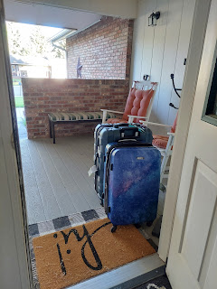

At least I had other clothes to wear because I was in my own home, but I didn't have any make-up or medications. I bought a few essentials early the next morning, but had to wait for my medications to arrive. Lesson learned is this: bring enough medications with me in my backpack next time, just in case this happens again.

So far, it feels pretty good to be home. I wasn't sure how I would feel about actually being in my house again, especially without Scott. It feels weird, but good, but weird. It's comfortable to be here, in a place that we worked so hard on over the years, in a wonderful neighborhood with friends and good neighbors. It feels good to be on U.S. soil where English is the primary language spoken. But it feels weird because I left my husband to be here and now he's on the other side of the world without me. He's eating his meals alone, as am I. And it feels weird, too, in the sense that even though this is my native country, I feel like I've somehow abandoned all of the military families back in Italy, like that I've somehow walked away from them and our budding friendships. In a nutshell, I feel like half of my heart is here in Idaho, and half of my heart is back in Italy.

Just before landing in Idaho Falls . . . the view was beautifully familiar.

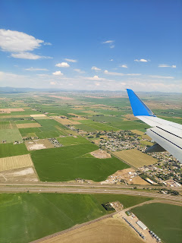

My friend Barb picked me up at the airport and drove me home, where I was shocked to see what a jungle my front yard looked like when we pulled up in the driveway. I had hired a landscaping company to take care of things while I was gone, but it was clear that they didn't take their job seriously. They turned on the sprinklers and fertilized the lawn, but that's about it. We had talked in great detail about keeping the weeds under control and how they intended to do that, but it did not happen at all.

The Scottish Elm (a.k.a. Umbrella Tree) was in desperate need of a haircut.

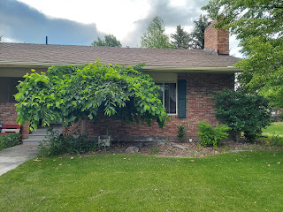

And the weeds underneath were tall enough to touch the drooping leaves hanging from above. Horrible and unacceptable.

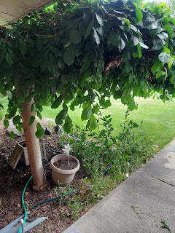

This was one garden bed that I had discussed numerous times with the owner of the landscaping company. I told him I would not be planting anything in my raised bed this season, and he said he would just have his crew spray roundup to kill any potential weeds. Um, I don't think they sprayed any roundup here . . .

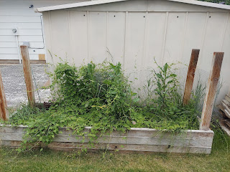

Even the firepit was growing weeds!

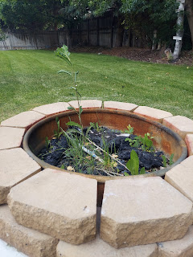

I'll need to harvest the rhubarb right away because it's gone to seed . . .

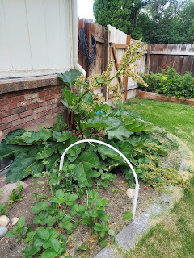

And my patriotic perrennial garden out front was FULL of weeds.

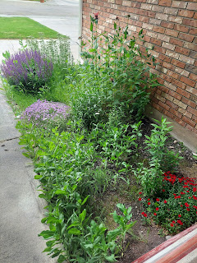

When I live next door to this (see below) - - I have to do my best to maintain my yard so that I don't get in trouble with the city for neglecting my property. Thank goodness for the Parkinsons across the street, who have been mowing my lawns and weed whacking regularly.

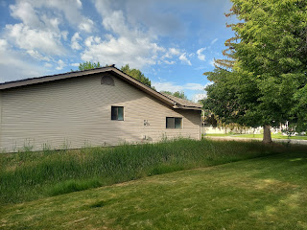

I've been working on clearing out the weeds these past few days, and have completed about 1/3 of what needs to be done so far. I even gave the Umbrella Tree a haircut, and he looks much nicer now.

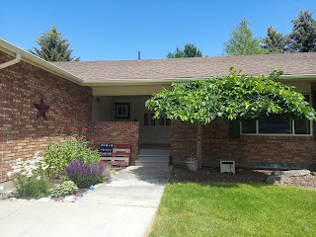

I sprayed off the front porch that had been covered in dust and pollen. It looks so much better now! I also restored the patriotic garden to its former glory, just in time for Independence Day. :)

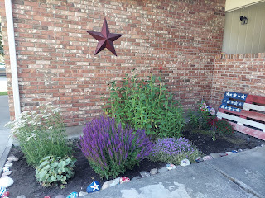

The day after I got home, I went to see a doctor about my Traveler's Diarrhea from Morocco. It had been hanging on for 9 days by that point and I was still on a very limited diet of bananas, applesauce, white bread, saltine crackers, and scrambled eggs. He had me take a stool collection kit home. How fun!

It didn't take long, once I turned in my sample to the lab at Mountain View Hospital, to get some results. There were 2 strains of bad bacteria in my gut: Campy Lobacter and e.Coli. The nurse told me that we all have some e.Coli in our gut, but it's usually in small amounts. This time, however, it had gotten out of control and what few good bacteria I had inside couldn't keep up or conquer the bad ones.

On Wednesday, when I went up to visit Scott's parents in Rigby, my mother-in-law gave me her last few probiotic capsules (the refrigerated kind) and I started using them immediately. I took one capsule that evening, and one the next day. By Friday, I noticed a marked difference in how I felt. I felt NORMAL for the first time in 11 days!! I was able to venture out and eat some granola for breakfast, some strawberries and watermelon for lunch, along with a little bit of pulled pork that I pulled out of my freezer. The food tasted AMAZING!! It's crazy what we take for granted. But imagine being on that kind of diet for 11 days and that's ALL you could eat. When you can finally eat something like a strawberry, it's just magical. :)

Later in the day on Friday is when I got a call from the nurse with the results from the lab. When she heard that I was feeling significantly better from using the probiotics, she said not to worry about picking up the antibiotic they had prescribed. The antibiotic would just kill everything - the good bacteria along with the bad. But the probiotics had beefed up my supply of good bacteria soldiers in my gut, and it was clear that they were winning the war against Campy Lobacter and e.Coli. Way to go, guys!!

In all, I lost 8 pounds in just over a week. Some might say that's a great way to lose weight. They are not wrong. But I still wouldn't recommend this weight loss plan to the next person . . .

I've been doing a little bit of research because I don't want this to happen ever again. There are probiotics and special formulas (such as Saccharomyces Boulardii) that can help to prevent traveler's diarrhea from ever happening in the first place. I am SO GRATEFUL to know this!! I can go to Morocco again next June and not be scared out of my mind that I'll get sick again like I did this time. Hooray for modern medicines and herbal remedies!!

Scott finished up his work in Morocco and has arrived safely back in Italy. We got two new A/C units installed - the day before he got home - and he says they are VERY efficient! He keeps turning the temperature UP because the air is so cold in the house, ha ha.



He went to the Leroy Merlin store yesterday and got a shade canopy for the terrace. It will help to keep the upstairs guest room cooler, which in turn will keep our house a bit cooler overall, too. He was able to anchor each of the canopy legs with strings that attach to something underneath the brick squares. What a good little worker he is!

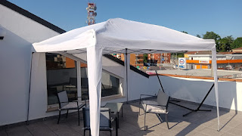

Time for Grandbabies . . .

Last Sunday evening, I drove up to Aviano one last time to see
Avery
before I left Italy. She is getting so close to crawling (!) and her 2 bottom teeth have poked through the gums now. She is always so friendly and darling - and I'm so glad I could see her again.





Kylie and Avery

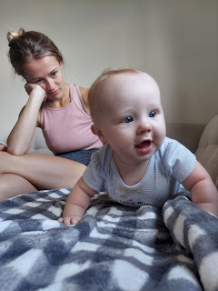

Benson and Avery



Video #1: Avery is excited to get over to the water bottle next to me and her bag of Gerber melts. (40 seconds)
https://photos.app.goo.gl/dGvuCfQqM762b4T27

Video #2: Avery is still trying to get over to the same items, and tries to pull herself closer. (27 seconds)
https://photos.app.goo.gl/boooXYuEgpX9PH4Y6

Video #3: Avery had been giggling with Kylie, and I tried to catch it on video. (20 seconds)
https://photos.app.goo.gl/HRgxRZKktFGHR7o58

Video #4: Kylie sent this yesterday. SUPER CUTE!! I love her cute little raspy giggles!! (59 seconds)

https://photos.app.goo.gl/h7CuA2k7aqXavkQf7

Jack
has been having a lot of summertime fun on the East Coast.

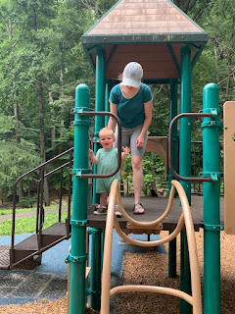

Video #1: Jack is so proud of all the rocks he's digging up from the stream! (59 seconds)
https://photos.app.goo.gl/p9vpMQymNeF2x93w8

Video #2: Jack is trying out a summertime favorite snack food - Doritos. (15 seconds)
https://photos.app.goo.gl/RLCqHdbDuhswJ1mKA

Video #3: He loves hiding in the closet and shutting the door. (13 seconds)
https://photos.app.goo.gl/mo6kQ3CbbKv4vSKh7

I don't have any fresh photos of
Abby
or
Gwen
, but they all had a wonderful time on the beach in Florida for their family reunion last weekend.

Amber and Weston - XOXO



Amber has been struggling with issues from ADHD for a while now, and is trying to be patient as she waits to get an appointment with a medical professional. We talked on the phone yesterday for a quite a while. She was pretty discouraged about her inability to concentrate and complete basic tasks, but I told her to give herself a break. Just love those girls, and love her husband and
herself
, while she waits to get a prescription and some relief. We talked about a lot of things and she felt more uplifted and peaceful by the time we hung up. I'm grateful for what a wonderful person she is, and I don't want her to feel that the ADHD is ruling her life. She is so much more than ADHD!!



As for me, I'm trying to keep my Italy mindset (to slow down and enjoy life more), even though there are several things that I need to devote my time to in the near future. Girls Camp is in 1.5 weeks and I have a lot to do in preparation for that. More weeds need to be pulled. And I have already begun a FUN project for Avery - a quiet book for her 1st birthday later this year. I figure now is a good time to work on it, while I'm at home with all of my supplies, and then I can bring it back to Italy in my suitcase. :)

I am grateful to be home, to be in the United States of America, to have a roof over my head, to be in better health, and to have good things to look forward to. Life isn't always easy, but we can choose to be happy in spite of the tough things that we are sometimes dealt.

