Lots of Babies and Crafting
As I looked back through my photos from the week, they were overwhelmingly all about the beloved babies! It was a fun week to see all of my grandchildren and all the wonderful things they are doing.
Amber's family:
They are all fully recovered from Covid and are doing great. Abby went back to school this week, and Gwen went back to preschool as well. They enjoyed a fun visit with Weston's parents last weekend, staying at home mostly, and even worked out in the yard together - chopping down trees and pruning rose bushes. How nice that they weren't buried in the snow to be able to do all that!
Gwen, polishing off her giant carrot.
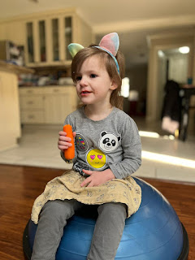

Amber and Gwen took the most darling photo while having a delightful lunch date together.

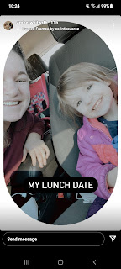

This little gem (Gwen) popped up on Amber's Google photo memories sometime this week. She looks to be quite conniving and precocious at such a young age . . . :) Moo-ha-ha-ha-ha

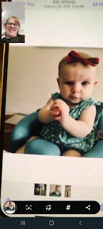

I video called the Whitworths on Tuesday and the girls were so excited to talk to me - but both at the same time unfortunately. Gwen snatched the phone within 3 seconds of me calling and ran off with it (and me). She wanted to show me the fort that she built in the living room . . .

This sent Abby into tears because she wanted to talk to me just as badly as Gwen did. By the time Amber rounded up her phone and brought it back to Abby, I could hear her sweet little words in the background, "I just never get to talk to Mimi very much because I'm always at school." Sadly, she's right. I need to make it more of a point to call when Abby is home, too. We had a great chat this time, though. She sure is growing up fast, and I love having deeper conversations with her because of this.

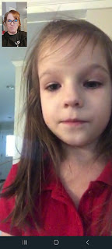

Amber and I chatted for quite a while after I talked to the girls - she was working on dinner in Louisiana while I washed dished here in Idaho. It was nice to just "hang out" while we simultaneously took care of our own household responsibilities.

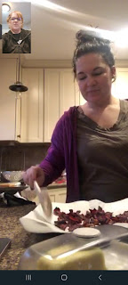

Amber also started on a cute project for Gwennie's bedroom. She designed an accent wall that looks like a Victorian village of some sort, and has been busy painting all of the detail work the last couple days.
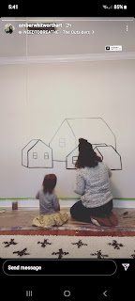

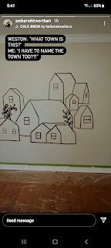

I'm sure Gwen is SUPER happy about these creative additions to her room. It looks so inviting and I can just imagine some of the stories that she will come up with as she falls asleep every night.

The girls also had a fun time playing on this exercise ball called a BOSU trainer. You'll see it here . . .
(30 seconds)
https://photos.app.goo.gl/7nrszUg9bbg4uv9o8

Amber also shared this hilarious photo that she found in a public bathroom. It says: "Wash your hands like you just ate crawfish and you need to change your contacts!" Only in Louisiana . . . :)

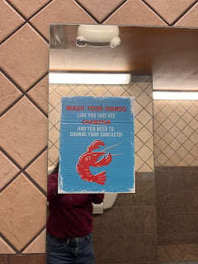

Jacob's family:
They have been moving into their new apartment this weekend, and as far as we know it was a success. We will try to call them later today (Sunday) just to double check. Below you can see Jack drinking his bottle on the freshly cleaned carpet at the new place.
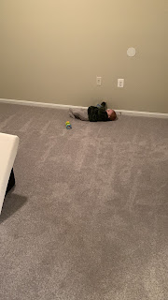

Here are a few darling videos of Jack from the week.

Video #1: This one shows just how fast Jack's army crawl is lately. (20 seconds)
https://photos.app.goo.gl/GFvrovyuuVuTFqq38

Video #2: Hannah is patiently trying to chop up another bite of food for Jack. (29 seconds)
https://photos.app.goo.gl/pMJKCmRfJdWXUa877

Video #3: Jack is eating his little goldfish crackers and doing a silent happy dance. (31 seconds)
https://photos.app.goo.gl/vYn5puafLKhH7KDu8

Video #4: Jack is learning how to stand and hold onto the couch now! (50 seconds) Plus you can hear their cute nickname for him - "Buggy".
https://photos.app.goo.gl/abgoCskwqhAKVyCz8

Video #5: Jack is having the CUTEST giggle fit - while he also has a mouthful of green goo at the same time. (34 seconds)
https://photos.app.goo.gl/NaLEteww5r5VSuTXA

Somehow they made it through working all week and caring for Jack and packing up all their belongings at the same time! What a week they must have gone through. Jacob shared a photo of what he called "Rainy Day Nachos" in the middle of the week. He's such a good husband and father, and always enjoys cooking up something tasty. Hannah is such a wonderful mother, too. I particularly loved the video of her making Jack laugh. I can just feel how much love is in their home and it makes me so happy.



Benson's family:

Between Benson working long hours and them both trying to keep up with caring for a newborn, I'm so proud of them! It's not easy by any means, but they are doing it! Raising children can be difficult at times, but it is SO WORTH IT!! I enjoyed raising each one of my little ones and seeing them develop new skills and watching them grow.

Seeing Avery in photos and videos each week makes our hearts sing because she is just so darn cute!



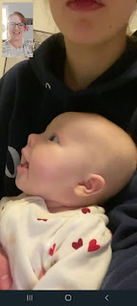



I really enjoyed a video chat with Kylie at the end of the week, too. It was really nice to visit for a while and get a feel for what their life is like in Italy with a new baby. They are trying really hard to learn all the things that caring for a baby requires and I'm so proud of them and all they are doing!

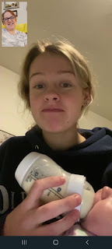

Video of Avery just talking up a storm. (19 seconds)
https://photos.app.goo.gl/g4JTvmAkg5JXvQ5f7

Scott and Me:

Scott attended two long days of faculty meetings on Monday and Tuesday. The school district is trying to promote a new way (and in some ways reinventing the already invented wheel) of doing things, so it took two full days to get the information out. He was pretty exhausted when he came home each day after having to sit and listen for all those hours.

Early in the week, we squeezed in a couple extra visits up to Rigby, not only to check on Scott's parents and their recovery from (likely) Covid, but to also spend a little time with his brother, Gordon, before he flew home.

Below: Gordon was telling a story while Coy was sampling some of the butternut squash soup I brought up for them. (She had a sore throat and the "cruds")

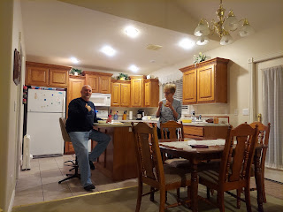

The following night, the menfolk hung out together, discussing everything from politics and religion to the latest football scores. While they solved all the world's problems, Coy and I went downstairs to dig through her craft supplies for my upcoming Big Project.

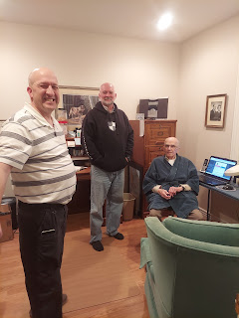

I decided to start making a Quiet Book for Jack's upcoming first birthday. I figured now was a great time to begin, since it's the dead of winter and I needed something fun to dig into. I enjoyed making a "1-year old version" for Abby that was later passed down to Gwen. I knew I wanted to make another one for the next up-and-coming 1-year old. The trick is to find pages that are age appropriate for "right now" as well as having a few pages that are a tiny bit challenging, thus giving them something to learn and master on the way toward their second birthday.

I researched heavily on the internet first, narrowing down my saved photos and Pinterest "pins" to a manageable 10-12 pages total. I made a list (with an occasional accompanied sketch) of what I plan to do, and then I dug through my large supply of miscellaneous crafts to see what I have on hand and what I need to buy.

These are a couple of the pages I've built so far.

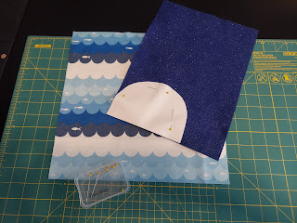

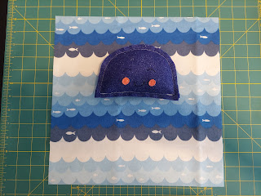

It's a JELLYFISH - with lots of tentacles of varying textures to feel and play with and comb through with your fingers.

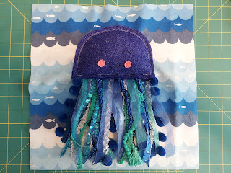

This is a Texture Turtle. He is a work in progress, as of Saturday.

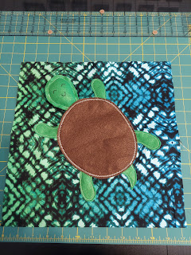

I took this photo to use as my "map". I'm a little more than halfway done sewing on all the buttons by hand.

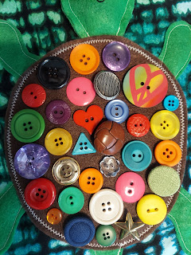

I'll share updates in the coming weeks as I joyfully work through this fun project. For now, this is my work station on the dining room table. Not much room for eating here, but thankfully there's a kitchen counter with barstools where we can eat . . .

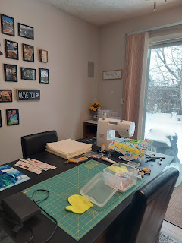

Saturday, Scott and I spent a while cleaning out sections of our room and the office, getting rid of clutter and unnecessary stuff. It felt really good to do some decluttering! I even took it a step further and decided to organize my sewing supplies, which I have been accumulating for years.

It went from this:

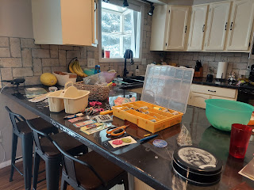

To this:

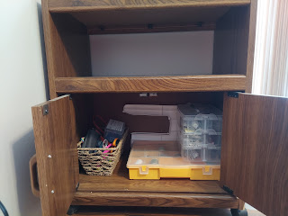

Much better.

I was also able to finish a belated Christmas gift for my cousin, Valorie. She is almost 80 years old and doesn't have any internet. Technically, she's hiding from the "gubment" because she hasn't paid all of her taxes in the past. So she doesn't have a computer or email or anything that the internet provides. We have been writing by "snail mail" for a full year now, sharing stories and other news from our lives. She was particularly interested in the many trips I have taken recently, so I decided to have Scott help me to print 750 pages' worth from my blog and make it all into a Blog Book for her.

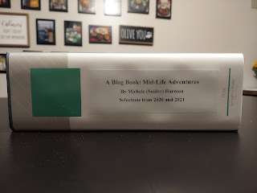

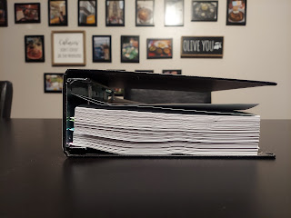

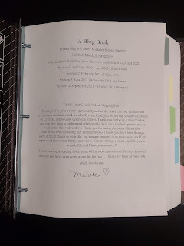

I made a cover page letter for her, and then beautified the plainness of the binder with a big bow. She's always very quick to get a card or letter off to people, so I anticipate a giddy piece of mail from her very soon. :)

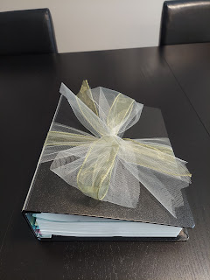

I also researched a new hairstyle for myself. I was 2 weeks overdue with my usual every-5-weeks haircut. (Had to reschedule due to Covid) I searched on Google, using the phrase: "cute updo's for shoulder length curly hair". I found a 3 minute YouTube video that gave instructions for this cute hairstyle below.

Tutorial: (2 min, 55 sec)
https://www.youtube.com/watch?v=_OmqwGEyF7M&ab_channel=leahnoel



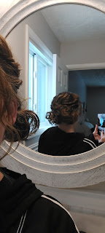

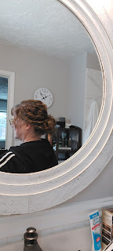

I love it so much! And the best part is that it only takes me about 3-4 minutes to finish. Of course, that's
after
I've allowed my very thick hair to air dry for about 2-3 hours, ha ha. So basically, if I'm just planning to be home most of the day, I put a couple products in my hair to control the frizz and just let it air dry while I do other things. Then, when I'm ready to go run errands, or if I have somewhere important to go in the evening, then this is my new favorite hairdo.

On days that I'm in a hurry to get out the door, I use my blowout hair-dryer to dry it and smooth it all very nicely in roughly 10 minutes. Then I can just walk out the door and my hair is all done. Voila! So it just depends on what I'm doing that day as to how I style my hair . . .

Oh - last week I forgot to include a photo of the cupcakes I delivered to all the young women in my class. It was originally supposed to look like a hot cocoa mug (using a tiny candy cane hanging on the side as a mug "handle"), but I altered it slightly because I didn't have any candy canes on hand.

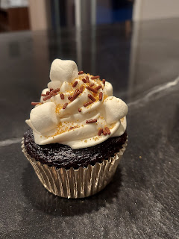

The quote I added was from Elder Jeffrey R. Holland: "Trust God & Believe in good things to come."

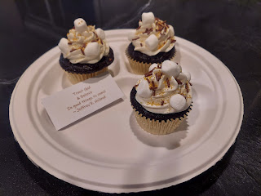

While I chatted with my Dad on Monday, after a separate lengthy phone call with my cousin Valorie, I decided to multi-task. I sanded down the unsightly border next to our new kitchen backsplash, and then applied putty to smooth out the imperfections.

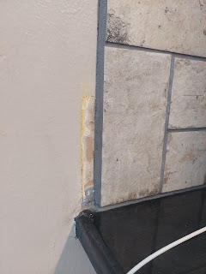

Then I slowly hunted for nail holes in the walls upstairs while I chatted, and filled in each hole with putty. This lovely pattern on my living room wall was leftover from Amber's gorgeous art gallery that used to live here. :)

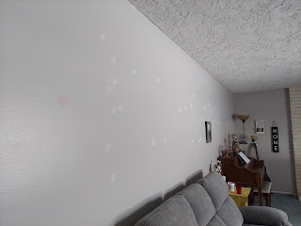

This coming week I plan to paint over all the "chicken pox" walls everywhere, ha ha.

I've also been making a few phone calls to some of my elderly cousins in the Rawles branch of the family, in order to gather some stories and information for an important upcoming project. I have been asked to create a Rawles Family Newsletter to help our extended family get to know each other better and stay more connected when we can't get together for a reunion. Not only have I been preparing a mailable newsletter, but I have also been creating a Rawles Family Blog at the same time. I'm hoping that after a couple of newsletter mailings that more and more people will just subscribe to the blog and we can save some money and some trees.

On Thursday, I borrowed our new YW class president, Linnea (on the right) to make a visit to our new class secretary, Lena (on the left), who wasn't able to come to a couple of very important training meetings recently. We helped Lena get all caught up on information, which she was really happy to receive. While we sat visiting in the front room, Lena's mom made us chocolate chip cookies and brought them in on a tray with cute little mugs of milk. :) Perfect! Especially since we had just gotten 2 inches of new snow that afternoon. Very cozy . . .

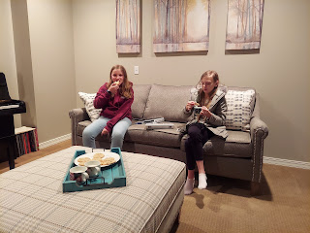

It's so nice to have the evenings and weekends to spend with this guy. Take last night for example. We played games and then stayed up until almost 1:00 a.m. LISTENING TO MUSIC!! (NOT typical at all to stay up so late by the way) We were just having too much fun playing the guessing game. He likes to play a song and see how long it takes me to guess who it is. Plus we were enjoying several new albums on Spotify that we hadn't discovered before. I love hanging out and doing nerdy stuff with my best friend.

We have some wonderful and exciting opportunities ahead, but at the same time, it also hit me recently that it means we will be spending 50% of our time APART over the next few years . . . At least it will be in much smaller and more manageable chunks. (90 days at a time)

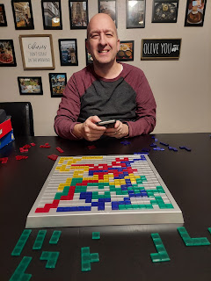

I'm just trying to focus on all the good things that will come from his upcoming service in Italy.
So
many good things . . . but only one potential bad thing. (Us being apart from time to time) I will just have to find projects to do and people to visit . . . :) That's not too hard.

