Minneapolis with Jack and Maisie
Man, I have so much catching up to do!! I'm so behind, but I'll get there eventually, ha ha.

Wednesday, April 2nd:
Two weeks ago we were in Minneapolis with our middle son, Jacob, and his darling little family. We played with Jack and Maisie, and had some meaningful conversations with our son and his angel wife, Hannah. We went to the Mall of America, the zoo, the Cathedral, Little Italy, and a handful of playgrounds and parks.

Video as we drove from the Minneapolis-St. Paul Airport through town and over to the east side where Jake and Hannah live: (9 seconds)
https://photos.app.goo.gl/yQchhepNM7udFF8XA

The skyscrapers peeking through the fog were especially beautiful, I thought.

At 7 months old, Maisie was just coming out of the "Stranger Danger" phase, so she was highly suspicious of us when we first arrived that evening. It took her a little while before she was comfortable being on the floor and independent of her parents, but she was still keeping a close watch on the two of us . . .

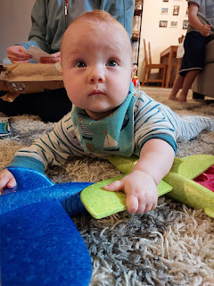

Eventually, though, we wore her down and she was okay to let us hold her. :)

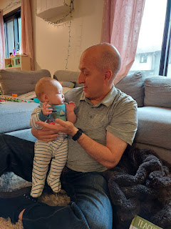

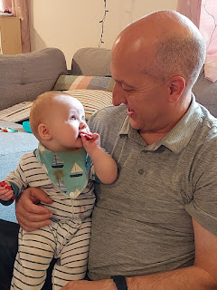

I had a blast playing "Toss the Stuffies Up the Stairs" with Jack for several minutes. He likes all 200 of his stuffies to be downstairs when it's daytime, but he wants them all in bed with him at night. This stuffie-chucking game evolved into a game of "Deflect", a new word that Jack enjoyed grabbing ahold of once I explained it to him. He stood at the top of the stairs and would try his best to "deflect" the giant toy octopus that I was tossing up to him. Eventually, as my pitching arm began to tire, Scott offered to swap me out and the game soon evolved into "Octopus Baseball", a subversion of "Deflect".

Video of Octopus Baseball: (24 seconds)
https://photos.app.goo.gl/AmPeYEg7S33e6Hnb6

We ate a late dinner and then headed to our hotel to get some sleep. We love staying at the Hampton Inn in Roseville, which is just about 6 minutes north of Jake and Hannah's place. We stayed here the first time last November when we flew in from Iceland for Thanksgiving.

Thursday, April 3rd:
After breakfast at the hotel, we drove over to see Jack and Maisie. This was the beginning of 4 days of Jack opening birthday gifts, ha ha. His birthday was on Sunday, April 6th, but he got to open something every day while we were there.

He opened our gifts and Grandma Linda's gifts on the first day. He was in absolute heaven playing with everything! We got him a large set of magna-tiles and a set of glider planes with gun-launchers to send them soaring outside. Grandma Linda sent some under-the-sea creatures and a cute little octopus toy. Jack spent HOURS playing with the tiny little crabs that came in the sea creature set. Everywhere that Jack went, the crabs were sure to go.

He loved lining them all up and then describing what each sea creature was. He is a walking encyclopedia and he remembers everything!

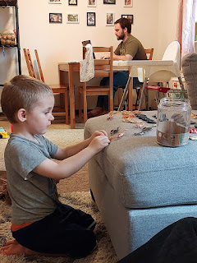

Video of Jack describing his beloved crabs: (1 minute, 12 seconds)
https://photos.app.goo.gl/oY21cV43KC9bEKMo6

Video of Jack describing the Northern Clown Fish and the Northern Fiddler Crab: (1 min, 37 sec)
https://photos.app.goo.gl/jUBzZ1v1UKxJranQ6

Video of Jack describing the Northern Sturgeon Fish and the Northern Puffer: (1 min, 17 sec)
https://photos.app.goo.gl/mx6szdRWBvsuMpCi6

**He had the cutest obsession with everything being a Northern _____ (something or other).

Video of Maisie playing with her little stuffed beaver: (24 seconds)
https://photos.app.goo.gl/AKgDT3XN4JLdDHN9A

Finally, we got a photo of me holding Maisie . . .

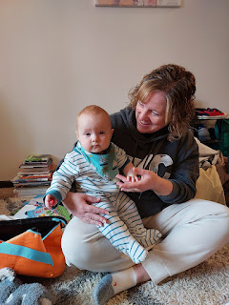

Jack and Grandpa built lots of cool towers with the new magna-tiles, and then Jack would crash them down.

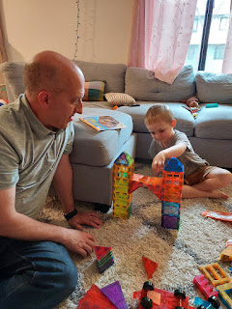

Maisie and I were busy practicing our selfie skills . . .

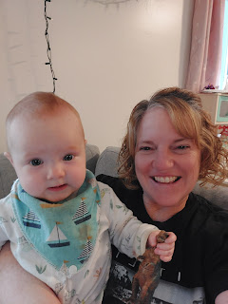

Once Jake got done with work for the day (he works remotely from home), we piled into our 2 cars and caravanned over to the Mall of America, about 20 minutes west and close to the airport. I had heard that it was huge, but I had no idea just how massive it truly was! It used to be a giant sports stadium (the Metropolitan Stadium), which housed the Minnesota Vikings and the Twins. But after it was demolished in 1985, a Canadian development firm won the bidding process and then converted the 78 acres into a mega-mall, an amusement park, a convention center, etc. The Mall of America opened to the public in 1992.

Maisie fell asleep on the drive over . . . what a precious.

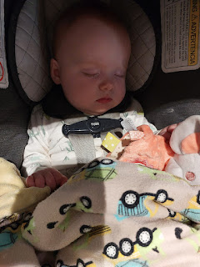

Jake and Hannah said that they enjoy popping over here from time to time because they can just load up their amusement park "card" for Jack to go on a few rides, and then once the card is depleted then it's time to go home. Each ride is worth so many credits, and you can just tap the card to enter.

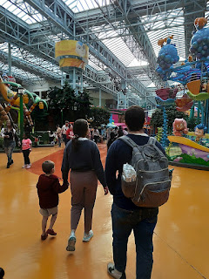

Jack and I went on a ride together . . .

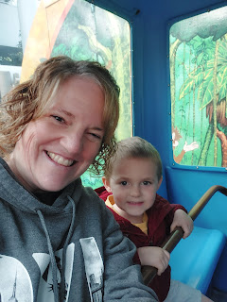

Maisie did a great job of just being adorable . . .

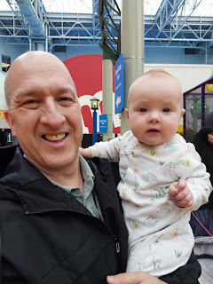

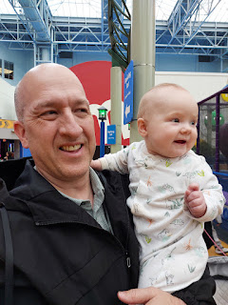

After a few rides, Jack finished out the afternoon in the arcade section.

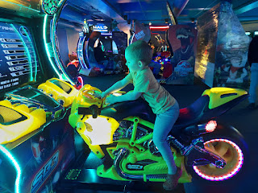

Video of Jake and Jack playing space invaders (I love how Jack's feet are just a-going!):
(6 seconds)
https://photos.app.goo.gl/r5KBQwEYBYC2cAzB6

On our way back to the car, we passed by a booth set up from NBC's "The Voice", where you could pretend you were a judge for a minute. They were also giving out canvas bags with The Voice logo on the side. I am a huge fan of The Voice, so I hopped right into that swiveling seat. They emailed me the video immediately afterwards. Yay!

Video of me on The Voice: (9 seconds)
https://photos.app.goo.gl/DjtekXQf4CW28JQz7

While Jake and Hannah worked on dinner, Scott and I got to play with Jack and Maisie. I offered to help in the kitchen, but I was promptly refused. We were having too much fun anyway . . .

Video of Maisie being a little extra chatty: (27 seconds)
https://photos.app.goo.gl/WKwYukdB4uunbF3a9

Video of Maisie playing with her daddy and giggling: (45 seconds)
https://photos.app.goo.gl/tCPk59emEU1efYiWA

Friday, April 4th:
The day began with another round of gifts for Jack to open up.

Video of Jack opening up the homemade gifts from Aunt Amber: (1 minute, 31 seconds)
"It's a Triceratops Stuffie!"
https://photos.app.goo.gl/j4xiuzZUzGxJeroc9

She crocheted each one of those darling stuffies!!

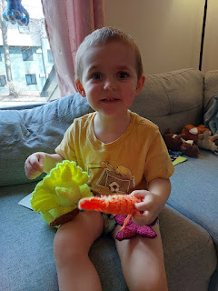

While Jake was working from home that day, Hannah drove the kids and we followed behind to the nearby Rocket Park. There is a similar rocket structure in the City Park where I grew up in Ukiah, CA.

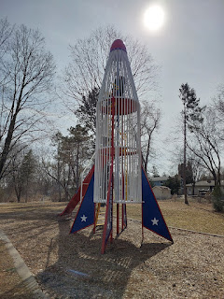

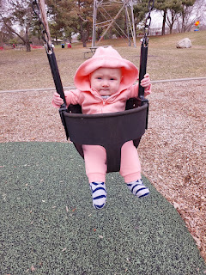

Maisie had this same straight face the whole time she was swinging, lol.
Video here: (6 seconds)
https://photos.app.goo.gl/XppHmqK7Gnou1AAq9

Minnesota weather is pretty crazy. One day it will be comfortably pleasant outside with the sun shining, and then the very next day you step outside and instantly turn into a popsicle. We had a few of those bitter cold and windy days while we were there. It was always a massive slap in the face when you stepped outside and immediately felt that brutal Canadian air take you hostage.

Scott did a good job keeping Maisie warm on one of the "warmer" days that we were there in Minneapolis.

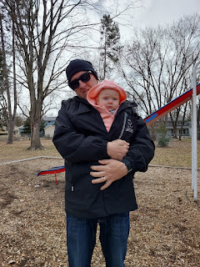

Jenn
- I totally meant to send this to you when I first took this photo 2 weeks ago . . . XOXO
My friend Jenn C. - who is very talented herself - has a very talented daughter who loves to sew. She made me some toddler bibs a few months ago, and Maisie was the recipient of one of them. These bibs are SO SOFT and plush. I just love them!! Thank you Layla!!! Maisie loves hers. :)

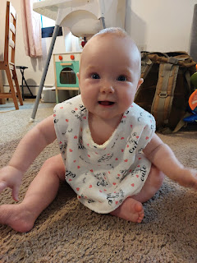

Video of Maisie, with a few additional things to say: (17 seconds)
https://photos.app.goo.gl/v2YmZ2AuyWRZ4fug6

Video of Maisie having a cute conversation with me (I was so lucky she didn't drool in my mouth, ha ha): (36 seconds)
https://photos.app.goo.gl/HbTPGUbbie5irWP16

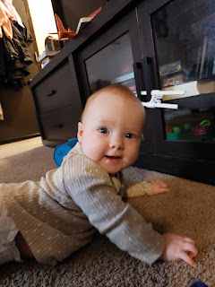

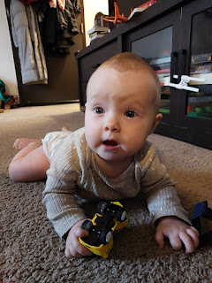

A little tummy time with Grandpa before dinner . . .

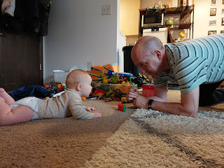

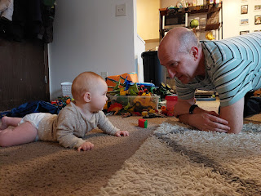

After dinner, we went to see the Cathedral of St. Paul, one of Jake and Hannah's favorite places to show people when they come to visit. It's easy to see why . . . this place was gorgeous!

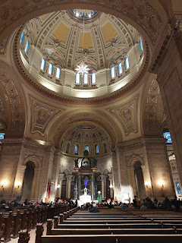

The Cathedral is over by the Mall of America and the Airport in St. Paul. Surprisingly, it looks like it's been around for much longer than it actually has. When I read this description hanging in the nave, I was shocked to learn that it was completed just over a hundred years ago in 1915.

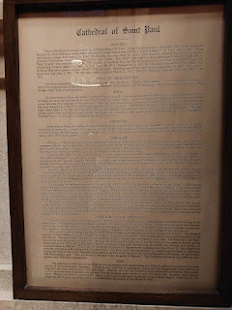

This is a recreation of The Pieta, which was originally made by Michelangelo and resides at the Vatican in Rome.

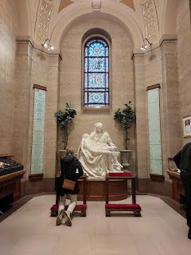

Outside the Cathedral, which sits up on a hill, you can see the skyline of Minneapolis nearby . . .

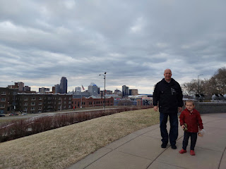

Scott and me outside the Cathedral of St. Paul . . .

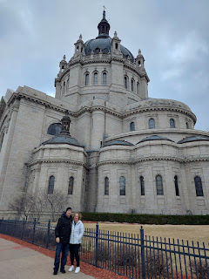

There was a musical program that was about to begin while we were inside the Cathedral, but unfortunately we didn't get to stay to watch it. When you have little ones in the group, you abide by the wisdom of their parents to determine if sitting and being quiet is a good idea or not.

Instead, we drove a few blocks over to visit St. Paul's Little Italy. This place was SO COOL!!!

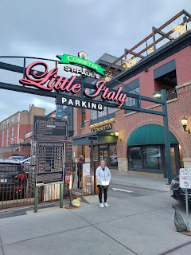

Inside, there are restaurants, shops, GELATO, and so much to take in. We wandered through the grocery store, and I told Jake and Hannah that the items being sold there were spot on as far as offerings and prices. Jack doesn't like anything soft like yogurt, bananas, ice cream, etc. so he chose an apple from the grocer. The guy told us he's never sold just one apple before, lol.

Video of Jack getting his red apple: (8 seconds)
https://photos.app.goo.gl/Xpg3M66gSA81e9Wm6

Video of all the beautiful and very tempting desserts in the glass case: (18 seconds)
https://photos.app.goo.gl/JutZLHHz9me4zaG58

We chose gelato, OF COURSE!!

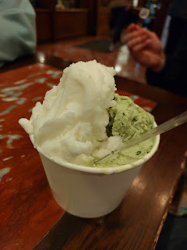

Maisie got her first taste of gelato that evening. She wasn't too sure at first, but I think she did end up liking it in the end.

Video here: (23 seconds)
https://photos.app.goo.gl/pBMfdo9znh4Kg6rX9

Jack devoured his entire apple and we were all happy with our purchases.

Walking the one block over to where our car was parked, it was now twilight and the Cathedral on the hill above us sure looked pretty.

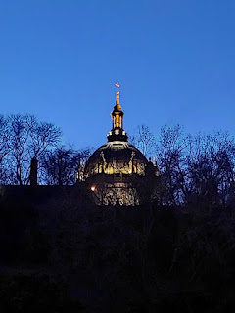

Saturday, April 5th:
We met the family over at the Gymnastics Center so we could see Jack in action. He started this gymnastics class a couple weeks before we got there, and he really looks forward to it. He was a very good listener and followed the instructions quite well, too.

Jack is 4th from the right - sitting on the balance beam and holding - or turning on - his listening ears for the class.

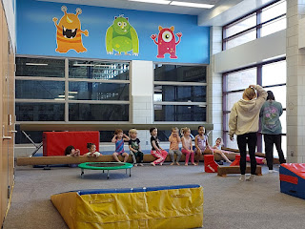

Video of Jack doing the rounds: (40 seconds)
https://photos.app.goo.gl/Zh4DXD1DmAxVaW9Q6

Miss Smiley after the class was over . . .

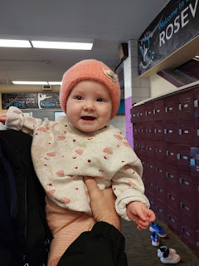

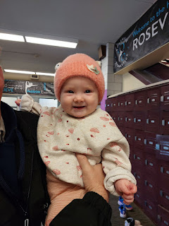

Next up, we all went to Como Zoo - which is a FREE zoo!! They like to come here pretty often.

Mr. Sloth, just hanging out in the tree . . .

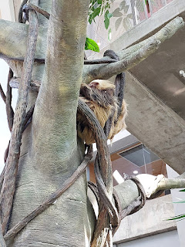

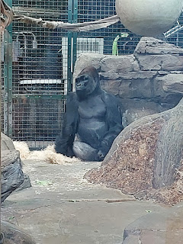

Jack got to pick out a new stuffie from the gift shop for his birthday, and he chose another octopus! :)

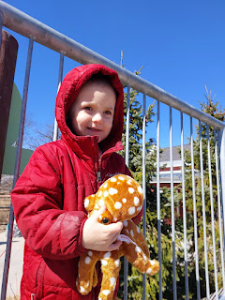

I think my favorite exhibit was the seals. They were so playful and they'd swim right past you as you stood by the window.

Video here: (4 seconds)
https://photos.app.goo.gl/QS1q2LJekJLv6FJV8

Grandpa and Jack pretended to drive the safari jeep. Jack was determined to go fast . . .

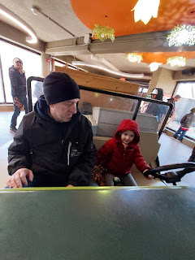

Truth be told, we loved ANY and ALL exhibits that were INDOORS at the zoo that day. It was the coldest day yet! It felt like the word "ridiculous" should be the prominent adjective coming out of our mouths if anyone was to ask for our opinion on the weather . . .

The first weekend in April is also General Conference for members of The Church of Jesus Christ of Latter-day Saints and for anyone else who wants to hear uplifting and beautiful messages about Jesus Christ and how we can become better people, better spouses, better sons and daughters, better friends and neighbors, etc.

Maisie was captivated by the choir singing one of the hymns for the Saturday morning session.

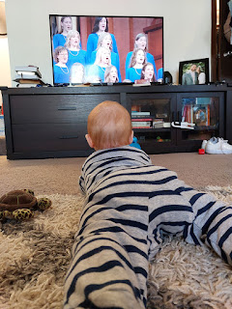

She watched . . .

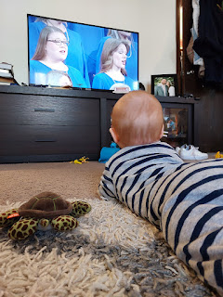

And watched . . .

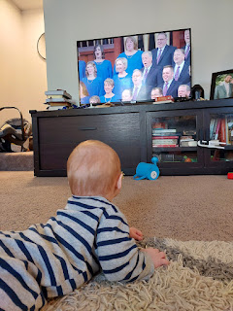

And watched . . . clear up until the opening prayer was finished.

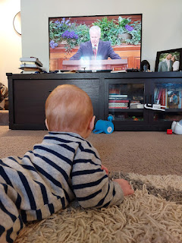

Thank goodness for modern technology! With the conference available to watch on YouTube, that meant we could start it and stop it whenever we needed to. I couldn't stop crying when I heard Tamara Runia's talk, "Your repentance doesn't burden Jesus Christ, it brightens his joy!". She gave so many examples of how you are so loved and worth so much, and how nothing you ever do (or don't do) can change how much God and Jesus Christ love you.

Her talk can be found here:
https://www.youtube.com/watch?v=UkHFwCiT5U8

There were several other talks that meant a great deal to me during General Conference. One of them was by Elder Neil L. Anderson, an Apostle. He spoke about cherishing life, and how on the one hand we do cherish life, and how on the other hand we cherish agency and the ability to choose for ourselves. He spoke about abortion and choice, sharing story after story about young ladies who found themselves pregnant out of wedlock. He conveyed the importance of showing kindness and love to those who struggle with an unplanned pregnancy.

I sure connected to his message because I was in that same situation 36 years ago and I was lucky enough to be shown Christlike love, kindness, and concern when I needed it most. Elder Anderson encouraged us to emulate and follow Christ's example still today. It's not so black and white - the decision that a mother faces when she is pregnant and either doesn't want to be, or when she DOES want to be - but the baby's life or her own life is in jeopardy. We should not judge or condemn. We should be kind and try to follow our Savior Jesus Christ. How would He treat her? How would He
behold
her? What would He say to help her in such a difficult situation?

Video of Maisie being CUTE: (10 seconds)
https://photos.app.goo.gl/MfR7tXMGqmZnQAV86

Jake and Hannah prepared Jack's favorite dinner, even though it was one day ahead of his ACTUAL birthday still. We ate shrimp tacos and watermelon and it was fantastic!! Hannah made mini lemon cupcakes with a lemon and strawberry frosting - also delicious!!

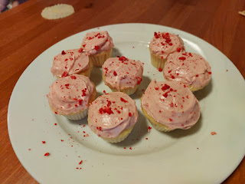

Video of Jack and his "tricky" candles: (18 seconds)
https://photos.app.goo.gl/b4FxEAj4MSaBQFt86

Sunday, April 6th:
We all gathered again to watch some more of General Conference. Jake and Hannah made a wonderful charcuterie board for us to snack on while we watched the messages. They arranged several types of cheeses, two types of salami, and some pistachios and dried figs. Yum!

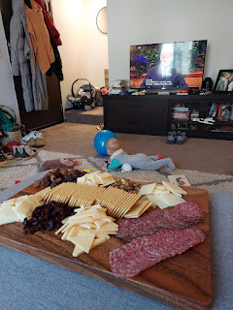

They are such loving parents and I love watching how they teach and interact with Jack. To help him be quiet so we could listen to the talks, they got out a game with lots of cool features that he could play with, yet not have to necessarily "play" the actual game. This kept his attention for several minutes as he arranged, stacked, and sorted the pieces, etc.

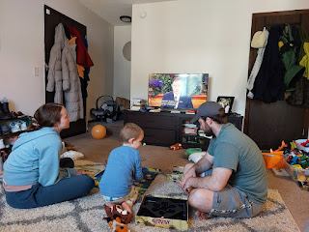

When Jack needed to get some wiggles out, they would pause the conference session and take a break outside. I caught a little snippet of the boys playing out in the sunshine.

Video here: (9 seconds)
https://photos.app.goo.gl/WHPJCHpnc8ma1KGd8
Once conference was all over, we all went swimming at the hotel pool. Jack had some new inflatable water wings to try - he was so excited when he realized he could swim all by himself!! Even Maisie joined us in the pool for a while.

Monday, April 7th:
Sadly, it was time to say goodbye . . . we spent a few minutes with Jake, Hannah, Jack and Maisie before we needed to drive back to the airport.

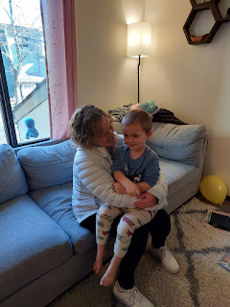

It's possible we might see their family again in the summertime, but most likely we won't see them until October when Gwen gets baptized up in Portland. We're aiming to have a little family reunion that weekend and I can't wait!

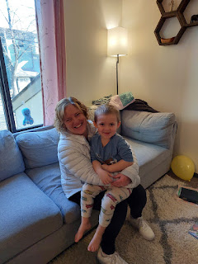

Our flight ended up being delayed by 3 hours, which was frustrating because we knew we had a long drive ahead of us once we landed back in San Francisco where our car was waiting . . .

I guess there was a big storm down in the Tampa, FL area which made a mess of the flight schedule, including ours. Instead of landing at 1:15 p.m., we landed in S.F. at 4:15 and hit the road just in time for the gnarly 5:00 traffic surrounding the Bay Area. How fun.

Seven long hours later we made it to our hotel in Winnemucca, Nevada, having gone up and over Donner Pass in the dark. Even though the temps were down to about 36 degrees near the top, the pavement was dry and safe, thank goodness.

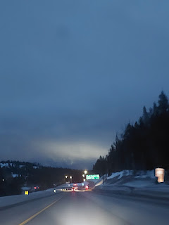

Tuesday, April 8th:
My dad happened to be traveling east on the same day, and he also got a hotel in Winnemucca! We coordinated to meet up for breakfast the following morning, having already adjusted it to be an hour later than we originally planned - due to our late arrival the night before.

We met at Sid's Restaurant - in between our two hotels - and had a great breakfast together.

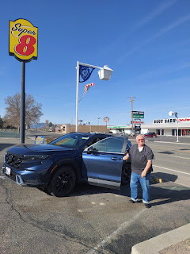

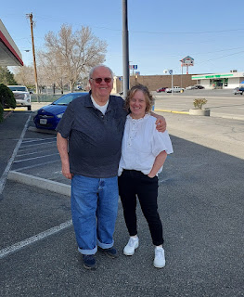

He was on his way to Manti, Utah for a funeral of a dear friend who passed away recently, Claudia Burton. She is who introduced my dad to his second wife, Michelle. I'm glad he made it all the way there and back safely. :)

We made good time getting home on that final day, arriving home just before the dinner hour. Happy Day and Yippy Skip - our passports and visas were there waiting for us when we walked in the door!!

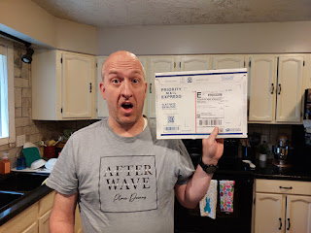

The express mail envelope had tracking to go with it, so Scott was keeping a close watch on where our documents were each day. We were able to let our neighbor Kim know and then she grabbed it out of the mailbox and set it inside for us while we were busy driving from San Francisco to Winnemucca.

I have so much to write about in the next 10 days!!
New banister and railing
Packing up for Italy
A visit to the ENT
We both spoke in church last Sunday
Scott's military retirement ceremony
Easter weekend with Benson
And lots more photos to share!
Happy Easter!!

