Mischief and Ministering
This cute little monkey has been learning some new tricks this week and the adorable smirk on Jack's face below just says it all, ha ha. He is so proud of himself, even if it is just a one-sock-on kind of day...
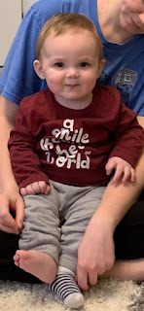

Cute video of Jack giggling: (9 seconds)
https://photos.app.goo.gl/L9Xxp8iDwyZBjLL16

Here is a life lesson for us all: Sometimes we think we know what we want and we are confident that it's the best thing we could possibly do for ourselves. But sometimes there is a Higher Plan in place at the same time, with its own lessons for us to learn . . . that is, if we are keen enough to recognize the subtle opportunity to gain a humbling, yet fresh perspective.

Take Jack for example. He saw an urgent need a few days ago to rescue his beloved Sloth Buddy from being imprisoned in the laundry basket. He knew immediately that he was the one who needed to rescue his friend, and that's what he set out to do. It was hard. It was tedious. He didn't know if he would make it or not, but his friend was depending on him, so he had to keep trying.

What he didn't know is that his loving parents had something greater in mind as they set up this "exercise".

Click here to watch: (31 seconds)
https://photos.app.goo.gl/afg11oFsx3AE48qFA

So many times we think we know what the plan is and what the expected outcome should be. But how many of those times is there an even greater lesson for us to learn from our Loving Heavenly Parents? As we put our trust in Them and keep our focus, They will be cheering us on as well!

Jack had also made an earlier attempt to rescue his other BFF, Cosmo the Cougar (BYU) from the same wretched laundry basket on another occasion. That time it didn't go quite as well though . . .

Click here to watch: (31 seconds)
https://photos.app.goo.gl/xnu58SYr2VQrwo42A

He's also been learning how to stand up on his own now, too . . . even when he's not supposed to be standing up . . .

Go to sleep little one, it's not time to exercise and explore right now. :)

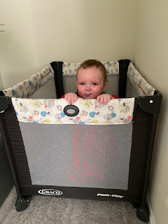

Jack was also the subject of a humorous experiment last Sunday night. His parents realized that they had let winter drift on by without using this furry and fluffy snowsuit to keep Jack warm, and time was running out! Even though the bunny suit was a 9 month size, and even though Jack is wearing 12-18 month clothing, they couldn't resist squeezing him in for a quick photo shoot. Jack didn't think it was very funny.

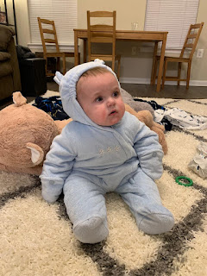

In Other News . . .

Abby and Gwen had their hair done up in curlers one evening after their baths. I bet Gwen was just tickled that her hair was finally long enough for some curls!! She's been talking about having hair as long as Rapunzel since she could first talk . . .

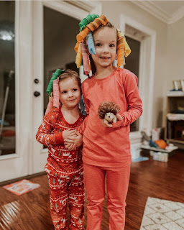

Gwen also got to go on a special field trip with her preschool class this week. They visited the Railroads and Waterworks Museums in Shreveport.

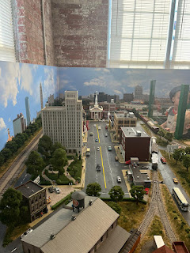

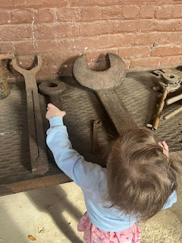

Notice the tour guide's face in the photo below LOL. Amber said he was a really fun tour guide, and that after he saw how Gwen could lift the giant wrench just fine, he asked her to lift all the heavy stuff after that. :)

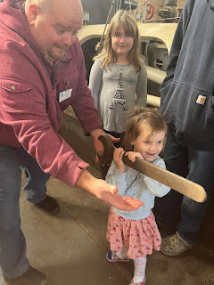

I just love Abby's shorter haircut lately. And I'm so proud of her and how she's learning to try more new foods.

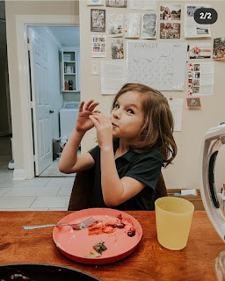

Amber wrote this about Abby:

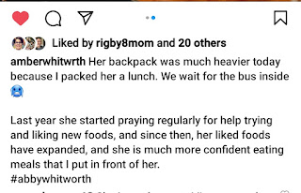

They also got SNOW in Louisiana at the end of the week!! BRRR!! It's always scarier to get snow in the South because they aren't prepared for it at all. They don't have any snowplows or dirt to throw down on the roads to give your tires something to grip onto either. But for the children, it's just a magical wonderland of delight to enjoy!!

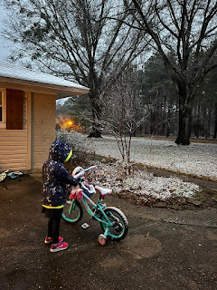

Speaking of snow, we got a tiny bit of snow mid-week. It didn't even really stick to the ground much, but it sure looked like we lived in a giant snow-globe! It was quite mesmerizing to watch the flakes slowly meander down to the ground.

Click here to watch: (21 seconds)
https://photos.app.goo.gl/mpZa47GC9kM6ssZN6

I even went tromping out into the deep snow out back to cut down 2 of our hornet traps. The liquid inside the bags was frozen solid, yet packed with dozens of dead hornets from last summer and fall. Scott thought it would be a good idea to get rid of them in their frozen state since the garbage man was coming through our neighborhood that same morning. The thing I was not prepared for was the stench. I think I will forever have that nasty smell in my nostrils. Gross!

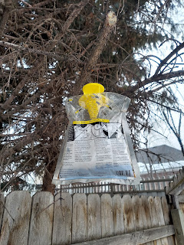

Something more joyful that same day was to bake cookies and arrange some plates for deliveries to our young women that night. We've gone 3 weeks with no activities, just to maintain more of a social distance with the recent surge of Covid cases. But I knew the girls were having a hard time without being able to have regular activities. I came up with an alternative plan that gained approval from the YW president and our Bishop: go pick up my class presidency and take them around to all the girls in our class to give them a plate of goodies and make sure they're okay. It was fun for them to visit at each door and ask how each girl is doing, how's school, etc.

These are the plates I put together for everyone. Homemade oatmeal cookies, plus a cake bite from a local confection shop, The Caramel Tree.

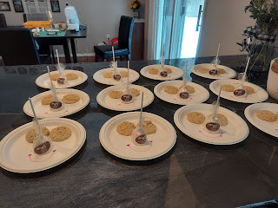

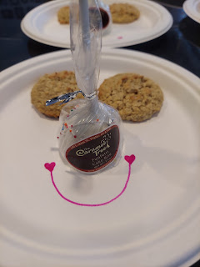

I had picked up a little pom-pom Valentine kit from the craft store, thinking that the girls could just quickly make them in the back seat in between each stop we made. I decided to make one ahead of time to test out the process before I turned it all over to 12 year old girls. That was a smart decision. It was way more labor intensive and I ended up just making all of them myself.

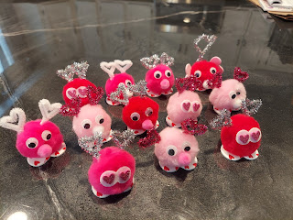

The girls had SO MUCH FUN in the backseat of my car as they came up with names for each pom-pom buddy to give to the next girl. They giggled and jibber-jabbered and had a wonderful time!

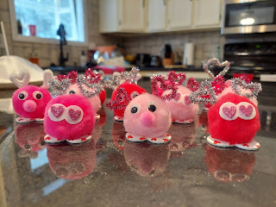

Here they are delivering all the goodies to Sedona, an 11 year old girl who isn't a member of our church, but who enjoys coming to activities and socializing with all the girls who are already her friends. We love for anyone to come to our activities - no matter the circumstances. :)

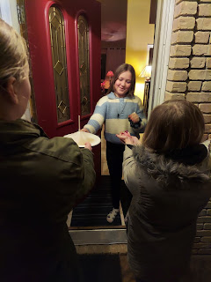

I've been experimenting with my hair lately, and have found another hairstyle that I like.

After blow-drying my hair upside down and getting some BIG results - - -



Some days I just want it all out of my face. So this is what I do with it - - -



I saw this online and couldn't resist saving it. While this isn't 100% me, there are still many things here that I can relate to! ha ha

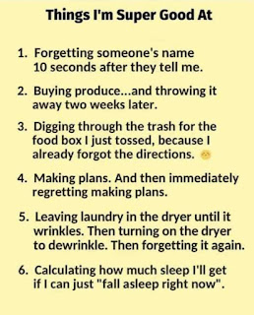

Some days you just need a good motivator to do something you needed to do in the first place. This happened to me on Wednesday. I knew that I would be hosting a YW meeting at my house on Thursday morning and that two of the moms would be bringing their little kids. So I decided to spruce up the downstairs and do some deep cleaning in anticipation of their arrival.

Scott helped chop up a LOT of wood and kindling so we could build a fire early the next morning to warm up the frigid basement. I figured it would be nice to have our meeting near a toasty fireplace when it was only going to be about 14 degrees for the high of the day.

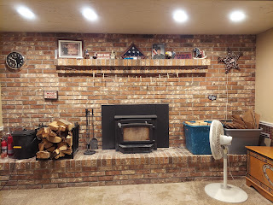

I even deep-cleaned the kids' guest room down the hall so the little ones could play in there while we had our meeting nearby.

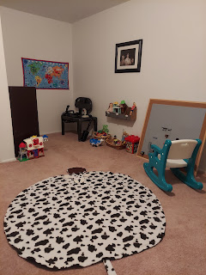

I just miss my little granddaughters - who I originally made this room for. They'll have to come and visit me again sometime soon!

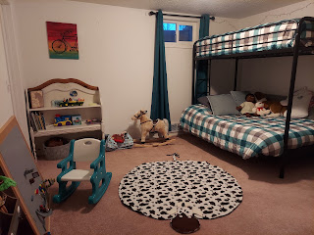

And I finally fixed up "The Way Back", a sort of time machine that we built for Abby and Gwen (mostly for Gwen, who loves to imagine she's in an airplane cockpit pushing all the buttons). The problem is that it had gotten so much use that the joysticks had come off, exposing some very sharp screws sticking up about 2 inches above the table surface. That's not a smart thing to encourage kids to play with . . . so I decided to remove the screws and hot-glue everything back on instead. Much better and much safer now!

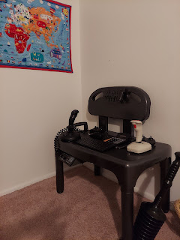

Still later that night, I sliced up 2 big bags of honeycrisp apples and prepared them for the food dehydrator. When Scott got home from the gym, he helped me with the final steps, which was nice. Honeycrisp apples are my favorite I think. They are crispy, juice, and tart. Yum!

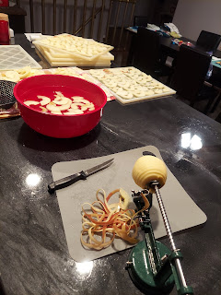

I've also been working here and there on Jack's Quiet Book.

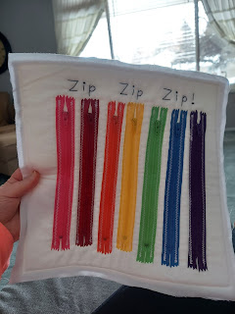

The needle work on the barnyard animals page is tedious, but necessary. :)

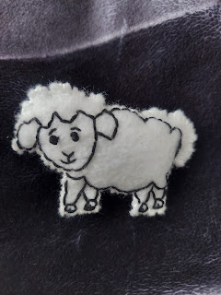

The cow isn't quite done yet, but here he is so far . . .

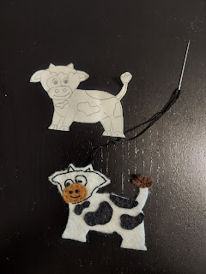

Everything below is just temporarily placed for a photo. I have a few ideas swirling around on how to make it all more permanent on the pages and I'll be working on that in the next week or two.

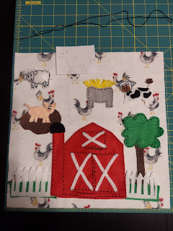

While Scott has been in Boise this weekend for his Army drill, I've been holding down the fort here at home. One thing that I had to deal with was figuring out which one of our MANY smoke detectors was chirping because the battery was getting weak. I thought I knew which one was making the horribly shrill chirps, but each time I brought it into the kitchen and took the battery out, another one would chirp shortly thereafter.

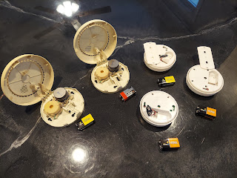

I ended up with a smoke detector graveyard of sorts, taking apart 7 in all before I found the culprit. It was late at night by this point, so I decided that I would go to Lowe's the following day and buy a bunch of 9V batteries and just replace them all at the same time. At least this could give me peace of mind knowing that they should all be in good shape for at least 6 months . . .

I went to bed, with a bit of worry that I would be unprotected during the night. Unfortunately, this caused some WEIRD dreams! I woke up to go to the bathroom around 3:30 a.m. and when I got back into bed, I saw a strange orange/yellowish glow over by the church through my bedroom window. My drop-back-into-sleep mind soon came to the conclusion that it was a fire and that it was headed my way! (Later I saw that it was just the glow of the streetlamp next to the church) I had some unsettling dreams that the fire was sending sparks into our yard and some were even hitting the house. This put other parts of my brain into high gear (while I was still "sleeping"), so I had to hurry and grab our 72-hour emergency kit downstairs. But then I noticed that our 72-hour kit was missing a few important items . . . so naturally I had to wake up enough to make a list on my phone at 5:00 a.m. Our brains are amazing, but sometimes they are pretty weird, too!

I didn't get a good night of sleep at all on Friday, and I finally just decided to get up and get going after I laid awake in bed for a long time. I did, however, get several new 9V batteries and got everything ship-shape and hung back up by Saturday afternoon. That felt good. This week I'll try to organize my 72-hour kit a little more, so I can be more prepared for future emergencies AND so I can sleep more peacefully at night!

Some last minute pictures and videos . . .

A couple favorite Tik Tok videos that I saved:

1) The absolute cutest little boy cooking his own meal with a tiny little "stove" and tiny little food products. (53 seconds)
https://photos.app.goo.gl/oFMYTd4cbky2jGbQ6

2) A darling little girl marching out to feed a baby calf - she's only 2 years old! I'm just so amazed at all the wonderful things that little ones can do and contribute. They are the BEST!!
(26 seconds)
https://photos.app.goo.gl/dftnBS2Pik6EWhWv7

I was able to visit with Kylie and Avery on a video call today. Yay! Avery was splashing around in the bath, having a good ol' time! :)



Kylie is doing her best in taking care of everything while Benson has been working some really long night shifts. Avery started sleeping through the night for a little bit, but the last few nights she's been waking up several times. She's growing and going through her first of many developmental milestones for sure! It seems like just when you get a baby figured out, they change it up and do something different, ha ha.

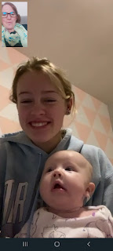

And lastly, Jacob shared this cute photo of their family from last night. They went to visit the Lunar New Year celebration at the Kennedy Center in Washington DC. How fun!



