Mont St. Michel Abbey, France
On Father's Day, Scott and I drove 90 minutes southwest from Omaha Beach, France to visit a 1,300 year old Abbey known as Mont St. Michel. This was another bucket-list dream of mine, that began as soon as I learned about this place a few years ago.

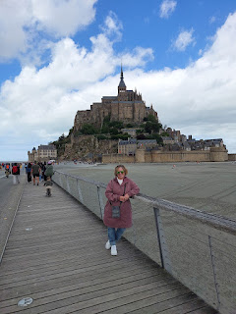

After we went to church in Caen that Sunday, we drove through the French countryside on our way to Mont St. Michel. The farm fields with their giant rolls of hay, along with the bright blue skies and puffy white clouds, made for some beautiful scenery.

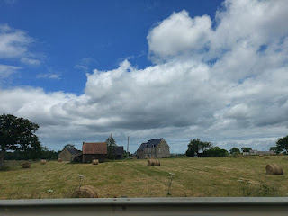

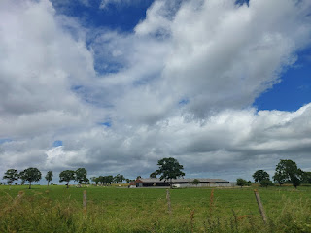

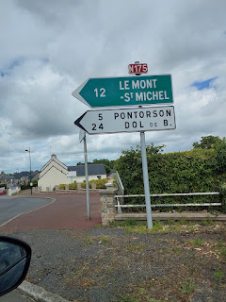

Video of a little drive through the French countryside: (19 seconds)
https://photos.app.goo.gl/6s5JW4mmCBo4xhcC7

If you look closely, you can see the Abbey off in the distance . . . (click photo to enlarge)

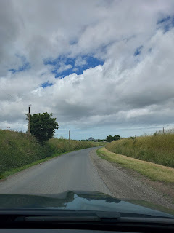

Video coming into the town that is nearest to the Abbey (La Caserne): (25 seconds)
https://photos.app.goo.gl/SMF1rSLdop5HRecr5

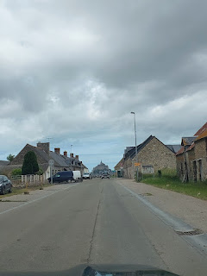

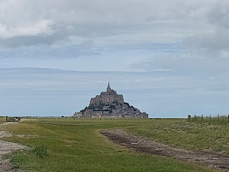

Mont St. Michel has such a long, rich, and colorful history, standing firm through the Hundred Years' War, the French Revolution, and was somehow miraculously spared during the bombardments of WWII. Here are a couple of a links that explain a little more of the history of Mont St. Michel. They are both quick and easy reads.

https://www.ot-montsaintmichel.com/en/discover/visit-the-mont-saint-michel/visit-the-mont-saint-michel/history/#:~:text=Origins,and%20built%20the%20first%20church.

https://whc.unesco.org/en/list/80/

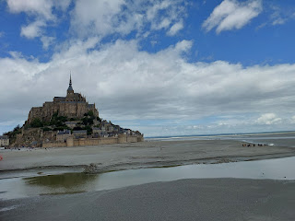

Before the giant causeway was built to connect the Abbey with mainland France, pilgrims and visitors had to be so careful and strategic about when they walked out to the island. Many succombed to the quicksand, and others were stranded as the tides came in.

Today, it is really easy to visit the Abbey. We parked in the spacious Mont St. Michel parking area, with signs pointing the way for a short walk to the visitor center, bathrooms, and a shuttle bus that leaves every 12 minutes. We rode the absolutely packed shuttle bus out to the Abbey, a ride that took about 20 minutes. It was quite warm on the bus and the French aren't exactly known for wearing deodorant . . . so we decided right away that we would just walk back to our car later, instead of riding the shuttle bus a second time.

Right away, as we stood below the Abbey, looking up with our jaws dropped, we decided that we wanted to get as far up to the top as we could. There are many sets of stairs to choose from, some are more common and some are more enchantingly secretive and secluded.

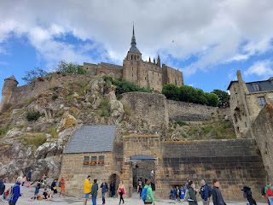

Video peeking over the Abbey wall: (13 seconds)
https://photos.app.goo.gl/yedHDVBELX6Lp3kaA

We saw several groups of people walking out on the sand, even a few tour groups who were recognizable because their guide had a tall flag he/she carried as the group made their way around. I'm not sure what the fascination was, to be honest. We also saw dozens and dozens of people rolling up their pantlegs to wade out into the shallow waters. Maybe it's some sort of a pilgrimage or something. We did not feel even 1% interested in getting our feet muddy and dirty to walk out onto the wet sand.

So, instead, we made our way UP.

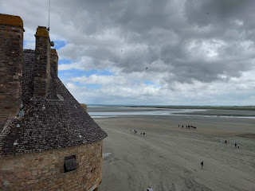

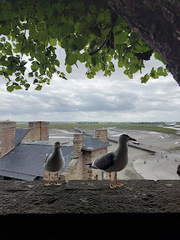

Video of the seagulls running along the wall: (13 seconds)
https://photos.app.goo.gl/u669noRm52CiAUr7A

Looking down below, as we paused about 1/3 of the way up . . .

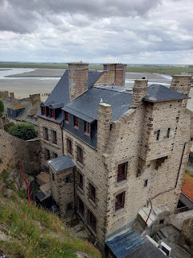

We still had a long ways to go . . .

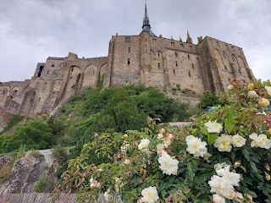

I told Scott that I wanted to get up to where I saw some people standing at the top of a long and steep "track". (click photo below to enlarge)

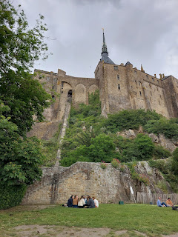

Video that shows the track for transporting goods up to the top of the Abbey: (8 seconds)
https://photos.app.goo.gl/rbzhSEHbGcXuAiai6

Video looking down from the top of the track, after we made it all the way up: (29 seconds)
https://photos.app.goo.gl/Su55gTdmzQTQQg5r9

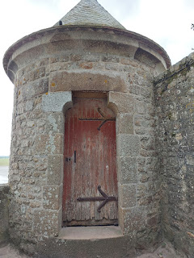

Although the Abbey and the Mont had several visitors that day, we never felt like it was overcrowded or difficult to navigate. We had read that first thing in the morning is ideal to visit, and preferably not on a Saturday or Sunday, but we didn't have much choice in our too-short and very packed 4-day weekend. It really wasn't that bad during our experience on a Sunday afternoon.

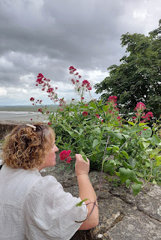

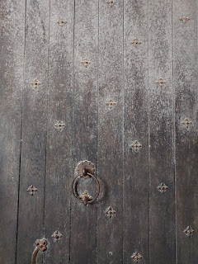

The archangel Michael is known in Christianity as a spiritual warrior and a "protector who fights against evil". In my church, The Church of Jesus Christ of Latter-day Saints, we also believe that he is the one who led the armies of heaven against Satan and his legions of evil minions, eventually driving Satan out forever. We also believe that Michael helped Jesus Christ in the creation of this beautiful world that we now live in, and that Michael is also Adam, the father and patriarch of the entire human race.

An artistic portrayal of the Archangel Michael, outside the entrance to the Abbey . . .

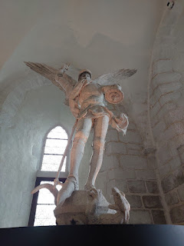

You can see for miles and miles from the island. It is really quite remarkable.

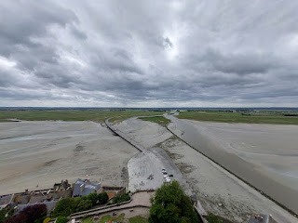

We finally made it up high enough to stand outside the Abbey entrance, the highest structure on the island . . .

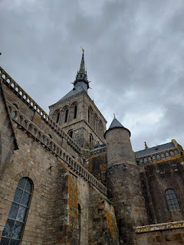

The golden statue at the top of the spire is the Archangel Michael, who stands majestically at 156 meters (511 feet) above sea level.

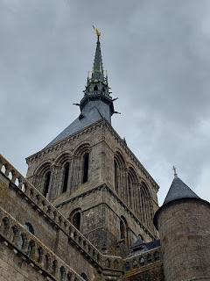

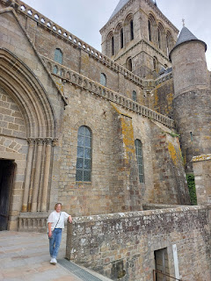

On this level, just outside the chapel, I noticed that on several of the stones below my feet, there were letters or numbers etched in. I recently looked it up to see what the etchings meant, and apparently they were intended to distinguish each brick maker, which helped keep track of who needed to be paid and how much.

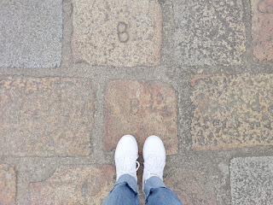

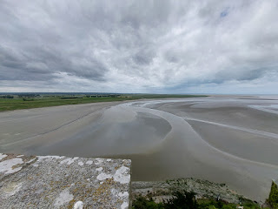

It was a very happy Father's Day for my favorite guy . . .

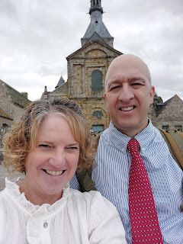

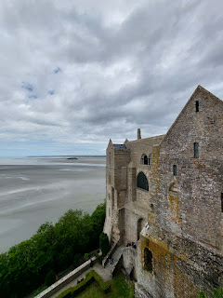

Here is a slightly closer look at the Archangel Michael on top of the spire . . .

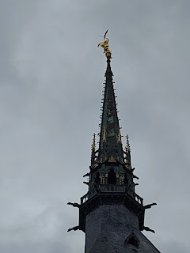

Video inside the Abbey chapel: (13 seconds)
https://photos.app.goo.gl/fpu86YiWykusrCmt6

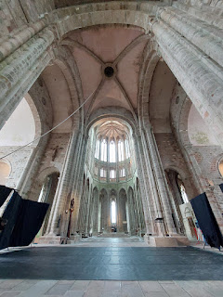

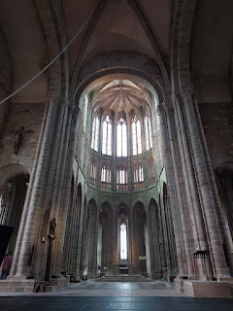

Someone carefully and meticulously made a diorama of the entire island of Mont St. Michel . . .

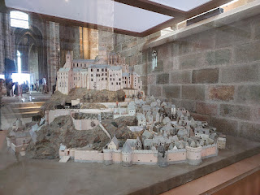

I loved the architecture everywhere . . . carefully crafted arches, windows, doors, door knockers, etc.

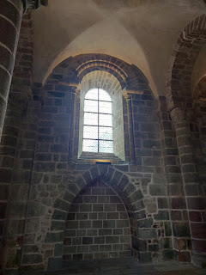

More artistic details . . .

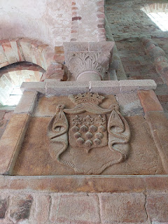

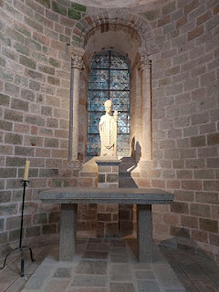

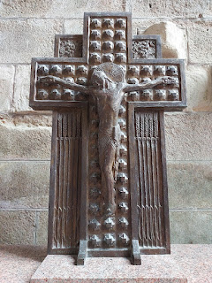

In each alcove of the chapel, there is at least one exquisite carving or painting, many of which date back to the mid-1500's.

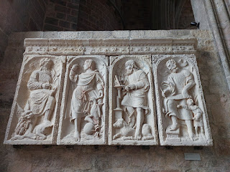

The translation for this one is: The Four Evangelists. 1547. Comes from the old fence of the Pierre de Caen choir.

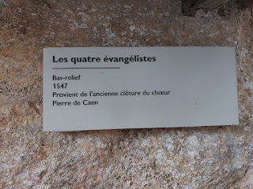

A broader view of the Four Evangelists . . .

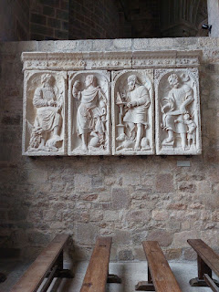

One of the many alcoves in the chapel of the Abbey . . .

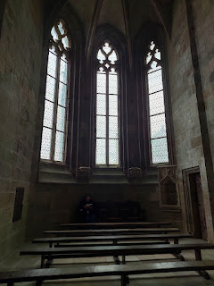

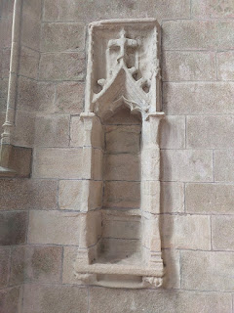

This one is translated to: Alterpiece. Second half of the 15th century. England. Comes from the abbey of La Lucerne in Outremer (Manche). Polychrome alabaster, gilded.

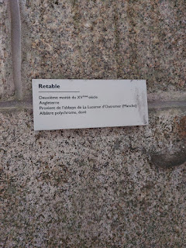

I loved the scenes depicted in this next one . . . each "window" shows part of the story of Christ and His ultimate atoning sacrifice for each one of us.

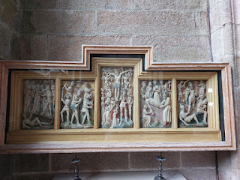

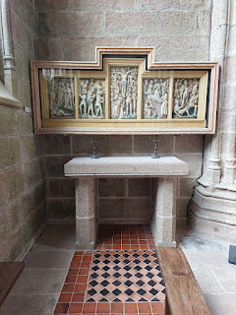

This one shows Adam and Eve . . .

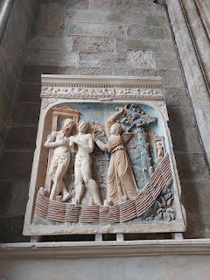

The translation says: Adam and Eve expelled from Paradise. Mid-16th century. Comes from the old choir enclosure.

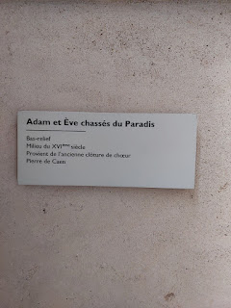

This one was curious to me, because I didn't know what it represented at first. On first glance, I was able to see Jesus and how he was saving those who appeared to be oppressed. The art is entitled: "Christ descending into limbo."

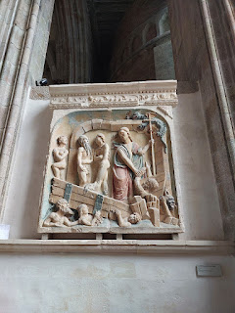

As I pondered this further, I think this may represent the period of time after Jesus was crucified and when He went to visit those who were in spirit prison before He was resurrected. (See 1 Peter 3:19)

If you have more questions, here is a very helpful link:
https://www.churchofjesuschrist.org/study/ensign/2003/07/the-saviors-visit-to-the-spirit-world?lang=eng

Old doors will probably fascinate me forever . . . they are inviting and curious, whether they are open or closed.

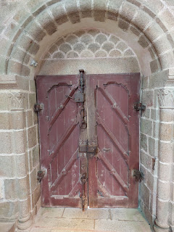

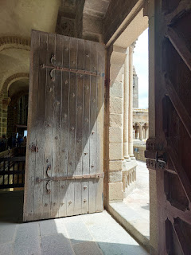

The cloister of the Abbey . . .

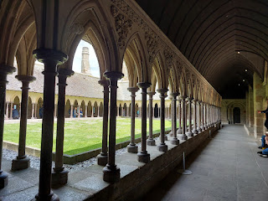

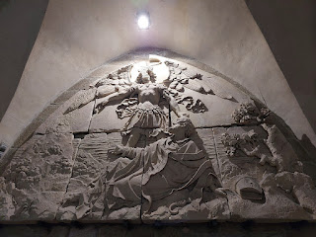

The explanation of this magnificent carving is translated to:
The Archangel Saint Michael appears to Aubert, Bishop of Avranches. Made in 1860 by the sculptor Barre for the tympanum of the south portal of the Pierre de Caen Abbey Church.

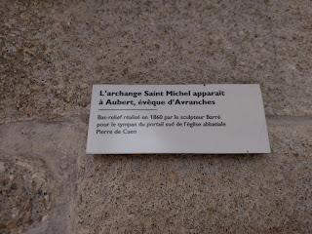

Our two little footsies, standing in this incredible and ancient place together . . .

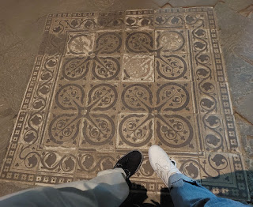

At the top of the transport "track", to haul goods (or people?) up and down, there is a room with a giant wheel and pulley system to help make it all happen.

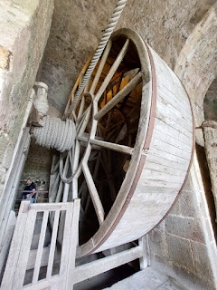

This is a fragment of a wall painting from the ruins of the abbey's former medieval infirmary, dated from the end of the 13th century.

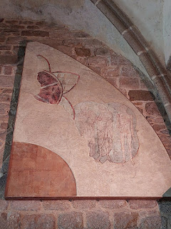

The painting is entitled, "The Meeting of the Three Dead and the Three Lively". The word "vifs" has a few different meanings, as seen in the description below for the painting. Vifs can mean: lively, energetic, strong, spry, bright, or fierce. Seems fitting for a painting that used to hang in an ancient infirmary!

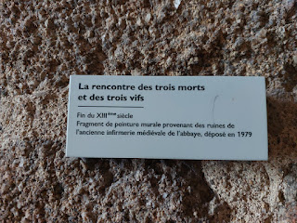

Stairs going up . . .

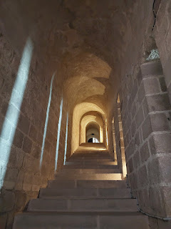

Stairs going down . . .

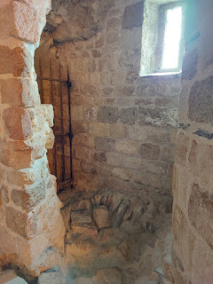

Video as I peeked around the corner of the gated stairs above, with very chunky rocks on the floor and what might have been a dungeon entrance: (9 seconds)
https://photos.app.goo.gl/Phb4xH5xf7yxxSJZ8

By and by, we ended up in a most interesting room. There was a large, singular, illuminated tree in the center of the spacious room, and it confused us because it was so modern! Thankfully, there were plenty of explanations to help us understand the symbolism of the beautiful tree. (click photo below to enlarge)

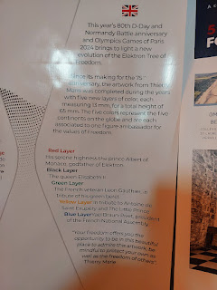

Video of some additional explanations for the special Elektron Tree: (25 seconds)
https://photos.app.goo.gl/KUB4MPdPk7eTBaWN8

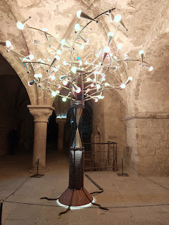

A slightly closer view of the 5 symbolic "roots" of the tree . . . with the names of the 5 D-Day beaches.

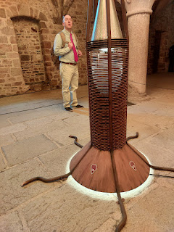

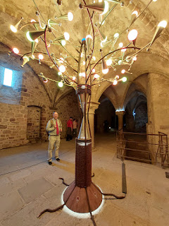

In another room that we passed through on our descent, there was some modern art on display (mostly framed photos) along with some items that a few French schoolchildren had contributed. I thought this tree was especially pretty.

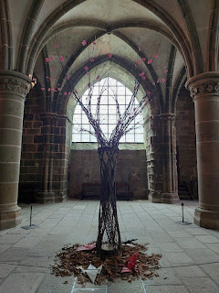

We hadn't passed these beautiful half-timbered houses that were near the bottom of the mount on our way up earlier, so they were a delightful surprise on the way down . . .

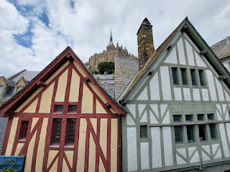

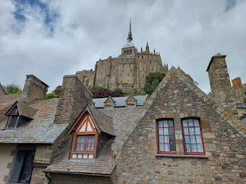

We did end up going out onto the sand briefly, because Scott wanted to launch his drone. We knew we might run into some issues with it being so close to a UNESCO World Heritage site, so we tried to be a little sneaky at first. Ultimately, it didn't even work. The drone is set up to receive important updates regularly, which includes warnings for restricted areas. In France, you are severely limited with the use of a drone. France might be lax in other categories, but apparently not with drones. He was only able to fly it up to about 30 meters in height in this location, which isn't very high at all.

So we took a selfie instead . . . ha ha.

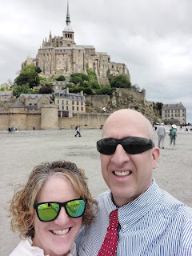

As we walked back to the parking lot, we paused along the way so that he could try launching his drone again. This time he was able to fly it up to a "whopping" 50 meters before the restrictions kicked in. And it's not just a set of restrictions that kick in, he is literally unable to fly it any higher. The drone stops working at whatever maximum height is allowed, except for bringing it back down to earth.

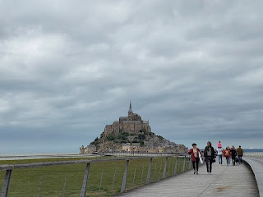

Goodbye, beautiful Mont St. Michel . . . you were old and dreamy, mysterious and intriguing, full of wonders and full of untold stories. I enjoyed walking through your hallways, marching up and down your endless stone steps, peeking carefully over your secure walls, and trying to imagine life as it may have been so many centuries ago. Thank you for staying strong enough to withstand the storms of life, the wars that raged around you, and the elements that were likely not in your favor. Thank you for honoring a strong and valiant man named Michael, and for striving to uphold Christian morals and values. Thank you for being so majestic and huge and epic. I had a wonderful time.

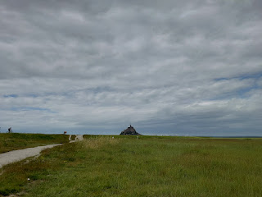

For more information in planning a visit to Mont St. Michel, this is a good website:
https://www.ot-montsaintmichel.com/en/discover/our-essentials/the-abbey-of-mont-saint-michel/

For dinner afterwards, we stopped at a DARLING place called "Bleu Banane" in a town called Carentan les Marais. There is a marina area that I wish we had had more time to explore. It sits along a large canal that connects the Taute and Douve Rivers.

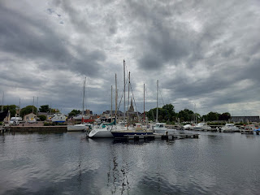

The restaurant offered some high-quality fish and chips in a casual family diner setting. We were in a bit of a time crunch that day because we needed to get over to the nearby D-Day Experience Museum before it closed. I wrote about this in my last blog post . . . and unfortunately, we didn't make it in time. We didn't know that we had to arrive before 5:30 p.m. in order to see the inner workings of the museum by closing time, which was 7:00 p.m.

But it was still a lovely day. We put in a lot of steps and miles together, and we got to see something really remarkable. We were exhausted by the time we got back to our farm near Omaha Beach that night, and boy, did we sleep like LOGS.

**Next week's post will be all about FAMILY!! We have had a JAM-PACKED 10 days . . . it's been part-circus, but mostly it's just been so full of fun and activities that I've barely had time to do anything except play, laugh, read a few stories, help prepare a meal, clean up the meal, play some more, go to the bathroom occasionally, and try to get a few hours of sleep each night. XOXO

