Morocco (Part 1)
Happy Father's Day to all you dads out there!!
You are such a wonderful contribution to the families all over the world, most especially to mine. XOXO :)
I would like to publicly thank the father figures in my life for what they have taught me, shared with me, and given me during the course of my life.
Top 5 Things I Appreciate About My Dad: (John)
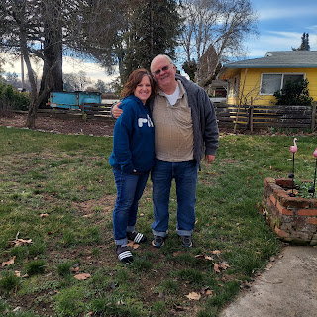

1. His willingness to drop whatever he's doing in order to help someone in need.
2. His sense of humor, albeit quirky or corny on many occasions. You know - the "Dad Jokes", ha ha.
3. His amazing balance of having a hard work ethic and an appreciation for rest and relaxation.
4. His humility in learning new things. He might not know one thing about what he's being asked to do, but he's willing to try.
5. His capacity to love and be a good listener. He is always a good ear on the other end of the phone.

Top 5 Things I Appreciate About My Father-in-Law: (Phil)

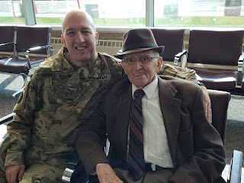

1. His love of studying intellectual things, especially scriptures, foreign languages, cultures, etc.
2. His desire to do what is right. All of the time.
3. His steady example of being diligent in setting goals and achieving them.
4. His gentlemanly ways, always being thoughtful about opening doors for a lady, helping her with her coat, etc.
5. His patience with teaching various grandchildren how to play chess along with how to give him a little bit of a challenge, ha ha.

Top 5 Things I Appreciate About My Step-Father: (Frank)

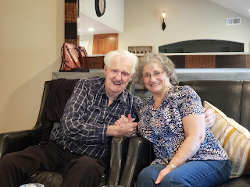

1. He always had a twinkle in his eyes and could light up the room with his smile.
2. He was a gentleman, through and through, always putting my mom first.
3. He was the king of positive thinking, always having several signature phrases that could smooth any ruffled feathers, perk up the downed spirits, and make each person feel like a million bucks.
4. His military service in WWII and his love of sharing stories from that part of his life.
5. His humility in learning about the Gospel. He may not have understood everything in the late stages of his life, but he sure wanted to try.

As you can see, I have learned such a variety of meaningful and positive traits and how to conduct myself through life from their wonderful examples. I love each of you and I wish you a
HAPPY FATHER'S DAY!!!

Now - it's time to share a little bit about my adventures in Morocco . . .

The internet is NOT THAT GREAT here, and I didn't have ANY of my photos from the past several days to draw from (in Google Photos). I chose just a handful of photos and one video and had to upload them to Google Photos one at a time . . . the rest will have to wait until I get back to Italy where I can use our fast internet there.

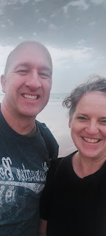

Our hotels are right on the beach (Agadir Beach). I said "hotels" (plural) because Scott has one that the military is paying for, and I have mine a short distance north of his (maybe a 10 minute walk). Hotels line the entire length of the beach, with a wide brick Promenade separating the hotels from the sands of the beach.

From very early in the morning to very late at night, strollers, walkers, joggers, bicyclists, skateboarders, etc. are enjoying the views and the people watching along the Promenade. And everyone is so friendly here! I think this place is the friendliest place I have EVER been, and that is saying a lot!!

The picture below is of the Marina at the far north end of Agadir Beach. It was very calm water first thing in the morning when I took the photo. There is usually a foggy haze that blankets the air here until late morning or so. When the sun pops out, though, you better have a hat and some sunscreen because it's blazing warm! Morocco is super close to the equator . . .

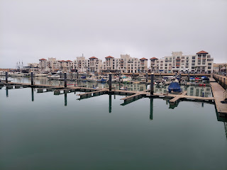

The view from the Marina looking back along the entire length of Agadir Beach. My hotel is probably directly across from where I'm standing, and Scott's is further south down the beach, where you can't see much of anything, ha ha. It took me about 30 minutes to walk from my hotel to this spot.

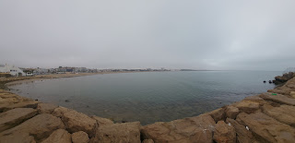

A couple of things that have surprised me the most about the culture of Morocco:

1. There is a lot of love and camaraderie among the people here and it is consistent and palpable. Families have an obvious love and adoration for each and every member, showing constant kindness and gentleness in all their dealings. Fathers are playful, yet soft spoken and gentle with their children, and I have seen many fathers strolling along while holding hands with their 9 or 10 year old son. I don't know that my sons would have wanted to do that when they were that age . . . but here it is normal and very peaceful. The mothers are very calm and loving with their children, along with having a healthy sense of humor. I see them smiling a lot and radiating joy as they teach and rear their children with love and respect.

2. Everyone is astoundingly welcoming everywhere I go. If I'm walking down the Promenade, it is a rarity if someone DOESN'T greet me as they pass by. Men, especially, are very gracious and kind to women here. They might be in the middle of jogging and are clearly focused on their breathing, but they will still look my way, nod, smile, and say good morning. The greeting might be in Arabic, or French, or sometimes English. Maybe they assume I speak English because of my pale skin or something, ha ha. A few times I've even seen a group of men, walking along and in the middle of an animated discussion with one another, yet they completely pause their conversation so they can acknowledge me and greet me with a nod, a smile, and some form of "good morning", before they return to what they were talking about together. Wow. You would NOT see that in America.

I have made some wonderful friends here. Scott is always eager to hear about who I met during the day while he was at work. I'll tell you about a couple of my new friends and then next week I'll have more pictures to share.

Abdo:
Abdo is short for Abdullah. I met him when I was out for my morning exercise walk and he was jogging by. He said, "Bon jour, madamoiselle." I replied, "Good morning." He completely stopped his jogging and circled back to talk to me. He was intrigued by my speaking in English, ha ha.

Turns out he is the same age as my daughter, Amber (28). (I learned that later) We spoke briefly, maybe a minute or two, and then he headed off to finish his jog. Eventually I caught up to him again, where he had stopped to use some of the resistance exercise equipment that are sprinkled along the Promenade for anyone to use. He excitedly greeted me like we were old friends!!

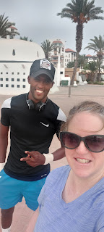

He had a lot of questions and wanted to practice his English skills with me. He typically speaks Arabic, along with some French, a language that is very common in Morocco. He wanted to know about my family, America, where I have traveled, etc. Because we were having such a fun conversation, he asked if it would be okay if he accompanied me on the rest of my walk. I said sure, because we are completely out in the open on the Promenade and he was such a happy and friendly young man. I felt 100% safe.

We have stayed in touch over the past few days and have met up on the Promenade to talk some more. At first I wasn't sure if I was doing the right thing or not. But one day he texted me and said, "You are an elegant and kind woman and I love you as my best friend and it is my duty to protect you." I replied that I thought of him as my son and that I appreciated his thoughtfulness. He has given me some good advice on how to stay safe here and checks on me often to make sure I'm okay. I also conferred with Scott each day, updating him on any conversations I had, and he has wholeheartedly approved of my friendship with Abdo.

I've learned that Abdo is one of 5 children, including twins. His parents are 1st or second cousins I think . . . at least that's how he did his best to convey it to me in his limited English. He said his parents' parents were brother and sister, so I think that means his parents would be 1st cousins . . . maybe something got lost in translation though . . . He is 28 years old and is a professional futbol player (down here that means soccer). He is Muslim and works in the restaurant industry of Agadir.

We talked about healthy diets (as we walked past a McDonalds, Pizza Hut and KFC on the boardwalk) because he wanted to know more about what Americans eat. We also talked about healthy relationships as I inquired if he had a girlfriend. He said the culture in Morocco is that if you are dating a girl for roughly one week, then she wants to seal the deal and get married. He is wanting to marry for love and not because of obligation or duty or tradition.

I encouraged him to pray for his future wife, as I encouraged my son, Benson, to do for years (starting when he was like 9 years old ha ha). Abdo thought that was a brilliant idea! I told him that if he's praying for her, then he is beginning to be more aware of her and that it's a form of selflessness. I also said that when the day comes that he finally meets her, she will be surprised and happy to know that he was praying for her all that time. Maybe she is going through some hard things and his prayers could be invaluable to help her get through those challenges. He really liked that idea a lot.

We also talked about religion a bit too. He wanted to know if I was Catholic. I told him no, and that even though the Catholics have a lot of good things that they believe in and do, we are different. I told him that we do not pay our ministers, or the choir members, or any of the teachers. We serve because we love God and want to be helpful to the other members of our congregation. We talked about the temple and how when we go inside we all dress in white so we are all equal before God. You don't know who is rich and who is poor, who is the doctor and who is the teacher. It doesn't matter because we are all God's children and He loves us equally.

We talked about prayer and how to pray for the right things. We talked about my marriage to Scott over the course of 30 years (we just celebrated our anniversary on June 13th), how we met, and all the many ways that Scott makes me happy. He laughed when I told him that the night I fell in love with Scott was a night that I laughed so much that my cheeks hurt. He was sincerely interested in everything I shared, asking me many questions to add to our conversation.

He is a wonderful son of God and I am so grateful that he took the time to talk to me so we could learn about each other's cultures. He told me at one point how remarkable it was that I was willing to talk so much with him. He said most other people are just in a hurry and don't want to stop and have a longer conversation. I told him that I AM a bit of a talker . . . :)

As I showed him photos of my children, grandchildren, my home and my home town of Idaho Falls, I told him that he was welcome to stay with us any time if he ever comes to America. He seemed very pleased about that.

I will never forget Abdo and his smile that just lights up the whole world. He is a joyful and kind, respectful and honorable young man. I hope he finds a young lady that makes him happy and they can have a wonderful life together.

Abdullah:
Abdullah was my taxi driver when I went to ride a horse on Friday morning. I thought he was just the driver, but at the end of my ride, he turned out to be much more!

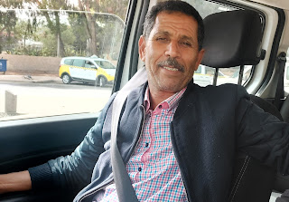

When my young guide helped me off my horse, Abdullah came over to me right away and wanted me to explain to 2 other men about my ride and my experience. The men were interested in riding a horse, but didn't have any experience. He wanted me to give sort of a testimonial for them. He said that coming from a woman, it would carry a lot of weight because most women don't ride a horse here.

One of the men thought that my horse, Hennie, was too small for him. He wanted a big, strong horse to ride on, and he was correct on that point since he was about 200 lbs. He wanted to ride the horse that my guide had ridden, but I told him that "Z" was too crazy if he didn't have much experience. The teenage boy that was my guide had to put "Z" in his place numerous times, and I was extremely grateful that I was on gentle Hennie instead of the rebellious "Z". But all the man could focus on was size and ended up mounting "Z" anyway.

Abdullah told the man to go with the guide across the field to where he had a few other horses and could help him change to a better horse more suited to his experience. Once that was settled, he opened the car door for me and we got in. We drove over to where the other horses were tied up along the fence and he asked ME to choose a horse for that man. I inquired about the strong looking black horse, and he said that was a good choice because not only was it a strong horse, but a calm one for an inexperienced rider. So it was settled. My word was gold. :) He told a couple of the men near the horses to prepare the black horse because the man would be coming over very soon, and then we drove away.

As we drove back to the hotel, I expressed remorse that I had not ridden on a camel yet in Agadir. I told him that I was jealous when I saw so many people riding camels and passing by us while I rode a horse.

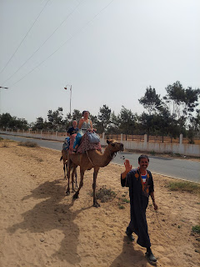

He told me emphatically that what I did was remarkable! He said, in his super cute Arabic accent, "You are woman. You are strong woman! Sisters here in Morocco no ride a horse. They scared! But you!! A WOMAN - from AMERICA - is
VERY
GOOD!!" And he said it all with the hugest smile from ear to ear. From that I learned to be happy with what I have, and not to worry about the seemingly greener grass on the other side of the fence.

He wanted to know more about why I was in Agadir. I told him my husband is here working right now. He asked what my husband does, and I told him he's in the military. He replied, "Oh no! He in military, he not like my jokes! He get mad for my jokes . . ." I laughed and said, "No, he is a good man. A calm man. He likes good jokes. He will not be mad at you." We had another good laugh over that and chatted the rest of the way back to the hotel.

I am just in awe of how amazing people are all over the world. I love learning about new cultures and new life stories.

By next weekend, I'll be able to share all of the beautiful flowers of Morocco that I have seen. Here is
one
photo, though. I see these all over Agadir and I am amazed that one single shrub can produce so many colors of blooms!

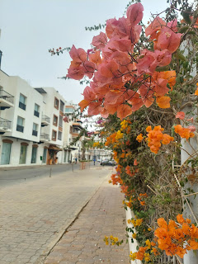

One last video: (25 seconds) A young man was playing a beautiful guitar solo as Scott and I walked to dinner last night. This video gives a nice sampling of the vibe along the Promenade.

https://photos.app.goo.gl/QHXLgNMNDJQDRMXXA

(It took the entire time I typed up this blog for that 25 second video to upload so I could share it.)

Lessons learned from Morocco:

Love your family
Treat them well, show respect, be happy with them
Treat women well, be kind to them, be a gentleman toward them
Be happy with whatever circumstances you are in
Have a good balance of hard work and meaningful recreation
Get enough sleep and rise early to begin your day
Treat strangers with the same kindness you would treat your family

I'll be sad to leave here on Tuesday. However, I am holding onto the hope of returning to Agadir next June when Scott comes down for training again.

