Morocco: The Full Adventure
Miraculously and amazingly I made it back home to Italy on Tuesday - it ended up being a really rough day . . . (more on that later)
I am so grateful that I was able to spend a week in a faraway land that I never in my wildest dreams thought I'd ever visit. Truly, the people are what made Morocco so special. A close second to that was the beautiful ocean, a few steps from our hotel rooms.

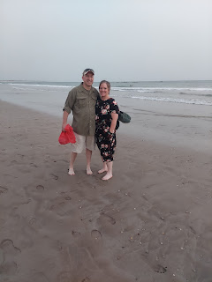

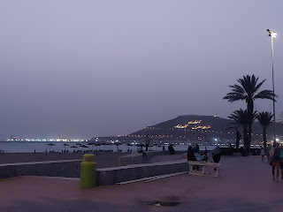

I'd like to start at the beginning and share the whole journey from Italy to Morocco and back.

Day 1:
Last Tuesday (June 14th), I drove myself down to Bologna and parked my car at a parking facility near to the airport. I was advised to arrive at the airport 3 hours before my flight, which at first I was skeptical about. The notification that I received said if you are flying to/from Morocco, Israel or Jordan, then get there 3 hours early. For my flight down, it was very apparent why this was the recommendation: so many large families were traveling together in groups, and they had a lot of luggage!!

It took me over
one hour
to get through the line just to check in my one suitcase. I've never had that happen before. It was chaotic and crazy, but I was glad to get on the plane soon after.

While this next photo doesn't show the largeness of the traveling family groups, it does show multiple generations. The fathers were the kindest fathers, so soft spoken and gentle with all of the children. I really got a sense of who the Moroccans are before I ever got on the plane.

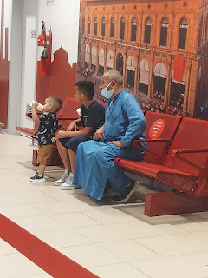

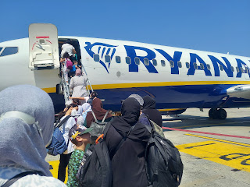

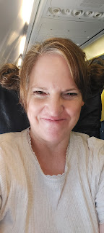

I felt my heart swell with love and admiration for the Moroccan women, too, as I watched them lovingly and joyfully shepherd their children in such a calm and cheerful manner. They really aren't any different than the women that I know already in my life. I watched the mother in this next photo pause to pose her childeren and quickly take a couple of photos before boarding the plane. Something I would have done, myself. :)

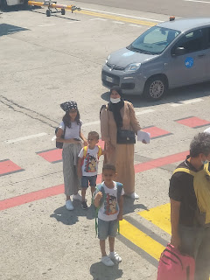

Something I NEVER heard even once in Morocco was the sound of a mother or father's voice yelling angrily at their child in public. In America, by contrast, we hear that all too often. In the grocery store, at the post office, walking down the street, getting into a car, etc. It always makes me so uncomfortable. I cringe when I think that there is a much better way to resolve the situation besides yelling and public humiliation.

I stood behind this little girl and her cute family for most of the hour as I waited to check in my suitcase. The dad had a twinkle in his eye, and the mom smiled a lot, including at me. I could feel the love they had for each other, as well as for their children. Their teenage son quietly and patiently pushed their huge luggage cart without a single complaint. Amazing.

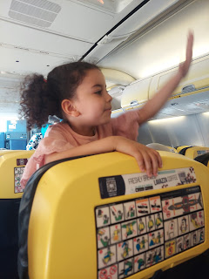

This little girl had oodles of energy on the plane, too. I know, because she sat right in front of me. She only had one volume: maximum!! Often, she would stand up in her seat to shout, "Baba!! Baba!!" until her father noticed and acknowledged her from a few rows back.

I think the singlemost thing that surprised me on that flight, was how everyone seemed to be friends with each other. Once the seatbelt sign was off, people began to mill about and visit with others throughout the plane. Even the flight attendants stood for long periods of time just visiting with and enjoying various people on the plane. I felt like I was on the outside, but not in a bad way. I was an observer of something wonderful going on, and it was just the beginning.

Video of the family in front of me having a really good time (ha ha): (21 seconds)
https://photos.app.goo.gl/oE2LjMBqXBDF3f6D6

I flew from the fertile greenness of Italy - -

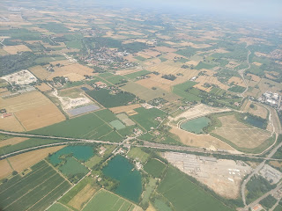

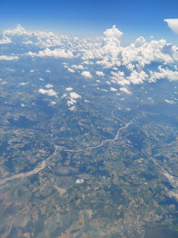

Over Monaco and the French Riviera - -

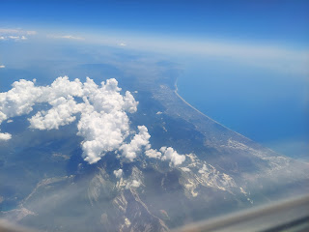

Across a lot of blue ocean - -

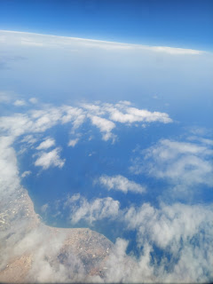

Past Spain, Tangier, and Gibraltar - - to North Africa

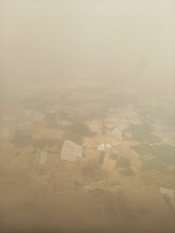

Just outside of Agadir, there were some farm fields, including a rare patch of green - -

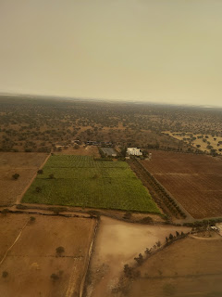

Video of our landing into Agadir: (20 seconds)
https://photos.app.goo.gl/Mf9asUVNGkLGvkcs6

If you listen carefully, you'll hear everyone start clapping after our plane touched down. They kept the clapping going for some time, too. Everyone was very happy and grateful that they were home.

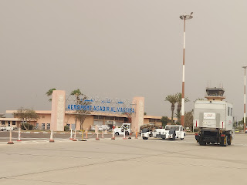

After some confusion regarding a driver to get me to my hotel (that took an additional 45 minutes), a very nice older man that worked at the airport helped me to secure a taxi. While I stood there waiting outside with my suitcase, I was able to watch all the reunions taking place as families coming off the plane met up with the rest of their family. So many times, I watched a father barely contain his joy and pleasure to have his wife and children come back to him. He would hurry over to hug and kiss each one on their cheeks. I'm glad I had the time to witness yet another special quality about the Moroccan people.

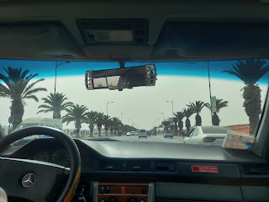

Video #1 driving through the outskirts of Agadir, closer to the airport: (15 seconds)
https://photos.app.goo.gl/HXj5i4pRYPH32R4i9

Video #2 driving through the middle of Agadir: (20 seconds)
https://photos.app.goo.gl/p9mybYhfS8z8eTxS8

From the airport it took 30 minutes to get to my hotel.

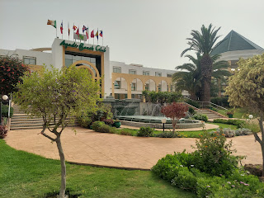

This was the view from my balcony.

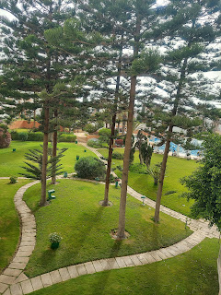

It was a large hotel, with who knows how many rooms. Each of these buildings on the map below (P1 - P9) have several floors and rooms in each building. I stayed in P2 on the second floor.

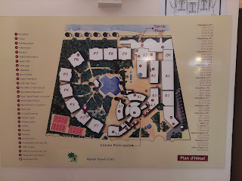

I waited in my room for Scott to get off work and meet me, which wasn't very long. He was staying at a separate hotel that the military paid for. He had been told that he would likely have an Army roommate, so we booked me a separate hotel that was about 10 minutes' walk from his. (He never had any other roommate besides his wife)

The beach is literally right behind all of the hotels and each one has their own private roped-off area on the sand with lounge chairs and umbrellas for their guests.

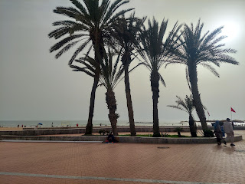

Scott had warned me about the panhandlers all along the Promenade, since he got there a few days ahead of me. It would definitely get annoying at times because of the semi-constant barrage and interruption to our own private conversations as we walked along. Some are more pushy than others, but a few are definitely more charismatic. Like this guy. His name is Marco and he is from Mali. He was super fun and I enjoyed talking with him before he started laying out his "wares" on the sidewalk.

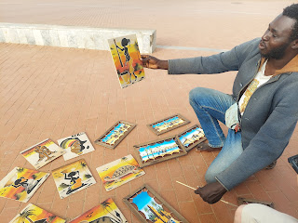

Of COURSE I bought a painting of an African woman for my daughter!! I was thinking of buying a different one for her, but I messaged Amber with the photo above to get her opinion. She wanted the one that he was holding in his hand. Great! We paid $40 for it.

I was super tired from a long day, but we needed to eat. So off we went across the plaza.

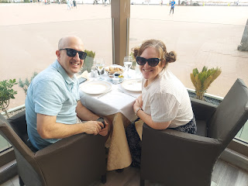

Chicken shawarma salad

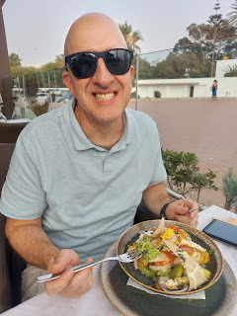

Moroccan vegetable soup

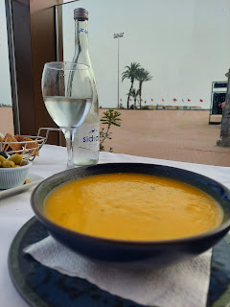

And some delicious steaks

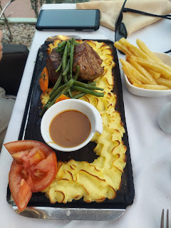

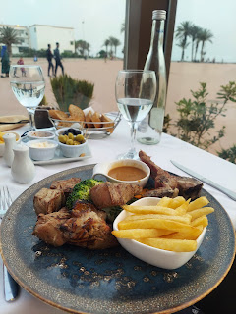

Video of the view of the Atlantic Ocean from the Promenade: (20 seconds)
https://photos.app.goo.gl/g9ezzu5Ngck3gLih7

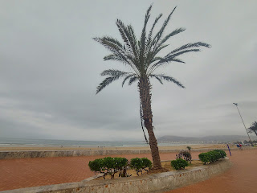

This is Scott's hotel

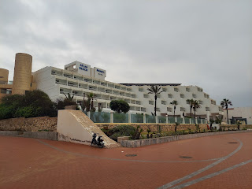

I enjoyed finding some amazing pops of color in Morocco - bright beautiful flowers contrasting against the tans and terra cotta colors that are so prominent everywhere.

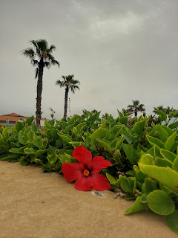

Day 2:
I got up early to exercise. I walked down the Promenade for a long ways, and then decided to walk back next to the water.

Video of the Atlantic Ocean: (20 seconds)
https://photos.app.goo.gl/4jySkDHmY3KUeVqb8

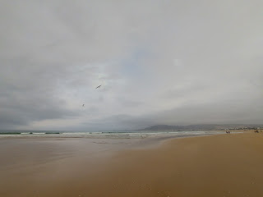

I noticed something flopping around in the sand, and moved over for a closer look.

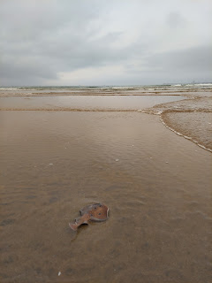

It was a mini skate fish - at least that's what I think he was. I stood there for a minute or two, watching him and taking photos, and wondering if the tide was coming back in to scoop him up, or if he would be stranded and left to die.

I must have attracted some attention, because right away, some local men came over to see what I was looking at and decided to help rescue the fish.

Video of the rescue: (33 seconds)
https://photos.app.goo.gl/YeVSq8cUoxieM3949

YAY!! They did it!!

Soon after, I came across this hilarious scene and HAD to video it: (28 seconds)
https://photos.app.goo.gl/7A5MzeSVr4vBYP2K6

Every day, all day long, there are futbol (soccer) games going on down the length of the beach. It doesn't matter how late the young people stay up at night, they are always out on the sand first thing in the morning to play again for hours.

After my walk, I showered and went downstairs to eat. It's a huge buffet area, and the Moroccan foods include a lot of breads, fresh veggies (cucumbers, tomatoes, carrots, cabbage), sliced meats and sliced cheeses, and a small variety of fruits and yogurt.

Here's what I chose: a crepe, 2 boiled eggs, some sauteed tomatoes and eggplant, and a small pastry.

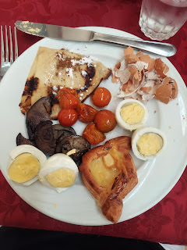

I loved how even the powdered sugar and cinnamon were in these cute little Moroccan bowls.

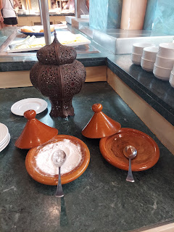

I had brought a book with me and was determined to finally read it. My mom gave it to me last year for my birthday before I went to Europe, but I never seemed to have any time to read it then. I brought it with me again, and this time it ended up being the perfect opportunity.

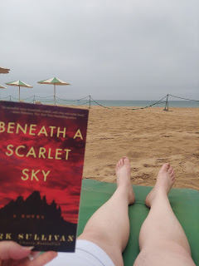

It was 513 pages. I read the whole book in 4 days. It was AMAZING!! It's a true story of an Italian spy during WWII named Pino Lella. He was also instrumental in helping to guide several Jews to safety over the Alps into Switzerland. I think they made it into a movie, but I haven't been able to actually find it.

I spent some of the day out by the ocean, listening to the waves as I read my book and tried to begin a feeble attempt at tanning my very white legs. After a while, I went back to my hotel room to get out of the sun for a bit, and continued to read.

Then I headed down to the pool area to read, tan, and bask in the fun music and social scene there. (aka - people watching)

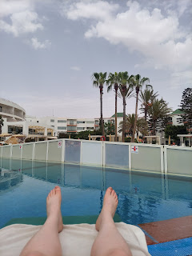

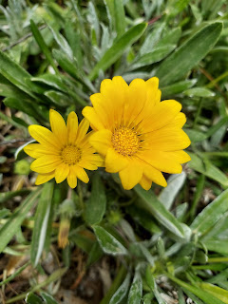

Soon enough, my favorite person showed up after work was done and we enjoyed the evening together. We walked along the beach, found some dinner, and talked about what we did all day.

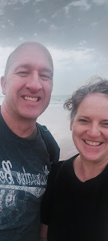

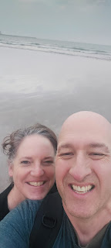

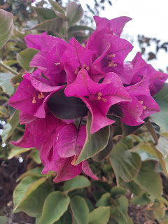

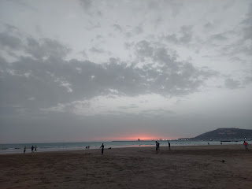

Day 3:
I got up early to exercise again, enjoying the mixture of greetings from other passersby in Arabic, French, or occasionally in English. This was the morning that I met Abdo,. I wrote all about him last week. :) What a wonderful young man!

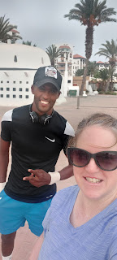

At one point, after I had returned to my hotel room, had showered and was mapping out my day, I heard some fun music coming from the pool below. They were doing a water aerobics class!! (On another occasion, I saw the same two young people leading a yoga class out on the sand by the hotel's private beach.) Super cool.

Video of the water aerobics: (21 seconds)
https://photos.app.goo.gl/F6eqFodGu2upoH8p6

This was also the day that I would "enjoy" my very first Moroccan Hammam and massage.

Here is some of the description that was on the very respectable site, Viator. (affiliated with Travelocity)
(click to see the wording better, ha ha)

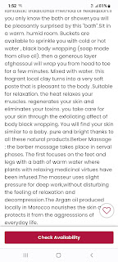

My taxi driver picked me up at the hotel, meeting me inside the lobby. After a 10 minute drive, we arrived at the spa. They invited me to sit down and relax for a couple of minutes before someone came to get me.

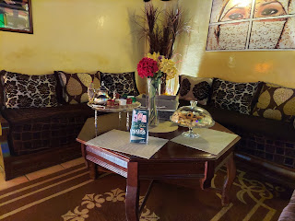

And this is where the cultural lessons began.
WARNING:
this might make some people uncomfortable to read. And just imagine my discomfort in experiencing it! Feel free to skip past the story if you prefer.

A lady who spoke zero English took me up 3 flights of stairs to a changing room. She indicated with Arabic and gestures that I needed to undress and put on the indicated robe and something small that looked like a tampon. And then she left.

I was mostly undressed and started opening up the tampon packaging, to learn that it wasn't a tampon. It was a paper napkin thong of sorts. I've never worn one before, and hadn't planned on ever wearing one in my lifetime, but I guess plans change.

As I was trying to figure out which way was the front and which way was the back (don't judge - unless you have done this, LOL). There really wasn't a measurable way to determine the better coverage. As I stood there pondering this issue, the lady returned as I stood there in all my glory. She helped me make a good decision by gesturing to turn it around. I had the whole thing backwards. It wasn't much different, but okay.

We locked up my things in a laundry basket in a locker, she gave me the key, and we went down a flight of stairs to the sauna room. She had me take off the robe and then sit in front of her while she prepared the hot water.

I think the hammam experience is also known as a Turkish bath, so you can look that up if you want to know more. There was a circular room made entirely out of bricks, with an arched ceiling. The whole room radiated a lot of heat. On one wall, there was a small brick fountain/pool with a couple of small hand buckets (to use as a ladle). After she got the water nice and toasty in the "sink", she began scooping bucket after bucket of water and dumping it all over me. Including on top of my head. I literally became a drowned rat.

Then she applied some sort of lotion all over my body, and indicated for me to lay down on the pedestal bed. It was made of bricks as well, but had a foam pad or cushion that was permanently affixed to the bed, with a pillow at one end. The pillow was synthetic, one that could be hosed off. As I climbed up and laid face down, it was all I could do to stay put and not slide off, ha ha.

This is when the scrubbing began. She had a hand mitt with something like sandpaper covering it (at least that's what it felt like) and proceeded to exfoliate every single inch of my body with FULL VIGOR. Occasionally she would tell me to "LOOK! LOOK!" I opened my eyes to see all the rolled up remains of what used to be my 4 outer layers of skin, piled up all over my body. When I asked if that was a lot, she must have understood what I was trying to say because her eyes got big and she nodded energetically. Well, it's not like I live nearby to a hammam spa back home in Idaho Falls to where I get regularly "exfoliated" . . . so yeah, I guess it was a lot to someone like her.

Eventually, the scraping stopped and she had me stand up by the sink area. She flung several more buckets of hot water all over me, and over the top of my head to where I drowned a second time.

She washed my hair and rinsed me from head to toe again.

Then she had me lay down so she could apply their special local product, ghassoul clay. It was a little slimey and sort of a translucent gray in color, with bits of grit in it.

I found this on the internet:

Mix 2 tsp of ghassoul clay with enough coconut milk to make a paste.
Apply onto skin where the irritation is, and leave to dry before gently washing off with warm water
. Organic Moroccan clay powder has natural astringent properties and because of this, ghassoul clay tightens skin and shrinks large pores.

Interestingly, you can buy ghassoul clay on Amazon!! Who knew?!!

Once she had applied it all over me, she had me lay there for several minutes while she cleaned up the room and the floor.

Then it was time for more buckets of hot water from head to toe, a third and final time.

Soon, she led me upstairs to this much needed recovery room. I could lay there in a ROBE (Hallelujah) and she even brought me a bottle of water to sip while I waited for the massage therapist to come fetch me.

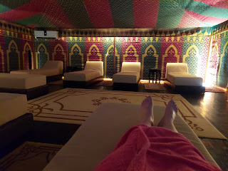

Some important things that I learned from the first part of this experience:

1. Moroccan women are very caring. The woman was not trying to make me uncomfortable or cause me to suffer. She was trying to CARE for me.
2. Body image is VERY different in this part of the world. There is no body shaming or embarassment about what your imperfections are. Your body is a gift. It is honored and revered. It is to be lovingly cared for. No need to feel awkward about standing there naked in front of another woman who is there to help you. (Easy to say, and yes, a full week later, I am still pondering this concept.)
3. Women around the world are amazing! They have traditions that have been passed down for thousands of years and I got to participate in just a tiny portion of what they have done for a very long time. Wow!!
4. I will never do a hammam experience ever again. There's no need. Now that I've done it, I have no need to do that ever, ever again.
5. Given the fact that I have had some childhood trauma in the misuse of my body, it was very uncomfortable at times. I just had to tell myself, repeatedly, that she was not my enemy. She was a loving and respectable woman. She treated me with respect and kindness and was not inappropriate in any way. It was just something so different from what I THOUGHT it was going to be, and I was really a bit shocked at various stages of the experience.
6. When it was all done, I did end up feeling like I had been lovingly cared for. She was meticuluous and dedicated to making sure she took the utmost care of my skin. All of it.

The masseuse did a good job, especially with incorporating a half gallon of argon oil into my skin and my hair. :)

After I finished the massage and got dressed into my own clothes again, I hung out downstairs in the comfortable seating area once again, until my driver came back for me. One of the shop assistants helped me pick out a few items to purchase and take with me. Our conversation improved mightily once I realized that she wasn't speaking to me in French (although it sounded like French). She was speaking in Arabic! That's when I changed the language on my Google Translate app, and that's when we began to understand each other. :)

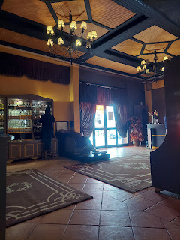

The entertaining music during my taxi drive back to the hotel. (10 seconds)
https://photos.app.goo.gl/MPdk5WZdtATB14kH7

Here are a few more Moroccan blooms that I came across.

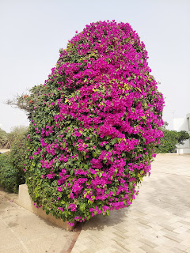

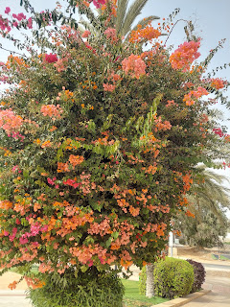

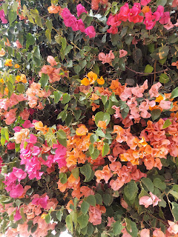

For dinner that night, Scott and I ordered room service delivery from the Moroccan Restaurant downstairs. We watched "America's Got Talent" and ate some really delicious food together. :)

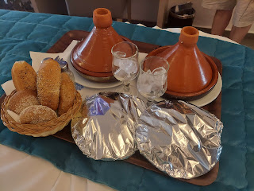

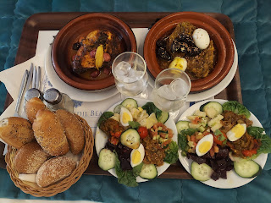

Day 4:
My second and final scheduled excursion in Morocco happened to be a horse ride down to the Souss-Massa River, which meets up with the Atlantic Ocean.

Once again, a driver picked me up. His name was Abdullah. You may recall the fun conversations I had with him, described in detail within my last post. He was the best taxi driver I had in Agadir!

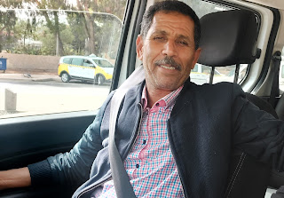

He dropped me off to Adam, my guide, and within about 7-8 minutes we were out on the trail.

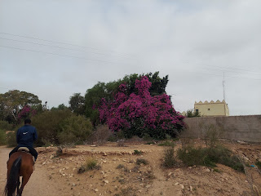

Most of the trail looked like this. Dusty, shrubs, rocks, and quiet. Adam didn't talk much. Perhaps because he didn't know much English. Perhaps because he was a teenage boy and preferred to be head-down looking at his phone 80% of our ride. Another 15% (or more) was spent scolding his horse, "Z", who wanted to buck him off many times. I was grateful to be on Hennie's back where life was more calm and predictable.

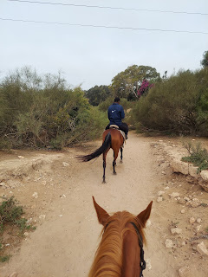

Every so often Adam would look up from his phone and point toward something off to the right or left, telling me in one word what I was looking at. "Golf", as he pointed toward a golf course through the shrubbery. "King's Palace" was always on the right. Endlessly. My goodness - the King sure owns a LOT of acreage that he doesn't visit very often. But at least it's there when he wants to come.

Eventually we could see the Souss-Massa River.

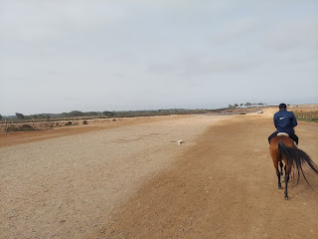

Adam led me onto a trail that paralleled the river.

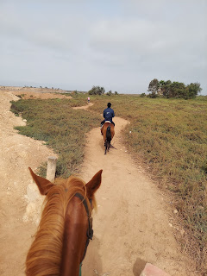

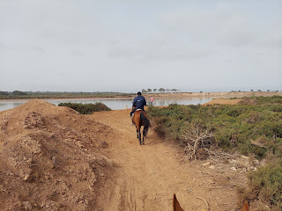

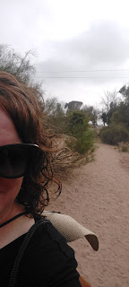

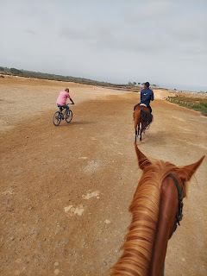

I asked him to please take a couple photos of me. He had to get "Z" under control first before I could pass off my phone . . . and the same process for him to hand it back to me.

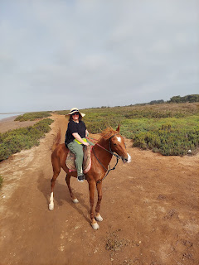

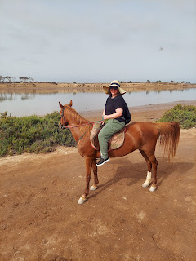

Unfortunately we didn't stay for very long where it was the most beautiful - along the river itself. We could see flamingos off in the distance but they were too far away for a cellphone camera. I could also see the ocean just past the flamingoes. I wish we could have gone farther.

Video of the river leading out to the sea, along with the King's palacial land on the right, for MUCH farther than the eye can see: (13 seconds)
https://photos.app.goo.gl/JPwkcdCQErqWpGGW9

I had the option of getting Hennie to gallup down the beach if I wanted to. Adam told me she loves to run. I ended up just walking her because at that point, I needed to go potty and didn't want to have anything embarrassing happen in the saddle . . .

I could tell Hennie was disappointed, too, but she got a second chance. There was a log in our path just moments later. After Adam told me to hold on and follow him, he set off in a short run with "Z", which caused Hennie to take off after the both of them. We jumped right over that log and boy was Adam pleased. He was amazed that Hennie jumped - so maybe she hadn't done that before? - and he was pleased that I handled it all very well, too. My favorite moment was that I didn't have any embarrassing moments to speak of, ha ha. But yes, I was proud of Hennie, at the same time. And it was pretty exciting.

Even though most of the trail was dusty and brown, just like anywhere else in Morocco, there are several little bright bursts of color along the way.

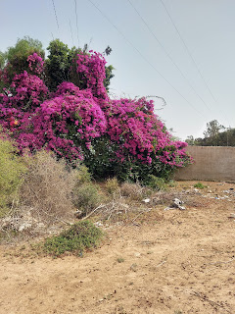

We also passed a pen full of sheep and goats that were happily eating various kinds of melons.

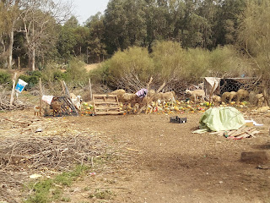

Just beyond the watermelon feast, we passed a shepherd out with his sheep.

Video of the sheep (watch closely for them and at the end you'll see the shepherd in front of the purple bush): (16 seconds)

https://photos.app.goo.gl/PZKUtk3nxRnZxFLM8

We also passed several camel tours on our way back, and I was envious of that, as I mentioned in last week's post. But I can still hear Abdullah's words ringing in my ears, "You are strong woman! Sisters here in Morocco no ride a horse. They scared! But you!! A WOMAN - from AMERICA - is
VERY
GOOD!!"

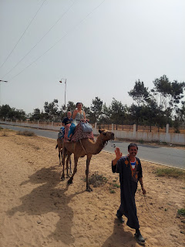

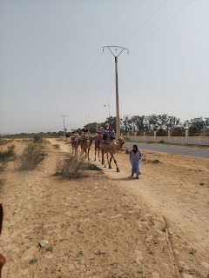

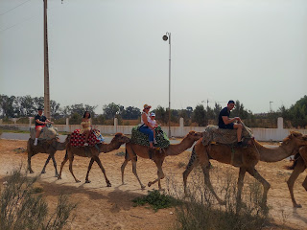

Video of a camel tour group passing by: (6 seconds)
https://photos.app.goo.gl/PU93dD7LwbGkq7gm7

Video of the camel and horse "lounge area": (12 seconds)
https://photos.app.goo.gl/GHvxg4GB8XTrWKEDA

Video of the baby camel: (6 seconds)
https://photos.app.goo.gl/iMLAt6eCSDaRM18n9

Video walking through all the resting camels: (16 seconds)
https://photos.app.goo.gl/qiEPMpvp9cdpxMFL8

One last photo of Hennie

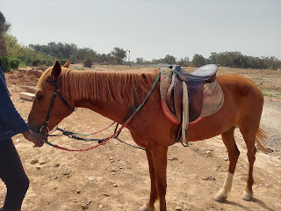

What an adventure! And it was HOT!! I was happy to just be quiet and on the back of a horse. It was our daughter who penned the most famous Harmon phrase (when she was about 10): "You'll feel better once you're riding a horse." And it's true.

Originally she wrote those wise words for our friend Mistie Lemons who had Non-Hodgkins Lymphoma and was in a really bad spot at the time. We have repeated that phrase too many times to count in the years since!!

Back at the hotel, I got myself some lunch and rested for a bit before heading out to the pool again. On my way to the pool, I met up with Daddy Turtle. I found out he was the dad because a man walking by said this was the dad (with the cracked shell on his back), whereas the mother was somewhere else on the property and had just recently become the mom of 4 little baby turtles!

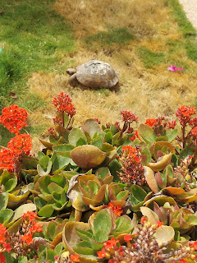

Video of Daddy Turtle: (33 seconds)
https://photos.app.goo.gl/Snto9ytkHufopBTk7

Once Scott got home from work, we found some dinner and caught up on each other's day. I believe this particular night we just ate in the buffet restaurant at his hotel. I can never eat my money's worth at a buffet, but it sure was convenient to just eat and be done. Restaurants in this half of the world make eating a meal more of an "experience", which is fine sometimes, but too many times it's not. It takes about 2 hours to finish dinner in a restaurant over here . . .

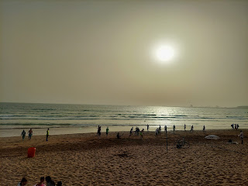

Day 5:
For my morning walk, I decided to walk all the way to the end of the beach and go see the marina that everyone kept talking about. It took me about 30 minutes to walk that far, but it truly was very beautiful, especially with the water being so calm first thing in the morning.

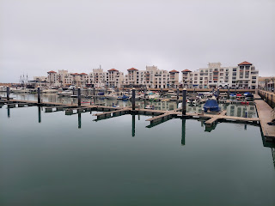

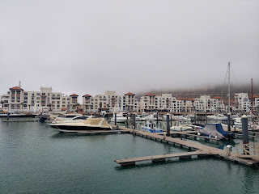

From where I took this photo near the marina, my hotel is probably directly across the water from me. I believe this area is called Agadir Bay. There are several shops and restaurants between my hotel and here.

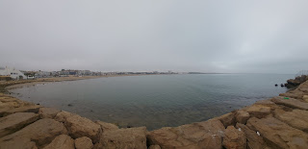

I wished that I had brought my wallet with me, so I didn't have to walk all the way down again later in the day. But at the same time, I didn't REALLY want to be doing shopping in my exercise clothes either . . .

Last week I shared a photo of a shrub that produces multiple colors of blooms. I don't know what it's called, but on my little explore that particular morning, I found several pretty flowers to photograph.

Video of the multi-colored blooms: (23 seconds)
https://photos.app.goo.gl/gCehxnZqnTGkBy5J6

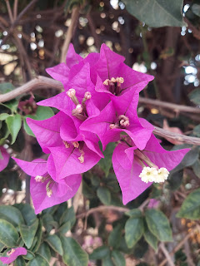

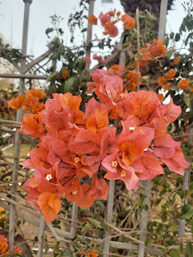

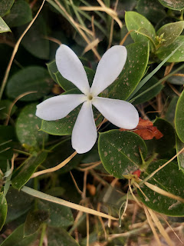

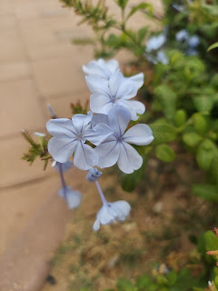

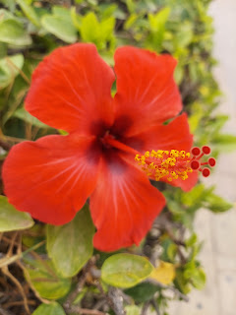

When I saw this sign on the front of a restaurant along the beach, I laughed and then sent it to my kids.
"Fresh AND Food" ha ha

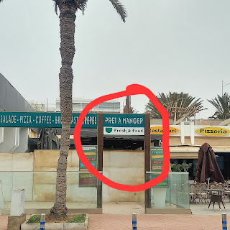

When I walked back down to the marina area later, the big Rugby Tournament had started. I had seen signs everywhere, advertising the 16th Annual Rugby Tournament on Agadir Beach, but I'm not sure where all the teams were from.

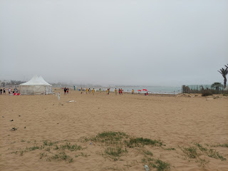

Short video of some rugby action on the beach: (15 seconds)
https://photos.app.goo.gl/Sk8Lekymg6YA5iS67

I'm not much of a cat person, but I took a photo of this stray cat wandering the streets of Morocco, just in case someone was interested.

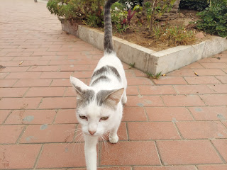

This stretch of shops and restaurants along the beach was a tourist heaven.

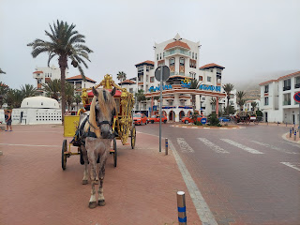

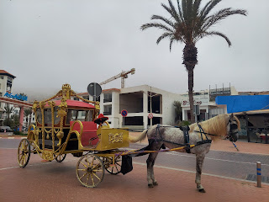

For lunch, I had a really nice visit with my waiter, whose name was Yusef. He is from Istanbul, but his dream is to make it to Spain sometime soon. He says the pay and the future of his career isn't that great in Agadir, but he's been to Spain and is very excited to save the last bit of money that he needs to get established there. He was young, maybe mid-20's, and tried really, really hard to carry a conversation with me in English. He wanted to know where I was from, so I showed him on a map. He had never heard of Yellowstone, so I showed him some pictures. He didn't know what whitewater rafting was either, so I showed him a photo of when we took all of our kids a few summers ago. I explained in very simple terms how when the water is "crazy" (with lots of gesturing of the water crashing all around), it turns white. He was like, "Ohhhh!!" And he got it. :)

The food was okay, but it took forever for them to bring me one thing at a time. The best part was definitely just visiting with Yusef. This is a Moroccan Salad and it was actually pretty good. The fish that they brought out in the clay pot (Tagine) was so full of bones that I hardly got any actual meat. It seems like there should be a better way of preparing the dish so it's more enjoyable for your customers. My dad could show them how to fillet the fish and skip all the bones . . .

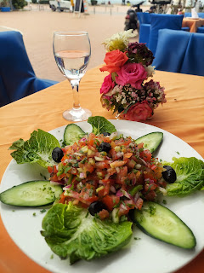

I found a couple of fun things to buy in the shops, including a traditional Moroccan dress in a bright teal green color, and a couple of trinkets (a.k.a. fridge magnet) to take home. I spent a little more quiet time in my hotel room before heading down to the pool again while I waited for Scott.

For dinner later, he wanted to try another new restaurant with Lebanese fare, so off we went, walking almost down to the marina for the third time that day (for me).

I ordered one of these Turkish Buraks. I really wanted the spinach one, but they had run out of spinach for the day. So I got the mixed pancake burak - half with chicken and half with lamb. The lamb and mint half was definitely my favorite.

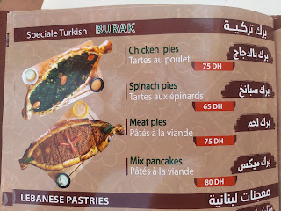

Our waitress was such a delight. Her name was Fadwa and she was hilarious and bubbly and friendly. She nicknamed us Rose and Jack from the Titanic. I think it was because we were asking about a big pirate looking ship that we saw out in the bay, which turned out to be available for tours that left every hour from the marina. ($15 each)

While we waited for our food, I called my sister Charmaine back. She had called earlier as I was leaving the pool area and I needed to get dressed for dinner, so I had arranged to call her a little bit later. Turned out that now SHE was the one hanging out by the pool, ha ha. (Down in San Diego)

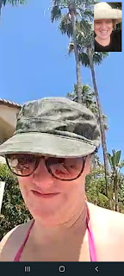

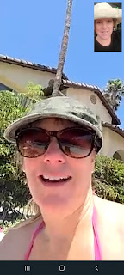

Day 6:
A few more Moroccan flowers from my morning walk . . .

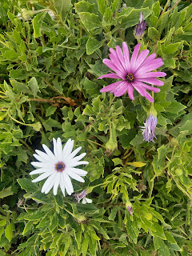

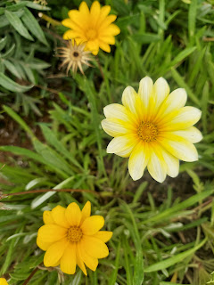

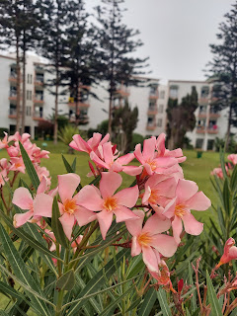

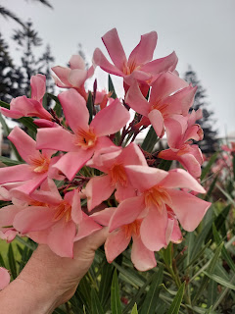

I had met a new friend the previous evening down by the pool. Her name is Imane. (pronounced like ee-MONN) She was nearby in a sun lounger chair and overheard me talking to Scott in English. She waited patiently for me to finish my phone call and then she asked where I was from. We hit it off and started talking together while we waited for Scott to come over to my hotel after work.

She is 35 and is originally from Marrakesh, Morocco and is Muslim, but has been living and working in Paris for the past 10 years as an IT Engineer. She is very smart and speaks very good English! She was very excited to meet her very first friend from America - yours truly. :) We agreed to meet by the pool again the following afternoon, which we did.

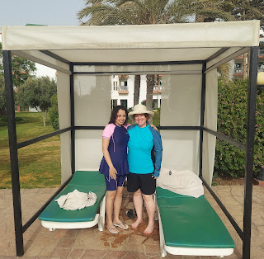

I learned that she has a boyfriend in Paris, but that things weren't going so well. As we talked about some of the issues, something she said made me think of the 5 Love Languages, which I introduced to her. She got very excited and wanted me to explain each of them in great detail, pausing after each one so that she could quickly decide if this was something that was a love language for herself, for her boyfriend, for them both, or for neither.

She is a gift GIVER, like I am. But she also likes to receive gifts in return, which I have less need of. But her boyfriend appears to not need gifts for himself, nor does he seem to be a giver of gifts to others (most especially Imane). This was causing a rift between them.

I shared some highlights from our 30 years of marriage, including some harder lessons I've had to learn, but important ones nonetheless. For example, one of the biggest differences between Scott and me is that he is a money hoarder and I am a money spender. We have figured out a way to work together over the years and not get angry at the other person. We might get frustrated, but we recognize that the other person's feelings, thoughts, and opinions matter very much and that it's important to take the time to listen and learn where they are coming from. Eventually we work out a compromise that makes us both feel good, and then we move on.

We talked for a very long time about relationships and communication styles and how to understand our partner better. She was so engaged in the conversation and I loved being able to help her a little!! I hope they can figure things out and learn how to understand each other better.

Soon, Scott showed up and I was still all wet down by the pool and not even close to being dressed for dinner, ha ha. But hey, we're in Morocco and there is no hurry. :)

Imane loves to take a lot of photos like I do, so she offered to take one of Scott and me. XOXO

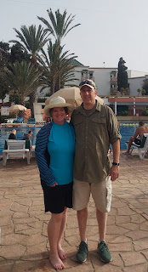

I said goodbye to Imane for the evening, promising to meet up with her again the following morning.

Scott and I walked down to a restaurant that was next to the Lebanese one from the night before. This one was called Istanbul. I think it was my favorite food of the week - but it might be tied with the Moroccan food from his hotel a few days earlier.

This was a sampler platter with all the fixings: hummus, baba ganoush, tzatziki sauce, falafel, etc. SO GOOD!!

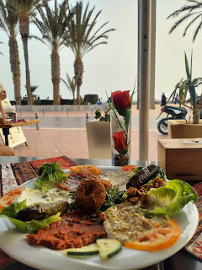

My mixed grill platter with lamb, chicken, liver, wings, rice, etc. Super good. (I didn't eat the liver) (Well, I ate one bite. But that was all)

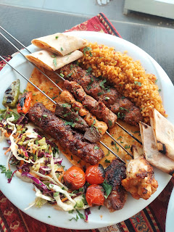

Scott's chicken shawarma - his favorite.

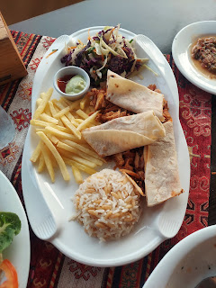

After dinner we walked back along the water's edge for a long time. It was so relaxing and lovely.

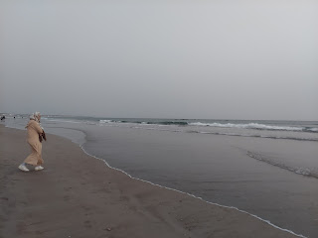

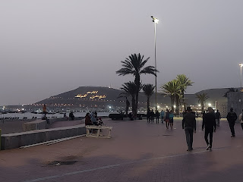

Also - it was Father's Day. :) I love this guy so much!!

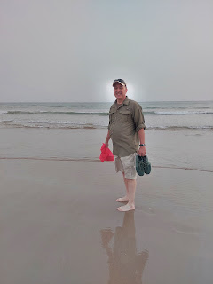

Short video of our walk along with the views: (24 seconds)
https://photos.app.goo.gl/4D5Zxgprj9R8S4Bm8

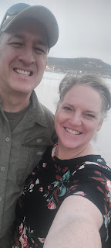

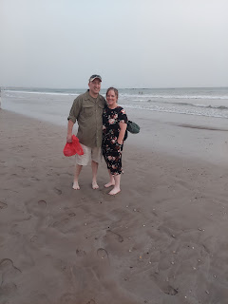

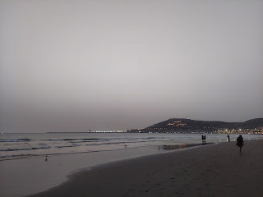

We had set up a meet with Abdo for that evening after we finished dinner. He met us on the Promenade next to my hotel. I wanted Scott to meet him, and for him to meet Scott. I had talked so much about Abdo to Scott, and I shared a lot of stories about Scott with Abdo. It was nice to hang out with him for a bit as the evening wound down.

I had to run upstairs and collect a few things for my nightly sleepover at Scott's hotel, so the men waited for me together down in the lobby where there several comfy couches. I hoped they would visit and laugh together some more while they waited for me, and yet I tried to be quick, knowing that Scott is not much of a talker . . .

I was not surprised at all to come downstairs and find them both quietly absorbed on their cellphones, ha ha. I was sneaking a photo of the two of them, when Abdo happened to look up just as I was taking the photo. He squeezed in another big smile. :)

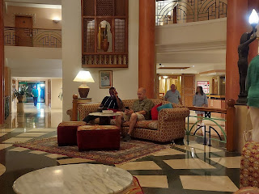

We invited him to walk with us further so we could continue visiting, and which he was happy to do. Eventually, we parted ways at Scott's hotel, agreeing to meet up in the morning with Imane (who I really wanted him to meet).

*Oh! I should also mention that this same day (Father's Day) was also Juneteenth, a celebration of the day when ALL the slaves got word that they were emancipated (in the U.S.). It took a while for all of them to get the good news! What a privilege it was to be a part of the celebration while visiting in Northern Africa!! As we walked to dinner and along the beach, there were clearly more crowds than usual, with lots of music and festivities all around us. It felt really good to be among such wonderful people and to feel of their joyful spirits.

Day 7:
I went with Imane down to the beach to hang out, and Abdo met us there a short time later. The guard of our little private roped-off beach wouldn't allow Abdo to sit with us under the shade of our umbrella, saying that it is only for hotel guests - no exceptions. So we grabbbed our towels and went to sit in the full sun instead. I was wearing my hat though, so that helped.

We had the BEST visit for the next TWO HOURS!! We talked about so many things...things that were deep and meaningful. We talked at length about relationships again, how to accept the differences in your partner and to allow them the space to be themselves, and not to dwell on the nitpicky things that so often become disproportionate in the relationship. We talked about homosexuality in the world today (!) and what we each believe and how religion is key to accepting and loving everyone no matter what our differences are.

Here's an interesting insight that I shared with them. This is something I have pondered on time and time again in the last several months. Hopefully I haven't already written about this - please forgive me if I'm repeating myself. But the thought is this: I believe that our generation (Scott and me) have a special obligation and opportunity to help bridge the gap between the older generation (our parents) and the younger generation (our children).

Let me explain.

All too often I see members of the older generation (70's and up) being very comfortable in all the traditions they were brought up in. This is not necessarily a bad thing. But their generation tends to see things in black or white. It's either right, or it's wrong. It's either socially accepted, or it's not. This is what you do (or don't do) because this is what we were taught by our parents, who were taught by their parents, etc.

The problem with this is that it makes it much more difficult to accept change, or to genuinely and sincerely love those with perceived problems or who have socially unacceptable behaviors or tendencies. (There are always exceptions to what I'm saying here - - this is just a generalization for the purpose of trying to explain my thought process.)

For example, before I left Idaho Falls, there was an older man in the grocery store that stopped to talk to me in the pasta aisle. He was in his 80's and was a lovely man. He told me story after story about how he loved having a positive influence on the young men, helping them to earn their Eagle Scout awards, etc. He was moved to tears as he shared how HE was honored at one of the award ceremonies, for giving so much of his own time to helping these young boys. He told me that he loved seeing them mature in their individual journeys and how so many of them went on to serve a mission and go to college, and how he felt like he helped to make a difference in their lives. But just a couple of sentences later, he almost spat as he flipped his whole train of thought and said, "But it makes me sick to hear about all these young people today that are gay! It's disgusting! I don't even understand! They just need to . . . " blah blah blah.

To me, it felt like he had just thrown out all the good that he just told me about - he had genuinely cried from the love he felt for that first group of boys!! If you love some young people, but don't love the others because they are gay, well, that's just wrong. If God loves all of them, EACH of them, then shouldn't we? But he truly couldn't see that. The eagle scout awards were RIGHT in his mind, and being gay was WRONG in his mind. He couldn't connect those two worlds together at all. He couldn't see that loving gay people is different than choosing to agree with their lifestyle. We CAN have both. We can both love the individual AND maintain our own standards. We cannot force our ideals and belief system on anyone, nor should we scorn them for the times they choose differently. We can always choose kindness.

The younger generation, on the other hand, is VERY OPEN MINDED. They seem to have taken all of the traditions that have been around for decades, and dumped them all out like a barrel of monkeys. They are systematically taking each one at a time and looking at it from many angles. They are assessing if it's simply a tradition, and if it is a valid way of thinking and living life. If it is, they are finding better and more efficient ways of keeping that alive. If it's not, then they are coming up with another idea to replace the old one. They truly desire to be more efficicient, and to be more meaningful and purposeful about every single thing they do.

Now, here we are, Scott and me, stuck in the middle between these two generations whom we love very much. We love our parents and we love our children. We love the older generation, and we love the younger generation as well. (Also - I don't mean to suggest that our own parents have behaved in a poor way, or that our children are perfect angels. I think it's more of a society issue - not so much a Snider/Harmon family issue.) But this is where taking the time to understand each other is so important.

I don't always realize the times when I am just following a tradition that I've been taught, but my children will let me know if I am, and if the blind-following-the-blind approach is undesirable. I am so grateful that our children have been teaching us to open our minds to the ROOT of the issues in society, to really look hard to find the most meaningful approach - one that takes all sides into consideration, and to step outside of our comfort zones. I feel as though my spiritual capacity to learn has increased because of the younger generation. I am not just taking the information I receive at face value anymore, like I used to. I am consistently trying to step back and find the rest of the story. After all, every person has their own individual story.

What I shared with Imane and Abdo is that if they can try to understand where the older generation is coming from, then perhaps they won't get so frustrated with them. And vice versa. If the older generation can really listen to the younger ones, with a sincere desire to understand where they are coming from, that is when peace and love and connection can happen.

ANYWAY . . . wow, sorry, that was really long winded. But this is part of the deep conversation we were having out on the beach in that hot sand, ha ha. And it was amazing!! Everyone contributed some deep thoughts to the group chatter and we learned from each other and it was beautiful. I love these two so much! They both told me I am their first American friend ever. What an honor.

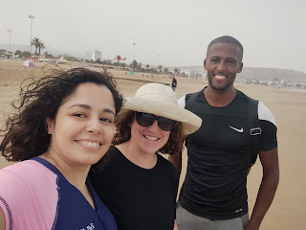

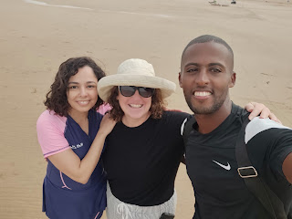

It was sad to say goodbye. Goodbyes are always hard. To keep our chins up, I told them I would be back next June. Because I really mean it.

The rest of the day I got all my things organized for travel, and that was that.

The absolute worst point of my day was having to say goodbye to Scott. I told him it would be easier if he said goodbye to me in my hotel room, rather than me saying goodbye to him in his hotel. I couldn't bear the thought of walking that long walk back to my hotel in tears. He tried to cheer me up by saying things like, "Just think of this as you going on a vacation from Italy. By yourself. But to see the family! It will be great! And you'll be back here before you know it." It didn't help. But a few days later, it has sunk in a little more and I see the wisdom in what he said. :)

Day 8:
Well, things just got interesting for me, starting around 2:00 a.m. on my travel day. I had chills in the night, but didn't realize it at the time. I just knew I couldn't sleep because I was cold. I got up and started getting dressed at 4:00 a.m. and was down in the lobby by 4:30 a.m. for the taxi to pick me up and take me to the airport.

The process for checking my bag went much faster in the Agadir Airport. Only one person in front of me this time . . .

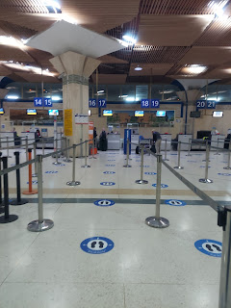

When flying on RyanAir, it's always best just to do whatever you are instructed to do, even if it doesn't make a whole lot of sense. In Bologna, for my trip down, they didn't even care about or need the printed paperwork that I was told to print ahead of time. So I didn't even bother to print any of it for my trip back up to Italy. Well, I guess in Morocco, they don't really have printers or capabilities to print boarding passes for you . . . So, using the email that I had received the day before, the ticket agent HAND WROTE my boarding pass for me. At each check point, someone would hand stamp my paper and then I could proceed. Wow.

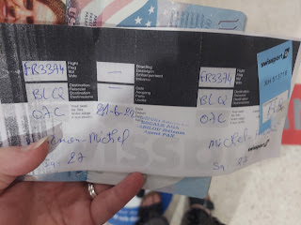

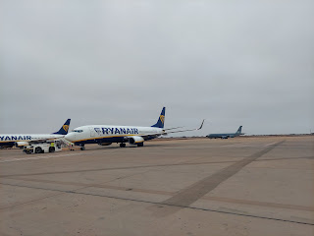

Throughout the day, I began feeling worse and worse. I didn't want to eat anything because it sent my stomach into cramp mode. All I did was just sip water and close my eyes. A few minutes before we landed, I emptied out what I thought was the end of what was in my colon. But I was wrong.

I got my suitcase and made it back to where I parked my car for the week. It didn't help that the inside of the car was 150 degrees when I was already feeling weak and dehydrated. And I couldn't let it run on idle for the A/C to cool things off either, because of what I had experienced coming home from my visit with Avery a couple weeks ago. So I sat on the burning leather seats in 150 degrees to get all situated as best as I could, pull up Google maps, get a few things out of my back pack, etc. And THEN start up the car and get the A/C blasting and start driving.

I was so lightheaded the whole drive (90 minutes) and was seriously worried about 2 things: 1) I didn't want to pass out or do something stupid because I was dizzy; and 2) I didn't want to poop in my pants.

I literally did deep breathing the entire way (in through the nose, out through the mouth) and it really seemed to help. I also prayed nonstop the whole way. I only had half of a water bottle to get me home, so every 5 minutes or so I would take a sip.

I was so relieved when I pulled into our courtyard to park the car. The last feat I had to accomplish was to get my heavy suitcase up 2 flights of stairs. I went up with just my backpack first, so I could turn the A/C on inside and then go back down to retrieve my suitcase. I was so exhausted at this point I wanted to die. The thermostat in our house said it was 31 degrees celsius. Gross!! (That's 87 degrees F)

I said one more prayer to please help me get my suitcase up the stairs, and it worked! I think angels must have helped take some of the weight off, because I went up with relative ease. Amazing. As soon as I could, I laid down on the bed and konked out.

That began my woeful tale of the Moroccan Bobos (that's our nickname for it) for the next 5 days. (*Monday Update: It's still going . . .) It's better known as Travelers Diarrhea, and is common in places like Africa for people with weak American stomachs, like me. Even though I was drinking bottled water in Morocco, it's not a guarantee that all the food we bought in the restaurants was prepared with bottled water. So at some point, some foreign bacteria - that the locals are accustomed to - got in my system and then things really got fouled up.

I lost 5 pounds in 4 days, which sounds great if you're wanting to lose weight. (*Monday Update: I've lost 7 lbs now) But I don't generally recommend this method. From Tuesday through Friday, all I could do was maybe one meaningful task each day. Get some groceries, for example. Fill the empty gas tank in the car on another day. And that was all I could do. The rest of the day I just lay on the couch or on the bed watching shows or closing my eyes. It was pretty miserable. The only friends I had were bananas, rice, applesauce, and toast (or in my case, bread, since we don't have a toaster). These friends are commonly known as BRAT.

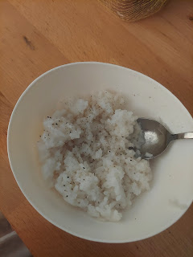

Friday I began to get more concerned at my lack of progress, knowing that just around the corner I would be traveling all the way back to Idaho Falls!! I needed strength, I needed to be able to get some nutrients from my food, and I needed to feel better. So I asked for a priesthood blessing. Two wonderful men from our ward here in Vicenza came over to visit with me and to give me a blessing. It was the right thing to do. By the next day, Saturday, I could feel strength returning to my frame and I had only a couple trips to the bathroom. I was able to do SEVERAL things in one day and not exhaust myself into a backslide. It felt amazing!!

I went to IKEA to get some important things before I leave town because when I come back in September, I won't have enough time to work on the guest rooms then. Our friends will be arriving within 2 days of my arrival. I put a duvet set together for the upstairs bedroom and spruced up a couple things.

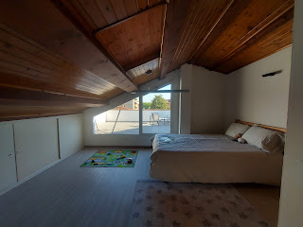

I also swept all the floors. I worked on this blog with a clear brain - yay! And I even assembled 2 new fans.

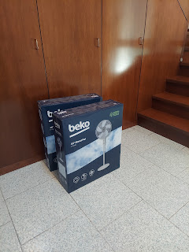

Oh yeah, I forgot to mention that our A/C is broken in the living room. I shut it off for my recent trip so we didn't pay for expensive utility fees when the house was empty. But it's also quite old, too. Right now, it's only blowing out about 5% cold air, just enough that you can feel it lightly blowing on you, but not enough to cool off the room at all. Here I am, 6 days later, and the temperature in the living room is only down to 26.5 degrees celsius. That's mostly from my nightly effort of opening up the windows to try to cool things off just a bit, even though it only cools off to 70 degrees outside. So having more fans to move the air around now is going to be fantastic!

Meanwhile, the fixer guy is going to install a whole new A/C unit later this coming week, just as Scott is getting home. He will be so grateful!!

Anyway, today, Sunday, I feel a little tired, but not terribly so, and I feel like the worst is definitely behind me. And thank goodness!! What an ordeal . . .

Speaking of Scott, he is doing great. He loves what he's doing down in Morocco and has made some wonderful friends. Like Badr. Yes, that's spelled correctly. It's pronounced like "badder". Scott says they laugh A LOT together.

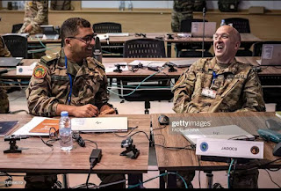

Here is an article that I found with a few photos of what they're doing in Morocco:

https://www.thenationalnews.com/mena/2022/06/22/african-lion-2022-military-exercise-in-morocco-in-pictures/

Unfortunately, some of the service members are either getting the Moroccan Bobos or dealing with a new spike in Covid cases. One of the guys that Scott works closely with every day just tested positive. But here is where I need to reassure Scott's mom: when he got Covid in January (same time as me) he only had symptoms for 24 hours and then he was just fine. So don't worry about him if he gets it again. He'll be over it so fast - he'll probably be all done with it before you even hear that he had it, ha ha. Please don't worry. :) XOXO

He'll be back up in Italy by Friday.

LASTLY: Time for Grandbabies . . .

It's been a while since I had access to the photos and videos I've received, so prepare yourself!

Let's start with Jack Jack and those handsome wavy curls.

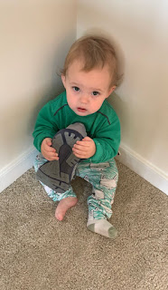

He found himself a new cellphone.

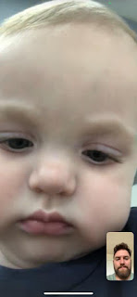

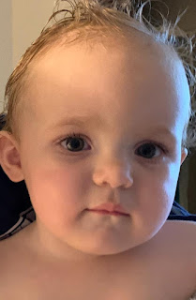

And he's been to a ton of National Monuments once again, as Jacob and Hannah have been hosting her sister and brother-in-law from Utah for a few days.

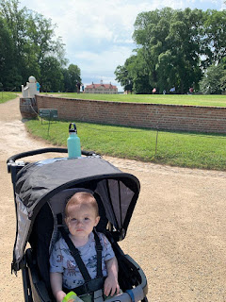

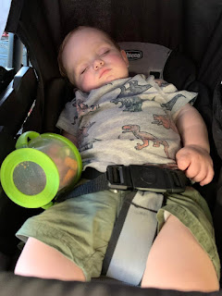

Mount Vernon - George Washington's home and estate

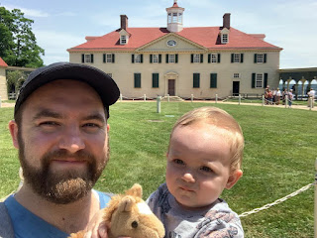

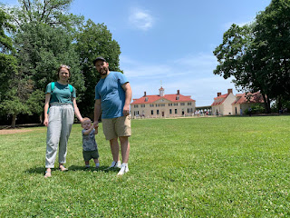

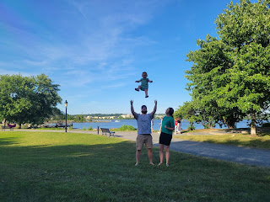

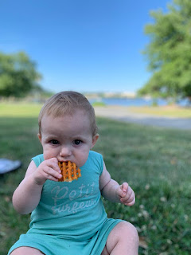

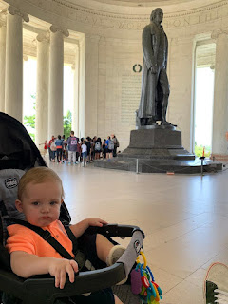

Sweet angel boy

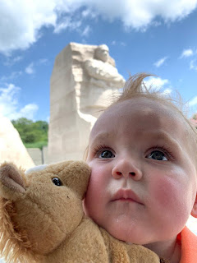

Hanging out at home on the balcony

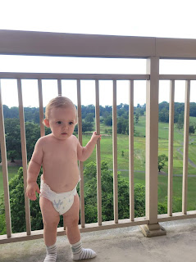

I can't remember the name of this cathedral in Washington DC, but Jacob has been here a few times. I always think it must be a cathedral in Europe or something because of the grandeur.



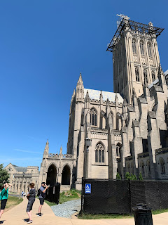

As for the southern girls - Abby and Gwen - this is probably my favorite photo of them EVER!!

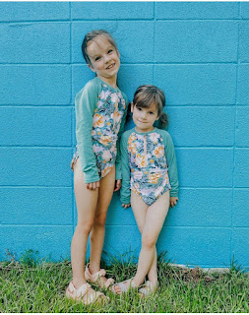

They have really enjoyed the packages of clothes I've been sending from Italy. This time, however, the girls took the time to model their new outfits for me. :)

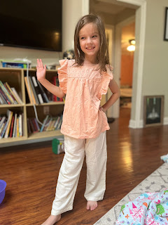

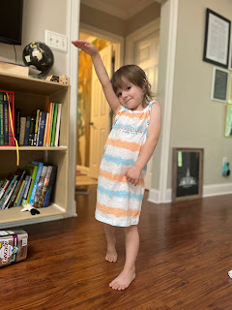

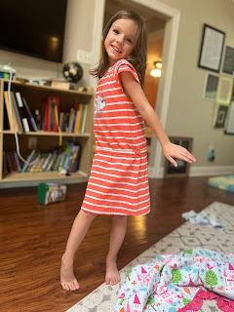

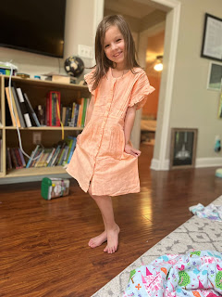

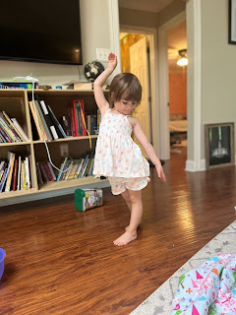

So fun!! They are currently in Florida for a Whitworth Family Reunion. I heard that Gwen got the stomach flu, so I hope it's not getting passed around to the whole clan . . . I hope they are having fun though!!

Amber just finished this gorgeous re-creation for a friend of theirs as a wedding anniversary gift. The husband paid Amber handsomely to do this for them. She is SO talented!!

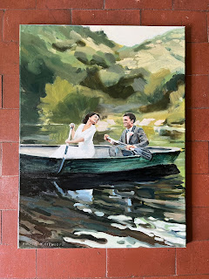

The only photo I have from the Aviano family is this one of their dog, Mocha, who somehow got a foxtail (obnoxious weed) stuck in her eyeball a couple days ago. She had to have it removed at the vet, and has to go back in to make sure they got it all out, otherwise she'll need surgery so she doesn't go blind. Yikes! Hope he got it all . . . poor thing. That sounds miserable!

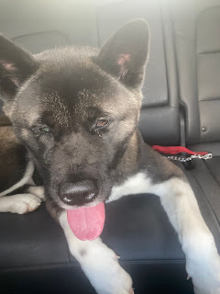

I fly home to Idaho Falls on Tuesday!!
I can't believe it . . . time has gone way too fast over here. I am starting to shift my heart a little bit now towards going to my other home. I'm eager to settle in and check on our house. I'm eager to visit family that I haven't seen in a long time, starting with Scott's parents.

Crossing fingers that the Moroccan Bobos will fade into the past and never return . . . . . . . .

