My Ancestral Jewish Home in Venice
I'm so excited to share this adventure with all of you! It took place about a month ago, just before Scott and I left Italy to fly home to Idaho together. I have been reading and researching a LOT about my Bassano ancestors from Italy over the past 2 years, and have had the glorious privilege of seeing some of their historical sites in person. But this day trip was a whole new level of special . . .

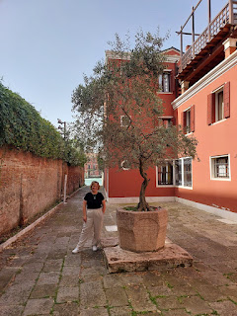

In the book, "Shakespeare Exhumed: The Bassano Chronicles," by Dr. Peter D. Matthews, he tells of visiting the archives in Venice and locating what he believes was the actual HOME of the Bassanos when they lived and worked in Venice, specifically for the Doge (Duke). We're talking the early 1500's here.

On his website, Dr. Matthews shares some important information on how he came to determine that this was their house. (
https://petermatthews.com.au/the-bassanos-jewish-guardians-of-the-ancient-arts/
)

If you scroll down about 1/4 through the main page, just past the Coat of Arms illustration, he says:

"
A similar coat-of-arms with the
Tree of Life
is found on a canal fronted building with merchant access to the roof space in San Maurizio, Venice. This is very interesting as it has three
Tree of Life
coat-of-arms affixed to the front of the building that were significantly eroded and two cameos. Historical property records confirm an owner in the last century had one of coat-of-arms replicated by taking a mould and reaffixing it over one of the existing.

"
The City of Venice records office confirm the building is as an “ancient Venetian home”,
[24]
although no surname is recorded. Records simply confirm it was previously owned by a family of merchants and musicians in the early 16
th
century who served Doge Andrea Gritti. Now this does sound quite interesting, considering the Bassanos were recorded in that very street in the parish of San Maurizio, and they did in fact serve Doge Andrea Gritti as musicians from 1523 until he passed away in December 1538. In fact, Jacomo Bassano’s daughter married the grandson of Doge Andrea Gritti, so the Bassanos were very close indeed to the Doge’s family. It was soon after the death of Doge Andrea Gritti that the Bassanos departed for England on 1 October 1539
."

Just imagine my excitement when I read this! I've been to Venice a few times now, but this was worth another day trip. I talked Scott into coming with me, bless his heart. He doesn't like the crowds of Venice, but we decided to go on a weekday AND first thing in the morning so there would be less people to contend with.

We left Vicenza at 8:00 a.m. on the train, and arrived at the Santa Lucia Station in Venice a little before 9:00 a.m. I had already mapped out the two places we wanted to visit ahead of time, "pinning" them on Google Maps so we could easily refer back to them. The two places we would be visiting were the likely home of the Bassano Family, and the Jewish Quarter of Venice. They are in two completely different areas, but we had a plan and we decided to just dig in.

On our way to the Bassano family home, we passed the Scuola Grande di San Rocco . . .

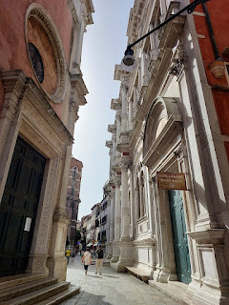

This school is one of five in Venice where religious confraternities have met for centuries. I can't find the specifics right now, but I remember reading that Jeronimo Bassano (my 17th great grandfather) had some connection to this school, along with one other school, the Scuola di San Marco.

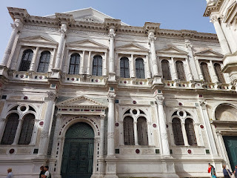

The Scuola Grande di San Rocco was founded in 1478. I've seen a few online photos of the magnificent ceiling paintings that the famous Italian artist Tintoretto made in 1549. We did not go inside to see them, but instead we just paused briefly to admire the outside.

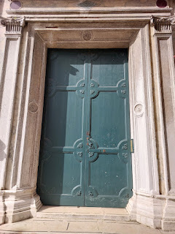

Google Maps indicated that we would need to catch a ferry to get to the other "neighborhood" called San Maurizio. I have never ridden a ferry in Venice before, choosing instead to just use my own two legs everywhere I want to go. But in the interest of time, we said, "Why not?"

What we ended up learning is that if you purchase a day pass for $25, it's only a few dollars more than 2 one-way ferry rides, and it allows you to use the ferry for unlimited rides all day long. You can even use the same ferry service to explore the nearby islands of Murano and Burano with this day pass.

With the day pass in hand, we checked the posted maps to learn which "booth" to wait in for the next ferry to come along and pick us up. There are two "waiting booths" at each stop. One is called "A" and the other is called "B". The one is for passengers heading in one direction, and the other is for passengers heading in the opposite direction. It's up to you to understand the map and to know which direction you need to go.

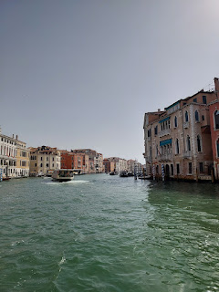

Video as we rode along the Grand Canal: (15 seconds)
https://photos.app.goo.gl/Jtwk25cP3QcKeZBa6

I enjoyed riding the ferry because A) it got us to where we needed to go much faster, B) I loved feeling the breeze on my face and it cooled me off, and C) we had a different perspective of the buildings and neighborhoods from the water.

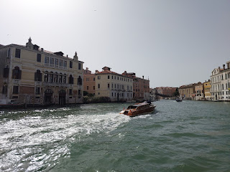

We got off at the Accademia ferry stop, which was extremely close to where the Bassano Home is located. In the photo below, you can see the Accademia Bridge in the foreground, and then past the bridge on the right, is a pinkish building. That pink building is directly across from the Bassano Home. (click photo to enlarge)

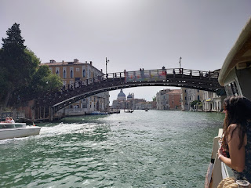

View from the Accademia Bridge . . . take note of the two shorter pink buildings on the left, just beyond the large ferry boat in the canal. Of those two buildings, the further one, or the one on the right, is the Bassano Home. (click photo to enlarge)

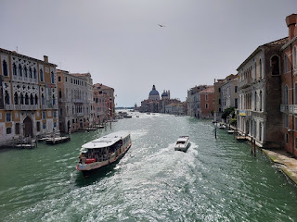

After we crossed the bridge, we passed through a piazza on our way through the San Maurizio neighborhood. This was no ordinary piazza, though. In this piazza, there is a building called the Museo della Musica and it's JUST AROUND THE CORNER from the Bassano Home!!

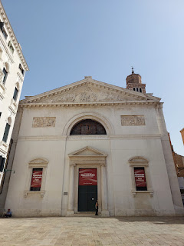

Here is a link to a very simple explanation of the Museum:
https://www.cntraveler.com/activities/venice/museo-della-musica

Spoiler: IT'S A MUSEUM ABOUT INSTRUMENT MAKING!! The Bassanos were INSTRUMENT MAKERS and they lived right around the corner!! There's gotta be a connection, because that's too much of a coincidence . . .

Here is a video that shows the piazza and the Museo della Musica: (19 seconds)
https://photos.app.goo.gl/ie9tGcvV3cdVrSLR7

One of the smaller canals on our way around the corner . . .

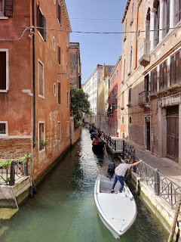

Layers underneath the centuries-old exterior that have stories to tell . . .

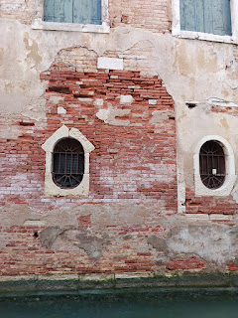

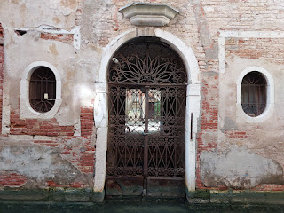

We got slightly lost while using Google Maps, and ended up at this place instead. It appeared to be a hotel from the outside, but it also had a mini police station inside, so . . .

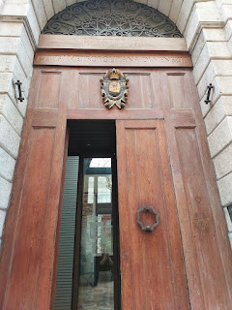

I did a quick look-up for what a Prefettura is, since that's what it says above the brown door. It's a Ministry of the Interior Office and every province has one. Their job is to be a liaison for the government at the local level. A prefetto = a prefect. They also oversee public safety. So that would explain the little room in the back with a police officer sitting behind the desk.

I wouldn't have known about the police officer, except that I wanted to go through what looked like a hotel lobby and into the little garden on the opposite side, but as I stepped over to the door, someone in the small line waiting to talk to someone made a clucking sound to get my attention and indicated to me that I couldn't go out there. When I tried to explain what I wanted to see, they told me to go talk to the police officer in the adjacent room. I obediently did so.

I told him what I was trying to find and I even showed him a screenshot on my phone from Dr. Matthews' website.

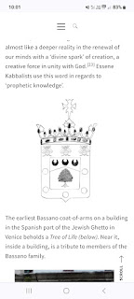

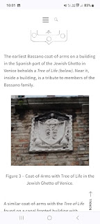

He was very nice, and in turn, he showed me an information page with a QR code relating to the garden that I was trying to get into. Apparently it's only open for a few months and on certain days/times.

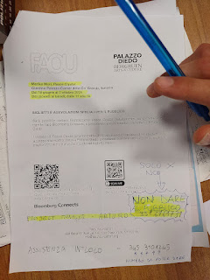

Once I got outside, I used Google Translate to understand what was on that piece of paper . . .

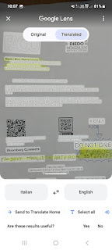

I knew that the garden is what linked the building in which we stood to the Bassano Home on the opposite side. That's why I was trying so intently to get into the garden.

Views from the lobby entrance where the Prefettura is located . . .

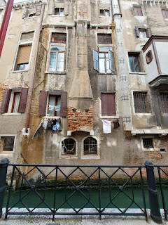

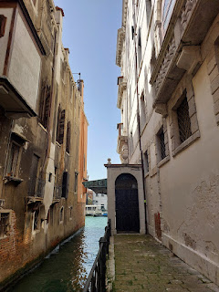

We used our own navigation from that point to get around to the opposite side of the garden. As we passed through the alleys and through the piazza with the Music Museum, I took some photos of a few details that captured my heart along the way.

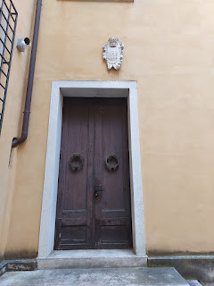

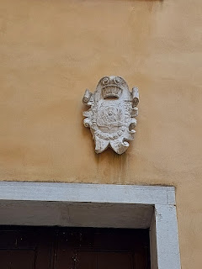

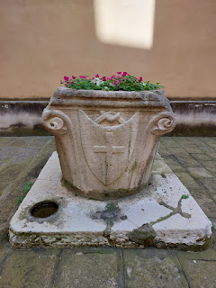

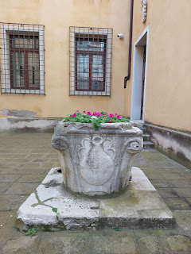

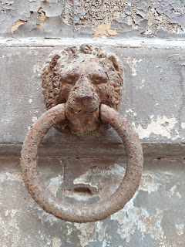

As we entered a long alleyway near the Bassano Home, I saw a "street sign" on the corner of a building that said, "Calle Da Ponte". It essentially means Da Ponte Street. "Calle" means "narrow street", of which there are millions in Italy, ha ha. The reason Calle Da Ponte caught my eye is because Jacopo Dal Ponte (also known as Jacopo Da Ponte and Jacopo Bassano) is somehow related to my Bassanos. I have come close recently to connecting those dots and figuring out how they were related, but I still need to do a little more research.

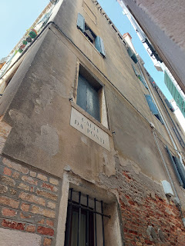

I really liked the circular windows in the San Maurizio neighborhood, also known as Rose Windows. I found a helpful link that explains the history of this artistic window style:
https://italiannotes.com/italys-rose-windows/

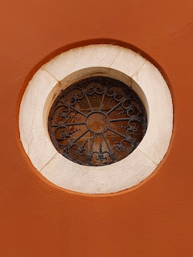

We found the garden's entrance on the opposite side . . . but it was closed up, as well.

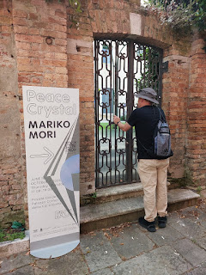

Poking my hands through the gate (carefully - so as not to drop my phone), I took a video, but I was underinspired from what the garden had to offer: (9 seconds)
https://photos.app.goo.gl/BQNvpX3ogdgZWoH8A

A whimsical peep-hole on the house next door to the Bassano Home . . .

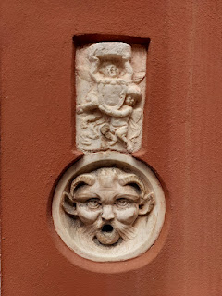

Below: I am standing in between the garden property (on the left) and the Bassano Home (on the right).

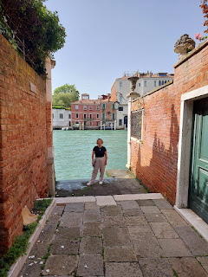

On the backside of the old Bassano Home, there was an open door, beckoning for me to enter and explore . . . but alas, I did not. I could hear voices inside and I didn't want to end up in an Italian jail!

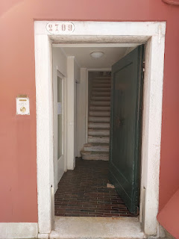

On the opposite side of the Bassano Home from where the garden was . . .

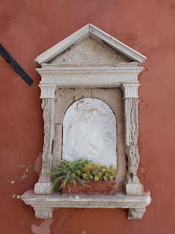

And finally, here is the waterfront entrance to the Bassano Home . . .

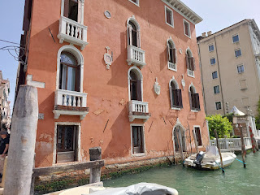

The Coat of Arms that Dr. Matthews spoke of was right there, too! What an exciting find!

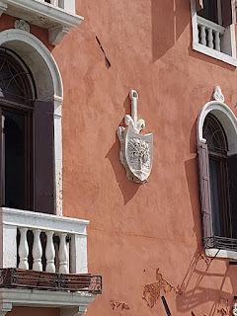

Video looking at the front of the house: (10 seconds)
https://photos.app.goo.gl/vuTuWZBHo7UU9Kg37

Video looking left and across the Grand Canal from the Bassano Home: (21 seconds)
https://photos.app.goo.gl/wiRMRAu48sczrxy16

There was a very distinguished building across the canal that I have since identified: The Palazzo da Mula Morosini. It was built in the 15th century by a noble family, and was later made famous by Claude Monet when he painted it in 1908. It hit me that he would have had to set up his easel either next to the Bassano Home, or in the next alley over, in order to have a good view of his subject. Wow. His painting is entitled, "Palazzo da Mula".

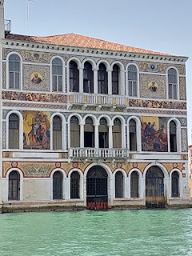

Here is a link to Claude Monet's painting of "Palazzo da Mula": (Currently on display in the National Gallery of Art in Washington, D.C.)
https://www.artsy.net/artwork/claude-monet-palazzo-da-mula-venice

I'll admit that I got a little teary-eyed as we concluded our visit to the Bassano Home on the Grand Canal. I have been so grateful time and time again for these opportunities to traipse around, do some detective work, and then stand in these special places on behalf of our entire family. To touch the building that I'm now convinced they used to live in was an experience I will never forget.

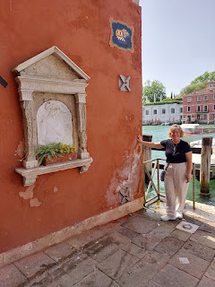

Walking away from the Bassano Home and looking toward the piazza where the Museo della Musica resides, here is the view . . .

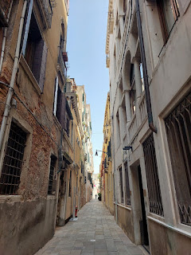

More details on the homes next to and down the alley from the Bassano Home . . .

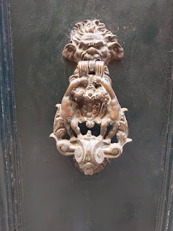

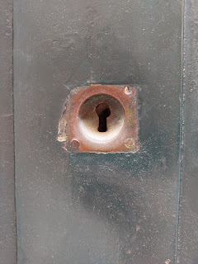

A side alley that shoots off from the main alley that leads away from the Bassano Home . . . this one dead-ends at the water. The water was teal and very pretty.

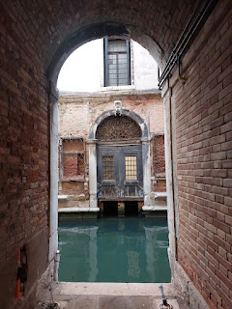

Video from the dead-end alley, looking left toward the Grand Canal, and then right. Note how quiet everything is in this neighborhood . . . (17 seconds)
https://photos.app.goo.gl/jUQipQxpaXX9hpxD8

Four doors down from the Bassano Home is the Gritti Palace, sitting right on the Grand Canal. The ladies in the "Wednesdays in Italy" group like to reserve a table (or three) at the Gritti Palace once a year for lunch. I haven't been there to participate in this outing yet, but hopefully this fall or next spring it will pop up on the schedule again. (The group consists of military wives who like to get together seasonally for an activity or an outing every Wednesday. We might go on a hike, or visit a historical place, or do a floral arranging class, etc.)

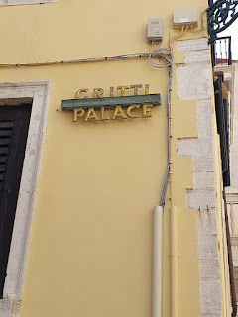

The Gritti Palace was built in 1475 by the Pisani family, but the exciting connection to the Bassanos is that THIS WAS WHERE THE DUKE OF VENICE LIVED - ANDREA GRITTI. My 17th great grandfather, Jeronimo Bassano (also known as Jeronimo de Bassan) worked FOR and WITH the Doge Andrea Gritti!! Andrea Gritti lived in this home beginning in 1525 and up until his death in 1538. The Pisani family built it, but it was commissioned by Gritti to become his family's residence.

Some interesting links to further explain the Gritti Palace: (with several ornate photos of the rooms and furnishings inside)

https://venetosecrets.com/en/luxury/the-gritti-palace-venice/

https://www.royist.com/travel/experience-venice-from-the-iconic-gritti-palace-hotel/

https://www.architecturaldigest.com/story/gritti-palace-hotel-history-venice-italy-blog

Standing in the large alley in front of the street entrance to the Gritti Palace . . .

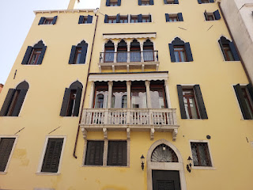

After all of this reminiscing, we walked back to the ferry stop at the Accademia Bridge and boarded the next ferry heading in the direction of the Jewish Quarter of Venice.

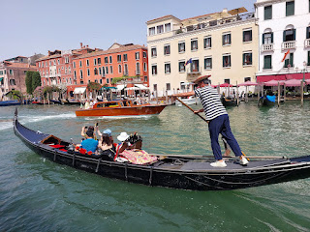

Video as we passed underneath the famous Rialto Bridge: (16 seconds)
https://photos.app.goo.gl/ovN63dByn1borp1x9

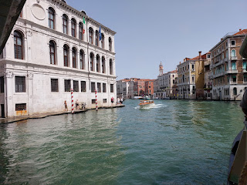

Entering the Jewish Quarter, also known as the Ghetto . . .

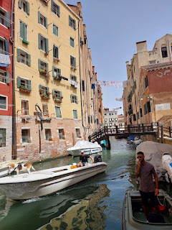

The Ghetto in Venice was the first of its kind in Italy. Here is some historical background: (AI based)

"The Venetian Ghetto,
established in 1516
, was the first and oldest ghetto in Italy, and the word "ghetto" comes from the Italian getto which means "casting" or the Venetian geto which means
"
foundry
"
. The ghetto was created on a swampy island that was once the site of a foundry, and was surrounded by canals and connected to the rest of the city by only two bridges. The ghetto was a gated and walled area where the Venetian government forced Jews to live, segregating them from the Christian population of Venice.
"The ghetto's history began when the Venetian Senate and Doge Leonardo Loredan issued a decree on March 29, 1516, in response to an influx of Jews expelled from Spain and Portugal. The decree included Jews within the city but excluded them from full rights. Jews were required to wear insignia to differentiate them from Christians, and were not allowed to leave the ghetto at night or without paying the guards. The first group of Jews allowed to worship in the ghetto were Germans and Italians, but they had to worship in a way that would not offend Christians, so their synagogues were built within existing buildings. In total, five synagogues were built to represent each diaspora of Jews in the ghetto.
"The ghetto was home to Jews of Italian and German origin, as well as Jews from the Iberian Peninsula, southern France, and the Ottoman Empire. The Jews also took on other roles in the ghetto, such as running pawnshops, an activity that was considered too different from local beliefs at the time."
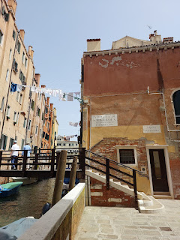

I had read in Dr. Matthews' book that there was a Balsam Tree planted in Venice by Jeronimo Bassano, but it wasn't planted in the Jewish Quarter. I was still fascinated by this beautiful tree in the center of a large piazza within the Ghetto. I wanted to imagine that it was planted by Jeronimo and that it had survived all these years.

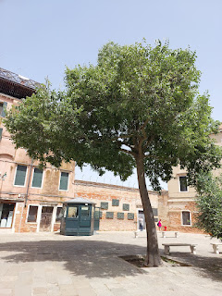

In this large plaza, there were several things of interest.

1) Artistic depictions of what happened to the victims that were arrested and hauled off near the end of WWII because they were Jewish.

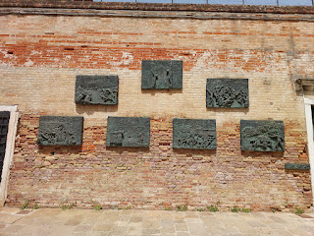

2) A description of what happened to the Venetian Jews during WWII: (Below)

"Men, women, children, masses for the gas chambers.
Advancing toward horror beneath the whip of the executioner,
Your sad Holocaust is engraved in history
And nothing shall purge your deaths from our memories,
For our memories are your only grave."

"The City of Venice remembers the Venetian Jews who were deported to the Nazi Concentration Camps on December 5th, 1943 and August 17th, 1944."

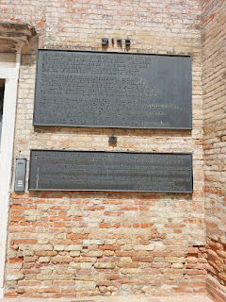

3) "Tripping Stones" - made by the same German artist that has made over 1,000 of these, including the ones we saw in Amsterdam this spring when we visited the Jewish areas where Anne Frank and her family resided. *Tripping stones were given this name because you have to look down where your feet are stepping in order to notice them. Some of them are not perfectly flush with the sidewalks, thus the tripping hazard.

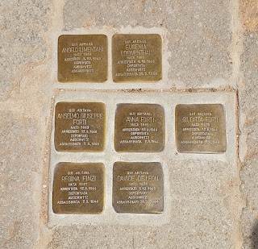

4) One of the "tripping stones" caught my eye . . . a BASSANO!! The Bassano name has had several derivatives: Bassano, Bassani, de Bassan, etc. In this case, Edward Bassano lived in the building that we stood in front of.

The "tripping stone" translates to:

Here lived
Edward Bassano
Born 1876
Arrested 5 Dec 1943
Deported to
Auschwitz
Assassinated 26 Feb 1944

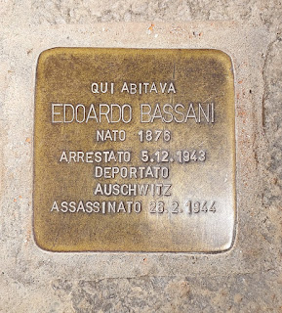

This is the front of the building where these people once lived, and you can see the "tripping stones" on the ground in front of the entry door.

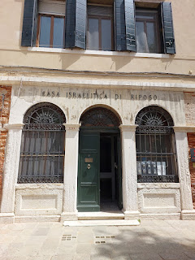

5) A Kosher restaurant called "Ba' Ghetto" is next door to the house above. We stopped here for lunch.

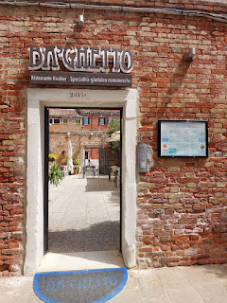

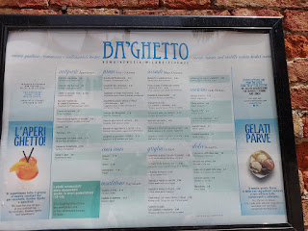

Our server, Mikhel, told me that Ba' Ghetto means "from the Ghetto".

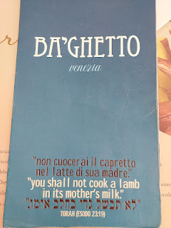

Scott doesn't usually eat lunch (except for a huge spoonful of peanut butter when he's at work), so it was up to me to order whatever I wanted to eat here. I leaned on the recommendations of Mikhel and ordered the Baccala alla Giudia (Cod - Jewish style) . . . with tomatoes, raisins, potatoes, and herbs.

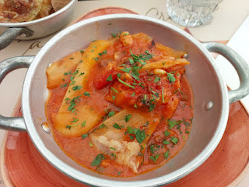

And the Jerusalem Artichoke, "Carciofo alla Giudia" . . . thin, crispy, and fried to perfection.

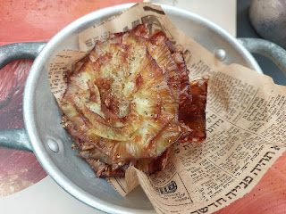

The food was delicious!! I enjoyed having conversations with Mikhel, and we noted that we had a similar name. Michele - - Mikhel. In Italian, my name would be pronounced more like "mee-KEL-leh".

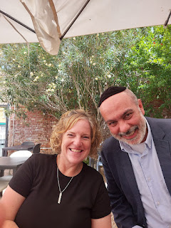

Near the end of our lunch, it started to really sink in that one of my relatives was deported and killed at Auschwitz. It was a sickening feeling and I got pretty emotional. I can't even imagine what the families went through during that dark time, but it's important that we never forget what happened either. When we forget, then bad things have a tendency to repeat themselves. This is the first relative that I've ever learned about who was killed because they were Jewish.

Here is a wider perspective of the large piazza, including the house with the "tripping stones" and the restaurant on the far right . . .

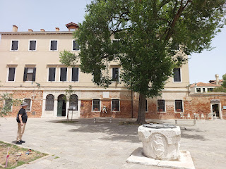

In the interest of time (and my husband's dwindling motivation to hang out in Venice), we opted to make our way back to the train station after lunch. I do plan to come back to the Jewish Quarter in September with my sister to visit some of these same places, and to tour at least one of the 5 synagogues. There are 5 distinct "flavors" of synagogues here, based on where the early Jewish residents came from originally. (Spain, Eastern Europe, Portugal, etc.) Three are available to tour, but not the other two.

Some distinct Judean features that I saw with my eagle eyes before we left the Ghetto . . .

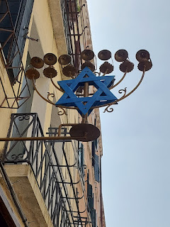

We passed by the Spanish Synagogue . . . this is the main one that I want to tour in September . . . (because Dr. Matthews is quite certain that our Jewish Bassanos came from Spain).

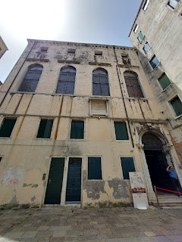

Hebrew Sweet Treats in a storefront window . . .

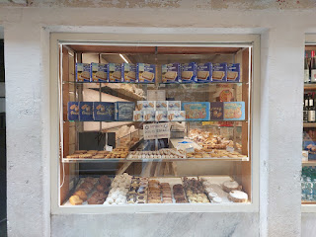

Another Jewish storefront . . .

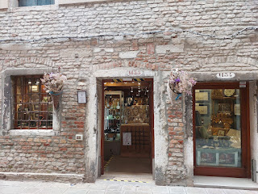

A very popular Hebrew Kosher restaurant called Gam Gam Bar . . .

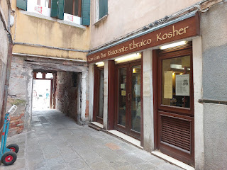

On the front of their window is an article published by the Wall Street Journal that is a FASCINATING read. (Click photo to enlarge) **It's all in ENGLISH. :)

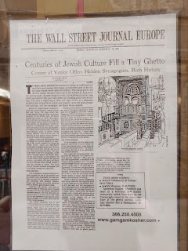

And in that same Gam Gam storefront window was a sign with Hebrew characters that give a portion of the menu. I used Google Translate to read about each dish and their ingredients. It all sounds really yummy!

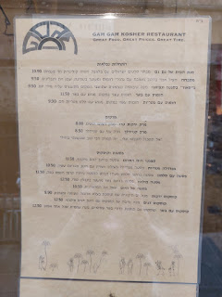

"Sotoportego de Gheto" means "under portico" or "underpass". Sometimes these Italian underpasses will feature ancient frescoes, like the Madonna. But because we were in the Jewish Ghetto, this one did not have Christian artwork. Instead, the peeling layers gave us a glimpse into the history that lies beneath the bricks and stucco.

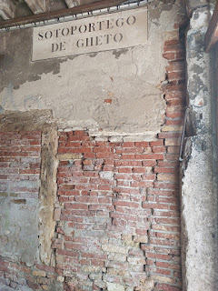

The Santa Lucia train station is "next to" the Jewish Ghetto. It was a short walk, maybe 10-15 minutes to get back to the station. Scott was out like a light within 5 minutes from when the train began to head back to Vicenza. What a cutie.

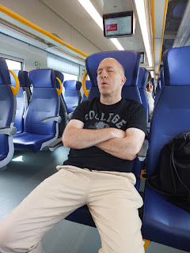

As I have revisited my photo gallery, along with some research to refine this blog post, I have been carried right back to Venice in my heart. It's like I was transported back to this very day in June when we found these special ancestral sites. I can't wait to get back over there and do some additional exploring this fall.

My wish list would include:
The Museo della Musica
The Palazzo da Mula Morosini
The Gritti Palace
The Jewish Quarter - especially the synagogues
The Hebrew Synagogue & Museum of Venice (Sinagoghe e Museo Ebraico di Venezia)
Chiesa Parrocchiale di San Giacomo dall'Orio (THIS is where Jeronimo planted the Balsam Tree!)
Scuola Grande di Santa Maria della Misericordia (Jeronimo was the leading pifaro player at this school, or brotherhood. As a Master of the Arts, he also led sacred musical processions through the streets of Venice to honor the dead with illuminated candles.)
Scuola Grande di San Rocco
Scuola Grande di San Marco
Jewish Cemetery on Lido Island (Bassanos are buried there)

