My Life = Jesus Take The Wheel
Places mentioned in this post:
Minneapolis, MN
Idaho Falls, ID

Lately, each day it feels like I am just floating along in my small and meager life preserver, just praying that I can make some headway in the current and that I will have the strength, the capacity, and the humility to face whatever that day will bring. Our plans seem to change every few days and I am just trying to keep up! It takes some practice to be adaptable, fluid, trusting, grateful, and positive. It seems like I'm getting lots of opportunities to practice these attributes right now . . .

I'll start with the best thing that's happened in my life lately: meeting my new granddaughter, Maisie.

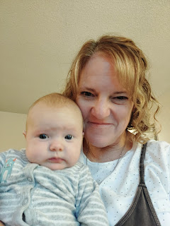

As we flew from Iceland to Minneapolis on Thanksgiving Eve, we chased the sunset for the entire 6 hours of our flight. It was so beautiful to look out the window and see a constant scene of gentle pastels the whole way.

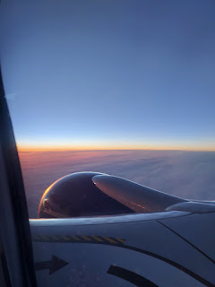



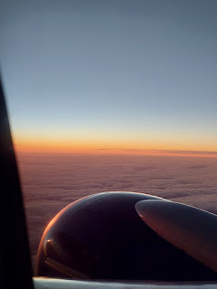

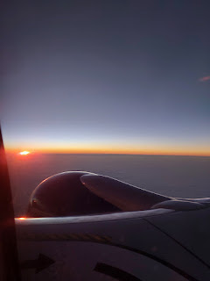

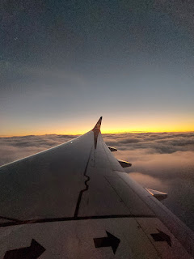

*Side note: I got to use my new Global Entry card when I arrived in Minneapolis as I went through customs. I was the ONLY person in that line, whereas Scott was stuck behind a line of 60 people or so - everyone that
didn't
have Global Entry. I had to wait for him for about 20-25 minutes before he finally made it through. This new skip-the-line program will be a lifesaver the next time I come through Denver. (Denver is the worst airport I have ever been in, and has been my constant nemesis.)

We got our rental car (a Subaru Forester - LOVED IT) and drove about 20 minutes to get to Jake and Hannah's place. The skyline of downtown Minneapolis is really cool - with all the skyscrapers and lights and the Minnesota Vikings Stadium, etc. We passed right through the downtown area while we were still on the freeway.

We arrived just in time for dinner with our son and his beautiful little family. A few slices of pizza later, we were all cozily hanging out in the living room, chatting away and taking turns holding Maisie.

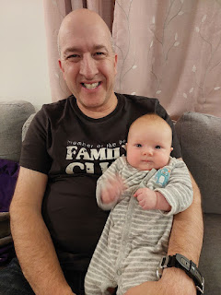

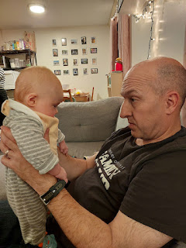

Jack was in almost constant motion, thus the blurriness in the photo below as he munched on a yellow bell pepper.

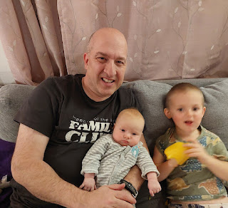

Maisie was so darling . . . she was bright-eyed and attentive, studying our faces and pleasantly content to let us hold her.

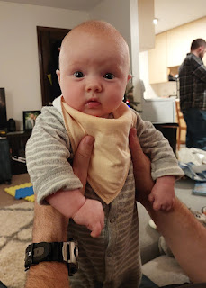

She has a really chill personality . . . she doesn't mind getting her diaper changed or just about anything else that happens to her.

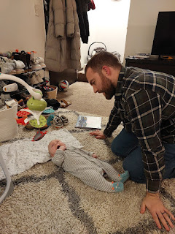

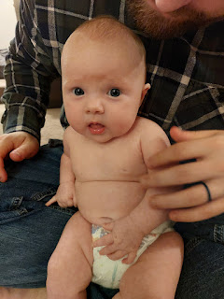

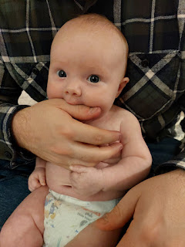

I was always so grateful when anyone offered to take a photo of me with Maisie, since I'm usually the one behind the camera . . .

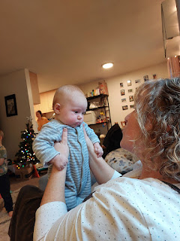

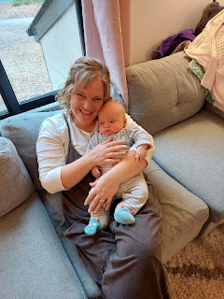

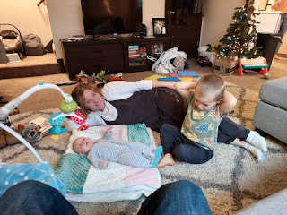

We went outside for a little bit each day, even though it was BRUTALLY cold. As soon as you stepped outside, the cold hit you like a huge slap in the face. But that didn't deter this little family. They bundle up and make the most of it, recognizing that it's important for Jack especially to get some fresh air and to have a place to run around and burn off some 3-year-old boy energy.

In the apartment complex where they live, it's government subsidized and many PhD students reside here. Many of them have young families, and there are several playgrounds spread out among the buildings. Jack has a few favorites that he likes to visit, and sometimes he rides on his recently acquired bike to get over to the next one. Someone was moving away and they gave him a pink bike for free (with training wheels attached), which suits him just fine for now. Eventually, they will get him a new bike, Jake said.

Hannah was not afraid of getting dirty, as she knelt down in the cold sand and helped Jack dig for dinosaur bones. The rest of us stood around and watched, visited, or took turns pushing Maisie in the stroller while she slept.

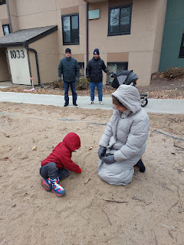

Video of Hannah and Jack doing some excavation work to hunt for dinosaurs buried in the sand:
(18 seconds)
https://photos.app.goo.gl/UDpWA9HYFADNPWTM7

Jack has limited screen time during the day, but he does enjoy watching the popular animal show called Zaboomafoo. My kids loved watching this same show when they were growing up, too. It was cute to see Grandpa and Jack eating their lunch and watching TV together.

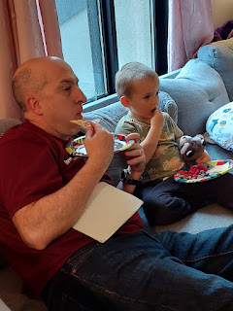

I would almost venture to say that Jack is inherently a vegetarian, because the foods that he eats nonstop and craves the most are all vegetables or fruits. His favorites are bell peppers, tomatoes, cucumbers, berries, celery, apple slices, fruit leather, etc. He does like some meat on occasion, especially shrimp. He does NOT like anything mushy, saucy, or creamy. No yogurts, bananas, mac & cheese, ice cream, etc.

Jake and Hannah prepared the entire Thanksgiving dinner while Scott and I just kicked back and played with Jack and Maisie. They had already baked a sweet potato pie ahead of time and brined the turkey for 3 days in a bucket just outside their front door. Funny side note: Jake had to move the bucket further into the covered walkway and stairwell that's part of their 4-plex because the briny liquid was starting to FREEZE, ha ha.

Jack helped Hannah prepare the blueberry pie on Thanksgiving Eve, and then on Thanksgiving morning she also made a chocolate cream pie.

Jacob baked the turkey at a low temperature for about 3 hours, and then took it out for an hour so that the stuffing could have a turn in the oven. He then roasted it at 500 degrees for maybe 20-30 minutes to brown it up afterwards. It was melt-in-your-mouth tender and extremely delicious.

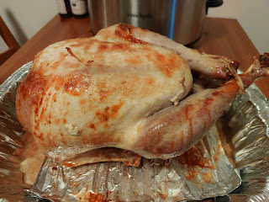

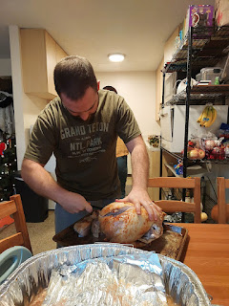

Jack allowed Scott to read a book to him, but not me, ha ha. He is very particular about who he wants to read to him.

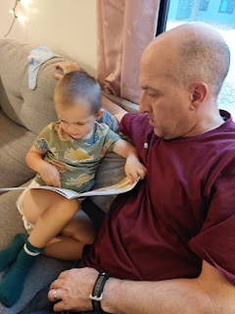

Just in the few days we were there visiting, Maisie went from trying to get her hands to cooperate and get into her mouth, to being more adept and calculating about the whole procedure. She was definitely on a learning curve and it was fun to watch her figuring stuff out.

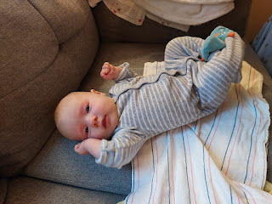

Video of Maisie figuring out how to eat her own hands: (15 seconds)
https://photos.app.goo.gl/b6nQ282CC6JXZjTb7

Other Thanksgiving fixings: Green Bean Casserole (Hannah's favorite) . . .

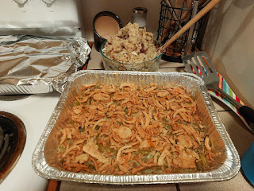

Roasted Brussels sprouts . . .

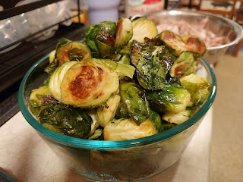

Homemade stuffing (my favorite) . . .

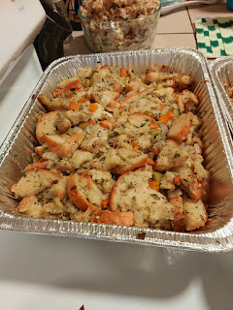

The four dishes on the right included: roasted mashed potatoes, rolls, homemade cranberry sauce (another favorite of mine), and the Brussels sprouts.

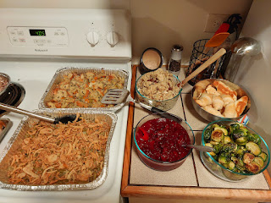

Beautifully sliced light and dark meat . . .

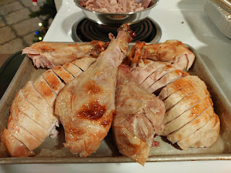

The blueberry pie . . .

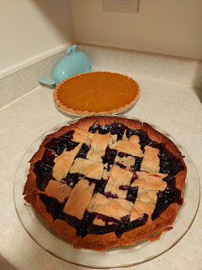

If you ever need an uplift, try holding a sweet baby and snuggle them for a while . . .

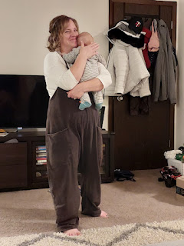

We had to take a break after the big meal before we had any room for pie. It was nice to just sit around and hang out for a while.

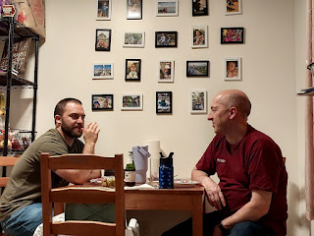

The chocolate cream pie was a huge hit. Both Scott and I loved this one the most. The sweet potato pie was great, too, once it was chilled. Hannah thought that the blueberry pie was a little too sweet, but it was also really good.

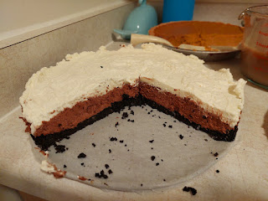

Video of Scott with Maisie: (10 seconds)
https://photos.app.goo.gl/eFT9V7g5yj5PxQyD6

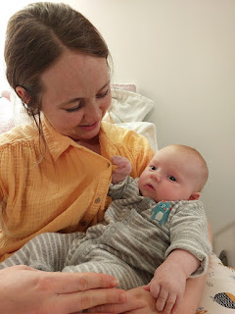

Maisie likes to grab onto anything and everything within reach of her little fingers, including Mom's shirt . . .

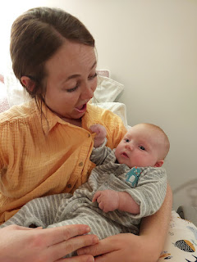

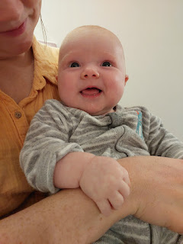

Scott and I slipped away to attend the St. Paul Temple on Black Friday before he needed to fly back to Italy the next day (where a temple is very far away). It was 20 minutes from our hotel and the same distance from Jake and Hannah's apartment. The St. Paul Temple is very small, but that's just fine. It had everything we needed in abundance.

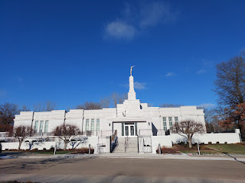

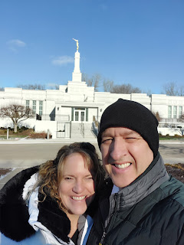

On Saturday morning, we went over to the church so Hannah and Jake could play volleyball with several ward members and friends. We made it our job to hang out with Jack and to hold Maisie while their parents got all sweaty.

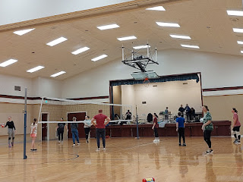

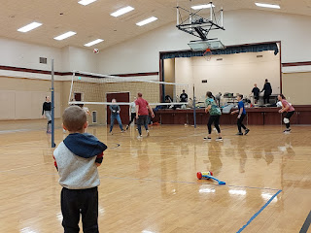

Video of the volleyball action: (29 seconds) Jake is in the dark shirt/grey shorts on the right, close to the edge of the stage. Hannah was the server and is only seen briefly in this clip.
https://photos.app.goo.gl/gvU9uRityyjsqYT57

There is literally nothing more satisfying in this world than to figure out how to put a baby to sleep in your arms. Each baby is different, and their preferred positioning is important, as is the amount of movement (or not) and the level of bouncing (or not). Jake and Hannah were quite impressed that I was able to successfully get Maisie to sleep without any help from them. I do have some experience of my own, though . . .

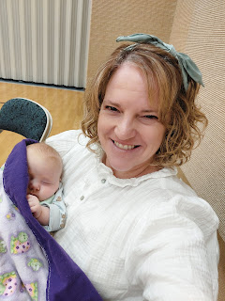

Jack had fun as we helped him spell his name with his body . . . J . . . A . . . C . . . K. He liked that I took photos of him so he could see what he actually looked like afterwards.

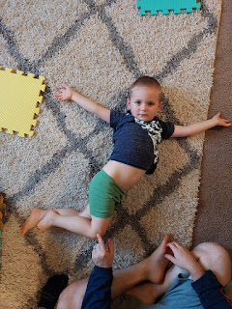

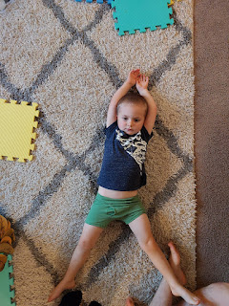

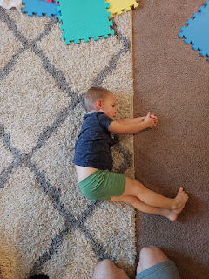

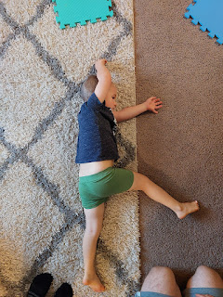

Video of some creative fun that Jake and Jack regularly do together - a train going through a tunnel. One of them is the train and the other is the tunnel. (7 seconds)
https://photos.app.goo.gl/DgvF9d197drJCEe9A

Video of them switching roles as the train and the tunnel: (11 seconds)
https://photos.app.goo.gl/rfjjShCABXc256g76

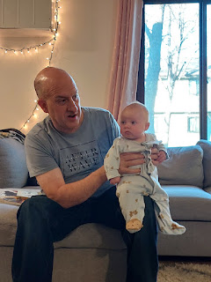

Video of Jake chatting with Maisie - just before I started filming, she made a few sounds like she was giggling for the first time, so I grabbed my camera to record her, but then no more giggles. Just rapt attention to her sweet daddy and what looked like a hint of a smile or two.
(35 seconds)
https://photos.app.goo.gl/EooQbD5deXTJhRhDA

Later in the afternoon on Saturday, I drove Scott to the Minneapolis Airport. We got stuck in some traffic on the way there, due to an accident, but we still got him there in time thankfully. On the way back, I had a stop to make at a store called Whole Foods. I needed to pick up a few items for J & H, and also return some boots (from Amazon) that we had hauled all the way to the US from Italy.

I accidentally chose the wrong location and ended up in the heart of downtown Minneapolis, which was very pretty with the skyscrapers and lights, but had zero parking that I could see. So I called Jacob and asked him which store he usually goes to and then I got myself out of there.

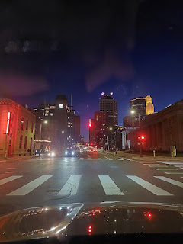

Funny story: I swear sometimes that if my head wasn't screwed on, I might just lose it and all the marbles with it, too. I had brought my boots along to make the Amazon return at Whole Foods, and they were sitting in the back seat of our rental car. I made my food purchases and on my way out of the store, I just HAPPENED to notice the Amazon symbol on a little sign at the customer service desk. It jogged my memory just enough to help me remember that OH YEAH . . . I needed to return the BOOTS!! Otherwise, I would have driven off without even a single thought about them . . .

On Sunday morning, I had the wonderful privilege of holding a soundly sleeping princess during Sunday School. What a cutie.

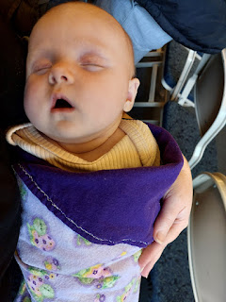

Jake continues to surprise me on a regular basis. He has been reading and studying all of the stories, photos, and memories of his grandparents and great-grandparents on FamilySearch lately. He shared with us that he was so intrigued by a book of poems that Grandma Coy mentioned as being one that her father used to read from - that he ordered a copy of the book for himself! He has been reading the poems a little at a time, including the one below. We had been discussing how in Europe (and Iceland) you typically get two twin beds pushed together when you stay at a hotel, and that Scott and I have been thinking of getting our own individual comforters because research shows that there are some real benefits to this!

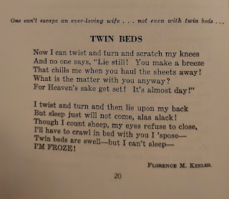

What surprised me the most was that as we were talking about twin beds and individual comforters, Jake grabbed the book of poetry and immediately turned to the poem about the beds!! Wow.

I know this will sound sexist, but I was happy when J & H dressed Maisie in a cute little pink outfit one day. She's been wearing a lot of Jack's hand-me-downs and let's face it, they just aren't quite as cute.

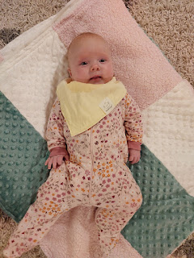

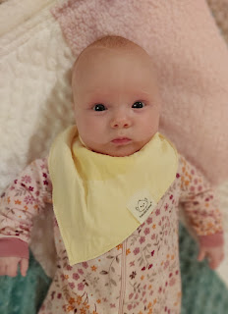

Video of Maisie hanging out in her swing next to the dinner table: (24 seconds)
https://photos.app.goo.gl/e2BuLu7bo21pCJ9G7

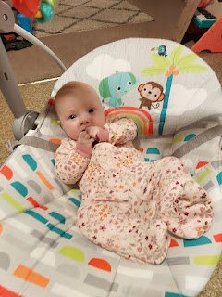

Jack was ecstatic when he woke up to snow on the ground on Monday morning. He was too young to remember the snow in Virginia where they used to live, so he was really looking forward to experiencing it in Minnesota. He couldn't wait to get all dressed up in his warm snow pants and all the various winter gear to go outside.

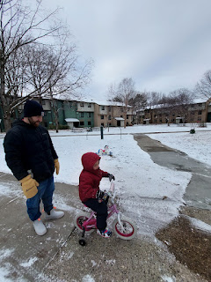

Jack loves to be a worker guy, and if his Dad suggests that they go outside to shovel the snow, he's all for it. (15 seconds)
https://photos.app.goo.gl/FQXSo68CrEQcC1yv6

Even I found it satisfying as a casual observer to just watch while Jack cleared off several different pathways of snow. I was a little under the weather and didn't have a lot of energy to contribute much at the time.
(11 seconds)
https://photos.app.goo.gl/sH4Ke643bokBoh8E7

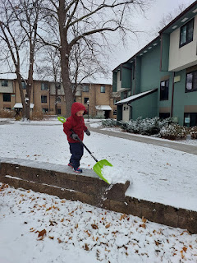

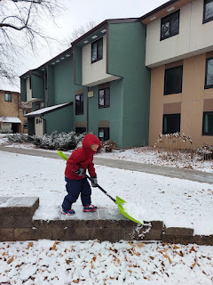

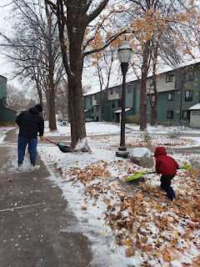

Video of Jack "ticking his ball into the doal": (30 seconds)
https://photos.app.goo.gl/aTjZL3qgnqXtiDq46

While Jake and Hannah were occupied in the kitchen, I entertained Jack by gradually building up a pile of his "stuffies" and encouraging him try to clear it by doing a high jump over the top. He got such a kick out of this . . .
(11 seconds)
https://photos.app.goo.gl/GybDYncpqht8G5JN7

Cute video of Jack and Maisie, while Jack was eating his snack next to her on the couch: (21 seconds)
https://photos.app.goo.gl/izANKftc5DieCaSU6

Video of Maisie smiling a few times: (37 seconds)
https://photos.app.goo.gl/NMz4kMpLhbUq71ph7

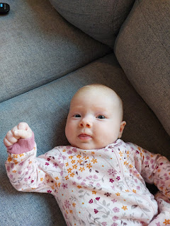

Jacob gave me a priesthood blessing the day before I flew home to Idaho Falls. I was worried about getting vertigo issues with my head congestion and the changes in altitude for my two upcoming flights. In the end, everything turned out just fine. I felt better the following day and traveled well to Denver and then on to Idaho Falls.

It was hard to leave the little ones, but I was also looking forward to being HOME.

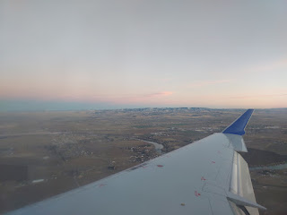

My niece, Mari, was so excited that I was back in town that she started texting me at 6:00 a.m. to ask if she could come come over and do a bunch of laundry that day . . . I had her postpone until the next day because I had a bunch of my own laundry to do first. She also wanted to make me dinner, too, which was so nice. She made us seasoned elk burgers with some meat that a friend had given her (his family does a lot of hunting so their freezer was loaded with the ground elk meat), roasted Brussels sprouts with bacon, and a lovely roasted sweet potato and diced apple mix with fresh sprigs of thyme. I enjoyed it all! We spent the whole day together and she got several loads of laundry done, so it was a win-win.

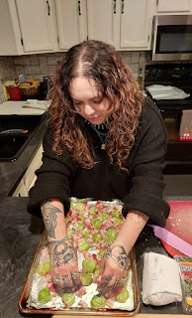

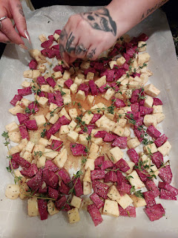

The following day I made some homemade hummus with freshly squeezed lemon, along with a colorful array of veggies and garlicky croutons. It was really satisfying as a light lunch option.

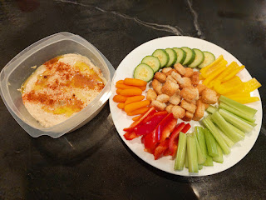

One of my favorite people in the world is Sherry Hanks. She lives two doors north of me in Idaho Falls. She is 80 years old and has been widowed for the past 3 or 4 years now, and she also has some health issues, but she is still 35 in her heart. She is extremely intelligent and wise from all the books she loves to read and discuss, and yet she is quick to giggle and always has a twinkle in her eyes.

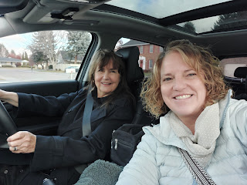

A few years ago, she and I walked home from stake conference together, where she shared the most profound example of co-parenting with God I had ever heard. I was struggling with how to reach my son, how to parent him, how to connect with him, how to help him, and how to "everything" with him at that time.

She told me the following story: (I will paraphrase what I remember)

There we were, at an impasse in our kitchen. Margaret, my teenage daughter, was sitting on the floor, bawling and distraught. I was standing at the kitchen sink, crying as well. I was supposed to be washing the dishes. We could not meet in the middle on whatever the issue was.

I remember saying a silent prayer over the sink, with defeated and slumped shoulders: "I don't know what else to do with her God, but You do, so I give her to you." Almost immediately, I heard the words flow into my mind and into my heart that said, "Thank you. I've been waiting for you to say that."

From that moment on, I realized that God wanted to help me, too. He sees what we're trying to do as parents, and with His help, we can accomplish some wonderful things. Sometimes we think we are the only ones dealing with the situations that come up, and sometimes we forget that God knows and understands more than we think we know and understand. He is always at the ready to help. We may just need to relinquish our meager micro-managing efforts and let God work some miracles that we may not have ever thought of.

I asked Sherry for permission to take that photo last week because I know she will not be around forever, and I wanted to capture that happy moment. I didn't tell her my reason for wanting the photo, but she happily agreed anyway. She changed the trajectory of my life that day, sometime in late 2017 or early 2018, when things were really hard at home. She reminded me that we co-parent with God. We are not alone in our efforts, and it is always better to include Him in the matters that matter.

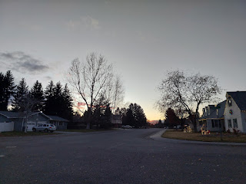

My first several days home so far have been filled with many good things:

I went to the temple and received comfort and strength in some personal matters.
I spent a whole day friendshipping with my niece, Mari.
I attended Stake Conference and was uplifted.
I sat in the car talking for several minutes with Sherry Hanks after church.
I had dinner with my friends, Scott and Jen Anderson, and their family.
I went to the temple a second time.
I went to our Ward Christmas Party with Mari.

And then I hit the road, driving to Meridian, Idaho and on to Portland, where I am spending Christmas with my daughter, Amber and her wonderful family.

I will share more about some of these special activities in my next post.

Merry Christmas!!

