No Need to Break In . . . My Front Door Works Now
Hooray! I got both my garage door and my front door fixed on Monday, so now I can actually get in and out without a hitch. Previously, my garage door wouldn't open from the outside. I would have to get out of the car and go through the front door to get into the garage to open it up. Then I could pull the car in.
But then my front door deadbolt started getting stuck. The first time it got stuck, thankfully I was on the inside and I used a hair dryer to help get it open. That's when it was about -18 degrees or so, and I thought it was an issue with the cold temps. But then when I got home from the airport after visiting Grandma Lillian in Oregon, I couldn't get in through the front door at all. The deadbolt was stuck halfway again. It wouldn't fully unlock, and it wouldn't fully lock either.
I went back out to the driveway and pushed the garage door button in my car several more times (with a silent prayer for help) until finally the door opened and I could pull the car inside. I don't know what I would have done if the garage door hadn't opened . . . maybe I would have had to break in through a window somewhere . . .
The hair dryer trick didn't work the second time on the deadbolt. Scott suggested the next day that I get some pliers to help force the lever to move.
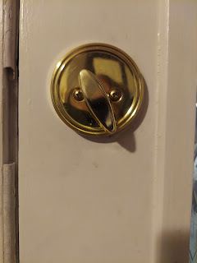

So I did. I slowly cranked the lever around once, then twice, then a half turn more before the deadbolt mechanism finally moved and I could open the door. Sheesh! I decided to just leave the deadbolt unlocked until it could get replaced, and just focus on locking the doorknob. Not the best feeling as far as security goes, but that's when the frigid temperatures can work in our favor. How many bad guys do you think would be willing to be outside in those negative temperatures trying to get into someone's house? Few enough that I could actually go to sleep and not worry too much about it . . .
I had already called the week before to set up an appointment for the garage door fixer guy to come on Monday afternoon. Smart move to have scheduled that when I did.
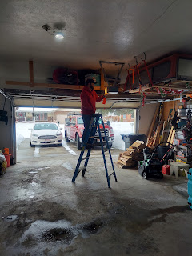
He was able to determine that the "board" is going bad - it provides the torque for the door to come up. He tightened it to help it have enough torque for now, but he said it's just a temporary fix. He's seen it last just a few days or it could last up to a year. As soon as it starts acting up again, he said we will need to replace the whole thing. ($425)
Later that evening, my good neighbor, Ben Parkinson, came over with his tools to put in a new set of front door locks for me. Scott had "accompanied" me to Lowe's earlier in the day (on a video chat) so we could pick out a new set of locks together.
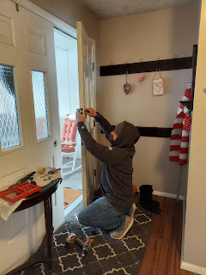

And now the front door opens and shuts perfectly! What a relief . . .

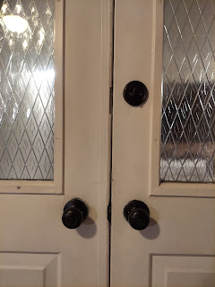

More brass is now heading off to the dump . . . always a good thing in my opinion . . .

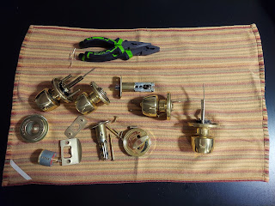

Tuesday morning I was able to go to the temple again. This time I was in for a surprise, though. Everything had been redone for the endowment session, but in the most amazing and thoughtful ways!! It was much more instructive, for one thing. I was able to really connect in more concrete ways to what I was being taught, and gain additional understanding about the covenants I was making. It was done in such a loving way that it felt like our Father in Heaven was teaching me personally and showing me and encouraging me Himself. I came out of the temple in awe of the whole experience and wishing I could hurry back and go again. I already have temple dates set up for every Tuesday up until I leave in March.

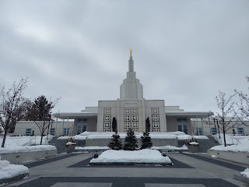



The bulk of this week was spent on a special project for my Grandma Lillian, who I just got home from visiting up in Salem, Oregon. I brought home 2 extra suitcases full of photos - and photo albums filled with photos - so that I could get them all scanned and digitized for her.

I spent Monday and Tuesday pulling all the pictures out of the dozen or so albums. Some of the albums had the adhesive scrapbook pages and some had little individual photo sleeves. It was time consuming, but very necessary in order to scan them.

I tried to keep everything organized in stacks around my living room.

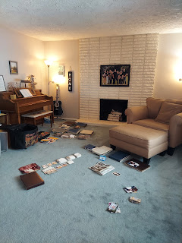

When it was time to finally go over to the FamilySearch Center, I loaded up all the stacks of photos into separate manila envelopes and ziploc bags that were labeled. It was a tight fit, but they somehow managed to fit into one of my laundry baskets.

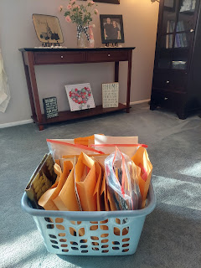

At the FamilySearch Center across town, they have some pretty awesome high-speed scanners that make it (relatively) enjoyable to get this important work done.

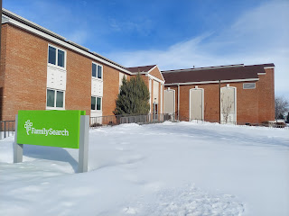

Video of how fast the photos go through the scanning process, and a special painting on the wall just above my work station: (8 seconds)
https://photos.app.goo.gl/tXHk3A9HEfb2QoTC7

Here are just a few of the 2650 photos that I scanned in 4 days . . .

My Dad as a young Navy recruit

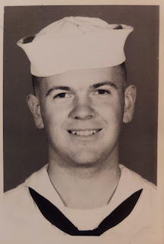

My Dad's high school graduation photos

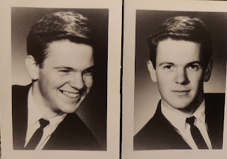

A Christmas postcard from the Philippines - my Dad's first Naval assignment after they were married

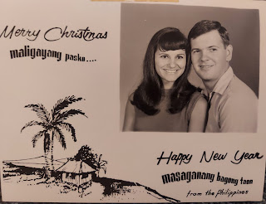

My Grandpa Linton had his own real estate office in Ukiah!! I don't remember this at all . . .
In the photo below is my Grandma Lillian (center), with her oldest son, Mike Moore, and Mike's wife, Suzy.

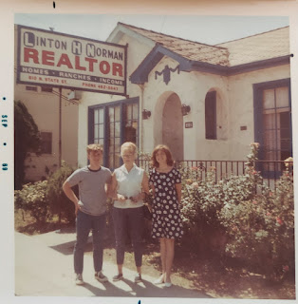

My Dad with Charmaine and me in Adak, Alaska (circa 1973)

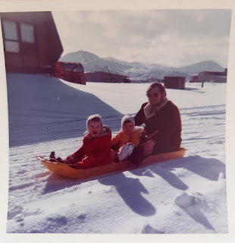

Yours Truly (circa 1972)

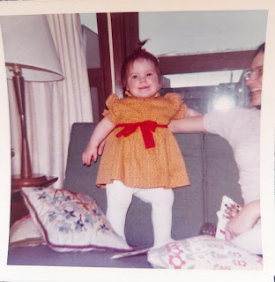

Grandma Lillian and Grandpa Linton Norman

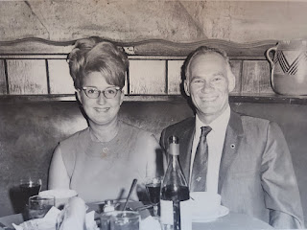

My beautiful Momma, during the month that she married my father (August 1967)

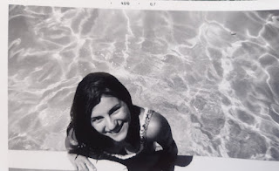

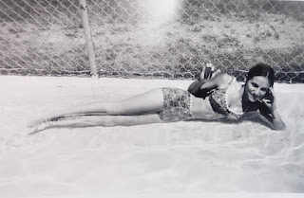

When I shared this next photo with my parents and siblings, it sparked a huge discussion about Grandpa's famous pork spareribs, and then inspired several of them to want to make some ribs this weekend.

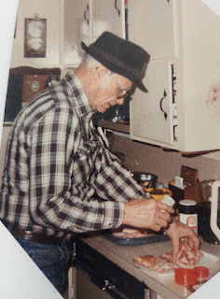

Grandpa always sprinkled Lawry's seasoning salt on the meat (sometimes adding some meat tenderizer as well), then poured a generous amount of Worcestershire sauce all over both sides. He let it sit for a few minutes before very slowwwwly barbecuing the ribs on the grill at a low temperature. They are a family tradition and a family favorite!!

I spent Wednesday, Thursday, and Friday scanning photos all afternoon. Saturday afternoon, I tackled all of the negatives that were loose and unidentified. This was a more tedious process, especially with the negatives that came from 110mm film . . .

Here's a little video that I made for my Dad, that shows the problems I kept running into with the 100mm negs. I had to add in a little "adapter" that could hold the tiny strips of film in place as I slid them through the scanning device. (Incidentally, this is the same exact device that I used last August to scan all of my Dad's 2100 slides.) The biggest problem with the 110mm strips is that there was a tiny little notch cut out on the end that was also the lead end. It kept snagging on everything possible as I tried to slide it through. I had to pull out the little adapter drawer and fix it every 2 seconds, ha ha.

Video: (1 min, 21 sec)
https://photos.app.goo.gl/UoHTuabjizrQiVXt8

It felt so good to accomplish this huge and important family history task!! I left in a little bit of a hurry Saturday afternoon (after doing 491 negatives) that I accidentally left my thumb drive there . . . I'll go back first thing Monday morning to retrieve it. Ha ha . . . oopsies . . .

I left in a hurry because I was picking up a friend, Brittany Vance, to go roller skating with me. She is the same age as my daughter, Amber, and they grew up together. She likes to roller blade, while I like to use the old-fashioned quad skates. We had a great time and I got pretty sweaty after 90 minutes of solid skating.

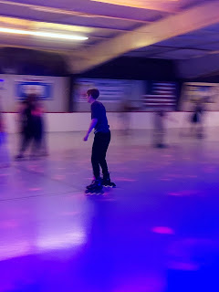

Right at the end of our skating session, Jack called me. He wanted to know what I was doing to stay warm when Idaho Falls is still so brutally cold. He was very impressed that I was at the skating rink with all the flashing disco lights.

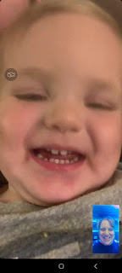

I told him I'd call him back as soon as I got home where it would be much quieter to have a conversation.



While I chatted with Jacob, I got to watch Jack throw a soccer ball down the hallway to his poppa several times.

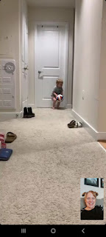

Next, he helped wash all the dishes.

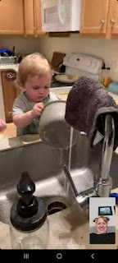

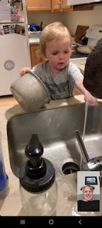

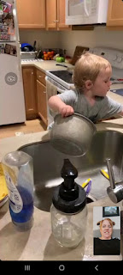

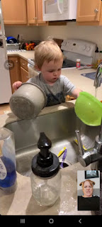

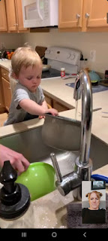

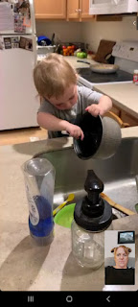

After getting thoroughly soaked at the sink, he wanted a bath. Once his parents took off his saturated t-shirt and soggy diaper, he streaked down the hall to the bathroom and hopped in the tub.

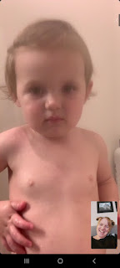

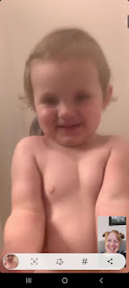

When it was time to say goodbye, he blew me kisses while chewing on a tiny rubber ducky at the same time. LOL

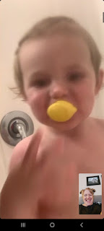

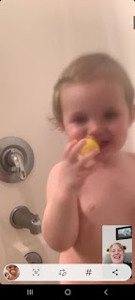

Here's a cute video of Jack eating some shrimp while watching a show during the week. (19 seconds)
https://photos.app.goo.gl/Ng8KTPpYh2U9iNcs6

His mom, Hannah, loves shrimp, too. (And so do I!) I'm glad to see he's also so enamored.

Avery is just the cutest little thing over in Italy, as always. :)

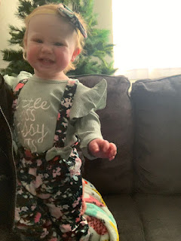

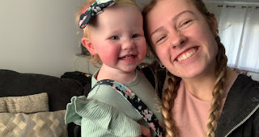

I got this cute video today of Avery giving Kylie kisses. (22 seconds)
https://photos.app.goo.gl/HGZnPRe3KDzSgkiz9

I miss that girl so much! I can't wait to get back to Italy and scoop her up for a big hug!!

Meanwhile, down South, Abby and Gwen are preparing for Valentine's Day at school. Abby was tasked with making her own treat bag, so she enlisted the crocheting skills of her mother, Amber, to make a little sweater to "hug" the bag.

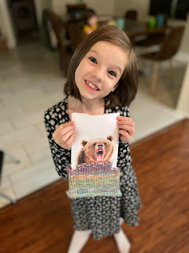

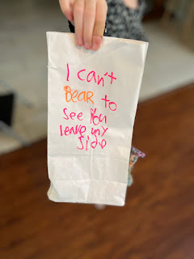

Tonight on the phone, Abby taught me a new trick: using a strand of pearls to make a headband. Very pretty!

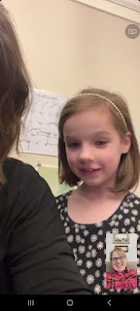

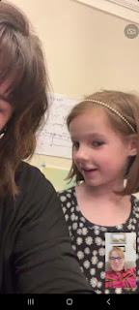

Gwen is a reading and roller-skating fiend lately. Amber says that when Gwen wakes up in the morning before school, she is immediately wheeling and dealing to get even just 5 minutes of skating in before the bus comes!

She is really enjoying reading a lot of books as well. It tends to run in the family . . .

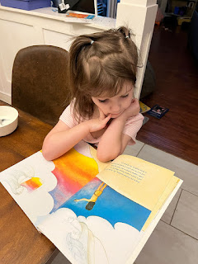

Gwen also went with her class to see a local production of Annie. She already knew all the songs because she and Abby love the movie Annie. (She's in the dark blue shirt in front)

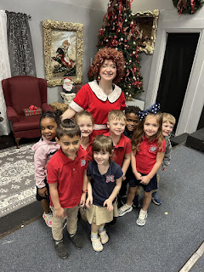

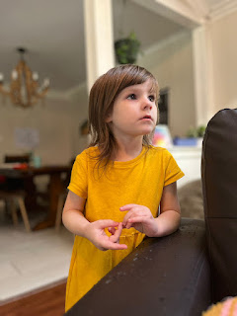

Tonight, near the end of our video chat, Gwen had been practicing her gargling. When I asked her how it was going, she gargled, "Gooooooooood." (with a thumbs up)

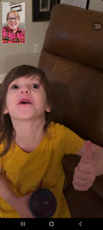

Today (Sunday) after church, I made a pot of Spaghetti Soup and drove up to Rigby to share it with Scott's parents, Phil and Coy. Coy made some cheesy garlic toast and fruit cups to accompany the main dish. We had a great visit, catching up on all the goings on.

After the kitchen was cleaned up, and while Papa curled up for a cozy little nap, I showed Coy one of my next projects and we brainstormed together on how best to go about it.

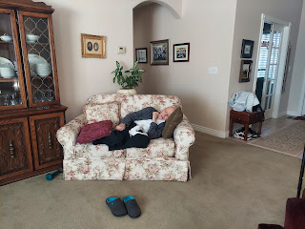

Abby will be getting baptized in April, and I've been discussing with Amber for a while on what to do, or make, or get for the special day. We settled on me buying a white dress for Abby to wear before and after the baptism, and to try to find a way to emboider something personalized on the inside.

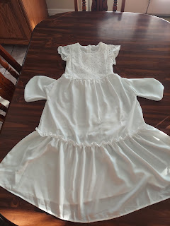

When the dress arrived recently, I noticed that it had POCKETS!! It is so darling, but I didn't know it had pockets when we ordered it. This opened up a whole new possibility of perhaps embroidering a scripture or small message inside the pockets that she can pull out and admire.

Coy remembered that she had a small collection of beautiful white hankies that I could do the embroidering on and then sew those onto the lining of each pocket.

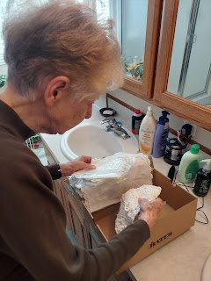

That's when I noticed that she had several white hankies with the initials "C H" in one corner. I asked if I might could use one of those . . . and she happily agreed. My thinking is that I would be adding one more special element to the dress - by including something that belonged to Abby's great-grandmother.

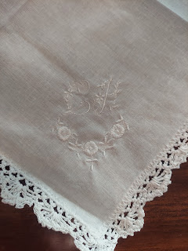

Coy spent a few minutes researching her sewing machine instruction booklet in regards to embroidery stitching, to see if we might want to sew on the scriptural message by machine.

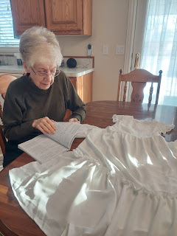

While the machine embroidery would be very beautiful, ultimately I think I will hand-stitch the words because we just don't have much room to work with (size-wise) and I'll just try to do my very best so it turns out well. I'll be using white embroidery floss so the words blend in nicely instead of being blaringly noticeable through the white dress fabric.

We spent a few minutes looking up a few scriptures regarding when Jesus Christ was baptized, and I think I found a good phrase to embroider . . . one that's not too long, but that has some good meaning at the same time.

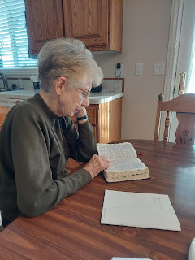

Phil was just so cute after his nap, admiring the solutions we had come up with. I impulsively asked if I could take his photo, to which he cheerfully agreed.

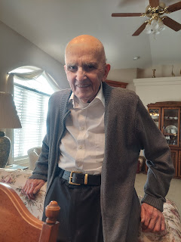

Over in Italy, Scott is doing great. He had a busy day today (Sunday) with meetings, training and leadership meetings both before and after church, and also leading a young men's class discussion. He is still hunting for a good second car, too. Hopefully this week will provide a winner!

I had bought him a nice warm hoodie last fall, only to learn that he doesn't like sweatshirts with HOODS. How did I not know this after 29.5 years of marriage??? It's been cold in Vicenza recently, and he's always wrapped up in a blankie or a sleeping bag when we talk on the phone each day. When I told him I would look for a warmer CREWNECK sweatshirt to send him, he dug out that hoodie that I bought for him just to try it out.

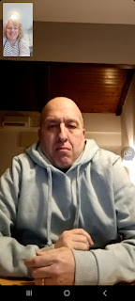

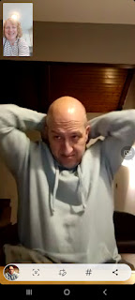

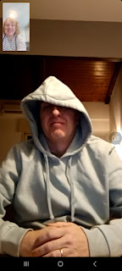

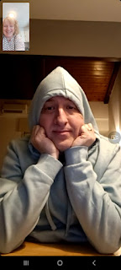

He just doesn't like when it bunches up behind his neck.

So the next day, when we got on the video chat, something had changed . . .

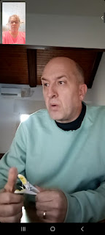

Yep. He cut the hood OFF!!! ha ha ha
What a pill.

I did find him a nice warm fleece pullover for him at Target, along with some very soft shirts, which I sent off in a flat-rate box on Saturday. He will love the pullover, because it has NO HOOD!!! :)

Just a couple more things and then I'm done.

On Wednesday, I came very close to rear-ending a semi-truck while coming home from the FamilySearch Center. Neither of us was going very fast, maybe 20 mph or so, as we slowed down for a stop sign near my house. Because his truck was so long, I couldn't see the loooooong section of black ice until it was too late. I wasn't tailgating him, but the patch was just super long.

I tried to brake, but I just kept sliding and sliding towards his rear bumper . . .

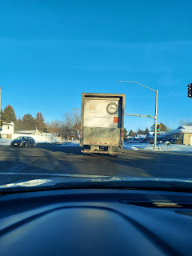

They tell you to steer in the direction you WANT to go when you're sliding on ice, and I WAS . . . . but it didn't do me any good. If he hadn't started to move forward right then at the 4-way stop, I would have slid right into him. I was extremely grateful that I didn't damage our only car. (*Note: I took the photo a minute later at the next red light.)

ALSO - I found a new favorite (and unusual) recipe.
Banana Pancakes.

All you need is one mashed banana and two eggs, whisked together. I divide the mixture into two separate pancakes, cooking them like you normally would, until they are golden brown on each side. They are AMAZING!! Sweet, simple, tasty, and LOW CARB. They don't even need any toppings at all. I ate them plain the first time and they were fantastic. I had some avocado toast on the side.

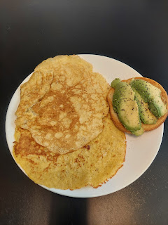

The next day, I added some strawberries and blueberries on top. Also delicious. This is my new Go-To Lunch. It makes me so happy.

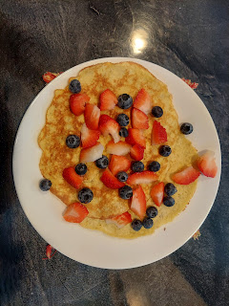

I saw this in the Target parking lot . . . LOL

