No Time to Be Bored
This was a week of giving service to many, many people. I didn't realize that I could do so much in one week to help others, but it felt extremely fulfilling each time I did something to help another person.
Horace Mann said, "Doing nothing for others is the undoing of ourselves." When we give of ourselves, we find ourselves.
My Dad reached out to me recently, concerned that I was bored or dwindling away into nothingness after Scott left and I was released from serving in the young women's organization at church. I told him that there was so much for me to do and that there was no time to be bored!
On any given day, I can choose from the following: (not including any household chores or errands)
Craft projects for my grandchildren (i.e. Jack's quiet book)
Family history (researching, organizing, digitizing, etc.)
Write letters to my older cousins who don't use the internet much (or at all)
Work on the menu for Girls Camp this summer and add more details to the Excel spreadsheet
Update the Rawles Reunion contact list as new information comes in regularly
Organize a room in the house, mostly to downsize
Help someone or visit someone (or call/text them)
Research for upcoming trips
I'm sure there are other things that I'm not thinking of right now, but this is the gist of what I wake up and choose from each day. I find purpose in having projects to choose from, and I thrive in staying busy. I feel more alive and more fulfilled by being "anxiously engaged in a good cause".
News from Scott
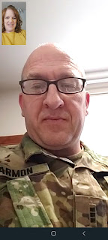
He finished his processing at Fort Bliss, Texas and safely arrived in Italy yesterday (Saturday). He had some bumps in the road as far as the travel went, but all is well now. Friday, he began making his way to the other side of the world by flying from El Paso to Chicago. Upon arriving in Chicago, he learned that his next plane was having some sort of issue and was delayed. Over three hours later, they were finally on their way across the Atlantic Ocean.
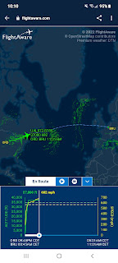
By the time he landed in Brussels, Belgium, he had already missed his flight to Venice, so United Airlines had arranged an alternate route instead. He flew from Brussels to Zurich (Switzerland), and finally on to Venice. He was curious to see if any of his 3 checked bags made it through all the changes. His garment bag was the only one that arrived at the same time that he did (stashed inside was his Class A uniform and a couple other outfits). The two heavier bags were nowhere to be found, so he located the Lost Baggage counter and got some help from the Italian lady working there. She found that his other bags were sitting in Frankfurt, Germany . . . After leaving his contact information with her, he met up with his new boss and his assigned sponsor outside. They drove him the short drive (less than an hour) to get to the base near Vicenza, and he was able to quickly get settled into his hotel room for the night.
Sunday update:
the last of his bags have now arrived and are safely in his possession. Hooray!
The base is quite small and he went on a walkabout this morning to learn where everything is. He will be in the hotel there on base until he is able to secure a house in the weeks to come. There are also a commissary and a PX nearby where he can get all his groceries and toiletries. Very nice.
This coming week, he will be doing all the in-processing and learning about his new job for the next long while. He slept really well in the hotel and he is also very excited to be there and to dig in starting tomorrow morning.
I'm so relieved that he made it, that he's actually there now, and it all feels much more real to me now, too. I'm also grateful that there is an Army community to take him in and help him with whatever he needs.
As for the Rest of the Week . . .
Monday:
Scott was quite anxious about getting all his medical exams and bloodwork done in Texas, worrying that his cholesterol would be too high and that he would be denied the opportunity to go to Italy. I sent him multiple texts to reassure him, as well as this cute video from TikTok. (8 seconds)
https://photos.app.goo.gl/s8suARnt6w395BVh6
Everything turned out fine, which I already knew in my heart would be the case. But Scott was hugely relieved when he got the thumbs up to proceed.
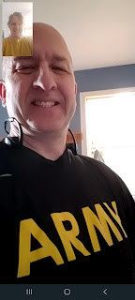

Even though he said this was the nicest needle poke he'd ever received (he didn't even feel anything at all), somehow there was a little bleeding under the surface that he didn't notice until later in the day.

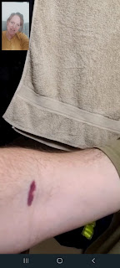

After going to the chiropractor in the morning to get myself all cracked up, I spent a good portion of the day working on Jack's quiet book. The focus was on ironing on the applique numbers for the lift-the-flaps counting pages, and also sewing on various colors of bias tape to frame each page.

My work station . . .

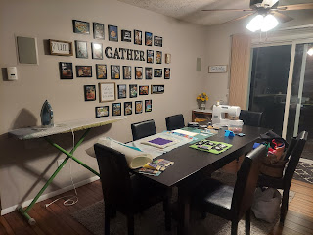

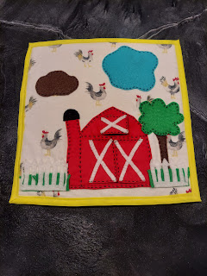

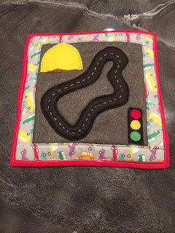

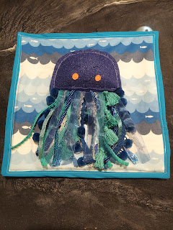

I also got this darling picture of Grandma Doris giving some love to a cute miniature toy poodle, only 8 weeks old. Someone brought him over to the care home and apparently he will be a regular visitor there. What a thoughtful idea! Soft little furry animals can be a great source of comfort, especially for the older folks.

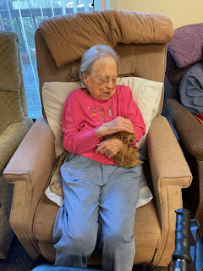

Tuesday:
We got a photo proving that the little red truck made it all the way to Louisiana and to Amber and Weston's driveway!

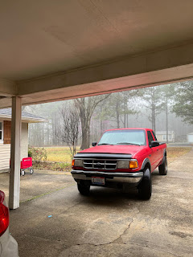

I also got to visit with the girls for a little while on the phone. I had called to ask Amber to find one of the quiet books that I made for Abby and Gwen a few years ago so I could see how I assembled the pages into their book cover. Amber was quite sick, unfortunately, with a bad sore throat and the cruds. Abby was also home from school because she wasn't feeling very well either.

After they found the quiet book and showed it to me, I was able to show them Jack's quiet book so far, which they happily oohed and aahed over.

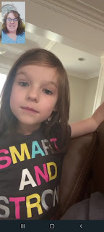

The girls showed me some of the magnificent creations they have recently made with magna-tiles, one of their favorite pastimes.

Gwen's -

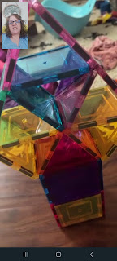

Abby's -

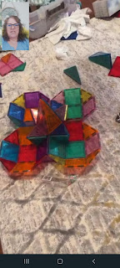

Abby also wanted me to know that she's been practicing her roller skating regularly. Good girl! I can't wait to take them skating soon!

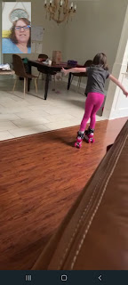

Amber shared this funny thing that Gwen said:

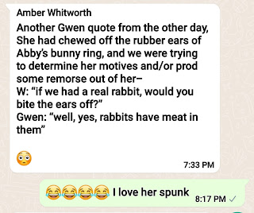

I took a break from the quiet book partway through the day to do something else. I began tackling the craziest (and messiest) room in the house: the downstairs craft room. This is where I keep all my family history bins (full of papers and heirlooms); all of my crafting supplies; and waaaaay too much fabric.

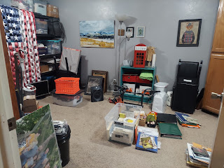

In one afternoon I organized the far right corner of the room, including the floor-to-ceiling cabinets. I am happy to report that I am well on my way of downsizing all my fabric stockpiles, and will be donating them to the Humanitarian Center here in town, or (if they don't want it) another local charity. I'll be continuing my progress in the craft room this coming week . . . and I'll add more photos later.

Prior to dinner, I cleared off my "work station" - sprawled all over the kitchen counter and dining room, to prepare for a family history class that evening. The oldest group of young women (16+) came over with their adult leaders to learn how to do some specific skills on their family trees. We had a great time! There were 6 girls and 2 leaders that came, and by the time they left, everyone had learned something new. It felt amazing to be able to teach others what I have learned for myself over a long, long time.

Below is what I set up in order to show everyone what I was doing (on a bigger screen) - and that was also connected to my laptop. It was Scott's genius idea and it worked very nicely.

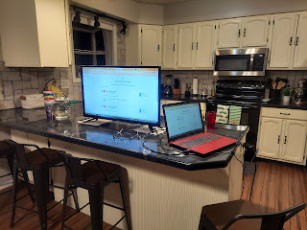

Wednesday:
Mixed in with my sewing project, I took a time-out to bake some lime cupcakes for my last "cupcake run" to the young women. They turned out really tasty! I loved that it used both lime zest and fresh lime juice. Here is the recipe that I used:

https://www.bylaurencermak.com/lime-cupcakes-lime-buttercream/#tasty-recipes-11872-jump-target

I also took a break to go get some honey-walnut shrimp at Panda Express for lunch. Sometimes ya just gotta.

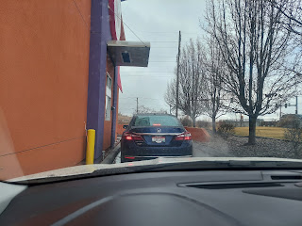
While there, I learned that for ONE week only, they are accepting donations for Ukrainian refugees. At the end of the week, the owners (across the U.S.) will add up all the money that has been donated, and they, in turn, will MATCH that amount!! Super cool!
It's not too late! You still have time to help - and they told me that 100% of the money will go to the Red Cross - specifically for Ukraine.


Later in the afternoon, I went over to Tom and Judy Hally's house to help them learn how to begin their family history research. Tom is on the Idaho Falls City Council and is a sweet, older man. We sat together at this desk and for 2.5 hours, I helped them learn some important new skills. It felt really, really good.

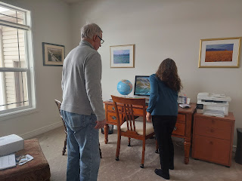

And at the end of the day, I went with my friend, Amanda, to a session at the temple. She is a new convert to the Church of Jesus Christ of Latter-day Saints, and has only been to the temple twice so far. She went once - just before Covid-19 hit and all the temples closed, and once when we went together last September (right before I went over to Europe). So this was only her third time. She has been struggling with working several jobs and also going to classes at the College of Eastern Idaho (CEI) to become a phlebotomist. She is also a single mom. As you might guess, she is exhausted all the time. When I came to pick her up and called her from the car to let her know I was out front, she had accidentally fallen asleep while waiting on hold to talk to the IRS . . . bless her heart. So she had to really hurry and get changed into a dress and meet me outside as fast as she could.

As we drove across town there was the most spectacular glow to the west as the sun was setting. I've never seen anything like that in my entire life! If I weren't driving, I would have taken a ton of pictures! It looked like the entire sky was all lit up in a bright golden glow. By the time I parked in front of the temple, you could only see a small portion of the colorful hues on the left. If I wasn't in such a hurry, I would have gone around to the other side to get a better view. But we were running late and had to head inside the temple.





Here's what it looked like when we came out at 9:45 pm. The clouds made it even more majestic looking. It was really special to go to the temple together. As we left, Amanda remarked that she felt much more calm and peaceful than when we had first entered. I'm so glad I could be there with her.



Thursday:
The morning started out looking like this - with a crusty, crunchy coating of snow everywhere.

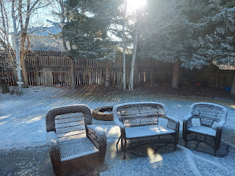

But by the afternoon it had melted away and looked much nicer. Classic Idaho.

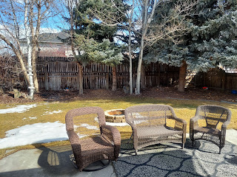

I made the vanilla-lime cream cheese frosting for the cupcakes and got them all decorated to deliver.
Here is the recipe that I used for the frosting:

https://rosebakes.com/key-lime-cream-cheese-frosting-recipe/#tasty-recipes-57195-jump-target

The frosting recipe that went with the cupcake recipe looked way too sweet and I'm a big fan of cream cheese frostings instead. This separate recipe was fantastic!! I added some rainbow sprinkles and a chocolate coin for the garnish.

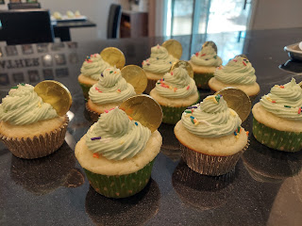

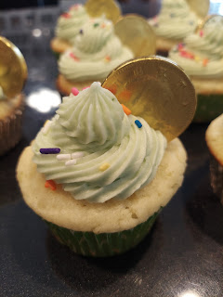

St. Patrick's Day is a special day for Scott's parents because it's also their wedding anniversary! This year they celebrated their 67th anniversary! Wowza. What a beautiful thing. :) I drove up to Rigby to take them some anniversary/St. Patty's Day cupcakes and also to get some advice from Coy on how to proceed with sewing the pages into Jack's quiet book.

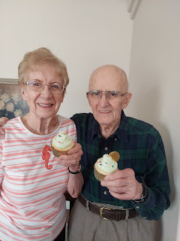

Friday:
I went to the dentist for my 6-month checkup and cleaning in the morning. Scott was already on his way to the airport in El Paso at that point.

I assembled the last page to go inside the back cover of the quiet book. I used a very clever idea that Coy had, to tie together the animal tail page along with it being the end of the book. You'll see the quote that I hand-stitched on the bottom right below.

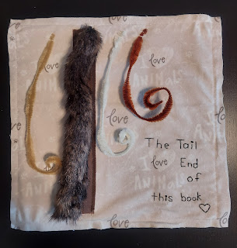

We also got this adorable photo of Gwen from the day before. Not lucky . . . Blessed!!

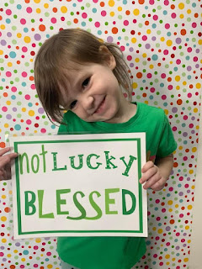

And when I called to see how Amber was feeling (much better she reported), Gwen wanted to show me her giant stack of magna-tiles. I suggested she try to eat it like a ginormous sandwich. She thought that was pretty funny. :)

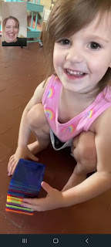

Saturday:
I received this snuggly white ball of Maltese fur - Sophie - to puppysit for the weekend. It's nice to have a little buddy in this quiet house.

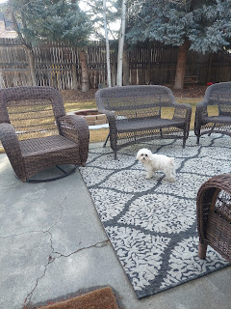

I wore my Italy t-shirt for the 2nd day in a row - since Scott wasn't quite there yet . . . and I sent him this photo (which he loved).

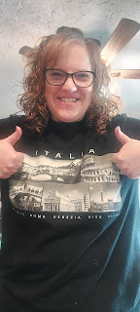

He gave me a video tour of his hotel room once he got settled in. It has all the usual hotel furnishings, but has plenty of storage and wardrobe closets and even a cooktop stove surface and some dishes. A kitchenette, I suppose. As I said earlier, this will be his home until he's able to secure a house for us someday. He's been told it will take a while. Probably at least a month, but hopefully not too much longer than that. If he doesn't have a house for us by the time I fly over there next month, then I'll be able to stay in the same hotel room with him until that happens.

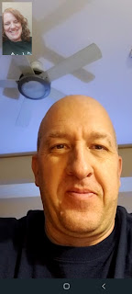

I worked HARD all day to get the quiet book all finished up. One of the biggest (and last) hurdles I had to overcome was what you see below:

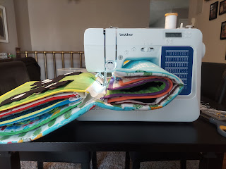

Sewing in between each page to attach it to the book cover was near impossible halfway into the task. I couldn't smush the pages any smaller to be able to push it all through this opening!! After getting a little sweaty and frustrated, I decided to hand stitch the rest of the pages into place. So I set up a Netflix movie (The Adam Project) and got it all done by about 9:00 p.m.

Did you hear that?? I'm ALL DONE!!! Here is a video tour of the entire book: (7 min, 25 sec)

https://photos.app.goo.gl/F3baEUoo17S1z4BU8

Man, that feels UH-MAZING!!! Just like every Sunday when I get my blog post all done, I feel so liberated and free!! Free to move on to more projects . . . ha ha . . . no seriously . . .

Sunday:
The rain was coming down when I woke up, but soon turned into really big snowflakes. The next time I looked out the window, it was a blizzard! The weather report called it a "snow squall", with wind gusts 30-40 mph and with a good couple inches of snow predicted.

I drove to church, even though it was right around the corner from my house.

I brought my laptop and a notepad with all my preparations for teaching a whirlwind family history class right after church. We had about 10-12 people in attendance, which was more than I expected since it was a snowy day and it's also the beginning of spring break and a lot of people are gone with their families. The class went really well! I was worried about how to fit the nuggets of information that I had prepared into the 25 minutes that I was allotted, but somehow it all miraculously worked out. I saw the lightbulbs go on in several faces as I taught them some research tips and techniques.

Scott, when he was serving as the Family History Leader before he left, made this simple but effective list for our ward to work on as an annual goal:

Everyone - Each Year

1. Index a batch on FamilySearch (at least one batch per year)
2. Attach a record to someone in your family tree
3. Add a memory to someone in your family tree
4. Add a new name to your tree
5. Submit an ordinance for someone in your tree to get temple work done

In my whirlwind class today, I showed them how to do #2, #3, and #5. All in 25 minutes!! There were 4 absolute beginners in attendance today, and they were excited to go home and dig in. That's fantastic! (*The reason I only had 25 minutes was because another ward would be coming in and we needed to vacate the classrooms.)

As I left the building, this was the state of my car.

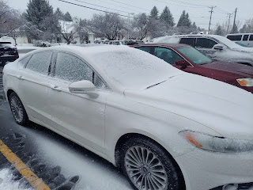

This side was completely encrusted in crunchy ice and snow and I had to work hard to be able to use the door handle. The other side had about 2 inches of wet, heavy snow piled up everywhere. In order to get my window scraper/brush from the back seat, it meant that approximately a gallon of snow landed in the back seat first as I opened the door, ha ha.

After I'm done with this blog post, I'll be changing into warm winter clothes to go outside and shovel some snow. Yay!

Scott is so happy. Which makes me so happy for him. I'm grateful for this opportunity to further his career and wind down his military service in such a wonderful way. Man I love this guy.

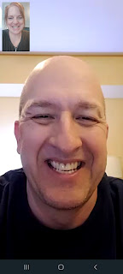

In summary regarding giving service, I love this quote:

"I cannot do all the good that the world needs. But the world needs all the good that I can do."
~ Jana Stanfield.

It's so true.

Time for Grandbabies . . .

Jack never really liked his binky. Except for this time when Jacob caught him on camera a few days ago.

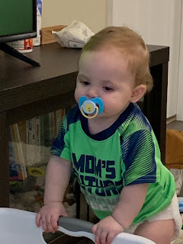

Here I think he was falling asleep in his stroller . . . he looks quite comfortable.

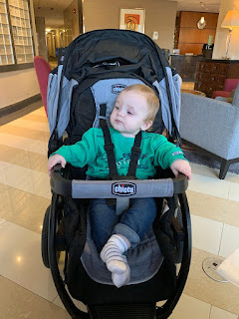

Avery is thriving and doing great - as her cute little round belly tells us. Tee hee. :)

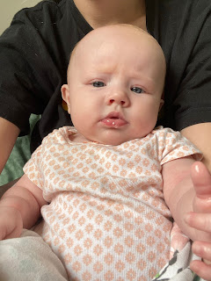

Gwen likes to hang out in the new hammock underneath her bed. Her bed used to be on the bottom, but now her bed is up on top. How fun!

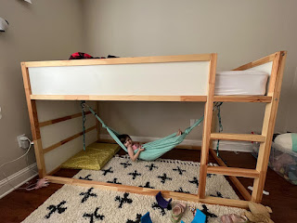

Amber set up this entertaining video for their cat, Goose, to watch. He was just about ready to pounce up on the bookshelf to get at that mouse . . . (31 seconds)

https://photos.app.goo.gl/8267EiaU6RbMkhtq6

And Weston set up a new trampoline for the girls! (16 seconds)

https://photos.app.goo.gl/sXFvP954p8C6j47P9

Last but not least . . . Jack says: Bye y'all. Or - Ciao!!

