Operation Louisiana Surprise!
Our Christmas surprise was definitely a success! The girls had no idea that we were coming. :) Amber told them shortly before we arrived that a special Christmas present was about to be delivered. So when the doorbell rang, they thought they were getting a gift that they could open right away . . .
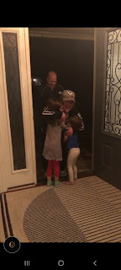

Video of our arrival and what the girls were doing inside the house while they waited: (2 min, 18 sec)
https://photos.app.goo.gl/QYTUPMFK1XcrPdqJ6

We did make a nice gift . . . just not one that you can literally "open", ha ha. Let me backtrack to share our adventures as we came across the country on our 3-day drive.

Sunday:
We left right after church to drive down to Provo, Utah. The drive was cold, but beautiful.

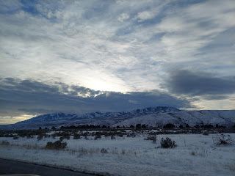

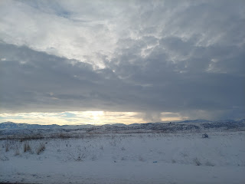

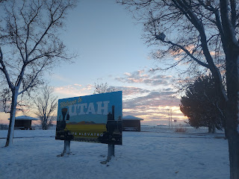

We had a lovely visit with our former neighbors, Jeremy and Julia Buell, and their kids. It was so nice to see them again! When you spend 13 years across the street from one of the greatest families on the planet, it's definitely a wonderful occasion when you can visit again and get caught up. They moved down to Provo about 2 years ago and have really enjoyed being closer to Julia's side of the family.
Below: (L to R) Taleea Buell (recently home from a mission), Bailey Buell (attending Utah State University), Zachary Buell (currently living in Houston & is one of Jacob's best buddies), and Scott

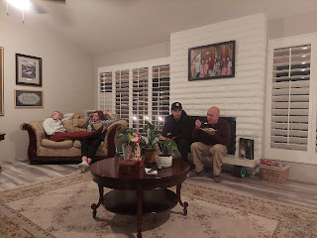

The mountains just outside their door are breathtaking!! Especially at night. On first glance, it looked like a sky full of winter clouds, but when you look closer you can see the massive mountain range where it meets up with the clouds.

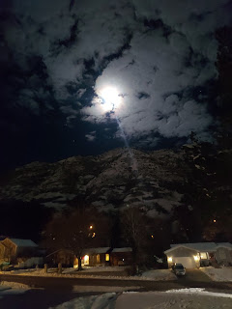

We visited until we were too tired to visit any more, and then we went to bed.

Monday:
After a tasty breakfast, some goodbyes and some hugs, we were on our way again.

Driving through Price Canyon, south of Provo, it was pretty darn cold! Look closely, and you'll see that the dash on the car showed a mere 7 degrees!! Brrrr!!

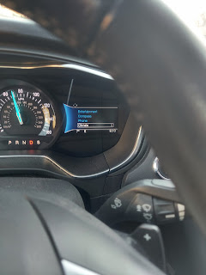

Eventually, we made it into warmer locations, such as Moab, Utah.

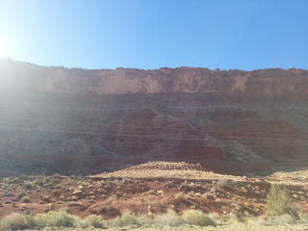

We stopped there for lunch. :)

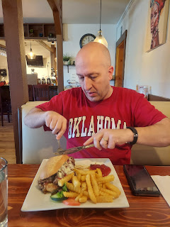

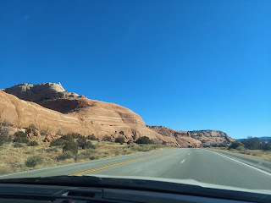

The southwest corner of Colorado still had a little bit of snow when we crossed the border.

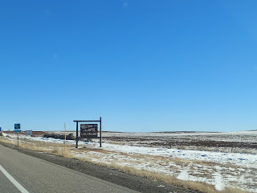

We had originally planned to visit Mesa Verde National Park as soon as we arrived at our hotel in Cortez, Colorado. We wanted to take advantage of the last couple hours of daylight and go on a explore within the Park. But I arrived at the hotel with a big headache, so we decided to change our plans to allow for me to rest for the afternoon instead.

When our tummies got hungry, we went for a nice long walk before finding a restaurant for dinner. The sunset was beautiful as the sky began to fill up with twinkly stars.

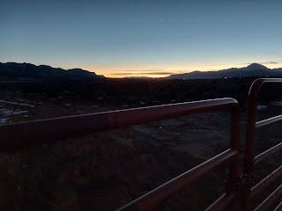

Tuesday:
We got up bright and early to exercise and get ready for a long day of driving.

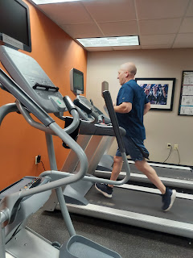

It was only 10 miles to get to the entrance of Mesa Verde, but the drive to get far enough into the park to see the ancient Cliff Palaces of the Ancestral Pueblos took an additional 40 minutes.

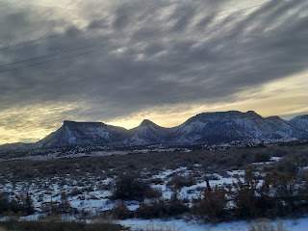

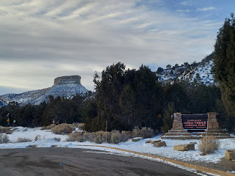

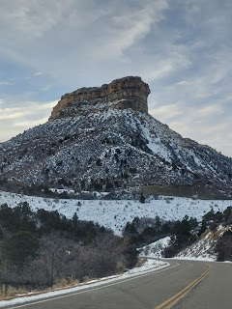

Some of the viewing areas were from a distance, while others were enclosed within a "shed" and you could walk around directly above the ancient houses.

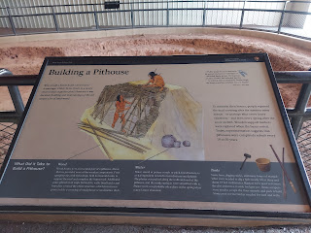

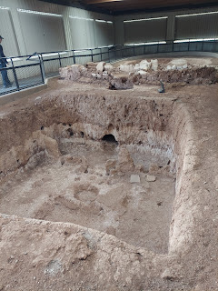

It felt really special to be able to visit a place such as this. The Ancestral Pueblos lived here from about 550 AD to 1270 AD, when they moved south to New Mexico and Arizona. I wish we had had more time to just slow down and feel more connected to what we were experiencing, so I would like to come back here again someday and have a more intimate experience.

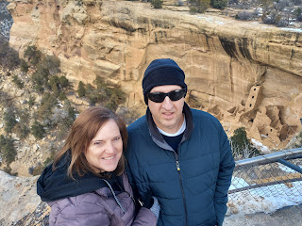

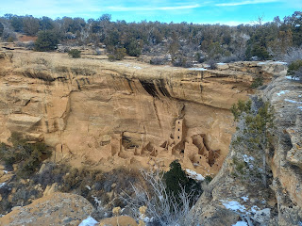

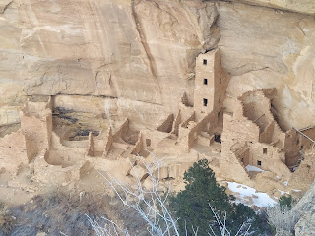

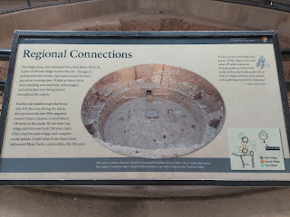

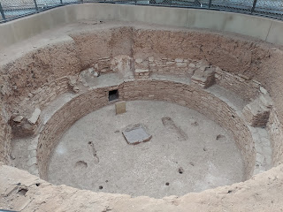

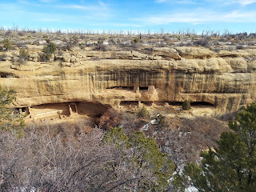

The mesas seemed to go on for days up there. At an elevation of 8500 feet, it was truly a wondrous site to see in the winter time. The snow added a layer of color and depth to the vistas.

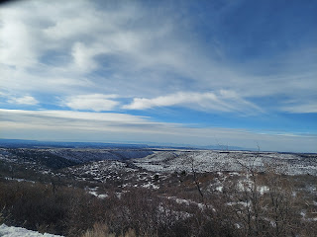

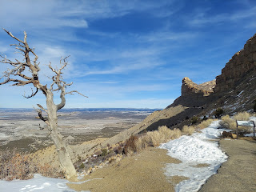

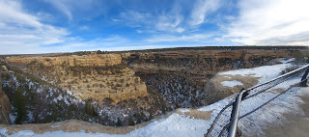

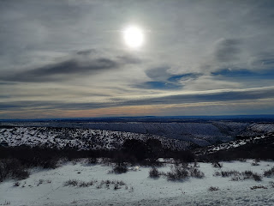

After we left the Park, we still had an entire day of driving in order to get to Amarillo, Texas. (about 8.5 hours) It was a beautiful drive - once we got across New Mexico, ha ha.

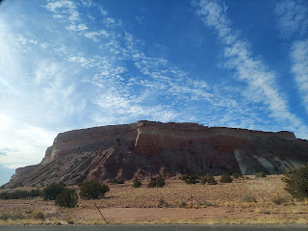

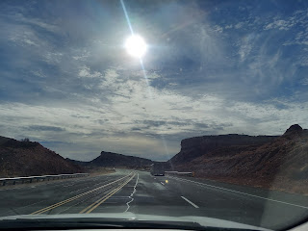

We arrived by about 7:00 p.m. and got all settled into our hotel, The Atrea Inn. We found a nice restaurant nearby, The Aspen Creek Grill, and walked over to enjoy some dinner before tucking ourselves in for the night.

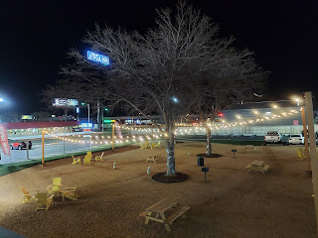

Wednesday:
We got up early so we could have a little time to see the Cadillac Graveyard just outside the Amarillo city limits. I thought it was quirky, unique, and fun. Scott didn't get it, though ha ha.

The owner of the Ranch also owns a nearby Cadillac Ranch RV, with some fun things onsite to stop and see as well. Such as this huge 2nd Amendment Cowboy. :)

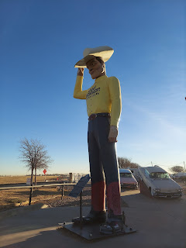

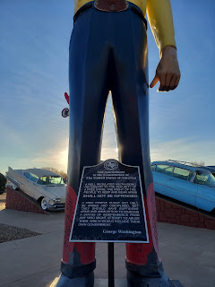

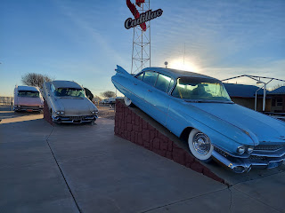

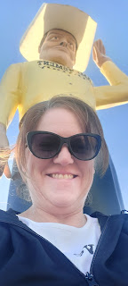

The actual graveyard of the Cadillacs is in a nearby field. If you look closely, you can see the half-buried Cadillacs in the distance from where Scott is standing.

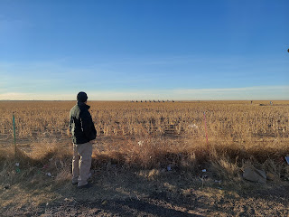

Even though it was first thing in the morning, several people were already there. Most came for a photo opportunity, but some came with cans of spray paint to add to the "art".

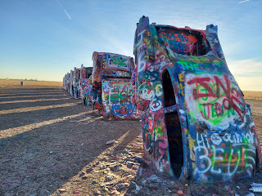

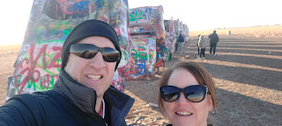

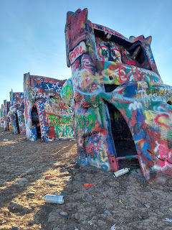

Even the underbellies had several inches of paint . . . Again, I thought it was fun, and even comical that someone took the time to place these old cars in the middle of a field, and now it's a popular tourist attraction. Scott just shook his head, and couldn't figure out why anyone would ever do this. :) I didn't care. I just loved the fun of it all.

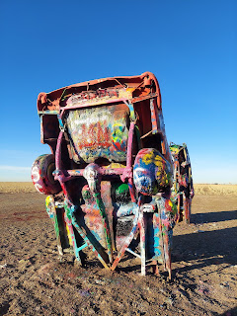

After we left the Cadillac Graveyard and headed east toward Shreveport, we saw several miles' worth of cotton crops being harvested. We had more questions than answers, which led to my looking up information on the internet so we could learn how a cotton plant is planted from a seed, how long does it take until it's ready to be harvested, what are some issues along the way, and how to successfully remove the "boll" without getting all pricked by the pokey parts that surround it. It was fun and interesting to learn so much as we drove along. (Below is a field of cotton that we saw)

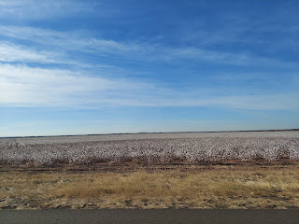

When we finally arrived at the Whitworth's house in Stonewall, Louisiana . . . Amber started a video inside the house with what was going on from their perspective. Weston told us later that he knew we had arrived when Alexa notified him that I had connected to their Wi-fi ha ha. (I connected automatically from when I was last there in May)

After parking the car, we took a minute to get all gussied up - well, actually it was just me that need to get gussied up, LOL. Then we walked around to the front door . . . and . . .

Click to watch the video of what happened: (2 minutes, 18 sec)
https://photos.app.goo.gl/mNjueKka4rdtP7kF6

It was pretty epic! Abby has said numerous times over the last couple of days, "This is the best Christmas gift ever!!" And she's already making plans for either us or Weston's parents to come surprise them every Christmas from here on out.



It was fun to snuggle with the girls and just visit for a while before bedtime. Amber has also started a new tradition this year for Christmas: she wraps up all the Christmas story books, each one individually. Then, the girls take turns opening up one book each night and that's what they read before bed. Scott has enjoyed reading the nightly book for the last couple of nights.

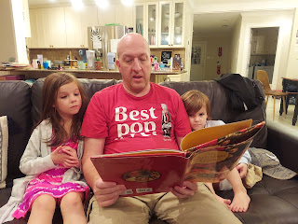

Thursday:
I woke up with a severe bout of vertigo. I was able, however, to get up and slowly make my way to the bathroom. A few minutes later, as I was leaning over my suitcase on the floor trying to choose my outfit for the day, suddenly it felt like I was a barrel rolling out of control down a steep hillside. I was not able to control it AT ALL, and quickly just kind of tipped over and laid down across my suitcase. A couple minutes later, Scott came in and asked if I was okay. I told him I wasn't able to get up at all . . .

Somehow we got me up off the floor and back into bed. I had several more rounds of spinning and it began to make me feel very nauseous. Scott started researching what might be causing such a profound episode, and came across several articles online about how sometimes a crystal that hangs out in your inner ear canal migrates from where it should be. It can cause extreme sensations of spinning and, by default, ensuing nausea.

The fix was to try what is called an Epley Maneuver. Scott watched a couple of YouTube videos that explained how to do it and what the goal is - to slowly get that crystal back to where it is supposed to be. We tried it, but man it was pretty difficult for me. I was crying and nauseous and basically a total wreck. It didn't hurt at all, but every movement made the world start spinning violently and I really thought I was going to throw up. Scott was very kind and patient as he helped me every step of the way. He also gave me a priesthood blessing, which I believe was instrumental in the subsequent Epley Maneuver being successful.

After the maneuver was finished, which only took about 10 minutes or so, I just laid there in the bed, resting, for another hour or two. Amber brought in a heated rice bag to snuggle with, and the girls came over to visit and check on me as well. Finally, I felt well enough to carefully get up and go over into the main part of the house where everyone else was hanging out. It took me until later in the afternoon before I felt well enough to take a shower, but it felt amazing!

In the couple days since, it has been a slow process to get rid of the dizziness and headache buzz that came with it. As I write this on Christmas evening, I recognize that right now I feel quite a bit better. Just the fact that I can wear my glasses again without feeling dizzy is a huge step in the right direction! I haven't been able to wear my glasses for 2 days. It made me feel super sick and woozy when I'd put them on.

Thursday evening I was able to go out with the family for dinner, which was nice. We went to a yummy pizza restaurant in Shreveport, about 15 minutes away. Everything is about 15 minutes away around here. As we left the house, there was a huge "H" in the sky above us. :)



While we waited for the pizza to bake at the restaurant, the Whitworths practiced making their best pucker face, and we played several rounds of "I Spy". The pizza was fantastic - it reminded me of the pizza that was my favorite as I grew up in Ukiah, CA. (Round Table Pizza) Every pizza that I eat - to this day - always gets compared to the Round Table Pizza in Ukiah. And maybe Round Table Pizza isn't all that great anymore, but maybe it still is! Who knows!

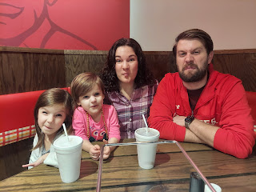

After we sufficiently stuffed ourselves, we split into two cars to drive past some Christmas light displays on our way home. Only the car with Scott and Weston somehow went straight home instead . . . weird, huh. So Amber and I drove the girls to see Candy Cane Lane in Shreveport by ourselves. :)

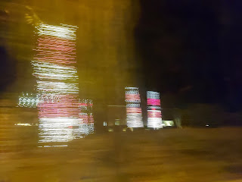

Video of us driving down Candy Cane Lane: (24 seconds)
https://photos.app.goo.gl/zsP6Eehn63QZYSBw5

Unfortunately, the speed limit was a little too fast for Candy Cane Lane. It was a main road and even if we did slow down to enjoy the lights, it would have made other drivers frustrated. So we zoomed down the road, turned around, and zoomed back through, ha ha.

After we got home, the girls opened up the last Christmas book from its gift wrap, and Pops sat down to read the story to them once again.

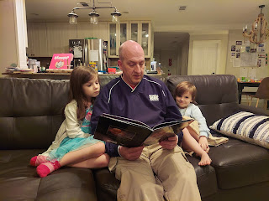

Gwen got a little tired part-way through the story of the Christmas Oranges . . .

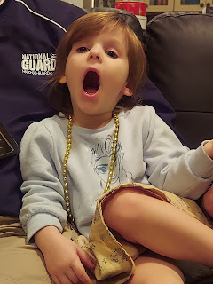

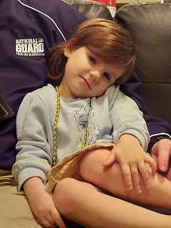

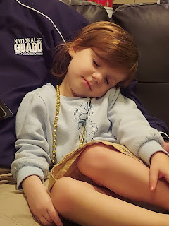

Eventually the girls went to bed, and soon after, we did too. Amber referred to the day as Christmas Adam, which I had never heard before. But I thought it was hilarious, especially when I realized the connection to Christmas Eve, which was the following day. :)

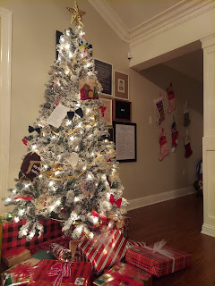

Friday:
(Christmas Eve) I started off a little slow (due to the leftover dizziness), but by late afternoon I was feeling a little better again. We mostly just hung out and played games or visited throughout the day. Amber and Weston went on a date to see "Spider Man: No Way Home" while Scott and I watched the girls for a few hours. We took them on a couple of walks, did some coloring, and watched Frozen II.

Scott and I took Abby to pick up Chicken Shawarma for dinner. She was being so silly on the way home in the back seat!

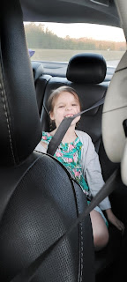

After dinner, Scott looked up where Santa was on the radar so we could track him throughout the evening. When we first looked, Santa was over Northern Africa, but by the time the girls were getting ready for bed he was just leaving Greenland and was heading for Canada. Fascinating! I'm sure he's got the most streamlined route set up for each year.

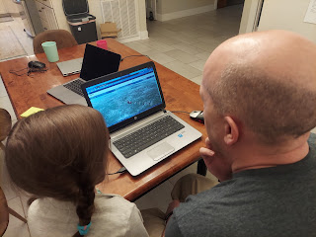

One last task for Abby before bed was to put out the reindeer food that they made at school, consisting of some raw oats along with some red and green glitter and sprinkles to attract them.

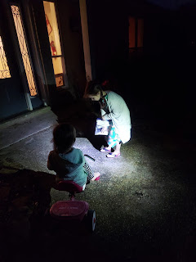

Here she is sprinkling out the food in little piles for the reindeer: (31 seconds)
https://photos.app.goo.gl/A3uMkdpUVVPQeabF8

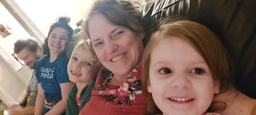

I forgot - the girls also did their Christmas Eve gift exchange, sharing a gift they picked out for each other. What a sweet tradition for them - and gives them something fun to play with as they try to go to sleep for the night.

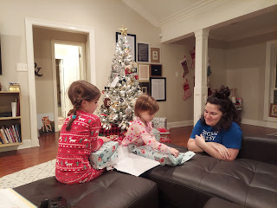

Abby gave Gwen a Raya doll from the Disney movie, and Gwen gave Abby a Baby Yoda. They were both super happy!

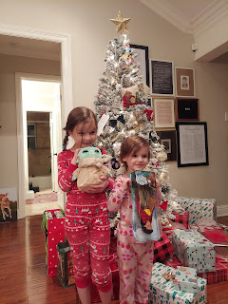

After the girls were in bed, the grownups worked on some last minute Christmas preparations, including getting the Breakfast Casserole into the crock pot (Scott and me), and wrapping some final gifts, or assembling them (Weston and Amber).

Weston (a.k.a. Santa) needed a helper to set out his newly assembled gift for Amber . . .

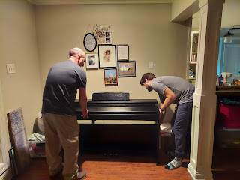

Amber put together an easel for Gwen . . . and Scott went out to clean up the reindeer food to make it look like the reindeer had actually come and eaten it all up.

Video of the reindeer "eating their food": (13 seconds)
https://photos.app.goo.gl/XLRTAe25AYbJe8kWA

Saturday:
(Christmas) We all woke up at 7:00 a.m., the agreed-upon time the night before. It seemed WAY too early for me, with my dizziness, but we all wanted to be there to see the girls' faces when they came out from their rooms and saw what Santa had left for them, so we got up and got dressed.

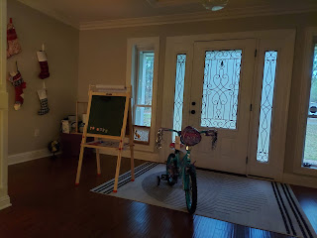

Video of sleepy eyed Gwen and Abby on Christmas morning: (12 seconds)
https://photos.app.goo.gl/4hacnVAVHXsgKMgm8

Video of Abby seeing her new bike for the first time: (1 minute, 6 sec)
https://photos.app.goo.gl/neuFdBjdsoow9saq8

Santa brought Gwen a chalkboard, white board, and painting easel; and he brought Abby a new bike with training wheels. They were both very happy!!

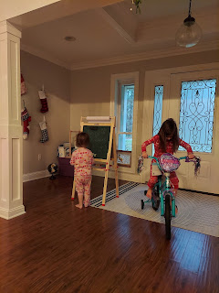

Scott and I had already given each other a large gift before we came to Louisiana: I gave him (and us) a set of snowshoes so we can go out and enjoy nature together during the winter months, and he bought me a new sewing machine. Still, we wanted to have something to unwrap on Christmas morning, so I bought him a special headlamp for running at night and some cologne. He bought me a new nut grinder (which I was super happy about because my old one broke - one that Benson gave me several years ago for Christmas) and some chocolates.

Amber loves her new digital piano. She mentioned that there are only a couple of musically-inclined people in their Stonewall Ward, she being one of them. She wanted to have a way to practice the piano for when she might be needed at church some day, but she also wanted to enjoy playing for her own enjoyment and to teach the girls how to play at some point as well.

Once everything quieted down a couple hours later, I went and crawled back into bed for a much needed nap. My head was extra dizzy that morning and I knew a rest would help. And it did! I felt much better afterwards. The whole time that everyone was unwrapping gifts, every movement would make me cringe because I would have to re-focus my eyes every time and I dreaded it. I didn't want to make any movements with my head at all, so I just tried to be in the background of all the excitement as much as possible. After my nap, though, I had energy, and I didn't have that constant dizzy buzz anymore. Hallelujah!!

Benson called us from Italy and we were able to ooh and aah over Avery for a bit as she went to sleep. She is so beautiful!

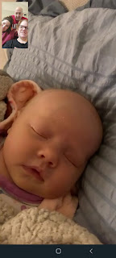

We were also able to have a video chat with Jack, who is visiting his grandparents out in Utah. Those facial expressions of his!! :)

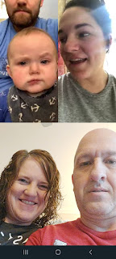

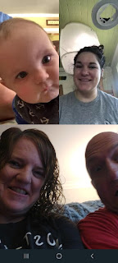

I went with Scott and the girls on a little walk around the neighborhood again. The weather was amazing! It's been about 75 degrees out here.

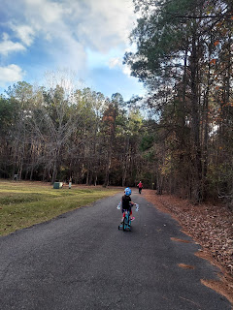

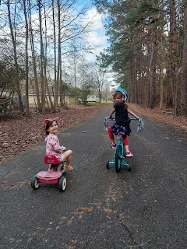

Other fun events from the week:

Jack went ice skating for the first time!



Video of Jacob pushing Jack in the stroller out on the ice: (20 seconds)
https://photos.app.goo.gl/FHsGUKx7Z22ha7uG8

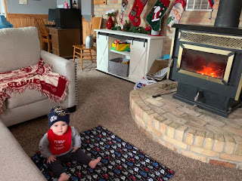

Jack's been visiting his cousins, aunts and uncles, and grandparents in Tooele and Scipio, Utah.

And even the cows seemed content on Christmas evening down in Scipio, Utah. (Hannah's parents live there on a ranch)

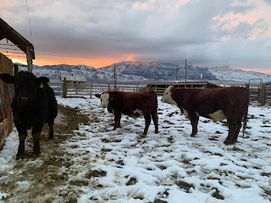

Grandma Doris seemed pretty happy for Christmas this year, too. In spite of recently breaking her wrist in a fall (she wasn't using her walker at the time), she was able to go visit family over at my mom's house a couple days before Christmas. From what I heard, she had a wonderful time, and she loved all the food too, requesting seconds and thirds. What a trooper she is at 100 years old!

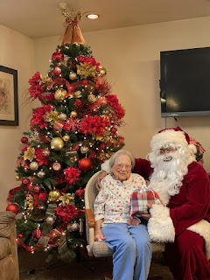

Merry Christmas! Next up - the hope of a Happy New Year!!

