Oregon & CA: Part One
Before I get into my trip to OR and CA, I'll just insert that this wasn't my first trip to CA this summer. In fact, this was my second trip to CA in less than two weeks. Round One was lightning fast, with a very specific purpose: to pick up my niece, Mari, and get her moved into an apartment back in Idaho Falls. I drove for two days to get out to Ukiah, CA, spent a very short few hours with my mom, loaded up the car, and then I left first thing the next morning to drive for two days back up to Idaho.

I stopped at a rest stop somewhere in Nevada at one point on my way out, and even though it was about 102 degrees, it felt good to walk around for a few minutes and get out of the car. The signs at the rest stop were pretty enlightening as they put things into perspective regarding the difference between the pioneers who traveled on foot (or wagon) so long ago vs. driving in a car nowadays.

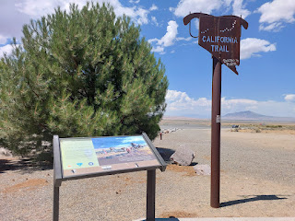

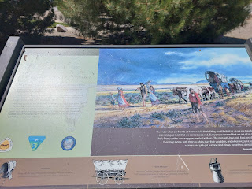

Take a closer look at this incredible perspective by clicking the photo below to enlarge it.

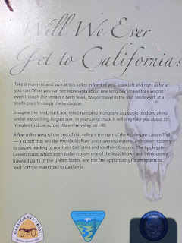

I also stopped briefly in Yuba City to see the Feather River Temple right in the center of town. It's so beautiful, with the olive trees in each corner of the property.

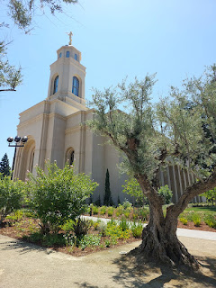

Video of the Temple: (7 seconds)
https://photos.app.goo.gl/GmEsJmQptedcM8SM9

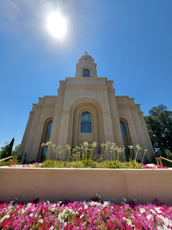

Mom and I took this photo together to prove to Scott that I had made it . . .

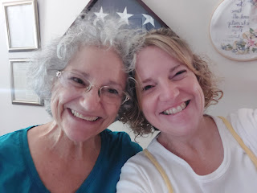

I helped Mari load up most of her stuff - not all of it was able to fit in my car - and then the very next morning we drove back up to Idaho Falls.

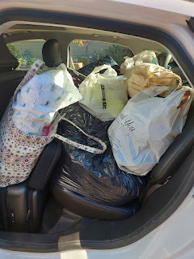

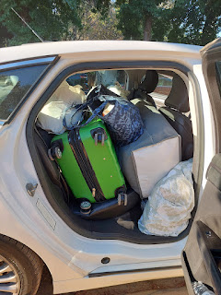

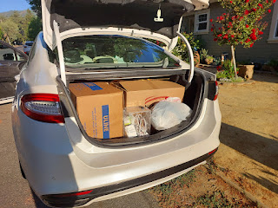

Mari stayed at my house for a couple of days until she got a key and had a working fridge. She was so excited to get into her new place!

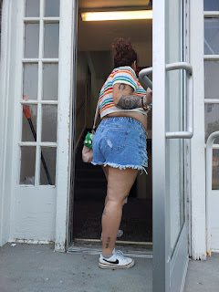

We picked her up a couple days later so she could come to the park with Amber, the girls, and me. She brought her dog of 13 years - Ducky Momo, and he enjoyed being outside and getting some fresh air.

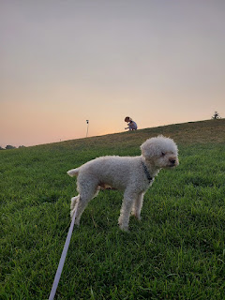

Abby, Gwen, and Ducky Momo . . .

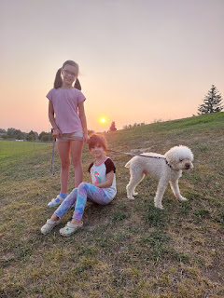

Another evening, we all went out to dinner together at a cute place called Manwaring Cheese, where they serve some AMAZING grilled cheese sandwiches and gelato.

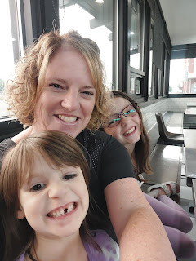

I got a rosemary infused grilled cheese sandwich - it was so perfect.

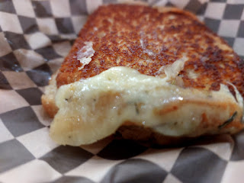

During a brief ten-minute visit one evening with Amber and my neighbor, Kim, on our front porch, Gwen made a big mess with some of the freshly cut grass (Kim's son William had just mowed it). She had plopped several piles of grass onto the front porch and around the back patio, too. I helped to "oversee" her getting it all cleaned up, ha ha. She didn't realize how much work it takes to get all the tiny pieces of grass clippings swept off the entry rugs and everywhere else. She promised to keep the grass IN the grass next time. :)

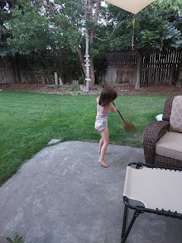

On a different day, I helped Abby set out some sunflower seeds for the squirrels and birds. One of the places she chose was to place some tiny little piles around the fire pit . . .

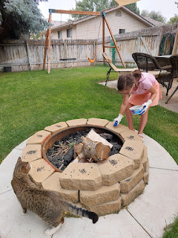

The Young Women came over on a Tuesday night, along with the sister missionaries, because they had asked me to teach them how to make pretzel bites. It was fun to see some of the girls that I used to teach a couple years ago, and to laugh and visit while we made pretzels together.

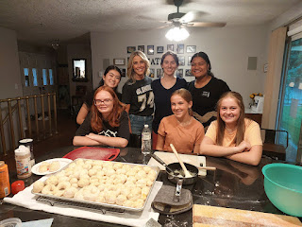

In preparation for our big road trip, Abby and I went to Hobby Lobby to get a few supplies. I was making an apron for my mother and needed some fabric, and Abby wanted to make a bouquet of flowers. I suggested that she make an assortment to place on her 4th great grandmother Ellen Lambert's grave for when we made a stop in Goldendale, Washington a few days later.

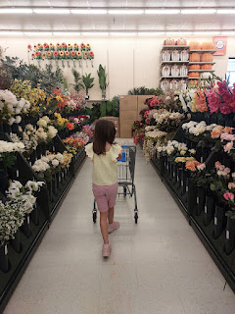

She wasn't sure what color of flowers to choose, and asked me if I knew what color Ellen liked. I told her that I had never met her, and that she passed away waaaaay before I was born. I encouraged her to pause and to be quiet for a moment to see if a feeling came to her on what color Ellen might like. She thought for a moment, and then radiantly responded, "Lavender!" Alrighty - let's go find some flowers. :) Once she selected some lavender tulips as the focal point, I taught her how to add a few more sprigs that complimented nicely and didn't try to compete or take away from the main flowers. We chose some smaller light pink buds and a few sprigs of dainty white flowers and stems for the background.

The next day, Abby left for Cousin Camp with her Whitworth grandparents in Rigby, Idaho. "Nana" Kathy has held Cousin Camp for several years now for all of their grandchildren that are at least 8 years old. This year, there were TEN grandchildren that all met together for 3 days.

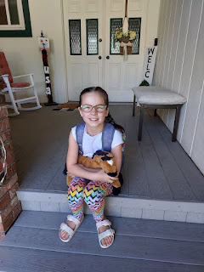

Before we dropped Abby off at Weston's parents' house for Cousin Camp, we stopped to have a snack with their brother, Jonny, at his gravesite in Rexburg. He was stillborn in 2016 and would be turning 8 this November if he were still with us.

Gwen and Abby . . .

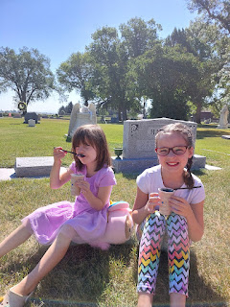

Jonny is right in between the two girls in age. They were all born one year apart.

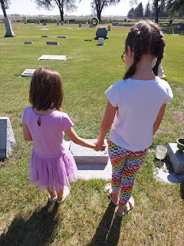

Abby wanted to place a little morning glory bloom on his headstone. How sweet.

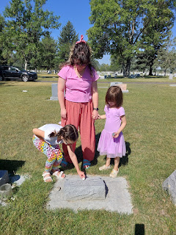

Abby, Amber, and Gwennie . . .

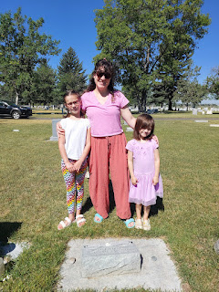

I noticed while we were there that someone had added a plaque to the back of the headstone that Scott's parents share. It recognizes Phil's military service during the Korean War. I'll have to ask Scott's sisters to see which one organized that. It is a really nice touch.

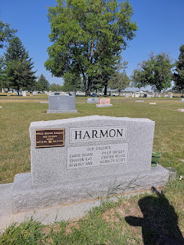

Miss Super Excited Abby with her father's parents, Kathy and Mike Whitworth, as Cousin Camp began.

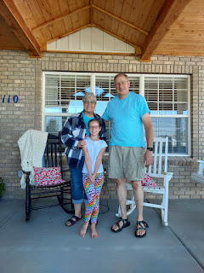

Amber and I worked hard to prepare for our road trip while Abby was playing with her cousins for 2.5 days. And as soon as we could pick Abby up, we hit the road on
Saturday, August 3rd
.

Our first stop was in Mountain Home, Idaho to see Benson. Yay! We hadn't seen him in about a month, so it was so great to hang out with him for a little bit.

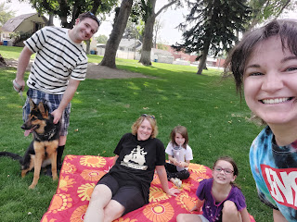

We met him at the Carl Miller Park, in the center of Mountain Home (the city, not the Air Force Base). It was roughly 105 degrees at 3:30 p.m. and the girls were pretty miserable in that kind of heat. We found a "nice" place in the shade and while Daisy (the doggie) kept slurping up all the water from several extra water bottles from our cars - one right after the other - we tried to pacify Abby and Gwen by promising them a nice cold treat after our visit with Uncle Benson was done.

Abby was especially melty, both physically and emotionally. We barely got her to look up and smile for our family selfie above, bless her little heart. I wish we could have spent longer with Benson, but under those conditions, it didn't make sense to stay much longer. We got the girls an Icee drink at the Maverik across the street, gassed up our cars, and then we just had a little further to go until we reached our hotel in Ontario, Oregon, which was just across the border from Boise.

We rounded up some dinner and the girls were happy as dolphins to swim and splash around in the hotel swimming pool before bedtime.

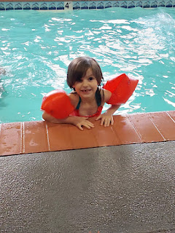

Sunday, August 4th:
We attended Sacrament meeting in Ontario at 9:00 a.m., just long enough to take the Sacrament and then we quietly slipped out so we could change clothes and check out of our hotel room. We had a long day of driving ahead, so it was important to get on the road.

I forgot to mention that we caravan'd in two cars so that we could haul some of Amber and Weston's things up to Portland. They have an apartment now and Weston got the keys a few days ago. They've had all their household stuff in a storage unit up near Portland for the past 2 months, but there were some straggling items still in my garage and around the house.

We had one of the girls in each of our cars and whenever we'd stop for a break every two hours, they would switch to the other car. We listened to the rest of Harry Potter (book 2) and most of book 3 by the time we got down to my Mom's house in Ukiah, CA.

A rare view of Amber in front of me on the interstate as we drove along the Columbia River . . .

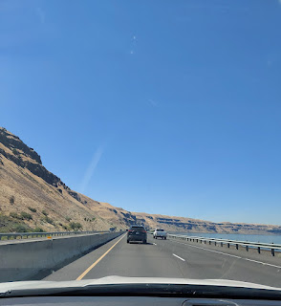

I say "rare view" because most of the time, I was in the lead, ha ha.

We crossed the bridge over the Columbia River to visit the cemetery in Goldendale, WA again. This has turned into my annual pilgrimage and I love it so much. I can't imagine NOT doing it.

Beautiful Abby with the bouquet of flowers that we put together from Hobby Lobby . . .

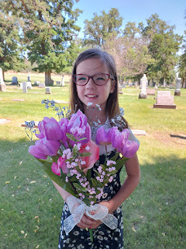

Gwen and Abby standing next to their 4th great grandmother's headstone, Ellen Lambert Baugh Pollan.

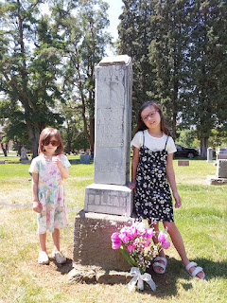

And I was there, too . . .

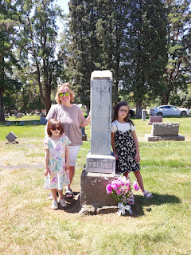

Amber and Gwen, resting in the shade for a few . . .

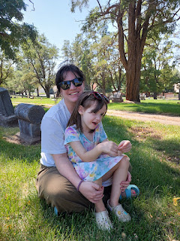

This is my 2nd great grandmother, Ellen Lambert Baugh with her second husband, William Carl Pollan. Ellen first married James Baugh at roughly 12, almost 13 years old. She gave birth to my great grandmother, Sarah Jane Baugh, and a younger brother, Addison, just before James Baugh was killed.

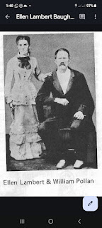

James Baugh had been accused of cattle rustling and after a trial ensued, he was acquitted and declared innocent. Unfortunately, after the courtroom cleared out, the two men exchanged words outside the courthouse and James was killed in broad daylight. He was only 30 years old, and Ellen was now a widow at 16 years old, with a 2 year old and a 3 month old baby. Approximately a year later, William Carl Pollan asked her to marry him, and he must have been a kind man to not only take her as his wife, but also her two young children. They moved up to Goldendale, WA a short time later and had several more children together. Ellen died shortly after giving birth to her final baby, Carl. Carl was born on 14 Dec 1882 and died in January of 1883. Ellen died on 19 December 1882, just 5 days after her baby was born. How terribly sad. And she was just 30 years old. That's the same age as my daughter, Amber, is now.

I'm so glad I could bring Amber and the girls here, to tell Ellen's story to them. And to place a beautiful bouquet next to her headstone that will last a long time . . . how special.

There was an old car show going on in the area of Goldendale, because we passed several hot rods around town.

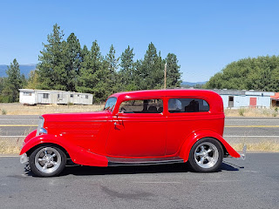

Abby was pretty comfy in the backseat of my car, even dozing off after we left Goldendale.

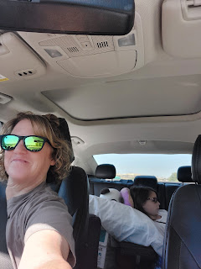

Finally, we met up with Amber's husband, Weston, in Oregon City, near Portland, where he's been staying in a hotel. We offloaded their gear and suitcases, I hugged everyone goodbye, and then I continued driving one more hour south to Salem to stay with my Uncle Mike and Aunt Suzy Moore so that I could be closer to my Grandma Lillian.

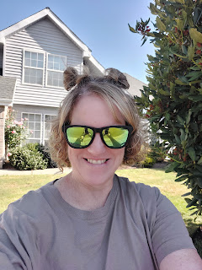

Monday, August 5th
: I spent the whole day with Grandma Lillian, just hanging out in her room at the nursing home. We chatted about our extended family and what everyone is up to, we watched some Olympic events with her roommate, Alice, and Amber and the girls drove down to spend a couple hours with us, as well.

In front of the care home sits a lovely pond where a large collection of ducks like to hang out. Per Grandma's suggestion, we asked the front desk for some "duck food", which they happily gave us. It was a brown bag with quite a load of pellets inside. The girls loved throwing the food out on the grass for the ducks to gobble down, including some for the two little baby ducklings.

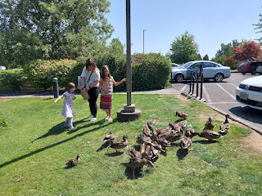

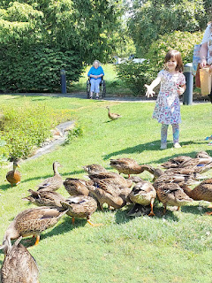

Video of the baby ducklings: (14 seconds)
https://photos.app.goo.gl/4fFdAYmXNU5NMrk69

Abby sat next to the pond for a really long time, admiring the delicate pink lilies amongst all the lily pads in the water. When I went over to check on her, she said she had been quietly asking the duckies if they wouldn't mind grabbing her a couple of blooms and then swimming them over to her. She was being really patient as she hoped they might comply.

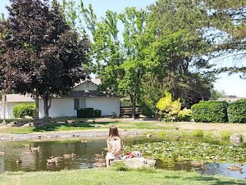

I picked up some lunch for us at a nearby Arby's and we ate it in the comfortable shade next to the pond.

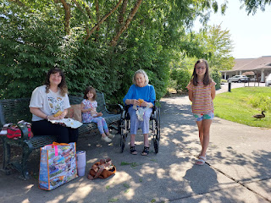

It was so nice to be outside in the fresh air and to spend that time with Grandma. Amber and the girls hugged her goodbye after a couple of hours, because they had some errands to run up in Lake Oswego regarding moving into their new apartment.

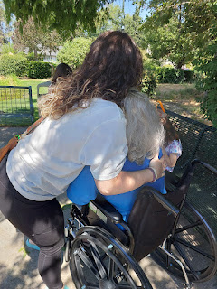

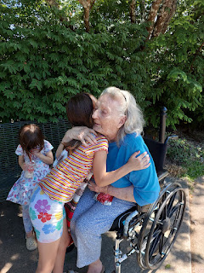

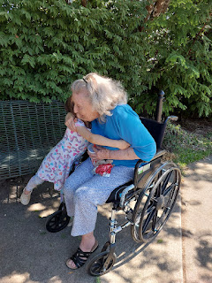

Grandma called out to me at one point while we were watching the Olympic canoeing event, and as I turned around, she took my picture, ha ha. I was sitting in her wheelchair with my feet up and resting on her walker.

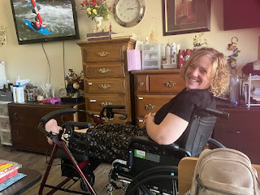

After a long and full day, I hugged her goodbye so I could return home to her oldest son's house (Mike) in time for dinner.

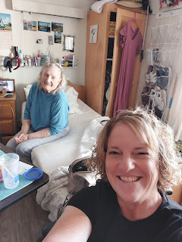

After dinner with Mike and Suzy, I went out into their backyard to pick a few blackberries, per their invitation. Suzy does a fabulous job with all of her beautiful flowers, including several colors of roses and dinner-plate sized dahlias.

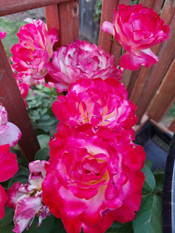

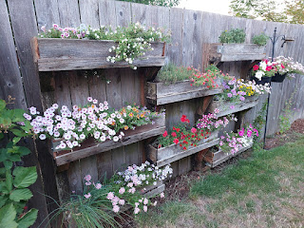

They also have a thornless blackberry bush with the biggest blackberries I've ever seen!! It was especially nice to pick a few juicy berries with no thorns to contend with.

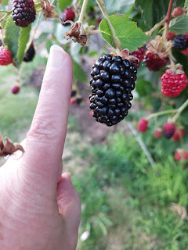

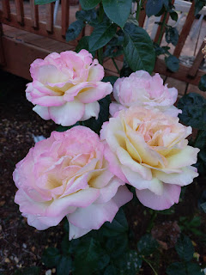

Their grandson, Michael (11), has been visiting them this summer. He and Grandpa Mike did some work out in the yard one morning, which included trimming back the mint plant. Michael asked if he could make us some mint tea, and it actually turned out quite delicious!!

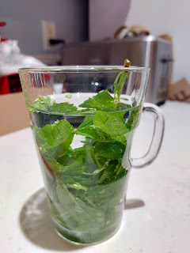

He placed one long sprig of mint into a mug of water, then we covered it up with saran wrap and microwaved it to just shy of boiling. Next, you take the leaves out after swirling them around a little in the water first. Add a squeeze of fresh lime and maybe a 1/2 tsp of sugar. And that's it! XOXO SO GOOD!!

Tuesday, August 6th:
Amber and I met over at Grandma's room again to spend a few minutes with her before heading south.

Gwen, Abby, Amber, and Grandma Lillian

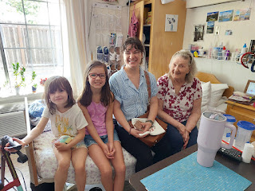

We drove down toward Grants Pass, OR and then over to Crescent City, where we parked it for the night. Our hotel room was huge, so I dug out the camping cot from my trunk and Abby slept in that comfortably and the rest of us had a little more room in our beds, too.

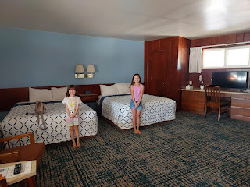

We stayed at the Curly Redwood Lodge and it was really cute, Even the fridge and microwave were cute! It's right across the street from the Crescent City Harbor and the ocean.

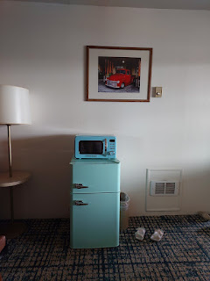

The girls and I went for a little explore together at the Harbor, while Amber went for a run. They contributed some silly faces when I tried to take their photo, ha ha.

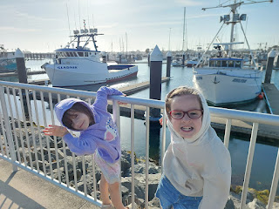

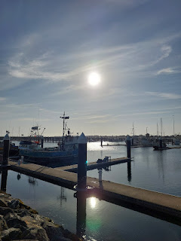

Video of the Harbor: (14 seconds)
https://photos.app.goo.gl/SKbPeT1xG1ZNryux7

The girls wanted their photos taken in front of a boat of their choosing.

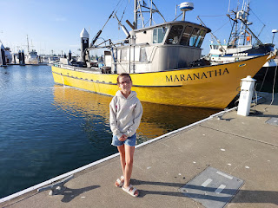

Abby (above) and Gwen (below) . . .

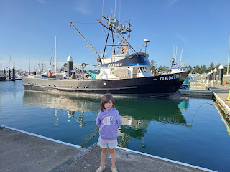

We stopped to read all about the fishing industry for Crescent City, noting the different seasons and what the "catch" was during each one. (click photo to enlarge)

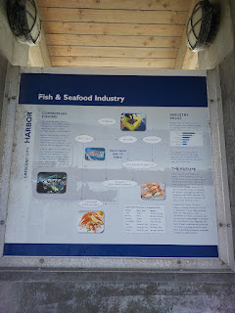

We found a wooden mermaid . . .

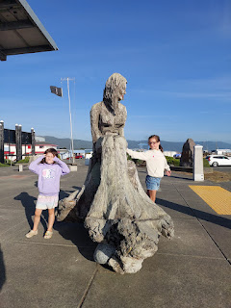

A giant smiling fish . . . and if you look closely you might see Gwen peeking through . . .

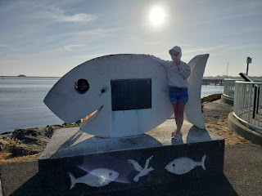

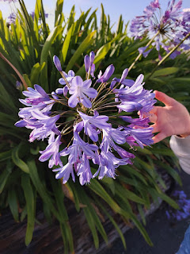

We talked about how Jesus is the Anchor of our souls and what that means for each of us . . .

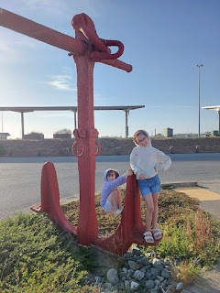

We had the tastiest dinner at the Boat House Restaurant next to the Harbor. We ordered dumplings, tempura veggies, coconut shrimp, seaweed salad, and sweet potato fries. We did a great job finishing off as much as we could before our tummies were full to the brim.

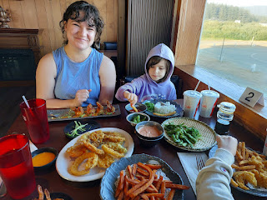

And lastly, we ended the day by walking over to the beach after dinner. It was colder by the end of the day, and the girls were wishing they had some pants on instead of shorts . . . We didn't stay too long because the sun was dipping down on the horizon . . .

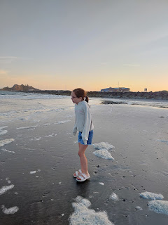

There was some intriguing white foamy fluff at the edge of the tide and the girls wanted to touch it.

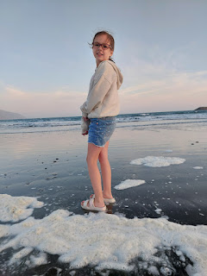

Gwen, being Gwen, got her hands nice and dark and dirty by playing in the wet sand. So Amber helped her clean her little hands off in a little patch of water that someone had made previously. It looked just like a sink! Not three minutes later, Gwen's hands were black once again because she just couldn't help herself, ha ha.

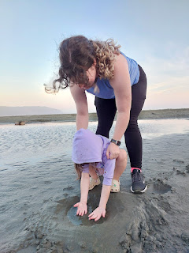

She "had to" dig a tiny little trench for the water to get all the way back to where we stood on the shore. What a cutie.

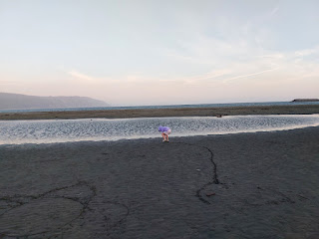

Next blog post:

Part Two of our trip, with a focus on our adventures in Northern CA.

