Problems With Miraculous Solutions
Yes, this week has been an interesting one . . . I'll just get it all out and then we can move on. :)
But first, here is Jack. He will magically bring some zen into this blog post before I even get going.

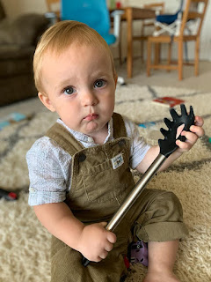

Problem #1:
My car. My 2016 Ford Fusion Titanium has been having an occasional issue for months, but nothing so regular that I felt it needed a trip to the fix-it shop. However, when I got home from girls camp, it was repeating the same issue numerous times throughout the day and that's when I got very concerned. As I accelerated, right around the time it would reach 25 mph, the car would JERK rather suddenly and emphatically. Sometimes, it would even make ME jump! It used to do this only once in a while, but last Saturday it was every single time I accelerated after a stop.

So Monday morning, I called the Ford dealership in town to have them take a look. Only actually, they are the
only
Ford dealership in town and with all the new people moving to Idaho Falls (from CA . . .), they are pretty backed up and couldn't get me in until AFTER my trip to CA in a couple weeks. That wouldn't do, so I called our favorite non-Ford fixer guys, Sage Creek Repair, and they told me to bring the car in right away!

They discovered over the course of the next couple of days that it was my grill shutters that weren't working. The shutters are supposed to sense heat and cold, as well as any abundant moisture, therefore knowing when to open or shut accordingly. But my shutters were closed and would not budge. They weren't allowing any ventilation to happen under the hood in the extreme heat we've been having, and that's when the car wanted to switch over into "limp mode" . . . get this . . .
right around 25 mph
!!!

On the third day with the fixer guys, they wanted to take the entire front bumper off to potentially replace the entire grill shutter assembly (for $2,066) . . . Meanwhile, Scott had an inspired epiphany over in Italy. He called me that morning and said, "Do you remember when we got all that work done on the front end of the car last year when I had that little fender bender? What if this problem is somehow related to that?"

So I called the Ford dealership again and after discussing the issue at length with the man that answered the phone in the body shop, he passed me off to the manager, Bob. Bob told me, "I see here (on his computer) that we did $7,000 worth of work on your car last August 13th, including installing a brand new grill shutter assembly. I'd like to take a look at this myself because I want to guarantee my work. How soon can you get it over here?"

I was able to get a ride from my neighbor's teenage daughter, Mady, and get the car over to Ford for a look-see. Just a few minutes after I got home, Bob called to say that he had already found the problem! When they installed it last August, somehow the assembly had been plugged into the wrong plug!! Instesad of the motor being plugged into the ACTUAL plug, they had plugged it into the "dummy plug". That's why it was unresponsive and uncooperative . . . it had no brains!! He fixed it, took it for a test drive, and declared it to be fit for my upcoming travels. Hooray! The best part - it didn't cost me a penny because it was still under warranty. I did pay the other fixer guys $168 for their time and efforts, and it was worth every penny I told them. If they hadn't gotten me in so quickly, this problem would not have been treated as urgently and I would still be having the worrisome issue . . . Amazing.

Problem #2:
A family issue came up where a person with good intentions became a little too aggressive in coming up with solutions. It's hard when our parents get older and some delicate decisions need to be made. Several of Scott's siblings would like to see Phil and Coy move into a smaller place, like a retirement center or assisted living, where they can be cared for and not have to do so much at their advancing age. But we also want to respect their wishes at the same time. It's a delicate balance of trying to help them vs. not forcing them to do something they really don't want to do.

After several phone calls where I was forced to become an integral part of the decision process, I tried to diffuse the situation (with the one individual) using love and the little bit of wisdom that I possess (on my good days). I said that we can have the best of intentions for someone we love, but we shouldn't force anything on them. That's the equivalent of taking away someone's agency, which is not something that Jesus would do. I also said that for Mom and Dad Harmon, if we try to circle the wagons a little too tightly, then they will feel strangled and claustrophobic about what we're trying to do and this will cause bad feelings and frustration. It's best to just respect their wishes at this point and let them have a choice in the matter.

I'm not sure I really got through to this person, but I felt good about my approach and what I tried to convince them of. I don't think this was a "miraculous solution", but maybe it was just a good attempt to keep the family on good terms in spite of some strong and passionate, yet differing views.

Problem #3:
My neighbor two doors down, Billie, called me and wanted to discuss the neighbor in between us (Ellen) and the problems that have been escalating next door because of hoarding. Yes, Ellen is a hoarder. It has been a problem for years, and sometimes it gets even worse as the garbage piles up outside her front door, attracting rodents and the neighborhood gang of raccoons. Her "lawn" is about 4 feet tall now and deader than dead, which is an extreme fire hazard with the HOT summer days we've been having lately.

After we talked at great length, we finally came up with some ideas of what we could do next. While Billie and her husband (an attorney) would work on some legalities, I offered to call and talk to Ellen, since I have a good relationship with her.

First, I did some research online on how to talk to a hoarder, and how to bring up the concerns we all have in our neighborhood. I found a really good PowerPoint presentation that I emailed to Doug and Billie, and they reported back that they found it to be very helpful.

I downloaded it, but you're welcome to look at it if you're curious:

file:///C:/Users/miche/
Downloads/How_to_Talk_to_
Someone_with_Hoarding_Problem.
pdf

I said a prayer before I called Ellen, and I know that it helped. As we visited, I asked about her health and how life was going. She asked about my kids and grandkids, and soon she took the first step in the direction I was hoping to go. She admitted that her yard outside needed to be taken care of, and pledged to make some calls and get someone over to weed-whack it all down.

I was able to carefully, respectfully, and gently navigate from the small talk to
eventually
being able to ask her, "Are you familiar with the term 'hoarder' and do you consider yourself to be one?" I had already told her that I care about her very much and that I am concerned about her health and safety, as well as the health and safety of the neighborhood. Either she is somewhat ignorant about the extent of the piles around (and in) her home, or she is in denial. But again, she pledged to get working on the piles of stuff by her front door. Overall, it was a very good first conversation, and it was a good foundation for the future.

She even called me back a few minutes later to report that she found someone to come and take care of the "lawn" (which is essentially just 100% weeds). I was so proud of her! She also wanted me to know how much she appreciated my friendship and the kindness that I showed to her. She said I am her only friend in the neighborhood and the only person she can trust. She even thanked me for being direct and honest in my questions, instead of "beating around the bush" and "lying" to her, as she felt others had done previously.

I was so grateful that I had not offended her, something I never want to do to anyone! I am also grateful that she was motivated to work on a couple of things, and now we will just sit back and give her some space to make those things happen. If they never happen, and/or if things get worse, then Doug might have to pull some legal strings . . . I hope it doesn't come to that. But I also don't want Ellen's house to go up in flames because something decides to spontaneously combust in the 97 degree temperatures. If it does, then not only will her house turn into toast within a matter of minutes, but MY house (and others) would be at risk as well.

There were a few other "fires" I had to help put out this week, but I won't mention them here. Suffice it to say that for Wednesday, Thursday, and Friday, I spent more time ON the phone than OFF the phone . . . Thank goodness for ear buds that connect to my phone so I can multi-task and get the weeds pulled, the dishes washed, the laundry folded, the room tidied, the bathroom cleaned, etc. while tending to loved ones and associates on the phone at the same time.

At one point, Scott said, "Keep it up, you're doing great things!" I responded with, "What if I'm tired of doing great things?! What if I just want to just put in a lame effort and have a lazy day?!" I tried to give myself one solid hour of quiet and peaceful time each of those days, and that seemed to help.

Other Happenings . . .

Monday:
Scott gave me a good photo opportunity while he was in Frankfurt, Germany for a certification course this week. He enjoyed the class and passed the test at the end of the week. He is now back home in Italy.



An old friend of mine, Marilyn Garn, stopped by for a visit. We used to get together with Andrea Garner and all of our little ones years ago, letting the kids play while the moms visited and lent support to each other in our parenting efforts. It's been years since I saw her last. We had a wonderful visit for a little over an hour, and as she left, she hugged me and with tears in her eyes, said, "You have always been one of my favorite people." What a sweet thing to say. :) She is a wonderful person, too, and I'm so glad she made the time to come and see me!



Tuesday:
I got my hair cut, colored, and even tried highlights for the first time!! I'm hoping that it will help to blend in the greys that inevitably show up, and that maybe I won't have to have my hair colored as often *if this works* . . .

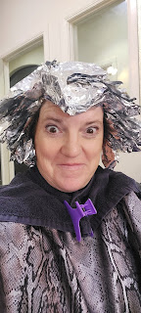



Scott and I were making pouty faces at each other . . . I can't even remember now why we did that, ha ha



Wednesday:
I borrowed a car from the Vances and was able to keep my scheduled appointment at the temple that morning. Thank goodness for wonderful friends! I enjoyed the peaceful spirit of the temple, amid so many things pressing in on me from outside those beautiful walls.

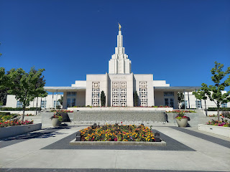

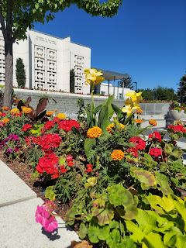

Later that evening, we had a Neighborhood Social in the grassy area across from the church meetinghouse. Fried chicken and mashed potatoes were provided, and those living in odd-numbered houses (like me) brought side dishes, while the even-numbered families brought desserts. We had slightly fewer numbers in attendance this year, but then it is summertime and lots of people were probably on vacation.

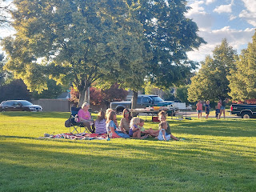

I zoomed in on Amanda, the YW president that I served with earlier this year and had so much fun up at girls camp with. I sent this photo to her in a text and told her, " You are so cool." ha ha

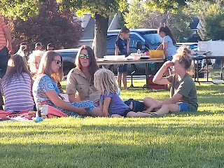

It was so fun to just sit and visit with everyone for about 2 hours. I brought a big fresh corn salad, with feta cheese, basil, cherry tomatoes, green onions, olive oil, vinegar, and a few spices. It was very tasty.

Thursday:
This was the day that I finally got my car back, but the day was busy and hectic with all the phone calls and networking that I had to do. At the end of the day, I also had a much needed 2.5 hour video chat with Chelsea, whom I hadn't talked to in a while . . . just a few texts here and there for the last few months because life gets so busy and we sometimes unintentionally neglect those that we care about the most.





Also, Bob, over at the Ford dealership, found this spazzy piece of tire shred wedged into my front grill. He said it may have also contributed to the grill shutters not wanting to open or shut . . .

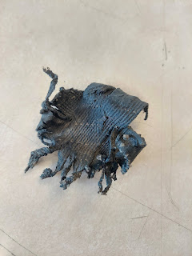

Friday:
I trimmed several tree branches out front that were hanging down pretty low, and I cleaned up the flower bed out by the sidewalk where my one remaining apricot tree lives on. No more weeds for a good few weeks I'm sure . . . By the time I was done, the dumpster was heaping and overflowing with all the greenery that I trimmed, plucked, or whacked.

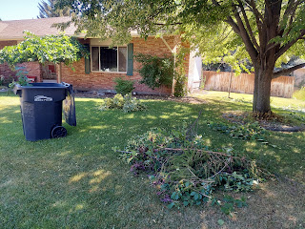

Amber and the girls left a day later than planned, because Gwen had had an averse reaction to some pizza they ate the night before. She has occasionally suffered from acid reflux issues, and this was unfortunately one of those times. After they spent the day (Thurs.) getting her all back to normal, they left their home in Louisiana on Friday morning to drive all the way across the country to Idaho.

Here they are on night #1 in their hotel room. Gwennie is showing me the melatonin gummy bear that Amber administered to her so that everyone could have the best night of sleep. :)

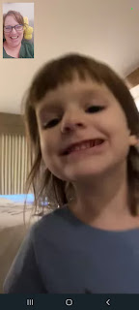

Meanwhile, Abby was getting her wiggles out by jumping from bed to bed. I've personally never seen kids ever do that before in a hotel room . . .



Saturday:
I picked a bunch of rhubarb from my hugely overgrown rhubarb plant, getting it all sliced up and ready for whatever I decide to bake in the next few days. (a strawberry-rhubarb pie for sure)



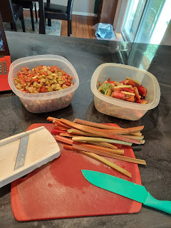

After spending several more hours on the phone, and multi-tasking much of that time, I slipped out with some friends that evening to get a pedicure for the first time!

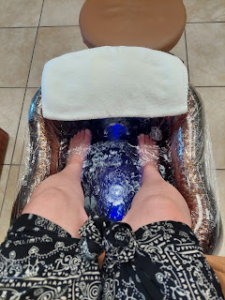

While my feet soaked in the warm water, and while I sat in a very thorough massage chair, we visited and laughed and had a good time. To my one side were Jen Anderson and Michelle Going (the girls camp director that I served with).



To my other side was Laurel Burch, a dear friend that has since moved out of our neighborhood.



The technician rotated back and forth between Laurel and me, while another technician took care of Jen and Michelle. I had a foot scrub (very tickly), a lower leg massage, and hot orange wax applied to my feet. Strange, but enjoyable. Apparently the hot wax works to seal in moisture which helps your feet to be softer.

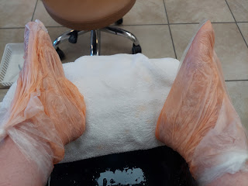



After our pedicures were all done, we went out to dinner at a nearby Indian restaurant called Tandoori Oven. I always love to get anything Saag (pronounced sog). Since I have had chicken saag and lamb saag in the past, this time I chose shrimp saag. It was amazing! It was Michelle's first time getting Indian food, but we all helped her with what to choose off the menu. She doesn't like anything spicy . . .



What a great way to end some really busy days all in a row. I'm not usually the one to instigate a girls night out, but I'll sure play along if someone invites me!

Sunday:
I was asked to fill in as an extra adult in a primary class at church, working with the 6-7 year olds. At the end of the lesson, the teacher asked them to think of a way they could "build" a spiritual wall of strength for themselves, giving them an example of "prayer" to get them started. As they came up with an idea, they first said it out loud, then they came up to draw a "brick" on the chalkboard. By the end of class, we had built a pretty solid spiritual wall of strength!

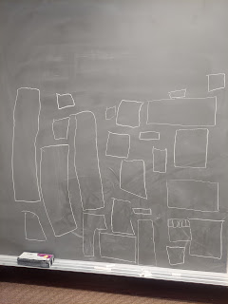

Some of their ideas included: prayer, scripture study, go to church, keep the commandments, follow the prophet, take the Sacrament, be kind, help others, keep the Sabbath Day holy, honor your parents, etc. They were a cute bunch of kids and I enjoyed hanging out with them for an hour. :)

Time for Grandbabies . . .

Miss Avery
- strawberry-blonde and beautiful.





Kylie shared a few videos with me upon request. Avery is soooo cute!!!

Video #1:
Avery trying what looks like bites of bread. But sometimes it gets stuck on the roof of your mouth, ha ha. (20 seconds)
https://photos.app.goo.gl/ohZ3SAe1m81uUNqDA

Video #2:
Avery wanting to pay a visit to their cat on the bed. (20 seconds)
https://photos.app.goo.gl/G97hAL8Ge5rLeFae7

Video #3:
Avery wanting to eat her mom's cellphone again. (21 seconds)
https://photos.app.goo.gl/EjSD2SQcX6XnXSYB6

Video #4:
Avery showcasing her stinkbug crawl style on the hard Italian flooring. *Note the chair that was intentionally placed in front of Mocha so that Avery wouldn't go over there, ha ha. (36 seconds)
https://photos.app.goo.gl/coac8X6Y1Lc2xZ2V8

Video #5: Avery trying her darndest to get some slickery and slurpy mac & cheese noodles into her mouth. (40 seconds)
https://photos.app.goo.gl/5XVbxiKuhggXUnzY9

Jack
- Mr. Handsome and so observant





For Jacob and Hannah's 3rd wedding anniversary, they went to the Planet Word Museum and a splash pad with Jack.



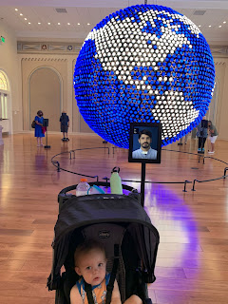

Jacob often asks us what we're all having for dinner. The question is usually: "What we all eating tonight?" This week he simply abbreviated it to: WWAE2N? I'm usually a little envious because he always shares a photo of what they are about to eat.

These shredded chicken nachos look sooo goooood . . .

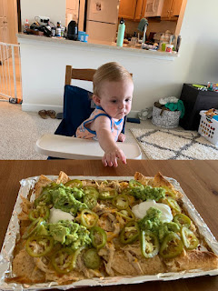

Bike tours around Washington, D.C.



Video: Jacob sent us this with the caption, "For once we're glad that construction takes forever. He's been project managing from the balcony 8-9 a.m. for weeks now. What will he do when they're done?"
(20 seconds)
https://photos.app.goo.gl/q5AncjNgtCAfat2s8

Gwen: Precocious McGillicutty

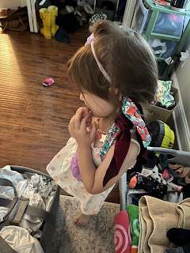

Amber sent us this photo with the explanation: "Gwen will sprint in here wearing every single hair accessory we own all over her body and be like, "there's a man with a whistle and he's making me run, he tells me when to stop and go, I'm on the purple team, what team are you on?" and then sprint out again before I can answer . . .

Abby: Smarter than her britches

As I spoke to Amber and the girls on Saturday once they made it to their hotel in Blanding, Utah, I asked them how the drive was that day. Abby excitedly shared with me that there were "so many sedimentary rock formations on my side!" Wow. I had to look that up to even know what she was talking about!! ha ha ha ha ha

Here's a link if you'd like to know more of what Abby already knows.

https://www.amnh.org/explore/ology/earth/if-rocks-could-talk2/three-types-of-rock#:~:text=Igneous%20rocks%20are%20formed%20from,by%20heat%20and%20pressure%20underground.

A few photos of Abby and Gwen as they journeyed across the United States.



Look familiar? This is Cadillac Ranch (or Graveyard) just outside of Amarillo, Texas.

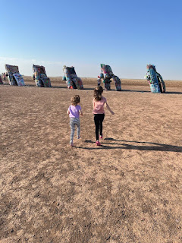

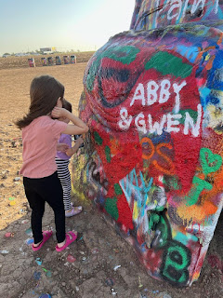

After it stopped raining in Blanding, Utah, there was a beautiful double rainbow!

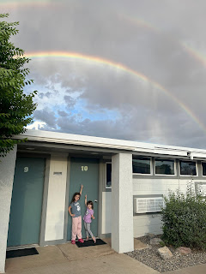

They will be here around 5:00 p.m. TODAY (which is in 2.5 hours). I'll wrap this up so I can work on getting dinner ready ahead of their arrival. Gonna make macaroni and cheese casserole!!! Yum! :)

