Projects Are My Default
It's been a super busy week, but a very good week. I'll start with the latest from Vicenza, Italy . . .

Scott has been busy training a couple of "substitutes" the past couple of weeks, and now he's winding down his final days as a Targeting Officer in the U.S. military. These substitutes will hold down the fort and do his new job for him while he'll be in the United States for about 6 weeks - starting next week.

Every day, he's been sending me a photo of something relating to our new home over there and I love it. I'll wake up in the morning and find photos like these in our WhatsApp chat . . .

The view from our kitchen, bedroom, or balcony . . .

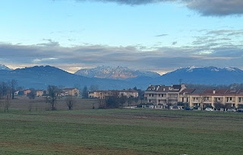

The magnolias that are SO CLOSE to opening up . . .

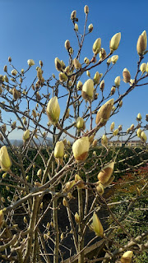

He's also been receiving a variety of awards and gifts in the past few days, like this beautiful plaque to commemorate his 3 years of service.

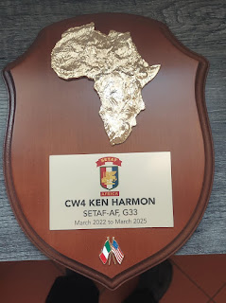

This was a special pin that the General gave to Scott after he (Scott) worked hard to prepare and oversee a new style of presenting at a recent briefing. What he did was so successful and made the General so happy, that he was given this pin as a token of appreciation. Scott has been an integral part of updating and upgrading how they present things at their weekly briefings, bringing his tech-savviness to the literal table. :) I'm so immensely proud of him. XOXO



Scott has also been building relations with our new downstairs neighbor, Bruno. Sometimes Scott will text me and mention Bruno and Bruna, and I thought he was just making up Bruno's girlfriend's name, ha ha. But then I just found out that Bruna is her ACTUAL NAME!! How cute is that.

He sent me this photo a couple days ago, after he helped Bruno and Bruna with some yardwork, which included trimming one of the trees that was hanging over the driveway. Scott said that Bruna would not let them call it a night until all the branches were neatly stacked into piles to be hauled away. She sounds like my kind of lady! I love when things are all neat and tidy and organized, too.

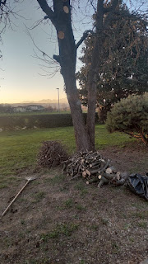

Scott will fly to Texas on March 12th, where he will spend a few days getting "debriefed" after his 3 year assignment in Italy. Once he's done with that, then he will fly up to Idaho and join me up here. Yay!

In the meantime, I have been rotating from project to project to project, with no shortage of things to choose from.

I recently paid quite a chunk of money to have this special and nostalgic sign put into a frame to protect it for the next several years. It used to hang at my grandparents' old ranch in Ukiah, CA (at the end of Helen Avenue) and it represents a very special place in my heart. I haven't decided where to hang it yet, so it's just sitting on a little bench in my living room for now.

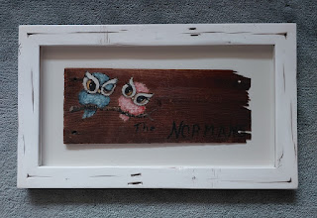

Over the course of two days (last Thursday and Friday), I scanned 1,000 slides that used to belong to my in-laws, Phil and Coy. I hauled various containers of slides in a laundry basket across town to the FamilySearch Center and got to work - 3 hours the first day and 2.5 hours the following day.

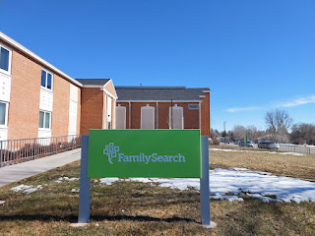

This is the tool that I used to scan each slide. There is a little "drawer" near the base where you can place one slide in at a time on the right side. It can hold up to 3 slides, but the middle one is what you are carefully centering in order to "capture" it by pushing a button. After you capture it, you place the next slide in on the right, which bumps out one of the completed slides on the left side.

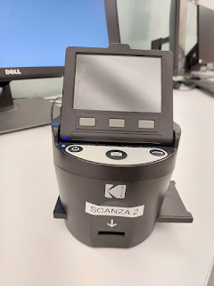

I created a system where I would pull out a certain amount of slides from whatever container they were in, and I'd stack them up into little piles. After I completed each pile, I'd put them back into the container that they came out of. Like this binder, for example - which was full of slides from Phil's trip to England many years ago where he visited the homes and towns of several famous authors and poets. (He was an English professor and also taught Shakespeare at Ricks College for almost 30 years.)

Each "page" in his binder had several slides tucked into plastic pockets. I had to remove them all, capture each one, then place them back into the pockets before moving on to the next page.

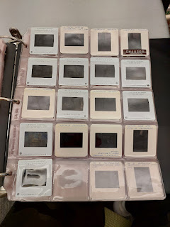

Another container - a metal box - was full of 200+ slides from Phil's military tour in Japan back in the 1950's. He hiked up Mount Fuji several times while he was there. I was really impressed by how often he'd hike up there, like it was some sort of a regular routine for him.

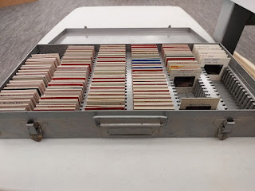

Mari made me dinner one night at my house. She made us some filet mignon and it was mouthwateringly delicious. She fried it up in my cast iron skillet, using melted butter and a seasoning mix that had salt, pepper, garlic, and truffle all mixed together. Once she got a nice seared crust on the outside, she put the whole pan into the oven for about 10 minutes to cook it a little more. It was so tender it just melted in my mouth . . .

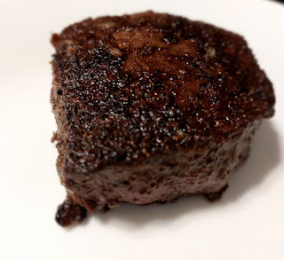

We roasted some golden beets and made a hearty side salad to accompany our juicy steaks.

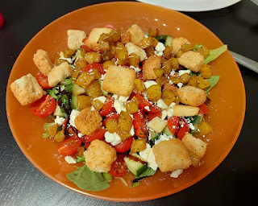

The following day, my nephew Caleb S. came over with his roommate, Daniel. I put them to work, ha ha. I had already decided that Saturday was the perfect day for washing the windows because it was predicted to be a warm and sunny day. I was grateful for their help, since I don't know how I would have gotten the screens in and out by myself. They were a bit tricky . . .

It took both of them to remove and then replace the screens, one worked from the inside and one of them was outside.

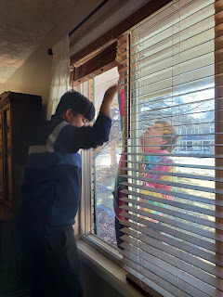

I cleaned and scrubbed the filthy living room screens while they puttered around the house, cleaning all the upstairs windows for me.

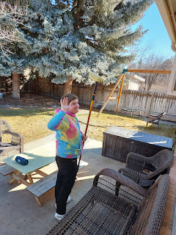

Daniel is ALWAYS smiling. Always. He is the best.

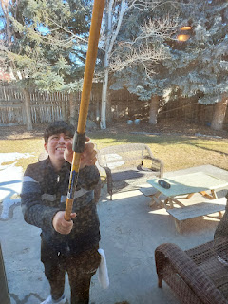

We ate pizza for lunch and played some card games in between all the work. They also accompanied me to Sam's Club to heft and haul six 40-lb bags of salt pellets home and down the stairs. We stacked all the bags in the utility room so they can be used in the water softener. We go through about 2 bags every 3 months, give or take. I was so grateful to have some extra muscles for such an exhaustive job. Could I have done it by myself? Absolutely, and I've done it before. But it was so nice to have some help this time.

A friend of mine back in Italy posted this recently, and I thought it was very helpful. Dalia is from Israel, but works at the Koko Mosaico in Ravenna, where some friends came with me to learn how to make a mosaic tile last November. Ramadan is a VERY important religious month for Muslims in the Islamic faith. I knew that Abdel (our Moroccan son) was looking forward to celebrating the sacred month, but I didn't know all of these things until Dalia posted this. (click to enlarge)



Last Sunday, I met a lady at church named Candice, who had just moved into the area a few days before. As we talked a little bit before Sunday School began, I learned that she and her teenage son (17) had been sleeping on the floor while they waited for some beds to arrive in the next day or two. After the class was over, I introduced her to my friend, Barb Vance, who is the new Relief Society president as of a few months ago. Barb and I coordinated over the next 24 hours to help Candice.

First, I drove over to Candice's apartment later that same afternoon to bring her my two camping cots with some nice and THICK sleeping pads. She was so grateful. Then, on Monday, Barb came over to my house and we loaded up a ton of groceries that were down in my food storage room. I had already talked to Barb about this a few weeks ago - how I wanted to donate several items before I left for Italy. Some of the things I have in my food storage can survive for decades because they're made to do so, like 50 lb bags of flour, sugar, and rice. Or #10 cans. Or dried beans and pasta.

But some things, like small cans of soup, vegetables, tomatoes, fruits, tuna, canned chicken, peanut butter, etc. are only meant to last a little while. I didn't want them to spoil because no one is here to use them, so Barb and I found a perfect solution by donating them to Candice. I had already sent Barb a list along with photos of everything that needed to go. She sat down with Candice on Sunday evening to see what was needed or wanted, and it was pretty much everything that I was offering! It ended up being a win-win for both Candice and me. :)

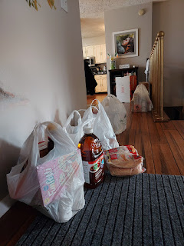

This next photo is out of order, but this is what my living room looks like tonight as I'm typing this up. Over by the window are the remains of the cots and pads that I just picked up from Candice's place last night. She had bundled all the sleeping pads into one giant burrito roll, and I just need to separate them out still and put them away in the garage. There are misc. flowers from Hobby Lobby laying on the floor that I need to work with: some will go into a hanging basket for our front door in Italy, and there are two giant flowers for Abby and Gwen that we will take up to them in a few weeks. The Norman sign still needs a spot to hang up somewhere. And there are pieces of fabric laying on the couch as I'm in the middle of making two baby blankets right now.

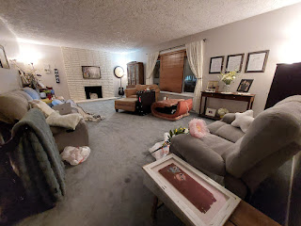

I also started on Maisie's quiet book a few days ago. I realized that if I can get some of the pages made ahead to a certain point, then I can do some handwork and embroidery while Scott and I will be in the car for several hours at the end of March into early April. We will be driving all the way up to Portland, then down to San Francisco, and eventually back to Idaho Falls.

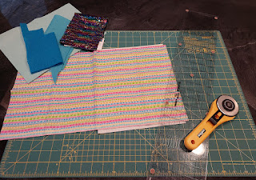

Page one is off to a good start. The pieces aren't stitched onto the page yet, but they are cut and ready to be sewn on. I think I'll embroider the words, "Glub Glub" down at the bottom. The sequin fabric is fun to play with as you brush the pattern one way with your fingers, and then brush it back into place again.

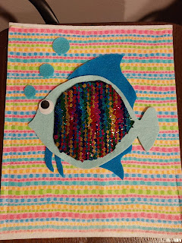

I made another weekly trek down to the temple in Pocatello on Wednesday, since the Idaho Falls Temple is still closed for another couple of weeks. The clouds were sure pretty in the sky behind it this time.

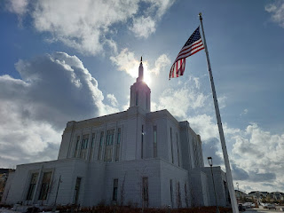

I really love the flower details on all the doors and windows of the temple . . .

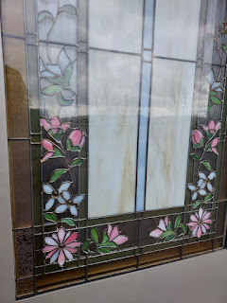

After my session inside was finished, I drove up behind the temple to take a couple photos with the snow-capped mountains off in the distance . . .

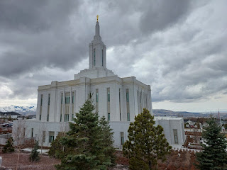

I posted on social media about my trip to the temple, and this is what I wrote: "Regularly attending the temple has taught me some very basic truths. God is in the details of our lives. He and His Son, Jesus Christ, love us infinitely. Everything we go through can bring us a little closer to them as we learn to trust them and follow their loving counsel. I feel so much happier these days, and it's because I have put my trust in Them. Everything is gonna be okay. If not now, then eventually. Keep trusting. Don't ever stop."

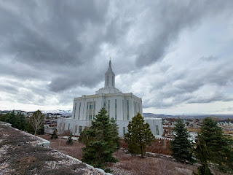

I was very disheartened when I came out of our local Joann's Fabric store a few days ago, to see these two guys hanging up a "going out of business" sign. Disheartened is an understatement. I think I was a little mad about it, actually. We have lost so many amazing fabric stores in Idaho Falls over the past several years (Hancock Fabrics, Porters, and now Joann's). All we have left now is Hobby Lobby, and they only have a medium-ish supply of fabric to choose from. What a huge bummer this is.

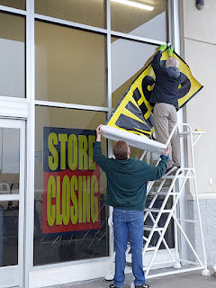

When I couldn't find what I needed at Joann's or Hobby Lobby, I ended up having to order some flannel from a couple of shops on Etsy. The problem there is that I can't touch the fabric, what if the color ends up being different from what I see on my computer screen, and I have to pay for shipping to get it here. Sigh. I think I might end up being one of those quilting/crafting ladies who looks for fabric stores when I'm on vacation, and then I'll stuff a bunch of fabric into my suitcase to haul home . . .

It was shaping up to be a lovely spring warming trend, with abundant sunshine, chirpy birds, dry sidewalks, and lighter layers while running errands . . . and then winter happened all over again.

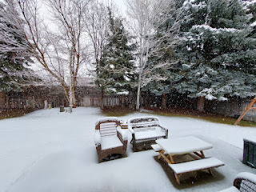

Well, at least I have plenty of projects to keep me busy indoors right now . . . (like baby blanket #1)

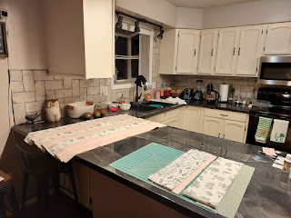

I've also started taking a whole slew of supplements in the past week. Yay. More pills to swallow.

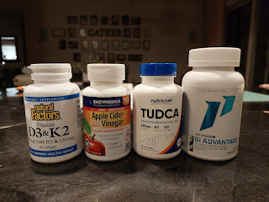

Ultimately, I think the GI Advantage will do the most potential good for my gut. It is supposed to virtually eliminate all the inflammation I've been experiencing, as well as work on tightening up the lining of my gut so that the good stuff doesn't leak out and the bad stuff can't infiltrate in. I'll let you know how it goes.

At the end of a recent video call with Jake and Jack, Maisie woke up from her morning nap and I got to say hello to her. She has the prettiest eyes!

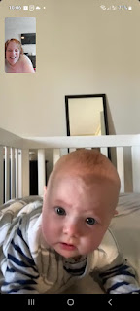

When Jake shared this next photo a couple days ago, Scott texted back: "Are you sure she is enjoying this?" Because just look at her face, ha ha.

Jacob responded back with: "Court mandated outdoor time."

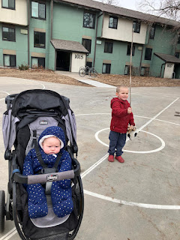

Video of Maisie having the cutest conversation with her daddy: (19 seconds)
https://photos.app.goo.gl/tqFetGb2UTuiQ3gr9

Video of Jacob trying to work from home upstairs, only he has a little "something" on his lap:
(7 seconds)
https://photos.app.goo.gl/TYuK17C1Prarpr2d7

And that's a wrap. It's 10:43 p.m. but I wanted to get this done tonight so I can dig back into my sewing projects tomorrow. I've been watching several classes today during the RootsTech Conference while also cutting fabric and sewing. I am learning a LOT about how to move forward in my family history efforts and I am so excited to implement some new techniques this year, especially in my German ancestry.

Coming Up:

I'll be visiting Benson and having a sleepover in Mountain Home on Sunday night. Yay!!
Baby blankets.
Maisie's Quiet Book.
Temple in Pocatello again.
And a MASSAGE. Hallelujah.

Have a wonderful weekend!!

