Qualified to Drive Stelvio Pass
It ONLY took me around 6 hours (spread out over 2 days) to work through all the materials and take 3 lengthy tests, but I am now the proud owner of an Italian Driving License! (If you're not sure what Stelvio Pass is, you might want to look it up, ha ha) (I'm not sure that I'm actually ready to drive that stretch of road in Italy, but at least I'm qualified to do so.)
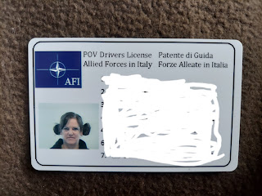

I took a 154-question pre-test, a 200-question practice test, and then a 100-question ACTUAL test. I had to get at least 85% to pass, and I got 94%. Hooray! It was so tedious and brain-draining and there were several times that I wanted to throw something across the room because I was so tired of sitting in my hotel room chair . . . But I made it, thankfully. And no, I didn't ever end up actually throwing anything. Just in case you wondered.

There was an urgent need for me to get this drivers license because I needed to be able to drive Scott's car (to get us all moved in) while he would be in Germany for 2 weeks. But on Tuesday, we got the BEST NEWS EVER: his training in Germany got canceled!! Hooray for us!! That literally changed everything. All the stress went away and suddenly I had much less on my shoulders than I did previously and I felt so very, very grateful. Now we can do everything as a TEAM and it just feels so amazing. :)

Tuesday:
I spent a good portion of the day getting my last blog post done. For dinner, we made a hotel room style chicken salad: bagged lettuce, tomatoes chopped with a butter knife on a plate, sauteed chicken in a pan with only salt and pepper, shredded cheese, ranch Doritos, and bottled dressing. It was "okay".

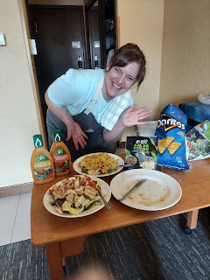

After dinner, we went for an evening walk around the track just outside our hotel. The evening was crisp and we wished that we had one more layer on as we walked. Instead, we just kept going and going until we warmed up 1%.

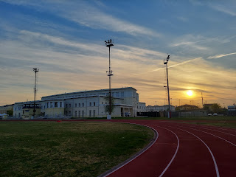

Kylie has a special skill: if she's driving and wants to know if Avery is asleep or not, she reaches behind and over her head to snap a picture of Avery in her carseat (while keeping her eyes on the road of course!). This time, Avery was very much NOT asleep, ha ha. What a sweet and precious face.

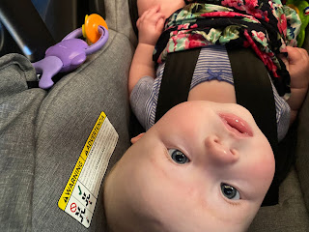

Wednesday:
I woke up and immediately began researching how to make Scott a birthday "cake in a mug". I found a great (and simple) recipe and figured that after I worked on my driver's training in the morning, I could get the supplies and bake the "cake" in the afternoon before he got home from work. Well, let's just say I spent WAAAY more time in the drivers training course than I ever anticipated!! I was quite stressed and out of time for baking by the time he got home, which was much earlier than usual, too.

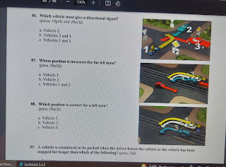

He got off early so that we could meet with Ana from the realtor's office over at the new house. She agreed to let us in because I needed to see the space in order to start planning and purchasing some things prior to moving in.

The handsome birthday boy coming to pick me up . . .

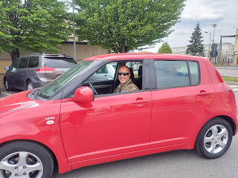

From the outside alley, this is the main entrance to get up to our apartment (1B). We can receive mail through a little slot next to the door, and there is also a camera to see who is at the door if they buzz to come up. We have our own buzzer button and the other tenant in 1A has her own, too.

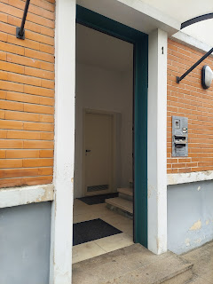

Before we went up the stairs, we checked out the little garage unit outside. We have 2 parking places, one in the garage and a small area next to the garage. (Note the glass windows on the side of the building - you'll see those from the inside in just a moment)

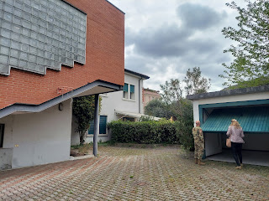

There is a reasonable amount of space inside the garage, which is nice.

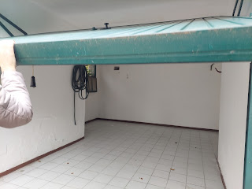

Video #1: Going inside and up the stairs. (28 sec)

https://photos.app.goo.gl/YS3tSuae8aqteUQh7

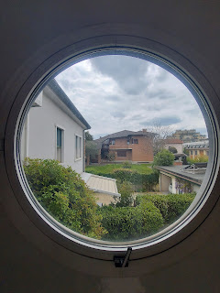

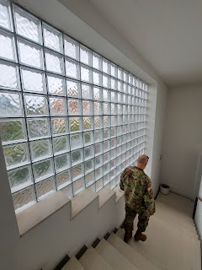

Video #2: Coming into 1B through the living room and then into the big kitchen. (1 min, 5 sec)
https://photos.app.goo.gl/3Ki8Zu9C3eBjde9u5

*Note that there are 2 video units to see who is wanting to come into our building - one as you enter the apartment, and one is in the kitchen as well.

The view from the bedroom hallway area looking toward the front entrance.

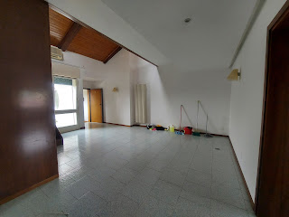

TONS of storage in this place. This shows a couple of the cupboards under the stairs . . .

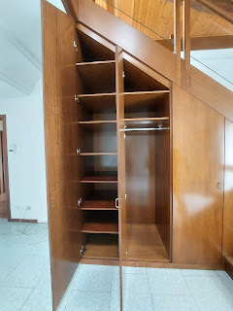

Very modern kitchen with lots of drawers and storage space.

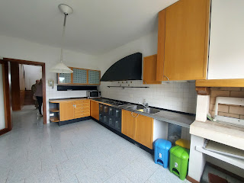

The fridge/freezer is hidden in what appears to be cupboards from the outside. The oven is smaller than an American oven. I need to find some smaller baking pans . . .

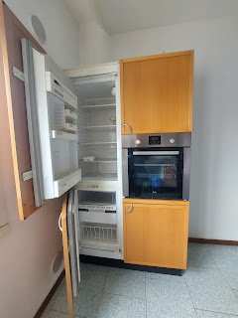

This is a "nook" in the kitchen that can be used as a grilling station. You can set up a small BBQ here and the fumes can safely go up the little chimney.

Also, there are 4 types of garbage in Italy and I am learning about what they are. I think they are paper/cardboard, plastic, dry waste (whatever that means), and glass. Different types of garbage get picked up on different days of the week.

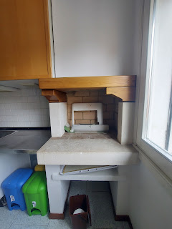

Video #3: Leaving the kitchen and heading toward the hallway with the bedrooms. There are 3 bedrooms on the main floor: a big one on the left, a small one in the middle (we plan to use it as an office), and the large master bedroom on the far right. (1 min, 54 sec)

https://photos.app.goo.gl/oMsz2iKWrRu3AapE6

Note that there are 2 bathrooms right next to each other. And they are very distinctive in colors, ha ha. The master bathroom is teal and white, with a walk-in shower. Scott was able to show photos of the walk-in shower he built in our master bathroom back home to the landlord, Giuseppe. They were both admiring each other's work and he could tell that Giuseppe was impressed with his talent, and that he (Giuseppe) would trust us to live in his home.

The guest bathroom next to our master bedroom/bathroom is VERY blue, ha ha.

Left guest room - -

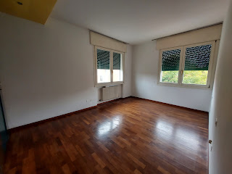

One of the many closets in that big guest room.

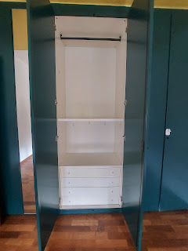

The small middle bedroom - the one we plan to use as an office.

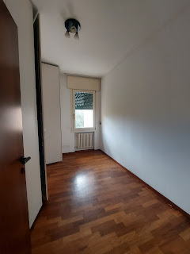

An amazing amount of storage space is in this small room.

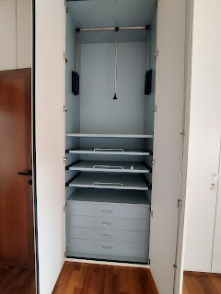

The master bedroom. The master bath is tucked inside on the right (can't be seen in this photo).

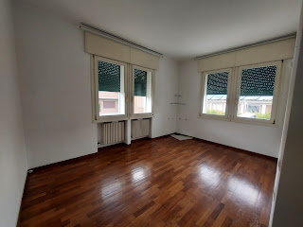

Master bath - -

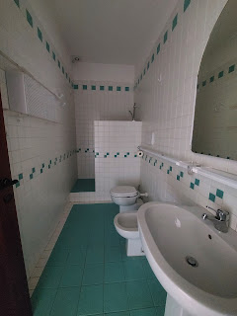

Video #4: Coming out from the master bedroom doorway and into the guest bathroom next door. We will be getting a washer/dryer later this coming week and they will go inside the guest bathroom on the left. (58 seconds)
https://photos.app.goo.gl/QTNPZNGHr1LwpGWM9

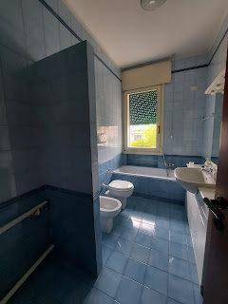

Video #5: Going upstairs to the loft and outside onto the rooftop terrace. (50 seconds)
https://photos.app.goo.gl/UinkHNBurDvp1c6X7

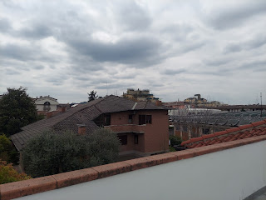

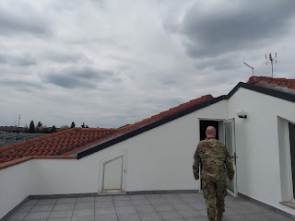

Next door is a gas station. Across the street are 2 grocery stores. Very convenient.

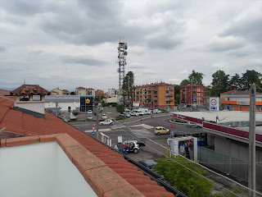

Video #6: Coming from the terrace and into the upstairs bedroom. It's a huge room and we're thinking of making it the Grandchildren Guest Room. It has its own bathroom (pink and white) and is just a really fun space and I can't wait to dig in and make it something special.
(1 min, 9 sec)
https://photos.app.goo.gl/YgzhFP5Nzo4R8GmG6

View of the loft area with the upstairs guest room on the left. (The Grandchildren Guest Suite)

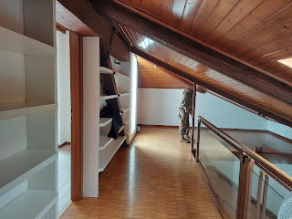

Soon-to-be the Grandchildren Guest Suite.

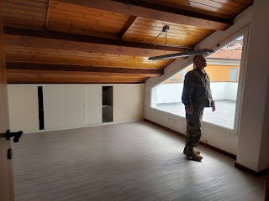

Going on this tour was SUPER helpful! I am a visual person so this was right up my alley. I have reviewed all the photos and videos numerous times as I've tried to compile some lists of what we need and what would "be nice" to have. Again, I feel such immense relief that Scott will be here to get moved in with me, instead of him being gone for 2 weeks. What a tremendous blessing this is right now!

After we got back to the hotel, it was back to the "books" for me. I worked hard on and did well on the 200-question practice test for my Italian license, getting a 95% score on this one. Yay!!

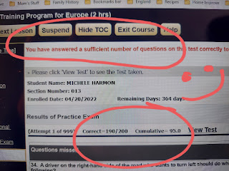

FINALLY I was able to get up out of that chair and be free for the evening. I was SO ANTSY at this point! I asked if we could walk to dinner just so I could get my wiggles out, so that's what we did. Our plan was to walk over to a nice Mexican restaurant for dinner, but when we got there we saw that they didn't open until 7:00 p.m. and we didn't want to wait that long. So we decided to backtrack and just get some pizza at the same place we got the shawarma dinner a couple days before.

The clouds and the evening sky were just right for photographing this old church on the way.

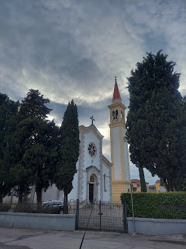

We got a kebab pizza to share and it was actually really good!

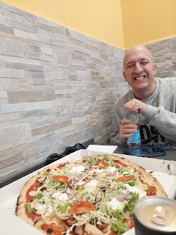

The wisteria is so pretty right now. I love seeing it all over everywhere.

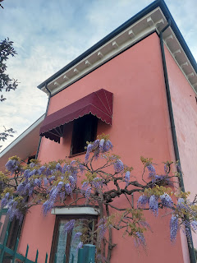

Since I didn't make a mug cake for Scott on his birthday, we walked across the street from the kebab restaurant to the gelateria. Gelato is my favorite. It's so good!! We got a cup to share and we each chose a flavor. I chose pistachio (top row, 2nd from left).

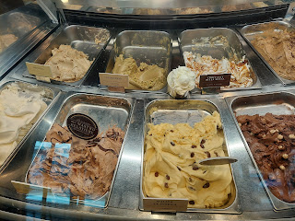

And the birthday boy chose Cremino 1911 - a mixture of hazelnut and chocolate. (top row, middle)

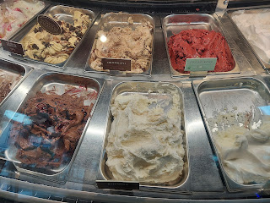

This place had several other fancy desserts to choose from, but they will have to wait until another day.

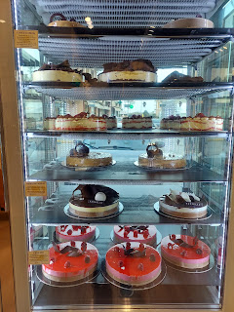

I sang happy birthday to him before he could take his first bite. :)

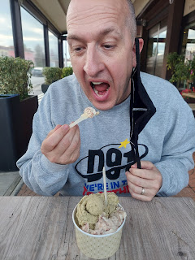

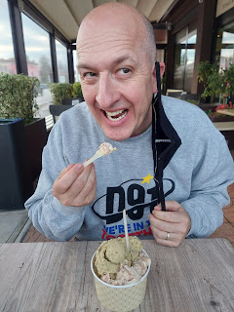

And then we walked back to the base. Everything is within about a 10-15 minute walk from our hotel.

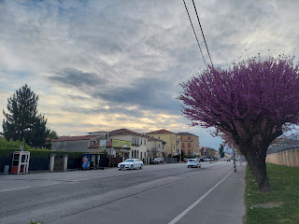

Thursday:
After exercising and getting ready, I sat my bottom back in that dreaded desk chair for one more final exam. 100 questions this time, but this was for real. I ended up getting 94% and passed. What a relief!!

I rewarded myself by going shopping. Mostly just window shopping, though. I put my destination into Google maps, selecting public transportation as my mode to get to the store. It said that Bus #1080 would be arriving at 1:03 p.m. I hustled and got to the bus stop by 12:50, but it never came. As the minutes ticked by and the bus never came, I refreshed the Google maps page and now it said that Bus #19 would be coming at 1:39 p.m. What?? I didn't have much choice but to wait. So I did.

While I waited, I was able to help an autistic Italian young man to make sure he was getting on the right bus. He didn't speak any English, but I just pulled up my Google Translate app and we were able to double check his route. He was very smiley and cheerful the whole time.

After he boarded his bus, another man arrived at the bus stop and was waiting with me. Eventually, he began speaking to me in Italian. I indicated that I only know English so he tried to communicate with the tiny amount of English that he knew, but I ended up having to pull up that trusty Google Translate app again. What I love about it is that you can hit the microphone button and just speak what you are trying to say (instead of typing it all, which can be tedious), and then it will translate your words into whatever language you need for the other person. After I say my part, I just hold up the phone for them to read the message in their own language. They can do the same thing, allowing me to read what they are trying to say to me.

After we communicated back and forth like this, trying to see what bus he needed, eventually I asked him other questions like was he from Vicenza, etc. He told me (through Google Translate) that he came here to work and that he is originally from Algeria! I had to look it up on a map to see where it is. It's on the northern tip of Africa, next to Morocco and Tunisia and not too far from Italy. Once I learned that he was Algerian, I asked him if Italian was his native language or not. It's not. He was just being polite because he knew enough of it to get by as I used the app. Instead, his native tongue is Arabic! So I switched the language in the app to Arabic and then we were on a roll, ha ha! Soon his bus came, however, and I was all alone again. Still waiting . . .

I waited for an hour at that bus stop for a way to get to the store. I was a little frustrated with how long it all took, but at least I had some interesting conversations during that time. Take those curveballs that life throws at you, and turn them into something positive. You'll be happier.

Finally, I arrived at Happy Casa, a home goods store that had been recommended to me by some members of the ward here. I spent 90 minutes just slowly wandering down each aisle, taking it all in and learning what they have and how much it costs.

Interesting FYI: If you want a shopping cart, you have to put some euros in and then you can unlock one. Weird, right??

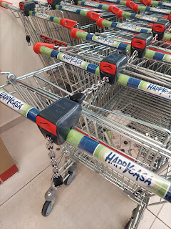

Instead of buying an entire broom, you buy the handle and then purchase whatever bristle heads you need separately.

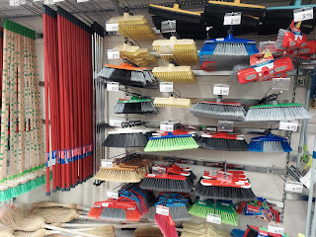

Electricity is somewhat restricted over here. I'm not sure if it's just super expensive, or not as readily available, or what . . . But you can't turn on your A/C until May 15th. The A/C season is from May 15 - Sept 15. If it's a hot day outside of that window, then you're on your own. Use a fan perhaps? Open the windows? (try not to invite TOO many mosquitoes in)

And most people don't put their clothes into a dryer over here, but they hang it out to dry instead. I'm thinking that it's because of the issue with electricity. Whatever the case, I used a drying rack that looked just like this one when I was in Germany last fall. It holds a lot of clothes and folds up when not in use. I think I'll get 1-2 of these for our house here.

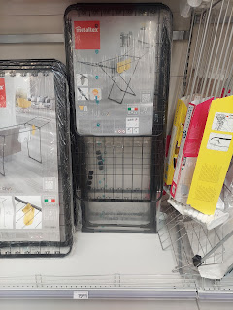

Defnitely need a clock or two for the house.

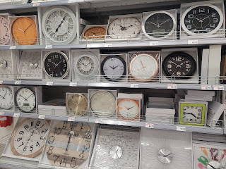

Rugs galore . . .

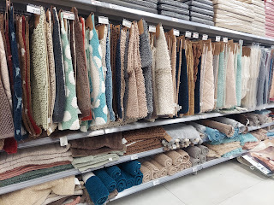

I almost bought this one for our teal/white bathroom, but found another one instead.

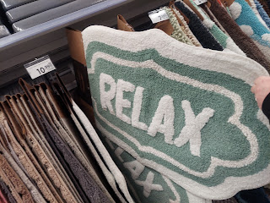

Home decor . . .

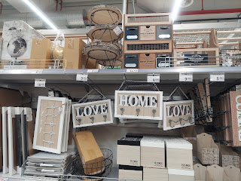

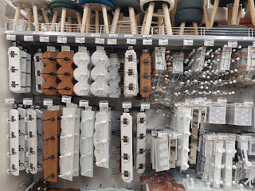

Hammocks. I hope there's a way to set up a hammock up on the terrace. I'm not sure how yet, but where there's a will - - - there's a way!!

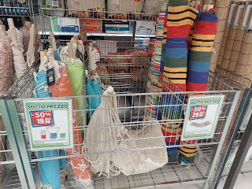

Nice sale price on patio chairs. ($6.99 each)

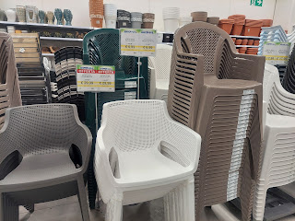

Endless selection of frying pans . . .

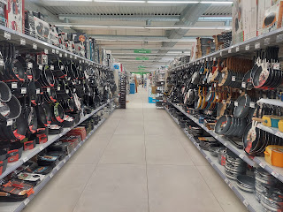

I love these dishes for the kitchen. The textures and neutral colors are very appealing to me.

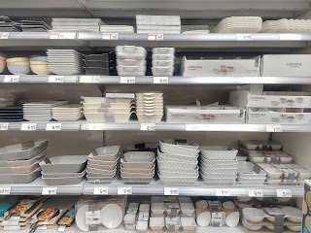

These are also very Italian though - bright and fun colors for sure.

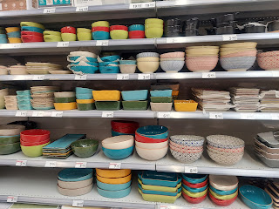

On the bus ride back, I passed this store called "Bimbo Store - Toy Center". Hilarious, but it's a children's toy store! I'll have to check that out at some point after we get settled in.

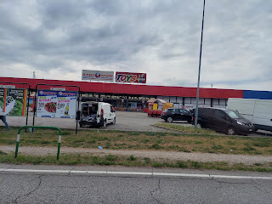

I bought two of these cream colored rugs for our bathroom floor, with 3 cute heart patterns on them.

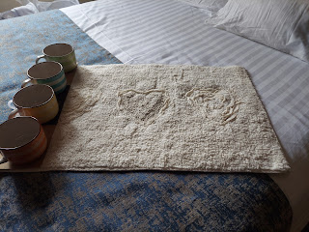

And who doesn't need some of these fun and colorful mugs? I bought them because they are big enough to use for soup or cereal, ice cream, and of course warm beverages.

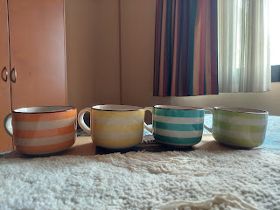

Friday:
I got my actual Italian drivers license by walking over to the building in between the hotel and the track to show them both certificates that proved I completed the course, then I filled out the appropriate paperwork and waited for them to review it all and take my photo. What an exciting accomplishment!

Next, I walked over to the Tax Relief Office to get some information, but apparently they are closed on Fridays. Darn it. Over here, there is a 22% tax added on to most things, including services such as utilities. There is an arrangement between Italy and several different governments (including Germany, Belgium, and the U.S.) that allows us to skip that monumental tax. I just need to learn what the process is so that we can proceed. Some of the ward members were trying to explain to us that if we want a bunch of stuff at IKEA, for example, then we have to get a form (at the store?) with all the items listed on it. Then we take the form to the Tax Relief Office and something awesome is supposed to happen, like them giving us a check or something to pay the difference . . . Once we have that from the TRO then we can actually order the items, minus the 22% tax. It takes a little longer, but saves a ton of money. I just need to get more info so I don't sound like a blubbering idiot. I'll let you know in the next post how it all works . . .

I walked over to the PX to get some food and ran into Cody, the young man that we took to the Easter dinner gathering last weekend. He had spent several days over at the Cinque Terre, kayaking and enjoying a pesto-making class that he said was phenomenal. How fun! I can't wait to learn how to make some authentic Italian pesto someday myself soon!

Inside the PX, there are several rotating local vendors that set up shop during the weekdays. They sell holiday items, artwork, locally made glass, and even essential oils.

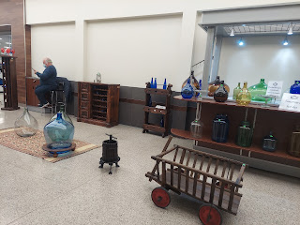

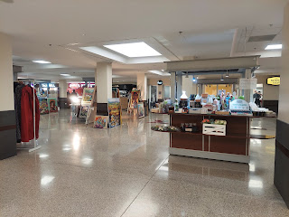

Once I found what I needed in the PX, I went back to the hotel room and started our laundry across the hall. I tell you, there is nothing more homey than doing laundry wherever you are in the world. I was grateful for the convenience of having the laundry room so close, and in between loads, I relaxed and watched "The Home Edit" on Netflix. It's a show where two friends teamed up with their respective organizational skills and then they teach us their methods, including this familiar rainbow-order technique. (I always arrange my clothes in rainbow order in my closet at home - it makes it easier to find what I need.)

Take a look at this gorgeous pantry! Wow.

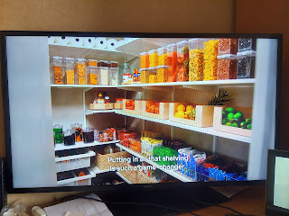

Scott is working on getting a 2nd car for us. It's a 2008 +/- Peugot wagon. It has a small oil leak which he'll get fixed this week, but it will be nice and more comfortable for longer drives and to transport friends and family who come to visit. It's not a stick shift, which will be great for me to drive when he's at work. Because I have an ITALIAN DRIVERS LICENSE!! ha ha

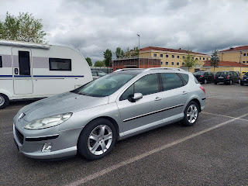

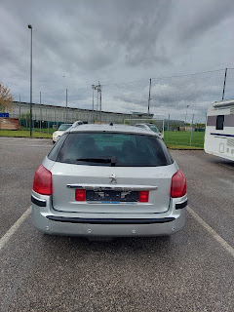

When Scott got home from work, we went on a grand adventure entitled, "Operation Mattress". I had already researched several stores for us to go to, so we chose the top 3 and headed out. The base (and our house) are in the SE section of Vicenza, but the stores we visited were all in the SW section. Along the way, we saw some of the same pretty sights that we see along our drive to church on Sundays.

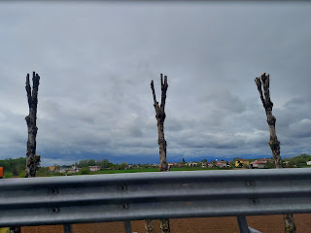

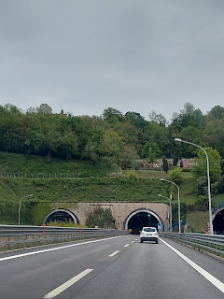

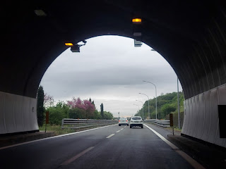

We really liked Store #1, and didn't really like Store #2, but Store #3 took the cake. Not only did they have the best price, but definitely had the best customer service, too. Zeno, the manager, spoke really good English, and had a great sense of humor. He was articulate and helpful and even shared some behind-the-scenes stories of the Mattress Mafia in Northern Italy, particularly in Vicenza. Apparently all the mattress shop owners who have been around for generations all have this pact to keep their prices the same, thus benefitting them all. But if a new owner comes in and has an exceptional product line at a lower cost (such as Zeno), the Mattress Mafia don't like that very much. (I dubbed them the Mattress Mafia, by the way. That's not really their name. Nor do they really have a name.)

He said that one day he came to work and someone had literally used a glue gun to glue the front door lock so that he couldn't get in. Another time, he got to work and found his whole front window shattered. He had already been warned about these older guys, but now he was finding out firsthand just what they are capable of. Thankfully for him, he is just renting the building and so the landlord was the one who had to pay for the new window. It didn't come out of his own earnings.

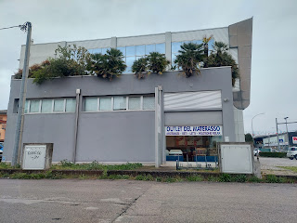

The Italian mattress we selected is being crafted offsite just outside of Bassano del Grappa - the place of my ancestors and where I went paragliding last October. It's got plenty of memory foam and is going to be such a delight - I can hardly wait! The price: 730 euros. Not bad, not bad.

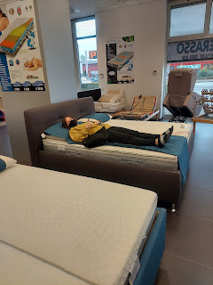

This interesting paradox was situated just outside Store #2. A contrast of old art and new (in the background).

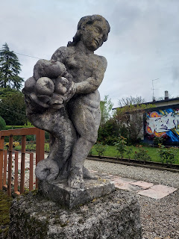

After returning to the base, we stopped at the Commissary for some groceries and happened to park next to this tender sign: "Reserved for Surviving Families. Please respect this spot and their sacrifice." Wow.

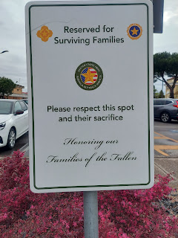

Opting for a "night in", we cooked up some pasta, veggies and chicken and watched a movie. It was relaxing and wonderful.

Saturday:
I had a cruddy night of sleep, so I woke up a little grumpy. Nevertheless, we drove over to the nearby IKEA store mid-morning because we knew it was important to utilize our time on the only Saturday before we move into our house next week. After a wrong turn that resulted in a toll of .80 euro (close to $1.00 US) and about 20 minutes of lost time from going in the opposite direction, Scott became grumpy. I jokingly said to him, "But you shouldn't be grumpy! I'm the one who didn't get any sleep and I'm the one that's happy." He laughed and made the needed attitude adjustment as we turned back to the east toward Padova.

IKEA is an overwhelming store even if you've been there before. But having everything labeled in either Scandinavian or Italian made it even more overwhelming.

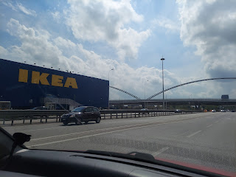

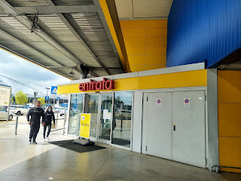

As I started looking around and getting some ideas for building a home . . .

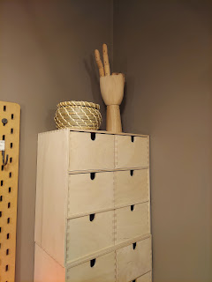

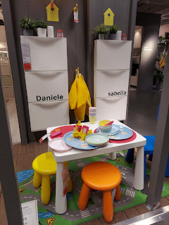

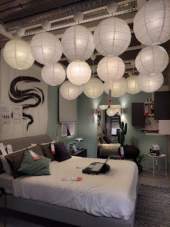

Scott found every available couch, chair, or otherwise to sit and wait for me.

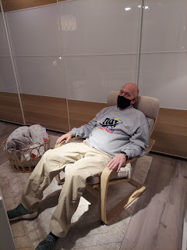

I liked this duvet cover, called Bergpalm. It's like a sage green with subtle stripes. But the names of everything are in Swedish or Italian, as I said earlier. So I was using my Google translate app to figure out what the tags or signs were saying. The tag for this duvet cover read: "Copripiumino e 2 federe". That meant "duver cover with 2 pillowcases".

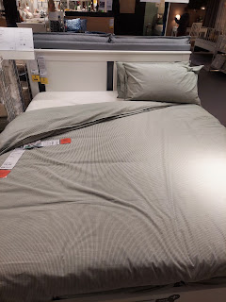

Time for intermission. The food court in IKEA is full of delectable foods, including their signature dish: Swedish meatballs with gravy and lingonberry jam. Yum!!

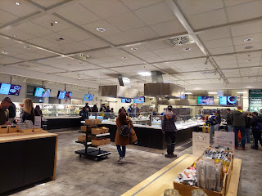

After showing our Covid vaccination cards, we could enter and choose what to eat. When we saw the salmon with lemon and dill sauce, it looked too good to pass up. I will need to get this every time from now on. Oh my gosh. The most delicious thing I've ever eaten!!

The lone blonde meatball-looking thing was a risotto something or other . . . I can't remember now. But inside it has risotto (like a rice), some red sauce and cheese, and fried on the outside. It was really good! But the salmon is what stole the show.

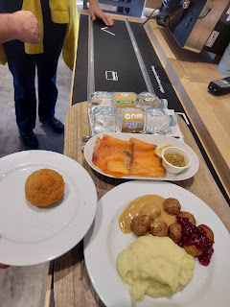

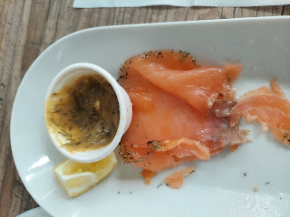

Back to more shopping. These adorable tiny little tea cups would be fun to have a tea-party with Abby and Gwen when they come for a visit. But I think they are actually for the shots of caffe that are so common over here in Europe.

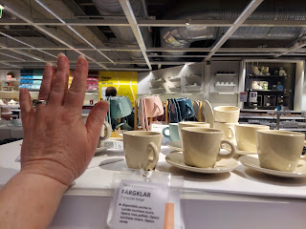

Some fun possibilities for our entry way . . . Mi casa es tu casa

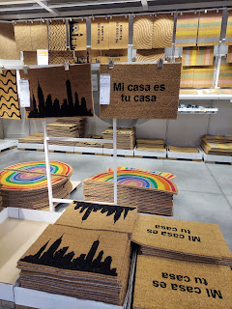

And a GIANT room filled with plants, plants, and plants.

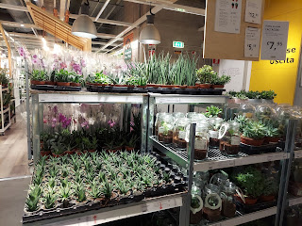

The ONE thing I left the store with - that I could not part with - was this little sheepie for 2 euros. Scott also bought us a duvet and duvet cover so at least we'll have some bedding when our mattress arrives next Friday. The rest of the things we need will have to wait and go on that tax form once I get the details on what to do.

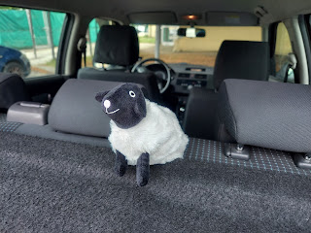

We spent a total of about 4 hours in IKEA. Sheesh. It was exhausting but at least we learned what they have in the store, which is helpful.

For dinner, we had a reservation at the Mexican restaurant where we wanted to eat earlier in the week. Sad that you have to wait until 7:00 p.m. to eat dinner. I'd rather be home and getting into my pajamas by that point . . . but the food and the ambiance made it worth the wait.

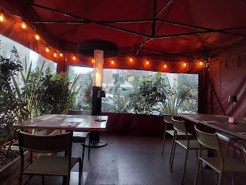

We sat in the tent area in front of the restaurant, and I especially liked the lighting and the heaters. It was chilly due to the rainstorm that was pushing through, and we had walked part of the way there, but the tent wasn't cold at all.

The custom was different than what I had expected when the food arrived. Scott had ordered beef nachos, which they brought out first, with two small plates so that we could share it.

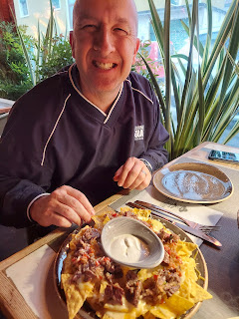

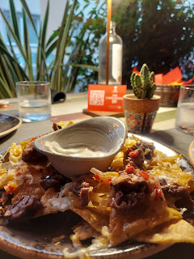

Later, they brought out the fajitas that I had ordered, with two plates of garnishes for us to share the entree together. How romantic!

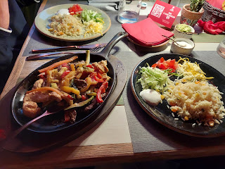

Walking back to where we parked the car just inside the gate of the base, the church steeple was lit up and beautiful against the cloudy and stormy sky. It rained lightly on us as we made our way home for the night.

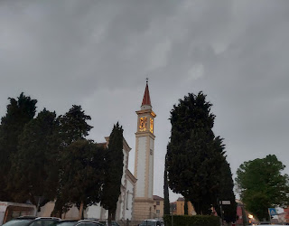

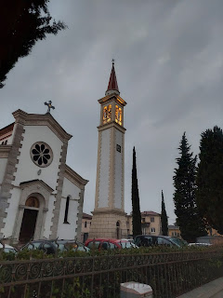

Sunday:
We arrived just in time for church to begin, due to a hair malfunction on my part, ha ha. I wish that I could just turn off the perfectionist part of my brain sometimes . . .

As we found some seats before the meeting began, the Bishop came over to us. He asked Scott to make sure that the ward clerk pulled his (Scott's) membership record over before leaving church today, and then he told me that the ward council had been "discussing" my name this morning. Umm, I hope it was all good! He smiled and said that they have something in mind for me to do, even though I'll be back and forth and my records won't officially be in this ward. I'm guessing it's going to have something to do with helping people with their family history, since last Sunday when I told him of my love for and my experience with family history, (and how I'm on the family history committee back home), he got really excited. It appears that they don't have anyone in the ward with that area of expertise, at least none that they know of. I would be honored and thrilled to help some people during the time that I'm here!!

In Relief Society, the sister missionaries taught the lesson and they did a great job! One of the things they did was to draw this on the white board:

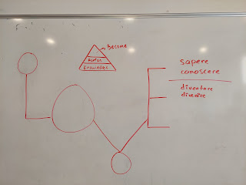

For those of you who are members of the Church of Jesus Christ of Latter-day Saints, you will understand when I say that the word "LOVE" above also fits with the Plan of Salvation, or the Plan of Happiness. See if you can fit the components in with what they drew. (For those of you who don't understand what I'm talking about, please message me.)

They also taught that (in the triangle above) our foundation of growth tends to begin with knowledge. As our knowledge increases, it leads to action. We make choices based on what we know. The highest level is that we BECOME. We learn, we choose and act, and then we become. The goal is to become what God wants us to become.

The additional words on the right are in Italian. The sister missionary taught that "sapere" means to know (to know facts, directions, etc) and that "conoscere" means to COME to know (i.e. people). The bottom 2 words have to do with becoming. The bottom word, "divenire" means to go back to what you already knew or were. If the goal is to become like Christ and our Heavenly Parents, then as we "become" and as we "go back to what we already were", we realize that we were Divine to begin with. What a deep thought to ponder . . .

I love this ward so much! It is unique in the sense that you have families and individuals from all around the world who bring their testimonies of Christ and specific life experiences with them to Vicenza. I feel like I'm about to learn a LOT while I'm here. I look forward to it all.

Time for Grandbabies . . .

(Kylie I hope you don't mind, but I stole this darling photo of Avery from your Instagram page, ha ha) She is SO CUTE I just had to take a screenshot. She has such a personality at her age - it's going to be so much fun seeing her grow up over the years. :)



Video of Avery trying to eat Kylie's phone: (1 min, 6 sec)
https://photos.app.goo.gl/1Sc9eFyEG5quuEji6

Kylie shared this hilarious photo in our group chat yesterday, accompanied by this explanation:
"A new undiscovered trait that Avery has from Benson. EYEBROWS."

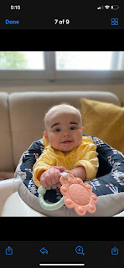

Video of Jack crawling at lightning speed across the room: (25 seconds)
https://photos.app.goo.gl/9EtieaUCu2b2UKJ67

Video of Jack and his favorite new game: (24 seconds)
https://photos.app.goo.gl/imHEbPNrjfquBZ9e9

Jacob replicated the over-the-shoulder photo of Jack in his carseat in the same style that Kylie did with Avery, ha ha

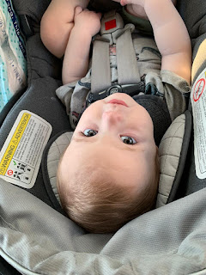

This photo of Abby is from last week. Amber described the scene as this:
"Picking out yarn for a summer craft. She goes, 'Woah, this one is so . . . red. I love it!"

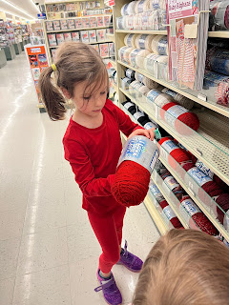

A sunny girl on a sunny day :)

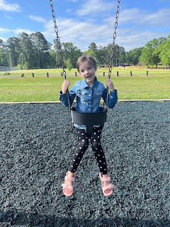

And lastly, our spunky Gwen :)



